LAB Logbook

Lab 1

Lab 2

The Cost of a larger house of size SID\*0.75 is approximately between 4.6 and 4.9

Lab 3

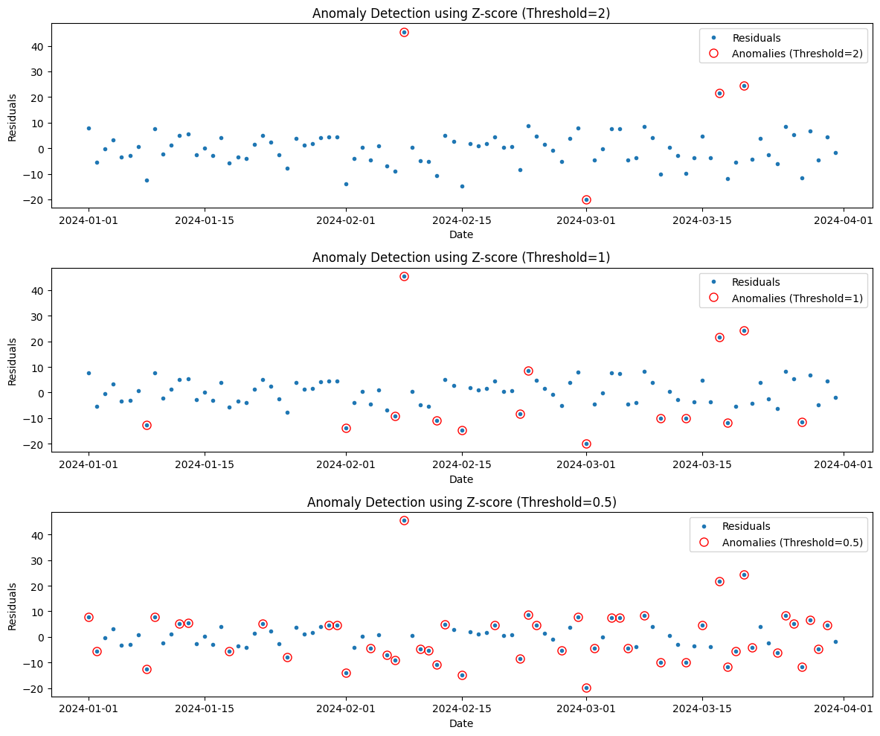

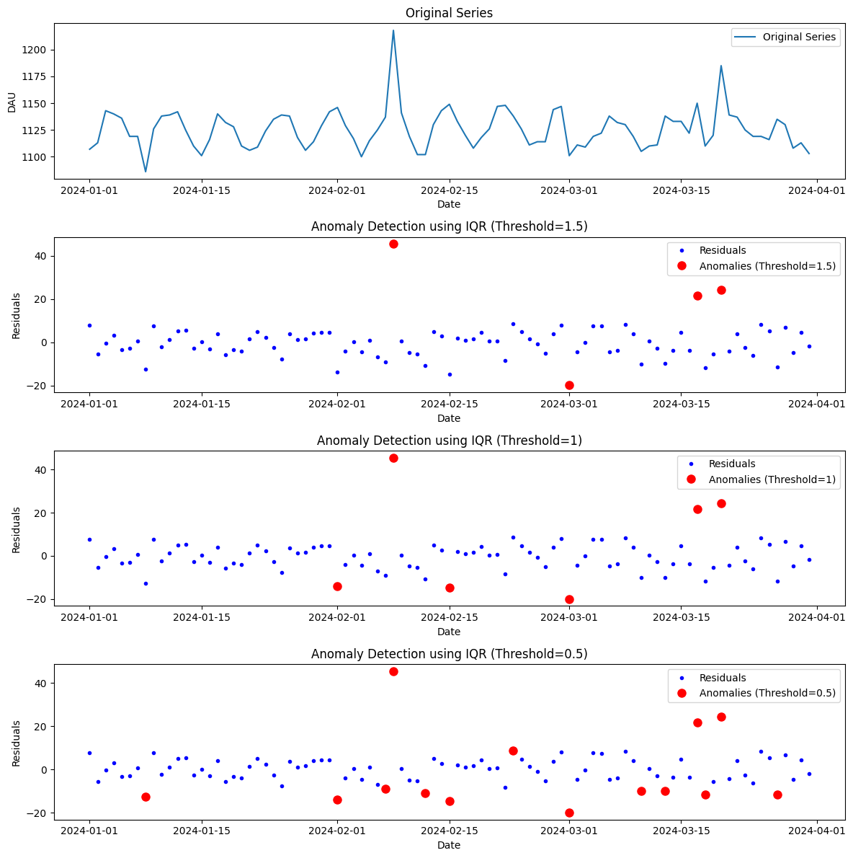

Lab 4

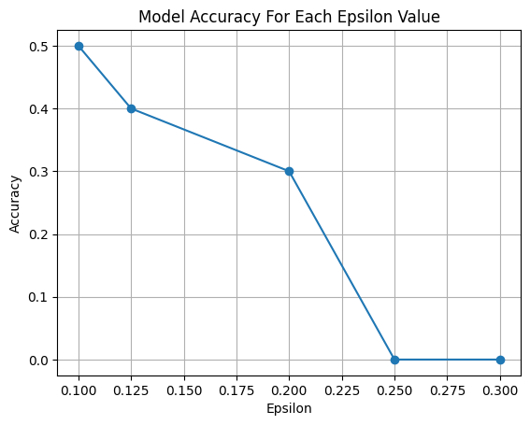

As the strength of the adversarial perturbation (epsilon) increases, the model's accuracy decreases, indicating its vulnerability to attacks.

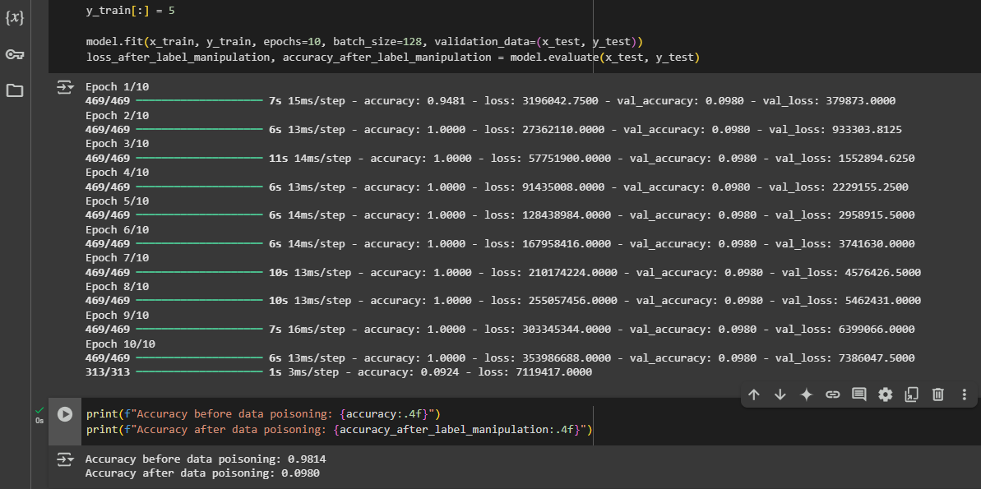

Lab 5

Lab 6

Lab 7

Lab 8

Lab 9

Lab 10

Lab 11

Lab 12