LAB Logbook

Lab 1

Lab 2

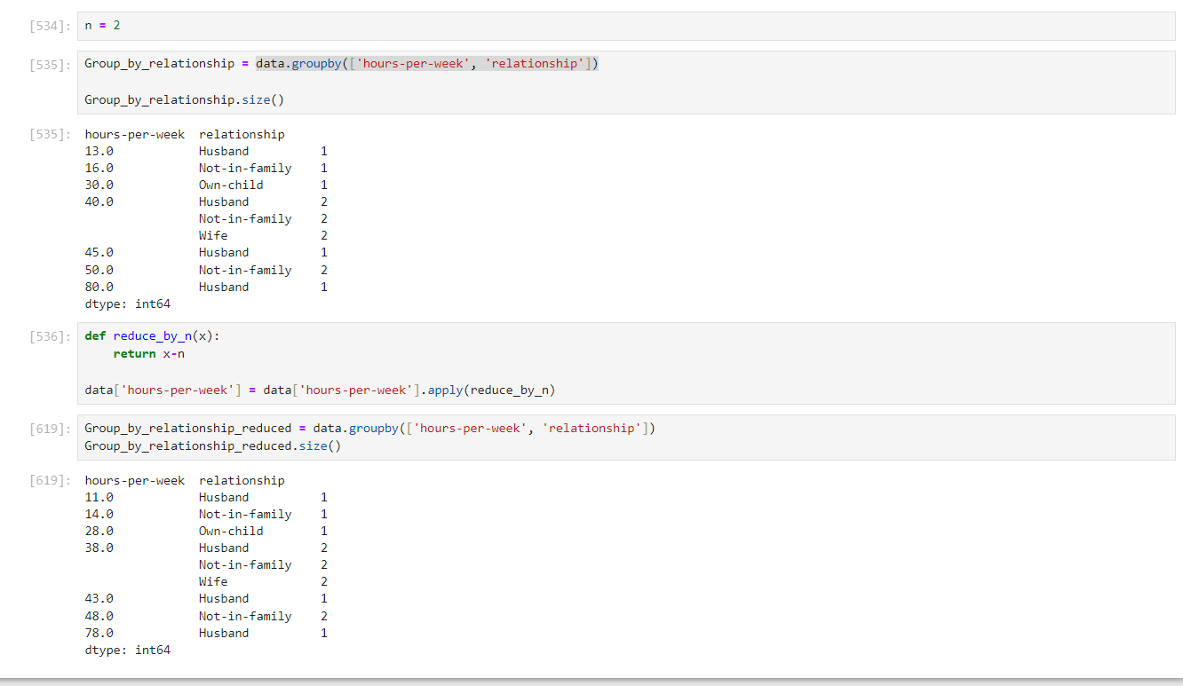

Lab 3

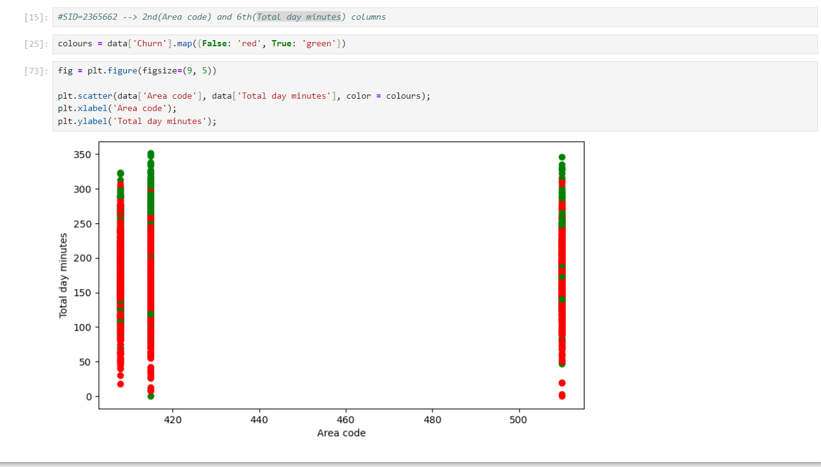

Lab 4

Lab 5

Lab 6

Lab7

Lab 8

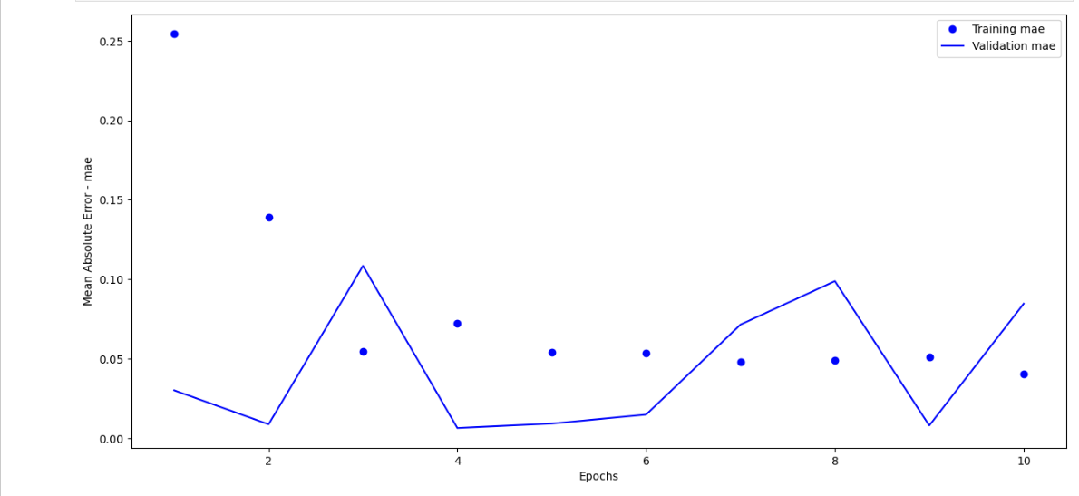

Lab 9

Lab 10

Lab 11

Lab 12