InAmigos Foundation
Website Improvement
Analysis Report

Annotated Screenshots | UX & Design Audit | Action Roadmap
inamigosfoundation.org.in · June 2025 · Prepared by Intern Team

How to Read This Report
Every screenshot below is annotated with coloured boxes and callout labels. Use this legend to interpret them:
🔴 Red Box = CRITICAL Issue | 🟠 Orange Box = HIGH Priority | 🟡 Yellow Box = MEDIUM Priority | 💬 Callout = Recommendation

SECTION 01
Navigation Bar
Sticky nav, logo sizing, missing CTA button

What We See: The top navigation bar is not fixed/sticky, the logo is undersized, and there is no Donate or Volunteer button visible — the most critical conversion elements for an NGO.
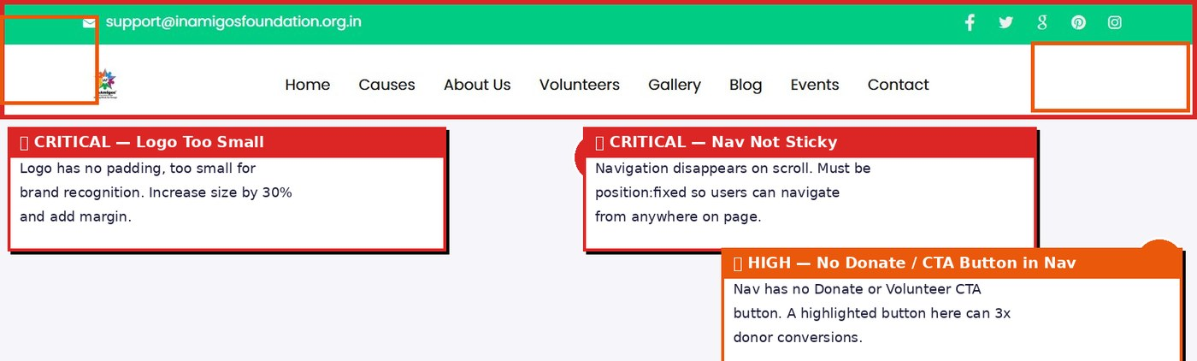
# | Area | Issue | Fix | Priority
1 | Logo | Logo is too small with no padding — hard to identify on mobile | Increase logo size by 30%, add left padding, ensure always clickable back to home | 🔴 CRITICAL
2 | Sticky Nav | Navigation disappears when scrolling down — users lose access to all menu links | Add position:fixed + background:white + box-shadow on scroll — one line of CSS | 🔴 CRITICAL
3 | Missing CTA | No Donate or Volunteer button in the navigation bar | Add a saffron-colored 'Donate Now' button on the right side of the nav — drives 3x more clicks | 🔴 CRITICAL
4 | Top Bar | Green top bar with email is fine but social icons are small and low contrast | Increase icon tap size to 44px minimum, add hover effects | 🟡 Medium

SECTION 02
Hero Banner / Slider
Missing CTAs, no progress dots, auto-rotate issues

What We See: 5 slider images cycle through project highlights — but none have a call-to-action button. Navigation arrows are nearly invisible. Users don't know how many slides there are.
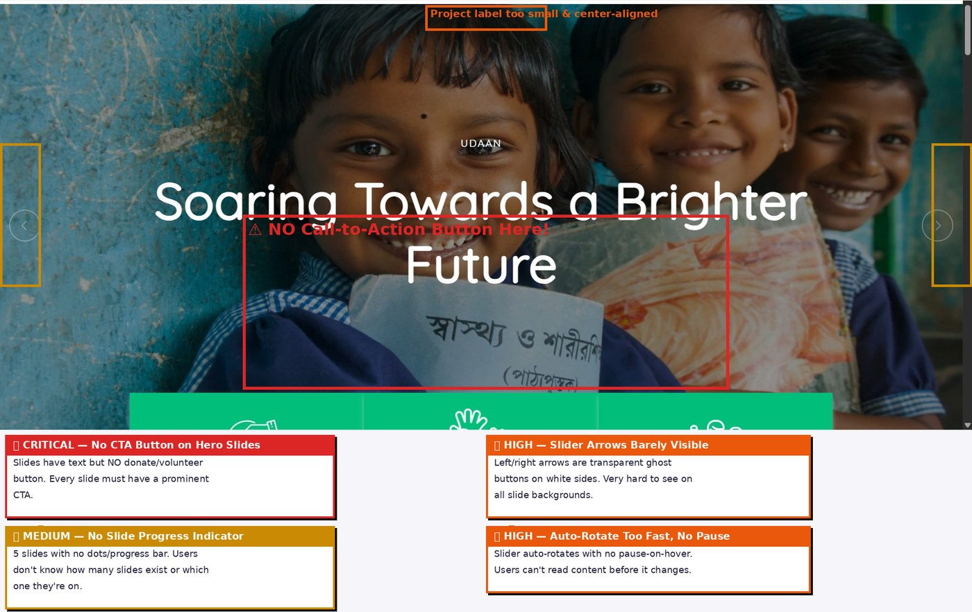
All 5 Banner Slides Observed:
Slide | Project | Issue
Banner 1 (UDAAN) | Soaring Towards a Brighter Future | No CTA button — users can't act on what they see
Banner 2 (PRAKRITI) | Plant for a Better Tomorrow | No CTA button — missed opportunity to drive volunteers
Banner 3 (BACHPANSALA) | Nurturing Young Minds, Building Futures | No CTA — education project with no donate link
Banner 4 (JEEV) | Empowering Lives, Spreading Compassion | No CTA — animal welfare slide with no action link
Banner 5 (SEWA) | Serving Humanity with Compassion | No CTA — food project with no donation prompt

# | Area | Issue | Fix | Priority
1 | CTA Buttons | None of the 5 slides has a Donate / Volunteer / Learn More button | Add a prominent white or saffron button on every slide, linked to the relevant project page | 🔴 CRITICAL
2 | Slide Arrows | Prev/Next arrows are ghost-transparent and nearly invisible on light slides | Style arrows as solid white circles with dark icons, always visible | 🟠 HIGH
3 | Progress Dots | No indicator showing how many slides exist or which one is active | Add dot indicators below or on the slide — standard UX pattern | 🟠 HIGH
4 | Auto-Rotate | Slides rotate automatically with no pause on hover | Pause rotation on mouse hover, resume on mouse leave | 🟡 Medium
5 | Project Label | Small all-caps project name (e.g. UDAAN) is centered and easy to miss | Left-align project label with a colored tag/badge for better readability | 🟡 Medium

SECTION 03
Homepage — Full View
Broken stats, missing donation section, dense text

What We See: The full homepage has strong content potential but critical bugs: all impact stats show 0, there is no dedicated donation section, and the About text is an unbroken wall of paragraph text.
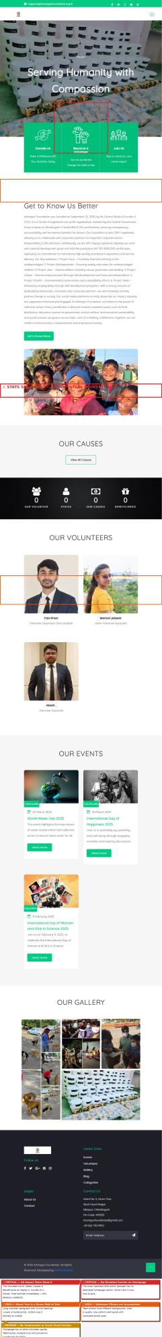
# | Area | Issue | Fix | Priority
1 | Impact Stats | ALL counter numbers show 0 — Volunteers: 0, States: 0, Causes: 0, Beneficiaries: 0 | Fix JavaScript IntersectionObserver counter animation. Hardcode fallback numbers as minimum. | 🔴 CRITICAL
2 | Donation Section | No homepage section inviting users to donate — the #1 NGO conversion action | Add a full-width 'Support Our Cause' section with amount buttons (₹100, ₹500, ₹1000) and Donate CTA | 🔴 CRITICAL
3 | About Text | Dense paragraph with no sub-headings, no images, no visual breaks | Break into 3 columns: Mission | Vision | Values each with an icon and 2-sentence description | 🟠 HIGH
4 | Volunteer Photos | Team photos are inconsistent sizes, backgrounds and quality | Use uniform card layout: same crop ratio, name, role, and soft card shadow | 🟠 HIGH
5 | No Testimonials | Zero donor or volunteer quotes on the entire homepage | Add testimonials carousel: name, photo, quote, role — minimum 4 entries | 🟠 HIGH
6 | Causes Section | Homepage 'Our Causes' button links to empty Causes page (shows No Results) | Urgently fix the Causes page content. This is the core offering of the NGO. | 🔴 CRITICAL

SECTION 04
About Us Page
Empty black banner, text wall, no photos or visual proof

What We See: A large empty black banner dominates the top. Below it is solid text — no images of the founder, no certification badges, no visual timeline. The credentials are buried in bullet lists.
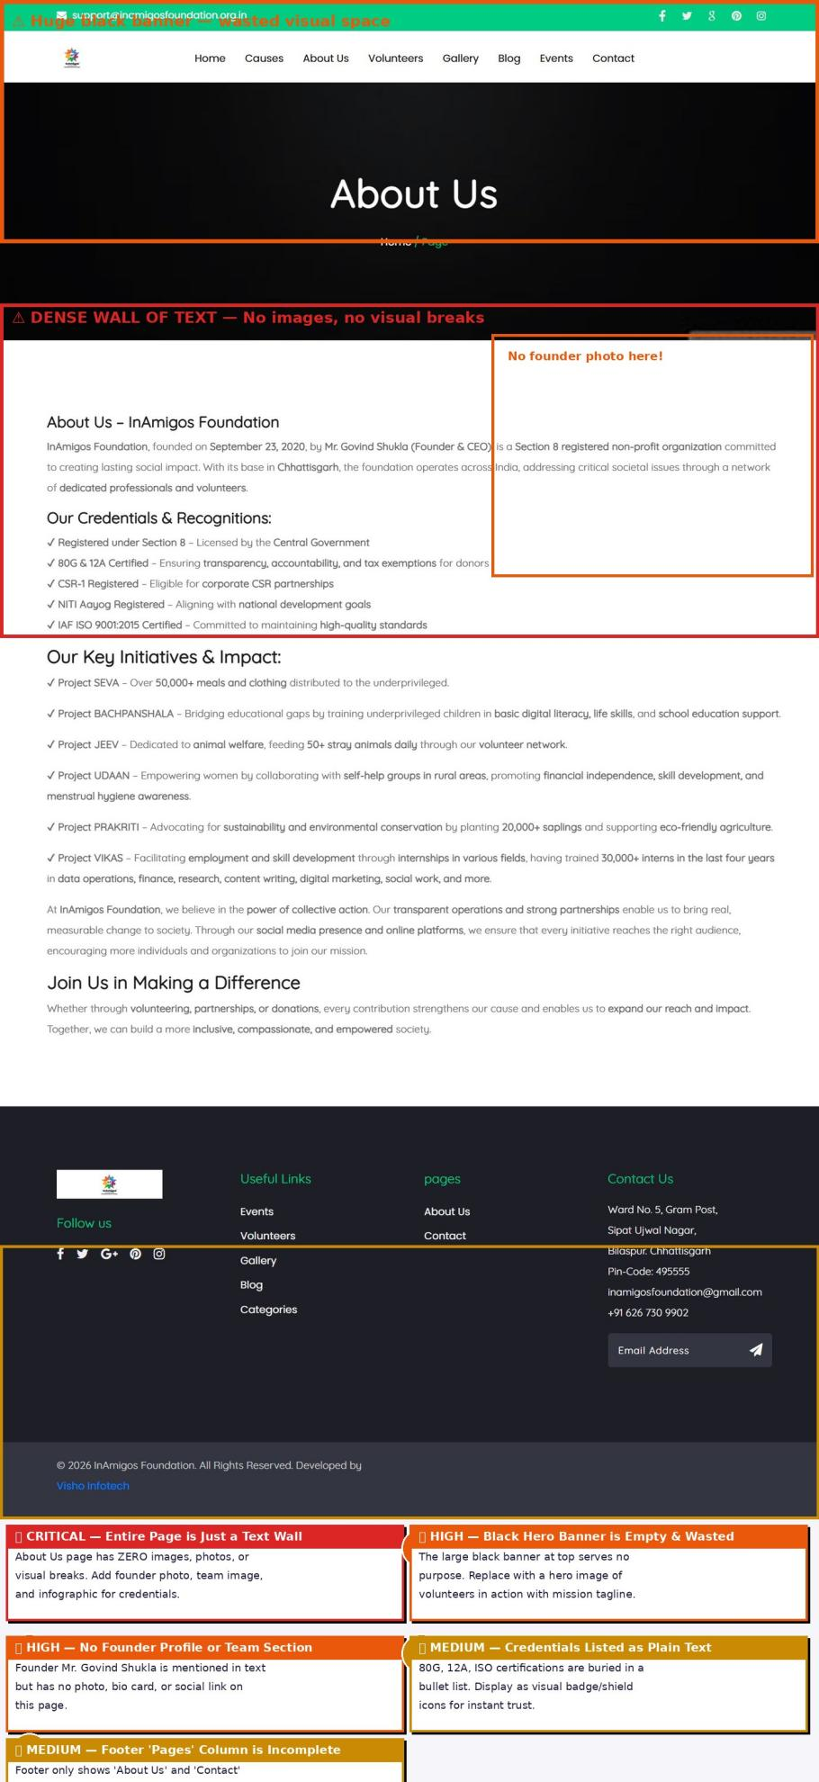
# | Area | Issue | Fix | Priority
1 | Black Banner | Top hero banner is solid black with only 'About Us' text — completely wasted | Replace with a hero image of volunteers in action + mission statement overlay | 🔴 CRITICAL
2 | No Founder Photo | Founder Mr. Govind Shukla is named in text but has no photo or bio card | Add founder photo card: photo, name, title, 2-sentence bio, LinkedIn link | 🔴 CRITICAL
3 | Text Wall | Entire page is dense paragraphs — no images, icons, infographics or breaks | Use 2-column layout: text on left, relevant image on right for each sub-section | 🟠 HIGH
4 | Certifications | 80G, 12A, ISO, NITI Aayog listed as plain text bullets — no visual weight | Display as badge icons: shield graphics with certification names for instant trust signals | 🟠 HIGH
5 | Footer — Pages | Footer 'Pages' column only shows 'About Us' and 'Contact' — very incomplete | Add all 6 projects + Events + Blog + Gallery to the Pages column in footer | 🟡 Medium
6 | No Impact Story | No real story of how a life was changed — purely organizational information | Add one 'Impact Story' highlight: a real person helped by one of the 6 projects | 🟡 Medium

SECTION 05
Causes / Projects Page
CRITICAL: Page shows 'No Results' — all projects missing

⚠ MOST CRITICAL FINDING: The Causes page — which should showcase all 6 flagship projects — displays only 'No Results'. This is the core offering of the entire website and it is completely broken.
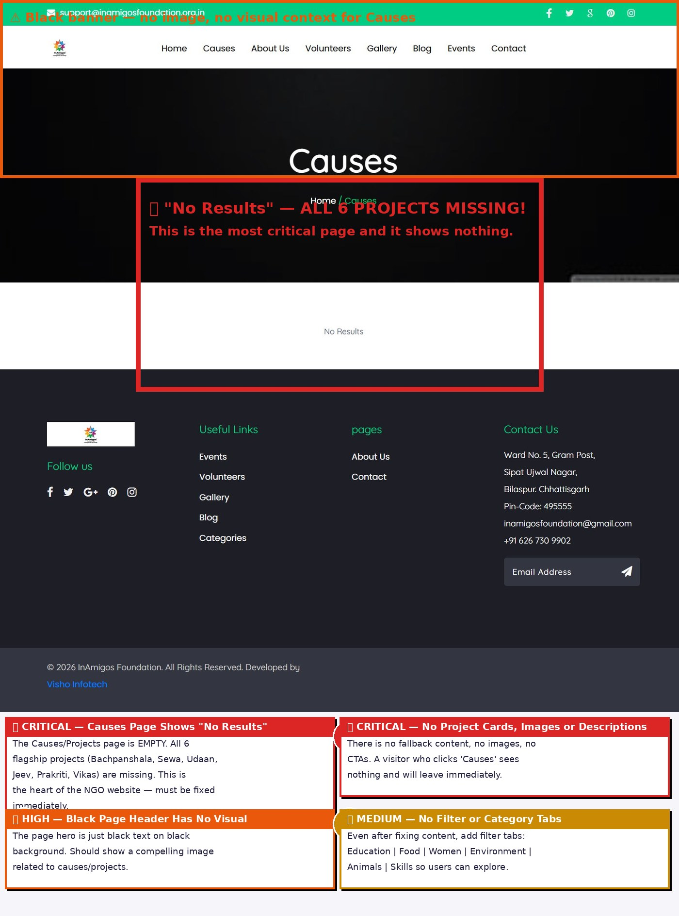
# | Area | Issue | Fix | Priority
1 | No Results Bug | Causes page shows 'No Results' — all 6 projects are missing from the page | Re-publish all 6 projects in the CMS. Check category/filter settings in backend. | 🔴 CRITICAL
2 | Empty Black Hero | Page header is just a black banner — no image representing the causes | Add a vibrant collage or project highlight image as the page banner | 🟠 HIGH
3 | No Project Cards | No images, descriptions, or donate links for any project | Create individual project cards: image, name, tagline, impact stat, Donate/Learn More CTA | 🔴 CRITICAL
4 | No Category Filter | Even after fix — no way to filter by Education, Environment, Women, etc. | Add filter tabs at top: All | Education | Food | Women | Environment | Animals | Skills | 🟡 Medium
5 | No Progress Bar | No fundraising progress bars showing how much has been raised per project | Add a progress bar for each project: Amount Raised vs Goal with percentage | 🟡 Medium

SECTION 06
Gallery Page
No captions, inconsistent sizes, no filters, no lightbox

What We See: 23+ powerful field photos are displayed in a basic grid — but with zero captions, mixed sizes, no category tags, and no lightbox viewer. The impact of this visual content is massively under-utilized.
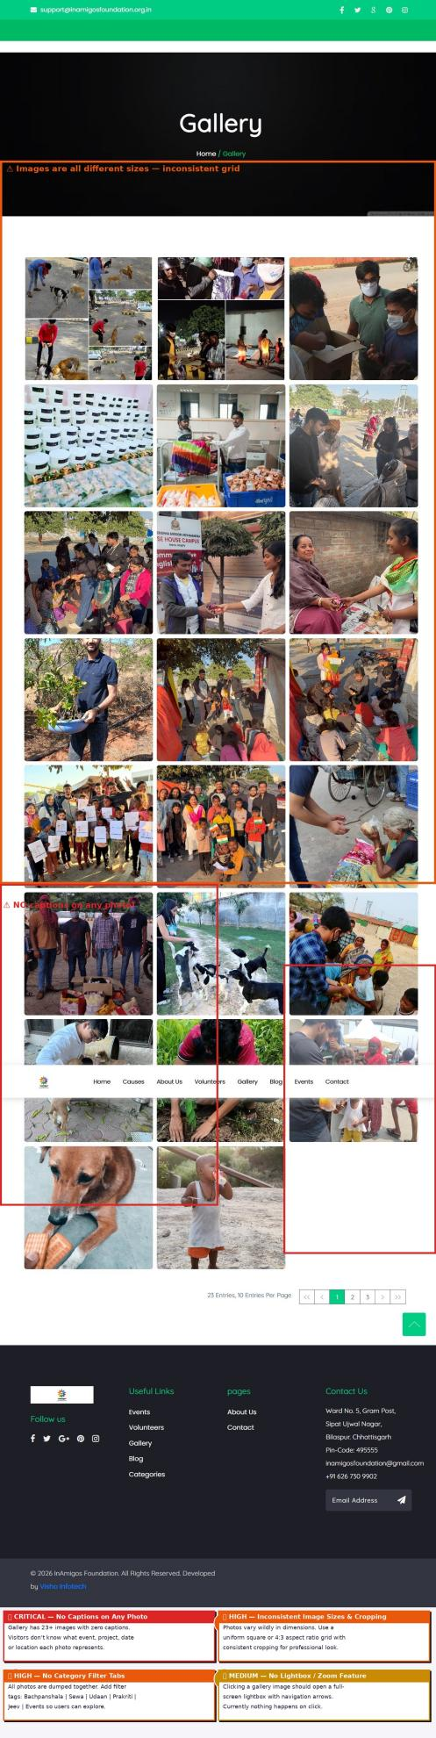
# | Area | Issue | Fix | Priority
1 | No Captions | All 23+ photos have zero captions — project, date, location all unknown | Add caption below every photo: Project Name | Location | Date | 🔴 CRITICAL
2 | Inconsistent Grid | Photos are different dimensions, crop ratios and quality — looks unprofessional | Use CSS grid with uniform 1:1 or 4:3 aspect-ratio cropping for all images | 🟠 HIGH
3 | No Category Filter | All photos lumped together — no way to browse by project | Add filter tabs: All | Bachpanshala | Sewa | Udaan | Jeev | Prakriti | Vikas | Events | 🟠 HIGH
4 | No Lightbox | Clicking a photo does nothing — no zoom or full-screen viewer | Implement lightbox (e.g. GLightbox or Fancybox) for full-screen photo viewing with arrows | 🟡 Medium
5 | Image Quality | Some photos are low resolution and appear blurry at grid size | Upload minimum 800x600px images. Use WebP format for faster loading | 🟡 Medium

SECTION 07
Blog Page
Titles cut off, no author info, stock images, no search

What We See: 10 blog posts exist but titles are truncated mid-word, no author names or read times are shown, thumbnail images are unrelated stock photos, and there is no way to search or filter posts.
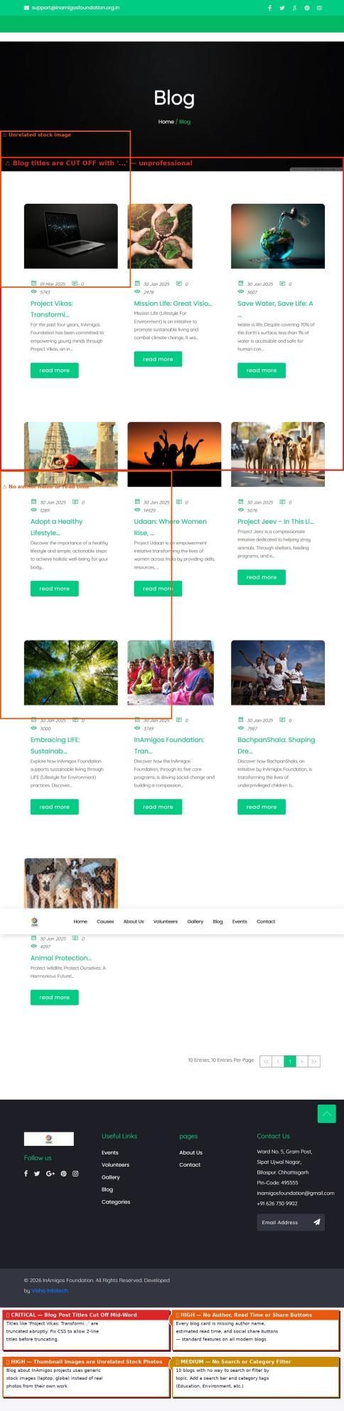
# | Area | Issue | Fix | Priority
1 | Titles Cut Off | Blog titles end mid-word with '...' e.g. 'Project Vikas: Transformi...' | Allow 2-line title display before truncating. Minimum 90 characters visible. | 🔴 CRITICAL
2 | No Author / Time | No author name, avatar or estimated read time on any blog card | Add author photo, name and '3 min read' to every card — standard blog UX | 🟠 HIGH
3 | Stock Images | Blog thumbnails use generic stock photos (laptop, globe) not real InAmigos content | Replace with actual photos from InAmigos field work for each corresponding project topic | 🟠 HIGH
4 | No Search / Filter | No way to search blog content or filter by category | Add search bar + category tags: Education | Environment | Women | Events | Impact | 🟠 HIGH
5 | No Share Buttons | No social share buttons on blog cards or individual posts | Add WhatsApp, LinkedIn, Twitter share buttons — essential for NGO content virality | 🟡 Medium
6 | View Count Display | View count shows '0' for older posts — looks inactive | Verify view counting is working or hide the counter until there is meaningful data | 🟡 Medium

SECTION 08
Events Page
All events are past, no upcoming events, no RSVP

What We See: Only 3 events total, all from Feb–March 2025. There is no 'Upcoming Events' section, no way to register, and event images are generic stock photos rather than real InAmigos photos.
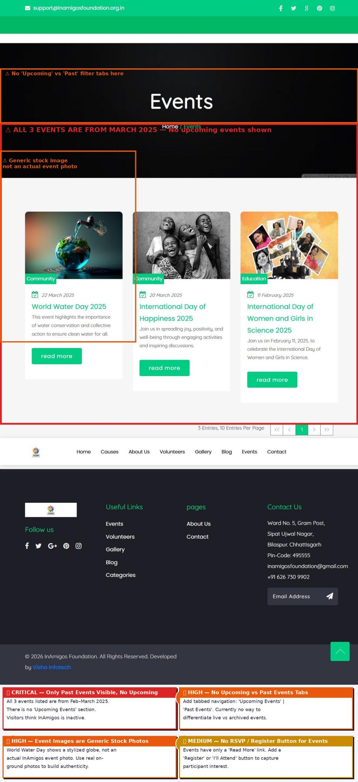
# | Area | Issue | Fix | Priority
1 | No Upcoming Events | All 3 listed events are past. No upcoming events shown — NGO appears inactive | Add a prominent 'Upcoming Events' section at top. Past events moved to 'Archive' tab | 🔴 CRITICAL
2 | No Tabs | No filter between Upcoming vs Past events — all mixed together | Add tab navigation: Upcoming | Past Events with count badges on each tab | 🟠 HIGH
3 | No RSVP Button | Events only have 'Read More' — no way for users to register or show interest | Add 'Register / RSVP' button linking to a Google Form or sign-up page | 🟠 HIGH
4 | Stock Images | Event thumbnails use AI-generated/stock images instead of real event photos | Replace with actual photos from past events. For upcoming, use a branded event graphic | 🟠 HIGH
5 | Only 3 Events | 3 total events for an active NGO with 200+ volunteers looks very sparse | Upload all past events and campaigns. Target minimum 10 entries on this page | 🟡 Medium

SECTION 09
Contact Page
Nav overlapping form, no map, missing form labels

What We See: The floating navigation bar overlaps the top of the contact form making fields inaccessible. Form has no visible labels (only placeholders), no Google Map, and a tiny Submit button.
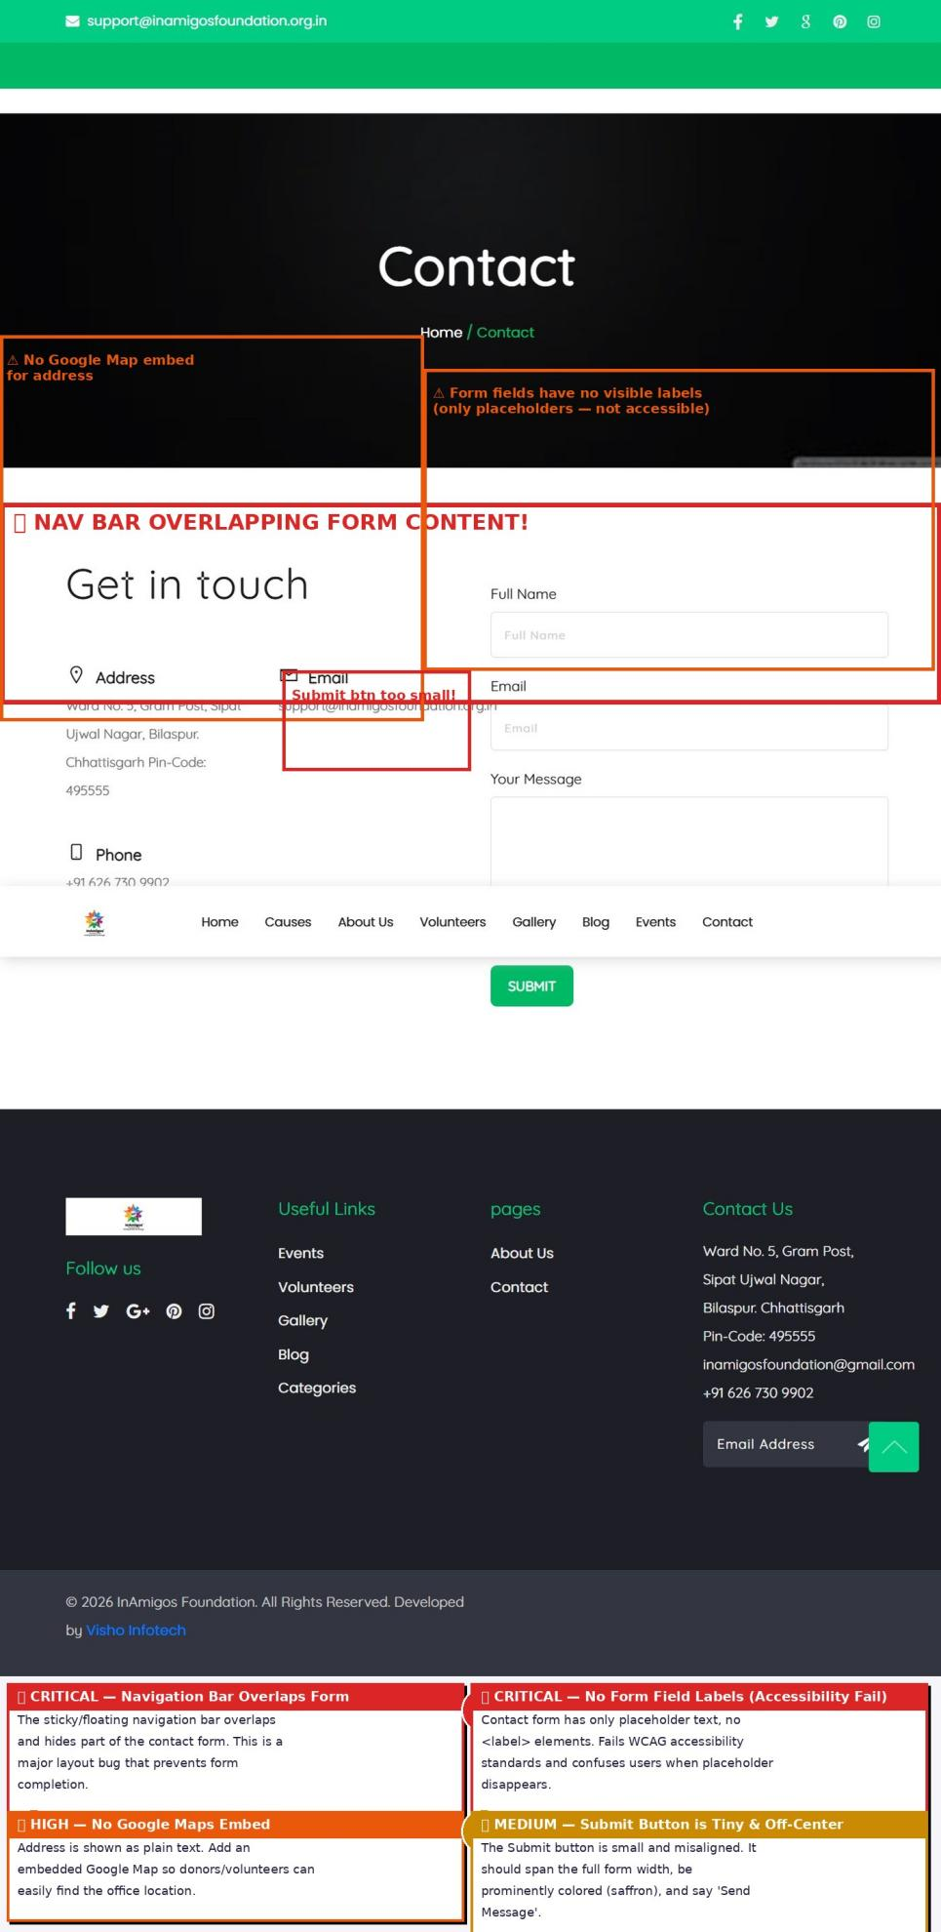
# | Area | Issue | Fix | Priority
1 | Nav Overlap | Floating nav bar physically covers the top of the contact form — form unusable | Add scroll-margin-top or padding-top to form section to offset fixed nav height | 🔴 CRITICAL
2 | No Form Labels | Form fields use only placeholder text — disappears when typing, fails accessibility | Add visible <label> above each field: Full Name, Email, Message — WCAG requirement | 🔴 CRITICAL
3 | No Google Map | Address shown as plain text only — no map embed | Embed a Google Map iframe pinned to the Bilaspur office location | 🟠 HIGH
4 | Submit Button | Submit button is small, off-center and plain green — easy to miss | Full-width button, saffron colored, reading 'Send Message' with send icon | 🟠 HIGH
5 | No Success Message | No confirmation after submitting the form — user doesn't know if it sent | Show a branded success toast/message: 'Thank you! We'll reply within 24 hours.' | 🟡 Medium
6 | No WhatsApp Link | Phone number shown as plain text — not clickable on mobile | Make phone a tel: link. Add a WhatsApp Chat button for instant messaging. | 🟡 Medium

SECTION 10
Volunteers Page
Inconsistent photos, broken names, poor card layout

What We See: 34 volunteers are listed but photos are wildly inconsistent (different backgrounds, crops, lighting). Several volunteers show incomplete names like 'Shiwani .' and 'Padmasri .' The last row has an orphaned single card.
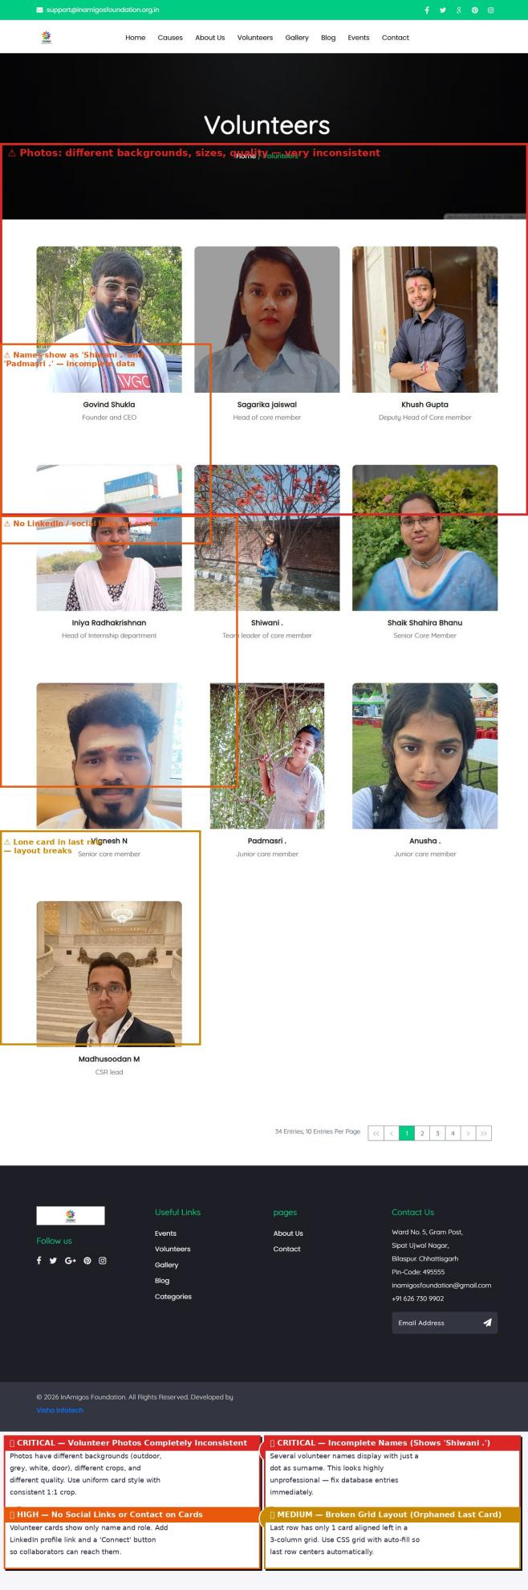
# | Area | Issue | Fix | Priority
1 | Inconsistent Photos | Photos have outdoor backgrounds, grey backgrounds, doors — no visual consistency | Set a uniform photo guideline: white or light background, shoulders-up, square crop | 🔴 CRITICAL
2 | Broken Names | Names display as 'Shiwani .' and 'Padmasri .' — incomplete surname data | Fix database entries. Remove trailing dots or mark as last name withheld intentionally | 🔴 CRITICAL
3 | No Social Links | Volunteer cards show only name and role — no LinkedIn or contact link | Add LinkedIn icon button to each card for professional networking | 🟠 HIGH
4 | Orphaned Card | Last row shows 1 card left-aligned in a 3-column grid — layout breaks | Use CSS: grid justify-items: center or flexbox with justify-content: center | 🟡 Medium
5 | No Search / Filter | 34 volunteers with no way to search by name or filter by department/role | Add search box and filter by role: Core Team | Interns | CSR | Department Leads | 🟡 Medium
6 | No Role Descriptions | Roles like 'Junior core member' give no context about responsibilities | Add 1-line role description or department tag to each card | 🟢 LOW

SECTION 11
Mobile View
Stats broken, text overflow, no mobile CTA

What We See: On mobile, the site has critical issues: all impact counters show 0, text overflows the screen horizontally, and there is no donation or volunteer button visible in the first screen — the most important real estate on mobile.
# | Area | Issue | Fix | Priority
1 | Stats Show 0 | Impact counters (200 volunteers, 28 states, 50K+ lives) all display 0 on mobile | Debug JS counter — add fallback static numbers so page never shows 0 stats | 🔴 CRITICAL
2 | Text Overflow | Text content overflows horizontally causing a scrollbar on mobile screens | Add overflow-x: hidden to body and fix all sections that exceed 100vw | 🔴 CRITICAL
3 | No Mobile CTA | No Donate or Volunteer button visible in the first screen on mobile | Add a sticky 'Donate Now' bottom bar on mobile that's always visible while scrolling | 🔴 CRITICAL
4 | Logo Too Small | Logo is barely visible at mobile scale — poor brand recognition | Set minimum logo width of 120px on mobile with proper padding | 🟠 HIGH
5 | Card Stacking | Volunteer and event cards stack into single column but alignment breaks | Test all card components in mobile view and fix padding/margin at <768px breakpoint | 🟠 HIGH
6 | Font Too Small | Some body text is below 14px on mobile — illegible on small screens | Set minimum font size of 16px for all body text on mobile (prevents iOS auto-zoom) | 🟡 Medium

SECTION 12
Action Roadmap
Prioritised fix list: This Week | Month 1 | Month 2–3

This Week — Fix Immediately (Days 1–7)
# | Critical Action | Page / Section | Effort
1 | Fix the Causes page — re-publish all 6 projects in CMS backend | Causes Page | 2 hrs
2 | Fix broken impact counter JavaScript — stats showing 0 everywhere | Homepage | 1 hr
3 | Add CTA button (Donate/Volunteer) to every hero slider slide | Homepage Hero | 2 hrs
4 | Fix nav overlap on Contact page with scroll-margin-top | Contact | 30 min
5 | Fix incomplete volunteer names (Shiwani ., Padmasri .) | Volunteers | 30 min
6 | Make navigation bar sticky/fixed on scroll | All Pages | 1 hr
7 | Fix blog post title truncation — allow 2-line display | Blog | 30 min
8 | Add <label> tags to all contact form fields | Contact | 1 hr

Month 1 — High Priority Improvements
# | High Priority Fix | Page / Section | Effort
1 | Add Donate Now button to navigation bar (saffron, rounded) | Navigation | 2 hrs
2 | Add gallery captions: project name, date, location on all 23 photos | Gallery | 3 hrs
3 | Add author name and read time to all blog post cards | Blog | 2 hrs
4 | Add gallery category filter tabs by project name | Gallery | 4 hrs
5 | Create upcoming events and add RSVP/Register button | Events | 3 hrs
6 | Replace stock event images with real InAmigos field photos | Events / Blog | 2 hrs
7 | Add Google Map embed to Contact page | Contact | 1 hr
8 | Add lightbox viewer to gallery (GLightbox — free plugin) | Gallery | 2 hrs
9 | Fix mobile text overflow and card stacking issues | Mobile | 4 hrs
10 | Add sticky mobile bottom bar with Donate Now button | Mobile | 3 hrs
11 | Replace empty black banners with relevant hero images | About / Causes | 3 hrs
12 | Add founder photo and bio card to About Us page | About Us | 1 hr

Month 2–3 — Long Term Enhancements
# | Enhancement | Page / Section | Effort
1 | Add testimonials section with donor / volunteer quotes and photos | Homepage | 1 week
2 | Create project cards with impact stats for Causes page | Causes | 1 week
3 | Add certification badges (80G, ISO, NITI Aayog) as visual shields | About Us | 3 days
4 | Establish consistent volunteer photo style guide + re-upload photos | Volunteers | 1 week
5 | Add fundraising progress bars per project | Causes | 3 days
6 | Build a Transparency page with annual reports and fund usage chart | New Page | 2 weeks
7 | Add blog search and category filter functionality | Blog | 1 week
8 | Add WhatsApp chat button across all pages | All Pages | 1 day
9 | Implement SEO meta titles and descriptions for all pages | All Pages | 1 week
10 | Launch newsletter signup with 2024 Impact Report as lead magnet | Homepage | 2 weeks

Conclusion
InAmigos Foundation is doing remarkable on-ground work across 28 states — the website must reflect that same level of excellence. Currently, the digital presence significantly underrepresents the real-world impact of the organisation.
3 Most Critical Fixes:  1. Fix the Causes page — it shows 'No Results'  2. Fix impact counter stats — all showing 0  3. Add CTA buttons on every hero slide | Expected Outcome:  Fixing the issues in this report can lift the website from its current ~50% health score to 85%+ — transforming it into a world-class NGO platform that inspires donors, recruits volunteers and builds trust.

