We need a minimal and user friendly process for Sign up.
Rhemito has one screen for Sign up and sign in.
We collect the email id of the user, the front-end must validate whether the format looks like email before submitting to the API.
We check whether the email is already registered.
If the email ID is registered, then we show the password field to the user to login/sign in
If the password is valid, we let the user access the dashboard.
If password in not valid we show the error message to the user.
If the email id new (un registered) then, we show the following fields to the user:
He can register as an Individual, or as Business.
Blow is screenshot of fields:
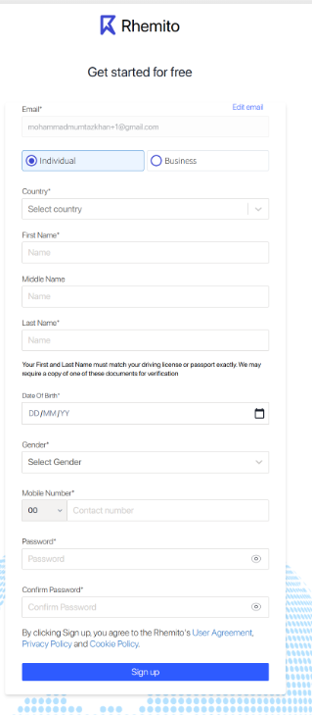
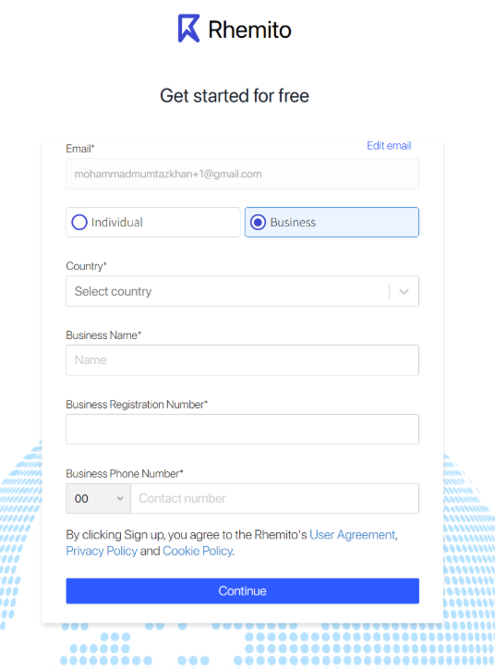
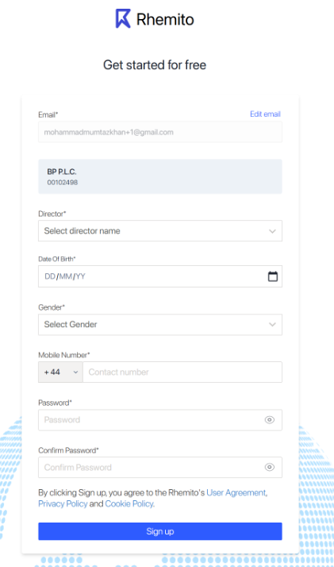
Date Of Birth* will be dd/mm/yyyy
After successfully submitting the individual and business form we send an OTP (one time password a 6 digit number) to the registered email id if the user. And inform him showing a user friendly message, also telling him to check his SPAM folder. The OPT will be valid for 1 hour and we let the user generate another OTP after 60 seconds if he has not received the OTP after generating the new OTP we need to tell the user that the previous OTP will become invalid by generating the new OTP. We need to Give am Option to the user to change the email address on OTP entry screen so that is the user has entered wrong email address he can correct it.
Once OTP is validated the account will be activated and the user will lan on the Dashboard. Also show correct message to user when OTP is wrong and when Account is activated by entering correct OTP.
Show a countdown time of 60 minutes countdown time once the OTP is sent to the user by email. Telling him that OTP expires in 60 minutes…counting down.
Always give proper and timely message to user

