User the Blue “R: logo as in the below image and Replace the current Logo Place holder with this logo on the Top Left of the below image.
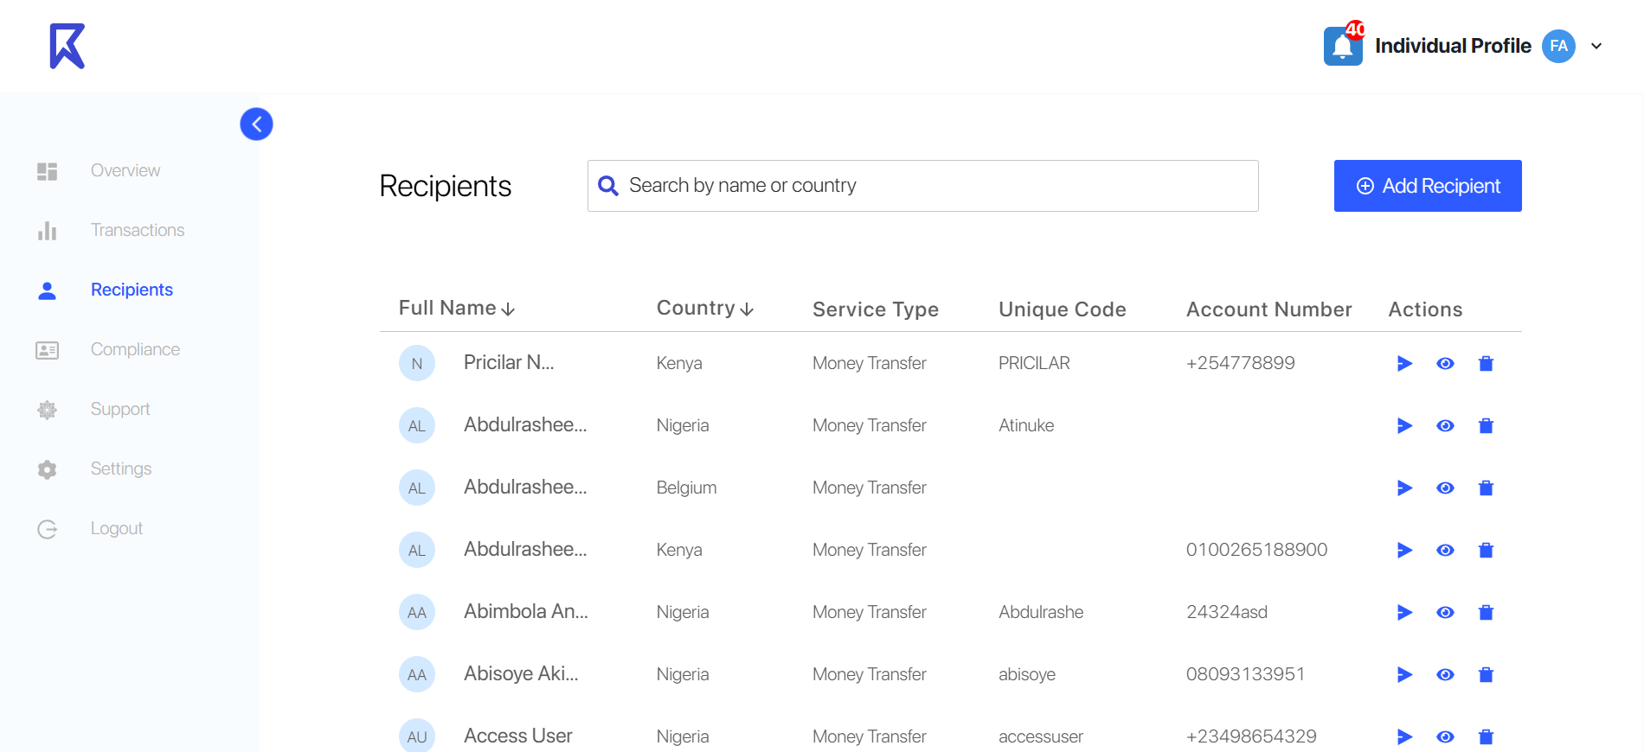
Add Senders link below the recipient link on the left panel. On clicking the Sender link the user will land on the senders page
Based on the attached screen, we need a page for viewing the senders (the people who are paying the requesters/users). The columns can be: Full name, country, Service Type (Collection). No unique code column, Account number column, Actions column.
The actions column will have three icons with tool tip namely, Request option/button, View sender option and delete option. On clicking the request button/option, the same modal will open asking “Ways to get paid” and the flow will continue, now the details of the sender will be prefilled as we know the sender.
On clicking view sender the sender Details page will open similar to the recipient details page: 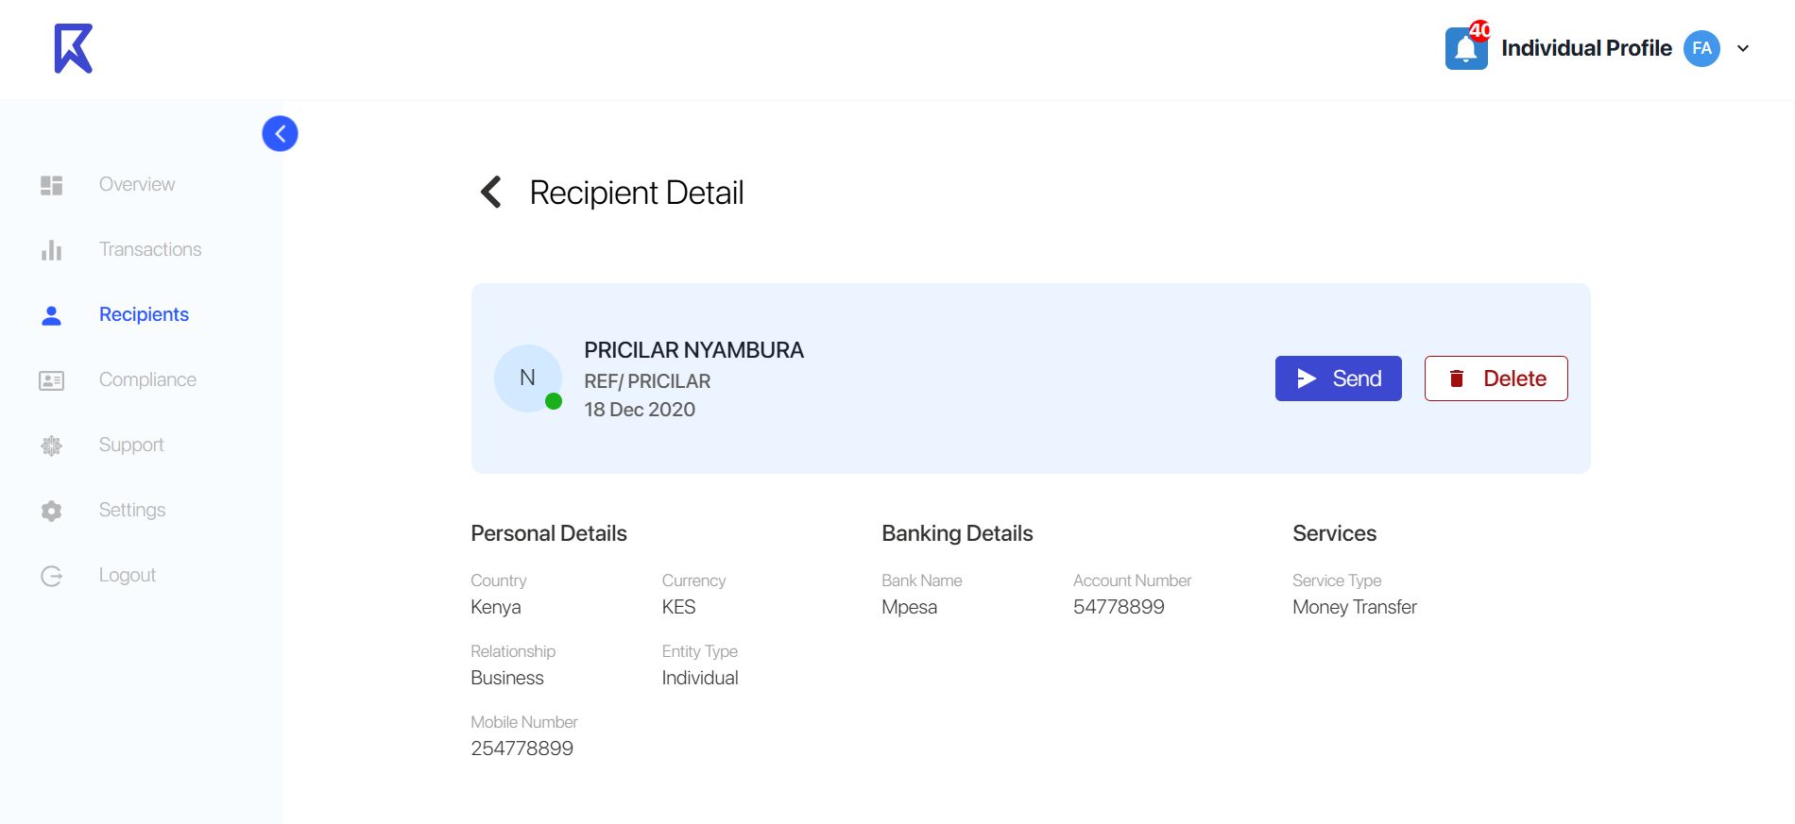
Instead of the send button it will be request button. On clicking the request button/option, the same modal will open asking “Ways to get paid”
We also need a functionality for creating new senders (Similar to the " add recipient” button on the page on the attached screen), after a new sender is created we need to see the confirmation message.
We also need to collect the Bank account/details of the requester. There can be a separate page for it before the sender's information/details are collected. We need also a functionality on the page to let the requester select an existing bank account. There can be only one bank account per currency (Payout account where the requester will receive the money).
We need a payout bank account management page for the requester. Where he can manage his payout bank accounts similar to the below UI:
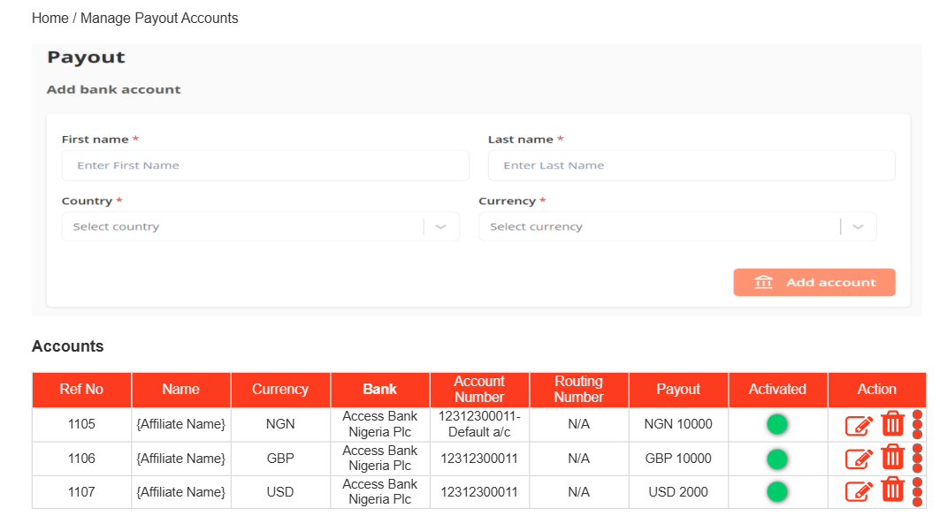
Instead of Affiliate name there will be the name of the Requester.

