Logo:
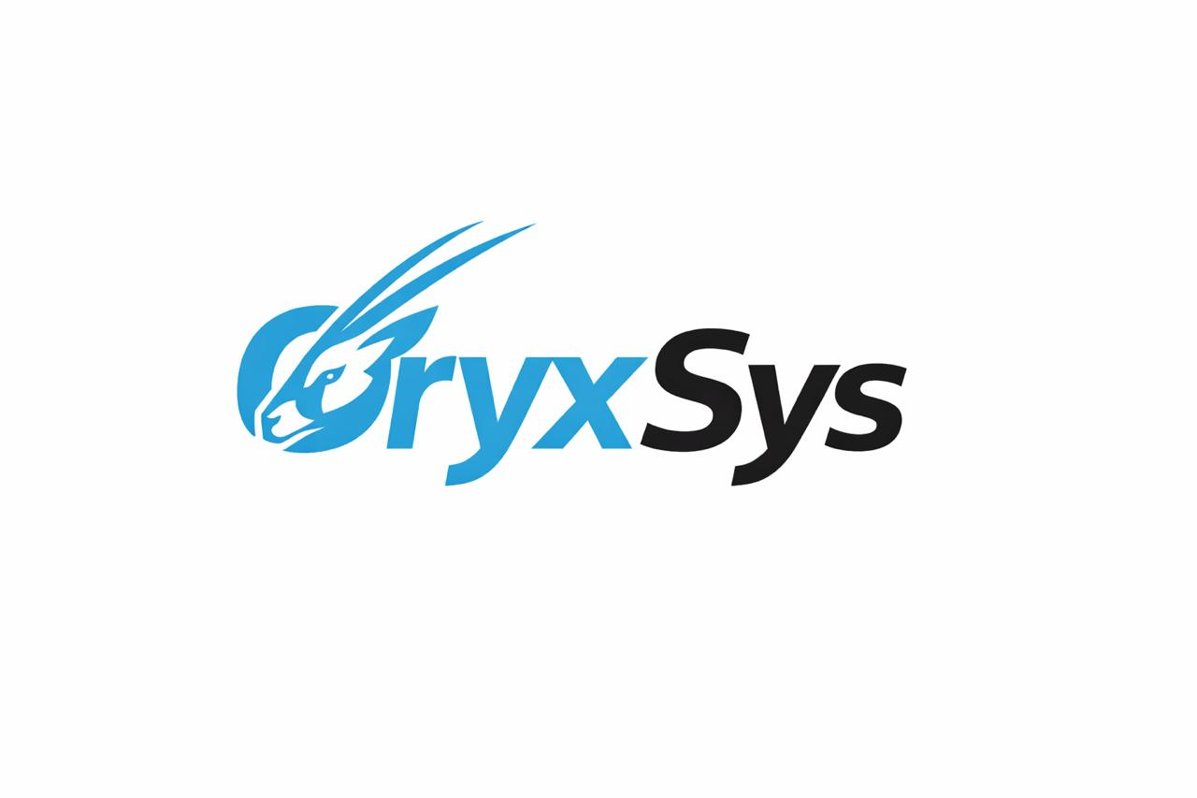
oryxsys-logo

1. Hero Section
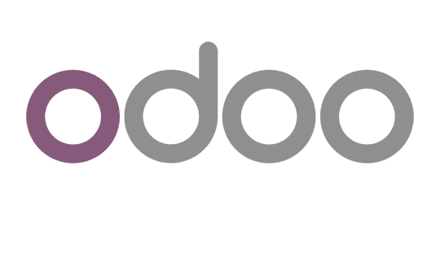
odoo-logo
Smart ERP. Real Business Control.
We implement powerful ERP solutions using Odoo, deliver tailored technology systems, and provide professional business accounting services—all designed to help your company operate smarter and scale faster.
What we do:
- ERP Implementation with Odoo
- Custom Technology Solutions
- Business Accounting & Financial Services

ABOUT US
OryxSys is a business solutions company specialized in ERP implementation, digital systems, and financial operations management.
We are an official partner of Odoo, delivering end-to-end ERP solutions that help businesses unify their operations and improve efficiency.
Our expertise goes beyond implementation—we help companies redesign how they work, manage their processes, and control their financial operations through structured systems and long-term support.
We combine technology with business understanding to deliver practical, scalable solutions.

Services
ERP Solutions with Odoo
We implement and customize ERP systems using Odoo to cover all business operations including sales, inventory, HR, and finance.
Business Accounting Services
We provide outsourced accounting services through structured contracts, including bookkeeping, financial reporting, and tax-related support.
Custom System Development
We design and build tailored systems for businesses that need specific functionality beyond standard ERP capabilities.
System Integration & Automation
We connect different systems together to ensure smooth data flow, automation, and better business visibility.

ODOO ERP SOLUTIONS
Smart ERP Powered by Odoo
We are an official implementation partner of Odoo, delivering complete ERP solutions that help businesses manage and automate their core operations in one unified system.
Odoo provides a flexible and powerful platform that covers all essential business functions including sales, accounting, inventory, HR, and operations.
At OryxSys, we go beyond standard implementation — we customize Odoo to match your exact business processes and ensure it works the way your company actually operates.
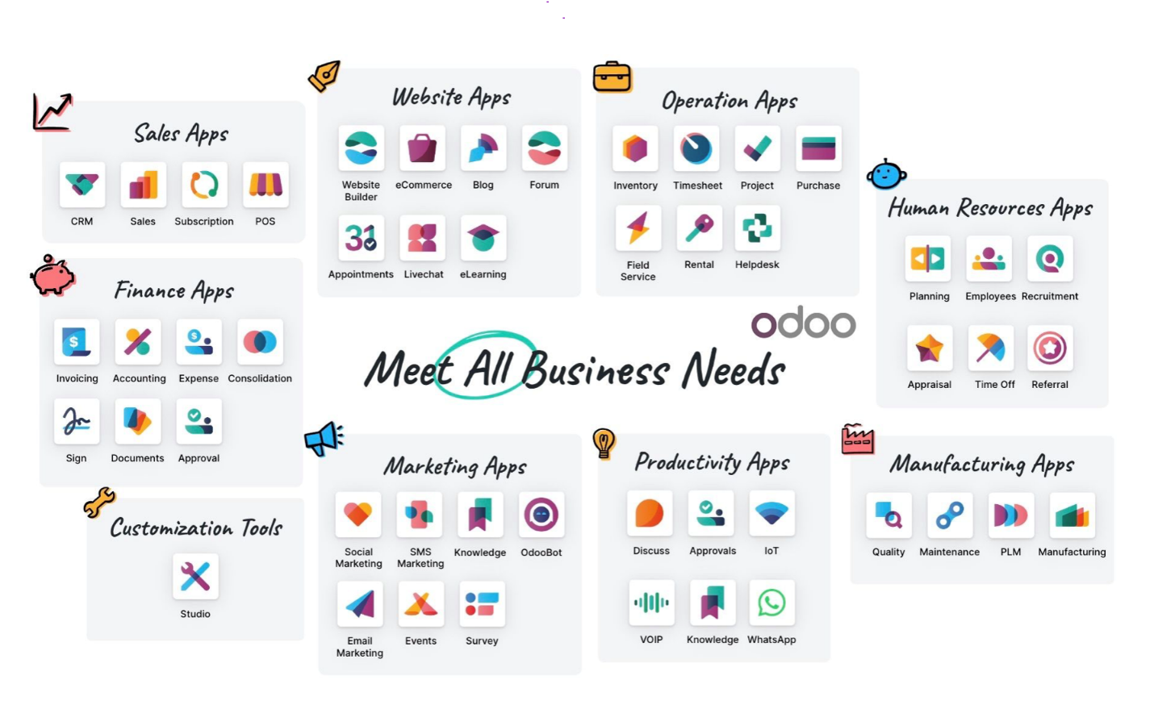

OUR CLIENTS
Al Noor Trading Co. (Sample Client for Design Preview)
This is a sample client used for UI demonstration purposes. It will be replaced with real clients.
- Company Logo Placeholder
- Case preview available upon request

CONTACT US
Let’s build your next ERP solution.
- Email: info@oryx-sys.com
- Phone: +962 7 9889 8691
- Instagram logo with link
- Facebook logo with link
- LinkedIn logo with link
- WhatsApp logo with link

