***Compiler Construction***

***CSC-323***

***Lab Journal 1***



**Muhammad Naeem Tahir**

**Enrolment No:** 01-134202-117

**BSCS 5A**

**Department of Computer Science**

**BAHRIA UNIVERSITY, ISLAMABAD**

**Lab # 1: Refresh C/C++ Programming**

**Objectives:**

To learn how to implement the Simulation of Compiler modules.

**Tools Used:**

**Submission Date:** Wednesday, September 28, 2022

**Evaluation: Signatures of Lab Engineer:**

**Task # 1:**

**Write a program that initializes an array. It inputs a value from the user and searches the number in the array.**

**Program/Procedure:**

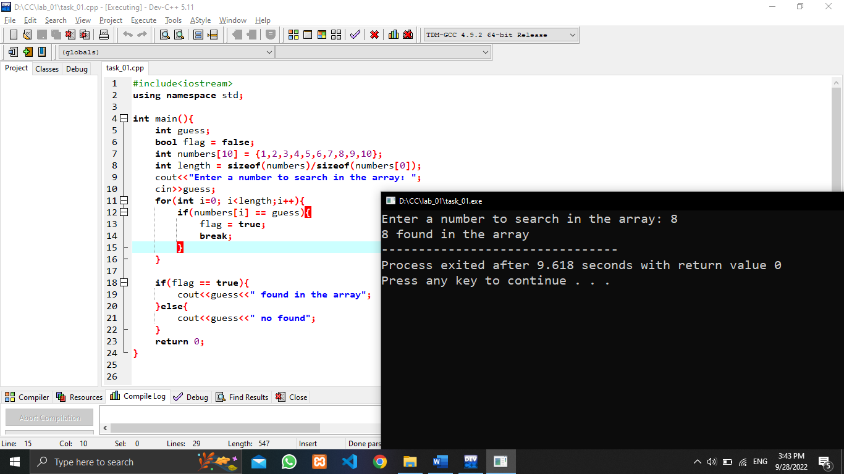

**Analysis:**

**Task # 2:**

**Write a program that declares a structure Book to store BookID, book name and price. It declares another structure Order that contains OrderID and an array of Book of length 5. The program should define a variable of type Order and input the values from the user. The program finally displays the values.**

**Program/Procedure:**

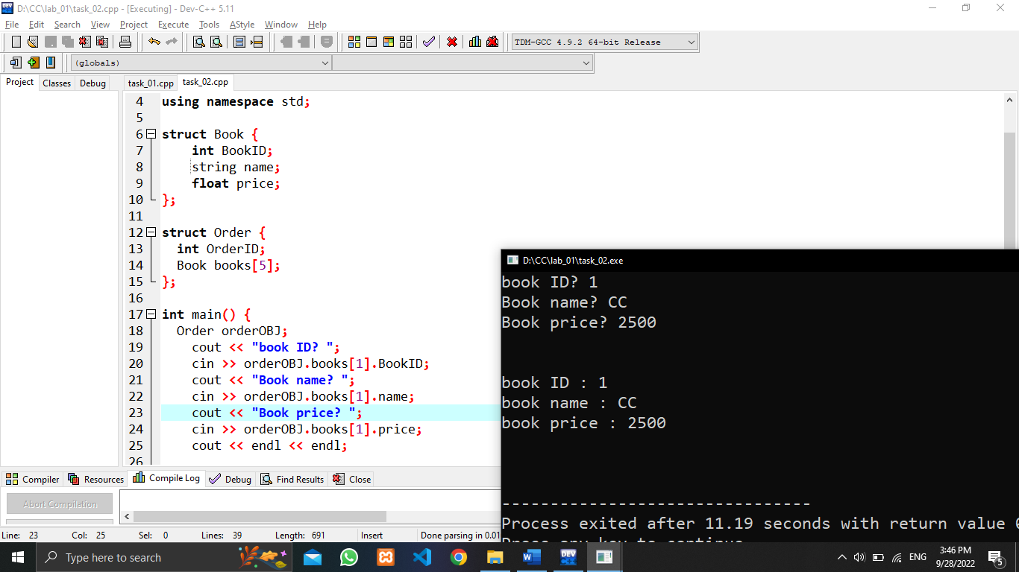

**Analysis:**

**Task # 3:**

**Write a program to input five integers in an array and display them using pointers.**

**Program/Procedure:**

**Analysis:**