***Compiler Construction***

***CSC-323***

***Lab Journal 2***



**Student Name**

**Enrolment No.**

**Class and Section**

**Department of Computer Science**

**BAHRIA UNIVERSITY, ISLAMABAD**

**Lab # 2: LEX tool – lexical analyzer tool**

**Objectives:**

To learn how to implement the tokenization module.

**Tools Used:**

**Submission Date:**

**Evaluation: Signatures of Lab Engineer:**

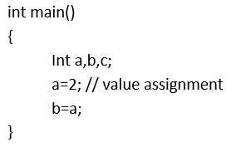**Task # 1:**

**Read file character by character in a char variable.**

**Program/Procedure:**

**Output:**

**Analysis:**

**Task # 2:**

**Check whether the character read is a space, tab, newline, if so skip and read next character.**

**Program/Procedure:**

**Output:**

**Analysis:**

**Task # 3:**

**Consume C style comments starting with // consume all character until newline char found.**

**Program/Procedure:**

**Output:**

**Analysis:**