Name: Mohammad Naim
Course: CS210
Project: Project Three – Corner Grocer Item Tracker
Date: February 22, 2026
CS210 Project Three Documentation
Overview:
This program reads the Corner Grocer’s daily purchase list from the file CS210_Project_Three_Input_File.txt. It counts how many times each item appears. The user can choose from a menu to see one item’s frequency, see all items with their counts, or see a histogram. The program also creates a backup file called frequency.dat with all item counts. This helps the store know which items are popular.
Classes Used:
The program uses one class called ItemTracker.
- It has a private map called itemFrequency to store items and counts.
- It has public methods:
  - loadFromFile(filename) reads the input file and counts the items.
  - saveToFile(filename) writes all items and counts to a backup file.
  - getFrequency(item) returns the count of one item.
  - printAllFrequencies() shows all items and their counts.
  - printHistogram() shows items with asterisks for the count.
Menu Options:
- Frequency of a specific item: The user types the item name. The program shows how many times it appears.
- List all items with frequencies: The program shows all items with their counts.
- Histogram of item frequencies: The program shows items with stars for the count.
- Exit: The program closes.
Best Practices:
- The program checks that the user enters 1, 2, 3, or 4.
- The variable names are simple and clear.
- The code has comments to explain what it does.
- The program reads the input file safely. It also saves the backup file.

Screenshots:

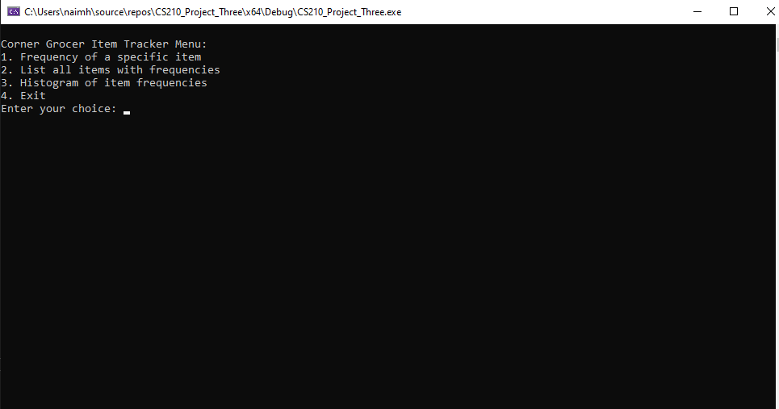
Figure 1: Main Menu

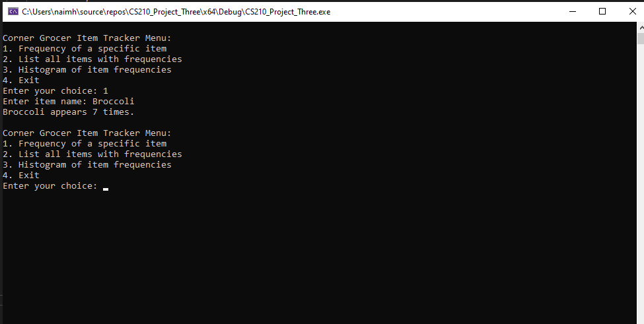
Figure 2: Option 1 – Frequency of Broccoli
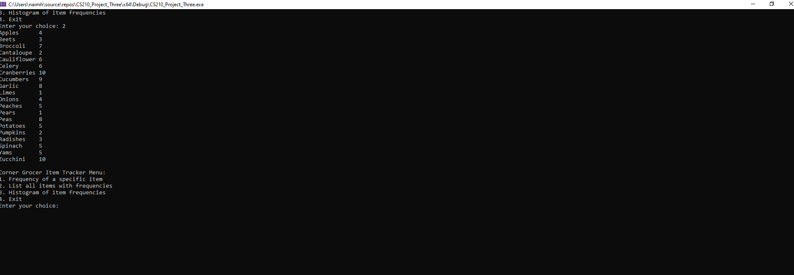
Figure 3: Option 2 – List of All Items with Frequencies

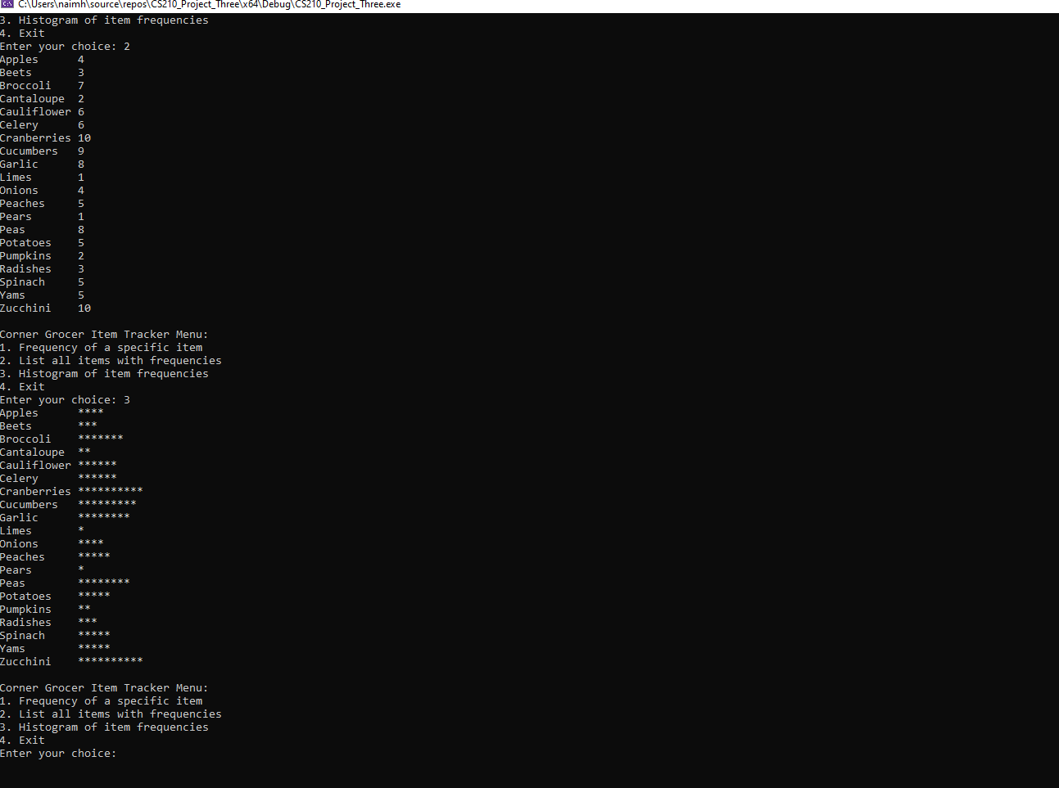
Figure 4: Option 3 – Histogram of Item Frequencies

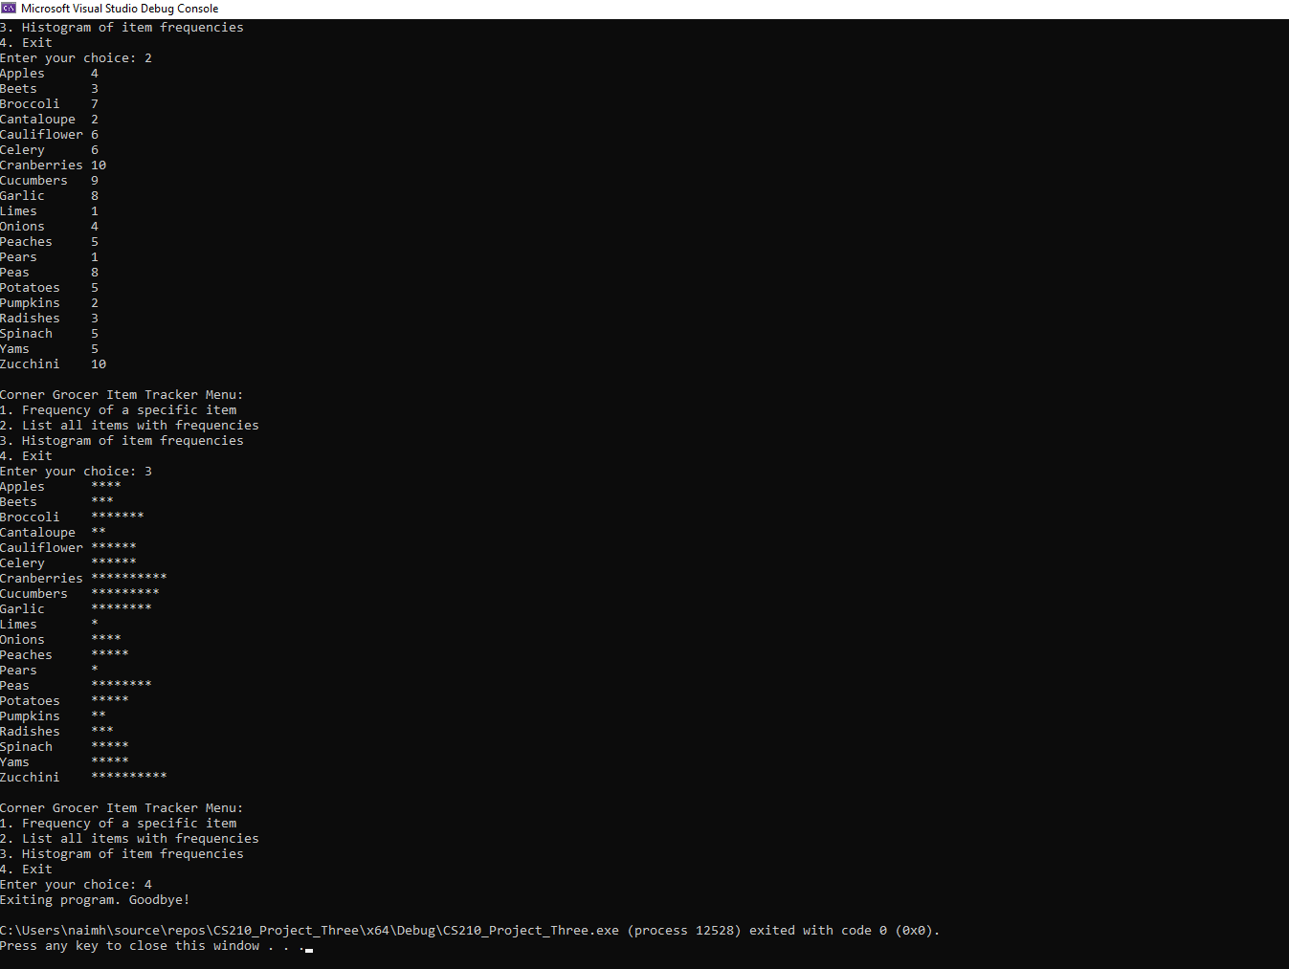

Figure 5: Option 4 – Exit Program

Conclusion:
The program works as required. It counts all items from the file. It shows results in a list or histogram. It saves a backup file. The code is easy to read and understand. The program meets all the points in the project rubric.

