**SR UNIVERSITY**

**AI ASSISTED CODING**

# NAME:MOHAMMAD NASRIN BATCH:19

**Using AI to Improve Code Quality and Readability**

**Lab Objectives**

* Use AI for automated code review and quality enhancement.
* Identify and fix syntax, logical, performance, and security issues in Python code.
* Improve readability and maintainability through structured refactoring and comments.
* Apply prompt engineering for targeted improvements.
* Evaluate AI-generated suggestions against PEP 8 standards and software engineering best practices

**TASK 1: Syntax and Error Detection**

Identify and fix syntax, indentation, and variable errors in the given script.

# buggy_code_task1.py

def add_numbers(a, b)

result = a + b

return reslt

print(add_numbers(10 20))

**Expected Output**:

* Corrected code with proper syntax (: after function, fixed variable name, corrected function call).
* AI should explain what was fixed.

**Before Detection:**

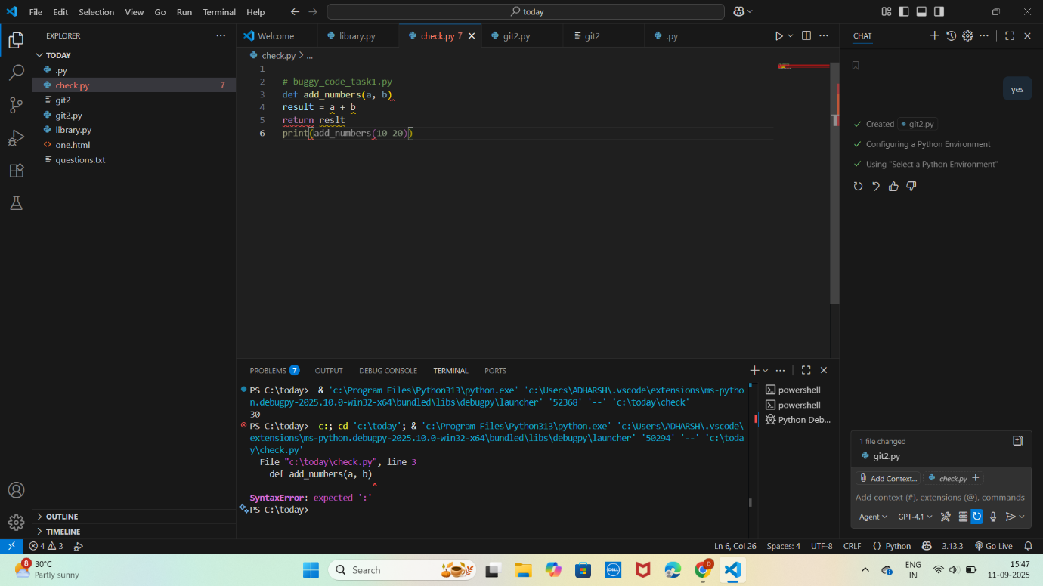

**After Detection:**

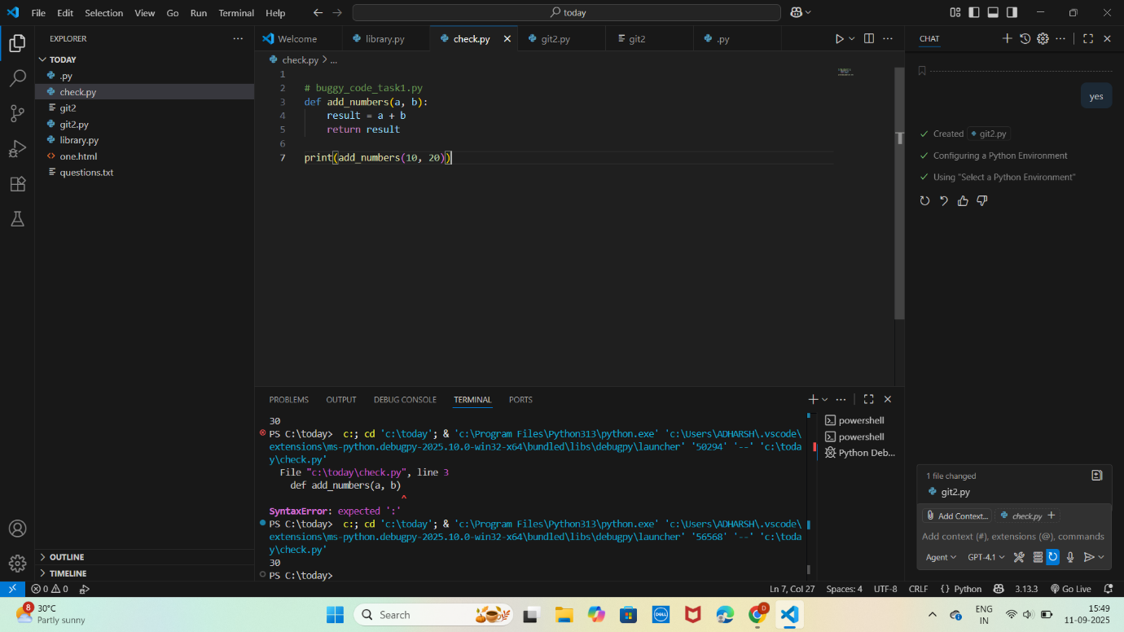

**Task 2: Logical and Performance Issue Review**

Optimize inefficient logic while keeping the result correct.

# buggy_code_task2.py

def find_duplicates(nums):

duplicates = []

for i in range(len(nums)):

for j in range(len(nums)):

if i != j and nums[i] == nums[j] and nums[i] not in duplicates:

duplicates.append(nums[i])

return duplicates

numbers = [1,2,3,2,4,5,1,6,1,2]

print(find_duplicates(numbers))

**Expected Output:**

More efficient duplicate detection (e.g., using sets).

AI should explain the optimization.

**Before detection:**

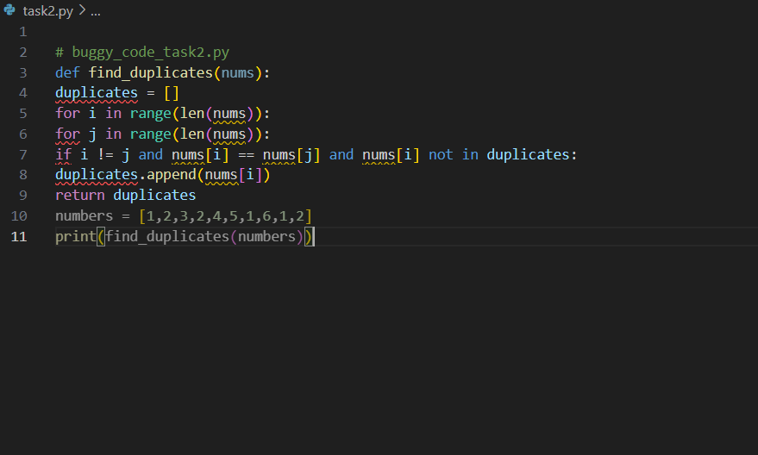

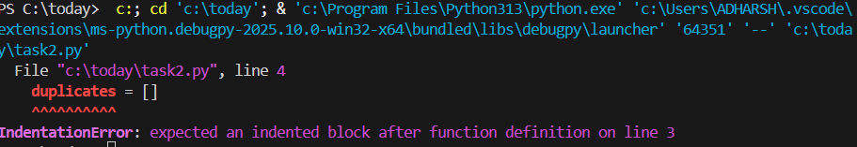

**After Detection:**

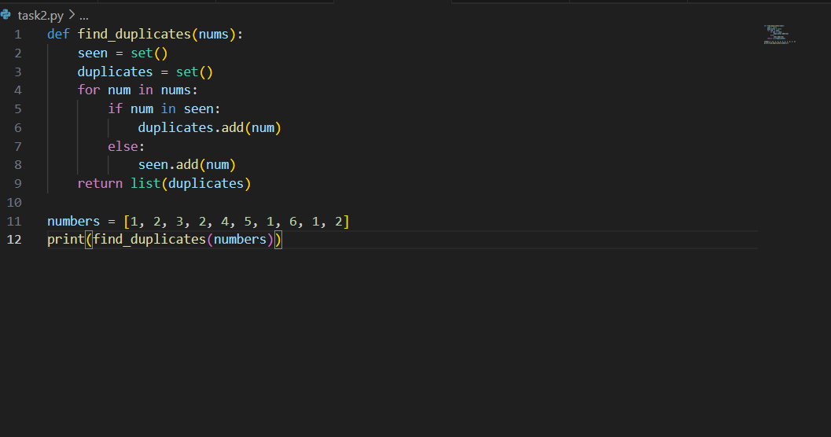

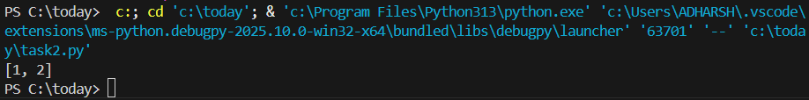

**Task 3: Code Refactoring for Readability**

Refactor messy code into clean, PEP 8–compliant, well-structured code.

# buggy_code_task3.py

def c(n):

x=1

for i in range(1,n+1):

x=x*i

return x

print(c(5))

**Expected Output:**

Function renamed to calculate_factorial.

Proper indentation, variable naming, docstrings, and formatting.

AI should provide a more readable version.

**Before Detection:**

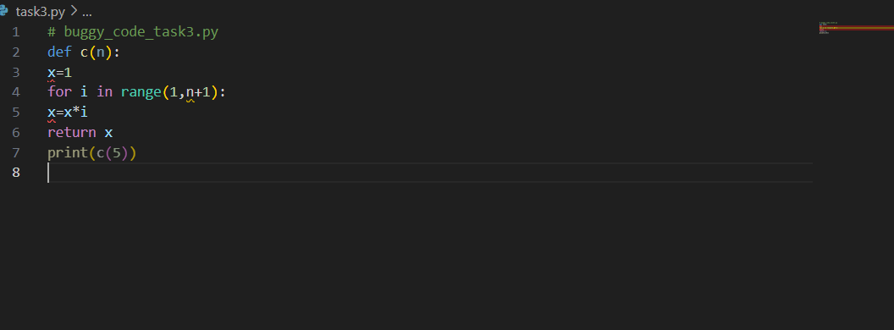

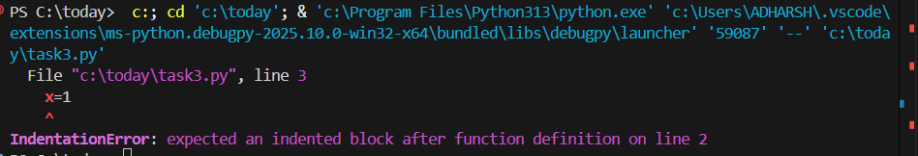

**After Detection:**

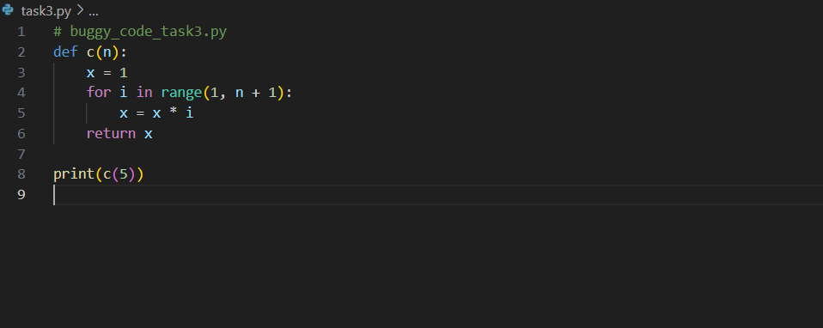

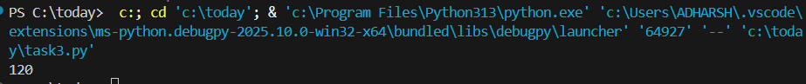

**Task 4: Security and Error Handling Enhancement**

Add security practices and exception handling to the code.

# buggy_code_task4.py

import sqlite3

def get_user_data(user_id):

conn = sqlite3.connect("users.db")

cursor = conn.cursor()

query = f"SELECT * FROM users WHERE id = {user_id};" # Potential SQL injection risk

cursor.execute(query)

result = cursor.fetchall()

conn.close()

return result

user_input = input("Enter user ID: ")

print(get_user_data(user_input))

**Expected Output:**

Safe query using parameterized SQL (? placeholders).

Try-except block for database errors.

Input validation before query execution.

**Before Detection:**

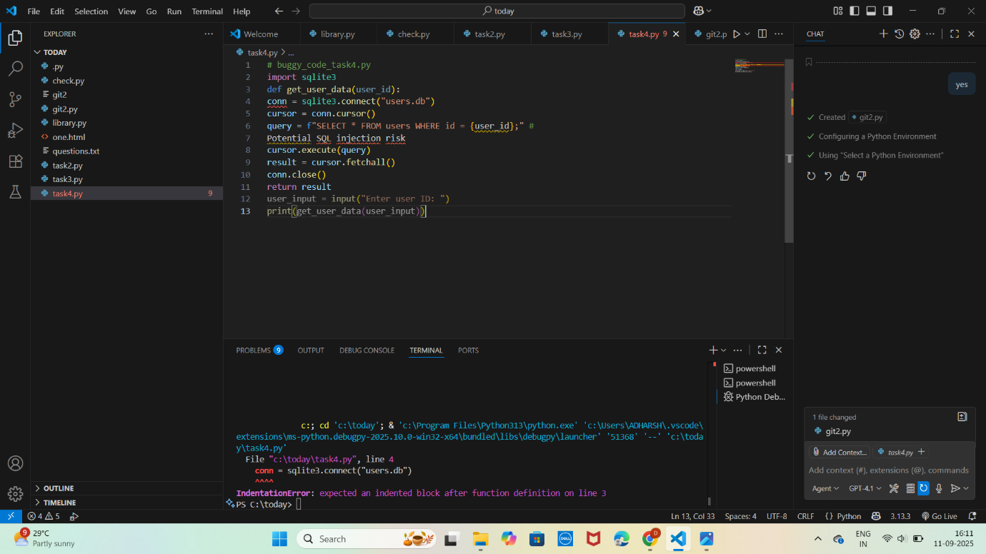

**After Detection:**

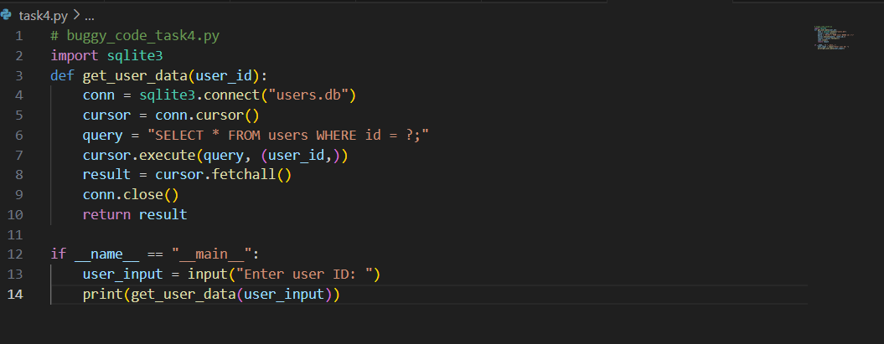



**Task 5: Automated Code Review Report Generation**

Generate a review report for this messy code.

# buggy_code_task5.py

def calc(x,y,z):

if z=="add":

return x+y

elif z=="sub": return x-y

elif z=="mul":

return x*y

elif z=="div":

return x/y

else: print("wrong")

print(calc(10,5,"add"))

print(calc(10,0,"div"))

**Expected Output:**

AI-generated review report should mention:

Missing docstrings

Inconsistent formatting (indentation, inline return)

Missing error handling for division by zero

Non-descriptive function/variable names

Suggestions for readability and PEP 8 compliance

**Before Detection:**

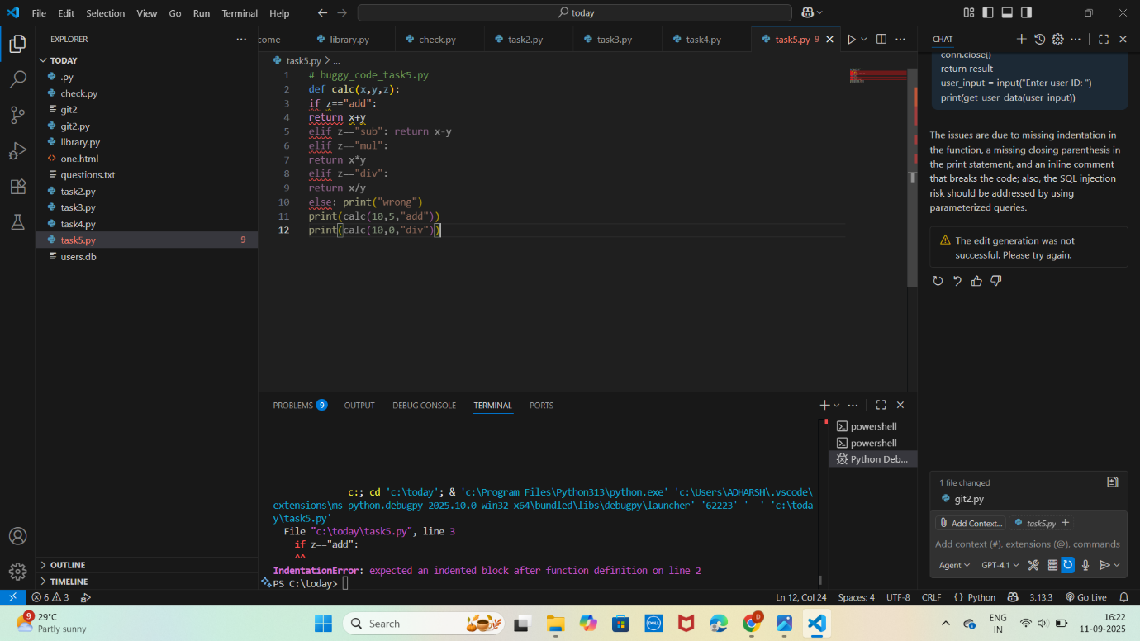

After Detection:

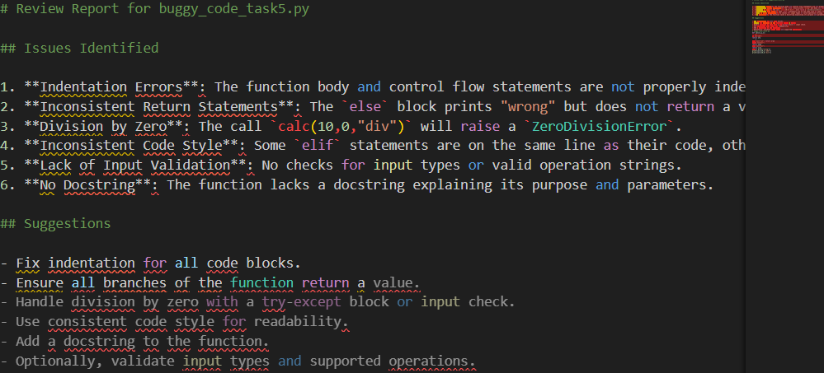

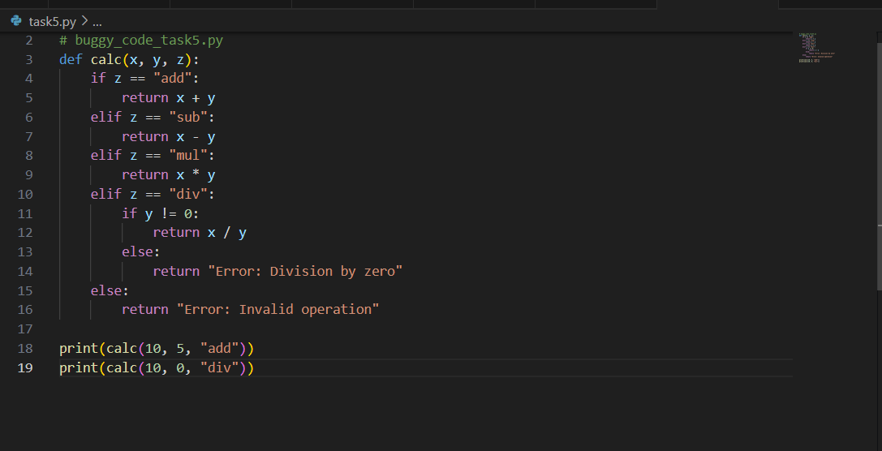

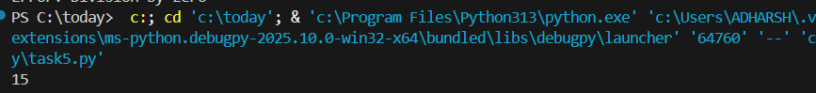

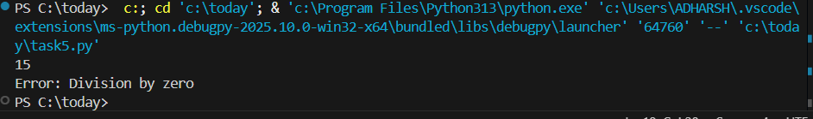

**D.ANKITHA**

**2503A51L09**