SR UNIVERSITY

AI ASSISTED CODING

**MOHAMMAD NASRIN**

**2503A51L23**

**Lab 9.5 – Documentation Generation: Automatic Documentation and Code Comments**

**Lab Objectives:**

* Inline Comments.
* Docstrings.
* Auto-Documentation Tools.
* AI assisted Summarization.

**TASK DESCRIPTION #1** (Automatic Code Commenting)

**Scenario:** You have been given a Python Function without comments .

def calculate_discount(price ,discount_rate):

Return price –(price*discount_rate/100)

* Use an AI tool (or manually simulate it) to generate line-by-line comments for the function.
* Modify the function so that it includes a docstring in Google-style or NumPy-style format.
* Compare the auto-generated comments with your manually written version.

**CODE:**

**OUTPUT:**

**TASK DESCRIPTION #2**(API Documentation Generator)

**Scenario:** A Team is building a **Libaray Management System** with multiple functions.

def add_book(title, author, year):

# code to add book

pass

def issue_book(book_id, user_id)

# code to issue book

Pass

* Write a Python script that uses docstrings for each function (with input, output, and description).
* Use a documentation generator tool (like pdoc, sphinx, or MkDocs) to automatically create HTML documentation.
* Submit both the code and the generated documentation as output.

**CODE :**

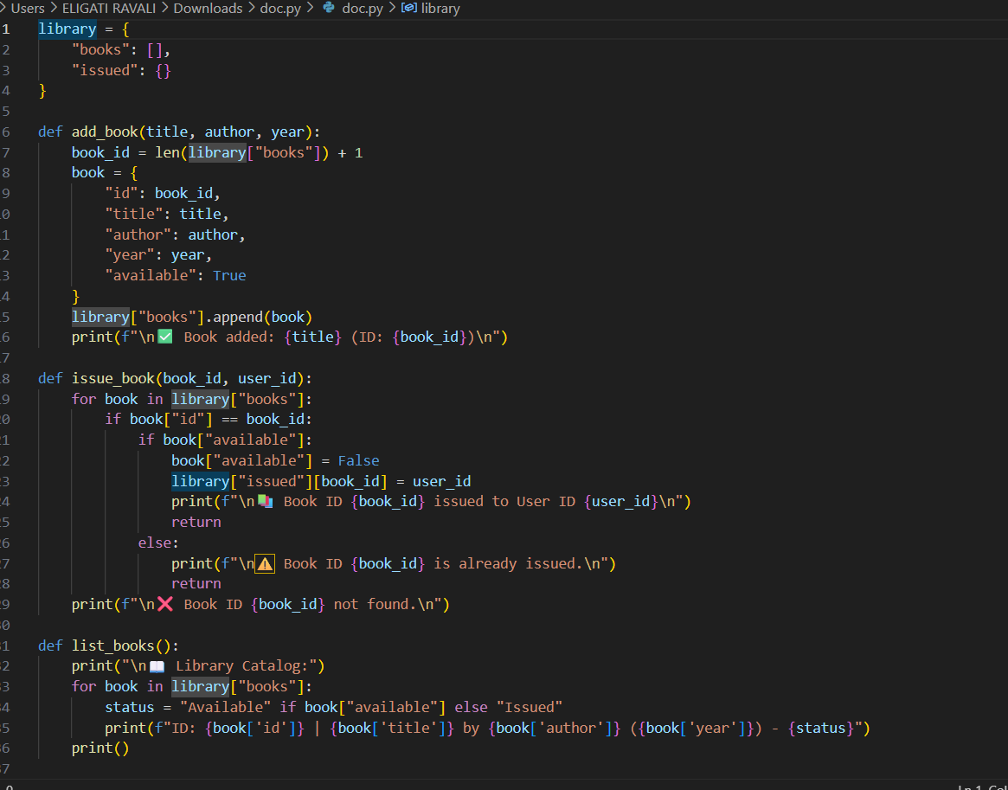

**OUTPUT :**

**TASK DESCRIPTION #3** (AI_Assisted Code Summarization)

**SCENARIO:** You are reviewing a colleagues codebase containing long functions.

def process_sensor_data(data):

Cleansed = [x for x in data if x is not None]

avg = sum (cleaned)/len(cleaned)

anomalies = [x for x in cleaned if abs(x- avg) > 10]

return {“average”: avg, “anomalies”:anomalies}

* Generate a summary comment explaining the purpose of the function in 2-3 lines.
* Create a flow-style comment (step-by-step explanation).
* Write a short paragraph of documentation describing possible use cases of this function in real-world scenarios.

**CODE :**

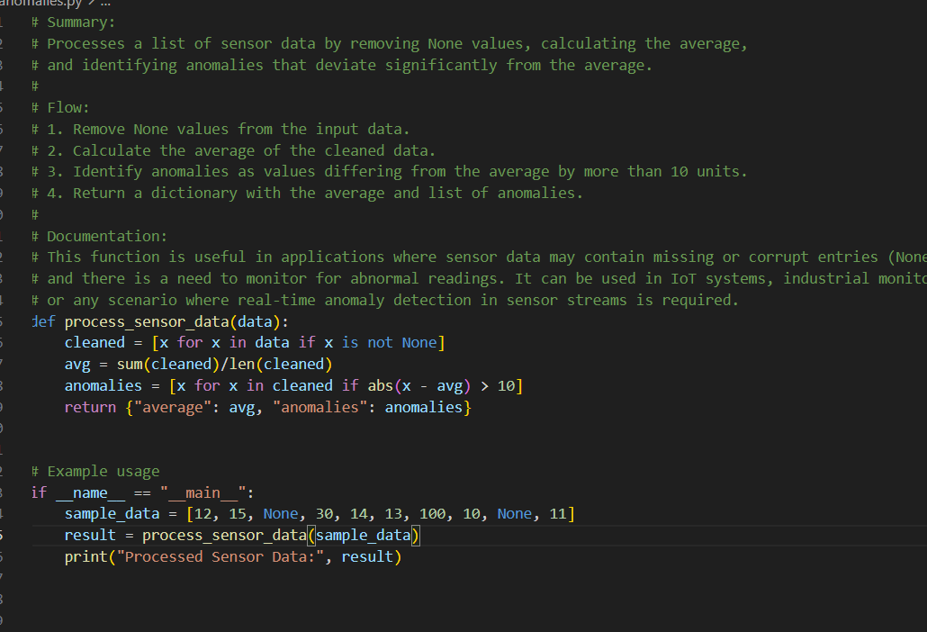

**OUTPUT:**

**TASK DESCRIPTION #4** (Real-Time Project Documentation)

**Scenario**: You are part of a project team that develops a Chatbot  
 Application. The team needs documentation for maintainability.

* Write a README.md file for the chatbot project (include project  
  description, installation steps, usage, and example).
* Add inline comments in the chatbot’s main Python script (focus  
  on explaining logic, not trivial code).
* Use an AI-assisted tool (or simulate it) to generate a usage guide  
  in plain English from your code comments
* Reflect: How does automated documentation help in real-time  
  projects compared to manual documentation?

**CODE:**

**OUTPUT:**

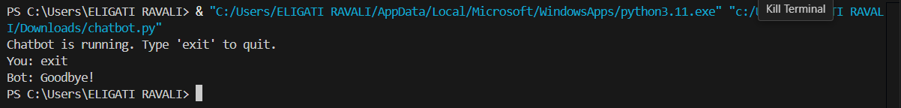

**OBSERVATIONS :**

By completing this Assignment ,I am able to:

* Compare the auto-generated comments with manually written version using AI Tools.
* Generates the API Documentation Generator using the python scripts .
* Generated the AI_Assisted Code Summarization.
* Implements the Real-Time Project Documentation.