Python Data Analysis Steps For Machine Learning

Data :
Data is the representation of meaning in a format machines understand.It is generated by research,human creativity,sensors,transactions,digital interactions,calculations and artifical intelligence.
it is used to make decisions,solve problems,drive automation,predictions,execute transactions,entertain,inform and secure.
Measuring and managing data is data complexity for example Big data.

The following are a few key Data types :
Big data,Meta data,Raw data,Source data,Unstructured data,structured data,Machine data,Transactional data,quantitative data,qualitative data etc...

Data Analysis :
Data Analysis is the systematic examination of data.it is a board activity that is used to build information assets,solve operational problems,support decisions and explore theories.

The following are common types of Data Analysis.

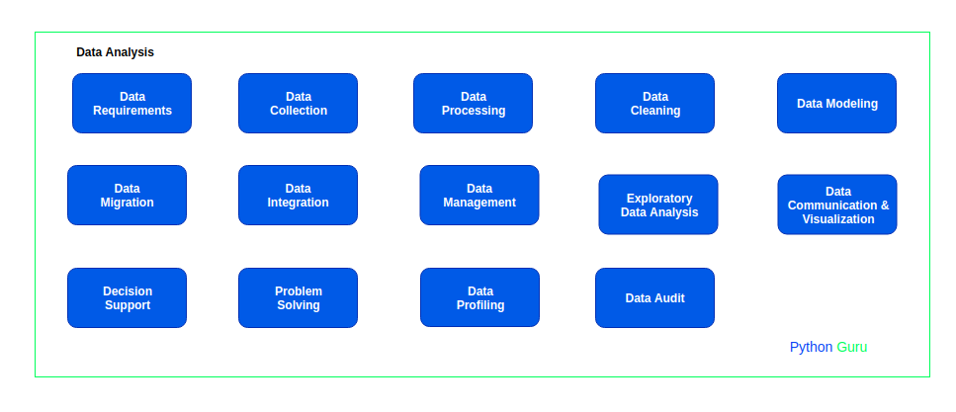

page-1

*1.Data_Requirements :

Requirements may be collected from stakeholders such as business units,customers,communities,users and subject matter experts in various areas.
We have 10+ data_Requirement types like Business Requirements,product Requirments,Customer Requirements types etc...

In this Article,For data analysis,Requirement type is Product requirement type.So here our product is mobile and here required domain knowledge on mobiles,To understand about mobile features.

Domain knowledge is that which helps to take a strong decision to select best domain.Simply Where as product knowledge is that in which person is aware about all features of product.

*2.Data Collection :

Collecting data from a variety of sources into a new structure.for example,an e commerce site that develops a product database using the product data.

In this Article, data collected through webscraping technique & Scrapped
e-commerce site (Flipkart),For mobile specifications and collected Mobiles data and stored into a csv file for data processing.

To know more about Webscraping.Follow python guru articles ‘‘webscraping with Beautifulsoup’’ (or) ‘‘webscarping with scrapy framework’’.

*3.Data processing:
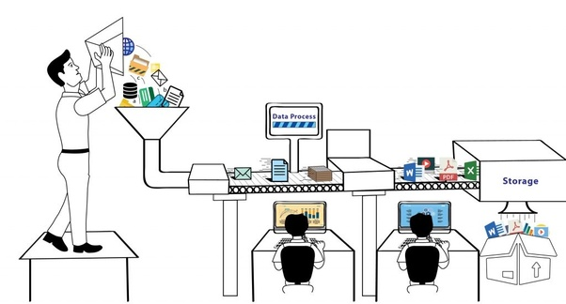
page-2

Data processing is the method of formatting information in a particular manner, which is easy to access and utilize. It is the process of organizing and controlling the large amount of data. It is useful to deal with the important data in synchronized manner and to do analysis on each and every feature for Exploratory Data Analysis (data profiling,data cleaning or data pre-processing).

In this Article,we have mobiles dataset.In this data set we have
15 columns(Features) like :

Mobile_name, Mobile_color, Price, Rom, Ram, Expandable_Ram, Dual_sim, Screen_in_inch, Display, Secondary_camera, Primary_camera, Battery-details, warranty, Rating.

*4.Exploratory Data Analysis :
Exploratory Data Analysis (EDA) plays a very important role in understanding the dataset.it is in initial analysis that is performed on a dataset that may help us to visually detect the presence of outliers,the distribution of the data, and the relationships between features.This step is an essential step that must be implemented before using the dataset for building a maching learning model.

*Data Profiling :
Data profiling is a process of examining data from an existing source and summarizing information about that data.it can be done for many reasons, but it is most commonly part of helping to determine data quality as a component of a larger datasets.profile data to determine the accuracy, completeness, and validity of our data.

Data-Profiling packages in Python :
pandas_profiling :
Generates profile reports from a pandas DataFrame. The pandas df.describe() function is great but a little basic for exploratory data analysis.pandas_profiling extends the pandas DataFrame with df.profile_report() for quick data analysis.
For each column the following statistics - if relevant for the column type - are presented in an interactive HTML report:
- Essentials: type, unique values, missing values
- Quantile statistics:like minimum value, Q1, median, Q3, maximum, range, interquartile range.
- Descriptive statistics: like mean, mode, standard deviation, sum, median absolute deviation, coefficient of variation, kurtosis, skewness
- Correlations:highlighting of highly correlated variables, Spearman, Pearson and Kendall matrices.
page-3

- Missing values: matrix, count, heatmap and dendrogram of missing values
- Most frequent values,Histogram
*Data pre_processing :
Data pre_processing (or) Data cleaning is Improving the quality of data by removing errors,handling missing values,Droping Unnecessary Columns,Create new variables,Transform data,Rename Variables,Merge two datastes and resolving inconsistencies etc...!

Data Cleaning (or) Data Pre_processing packages in Python :

Pandas : Pandas is used for data manipulation,data analysis and cleaning. Python pandas is well suited for different kinds of data.
NumPy :(Numerical Python) is an open source Python library for doing scientific computing with Python.It gives an ability to create multidimensional array objects and perform faster mathematical operations.
To know more about Pandas,Numpy libraries follow python guru articles.
*Data Visualization :
Data Visualization is the process of displaying information to more easily understand and Finding meaningful patterns in data and documenting or visualizing such data in a way that is meaningful to people.

Why we visualize data?
Humans, process visual input above all else and faster than any other method. This is the key reason for visualizing data.Humans are visual by nature, so it helps to see data in a visual format.It’s easier to find patterns, digest, and make decisions with visual data.

Data Visualization packages in Python :

Matplotlib :Matplotlib is a Python library used for plotting the beautiful and attractive Graphs.In data analysis,visualization is the important step.By using visualization we can easily understand than how data is split.

There are lots of libraries to visualize the data like seaborn,Bokeh,Plotly,ggplot etc...But amoung that the matplotlib is very famous and easy one.
To know more about Matplotlib,follow python guru articles.

page-4

Let’s start with practicle Example to cover all These topics (or) steps,what we discussed above,about data analysis.
For this example using python-pakages pandas-profiling lib for data-profiling,pandas-for-data Pre-processing,matplotlib-for-data visualization lib and Jupyter-notebook.
Step-A :
Data_Collection : We collected data using webscraping technique.Now we have e-commerce site (filpkart) Mobiles_data.
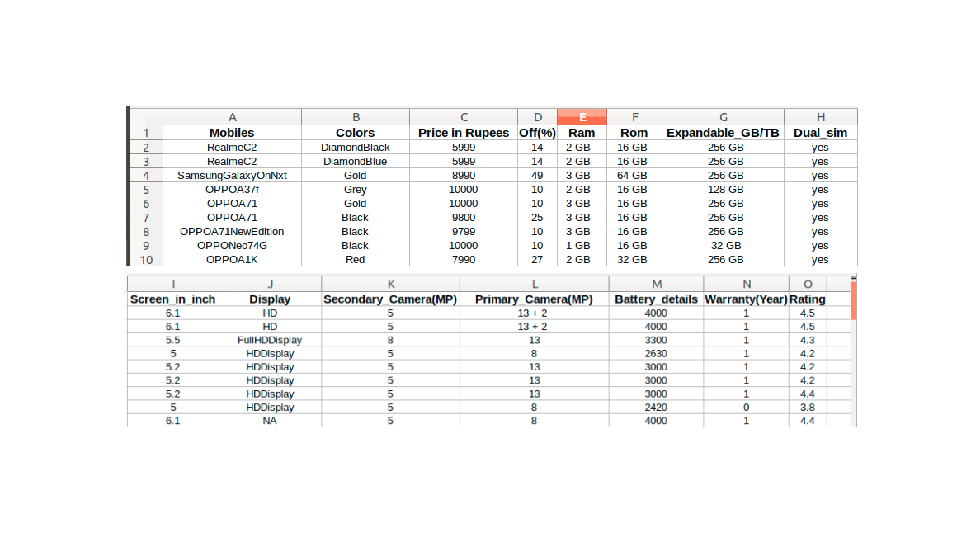
Scraped Flipkart Mobiles dataset

Step-B :
Data_processing :We have flipkart mobiles data,Now we need to do some processing(Analysis) on that data to select features to make a dataset.
After preparing this dataset we need to handle that data to process,means to apply machine learning algorithms or to build a model.
Step-C :
Exploratory Data Analysis :

