Machine Learning
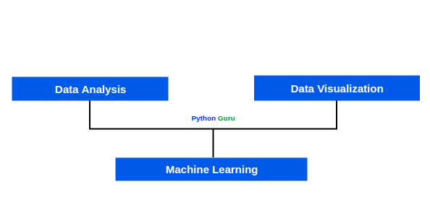

Data Analysis :
Data Analysis is the systematic examination of data.it is a board activity that is used to build information assets,solve operational problems,support decisions and explore theories.

The following are common types of data analysis.
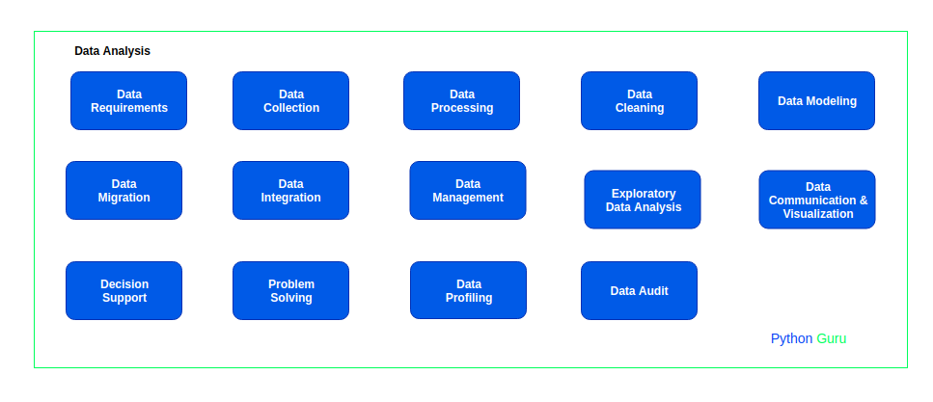

*1.Data_Requirements :
Developing requirements for data that doesn’t exit yet or modifications to existing data assets.

*2.Data Collection :
Collecting data from a variety of sources into a new structure.for example,an ecommerce site thar develops a product database using the product data from partners.
*3.Data processing:
Analysis of data processing steps such as business rules.for example,analysis of an algorithm that generates a risk score for credit applications.
Doing analysis on years of data to understand about data.
*4.Data Cleaning :
Data Cleaning (or) Data pre_processing Improving the quality of data by removing errors,handling missing values and resolving inconsistencies.
*5.Data Modeling :
Designing the structure of data and data relationships.Data modeling is a process of design that often requires significant analysis.
6.Data Migration :
The process of exporting data from a source,converting its format and structure and loading it into a target data repository.for example,migrating your customer database from a legacy system to a new system.
7.Data Integration :
Sharing data between data producers and data consumers,often in real time.For example, if a customer changes their address that address may be updates in multiple systems.Building integration transactions often requires significant analysis such as developing specifications for mappings between data models.
8.Data Management :
Analysis of the control and management of data.for example,an Organization that is replicating customer data in multiple systems may conduct an analysis to consider a master data management strategy.

*9.Exploratory Data Analysis:
Using data to confirm or develop strategies,plans and optimizations.for example, a marketing team uses historical sales data to confirm that a new pricing strategy is likely to improve revenue.

*10.Data Communication & Visualization :
Finding meaningful patterns in data and documenting or visualizing such data in a way that is meaningful to people.Foe example, an operational team uses an analytics tool to visualize production metrics for a weekly report.
*11.Decisoin Support :
Developing data to support decision making at the strategy or operational level.For example,a data analyst develops a report that benchmarks a firm’s production costs against its main competiton.
*12.Problem Solving :
Analysis of data to support problem sloving.For example,a firm that experiences a sudden drop in sales may conduct a data analysis to understand why?.
13.Data Profiling :
Data Profiling is the process of developing metadata such as data lineage information.
*14.Data Audit :
Investigating and reporting the quality of data.

10+ Types of Requirements :

Types :
Requirements may be collected from stackholders such as business units,customers,communities,users and subject matter experts in various areas.
By knowing about this types of Requirements,we can easly understand about data and it’s helpfull to get some domain knowledge.

The Following are common types of Requirements :
