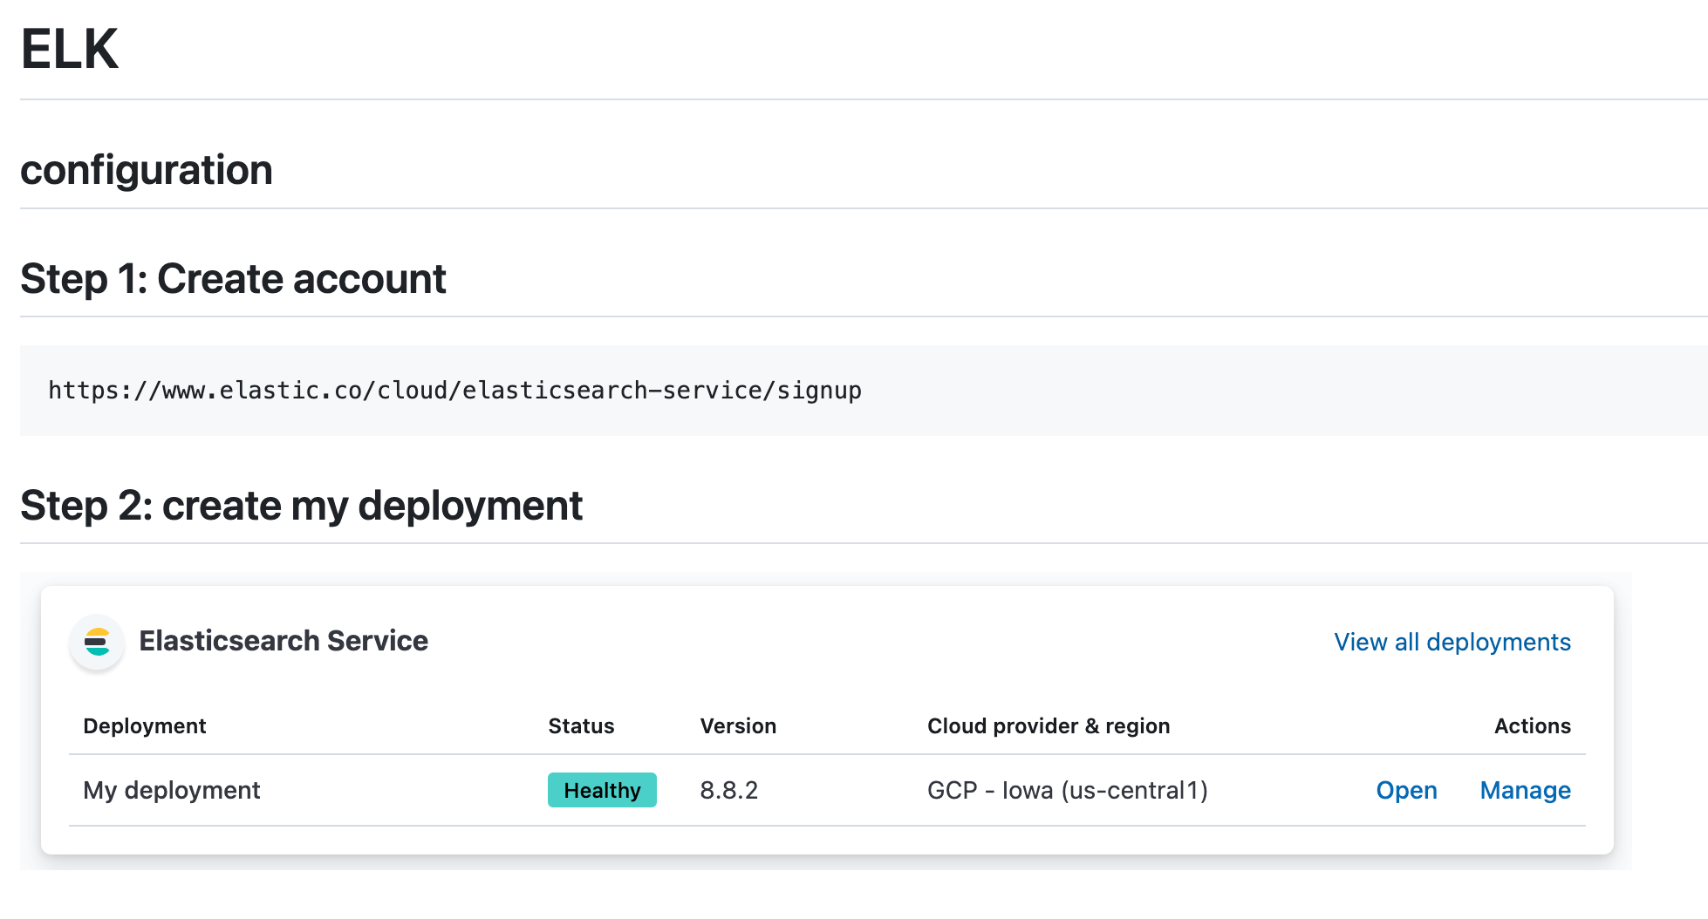

## **Step3: click on Manage ->security->reset password**

You will get username and password

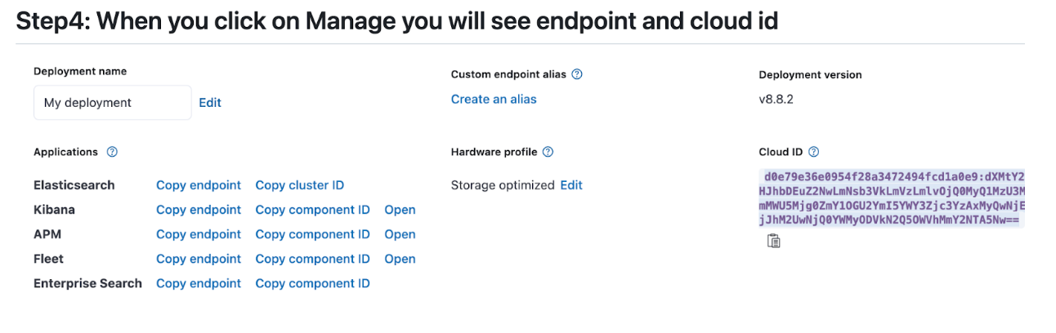

## **Step5: Metricbeat installation**

https://www.elastic.co/guide/en/beats/metricbeat/current/metricbeat-installation-configuration.html

curl -L -O https://artifacts.elastic.co/downloads/beats/metricbeat/metricbeat-8.9.2-amd64.deb

sudo dpkg -i metricbeat-8.9.2-amd64.deb

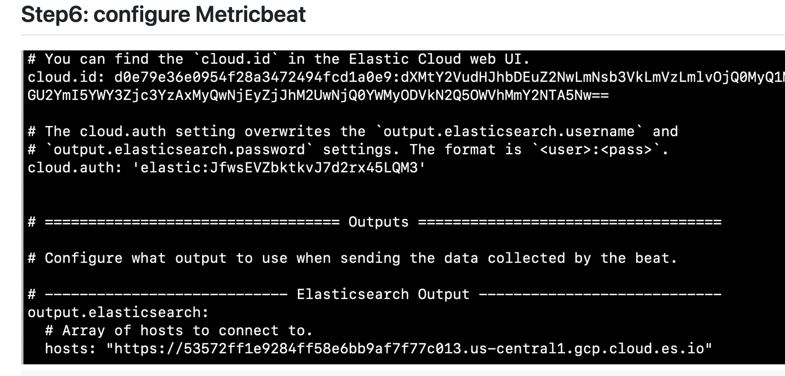

Enter your username and password, with your endpoints

cd /etc/metricbeat

copy username and password from manage->security->reset password, get cloudid & elasticsearch endpoint paste above

