**How to connect from windows to AWS Server:**

[**https://docs.aws.amazon.com/AWSEC2/latest/UserGuide/putty.html**](https://docs.aws.amazon.com/AWSEC2/latest/UserGuide/putty.html)

When you have created and launched an AWS Linux EC2 instance, you can connect to it from your computer using the Secure Shell (SSH) protocol. PuTTY is a free SSH client that allows you to do this from a local computer running Windows. Once the connection has been established, you work within the EC2 instance just like you would on a local computer running Linux.

To follow this tutorial, you will first need to create and launch a Linux EC2 instance to which you will connect. Instructions for this are found in the tutorial titled, Create a Basic Elastic Cloud Compute (EC2) t2.micro Instance. You must have an AWS account.

Generate a PuTTY Private Key (.ppk) file

1. Download and install PuTTY.

https://www.chiark.greenend.org.uk/~sgtatham/putty/latest.html

2. Open the folder in which PuTTY was installed (default path is C: > Program Files > PuTTY).

3. Double click on the file puttygen.exe. The first thing you will see is shown

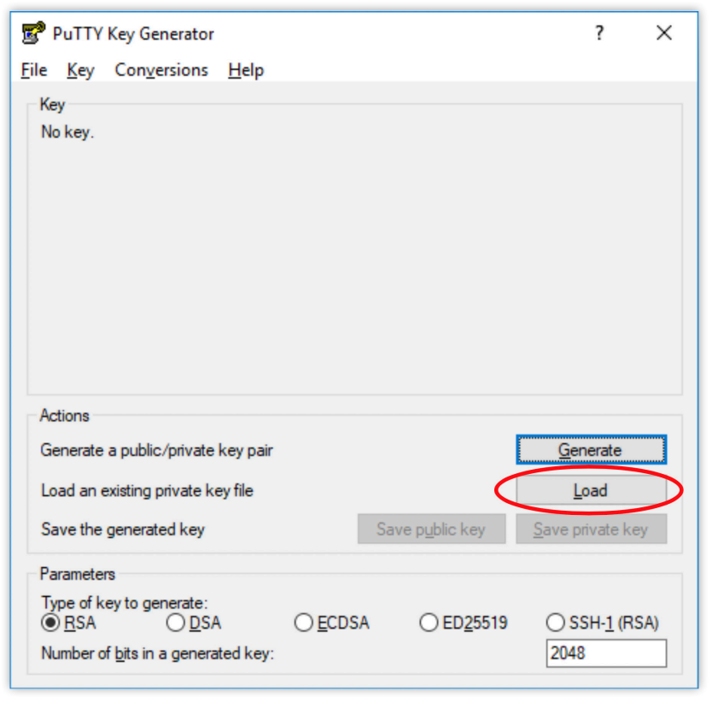

4. Click on the Load button in PuTTY Key Generator and navigate to the folder that contains the private key file (.pem) created during the EC2 configuration process.

5. Click on the PuTTY Private Key Files button in the lower right corner of the window and select All Files (*.*).

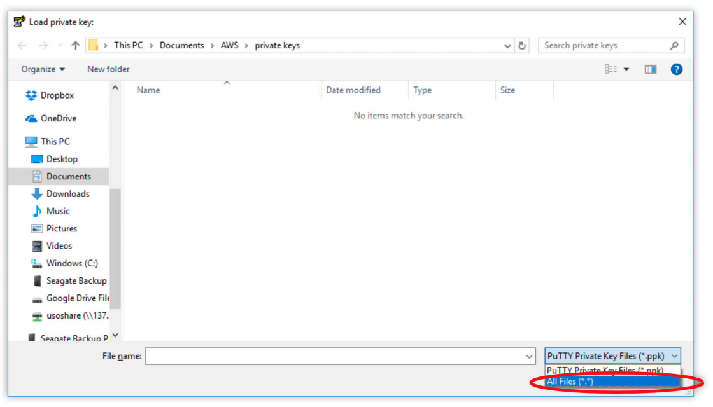

6. Click the box next to your private key file (.pem) to select it

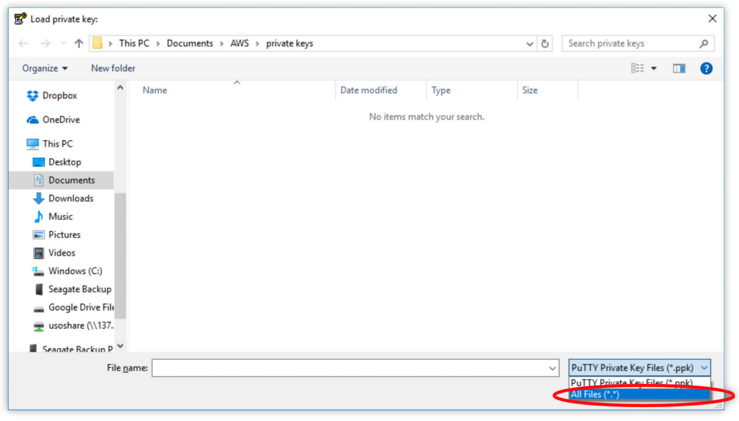

7. Click on Open.

8. Click OK to close the PuTTYgen Notice pop-up window

9. In PuTTY Key Generator, make sure Type of key to generate value is set to RSA

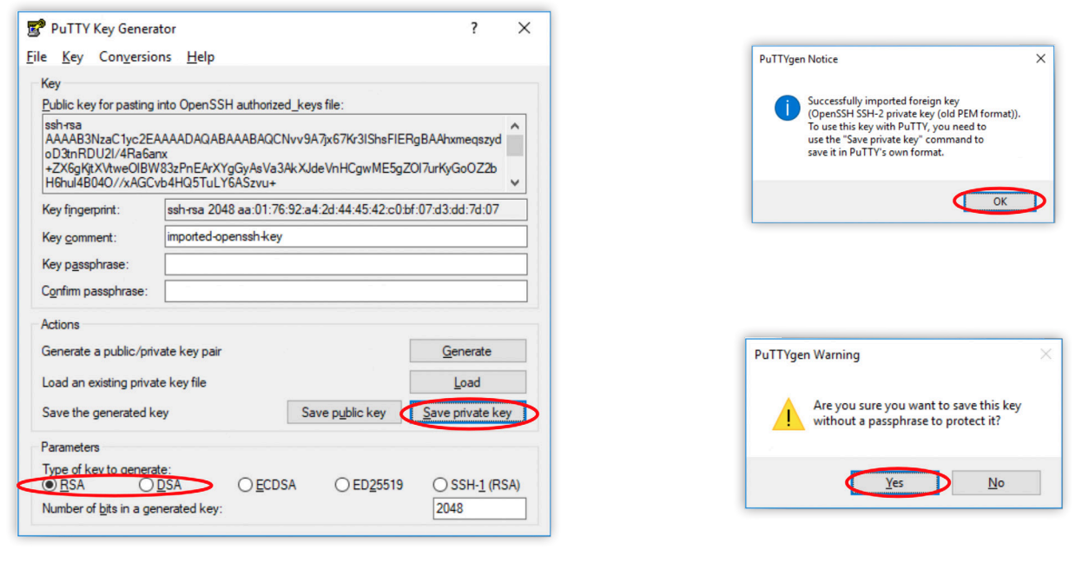

10. Click Save private key.

11. Click Yes to close the PuTTYgen Warning pop-up window.

12. Navigate to the location you want to store your PuTTY Private Key file (.ppk)

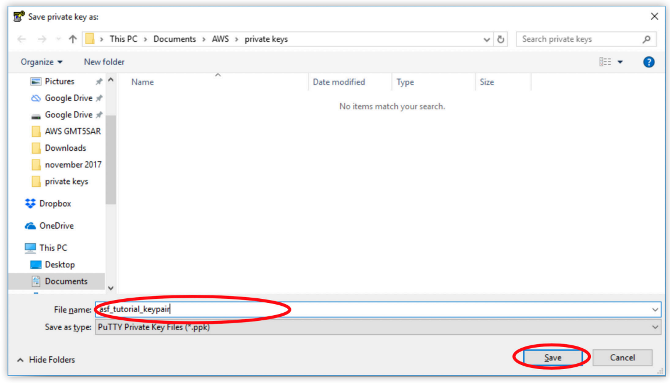

13. Give the file a name.

14. Click Save.

15. Close the PuTTY Key Generator window.

Once you have generated a private key, you can use it whenever you need to connect to a new EC2 instance. Connect to the EC2 instance

1. Click on the desktop icon or the putty.exe file in the PuTTY folder to open PuTTY

2. Type ubuntu@your_public_ip in the Host Name (or IP address) box

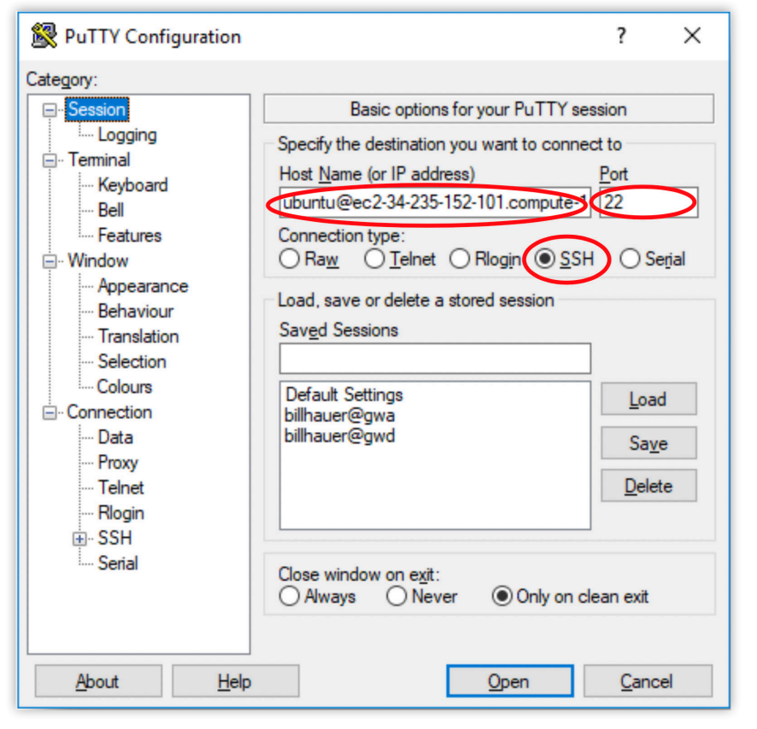

The Public ip address for your instance is displayed in AWS in the EC2 Management Console Instance Description in the middle of the screen. 3. Set the Port to 22. 4. Set the Connection Type to SSH

5. Click on the + next to SSH to expand the choices in the Category pane on the left of the PuTTY Configuration window under Connection

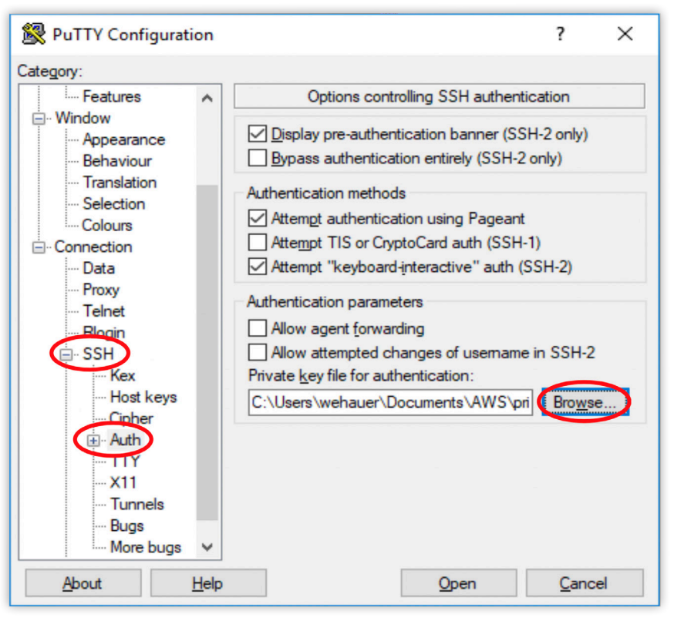

6. Click Browse under Authentication parameters and navigate to the directory where your PuTTY Private Key (.ppk) file is located and select it.

7. Click Open. If you want to save these settings to use later, navigate to Sessions in the PuTTY Category tree. Enter a name in the Saved Sessions box and click Save on the right.

8. Click Open in PuTTY Configuration to connect to your Instance. If this is the first time you have connected to your Instance, a PuTTY Security Alert will ask you whether to proceed with the connection.

9. Click Yes to complete the connection.

