**Mohammad Opal**

**CIS 476 Term Project**

**12/4/2024**

**GitHub Repo Link**:<https://github.com/mohammadopal1/mypass>

**Home page:** This is the initial page and also I added some quick links.

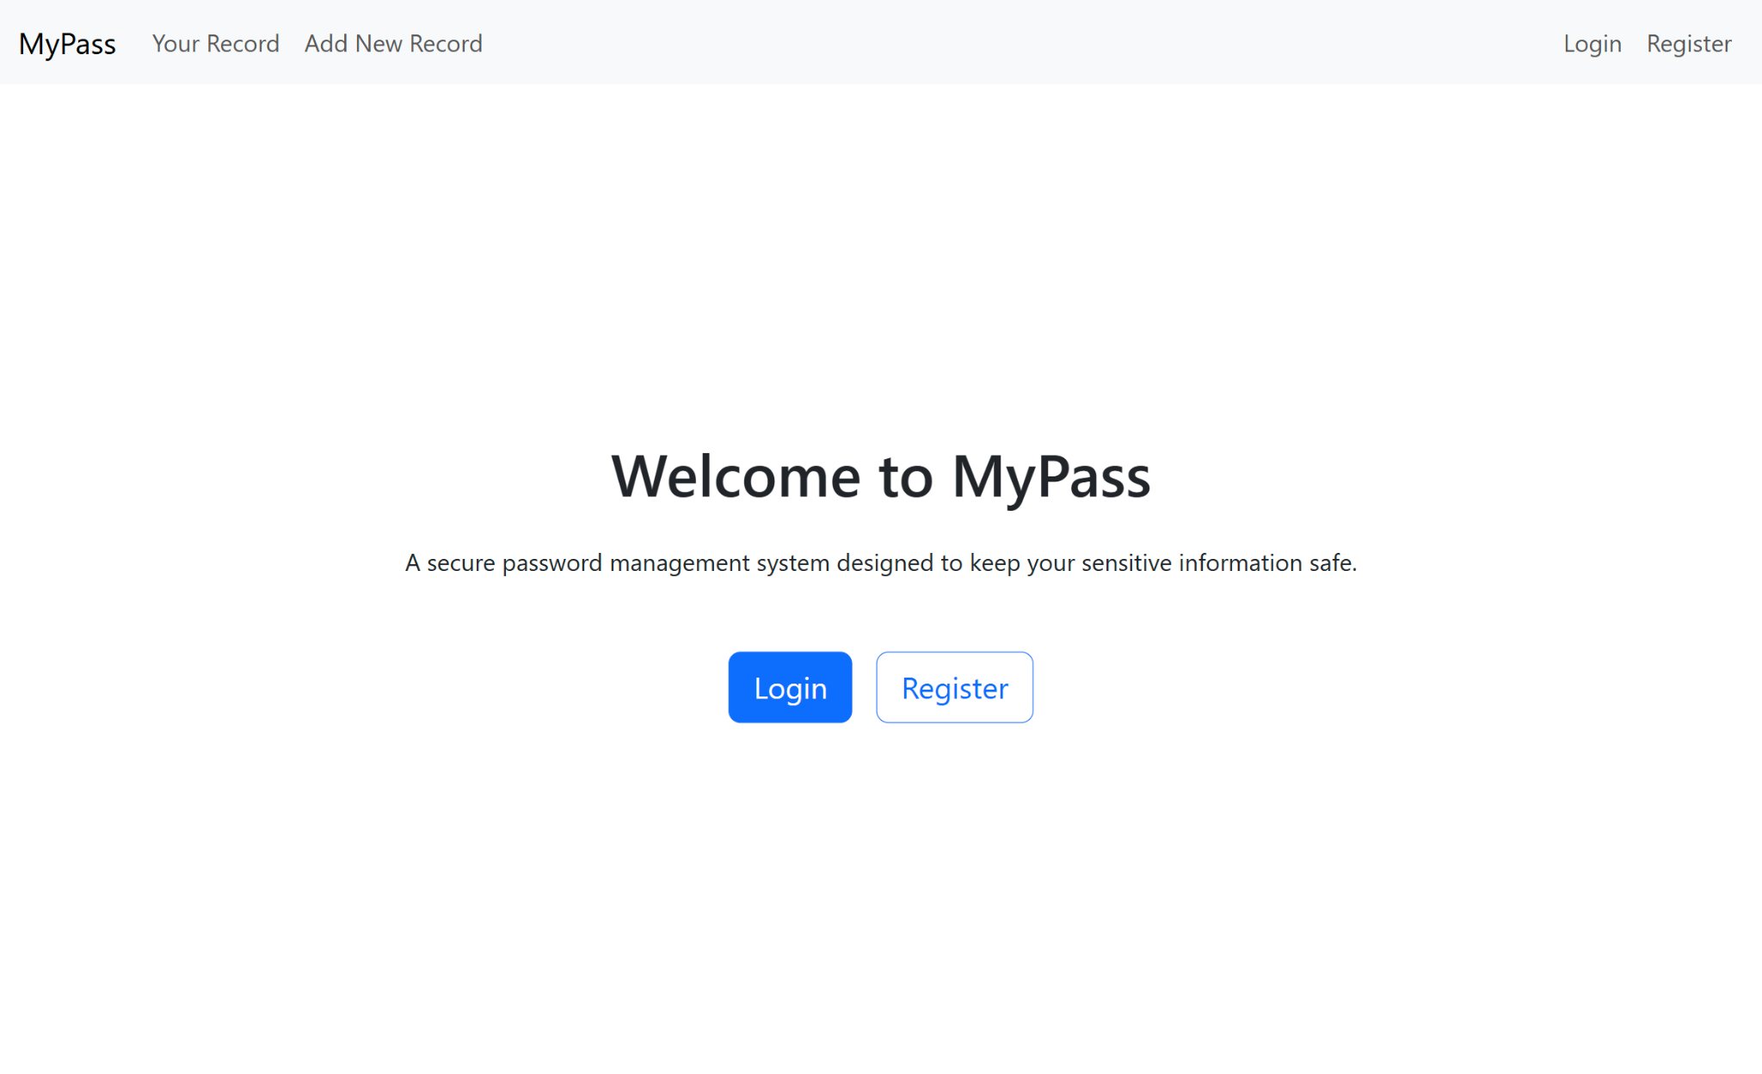

**Register:** Here we can register as a user. **UI:** Here in order to register we have to make password, some security que etc.

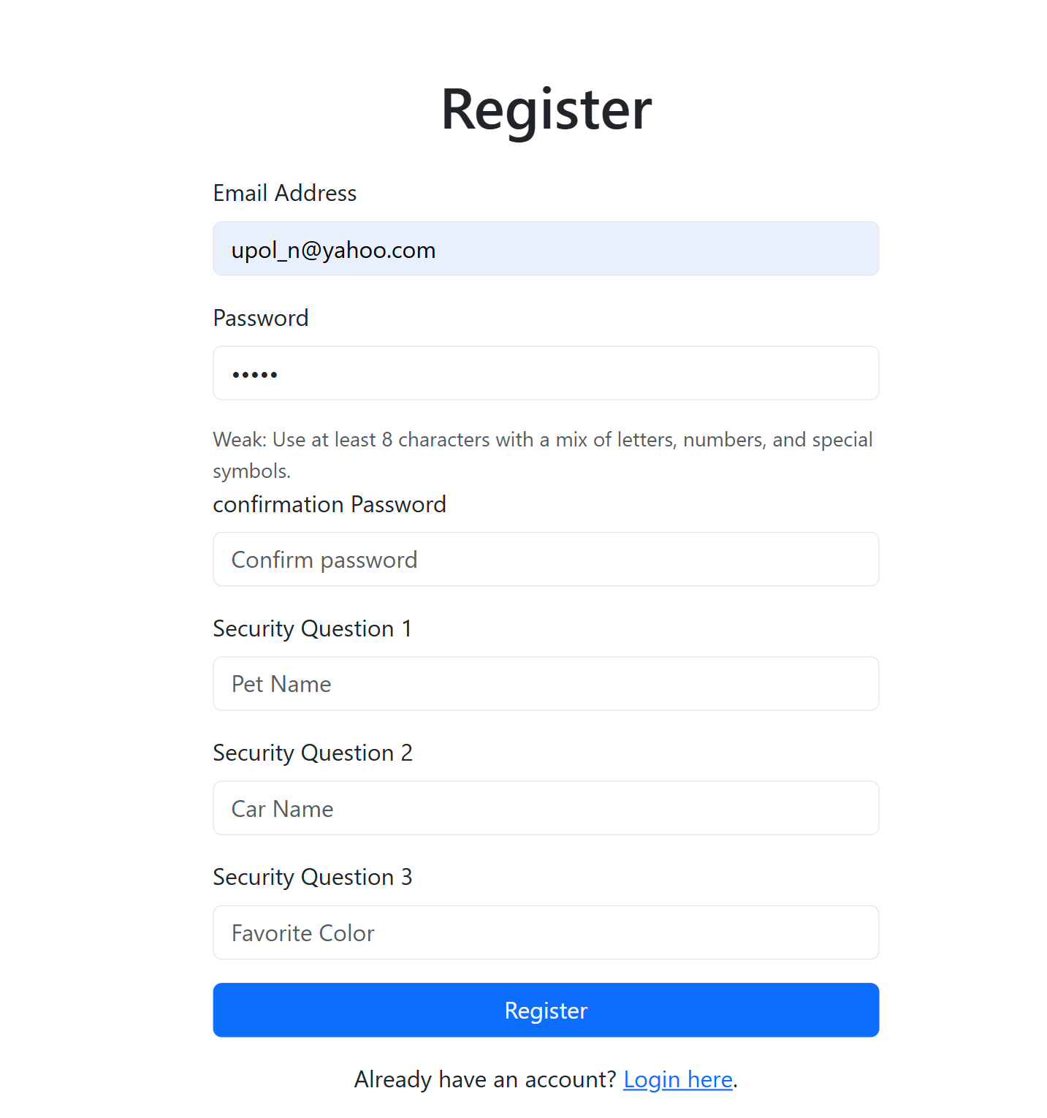

**Database Table:** This is user database table.

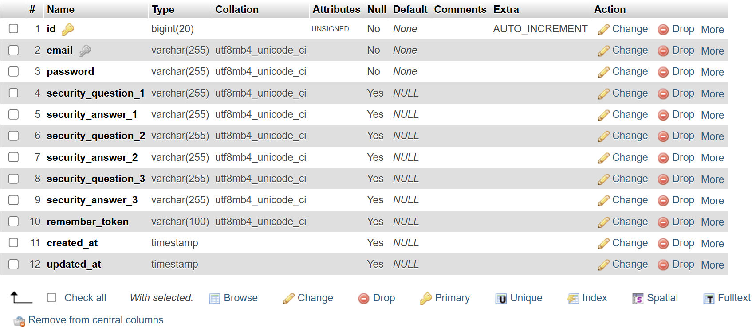

**Data Table:** This is the example of on of the data which is encrypted.



**Password Pattern:   
Using JavaScript:** In the user end it work like observer pattern and it validate password.  
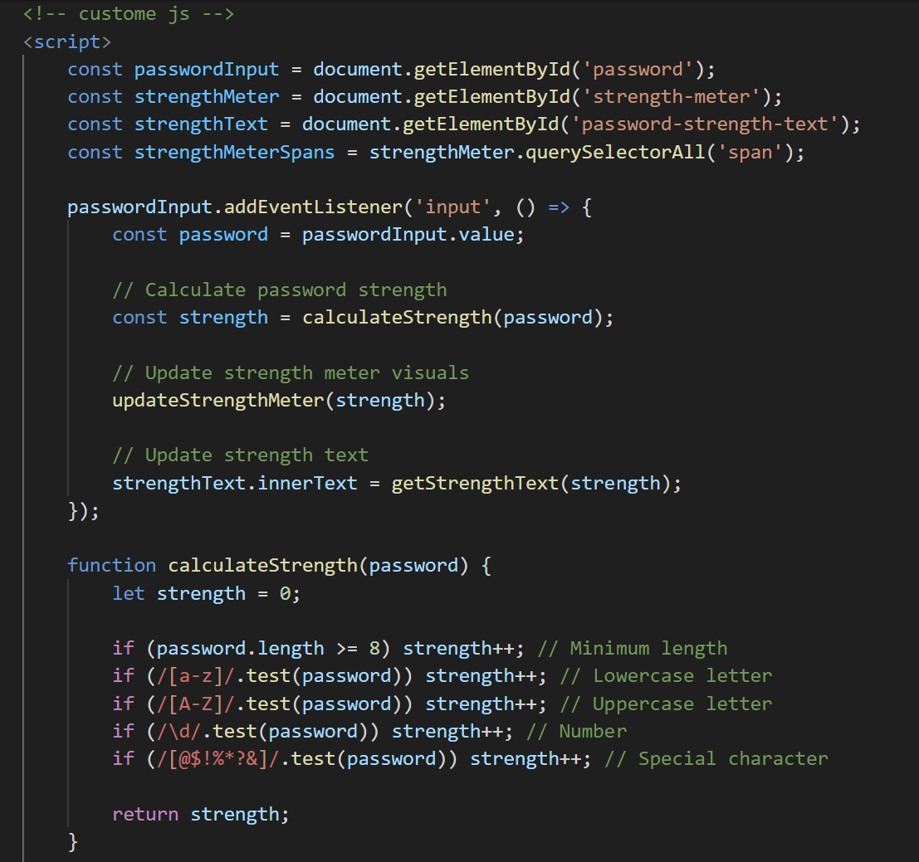

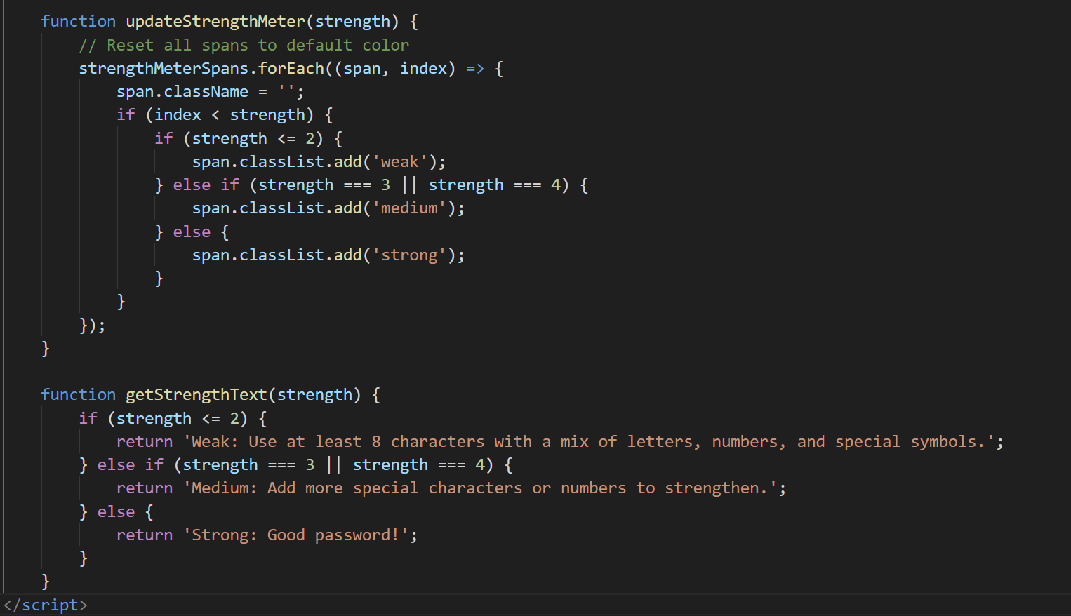

**PHP Code: PHP register PHP source code**: It validates password in the server end**.**

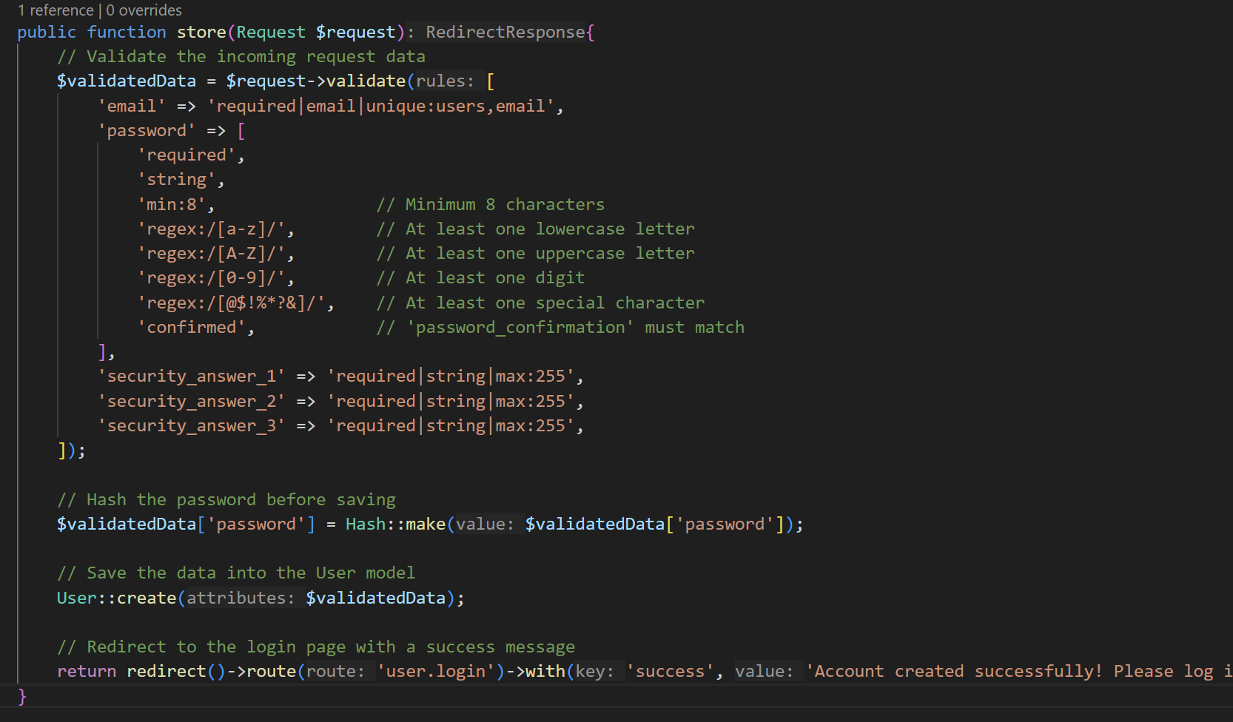

**Login: UI:** This is the login UI

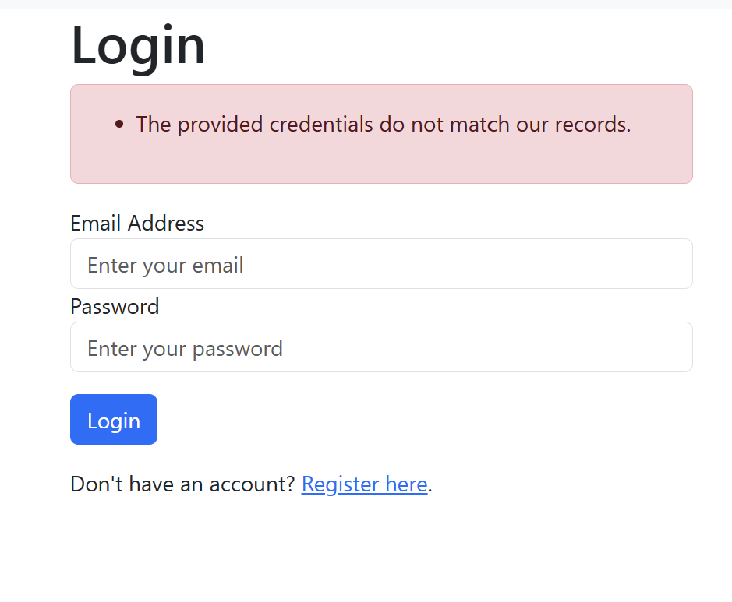

**Source Code:** Login source code

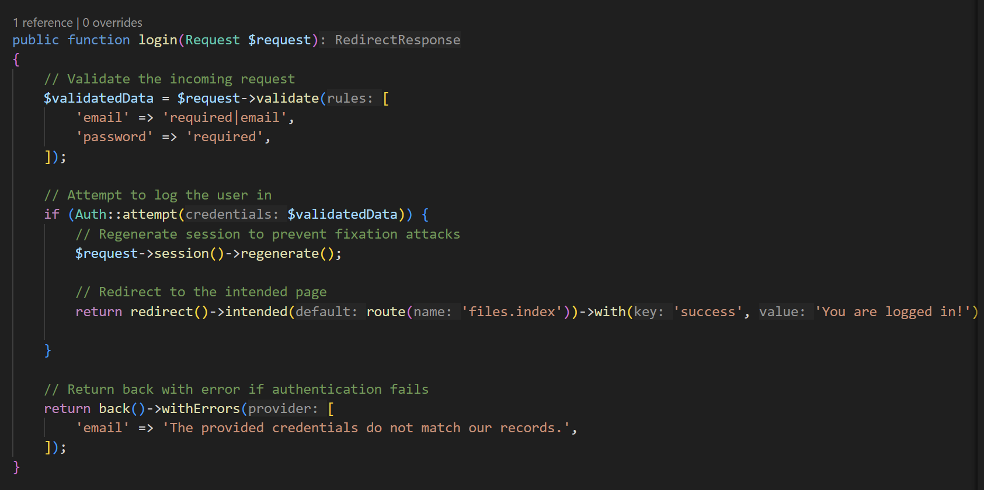

**Login timeout:** login timeout - 3 hours**.**

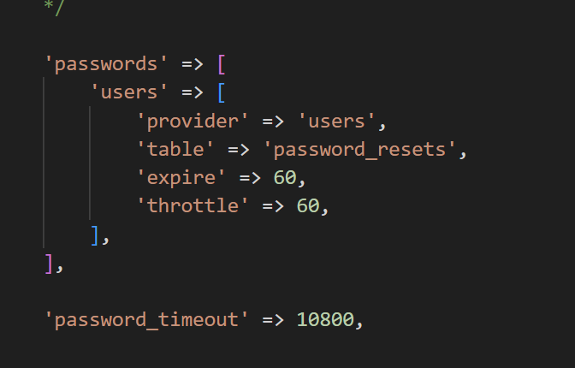

**Data List**: This is all record where we can add, delete and update data.

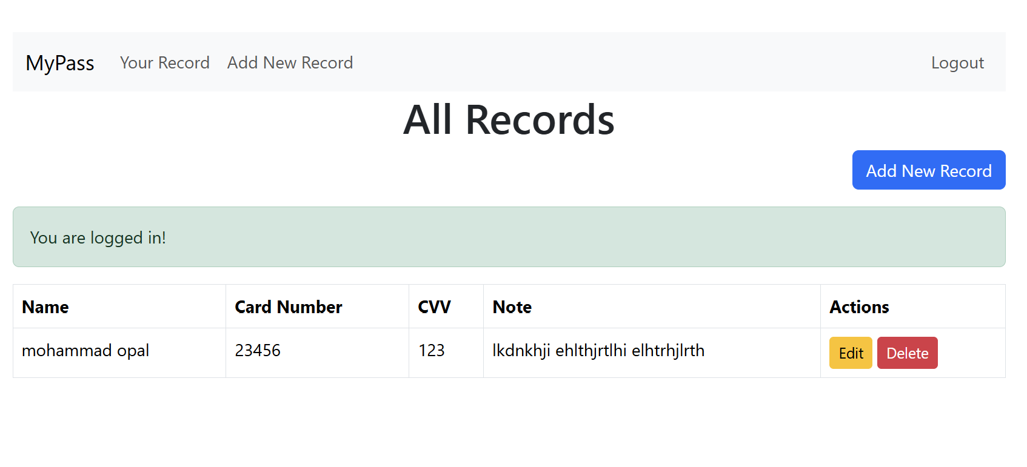

**Add Data**: This where we can add new data.

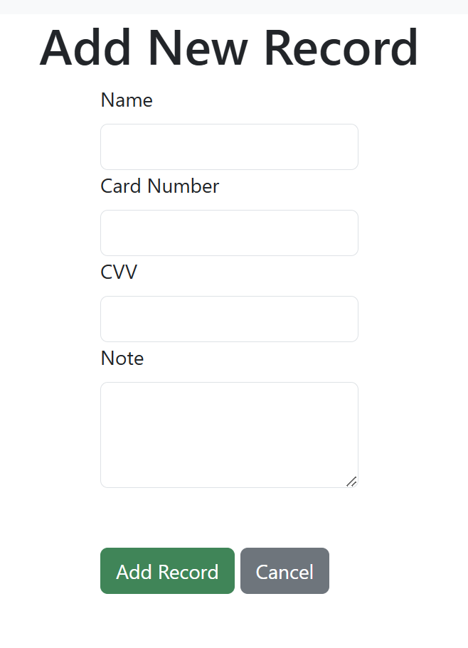

**Edit data:** Here we can edit record.

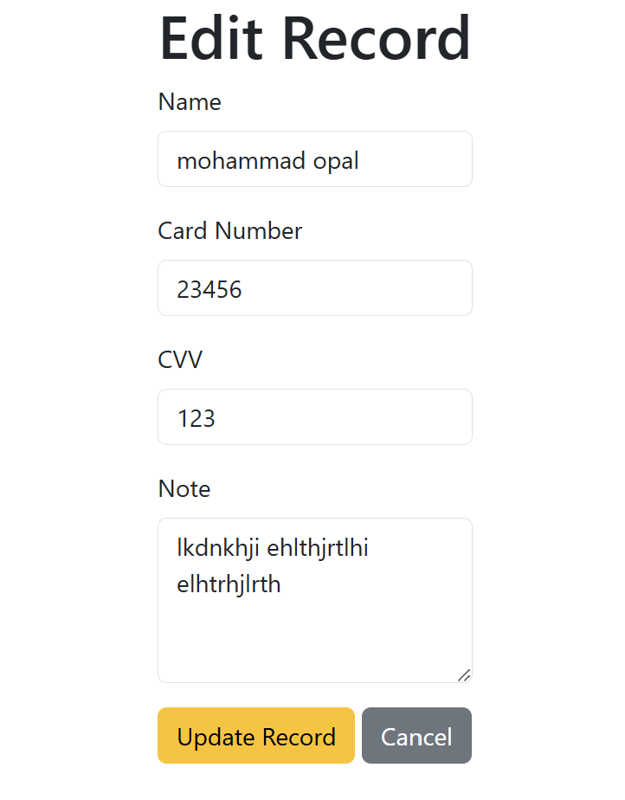

**Source code: Model Class:** Here it showing information which is used as a singleton pattern and for security purpose card number and CVV number is encrypted when it is saving and later on when it is showing to the user it is showing decrypted.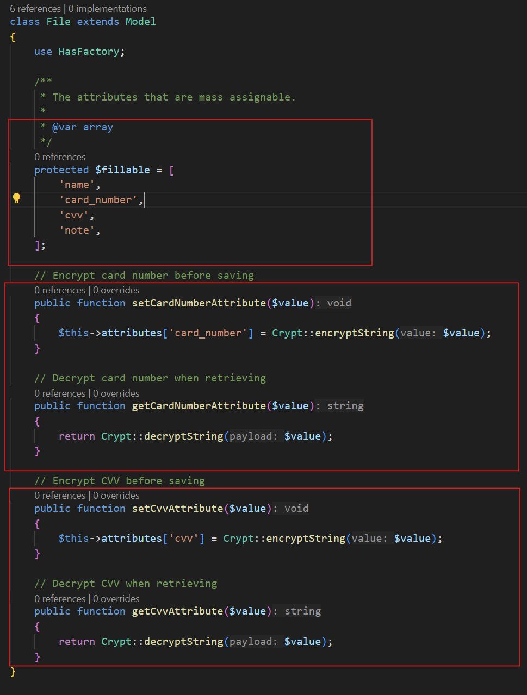

**Controller Class:** store update and delete function in the controller class.

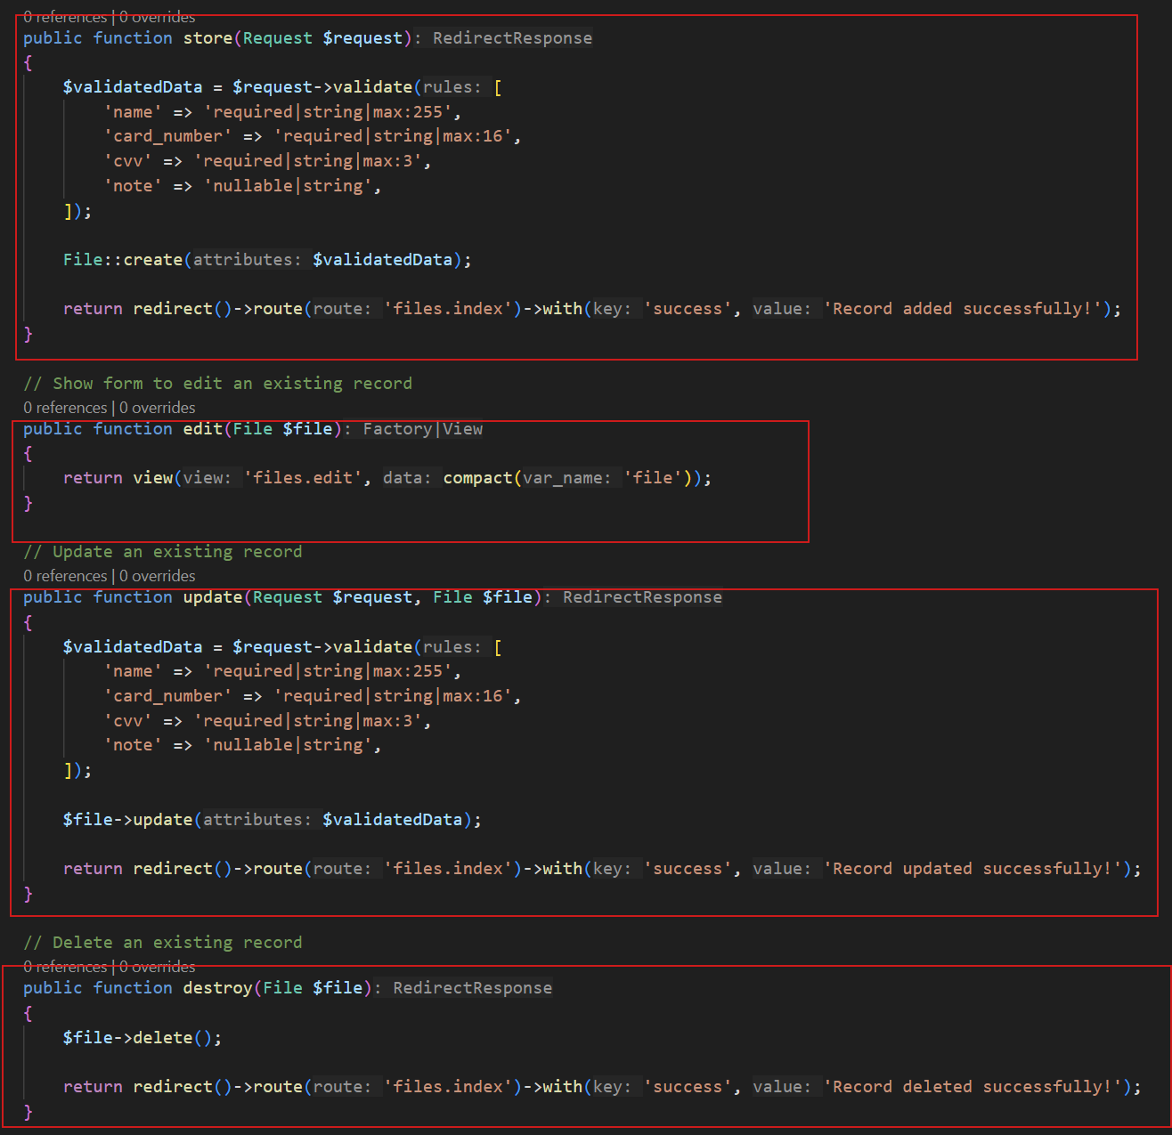

DB: File data table. Card number and CVV number Encrypt

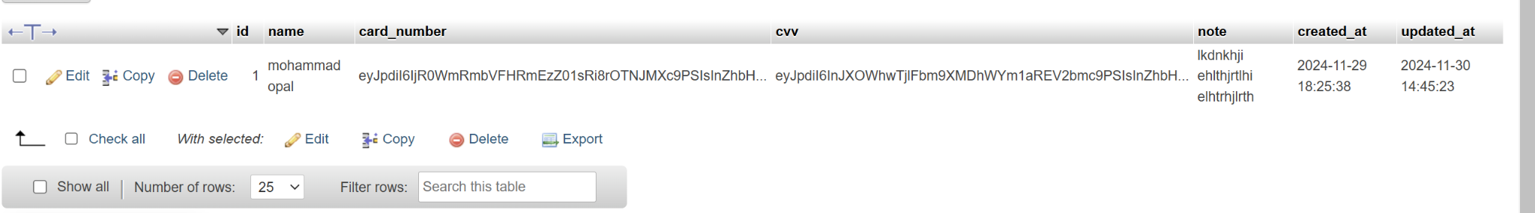

**Class Diagram:** This is my database tables class diagrams.

