Freight Rate Prediction - Approach and Validation

1. Summary
The final model is a hybrid: a robust linear model on log rate, with spline curves for distance, weight and the market signals, followed by LightGBM trained on the linear model's residuals. The linear stage's time trend is frozen at the last training day. On rolling monthly validation it has a mean absolute error of $48.8 one month ahead and $56.2 two months ahead, against $69.3 and $68.3 for plain LightGBM and $84.3 and $86.5 for a median rate-per-mile baseline (rows with plausible rates).

2. Data and quality issues
The labeled data has 48,000 loads from 2025-01-01 to 2025-10-31; the 12,000 loads to predict run from 2025-11-01 to 2025-12-31, strictly after it. There are no duplicate IDs or rows and no inconsistent category labels. The issues found, and how each was handled:
Issue | Train | Validation | Handling
missing weight | 300 | 165 | Filled with the equipment median from the training months only
negative weight | 292 | 145 | Absolute value taken (magnitudes look like valid weights) and flagged
capped weight | 1,204 | 301 | Kept, with a weight_is_capped flag
missing market index | 374 | 249 | Filled with the same-date median (within-day spread is ~0.025 vs ~0.17 across days)
distance over 1.5x haversine | 214 | 55 | Kept and flagged; most are short trips and their rates fit the stated distance
suspect rate | 646 | - | Kept; handled by a robust (Huber) loss. Rate per mile below $1 or above $5

City coordinates are consistent per city but do not match real geography, so they are treated as location codes. Eight validation cities and 736 validation lanes (1,461 rows) never appear in training, so the model combines lane and city information with general features (distance, equipment, weight, market signals) rather than relying on lane lookups. Distance dominates the rate (Spearman 0.98); after removing distance and equipment effects, the daily price level is explained by market_index, quote_signal and an upward trend of about 7% a year (R-squared 0.91 together, 0.48 for market_index alone).

3. Data split and validation approach
Because the prediction period follows the training data in time, a random split would leak future market conditions into training. Instead, validation uses expanding-window monthly folds: each fold trains on every month before the holdout month (Jan-Jun -> Jul, Jan-Jul -> Aug, Jan-Aug -> Sep, Jan-Sep -> Oct). A second set of folds leaves a one-month gap between training and holdout, matching the final task where December is two months past the last labeled date. Models are chosen on the fold average and the October fold, then retrained on all 48,000 loads.
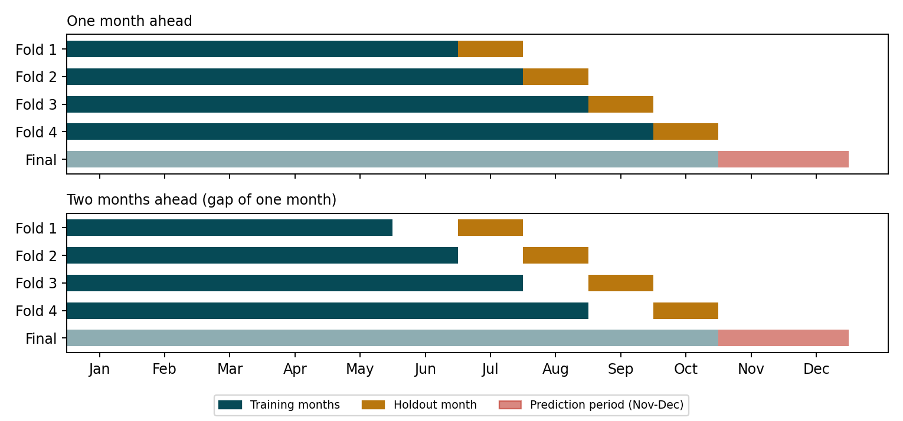
Everything learned from data (weight medians, lane and city encodings, frequency counts, spline knots) is fitted inside each fold's training months only; lane encodings for training rows are additionally computed out-of-fold. Errors are reported in dollars as MAE and RMSE, both on all holdout rows and on rows with plausible rates. The ~650 suspected corrupt rates sit in every holdout month and dominate RMSE (about $625-655 for every model), so model differences are judged mainly on the plausible-rate rows.

4. Models compared
Model | MAE 1 month ahead | MAE October | MAE 2 months ahead
Median rate per mile (equipment x distance band) | 84.3 | 79.2 | 86.5
LightGBM | 69.3 | 62.9 | 68.3
CatBoost | 71.9 | 68.5 | -
Robust linear model | 60.6 | 42.8 | -
Robust linear model with splines | 56.0 | 41.2 | -
Hybrid: linear + LightGBM on residuals | 55.3 | 34.0 | 75.3
Hybrid with splines | 50.9 | 34.3 | 64.2
Hybrid with splines, trend at half speed | 49.7 | 35.3 | 59.1
Hybrid with splines, trend frozen (final) | 48.8 | 36.7 | 56.2

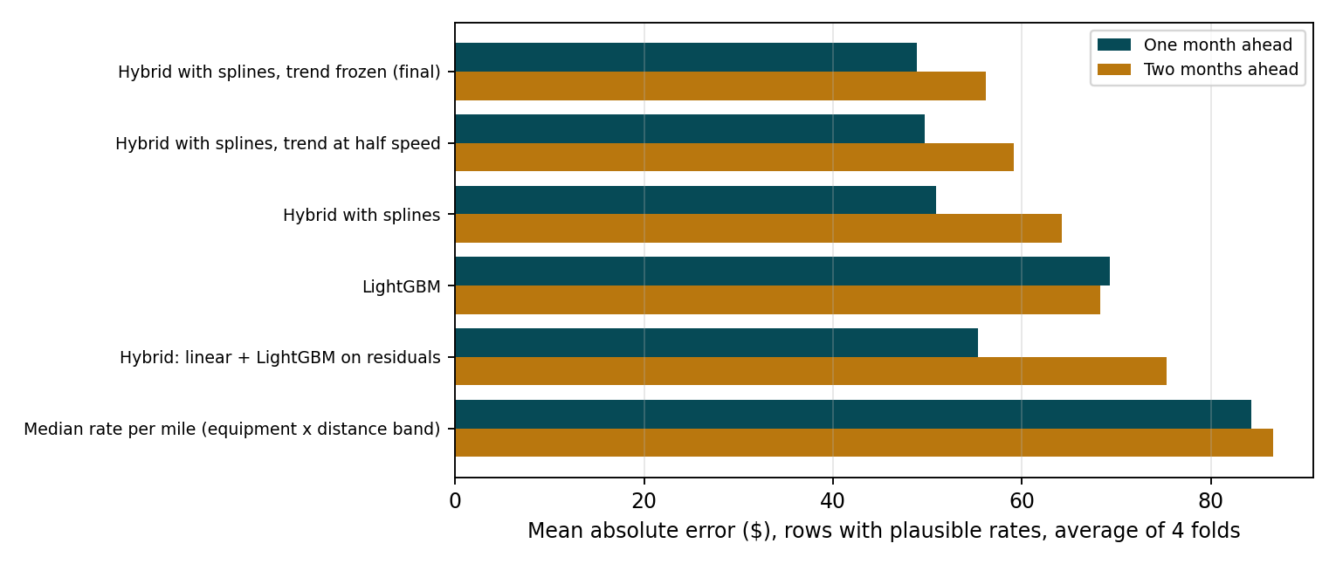
Pure tree models (LightGBM, CatBoost) cannot extend the price trend beyond their training dates and underpredict from August onward; the two libraries perform almost identically. A linear model follows the trend and already beats both. Fitting LightGBM on the linear model's residuals adds the non-linear distance, lane and interaction effects, and spline curves improve the linear stage further. Extending the trend is risky when the market turns: in the two-months-ahead August fold (trained on January-June) the full-trend hybrid keeps projecting the spring rise. Freezing the trend at the last training day removes most of that risk at a small cost in later months, and gives the best two-months-ahead result, so it was chosen.

5. Checks on the final model
Change to final model | MAE 1 month ahead | MAE 2 months ahead
None (final model) | 48.8 | 56.2
L1 loss in tree stage | 47.6 | 55.6
Squared (L2) loss in tree stage | 79.5 | 86.8
Exclude suspect rates from training | 48.7 | 55.2
Winsorise suspect rates | 49.2 | 56.7
No lane/city rate encodings | 48.9 | 55.7
No city categories | 51.5 | 56.2
No quote_signal | 55.5 | 74.1

A robust loss is essential: a squared loss in the tree stage is far worse. quote_signal looked weak in the data exploration but is important in combination with market_index. Excluding or winsorising suspect rates, L1 loss and dropping lane encodings all change the error by about $1, which is within the noise of four folds, so the final model keeps all rows and the default settings rather than deleting rows based on their target.

6. December chart
The December rows contain only lane, distance, equipment, weight and date. Coordinates come from the city lookup, and market_index and quote_signal are the same-date medians from validation.csv, which covers every December day. Predictions range from $830 to $848, inside the $780-$935 range of historical Dry Van loads on this lane, with a weekly cycle that follows market_index.
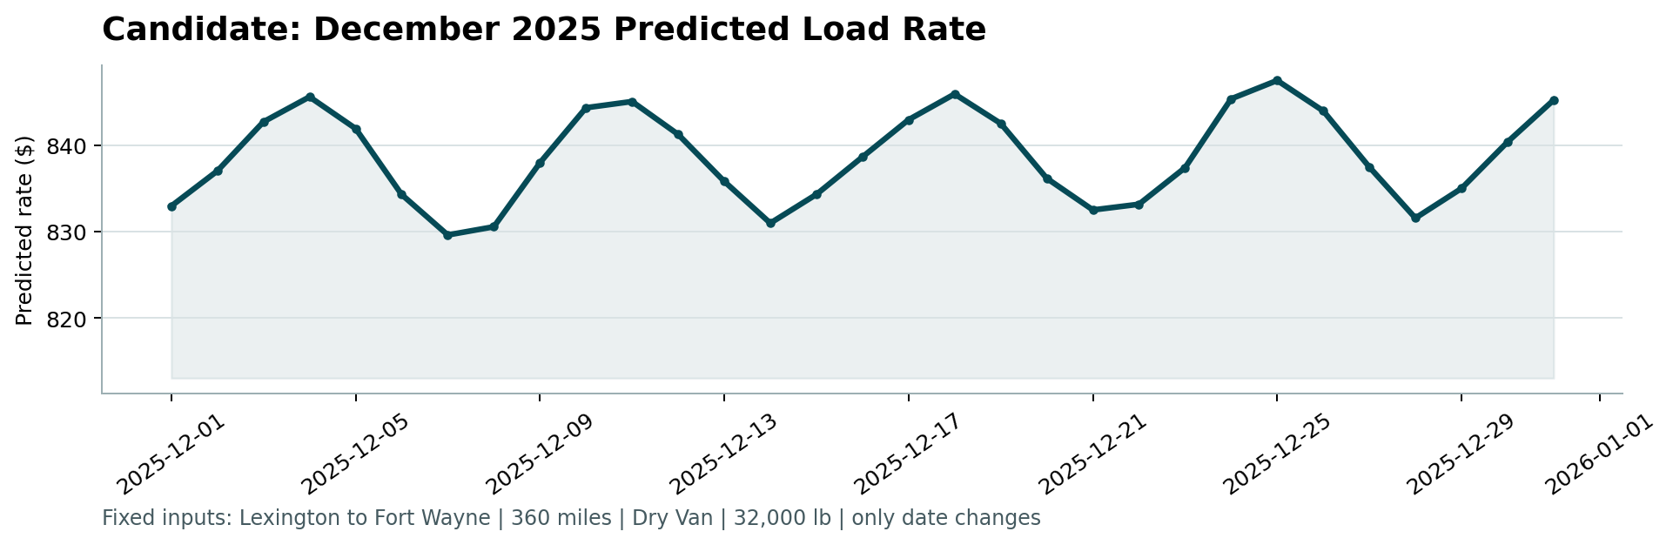

7. Limitations
- The training data has no Thanksgiving or Christmas periods, so the model has no holiday effect.
- Validation uses four monthly folds; differences of a dollar or two between setups are not meaningful.
- The frozen trend assumes prices hold their October level; a sustained rise in November-December would be underpredicted slightly.
- Suspected corrupt rates cannot be predicted, so any metric including similar rows in the scored set will be dominated by them.

