mohammadreza

Multimedia

HW2-object detection

محمدرضابابایی مصلح

in this report we are going to use and study some of the object detection and semantic segmentation algorithms.

Q1

In this question we are going to segments different farmland from each other you can see row photo below:

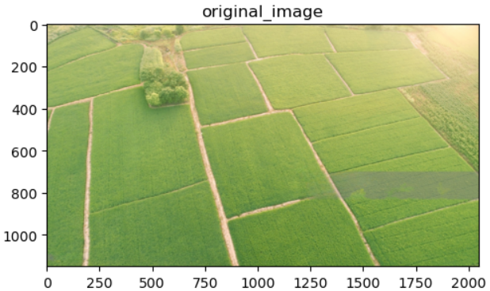

First of all we need to convert image to gray scale image:

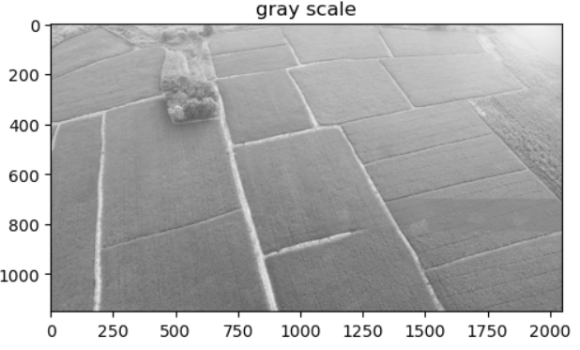

For the next step we have to convert image into binary form, for this task we used some different algorithms of edge detection to see their performance on image(we used some morphological algorithms too):

a) Bilateral filter:

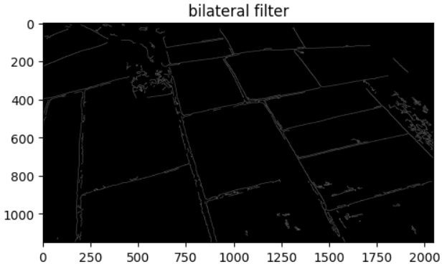

b) Adaptive thresholding:

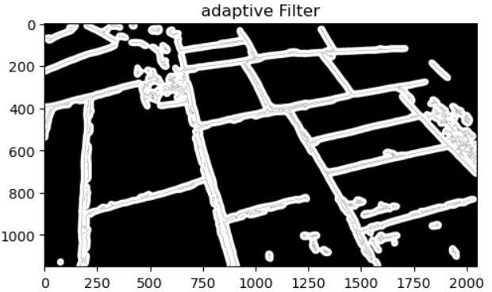

c) Dilated adaptive:

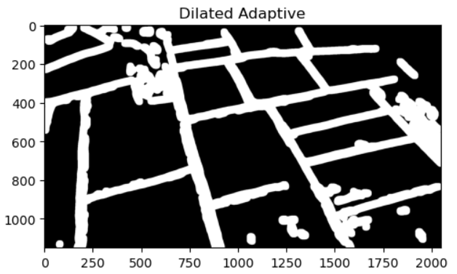

d) Sobel:

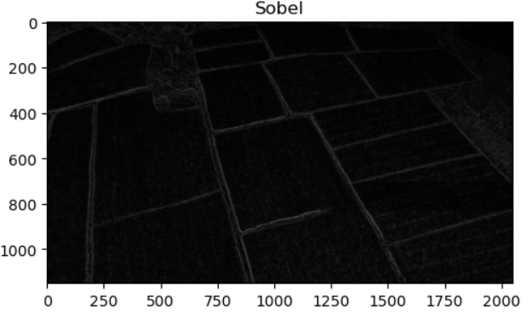

e) Bilateral after Sobel filter

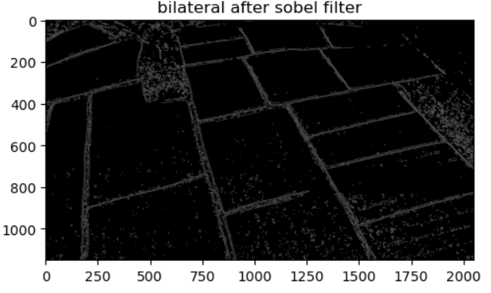

f) Delated Sobel:

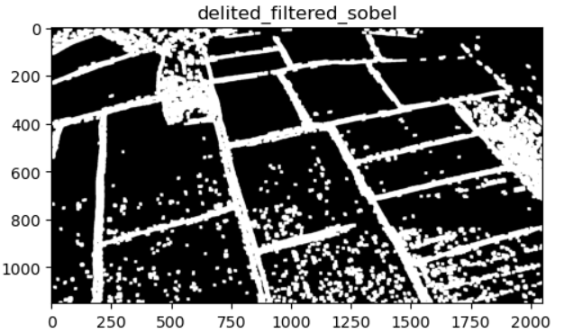

After that we tried finding contours using different binary forms and we found out best result comes with Delated_Sobel:

Then we drew contours:  
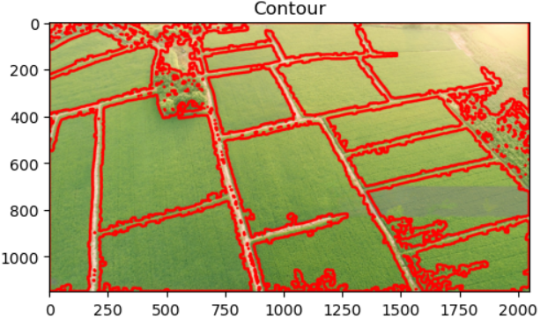

Then we sorted contours to sort farmland and this is the result(it worth mentioning that we used momentums to put numbers in center of mass of each farm):

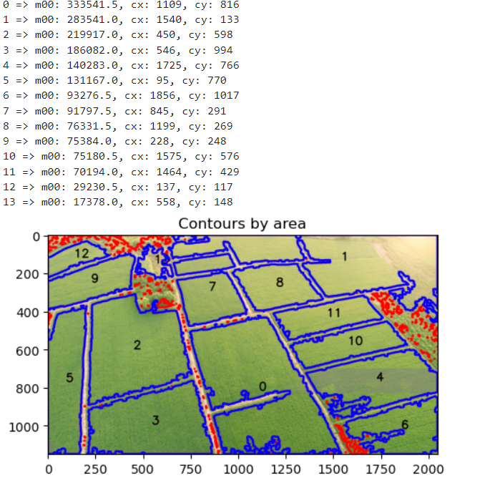

We can see that some farms are not been detected because of their wrong connection to other contours. But after all it works great.

Q2

In this question we want to find all the plans using template matching and a template of one of planes:

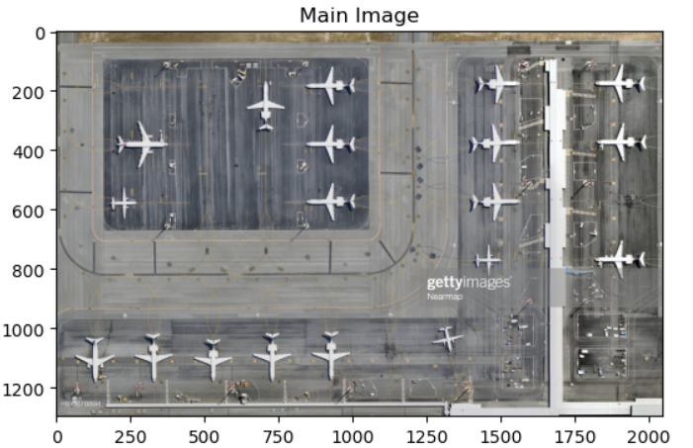

template

Then we turned it to gray-scale and using "cv2.TM_CCOEFF_NORMED" algorithm we found objects it worth mentioning that we rotated and resized template and reused it for finding different type of plans

The result is like below:

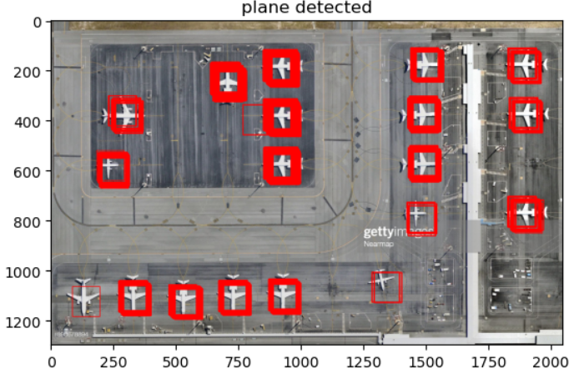

You can see that all planes are detected.

Q3

Just like Previous question we used template matching but with very high accuracy (threshold) this time

The main image is:

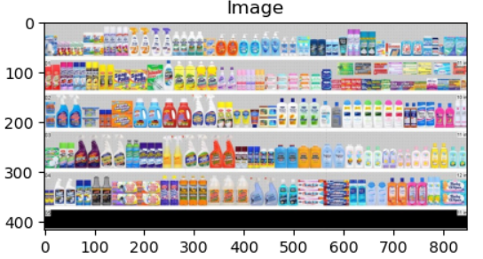

And here is the result that:

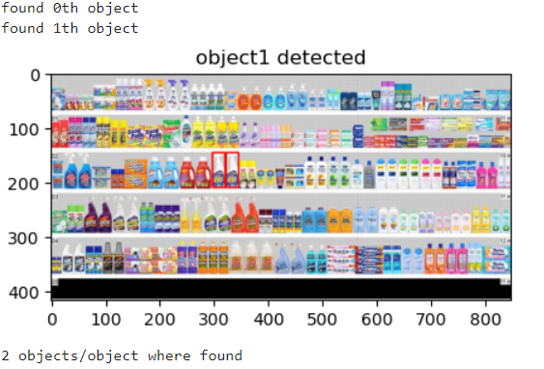

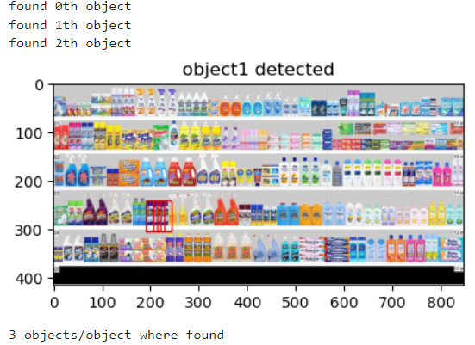

It can be seen that according to our codes the accuracy is mor e than 97 percent.

The End