**DAA-Lab**

**LAB - 2**

LQ1. Aim of the experiment : Write a program to find out which algorithm is faster for the following data. Estimate how many times it will be faster than the other two by step/frequency count method in each case. i. Find GCD of two numbers when both are very large i.e.GCD(31415, 14142) by applying each of the above algorithms. ii. Find GCD of two numbers when one of them can be very large i.e.GCD(56, 32566) or GCD(34218, 56) by applying each of the above algorithms. iii. Find GCD of two numbers when both are very small i.e.GCD(12,15) by applying each of the above algorithms. iv. Find GCD of two numbers when both are same i.e.GCD(31415, 31415) or GCD(12, 12) by applying each of the above algorithms.

CASE-1

**INPUT:**

Enter the two numbers: 31415, 14142

**OUTPUT:**

For EUCLID'S Algorithm. GCD is: 1

Total CPU Time in sec : 0.000010

CASE-2

**INPUT:**

Enter the two numbers: 56, 32566

**OUTPUT:**

For EUCLID'S Algorithm. GCD is: 2

Total CPU Time in sec : 0.000041

CASE-3

**INPUT:**

Enter the two numbers: 12, 15

**OUTPUT:**

For EUCLID'S Algorithm. GCD is: 3

Total CPU Time in sec : 0.000011

LQ2. Aim of the experiment : To test whether a number n, entered through keyboard is prime or not by using different algorithms you know for at least 10 inputs and note down the time complexity by step/frequency count method for each algorithm & for each input. Finally make a comparision of time complexities found for different inputs, plot an appropriate graph & decide which algorithm is faster.

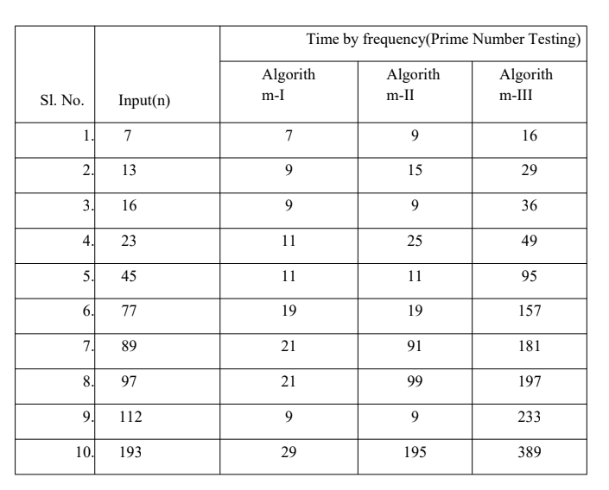

CASE-1

**INPUT:**

enter a number: 9.

**OUTPUT:**

9 is not a prime number

CASE-2

**INPUT:**

enter a number: 11.

**OUTPUT:**

11is a prime number

CASE-3

**INPUT:**

enter a number: 100.

**OUTPUT:**

100 is not a prime number