**DAA-Lab**

**LAB - 9**

LQ1. Aim of the experiment : To implement Disjoint-set forest Input : Refer to Graph A

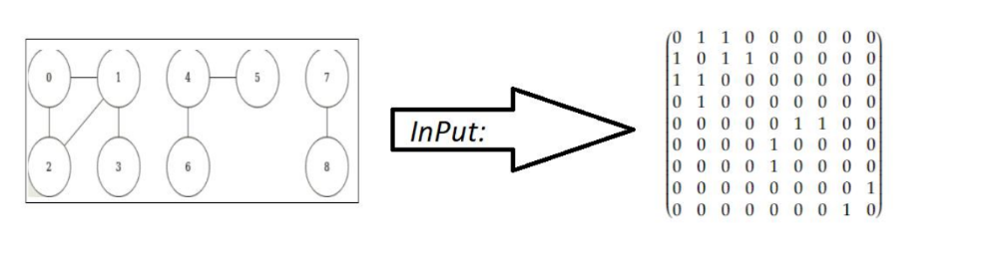

**INPUT:**

graph = { {0, 1, 1, 1, 1, 0, 0, 0, 0},

{1, 0, 0, 0, 0, 1, 0, 0, 0},

{1, 0, 0, 0, 0, 0, 0, 0, 0},

{1, 0, 0, 0, 0, 0, 1, 0, 0},

{1, 0, 0, 0, 0, 0, 0, 0, 0},

{0, 1, 0, 0, 0, 0, 0, 1, 0},

{0, 0, 0, 1, 0, 0, 0, 0, 1},

{0, 0, 0, 0, 0, 1, 0, 0, 0},

{0, 0, 0, 0, 0, 0, 1, 0, 0}

};

**OUTPUT:**

Connected Components:

0 1 2 3

4 5 6

7 8

LQ2. Aim of the experiment : To implement BFS and DFS. Input : Refer to Graph :

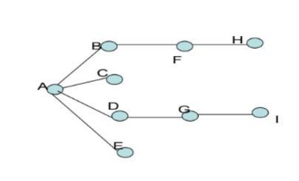

**INPUT:**

graph = { {0, 1, 1, 1, 1, 0, 0, 0, 0},

{1, 0, 0, 0, 0, 1, 0, 0, 0},

{1, 0, 0, 0, 0, 0, 0, 0, 0},

{1, 0, 0, 0, 0, 0, 1, 0, 0},

{1, 0, 0, 0, 0, 0, 0, 0, 0},

{0, 1, 0, 0, 0, 0, 0, 1, 0},

{0, 0, 0, 1, 0, 0, 0, 0, 1},

{0, 0, 0, 0, 0, 1, 0, 0, 0},

{0, 0, 0, 0, 0, 0, 1, 0, 0}};

**OUTPUT:**

DFS: A B F H C D G I E

BFS: A B C D E F G H I