Prog9.

Assest strore se->easystart

4-5 cube ( ontrig duplicate)

Plane

Legacy (ui->legacy) text 2 baar ek naam Time ek ka naam Score

Cubecollectorscript har cube pe daalo

Empty object named GameManager

GameManager ke andar GameNaam ki script

GameManager me jaake Time ko Time. Score ko Score

Main Camera ko thirdperson controller me daalo.

Pro8

Import unity chan freefab

Delete all its components

Add two components ( video player and audio source)

Import video file in assests and drag it to video clip of video player

In render mode select camara far play and drag the main camara into camara

In audio source select any audio using the side button

Disable play on awakein both audio and video

Click on unity chanin hirachy press window animation->animation press create and save the location and remember the name

Scale 1 is important and then start recoding move her at each second by 1

Stop recording

Goto project now we can see New Animation and A Controller

Double click on controller add new state make it default remember the connections

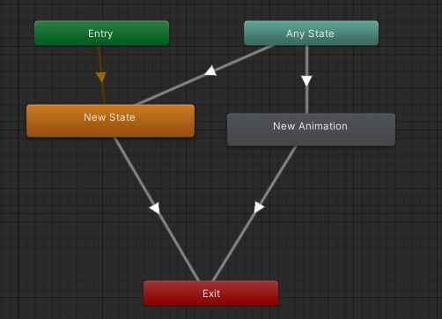

Save it (clt+s)

In hireachy right click UI->button text meshpro ( import both librieas)

Create a script uchan copy the code in code change new animation and class name

Drag the uchan to button ( script)

Select button and in uchan script add Animator Play button sound Player

Run happy happy happy

Program 7

Create a 3d projct and import ZIL military truck prefab in hierarchy

Download vehicle essential form asset store and import it

Open Vuforia developer portal login

Left click import package custom package and import two downloaded packages

Right click on hierarchy AR camera

Right click hierarchy Vuforia engine image target

AR camera open Vuforia engine confg add license

Open image target in type select from database select sammyl

Delete main camera

And make truck prefab child of image target

Click on truck in hierarchy -> window -> sequencing ->timeline

In plus add animation track and audio track

In animation track :

Create timeline and save….In time line move the truck every one second and do it for 5 seconds

Add audio source and duplicate for each second

Run be happy