

NAME : MOHAMMAD SHAIK BASHA

REG NO : 192111459

COURSE CODE : CSA1190

COURSE NAME : OBJECT ORIENTED ANALYSIS AND DESIGN

EXPERIMENT-1:

AIM:-To implement UML diagrams for passport management system..

DESIGN:-

1.USE CASE:

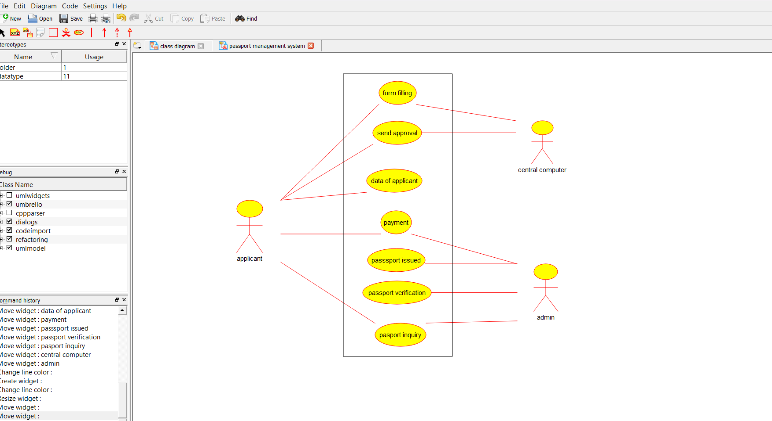

2.CLASS DIAGRAM:-

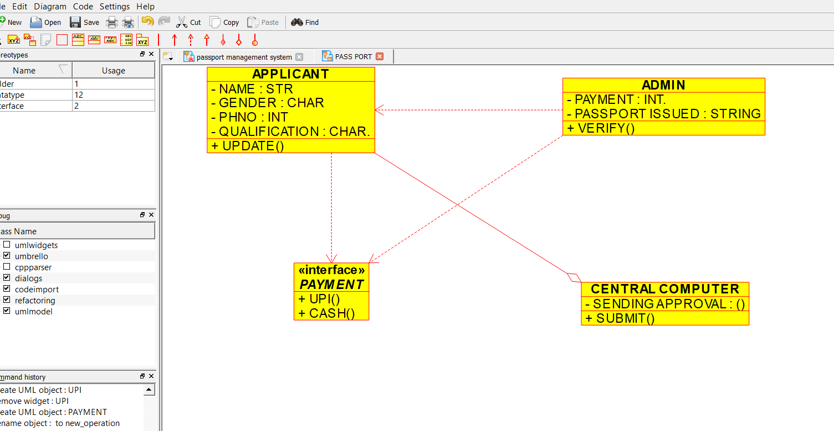

SEQUENCE DIAGRAM:-

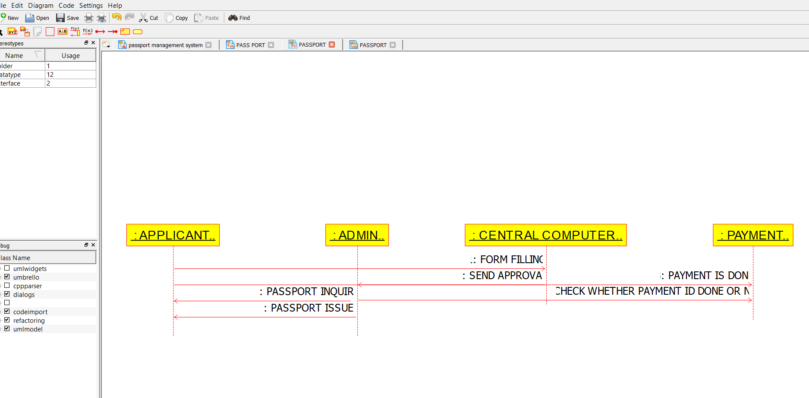

PACKAGE DIAGRAM:-

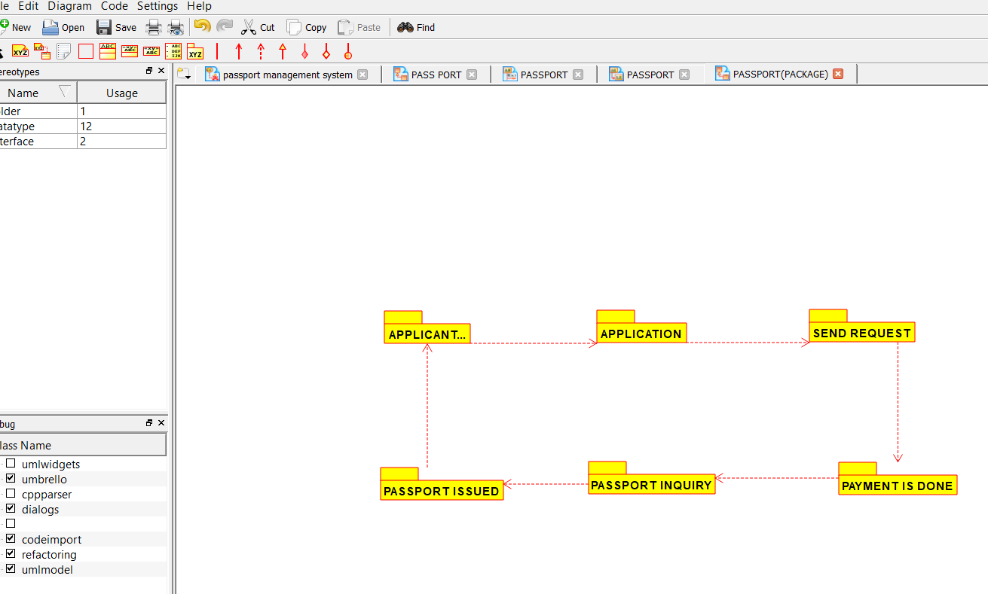

EXPERIMENT-2:

AIM:-To implement UML diagrams for BANK BOOK PROCESS ..

DESIGN:-

1.USE CASE:

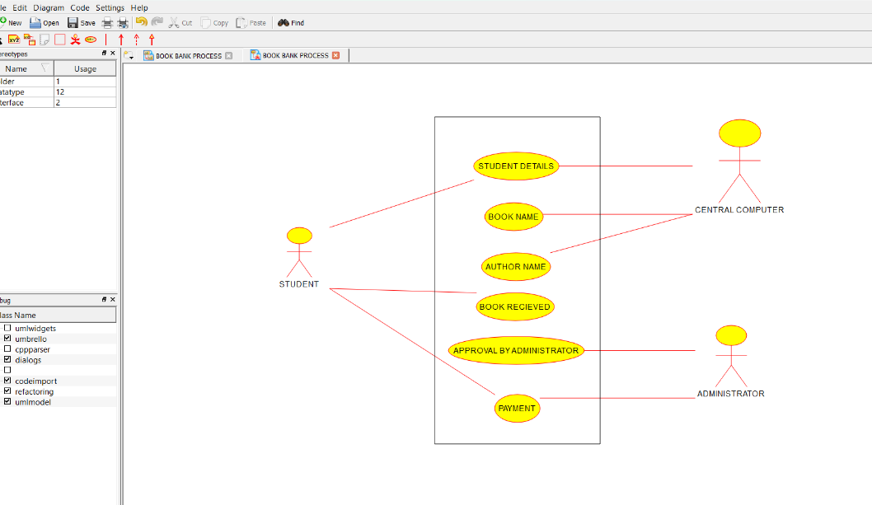

2.COLLABORATION DIAGRAM:-

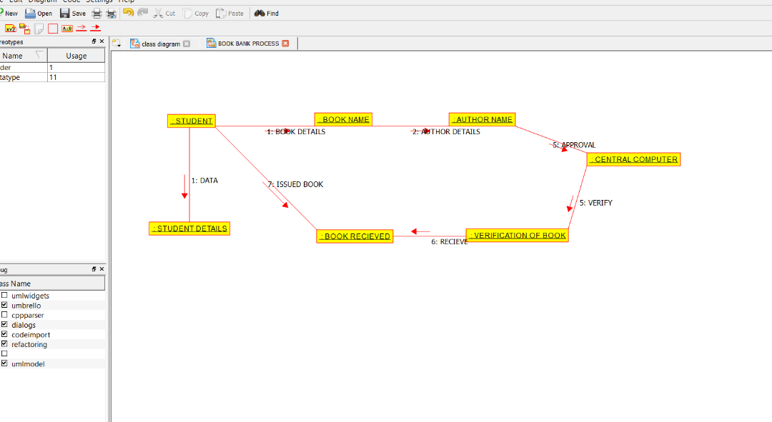

3.DEPLOYMENT DIAGRAM:-

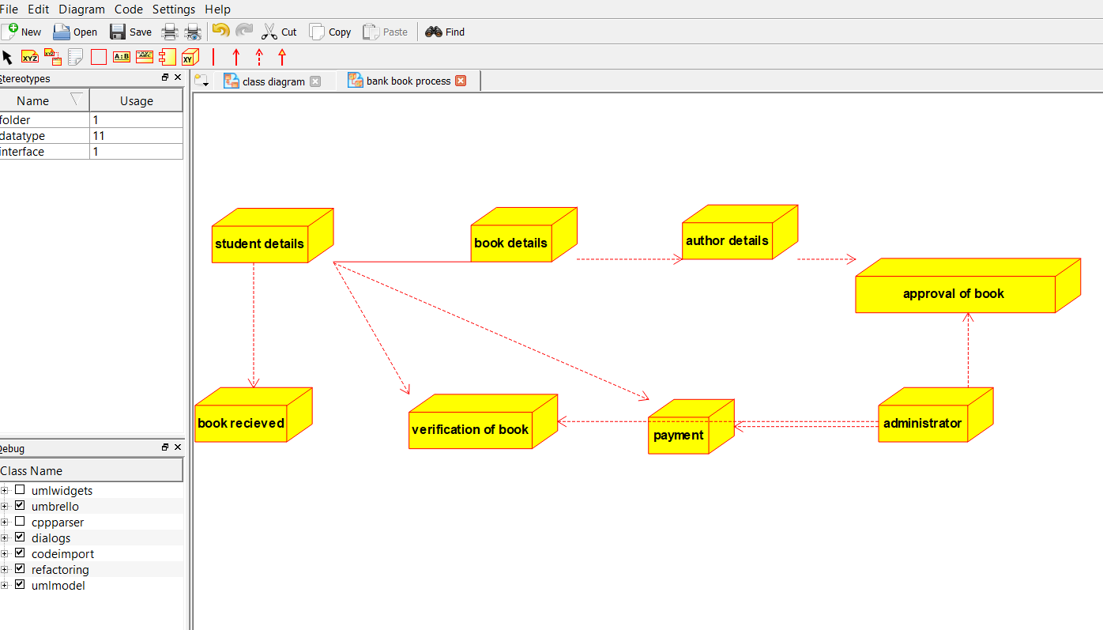

EXPERIMENT-3:

AIM:-To implement UML diagrams for EXAM REGISTRATION PORTAL…

DESIGN:-

1.COMPONENT DIAGRAM:

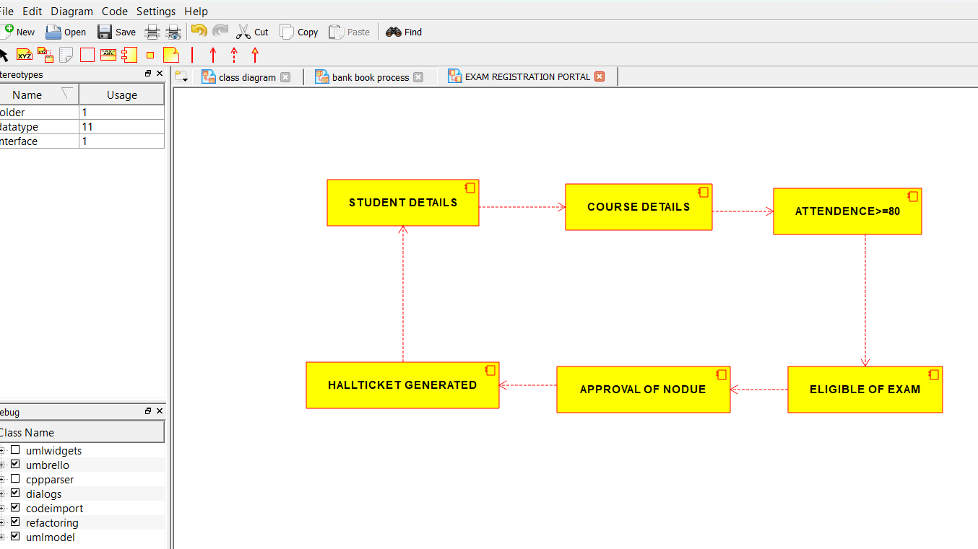

2.PACKAGE DIAGRAM:-

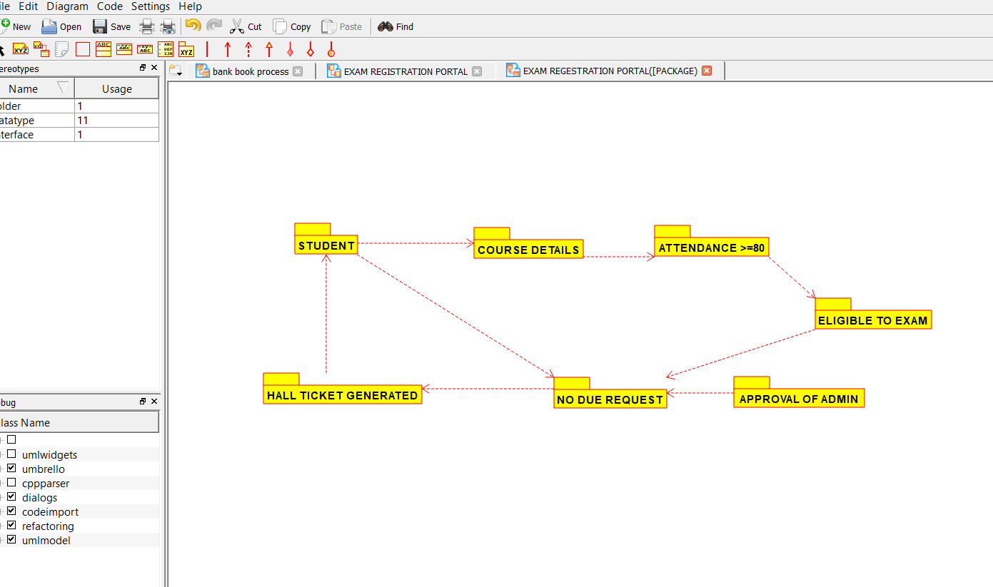

3.USECASE DIAGRAM:-

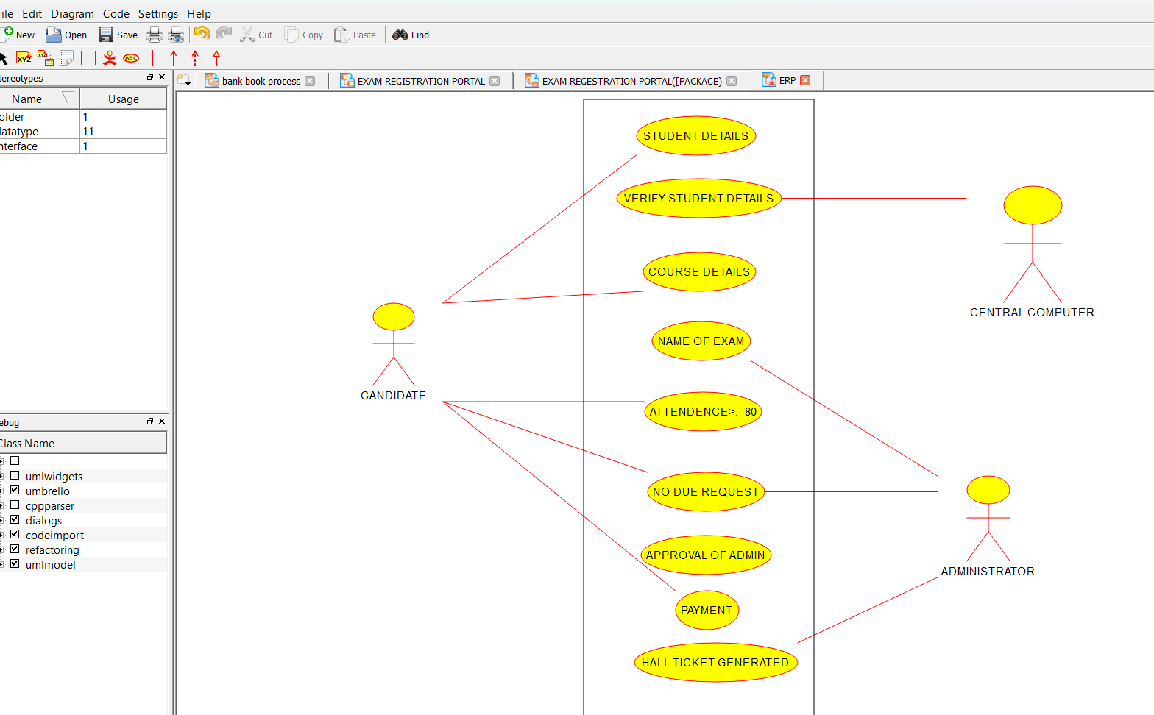

EXPERIMENT-4:

AIM:-To implement UML diagrams for STOCK MAINTAINANCE SYSTEM…

DESIGN:-

1.STATECHART DIAGRAM:-

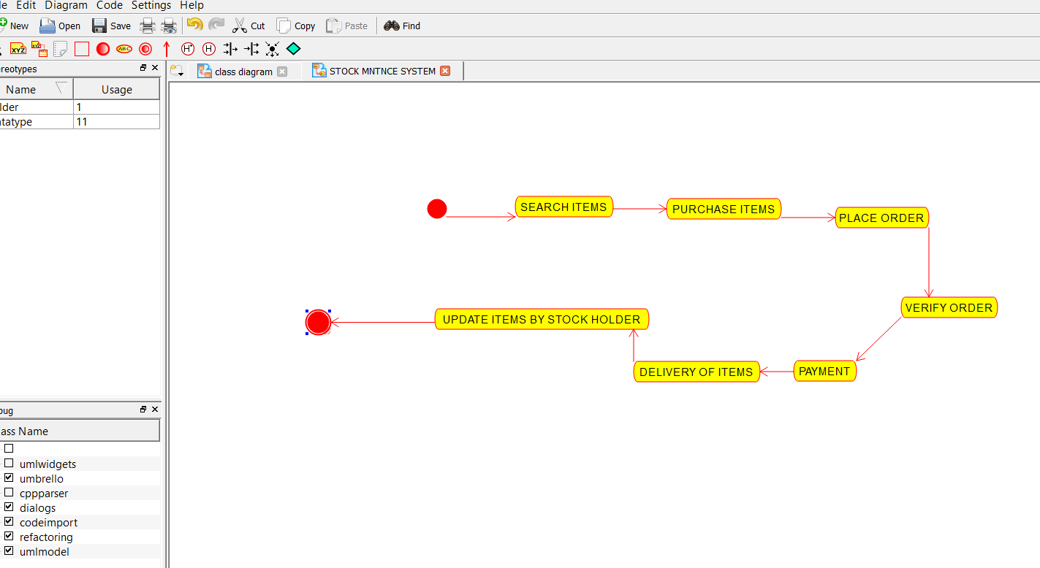

2.DEPLOYMENT DIAGRAM:-

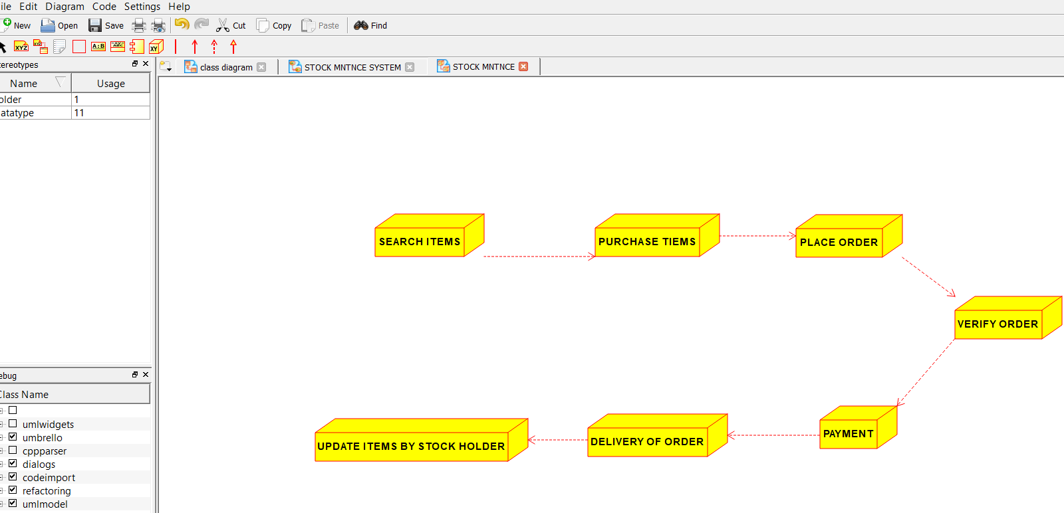

3.PACKAGE DIAGRAM:-

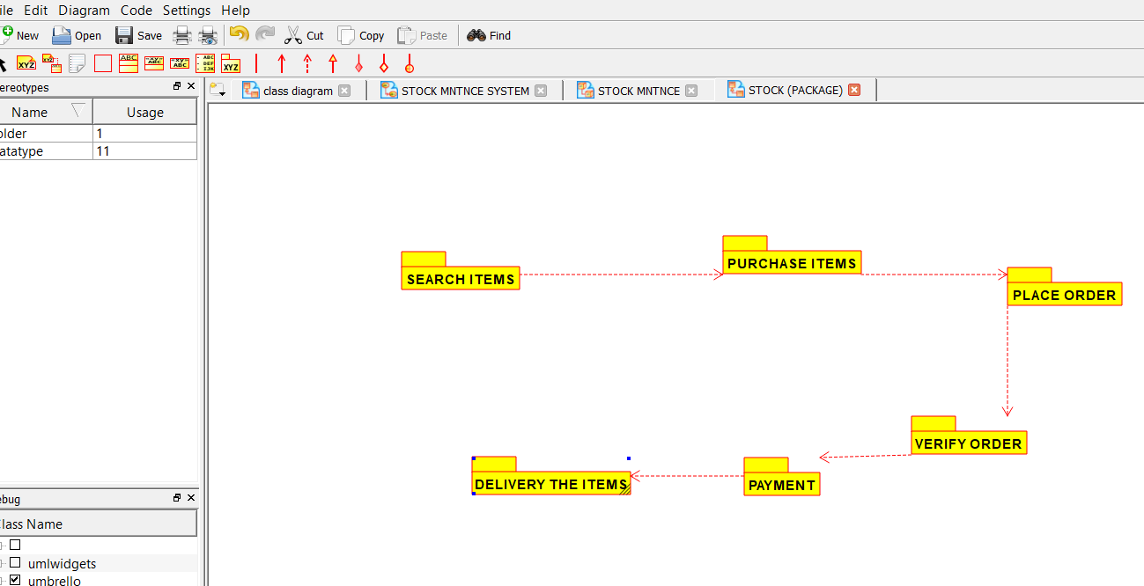

EXPERIMENT-5:

AIM:-To implement UML diagrams for ONLINE COURSE RESERVATION SYSTEM…

**DESIGN:-**

1.COLLABORATION DIAGRAM:-

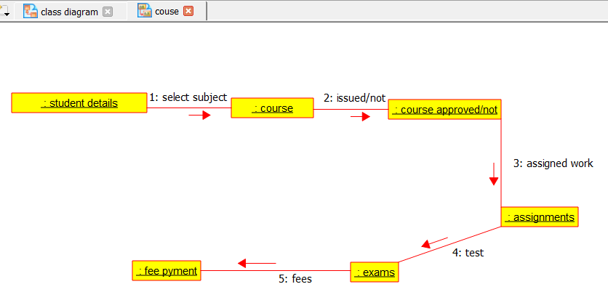

2.USECASE DIAGRAM:-

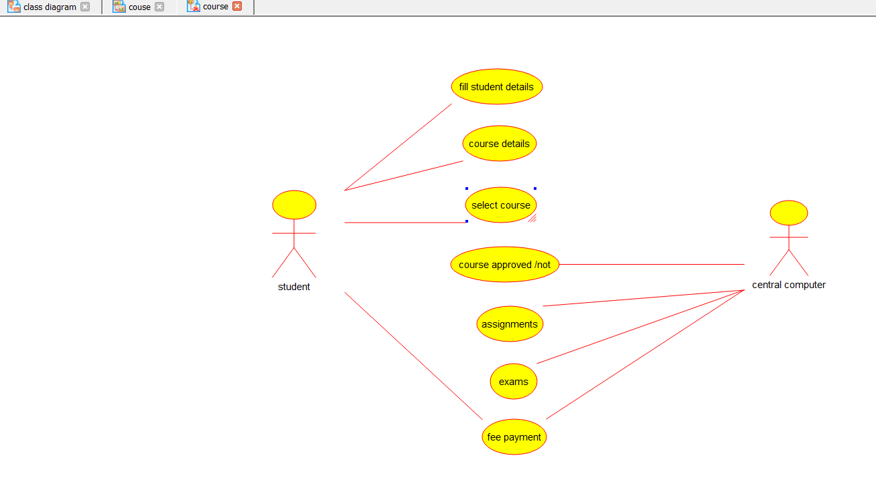

EXPERIMENT-6:

AIM:-To implement UML diagrams for E-TICKETING SYSTEM…

DESIGN:-

1.ACTIVITY DIAGRAM:-

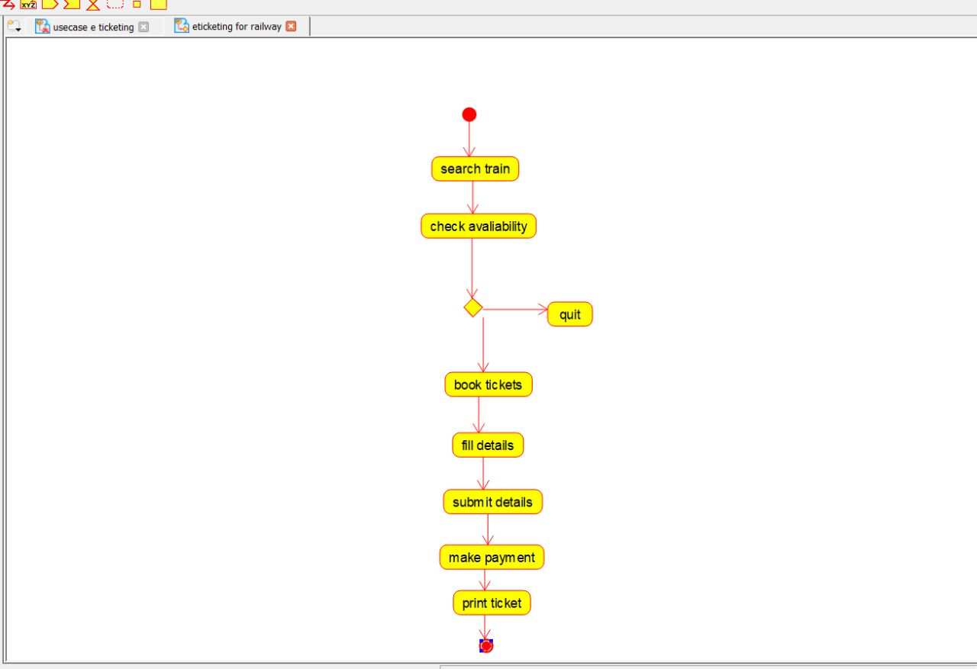

2.USECASE DIAGRAM:-

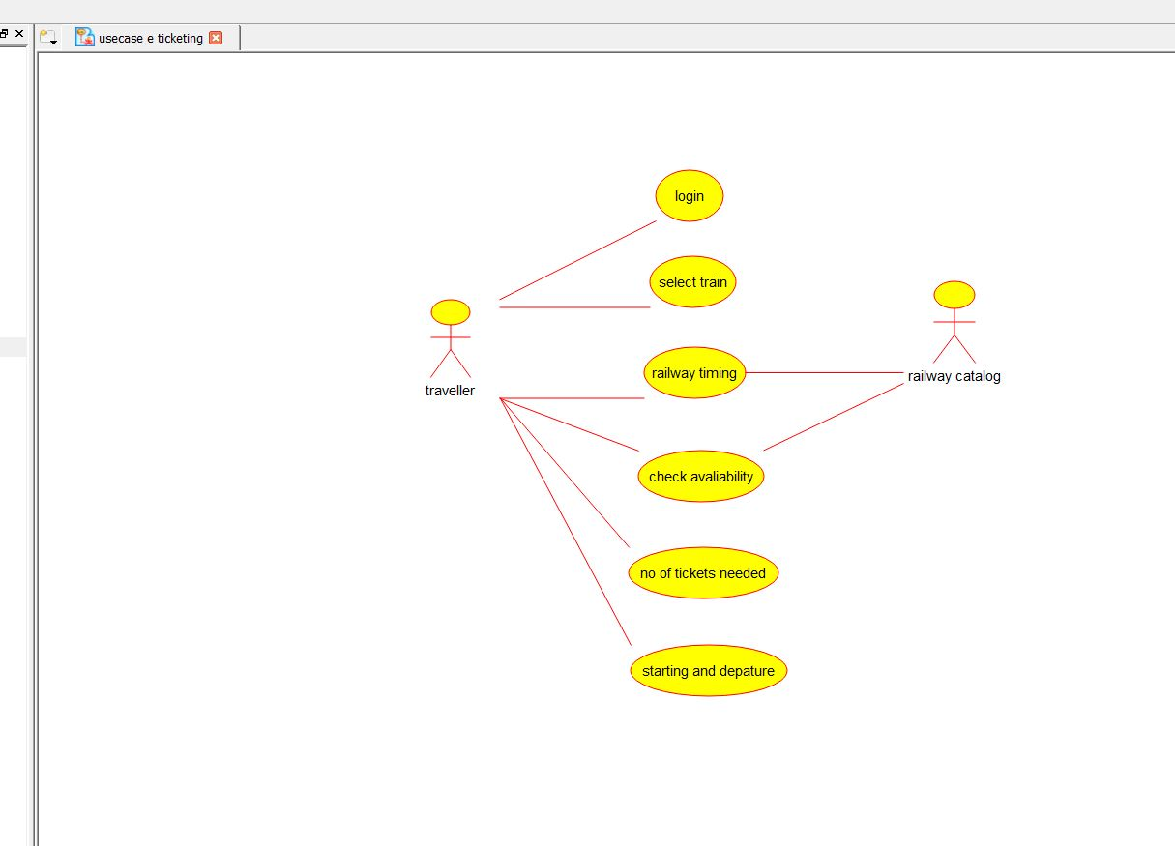

3.COMPONENT DIAGRAM:-

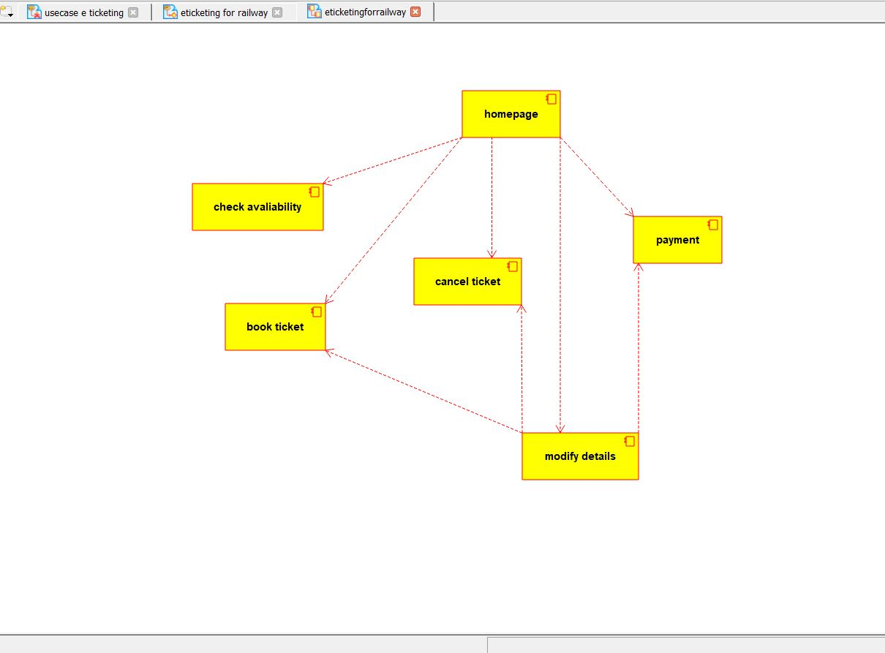

EXPERIMENT-7:

7.AIM:-To implement UML diagrams for CREDIT CARD PROCESSING SYSTEM…

DESIGN:-

1.ACTIVITY DIAGRAM:-

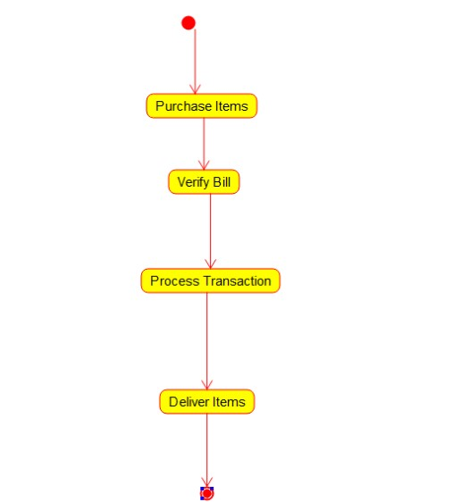

2.CLASS DIAGRAM:-

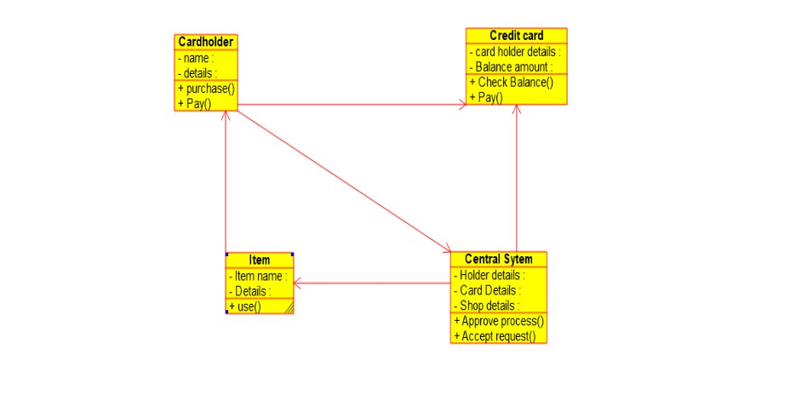

3.COMPONENT DIAGRAM:-

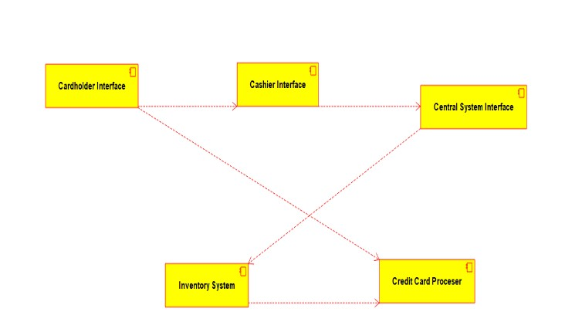

EXPERIMENT-8:

AIM:-To implement UML diagrams for Software Personnel Management SYSTEM…

DESIGN:-

1.COLLABORATION DIAGRAM:-

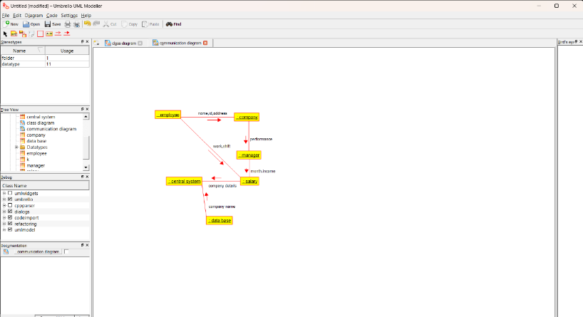

2.COMPONENT DIAGRAM:-

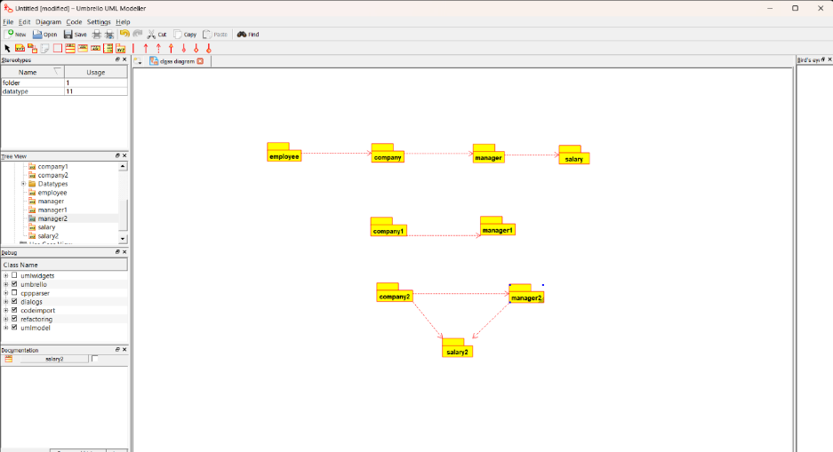

3.USECASE DIAGRAM:-

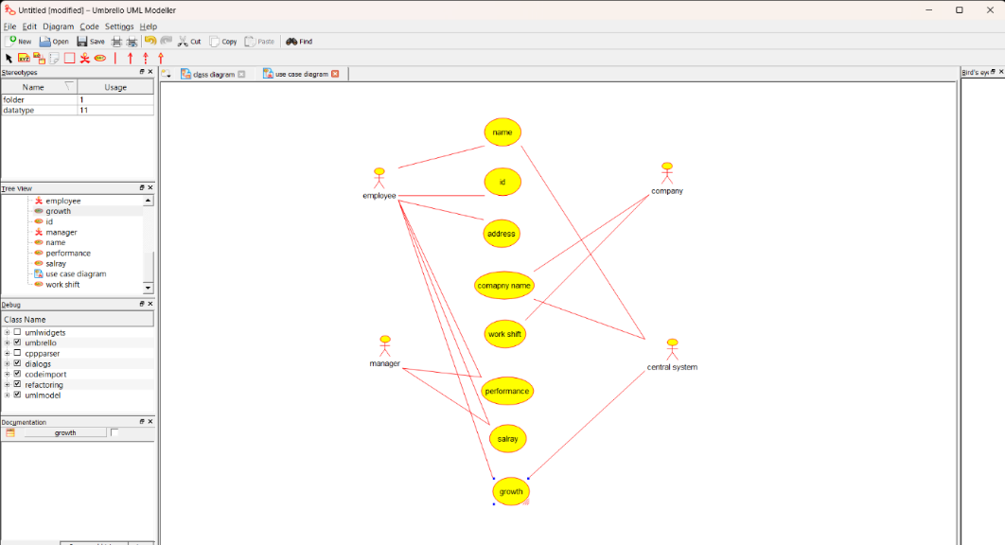

EXPERIMENT-9:

AIM:-To implement UML diagrams for E-BOOK MANAGEMENT SYSTEM…

DESIGN:-

1.USECASE DIAGRAM:-

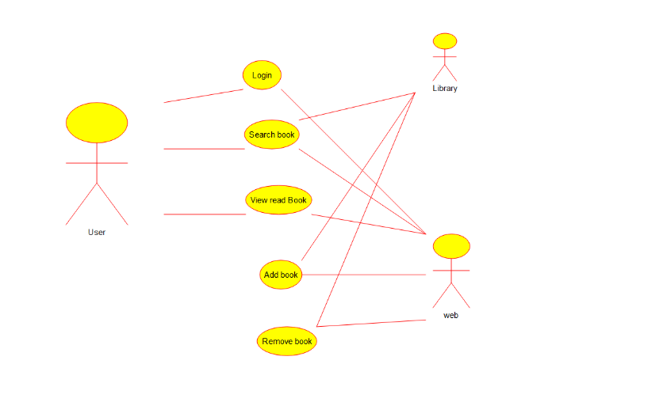

2.CLASS DIAGRAM:-

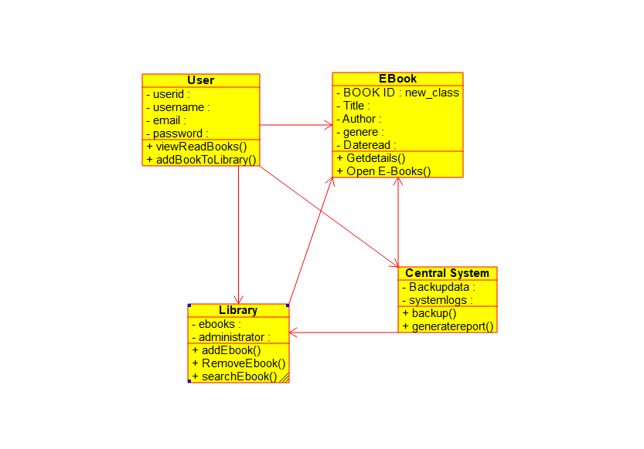

3.ACTIVITY DIAGRAM:-

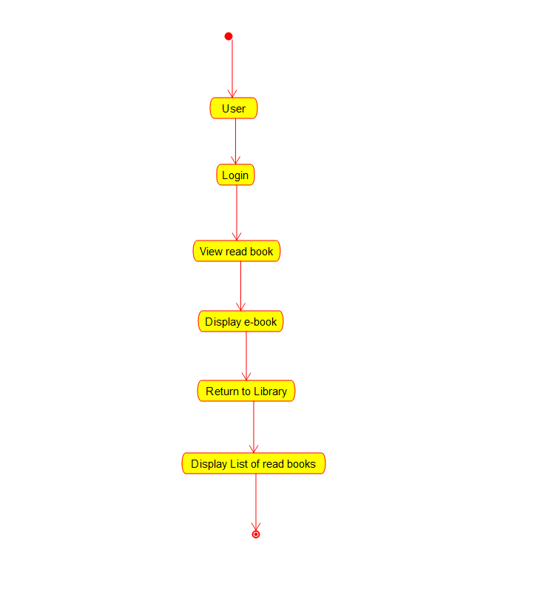

EXPERIMENT-10:

AIM:-To implement UML diagrams for SYSTEM…

DESIGN:-

1.PAKAGE DIAGRAM:-

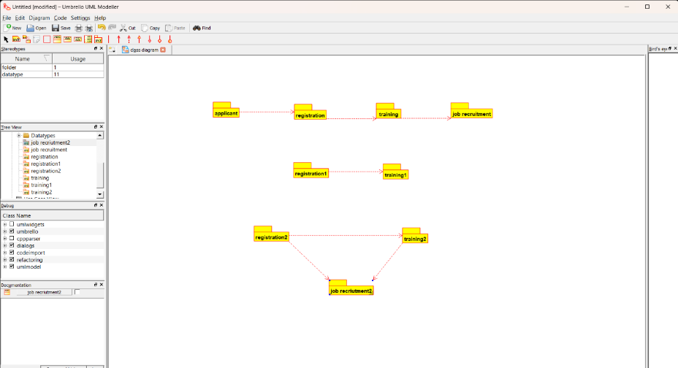

2.DEPLOYMENT DIAGRAM:-

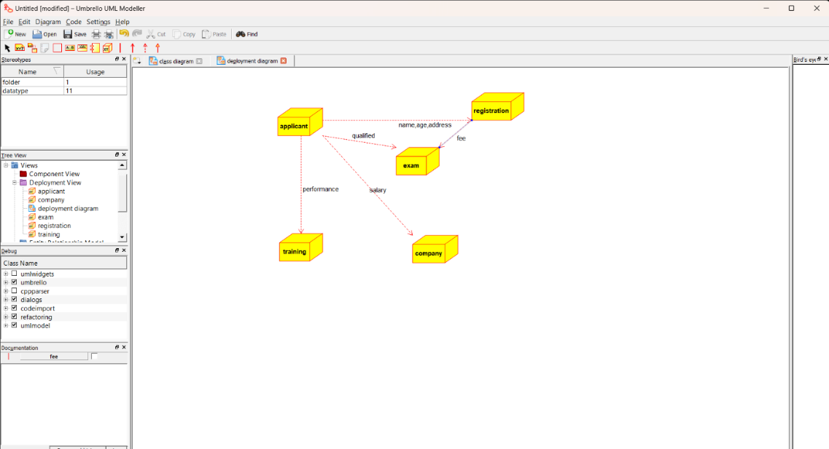

3.COMPONENT DIAGRAM:-

