

NAME : MOHAMMAD SHAIK BASHA

REG NO : 192111459

COURSE CODE : CSA1190

COURSE NAME : OBJECT ORIENTED ANALYSIS AND DESIGN

EXPERIMENT-11:

AIM:-To implement UML diagrams for Conference management system

DESIGN:-

1.USE CASE:

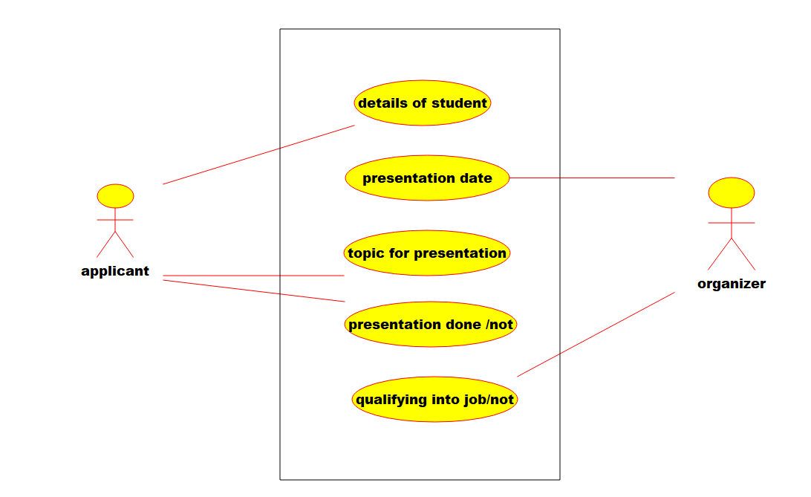

2.Deployment diagram:-

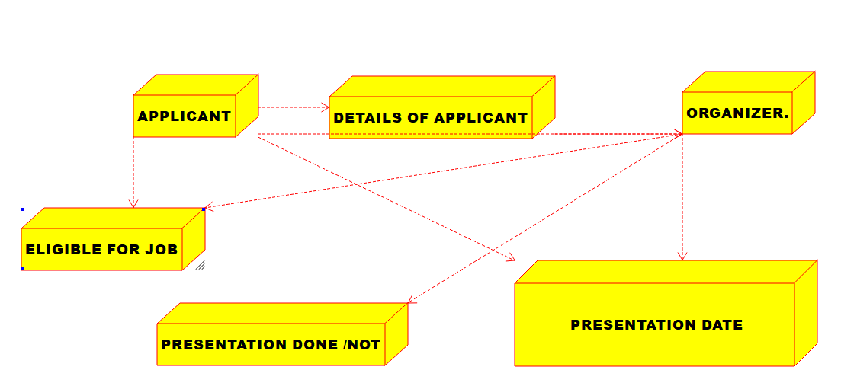

3.PACAKAGE DIAGRAM.:-

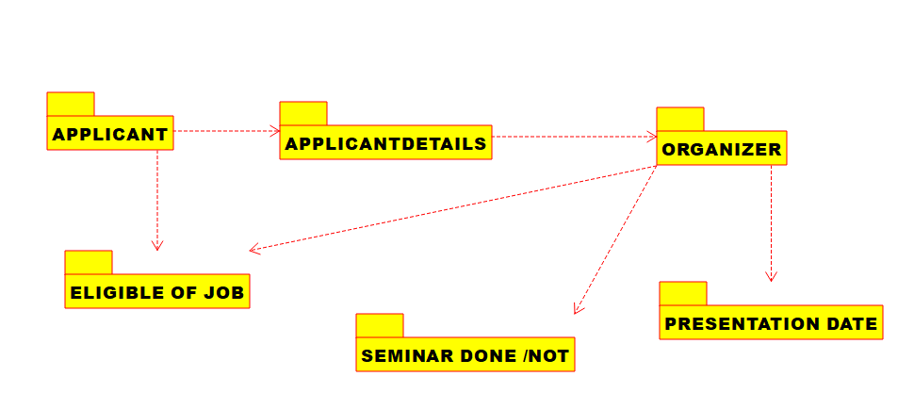

EXPERIMENT-12:

AIM:-To implement UML diagrams for Foreign Trading System

DESIGN:-

1.SEQUENCE DIAGRAM:

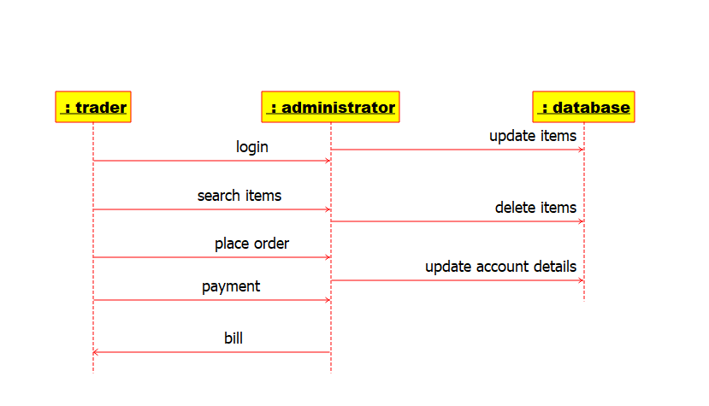

2.ACTIVITY DIAGRAM:-

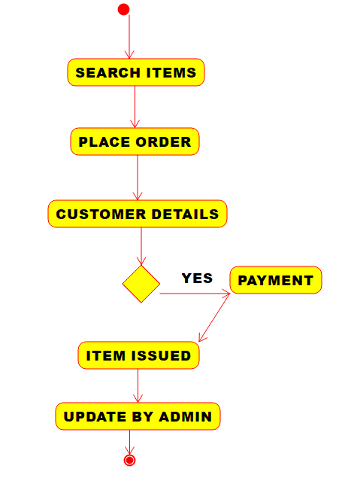

3.COMPONENT DIAGRAM:-

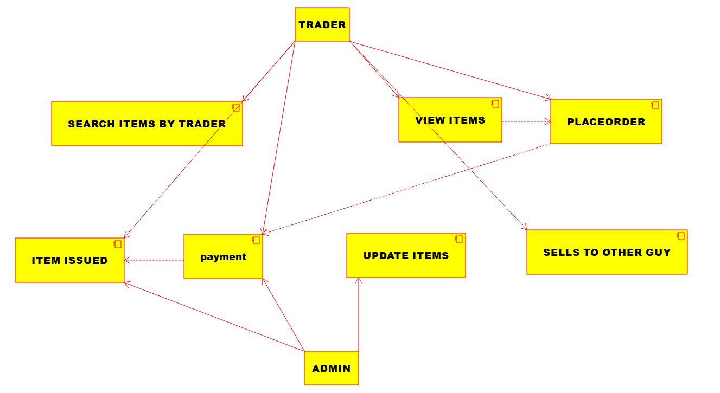

EXPERIMENT-13:

AIM:-To implement UML diagrams for BPO Management System

DESIGN:-

1.ACTIVITY DIAGRAM:-

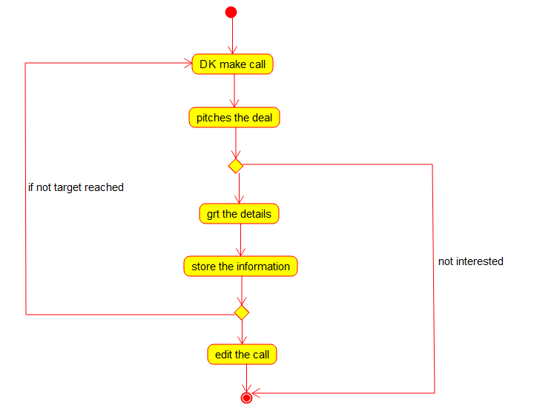

2.STATECHART DIAGRAM:-

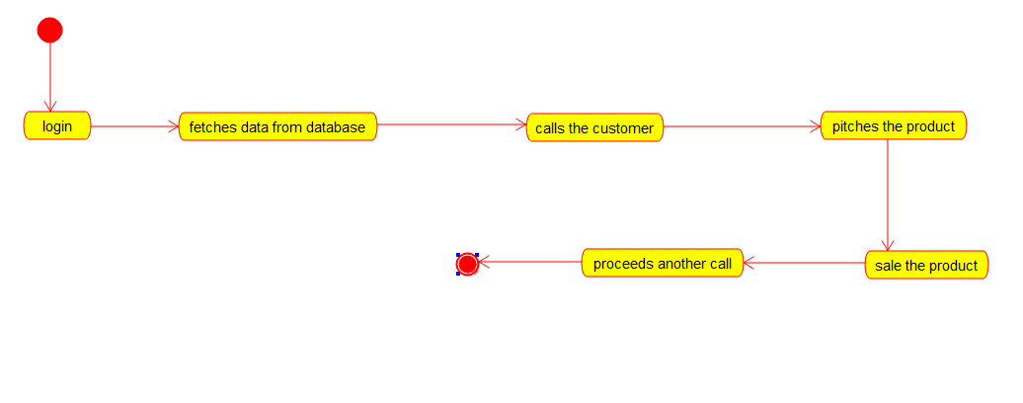

3.CLASS DIAGRAM:

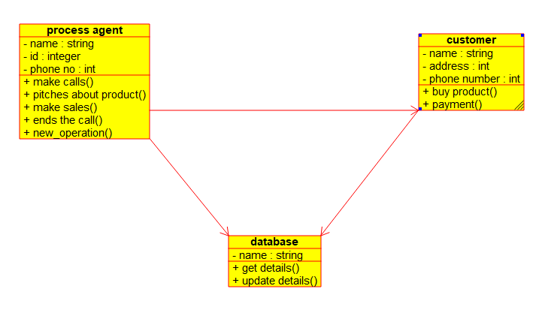

EXPERIMENT-14:

AIM:-To implement UML diagrams for E-Commerce Registration

DESIGN:-

1.ACTIVITY DIAGRAM:-

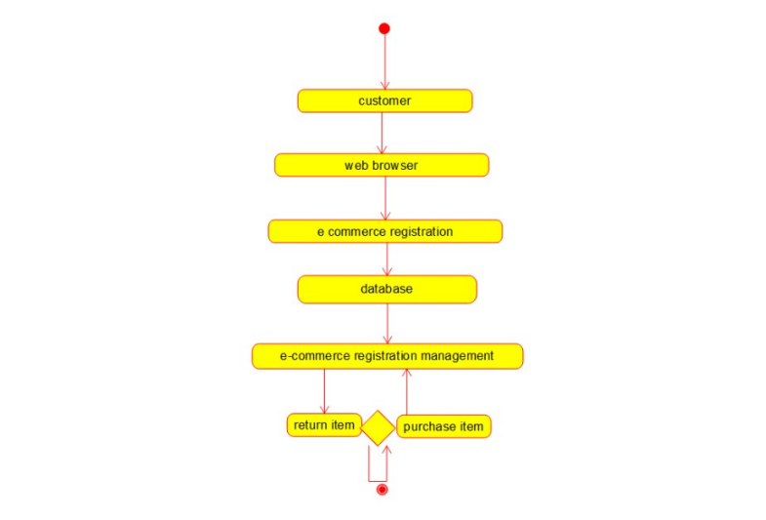

2.SEQUENCE DIAGRAM:-

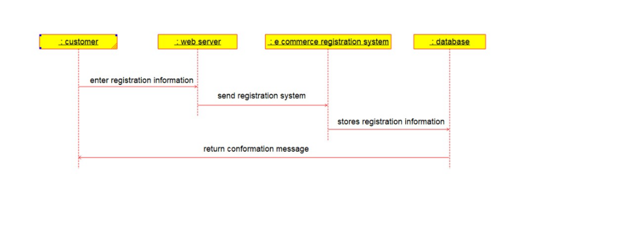

3.PACAKAGE DIAGRAM:-

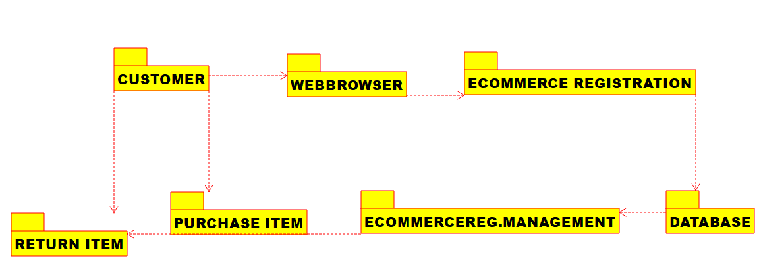

EXPERIMENT-15:

AIM:-To implement UML diagrams for Blood Bank Registration System

DESIGN:-

1.USE CASE:

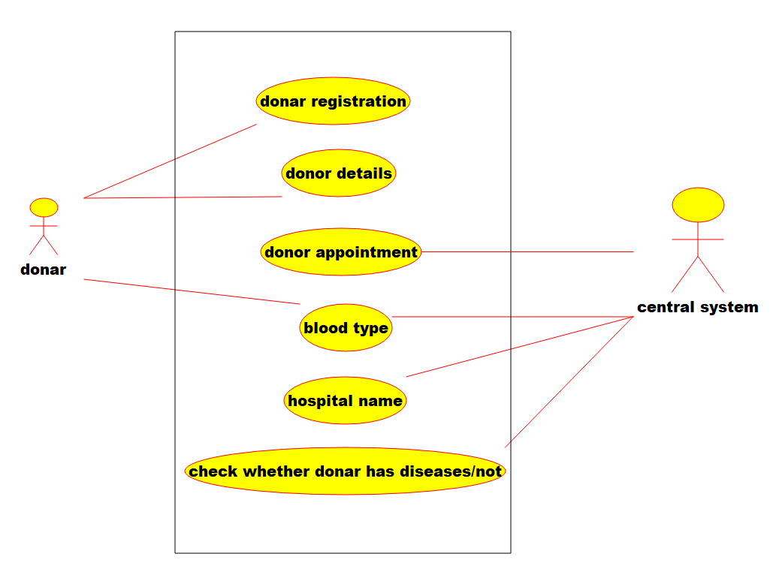

2.COLLABORATION DIAGRAM:-

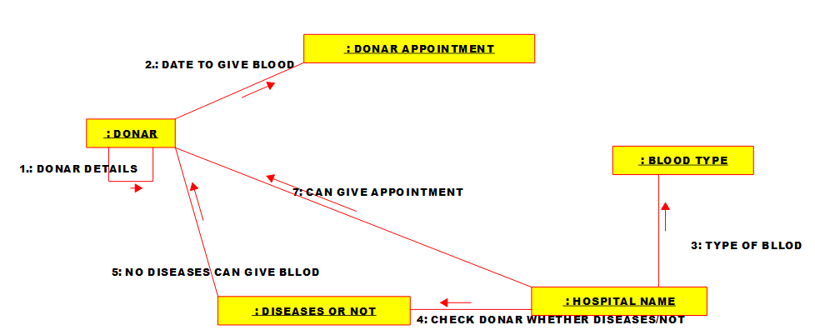

3.STATECHART DIAGRAM:-

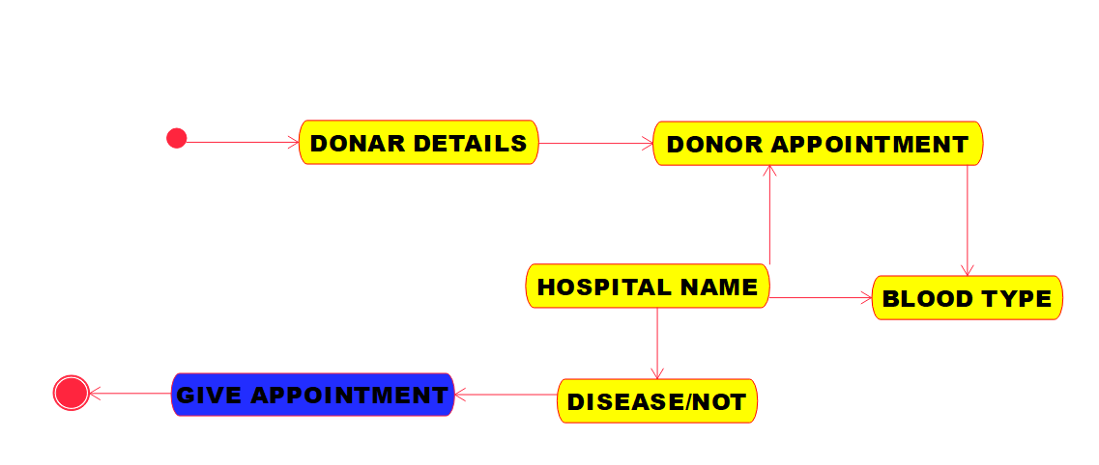

EXPERIMENT-16:

AIM:-To implement UML diagrams for Online Internship Registration System

DESIGN:-

1.COMPONENT DIAGRAM:-

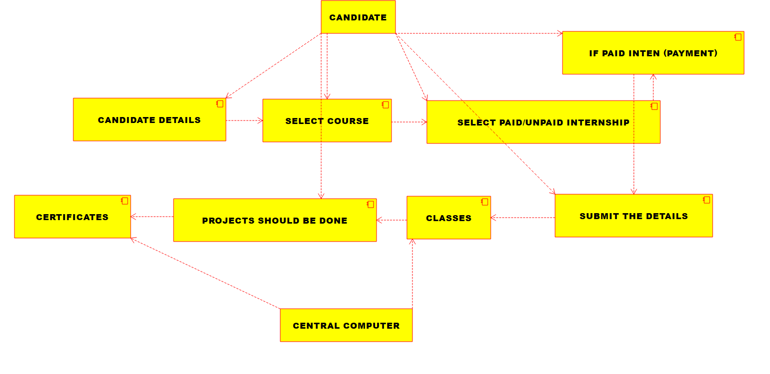

2.Deployment diagram:-

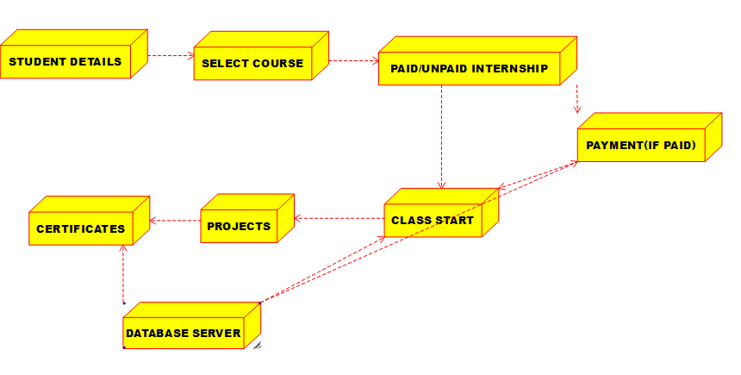

3.ACTIVITY DIAGRAM:-

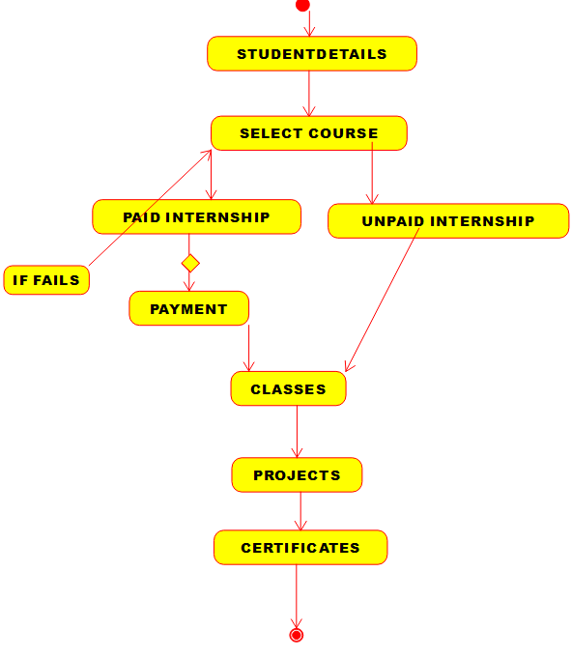

EXPERIMENT-17:

AIM:-To implement UML diagrams for Vehicle Registration Number Registering System

DESIGN:-

1.SEQUENCE DIAGRAM:

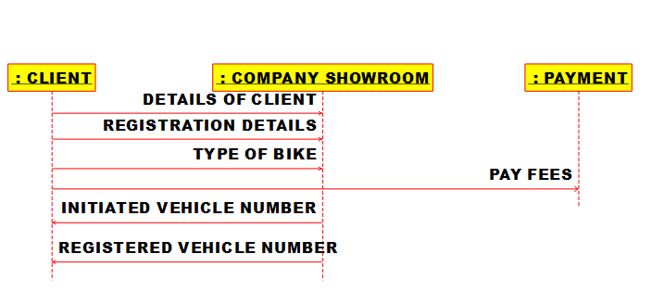

2.CLASS DIAGRAM:

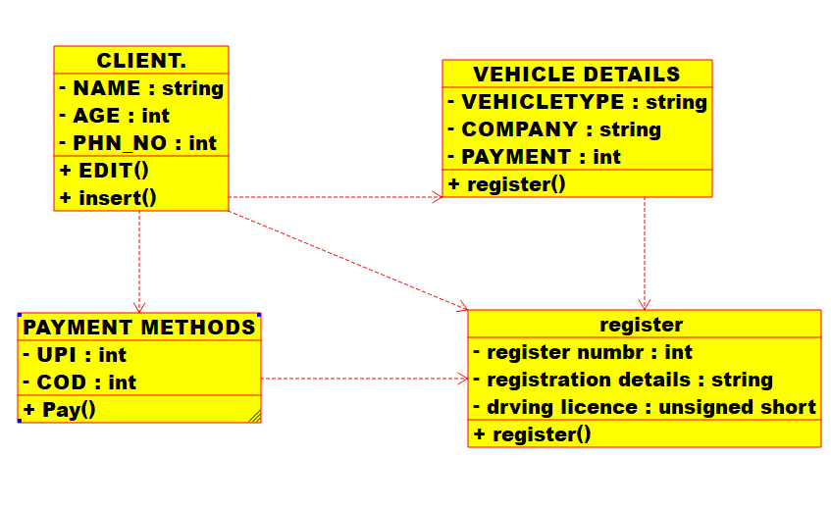

3.PACAKAGE DIAGRAM:

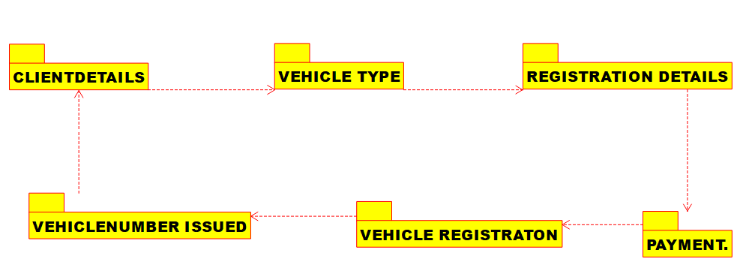

EXPERIMENT-18:

AIM:-To implement UML diagrams for FOOD ORDERING System

DESIGN:-

1.USE CASE:

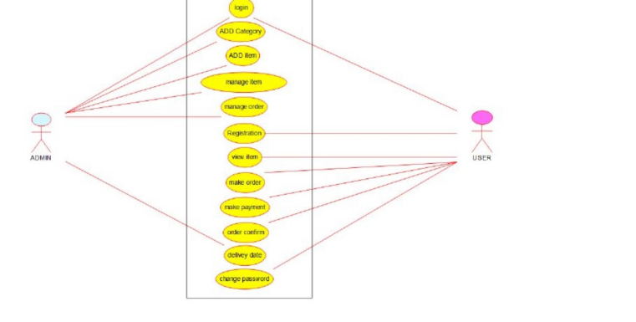

2.CLASS DIAGRAM:-

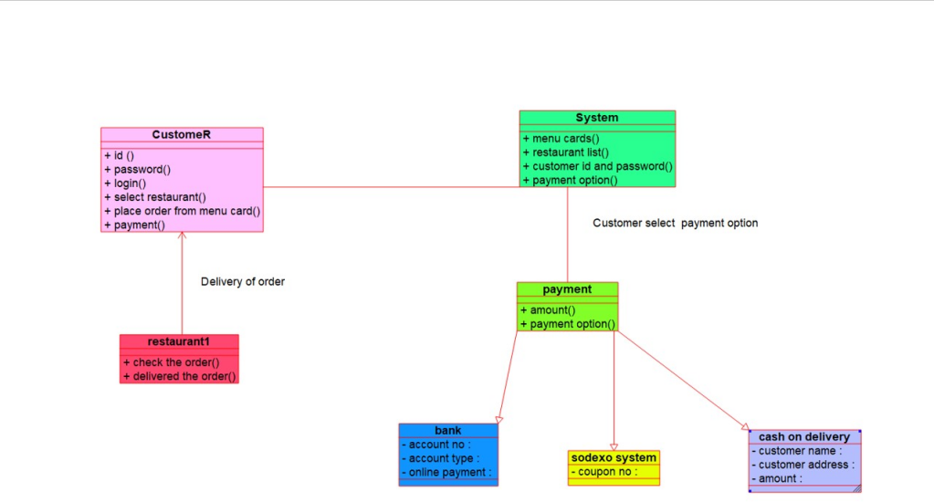

3.COLLABORATION DIAGRAM:-

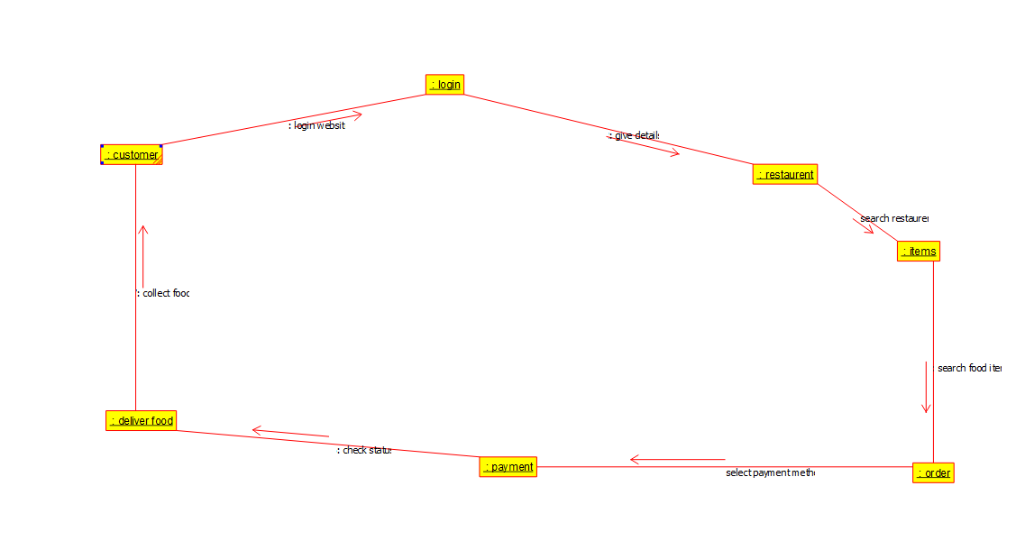

**EXPERIMENT-19:**

**AIM:** To implement UML diagrams for home service system

DESIGN:-

1. USE CASE:

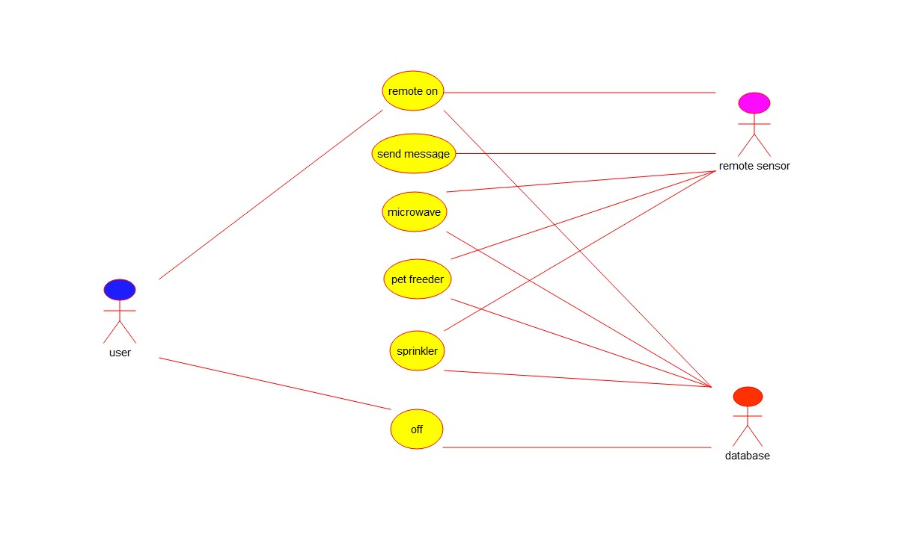

2.COMPONENT:

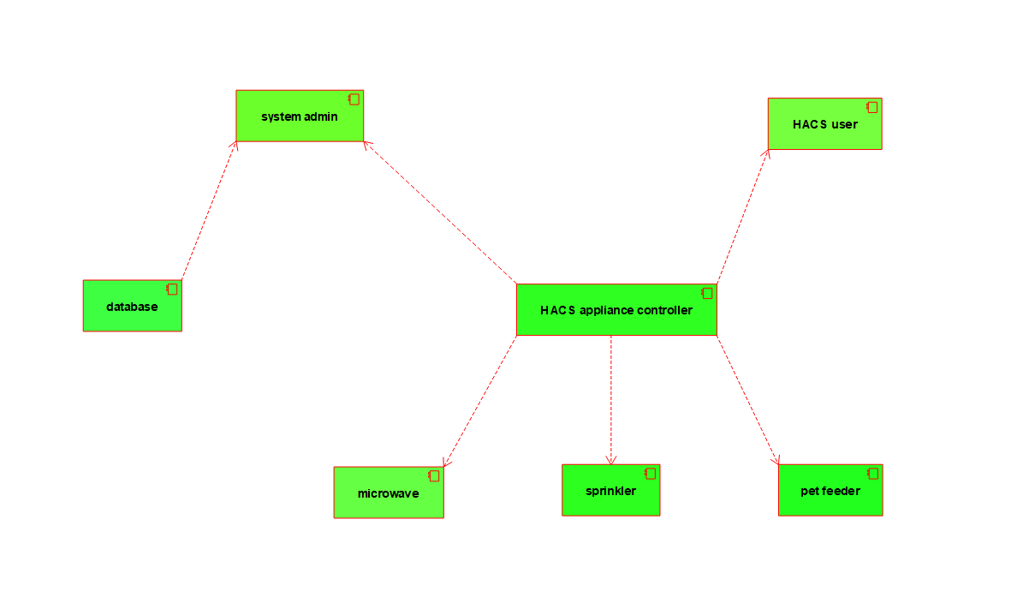

1. DEPLOYMENT: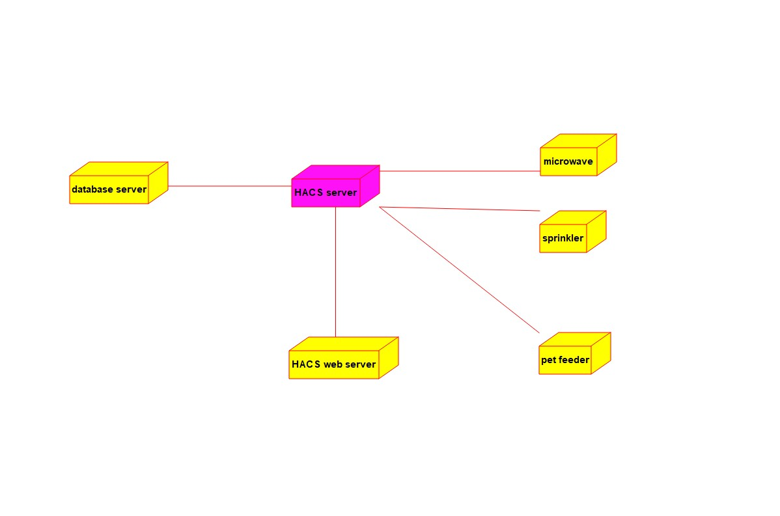

EXPERIMENT -20:

**AIM :** To implement UML diagrams for library management system

**1.CLASS DIAGRAM:**

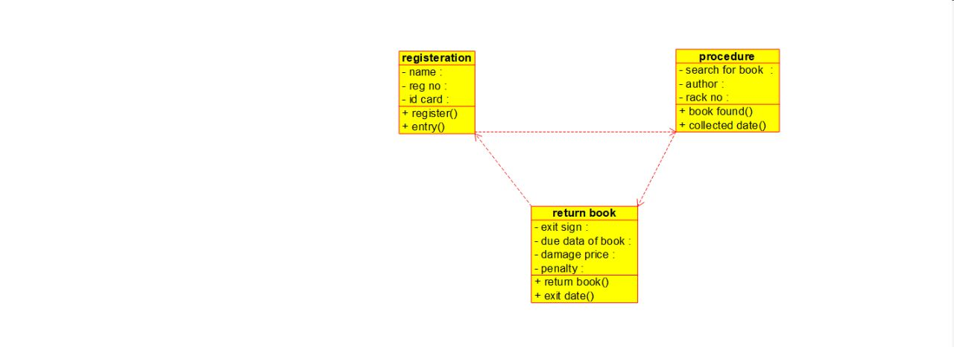

**2.COLLABRATION :**

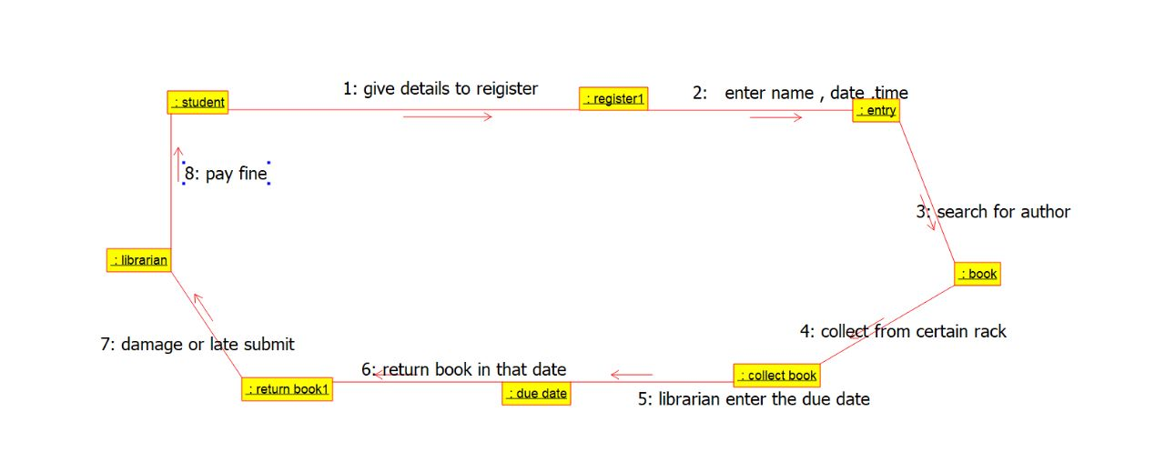

**3.USE CASE:**

