

NAME : MOHAMMAD SHAIK BASHA

REG NO : 192111459

COURSE CODE : CSA1190

COURSE NAME : OBJECT ORIENTED ANALYSIS AND DESIGN

EXPERIMENT-21:

Aim:- To implement UML diagrams for hospital management system

DESIGN:-

1.USE CASE:

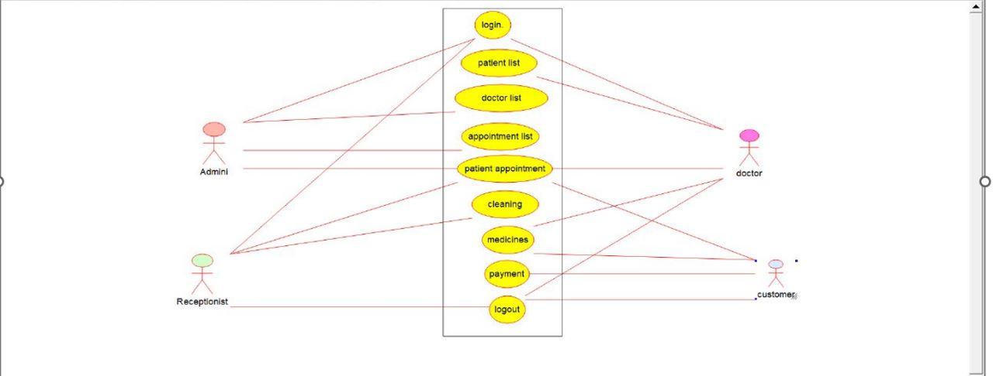

2.CLASS DIAGRAM:

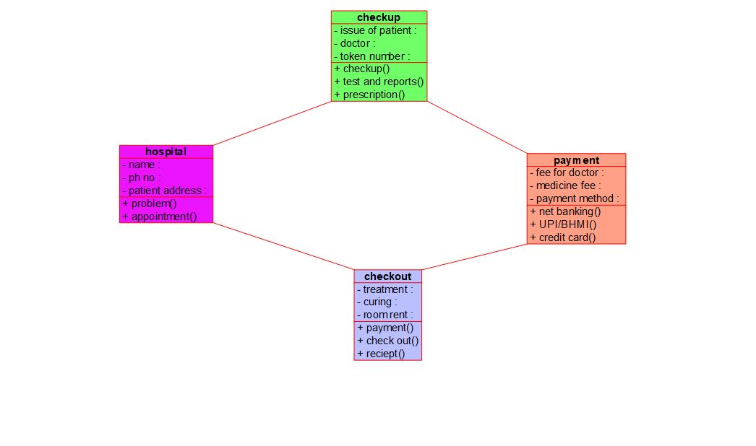

**3.COMPONENT :**

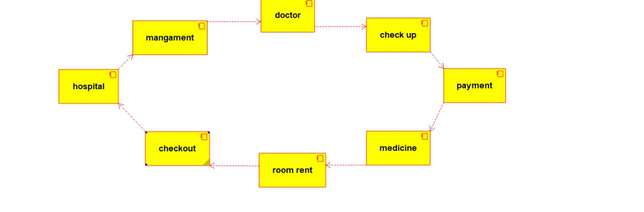

EXPERIMENT-22:

AIM:-To implement UML diagram for online insurance system

DESIGN:-

**ACTIVITY DIAGRAM:-**

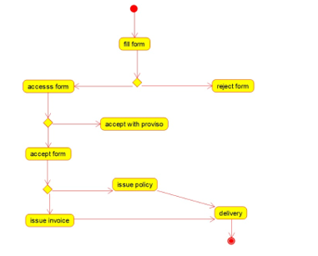

**SEQUENCE DIAGRAM:-**

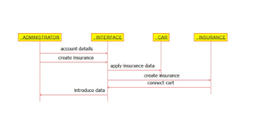

**USE-CASE DIAGRAM:-**

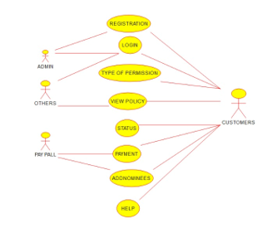

**EXPERIMENT-23:-**

**AIM:-** To draw the uml diagram for online shopping system

**COMPONENT DIAGRAM:-**

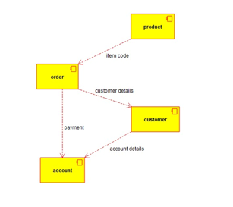

**USE-CASE DIAGRAM:-**

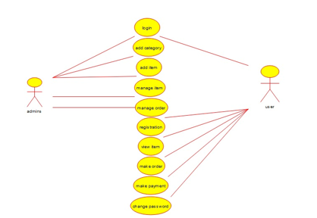

**ACTIVITY DIAGRAM:-**

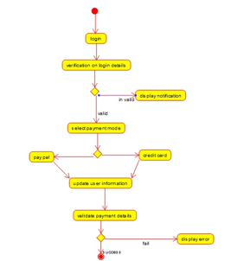

**EXPERIMENT-24:-**

**AIM:-** To draw the uml diagram for online stock market

**DESIGNS:-**

**SEQUENCE DIAGRAM:-**

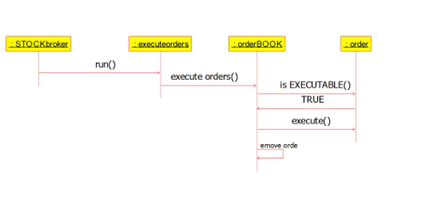

**DEPLOYMENT DIAGRAM:-**

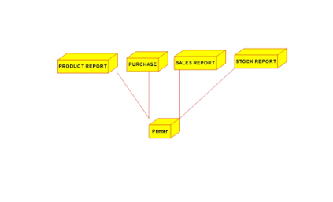

**COMPONENT DIAGRAM:-**

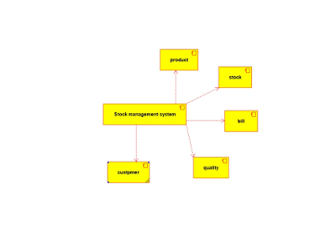

**EXPERIMENT-25:-**

**AIM:-** To draw the uml diagram for online voting system

**DESIGNS:-**

**ACTIVITY DIAGRAM:-**

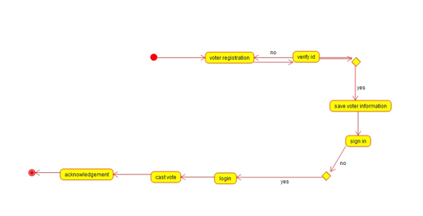

**COMPONENT DIAGRAM:-**

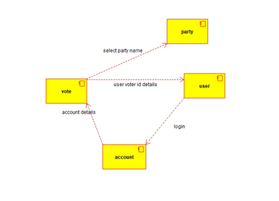

**CLASS DIAGRAM:-**

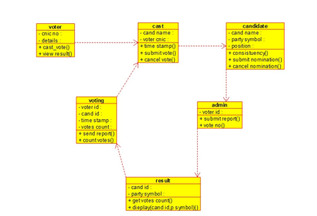

**EXPERIMENT-26:-**

**AIM:-** To draw the UML diagrams for jewellery shop management system using umbrello.

**DESIGNS:-**

**USE-CASE DIAGRAM:-**

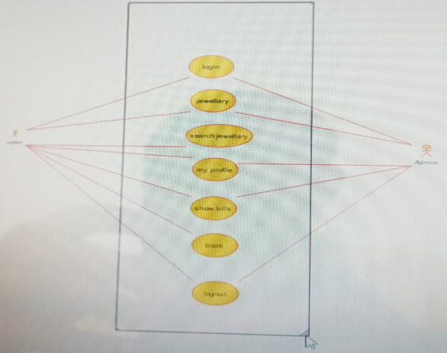

**SEQUENCE DIAGRAM:-**

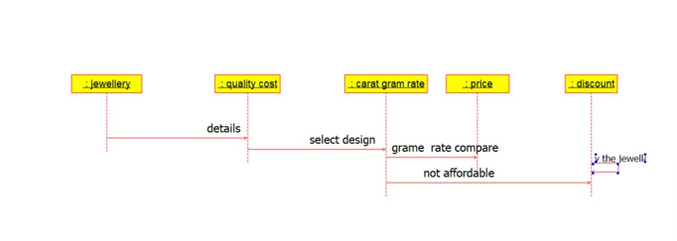

**COMPONENT DIAGRAM:-**

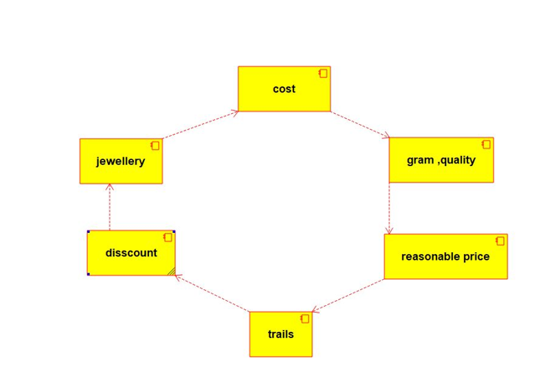

**EXPERIMENT-27:-**

**AIM:-** To draw the UML diagrams for SUPER MARKET MANAGEMENT SYSTEM.

**DESIGNS:-**

**USE-CASE DIAGRAM:-**

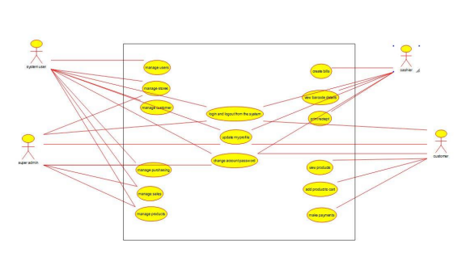

**ACTIVITY DIAGRAM:-**

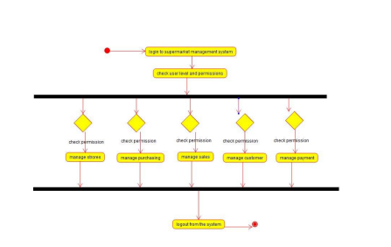

**CLASS DIAGRAM:-**

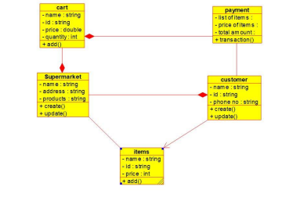

**EXPERIMENT-28:-**

**AIM:-** -To draw the UML diagrams for AIRLINE RESERVATION SYSTEM.

**DESIGNS:-**

**CLASS DIAGRAM:-**

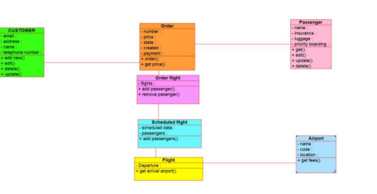

**ACTIVITY DIAGRAM:-**

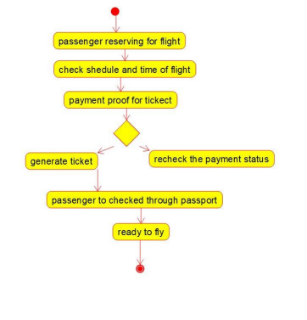

**USE-CASE DIAGRAM:-**

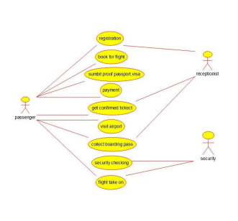

**EXPERIMENT-29:-**

**AIM:-** To draw the UML diagrams for BUS TICKET RESERVATION SYSTEM.

**DESIGNS:-**

**CLASS DIAGRAM:-**

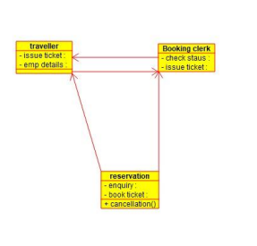

**COMPONENT DIAGRAM:-**

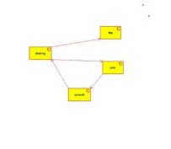

**USE-CASE DIAGRAM:-**

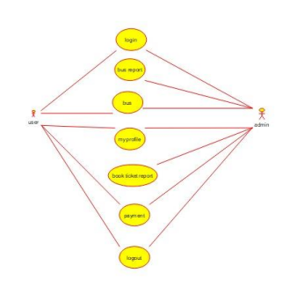

**EXPERIMENT-30:-**

**AIM:-** To draw the UML diagrams for TRAIN RESERVATION SYSTEM.

**DESIGNS:-**

**USE-CASE DIAGRAM:-**

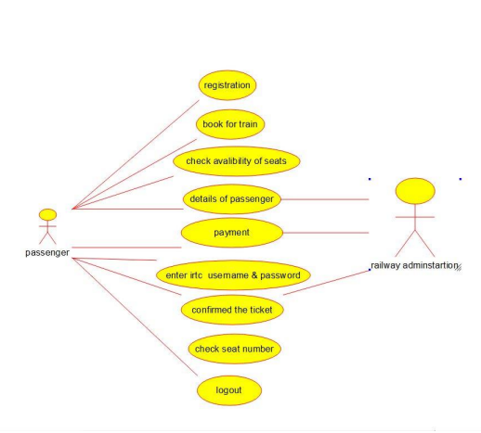

**ACTIVITY DIAGRAM:-**

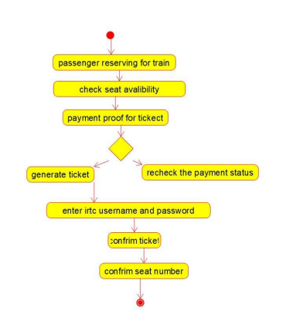

**COMPONENT DIAGRAM:-**

