**Big Data Analytics & Applications ICP1**

Description:

Perform 3 data analysis tasks on the data. Analysis tasks are the task that give you insight about data. It could be visualization tasks, class distribution in the data, or anything that provides more information about the data.

Objective :

Developed a code in python using Pandas, seaborn libraries.

Design/Implementation:

As per the description, I had developed 3 data analysis.

* Created simple Hello World program in a shell

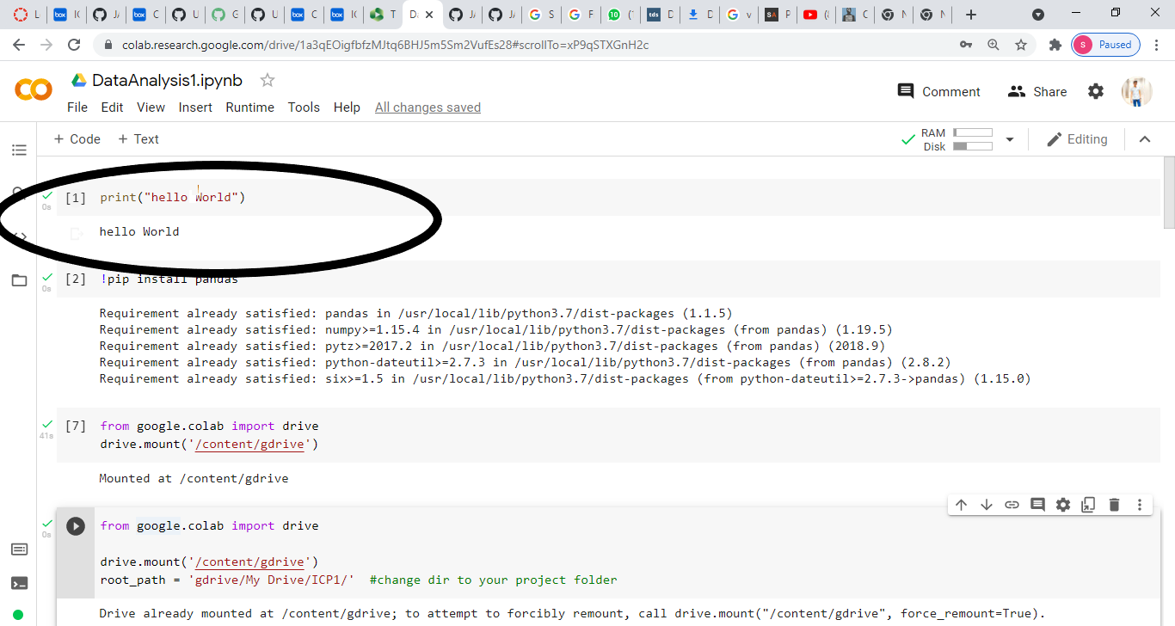

* Mount the data setr from google drive to Google Colab notebook by using following commands.

Read the data using python pandas library.

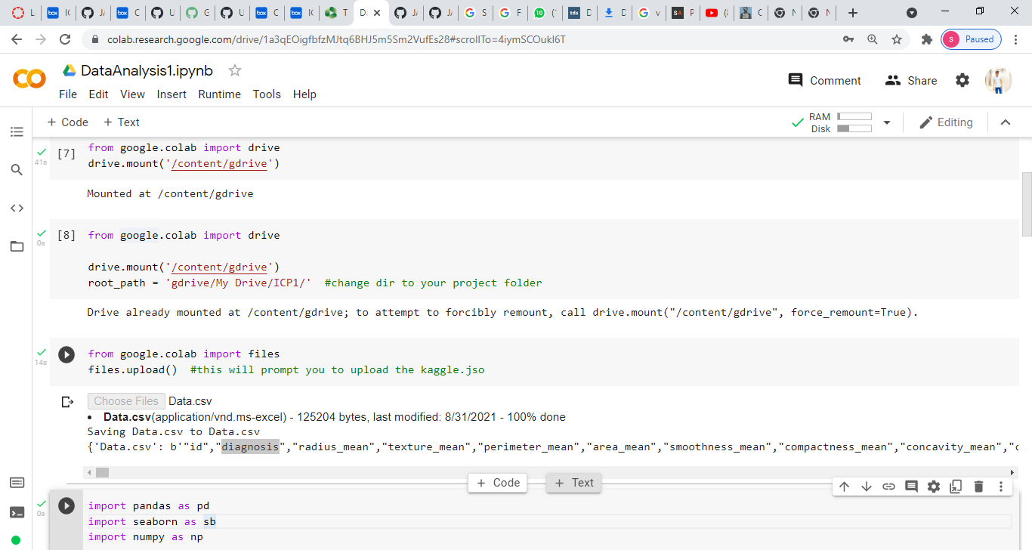

* Perform commands like Read, Structure, first 10 rows from the data set.

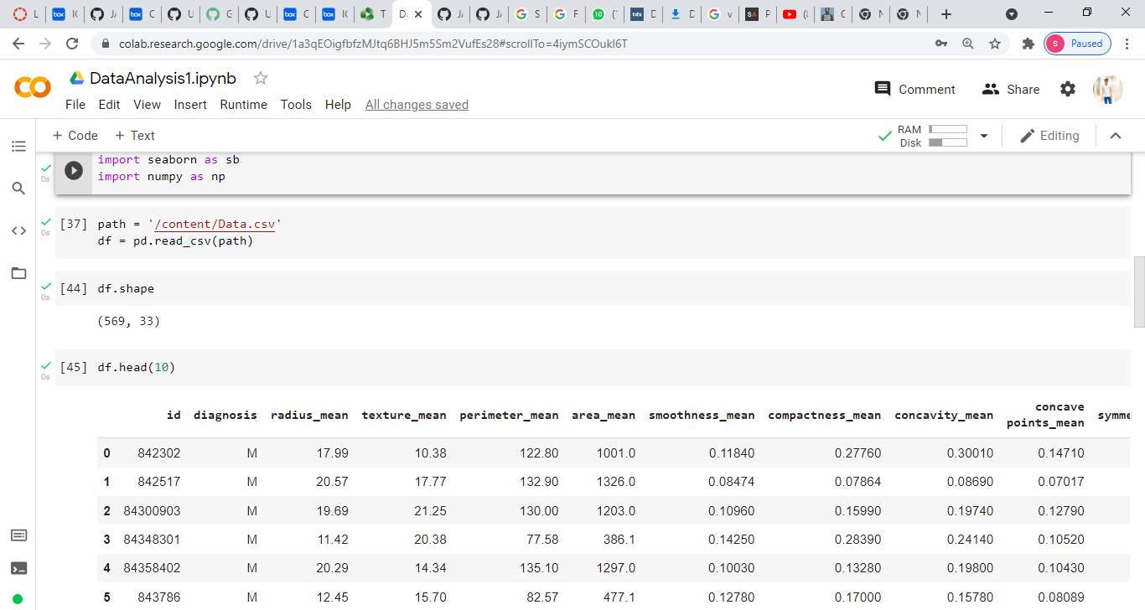

* Perform Data Visualization on column ‘radius_mean’ by using histogram.

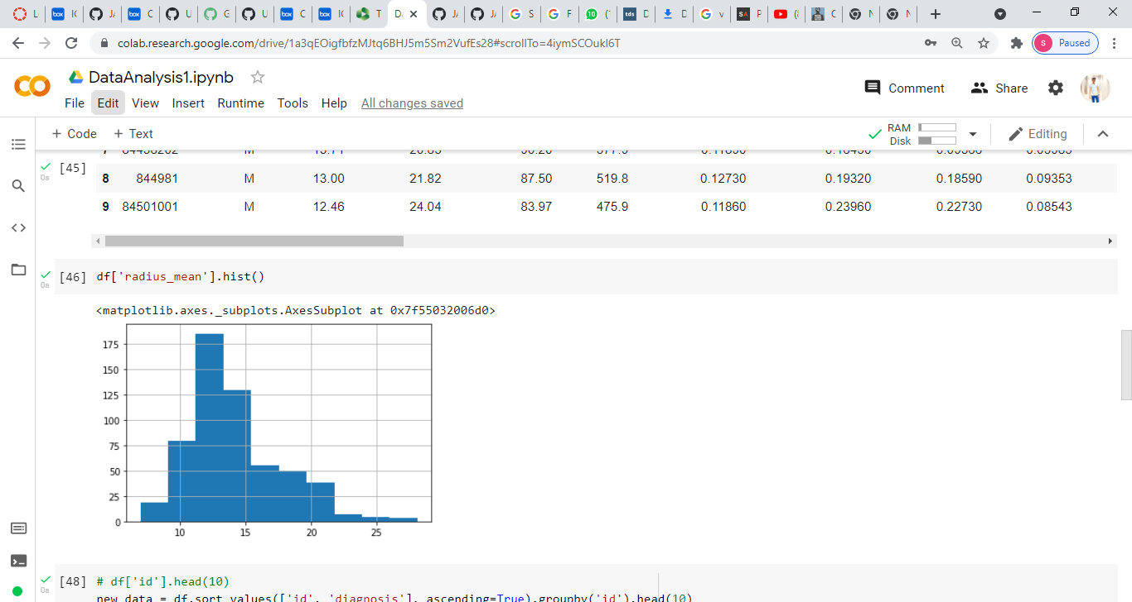

* Perform Sort operation on the 2 cols and print first 10 rows in ascending order as per ‘id’ column.

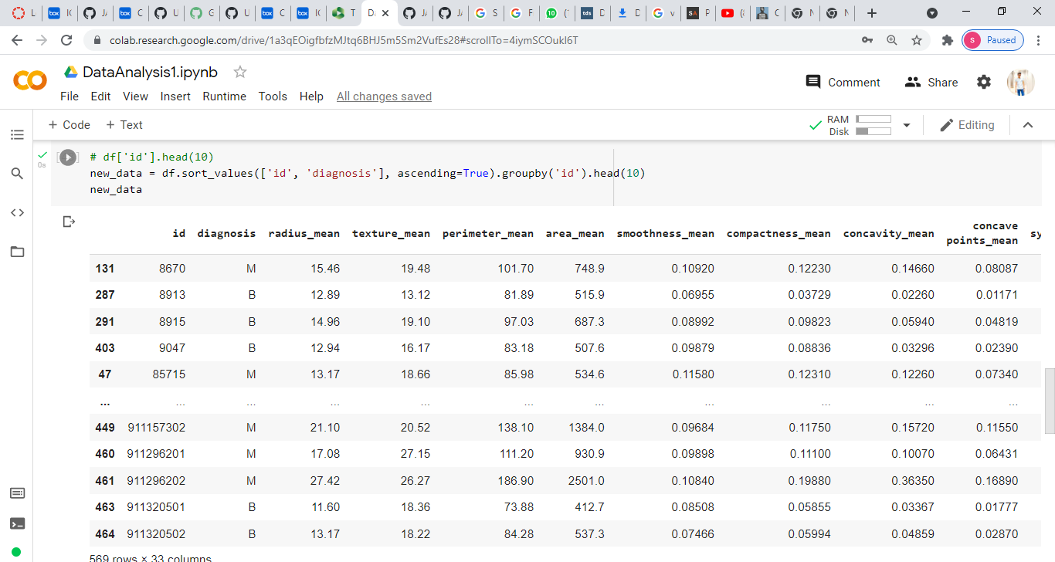

* Perform Data Visualization task using line plot.

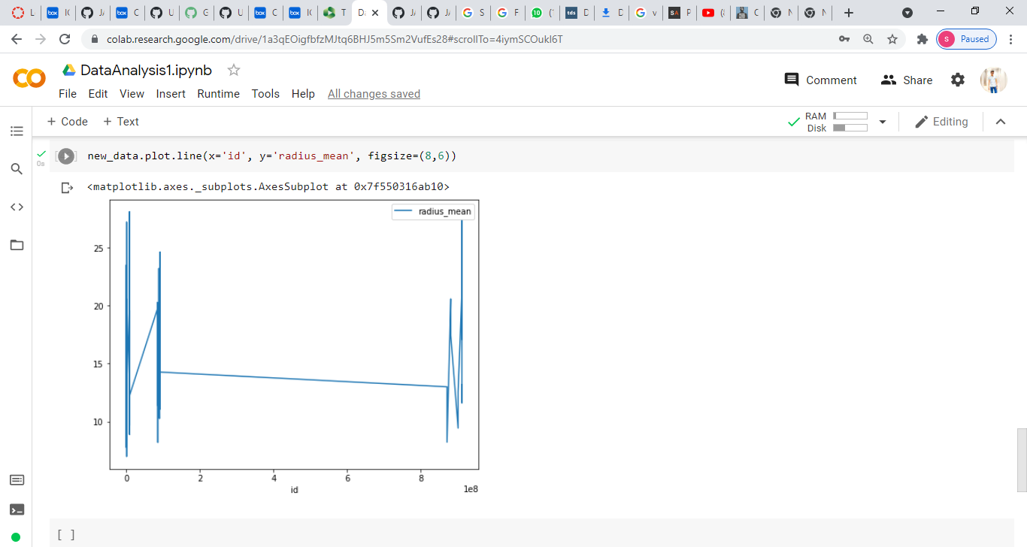

Conclusion :

New Learnings:

* Learnt few Hands on exercise GitHub softeware.
* Learnt mounting data from google drive to google colab notebook.

Challenge Faced:

* GitHub Commands like commit, File creation etc..