

Project Report

**Course: IIA**

**Teacher: SIR: Naveed**

**Project Title: Ibex-Global**

***Submission Date:18-04-2018***

|  |  |  |  |
| --- | --- | --- | --- |
| *S.No.* | *Stud. ID* | *Names* | *Course ID* |
| 1 | 7651 | Muhammad Sharjil | 66276 |
| 2 | 7497 | Aikrama bin fawad |
| 3 | 7582 | Mufaddal |

# **TABLE OF CONTENT**

Main Topology 3.

Karachi Topology **4.**

Islamabad Topology **5.**

Lahore Topology **6.**

Description 7.

KARACHI 7.

Configuration for Main,Backup,Branch, Server Routers **8-19.**

SHOW RUNNING-CONFIG **8-10.**

SHOW IP INTERFACE BRIEF **10-13.**

SHOW IP ROUTE **14-16.**

PING RESULTS **17-18.**

ISLAMABAD 19.

Configuration for Main,Backup,Branch, Server Routers **20-22.**

SHOW RUNNING-CONFIG **23-25.**

SHOW IP INTERFACE BRIEF **26-27.**

SHOW IP ROUTE **27-29.**

PING RESULTS **30.**

LAHORE 31.

Configuration for Main,Backup,Branch, Server Routers **32-35.**

SHOW RUNNING-CONFIG **36-38.**

SHOW IP INTEFACE BRIEF **38-40.**

SHOW IP ROUTE **41.**

PING RESULTS **42-44.**

REDISTRIBUTION ROUTERS………………………………………………………………………………………………………………**45-48.**

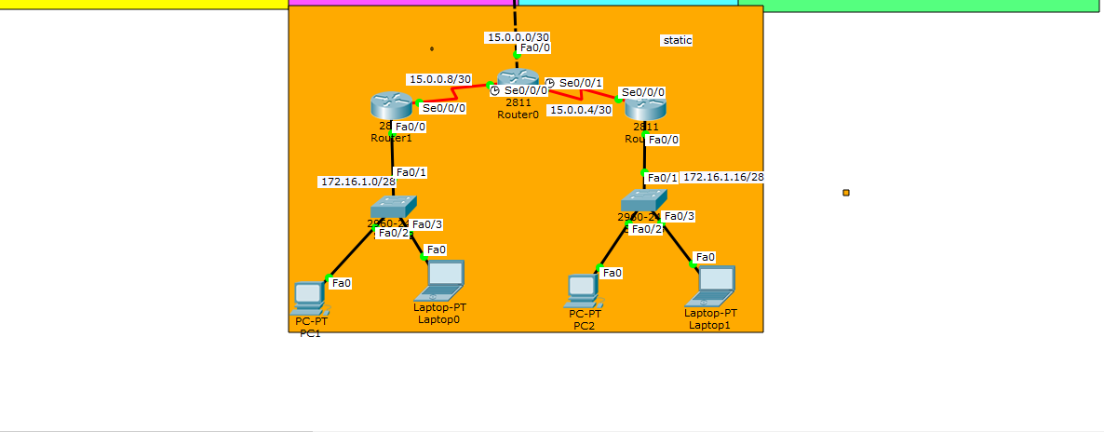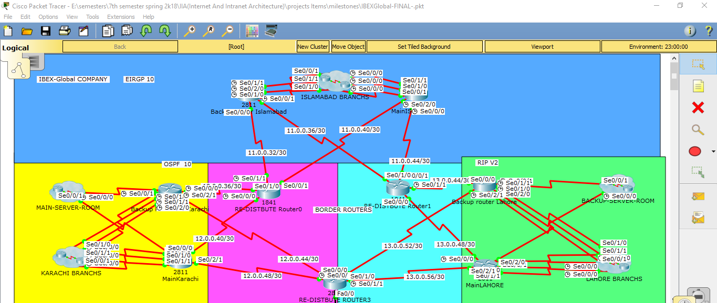**Main Topology:**

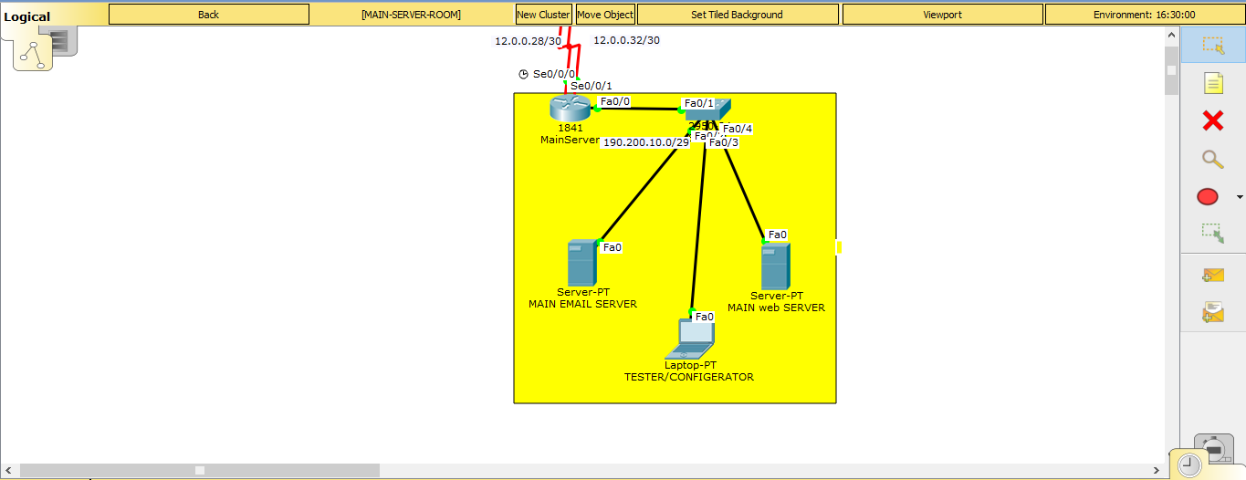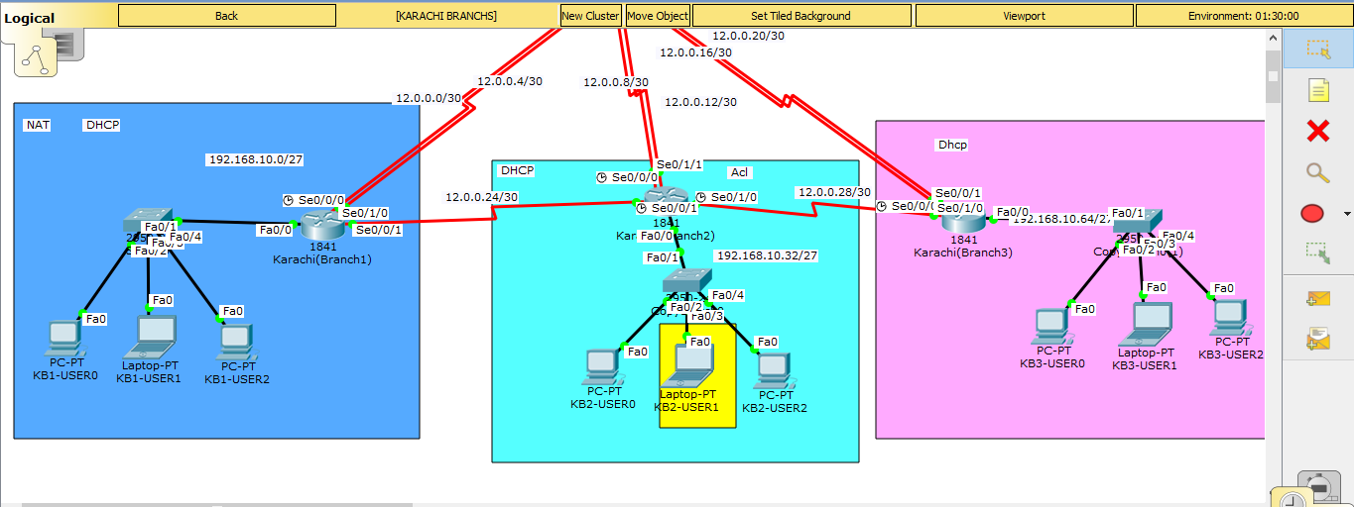**Karachi Topology:**

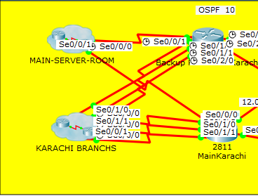

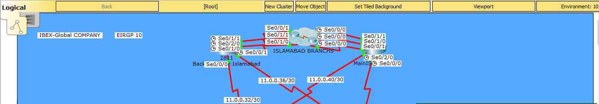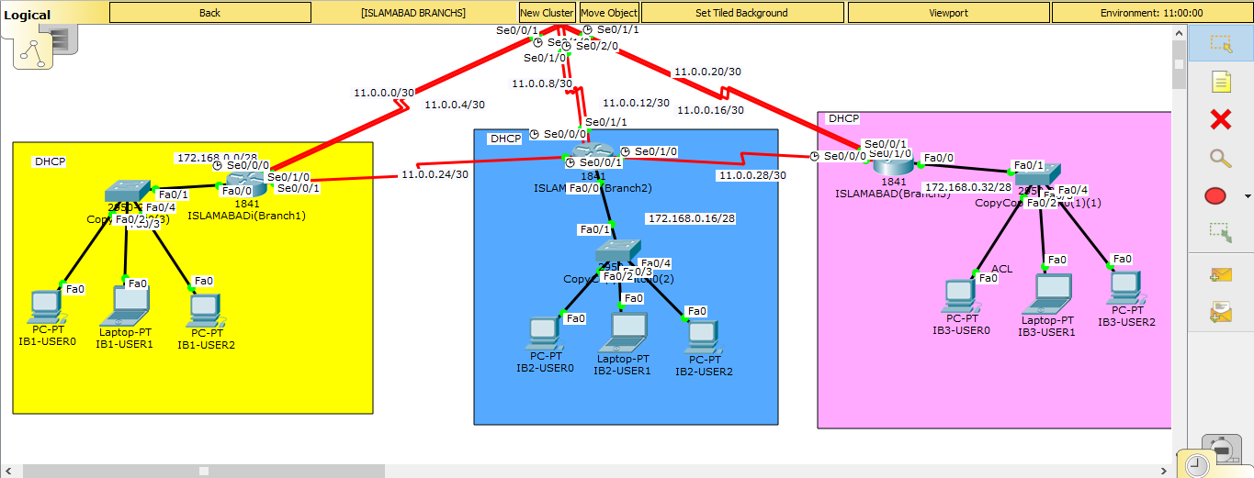**Islamabad Topology:**

**Lahore Topology:**

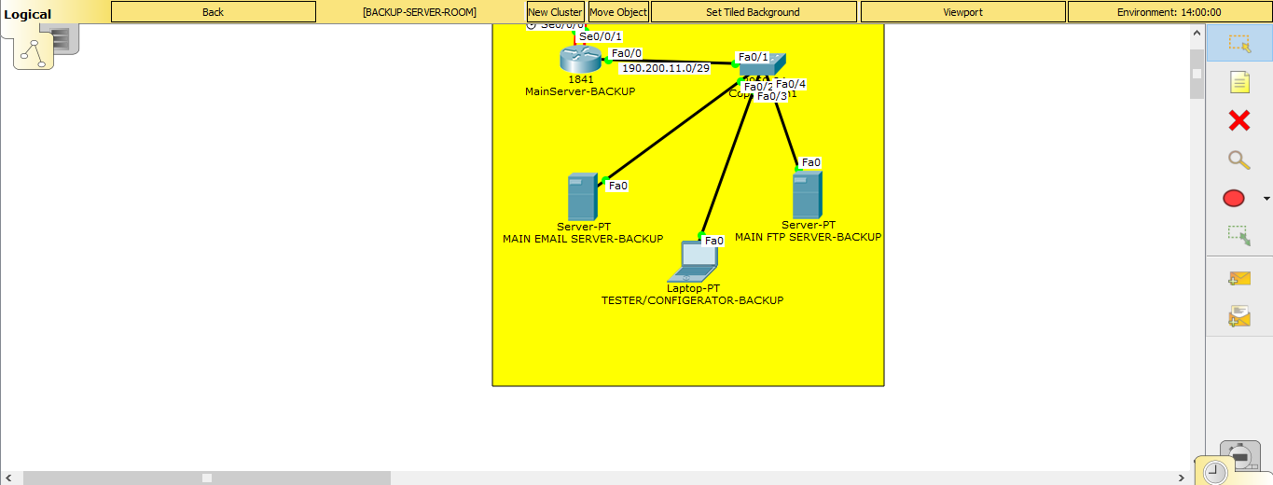

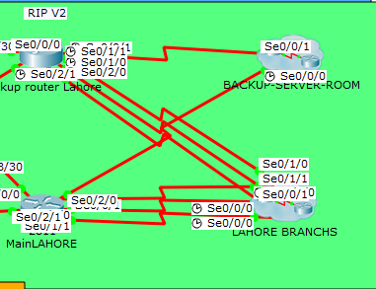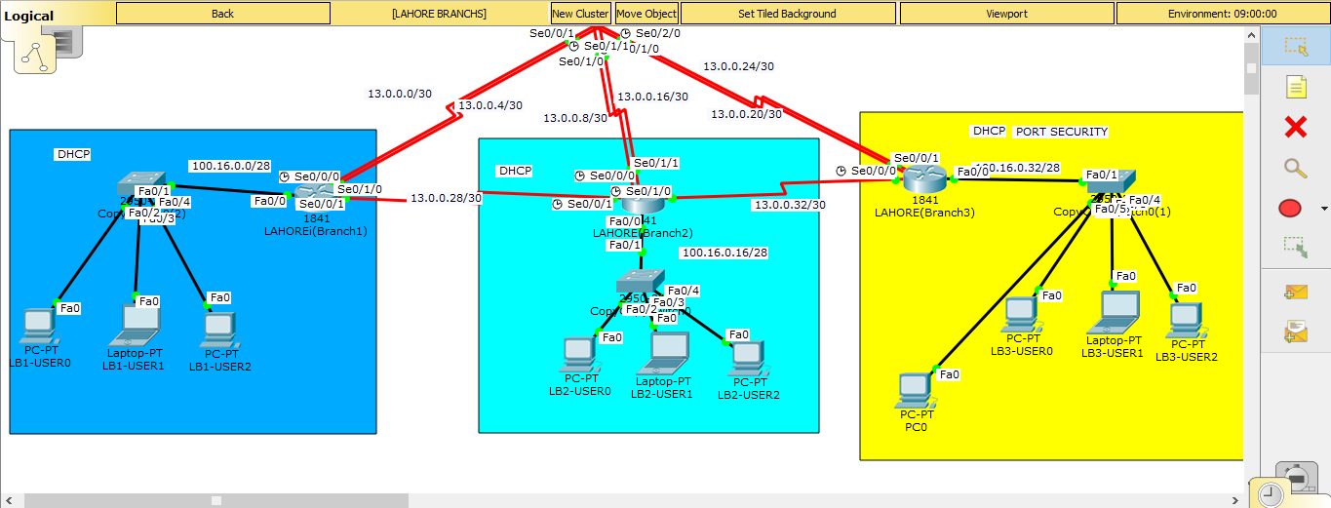

**Brief Description:**

This Topology shows the wide range of cities the IBEX-GLOBAL networks provide its connectivity through, from the economic hub Karachi AND Lahore to the capital of Pakistan Islamabad. Just to show our companies capabilities we configured many routing protocols like DHCP, RIPv2, OSPF, EIGRP, Static and also implemented Acl, Port Security and even natting. To connect these protocols, we made use of Redistribution Routers.

**Karachi Router Configurations:**

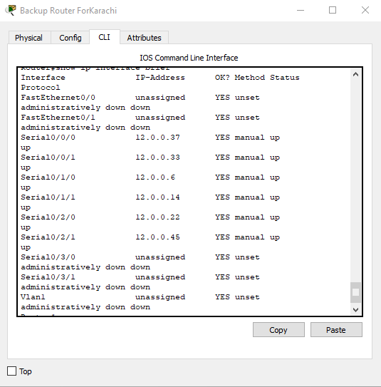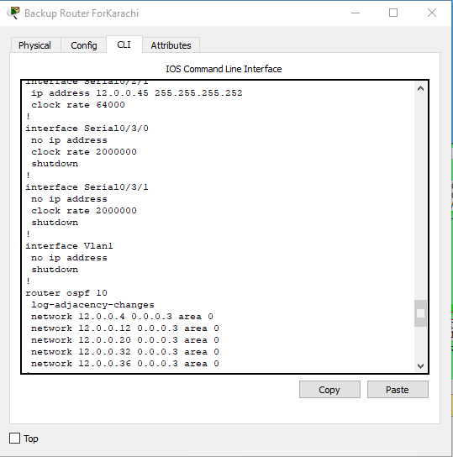Show running configuration, show Ip interface brief

**Show ip route:**

**For Backup Router:**

11.0.0.0/30 is subnetted, 12 subnets

O E2 11.0.0.0 [110/200] via 12.0.0.38, 00:34:32, Serial0/0/0

O E2 11.0.0.4 [110/200] via 12.0.0.38, 00:34:32, Serial0/0/0

O E2 11.0.0.8 [110/200] via 12.0.0.38, 00:34:32, Serial0/0/0

O E2 11.0.0.12 [110/200] via 12.0.0.38, 00:34:32, Serial0/0/0

O E2 11.0.0.16 [110/200] via 12.0.0.38, 00:34:32, Serial0/0/0

O E2 11.0.0.20 [110/200] via 12.0.0.38, 00:34:32, Serial0/0/0

O E2 11.0.0.24 [110/200] via 12.0.0.38, 00:34:32, Serial0/0/0

O E2 11.0.0.28 [110/200] via 12.0.0.38, 00:34:32, Serial0/0/0

O E2 11.0.0.32 [110/200] via 12.0.0.38, 00:34:32, Serial0/0/0

O E2 11.0.0.36 [110/200] via 12.0.0.38, 00:34:32, Serial0/0/0

O E2 11.0.0.40 [110/200] via 12.0.0.38, 00:34:32, Serial0/0/0

O E2 11.0.0.44 [110/200] via 12.0.0.38, 00:34:32, Serial0/0/0

12.0.0.0/30 is subnetted, 13 subnets

O 12.0.0.0 [110/128] via 12.0.0.5, 00:34:32, Serial0/1/0

C 12.0.0.4 is directly connected, Serial0/1/0

O 12.0.0.8 [110/128] via 12.0.0.13, 00:34:32, Serial0/1/1

C 12.0.0.12 is directly connected, Serial0/1/1

O 12.0.0.16 [110/128] via 12.0.0.21, 00:34:32, Serial0/2/0

C 12.0.0.20 is directly connected, Serial0/2/0

O 12.0.0.24 [110/128] via 12.0.0.13, 00:34:32, Serial0/1/1

[110/128] via 12.0.0.5, 00:34:32, Serial0/1/0

O 12.0.0.28 [110/128] via 12.0.0.33, 00:34:32, Serial0/0/1

[110/128] via 12.0.0.13, 00:34:32, Serial0/1/1

[110/128] via 12.0.0.21, 00:34:32, Serial0/2/0

C 12.0.0.32 is directly connected, Serial0/0/1

C 12.0.0.36 is directly connected, Serial0/0/0

O 12.0.0.40 [110/128] via 12.0.0.38, 00:34:32, Serial0/0/0

C 12.0.0.44 is directly connected, Serial0/2/1

O E2 12.0.0.48 [110/200] via 12.0.0.38, 00:34:32, Serial0/0/0

13.0.0.0/30 is subnetted, 14 subnets

O E2 13.0.0.0 [110/200] via 12.0.0.38, 00:34:32, Serial0/0/0

O E2 13.0.0.4 [110/200] via 12.0.0.38, 00:34:32, Serial0/0/0

O E2 13.0.0.8 [110/200] via 12.0.0.38, 00:34:32, Serial0/0/0

O E2 13.0.0.16 [110/200] via 12.0.0.38, 00:34:32, Serial0/0/0

O E2 13.0.0.20 [110/200] via 12.0.0.38, 00:34:32, Serial0/0/0

O E2 13.0.0.24 [110/200] via 12.0.0.38, 00:34:32, Serial0/0/0

O E2 13.0.0.28 [110/200] via 12.0.0.38, 00:34:32, Serial0/0/0

O E2 13.0.0.32 [110/200] via 12.0.0.38, 00:34:32, Serial0/0/0

O E2 13.0.0.36 [110/200] via 12.0.0.38, 00:34:32, Serial0/0/0

O E2 13.0.0.40 [110/200] via 12.0.0.38, 00:34:32, Serial0/0/0

O E2 13.0.0.44 [110/200] via 12.0.0.38, 00:34:32, Serial0/0/0

O E2 13.0.0.48 [110/200] via 12.0.0.38, 00:34:32, Serial0/0/0

O E2 13.0.0.52 [110/200] via 12.0.0.38, 00:34:32, Serial0/0/0

O E2 13.0.0.56 [110/200] via 12.0.0.38, 00:34:32, Serial0/0/0

15.0.0.0/30 is subnetted, 2 subnets

O E2 15.0.0.4 [110/200] via 12.0.0.38, 00:34:32, Serial0/0/0

O E2 15.0.0.8 [110/200] via 12.0.0.38, 00:34:32, Serial0/0/0

100.0.0.0/28 is subnetted, 3 subnets

O E2 100.16.0.0 [110/200] via 12.0.0.38, 00:34:32, Serial0/0/0

O E2 100.16.0.16 [110/200] via 12.0.0.38, 00:34:32, Serial0/0/0

O E2 100.16.0.32 [110/200] via 12.0.0.38, 00:34:32, Serial0/0/0

172.16.0.0/28 is subnetted, 2 subnets

O E2 172.16.1.0 [110/200] via 12.0.0.38, 00:34:32, Serial0/0/0

O E2 172.16.1.16 [110/200] via 12.0.0.38, 00:34:32, Serial0/0/0

172.168.0.0/28 is subnetted, 3 subnets

O E2 172.168.0.0 [110/200] via 12.0.0.38, 00:34:32, Serial0/0/0

O E2 172.168.0.16 [110/200] via 12.0.0.38, 00:34:32, Serial0/0/0

O E2 172.168.0.32 [110/200] via 12.0.0.38, 00:34:32, Serial0/0/0

190.200.0.0/29 is subnetted, 2 subnets

O 190.200.10.0 [110/65] via 12.0.0.33, 00:34:32, Serial0/0/1

O E2 190.200.11.0 [110/200] via 12.0.0.38, 00:34:32, Serial0/0/0

192.168.10.0/27 is subnetted, 3 subnets

O 192.168.10.0 [110/65] via 12.0.0.5, 00:34:32, Serial0/1/0

O 192.168.10.32 [110/65] via 12.0.0.13, 00:34:32, Serial0/1/1

O 192.168.10.64 [110/65] via 12.0.0.21, 00:34:32, Serial0/2/0

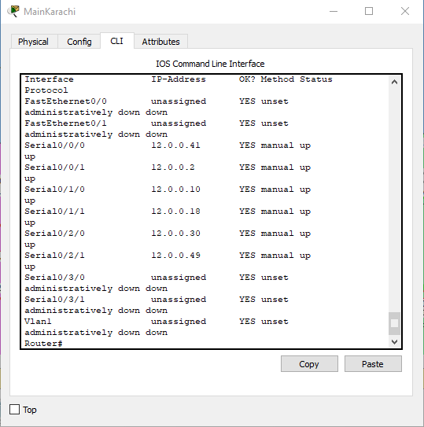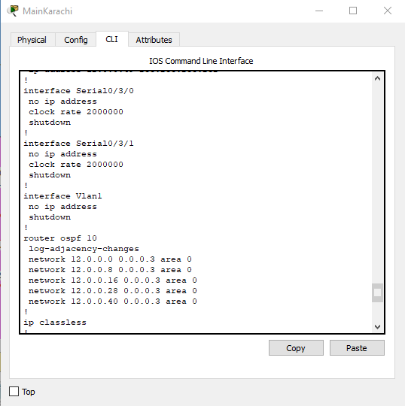Main Karachi: how running configuration, show Ip interface brief

Show ip route:

11.0.0.0/30 is subnetted, 12 subnets

O E2 11.0.0.0 [110/200] via 12.0.0.42, 00:35:18, Serial0/0/0

O E2 11.0.0.4 [110/200] via 12.0.0.42, 00:35:18, Serial0/0/0

O E2 11.0.0.8 [110/200] via 12.0.0.42, 00:35:18, Serial0/0/0

O E2 11.0.0.12 [110/200] via 12.0.0.42, 00:35:18, Serial0/0/0

O E2 11.0.0.16 [110/200] via 12.0.0.42, 00:35:18, Serial0/0/0

O E2 11.0.0.20 [110/200] via 12.0.0.42, 00:35:18, Serial0/0/0

O E2 11.0.0.24 [110/200] via 12.0.0.42, 00:35:18, Serial0/0/0

O E2 11.0.0.28 [110/200] via 12.0.0.42, 00:35:18, Serial0/0/0

O E2 11.0.0.32 [110/200] via 12.0.0.42, 00:35:18, Serial0/0/0

O E2 11.0.0.36 [110/200] via 12.0.0.42, 00:35:18, Serial0/0/0

O E2 11.0.0.40 [110/200] via 12.0.0.42, 00:35:18, Serial0/0/0

O E2 11.0.0.44 [110/200] via 12.0.0.42, 00:35:18, Serial0/0/0

12.0.0.0/30 is subnetted, 13 subnets

C 12.0.0.0 is directly connected, Serial0/0/1

O 12.0.0.4 [110/128] via 12.0.0.1, 00:35:18, Serial0/0/1

C 12.0.0.8 is directly connected, Serial0/1/0

O 12.0.0.12 [110/128] via 12.0.0.9, 00:35:18, Serial0/1/0

C 12.0.0.16 is directly connected, Serial0/1/1

O 12.0.0.20 [110/128] via 12.0.0.17, 00:35:18, Serial0/1/1

O 12.0.0.24 [110/128] via 12.0.0.1, 00:35:18, Serial0/0/1

[110/128] via 12.0.0.9, 00:35:18, Serial0/1/0

C 12.0.0.28 is directly connected, Serial0/2/0

O 12.0.0.32 [110/128] via 12.0.0.29, 00:35:18, Serial0/2/0

O 12.0.0.36 [110/128] via 12.0.0.42, 00:35:18, Serial0/0/0

C 12.0.0.40 is directly connected, Serial0/0/0

O E2 12.0.0.44 [110/200] via 12.0.0.42, 00:35:18, Serial0/0/0

C 12.0.0.48 is directly connected, Serial0/2/1

13.0.0.0/30 is subnetted, 14 subnets

O E2 13.0.0.0 [110/200] via 12.0.0.42, 00:35:18, Serial0/0/0

O E2 13.0.0.4 [110/200] via 12.0.0.42, 00:35:18, Serial0/0/0

O E2 13.0.0.8 [110/200] via 12.0.0.42, 00:35:18, Serial0/0/0

O E2 13.0.0.16 [110/200] via 12.0.0.42, 00:35:18, Serial0/0/0

O E2 13.0.0.20 [110/200] via 12.0.0.42, 00:35:18, Serial0/0/0

O E2 13.0.0.24 [110/200] via 12.0.0.42, 00:35:18, Serial0/0/0

O E2 13.0.0.28 [110/200] via 12.0.0.42, 00:35:18, Serial0/0/0

O E2 13.0.0.32 [110/200] via 12.0.0.42, 00:35:18, Serial0/0/0

O E2 13.0.0.36 [110/200] via 12.0.0.42, 00:35:18, Serial0/0/0

O E2 13.0.0.40 [110/200] via 12.0.0.42, 00:35:18, Serial0/0/0

O E2 13.0.0.44 [110/200] via 12.0.0.42, 00:35:18, Serial0/0/0

O E2 13.0.0.48 [110/200] via 12.0.0.42, 00:35:18, Serial0/0/0

O E2 13.0.0.52 [110/200] via 12.0.0.42, 00:35:18, Serial0/0/0

O E2 13.0.0.56 [110/200] via 12.0.0.42, 00:35:18, Serial0/0/0

15.0.0.0/30 is subnetted, 2 subnets

O E2 15.0.0.4 [110/200] via 12.0.0.42, 00:35:18, Serial0/0/0

O E2 15.0.0.8 [110/200] via 12.0.0.42, 00:35:18, Serial0/0/0

100.0.0.0/28 is subnetted, 3 subnets

O E2 100.16.0.0 [110/200] via 12.0.0.42, 00:35:18, Serial0/0/0

O E2 100.16.0.16 [110/200] via 12.0.0.42, 00:35:18, Serial0/0/0

O E2 100.16.0.32 [110/200] via 12.0.0.42, 00:35:18, Serial0/0/0

172.16.0.0/28 is subnetted, 2 subnets

O E2 172.16.1.0 [110/200] via 12.0.0.42, 00:35:18, Serial0/0/0

O E2 172.16.1.16 [110/200] via 12.0.0.42, 00:35:18, Serial0/0/0

172.168.0.0/28 is subnetted, 3 subnets

O E2 172.168.0.0 [110/200] via 12.0.0.42, 00:35:18, Serial0/0/0

O E2 172.168.0.16 [110/200] via 12.0.0.42, 00:35:18, Serial0/0/0

O E2 172.168.0.32 [110/200] via 12.0.0.42, 00:35:18, Serial0/0/0

190.200.0.0/29 is subnetted, 2 subnets

O 190.200.10.0 [110/65] via 12.0.0.29, 00:35:18, Serial0/2/0

O E2 190.200.11.0 [110/200] via 12.0.0.42, 00:35:18, Serial0/0/0

192.168.10.0/27 is subnetted, 3 subnets

O 192.168.10.0 [110/65] via 12.0.0.1, 00:35:18, Serial0/0/1

O 192.168.10.32 [110/65] via 12.0.0.9, 00:35:18, Serial0/1/0

O 192.168.10.64 [110/65] via 12.0.0.17, 00:35:18, Serial0/1/1

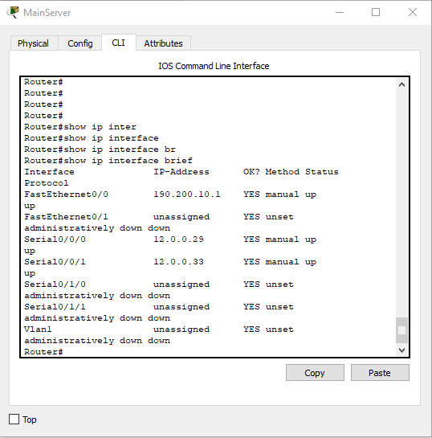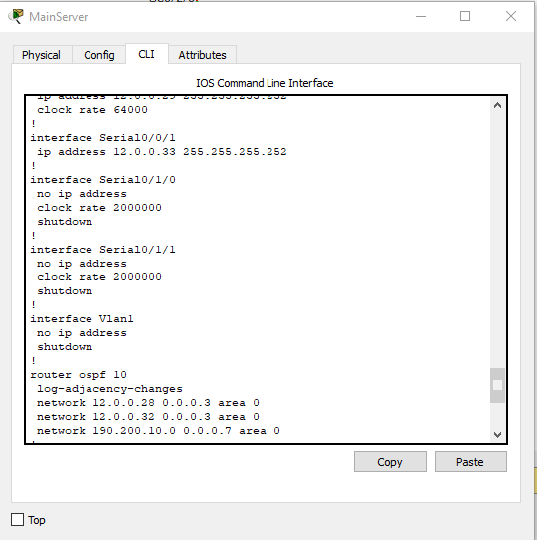Main server room: Show running config and show ip interface brief

Show ip route:

11.0.0.0/30 is subnetted, 12 subnets

O E2 11.0.0.0 [110/200] via 12.0.0.30, 00:38:48, Serial0/0/0

[110/200] via 12.0.0.33, 00:38:48, Serial0/0/1

O E2 11.0.0.4 [110/200] via 12.0.0.30, 00:38:48, Serial0/0/0

[110/200] via 12.0.0.33, 00:38:48, Serial0/0/1

O E2 11.0.0.8 [110/200] via 12.0.0.30, 00:38:48, Serial0/0/0

[110/200] via 12.0.0.33, 00:38:48, Serial0/0/1

O E2 11.0.0.12 [110/200] via 12.0.0.30, 00:38:48, Serial0/0/0

[110/200] via 12.0.0.33, 00:38:48, Serial0/0/1

O E2 11.0.0.16 [110/200] via 12.0.0.30, 00:38:48, Serial0/0/0

[110/200] via 12.0.0.33, 00:38:48, Serial0/0/1

O E2 11.0.0.20 [110/200] via 12.0.0.30, 00:38:48, Serial0/0/0

[110/200] via 12.0.0.33, 00:38:48, Serial0/0/1

O E2 11.0.0.24 [110/200] via 12.0.0.30, 00:38:48, Serial0/0/0

[110/200] via 12.0.0.33, 00:38:48, Serial0/0/1

O E2 11.0.0.28 [110/200] via 12.0.0.30, 00:38:48, Serial0/0/0

[110/200] via 12.0.0.33, 00:38:48, Serial0/0/1

O E2 11.0.0.32 [110/200] via 12.0.0.30, 00:38:48, Serial0/0/0

[110/200] via 12.0.0.33, 00:38:48, Serial0/0/1

O E2 11.0.0.36 [110/200] via 12.0.0.30, 00:38:48, Serial0/0/0

[110/200] via 12.0.0.33, 00:38:48, Serial0/0/1

O E2 11.0.0.40 [110/200] via 12.0.0.30, 00:38:48, Serial0/0/0

[110/200] via 12.0.0.33, 00:38:48, Serial0/0/1

O E2 11.0.0.44 [110/200] via 12.0.0.30, 00:38:48, Serial0/0/0

[110/200] via 12.0.0.33, 00:38:48, Serial0/0/1

12.0.0.0/30 is subnetted, 13 subnets

O 12.0.0.0 [110/128] via 12.0.0.30, 00:38:48, Serial0/0/0

O 12.0.0.4 [110/128] via 12.0.0.33, 00:38:48, Serial0/0/1

O 12.0.0.8 [110/128] via 12.0.0.30, 00:38:48, Serial0/0/0

O 12.0.0.12 [110/128] via 12.0.0.33, 00:38:48, Serial0/0/1

O 12.0.0.16 [110/128] via 12.0.0.30, 00:38:48, Serial0/0/0

O 12.0.0.20 [110/128] via 12.0.0.33, 00:38:48, Serial0/0/1

O 12.0.0.24 [110/192] via 12.0.0.30, 00:38:48, Serial0/0/0

[110/192] via 12.0.0.33, 00:38:48, Serial0/0/1

C 12.0.0.28 is directly connected, Serial0/0/0

C 12.0.0.32 is directly connected, Serial0/0/1

O 12.0.0.36 [110/128] via 12.0.0.33, 00:38:48, Serial0/0/1

O 12.0.0.40 [110/128] via 12.0.0.30, 00:38:48, Serial0/0/0

O E2 12.0.0.44 [110/200] via 12.0.0.30, 00:38:48, Serial0/0/0

[110/200] via 12.0.0.33, 00:38:48, Serial0/0/1

O E2 12.0.0.48 [110/200] via 12.0.0.30, 00:38:48, Serial0/0/0

[110/200] via 12.0.0.33, 00:38:48, Serial0/0/1

13.0.0.0/30 is subnetted, 14 subnets

O E2 13.0.0.0 [110/200] via 12.0.0.30, 00:38:48, Serial0/0/0

[110/200] via 12.0.0.33, 00:38:48, Serial0/0/1

O E2 13.0.0.4 [110/200] via 12.0.0.30, 00:38:48, Serial0/0/0

[110/200] via 12.0.0.33, 00:38:48, Serial0/0/1

O E2 13.0.0.8 [110/200] via 12.0.0.30, 00:38:48, Serial0/0/0

[110/200] via 12.0.0.33, 00:38:48, Serial0/0/1

O E2 13.0.0.16 [110/200] via 12.0.0.30, 00:38:48, Serial0/0/0

[110/200] via 12.0.0.33, 00:38:48, Serial0/0/1

O E2 13.0.0.20 [110/200] via 12.0.0.30, 00:38:48, Serial0/0/0

[110/200] via 12.0.0.33, 00:38:48, Serial0/0/1

O E2 13.0.0.24 [110/200] via 12.0.0.30, 00:38:48, Serial0/0/0

[110/200] via 12.0.0.33, 00:38:48, Serial0/0/1

O E2 13.0.0.28 [110/200] via 12.0.0.30, 00:38:48, Serial0/0/0

[110/200] via 12.0.0.33, 00:38:48, Serial0/0/1

O E2 13.0.0.32 [110/200] via 12.0.0.30, 00:38:48, Serial0/0/0

[110/200] via 12.0.0.33, 00:38:48, Serial0/0/1

O E2 13.0.0.36 [110/200] via 12.0.0.30, 00:38:48, Serial0/0/0

[110/200] via 12.0.0.33, 00:38:48, Serial0/0/1

O E2 13.0.0.40 [110/200] via 12.0.0.30, 00:38:48, Serial0/0/0

[110/200] via 12.0.0.33, 00:38:48, Serial0/0/1

O E2 13.0.0.44 [110/200] via 12.0.0.30, 00:38:48, Serial0/0/0

[110/200] via 12.0.0.33, 00:38:48, Serial0/0/1

O E2 13.0.0.48 [110/200] via 12.0.0.30, 00:38:48, Serial0/0/0

[110/200] via 12.0.0.33, 00:38:48, Serial0/0/1

O E2 13.0.0.52 [110/200] via 12.0.0.30, 00:38:48, Serial0/0/0

[110/200] via 12.0.0.33, 00:38:48, Serial0/0/1

O E2 13.0.0.56 [110/200] via 12.0.0.30, 00:38:48, Serial0/0/0

[110/200] via 12.0.0.33, 00:38:48, Serial0/0/1

15.0.0.0/30 is subnetted, 2 subnets

O E2 15.0.0.4 [110/200] via 12.0.0.30, 00:38:48, Serial0/0/0

[110/200] via 12.0.0.33, 00:38:48, Serial0/0/1

O E2 15.0.0.8 [110/200] via 12.0.0.30, 00:38:48, Serial0/0/0

[110/200] via 12.0.0.33, 00:38:48, Serial0/0/1

100.0.0.0/28 is subnetted, 3 subnets

O E2 100.16.0.0 [110/200] via 12.0.0.30, 00:38:48, Serial0/0/0

[110/200] via 12.0.0.33, 00:38:48, Serial0/0/1

O E2 100.16.0.16 [110/200] via 12.0.0.30, 00:38:48, Serial0/0/0

[110/200] via 12.0.0.33, 00:38:48, Serial0/0/1

O E2 100.16.0.32 [110/200] via 12.0.0.30, 00:38:48, Serial0/0/0

[110/200] via 12.0.0.33, 00:38:48, Serial0/0/1

172.16.0.0/28 is subnetted, 2 subnets

O E2 172.16.1.0 [110/200] via 12.0.0.30, 00:38:48, Serial0/0/0

[110/200] via 12.0.0.33, 00:38:48, Serial0/0/1

O E2 172.16.1.16 [110/200] via 12.0.0.30, 00:38:48, Serial0/0/0

[110/200] via 12.0.0.33, 00:38:48, Serial0/0/1

172.168.0.0/28 is subnetted, 3 subnets

O E2 172.168.0.0 [110/200] via 12.0.0.30, 00:38:48, Serial0/0/0

[110/200] via 12.0.0.33, 00:38:48, Serial0/0/1

O E2 172.168.0.16 [110/200] via 12.0.0.30, 00:38:48, Serial0/0/0

[110/200] via 12.0.0.33, 00:38:48, Serial0/0/1

O E2 172.168.0.32 [110/200] via 12.0.0.30, 00:38:48, Serial0/0/0

[110/200] via 12.0.0.33, 00:38:48, Serial0/0/1

190.200.0.0/29 is subnetted, 2 subnets

C 190.200.10.0 is directly connected, FastEthernet0/0

O E2 190.200.11.0 [110/200] via 12.0.0.30, 00:38:48, Serial0/0/0

[110/200] via 12.0.0.33, 00:38:48, Serial0/0/1

192.168.10.0/27 is subnetted, 3 subnets

O 192.168.10.0 [110/129] via 12.0.0.30, 00:38:48, Serial0/0/0

[110/129] via 12.0.0.33, 00:38:48, Serial0/0/1

O 192.168.10.32 [110/129] via 12.0.0.30, 00:38:48, Serial0/0/0

[110/129] via 12.0.0.33, 00:38:48, Serial0/0/1

O 192.168.10.64 [110/129] via 12.0.0.30, 00:38:48, Serial0/0/0

[110/129] via 12.0.0.33, 00:38:48, Serial0/0/1

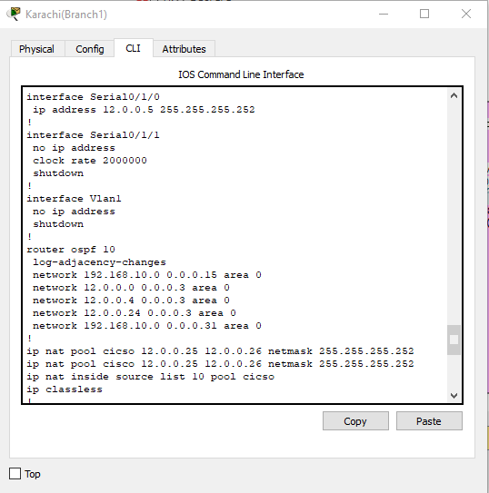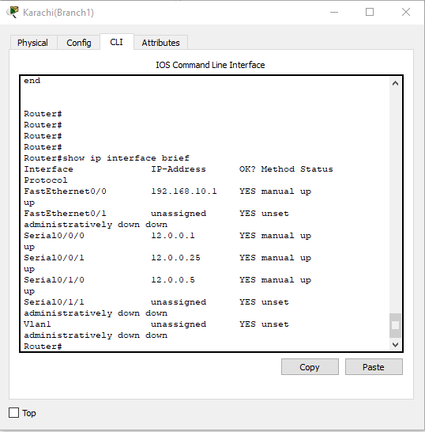Main branch 1: show running config and show ip interface brief

Show ip route:

11.0.0.0/30 is subnetted, 12 subnets

O E2 11.0.0.0 [110/200] via 12.0.0.2, 00:40:16, Serial0/0/0

[110/200] via 12.0.0.6, 00:40:16, Serial0/1/0

O E2 11.0.0.4 [110/200] via 12.0.0.2, 00:40:16, Serial0/0/0

[110/200] via 12.0.0.6, 00:40:16, Serial0/1/0

O E2 11.0.0.8 [110/200] via 12.0.0.2, 00:40:16, Serial0/0/0

[110/200] via 12.0.0.6, 00:40:16, Serial0/1/0

O E2 11.0.0.12 [110/200] via 12.0.0.2, 00:40:16, Serial0/0/0

[110/200] via 12.0.0.6, 00:40:16, Serial0/1/0

O E2 11.0.0.16 [110/200] via 12.0.0.2, 00:40:16, Serial0/0/0

[110/200] via 12.0.0.6, 00:40:16, Serial0/1/0

O E2 11.0.0.20 [110/200] via 12.0.0.2, 00:40:16, Serial0/0/0

[110/200] via 12.0.0.6, 00:40:16, Serial0/1/0

O E2 11.0.0.24 [110/200] via 12.0.0.2, 00:40:16, Serial0/0/0

[110/200] via 12.0.0.6, 00:40:16, Serial0/1/0

O E2 11.0.0.28 [110/200] via 12.0.0.2, 00:40:16, Serial0/0/0

[110/200] via 12.0.0.6, 00:40:16, Serial0/1/0

O E2 11.0.0.32 [110/200] via 12.0.0.2, 00:40:16, Serial0/0/0

[110/200] via 12.0.0.6, 00:40:16, Serial0/1/0

O E2 11.0.0.36 [110/200] via 12.0.0.2, 00:40:16, Serial0/0/0

[110/200] via 12.0.0.6, 00:40:16, Serial0/1/0

O E2 11.0.0.40 [110/200] via 12.0.0.2, 00:40:16, Serial0/0/0

[110/200] via 12.0.0.6, 00:40:16, Serial0/1/0

O E2 11.0.0.44 [110/200] via 12.0.0.2, 00:40:16, Serial0/0/0

[110/200] via 12.0.0.6, 00:40:16, Serial0/1/0

12.0.0.0/30 is subnetted, 13 subnets

C 12.0.0.0 is directly connected, Serial0/0/0

C 12.0.0.4 is directly connected, Serial0/1/0

O 12.0.0.8 [110/128] via 12.0.0.2, 00:40:16, Serial0/0/0

[110/128] via 12.0.0.26, 00:40:16, Serial0/0/1

O 12.0.0.12 [110/128] via 12.0.0.26, 00:40:16, Serial0/0/1

[110/128] via 12.0.0.6, 00:40:16, Serial0/1/0

O 12.0.0.16 [110/128] via 12.0.0.2, 00:40:16, Serial0/0/0

O 12.0.0.20 [110/128] via 12.0.0.6, 00:40:16, Serial0/1/0

C 12.0.0.24 is directly connected, Serial0/0/1

O 12.0.0.28 [110/128] via 12.0.0.2, 00:40:16, Serial0/0/0

[110/128] via 12.0.0.26, 00:40:16, Serial0/0/1

O 12.0.0.32 [110/128] via 12.0.0.6, 00:40:16, Serial0/1/0

O 12.0.0.36 [110/128] via 12.0.0.6, 00:40:16, Serial0/1/0

O 12.0.0.40 [110/128] via 12.0.0.2, 00:40:16, Serial0/0/0

O E2 12.0.0.44 [110/200] via 12.0.0.2, 00:40:16, Serial0/0/0

[110/200] via 12.0.0.6, 00:40:16, Serial0/1/0

O E2 12.0.0.48 [110/200] via 12.0.0.2, 00:40:16, Serial0/0/0

[110/200] via 12.0.0.6, 00:40:16, Serial0/1/0

13.0.0.0/30 is subnetted, 14 subnets

O E2 13.0.0.0 [110/200] via 12.0.0.2, 00:40:16, Serial0/0/0

[110/200] via 12.0.0.6, 00:40:16, Serial0/1/0

O E2 13.0.0.4 [110/200] via 12.0.0.2, 00:40:16, Serial0/0/0

[110/200] via 12.0.0.6, 00:40:16, Serial0/1/0

O E2 13.0.0.8 [110/200] via 12.0.0.2, 00:40:16, Serial0/0/0

[110/200] via 12.0.0.6, 00:40:16, Serial0/1/0

O E2 13.0.0.16 [110/200] via 12.0.0.2, 00:40:16, Serial0/0/0

[110/200] via 12.0.0.6, 00:40:16, Serial0/1/0

O E2 13.0.0.20 [110/200] via 12.0.0.2, 00:40:16, Serial0/0/0

[110/200] via 12.0.0.6, 00:40:16, Serial0/1/0

O E2 13.0.0.24 [110/200] via 12.0.0.2, 00:40:16, Serial0/0/0

[110/200] via 12.0.0.6, 00:40:16, Serial0/1/0

O E2 13.0.0.28 [110/200] via 12.0.0.2, 00:40:16, Serial0/0/0

[110/200] via 12.0.0.6, 00:40:16, Serial0/1/0

O E2 13.0.0.32 [110/200] via 12.0.0.2, 00:40:16, Serial0/0/0

[110/200] via 12.0.0.6, 00:40:16, Serial0/1/0

O E2 13.0.0.36 [110/200] via 12.0.0.2, 00:40:16, Serial0/0/0

[110/200] via 12.0.0.6, 00:40:16, Serial0/1/0

O E2 13.0.0.40 [110/200] via 12.0.0.2, 00:40:16, Serial0/0/0

[110/200] via 12.0.0.6, 00:40:16, Serial0/1/0

O E2 13.0.0.44 [110/200] via 12.0.0.2, 00:40:16, Serial0/0/0

[110/200] via 12.0.0.6, 00:40:16, Serial0/1/0

O E2 13.0.0.48 [110/200] via 12.0.0.2, 00:40:16, Serial0/0/0

[110/200] via 12.0.0.6, 00:40:16, Serial0/1/0

O E2 13.0.0.52 [110/200] via 12.0.0.2, 00:40:16, Serial0/0/0

[110/200] via 12.0.0.6, 00:40:16, Serial0/1/0

O E2 13.0.0.56 [110/200] via 12.0.0.2, 00:40:16, Serial0/0/0

[110/200] via 12.0.0.6, 00:40:16, Serial0/1/0

15.0.0.0/30 is subnetted, 2 subnets

O E2 15.0.0.4 [110/200] via 12.0.0.2, 00:40:16, Serial0/0/0

[110/200] via 12.0.0.6, 00:40:16, Serial0/1/0

O E2 15.0.0.8 [110/200] via 12.0.0.2, 00:40:16, Serial0/0/0

[110/200] via 12.0.0.6, 00:40:16, Serial0/1/0

100.0.0.0/28 is subnetted, 3 subnets

O E2 100.16.0.0 [110/200] via 12.0.0.2, 00:40:16, Serial0/0/0

[110/200] via 12.0.0.6, 00:40:16, Serial0/1/0

O E2 100.16.0.16 [110/200] via 12.0.0.2, 00:40:16, Serial0/0/0

[110/200] via 12.0.0.6, 00:40:16, Serial0/1/0

O E2 100.16.0.32 [110/200] via 12.0.0.2, 00:40:16, Serial0/0/0

[110/200] via 12.0.0.6, 00:40:16, Serial0/1/0

172.16.0.0/28 is subnetted, 2 subnets

O E2 172.16.1.0 [110/200] via 12.0.0.2, 00:40:16, Serial0/0/0

[110/200] via 12.0.0.6, 00:40:16, Serial0/1/0

O E2 172.16.1.16 [110/200] via 12.0.0.2, 00:40:16, Serial0/0/0

[110/200] via 12.0.0.6, 00:40:16, Serial0/1/0

172.168.0.0/28 is subnetted, 3 subnets

O E2 172.168.0.0 [110/200] via 12.0.0.2, 00:40:16, Serial0/0/0

[110/200] via 12.0.0.6, 00:40:16, Serial0/1/0

O E2 172.168.0.16 [110/200] via 12.0.0.2, 00:40:16, Serial0/0/0

[110/200] via 12.0.0.6, 00:40:16, Serial0/1/0

O E2 172.168.0.32 [110/200] via 12.0.0.2, 00:40:16, Serial0/0/0

[110/200] via 12.0.0.6, 00:40:16, Serial0/1/0

190.200.0.0/29 is subnetted, 2 subnets

O 190.200.10.0 [110/129] via 12.0.0.2, 00:40:16, Serial0/0/0

[110/129] via 12.0.0.6, 00:40:16, Serial0/1/0

O E2 190.200.11.0 [110/200] via 12.0.0.2, 00:40:16, Serial0/0/0

[110/200] via 12.0.0.6, 00:40:16, Serial0/1/0

192.168.10.0/27 is subnetted, 3 subnets

C 192.168.10.0 is directly connected, FastEthernet0/0

O 192.168.10.32 [110/65] via 12.0.0.26, 00:40:16, Serial0/0/1

O 192.168.10.64 [110/129] via 12.0.0.2, 00:40:16, Serial0/0/0

[110/129] via 12.0.0.26, 00:40:16, Serial0/0/1

[110/129] via 12.0.0.6, 00:40:16, Serial0/1/0

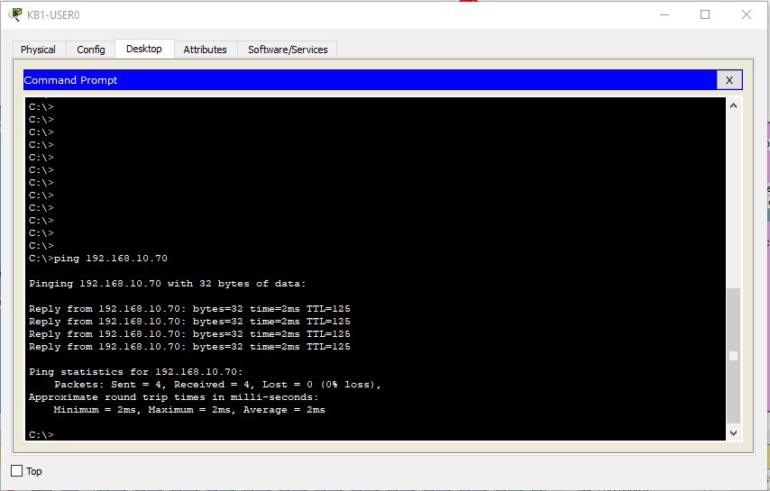Ping response for Natting:

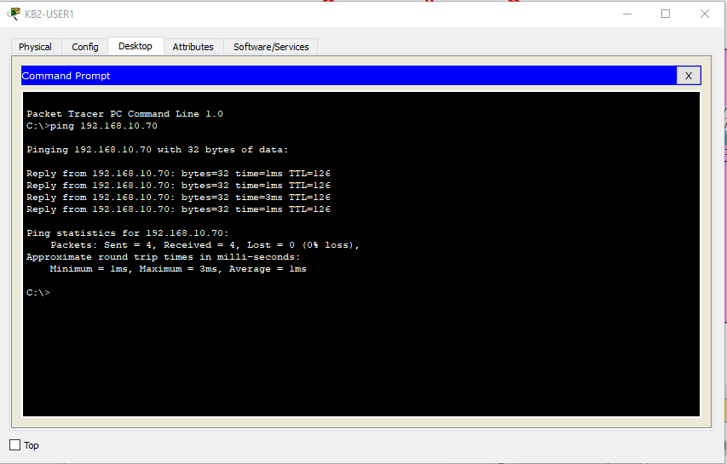Ping response for ACL in branch 2

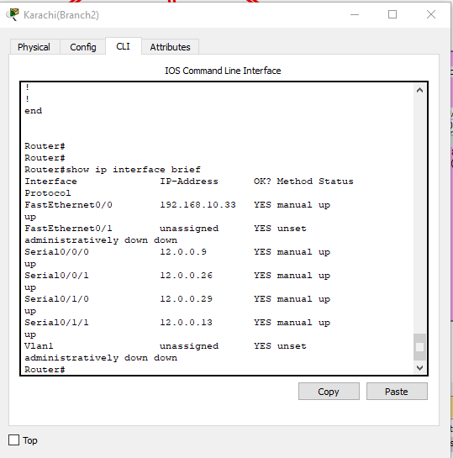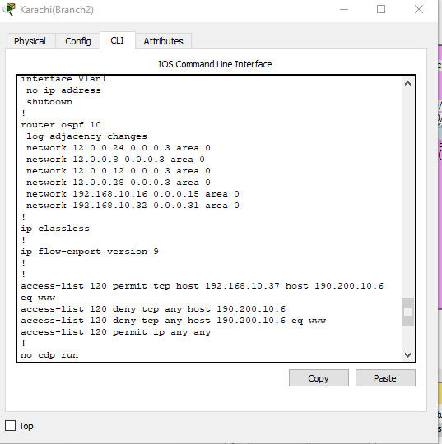Karachi Main branch 2: show running config and show ip interface brief

Show ip route:

11.0.0.0/30 is subnetted, 12 subnets

O E2 11.0.0.0 [110/200] via 12.0.0.10, 00:08:38, Serial0/0/0

[110/200] via 12.0.0.14, 00:08:38, Serial0/1/1

O E2 11.0.0.4 [110/200] via 12.0.0.10, 00:08:38, Serial0/0/0

[110/200] via 12.0.0.14, 00:08:38, Serial0/1/1

O E2 11.0.0.8 [110/200] via 12.0.0.10, 00:08:38, Serial0/0/0

[110/200] via 12.0.0.14, 00:08:38, Serial0/1/1

O E2 11.0.0.12 [110/200] via 12.0.0.10, 00:08:38, Serial0/0/0

[110/200] via 12.0.0.14, 00:08:38, Serial0/1/1

O E2 11.0.0.16 [110/200] via 12.0.0.10, 00:08:38, Serial0/0/0

[110/200] via 12.0.0.14, 00:08:38, Serial0/1/1

O E2 11.0.0.20 [110/200] via 12.0.0.10, 00:08:38, Serial0/0/0

[110/200] via 12.0.0.14, 00:08:38, Serial0/1/1

O E2 11.0.0.24 [110/200] via 12.0.0.10, 00:08:38, Serial0/0/0

[110/200] via 12.0.0.14, 00:08:38, Serial0/1/1

O E2 11.0.0.28 [110/200] via 12.0.0.10, 00:08:38, Serial0/0/0

[110/200] via 12.0.0.14, 00:08:38, Serial0/1/1

O E2 11.0.0.32 [110/200] via 12.0.0.10, 00:08:38, Serial0/0/0

[110/200] via 12.0.0.14, 00:08:38, Serial0/1/1

O E2 11.0.0.36 [110/200] via 12.0.0.10, 00:08:38, Serial0/0/0

[110/200] via 12.0.0.14, 00:08:38, Serial0/1/1

O E2 11.0.0.40 [110/200] via 12.0.0.10, 00:08:38, Serial0/0/0

[110/200] via 12.0.0.14, 00:08:38, Serial0/1/1

O E2 11.0.0.44 [110/200] via 12.0.0.10, 00:08:38, Serial0/0/0

[110/200] via 12.0.0.14, 00:08:38, Serial0/1/1

12.0.0.0/30 is subnetted, 13 subnets

O 12.0.0.0 [110/128] via 12.0.0.25, 00:08:38, Serial0/0/1

[110/128] via 12.0.0.10, 00:08:38, Serial0/0/0

O 12.0.0.4 [110/128] via 12.0.0.25, 00:08:38, Serial0/0/1

[110/128] via 12.0.0.14, 00:08:38, Serial0/1/1

C 12.0.0.8 is directly connected, Serial0/0/0

C 12.0.0.12 is directly connected, Serial0/1/1

O 12.0.0.16 [110/128] via 12.0.0.10, 00:08:38, Serial0/0/0

[110/128] via 12.0.0.30, 00:08:38, Serial0/1/0

O 12.0.0.20 [110/128] via 12.0.0.14, 00:08:38, Serial0/1/1

[110/128] via 12.0.0.30, 00:08:38, Serial0/1/0

C 12.0.0.24 is directly connected, Serial0/0/1

C 12.0.0.28 is directly connected, Serial0/1/0

O 12.0.0.32 [110/128] via 12.0.0.14, 00:08:38, Serial0/1/1

O 12.0.0.36 [110/128] via 12.0.0.14, 00:08:38, Serial0/1/1

O 12.0.0.40 [110/128] via 12.0.0.10, 00:08:38, Serial0/0/0

O E2 12.0.0.44 [110/200] via 12.0.0.10, 00:08:38, Serial0/0/0

[110/200] via 12.0.0.14, 00:08:38, Serial0/1/1

O E2 12.0.0.48 [110/200] via 12.0.0.10, 00:08:38, Serial0/0/0

[110/200] via 12.0.0.14, 00:08:38, Serial0/1/1

13.0.0.0/30 is subnetted, 14 subnets

O E2 13.0.0.0 [110/200] via 12.0.0.10, 00:08:38, Serial0/0/0

[110/200] via 12.0.0.14, 00:08:38, Serial0/1/1

O E2 13.0.0.4 [110/200] via 12.0.0.10, 00:08:38, Serial0/0/0

[110/200] via 12.0.0.14, 00:08:38, Serial0/1/1

O E2 13.0.0.8 [110/200] via 12.0.0.10, 00:08:38, Serial0/0/0

[110/200] via 12.0.0.14, 00:08:38, Serial0/1/1

O E2 13.0.0.16 [110/200] via 12.0.0.10, 00:08:38, Serial0/0/0

[110/200] via 12.0.0.14, 00:08:38, Serial0/1/1

O E2 13.0.0.20 [110/200] via 12.0.0.10, 00:08:38, Serial0/0/0

[110/200] via 12.0.0.14, 00:08:38, Serial0/1/1

O E2 13.0.0.24 [110/200] via 12.0.0.10, 00:08:38, Serial0/0/0

[110/200] via 12.0.0.14, 00:08:38, Serial0/1/1

O E2 13.0.0.28 [110/200] via 12.0.0.10, 00:08:38, Serial0/0/0

[110/200] via 12.0.0.14, 00:08:38, Serial0/1/1

O E2 13.0.0.32 [110/200] via 12.0.0.10, 00:08:38, Serial0/0/0

[110/200] via 12.0.0.14, 00:08:38, Serial0/1/1

O E2 13.0.0.36 [110/200] via 12.0.0.10, 00:08:38, Serial0/0/0

[110/200] via 12.0.0.14, 00:08:38, Serial0/1/1

O E2 13.0.0.40 [110/200] via 12.0.0.10, 00:08:38, Serial0/0/0

[110/200] via 12.0.0.14, 00:08:38, Serial0/1/1

O E2 13.0.0.44 [110/200] via 12.0.0.10, 00:08:38, Serial0/0/0

[110/200] via 12.0.0.14, 00:08:38, Serial0/1/1

O E2 13.0.0.48 [110/200] via 12.0.0.10, 00:08:38, Serial0/0/0

[110/200] via 12.0.0.14, 00:08:38, Serial0/1/1

O E2 13.0.0.52 [110/200] via 12.0.0.10, 00:08:38, Serial0/0/0

[110/200] via 12.0.0.14, 00:08:38, Serial0/1/1

O E2 13.0.0.56 [110/200] via 12.0.0.10, 00:08:38, Serial0/0/0

[110/200] via 12.0.0.14, 00:08:38, Serial0/1/1

15.0.0.0/30 is subnetted, 2 subnets

O E2 15.0.0.4 [110/200] via 12.0.0.10, 00:08:38, Serial0/0/0

[110/200] via 12.0.0.14, 00:08:38, Serial0/1/1

O E2 15.0.0.8 [110/200] via 12.0.0.10, 00:08:38, Serial0/0/0

[110/200] via 12.0.0.14, 00:08:38, Serial0/1/1

100.0.0.0/28 is subnetted, 3 subnets

O E2 100.16.0.0 [110/200] via 12.0.0.10, 00:08:38, Serial0/0/0

[110/200] via 12.0.0.14, 00:08:38, Serial0/1/1

O E2 100.16.0.16 [110/200] via 12.0.0.10, 00:08:38, Serial0/0/0

[110/200] via 12.0.0.14, 00:08:38, Serial0/1/1

O E2 100.16.0.32 [110/200] via 12.0.0.10, 00:08:38, Serial0/0/0

[110/200] via 12.0.0.14, 00:08:38, Serial0/1/1

172.16.0.0/28 is subnetted, 2 subnets

O E2 172.16.1.0 [110/200] via 12.0.0.10, 00:08:38, Serial0/0/0

[110/200] via 12.0.0.14, 00:08:38, Serial0/1/1

O E2 172.16.1.16 [110/200] via 12.0.0.10, 00:08:38, Serial0/0/0

[110/200] via 12.0.0.14, 00:08:38, Serial0/1/1

172.168.0.0/28 is subnetted, 3 subnets

O E2 172.168.0.0 [110/200] via 12.0.0.10, 00:08:38, Serial0/0/0

[110/200] via 12.0.0.14, 00:08:38, Serial0/1/1

O E2 172.168.0.16 [110/200] via 12.0.0.10, 00:08:38, Serial0/0/0

[110/200] via 12.0.0.14, 00:08:38, Serial0/1/1

O E2 172.168.0.32 [110/200] via 12.0.0.10, 00:08:38, Serial0/0/0

[110/200] via 12.0.0.14, 00:08:38, Serial0/1/1

190.200.0.0/29 is subnetted, 2 subnets

O 190.200.10.0 [110/129] via 12.0.0.10, 00:08:38, Serial0/0/0

[110/129] via 12.0.0.14, 00:08:38, Serial0/1/1

O E2 190.200.11.0 [110/200] via 12.0.0.10, 00:08:38, Serial0/0/0

[110/200] via 12.0.0.14, 00:08:38, Serial0/1/1

192.168.10.0/27 is subnetted, 3 subnets

O 192.168.10.0 [110/65] via 12.0.0.25, 00:08:38, Serial0/0/1

C 192.168.10.32 is directly connected, FastEthernet0/0

O 192.168.10.64 [110/65] via 12.0.0.30, 00:08:38, Serial0/1/0

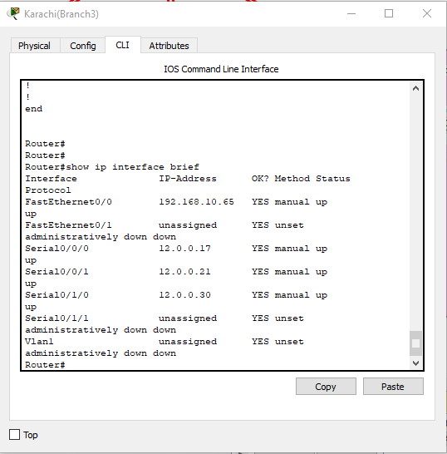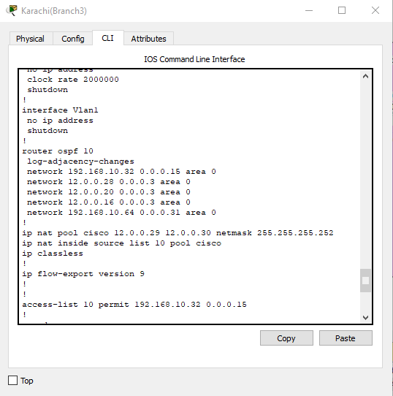Karachi main branch 3: show ip config and show ip interface brief

Show ip route:

11.0.0.0/30 is subnetted, 12 subnets

O E2 11.0.0.0 [110/200] via 12.0.0.22, 00:10:00, Serial0/0/1

[110/200] via 12.0.0.18, 00:10:00, Serial0/0/0

O E2 11.0.0.4 [110/200] via 12.0.0.22, 00:10:00, Serial0/0/1

[110/200] via 12.0.0.18, 00:10:00, Serial0/0/0

O E2 11.0.0.8 [110/200] via 12.0.0.22, 00:10:00, Serial0/0/1

[110/200] via 12.0.0.18, 00:10:00, Serial0/0/0

O E2 11.0.0.12 [110/200] via 12.0.0.22, 00:10:00, Serial0/0/1

[110/200] via 12.0.0.18, 00:10:00, Serial0/0/0

O E2 11.0.0.16 [110/200] via 12.0.0.22, 00:10:00, Serial0/0/1

[110/200] via 12.0.0.18, 00:10:00, Serial0/0/0

O E2 11.0.0.20 [110/200] via 12.0.0.22, 00:10:00, Serial0/0/1

[110/200] via 12.0.0.18, 00:10:00, Serial0/0/0

O E2 11.0.0.24 [110/200] via 12.0.0.22, 00:10:00, Serial0/0/1

[110/200] via 12.0.0.18, 00:10:00, Serial0/0/0

O E2 11.0.0.28 [110/200] via 12.0.0.22, 00:10:00, Serial0/0/1

[110/200] via 12.0.0.18, 00:10:00, Serial0/0/0

O E2 11.0.0.32 [110/200] via 12.0.0.22, 00:10:00, Serial0/0/1

[110/200] via 12.0.0.18, 00:10:00, Serial0/0/0

O E2 11.0.0.36 [110/200] via 12.0.0.22, 00:10:00, Serial0/0/1

[110/200] via 12.0.0.18, 00:10:00, Serial0/0/0

O E2 11.0.0.40 [110/200] via 12.0.0.22, 00:10:00, Serial0/0/1

[110/200] via 12.0.0.18, 00:10:00, Serial0/0/0

O E2 11.0.0.44 [110/200] via 12.0.0.22, 00:10:00, Serial0/0/1

[110/200] via 12.0.0.18, 00:10:00, Serial0/0/0

12.0.0.0/30 is subnetted, 13 subnets

O 12.0.0.0 [110/128] via 12.0.0.18, 00:10:00, Serial0/0/0

O 12.0.0.4 [110/128] via 12.0.0.22, 00:10:00, Serial0/0/1

O 12.0.0.8 [110/128] via 12.0.0.18, 00:10:00, Serial0/0/0

[110/128] via 12.0.0.29, 00:10:00, Serial0/1/0

O 12.0.0.12 [110/128] via 12.0.0.22, 00:10:00, Serial0/0/1

[110/128] via 12.0.0.29, 00:10:00, Serial0/1/0

C 12.0.0.16 is directly connected, Serial0/0/0

C 12.0.0.20 is directly connected, Serial0/0/1

O 12.0.0.24 [110/128] via 12.0.0.29, 00:10:00, Serial0/1/0

C 12.0.0.28 is directly connected, Serial0/1/0

O 12.0.0.32 [110/128] via 12.0.0.22, 00:10:00, Serial0/0/1

O 12.0.0.36 [110/128] via 12.0.0.22, 00:10:00, Serial0/0/1

O 12.0.0.40 [110/128] via 12.0.0.18, 00:10:00, Serial0/0/0

O E2 12.0.0.44 [110/200] via 12.0.0.22, 00:10:00, Serial0/0/1

[110/200] via 12.0.0.18, 00:10:00, Serial0/0/0

O E2 12.0.0.48 [110/200] via 12.0.0.22, 00:10:00, Serial0/0/1

[110/200] via 12.0.0.18, 00:10:00, Serial0/0/0

13.0.0.0/30 is subnetted, 14 subnets

O E2 13.0.0.0 [110/200] via 12.0.0.22, 00:10:00, Serial0/0/1

[110/200] via 12.0.0.18, 00:10:00, Serial0/0/0

O E2 13.0.0.4 [110/200] via 12.0.0.22, 00:10:00, Serial0/0/1

[110/200] via 12.0.0.18, 00:10:00, Serial0/0/0

O E2 13.0.0.8 [110/200] via 12.0.0.22, 00:10:00, Serial0/0/1

[110/200] via 12.0.0.18, 00:10:00, Serial0/0/0

O E2 13.0.0.16 [110/200] via 12.0.0.22, 00:10:00, Serial0/0/1

[110/200] via 12.0.0.18, 00:10:00, Serial0/0/0

O E2 13.0.0.20 [110/200] via 12.0.0.22, 00:10:00, Serial0/0/1

[110/200] via 12.0.0.18, 00:10:00, Serial0/0/0

O E2 13.0.0.24 [110/200] via 12.0.0.22, 00:10:00, Serial0/0/1

[110/200] via 12.0.0.18, 00:10:00, Serial0/0/0

O E2 13.0.0.28 [110/200] via 12.0.0.22, 00:10:00, Serial0/0/1

[110/200] via 12.0.0.18, 00:10:00, Serial0/0/0

O E2 13.0.0.32 [110/200] via 12.0.0.22, 00:10:00, Serial0/0/1

[110/200] via 12.0.0.18, 00:10:00, Serial0/0/0

O E2 13.0.0.36 [110/200] via 12.0.0.22, 00:10:00, Serial0/0/1

[110/200] via 12.0.0.18, 00:10:00, Serial0/0/0

O E2 13.0.0.40 [110/200] via 12.0.0.22, 00:10:00, Serial0/0/1

[110/200] via 12.0.0.18, 00:10:00, Serial0/0/0

O E2 13.0.0.44 [110/200] via 12.0.0.22, 00:10:00, Serial0/0/1

[110/200] via 12.0.0.18, 00:10:00, Serial0/0/0

O E2 13.0.0.48 [110/200] via 12.0.0.22, 00:10:00, Serial0/0/1

[110/200] via 12.0.0.18, 00:10:00, Serial0/0/0

O E2 13.0.0.52 [110/200] via 12.0.0.22, 00:10:00, Serial0/0/1

[110/200] via 12.0.0.18, 00:10:00, Serial0/0/0

O E2 13.0.0.56 [110/200] via 12.0.0.22, 00:10:00, Serial0/0/1

[110/200] via 12.0.0.18, 00:10:00, Serial0/0/0

15.0.0.0/30 is subnetted, 2 subnets

O E2 15.0.0.4 [110/200] via 12.0.0.22, 00:10:00, Serial0/0/1

[110/200] via 12.0.0.18, 00:10:00, Serial0/0/0

O E2 15.0.0.8 [110/200] via 12.0.0.22, 00:10:00, Serial0/0/1

[110/200] via 12.0.0.18, 00:10:00, Serial0/0/0

100.0.0.0/28 is subnetted, 3 subnets

O E2 100.16.0.0 [110/200] via 12.0.0.22, 00:10:00, Serial0/0/1

[110/200] via 12.0.0.18, 00:10:00, Serial0/0/0

O E2 100.16.0.16 [110/200] via 12.0.0.22, 00:10:00, Serial0/0/1

[110/200] via 12.0.0.18, 00:10:00, Serial0/0/0

O E2 100.16.0.32 [110/200] via 12.0.0.22, 00:10:00, Serial0/0/1

[110/200] via 12.0.0.18, 00:10:00, Serial0/0/0

172.16.0.0/28 is subnetted, 2 subnets

O E2 172.16.1.0 [110/200] via 12.0.0.22, 00:10:00, Serial0/0/1

[110/200] via 12.0.0.18, 00:10:00, Serial0/0/0

O E2 172.16.1.16 [110/200] via 12.0.0.22, 00:10:00, Serial0/0/1

[110/200] via 12.0.0.18, 00:10:00, Serial0/0/0

172.168.0.0/28 is subnetted, 3 subnets

O E2 172.168.0.0 [110/200] via 12.0.0.22, 00:10:00, Serial0/0/1

[110/200] via 12.0.0.18, 00:10:00, Serial0/0/0

O E2 172.168.0.16 [110/200] via 12.0.0.22, 00:10:00, Serial0/0/1

[110/200] via 12.0.0.18, 00:10:00, Serial0/0/0

O E2 172.168.0.32 [110/200] via 12.0.0.22, 00:10:00, Serial0/0/1

[110/200] via 12.0.0.18, 00:10:00, Serial0/0/0

190.200.0.0/29 is subnetted, 2 subnets

O 190.200.10.0 [110/129] via 12.0.0.22, 00:10:00, Serial0/0/1

[110/129] via 12.0.0.18, 00:10:00, Serial0/0/0

O E2 190.200.11.0 [110/200] via 12.0.0.22, 00:10:00, Serial0/0/1

[110/200] via 12.0.0.18, 00:10:00, Serial0/0/0

192.168.10.0/27 is subnetted, 3 subnets

O 192.168.10.0 [110/129] via 12.0.0.22, 00:10:00, Serial0/0/1

[110/129] via 12.0.0.18, 00:10:00, Serial0/0/0

[110/129] via 12.0.0.29, 00:10:00, Serial0/1/0

O 192.168.10.32 [110/65] via 12.0.0.29, 00:10:00, Serial0/1/0

C 192.168.10.64 is directly connected, FastEthernet0/0

ISLAMABAD ROUTER CONFIGURATIONS:

Backup router Configuration:

Show running configuration and show ip interface brief

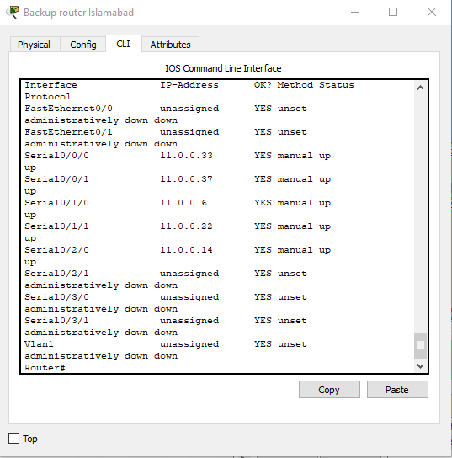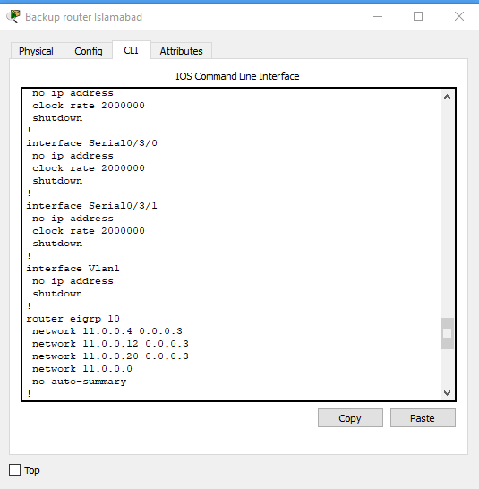show ip route:

11.0.0.0/30 is subnetted, 12 subnets

D 11.0.0.0 [90/2681856] via 11.0.0.5, 00:16:57, Serial0/1/0

C 11.0.0.4 is directly connected, Serial0/1/0

D 11.0.0.8 [90/2681856] via 11.0.0.13, 00:16:55, Serial0/2/0

C 11.0.0.12 is directly connected, Serial0/2/0

D 11.0.0.16 [90/2681856] via 11.0.0.21, 00:16:55, Serial0/1/1

C 11.0.0.20 is directly connected, Serial0/1/1

D 11.0.0.24 [90/2681856] via 11.0.0.5, 00:16:56, Serial0/1/0

[90/2681856] via 11.0.0.13, 00:16:56, Serial0/2/0

D 11.0.0.28 [90/2681856] via 11.0.0.21, 00:16:55, Serial0/1/1

[90/2681856] via 11.0.0.13, 00:16:55, Serial0/2/0

C 11.0.0.32 is directly connected, Serial0/0/0

C 11.0.0.36 is directly connected, Serial0/0/1

D 11.0.0.40 [90/2681856] via 11.0.0.34, 00:16:52, Serial0/0/0

D 11.0.0.44 [90/2681856] via 11.0.0.38, 00:16:57, Serial0/0/1

12.0.0.0/30 is subnetted, 13 subnets

D EX 12.0.0.0 [170/3074560] via 11.0.0.34, 00:16:34, Serial0/0/0

D EX 12.0.0.4 [170/3074560] via 11.0.0.34, 00:16:34, Serial0/0/0

D EX 12.0.0.8 [170/3074560] via 11.0.0.34, 00:16:34, Serial0/0/0

D EX 12.0.0.12 [170/3074560] via 11.0.0.34, 00:16:34, Serial0/0/0

D EX 12.0.0.16 [170/3074560] via 11.0.0.34, 00:16:34, Serial0/0/0

D EX 12.0.0.20 [170/3074560] via 11.0.0.34, 00:16:34, Serial0/0/0

D EX 12.0.0.24 [170/3074560] via 11.0.0.34, 00:16:34, Serial0/0/0

D EX 12.0.0.28 [170/3074560] via 11.0.0.34, 00:16:34, Serial0/0/0

D EX 12.0.0.32 [170/3074560] via 11.0.0.34, 00:16:34, Serial0/0/0

D EX 12.0.0.36 [170/3074560] via 11.0.0.34, 00:16:56, Serial0/0/0

D EX 12.0.0.40 [170/3074560] via 11.0.0.34, 00:16:56, Serial0/0/0

D EX 12.0.0.44 [170/3072000] via 11.0.0.38, 00:16:52, Serial0/0/1

D EX 12.0.0.48 [170/3072000] via 11.0.0.38, 00:16:52, Serial0/0/1

13.0.0.0/30 is subnetted, 14 subnets

D EX 13.0.0.0 [170/3072000] via 11.0.0.38, 00:16:54, Serial0/0/1

D EX 13.0.0.4 [170/3072000] via 11.0.0.38, 00:16:55, Serial0/0/1

D EX 13.0.0.8 [170/3072000] via 11.0.0.38, 00:16:53, Serial0/0/1

D EX 13.0.0.16 [170/3072000] via 11.0.0.38, 00:16:55, Serial0/0/1

D EX 13.0.0.20 [170/3072000] via 11.0.0.38, 00:16:53, Serial0/0/1

D EX 13.0.0.24 [170/3072000] via 11.0.0.38, 00:16:53, Serial0/0/1

D EX 13.0.0.28 [170/3072000] via 11.0.0.38, 00:16:52, Serial0/0/1

D EX 13.0.0.32 [170/3072000] via 11.0.0.38, 00:16:53, Serial0/0/1

D EX 13.0.0.36 [170/3072000] via 11.0.0.38, 00:16:54, Serial0/0/1

D EX 13.0.0.40 [170/3072000] via 11.0.0.38, 00:16:53, Serial0/0/1

D EX 13.0.0.44 [170/3072000] via 11.0.0.38, 00:16:57, Serial0/0/1

D EX 13.0.0.48 [170/3072000] via 11.0.0.38, 00:16:57, Serial0/0/1

D EX 13.0.0.52 [170/3072000] via 11.0.0.38, 00:16:52, Serial0/0/1

D EX 13.0.0.56 [170/3072000] via 11.0.0.38, 00:16:54, Serial0/0/1

15.0.0.0/30 is subnetted, 2 subnets

D EX 15.0.0.4 [170/3072000] via 11.0.0.38, 00:16:52, Serial0/0/1

D EX 15.0.0.8 [170/3072000] via 11.0.0.38, 00:16:52, Serial0/0/1

100.0.0.0/28 is subnetted, 3 subnets

D EX 100.16.0.0 [170/3072000] via 11.0.0.38, 00:16:54, Serial0/0/1

D EX 100.16.0.16 [170/3072000] via 11.0.0.38, 00:16:53, Serial0/0/1

D EX 100.16.0.32 [170/3072000] via 11.0.0.38, 00:16:53, Serial0/0/1

172.16.0.0/28 is subnetted, 2 subnets

D EX 172.16.1.0 [170/3072000] via 11.0.0.38, 00:16:52, Serial0/0/1

D EX 172.16.1.16 [170/3072000] via 11.0.0.38, 00:16:52, Serial0/0/1

172.168.0.0/28 is subnetted, 3 subnets

D 172.168.0.0 [90/2172416] via 11.0.0.5, 00:16:57, Serial0/1/0

D 172.168.0.16 [90/2172416] via 11.0.0.13, 00:16:56, Serial0/2/0

D 172.168.0.32 [90/2172416] via 11.0.0.21, 00:16:57, Serial0/1/1

190.200.0.0/29 is subnetted, 2 subnets

D EX 190.200.10.0 [170/3074560] via 11.0.0.34, 00:16:34, Serial0/0/0

D EX 190.200.11.0 [170/3072000] via 11.0.0.38, 00:16:54, Serial0/0/1

192.168.10.0/27 is subnetted, 3 subnets

D EX 192.168.10.0 [170/3074560] via 11.0.0.34, 00:16:34, Serial0/0/0

D EX 192.168.10.32 [170/3074560] via 11.0.0.34, 00:16:34, Serial0/0/0

D EX 192.168.10.64 [170/3074560] via 11.0.0.34, 00:16:34, Serial0/0/0

Main Islamabad:

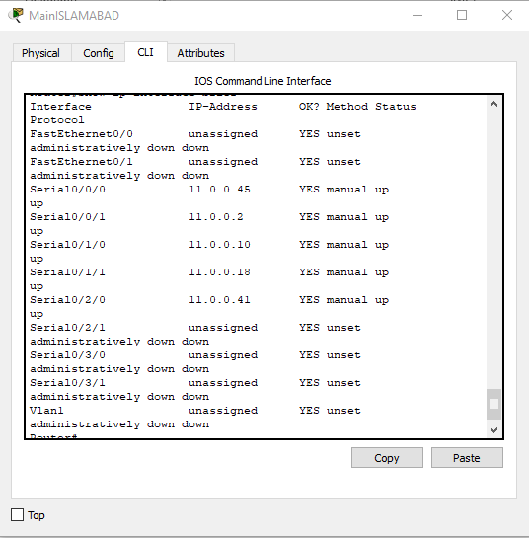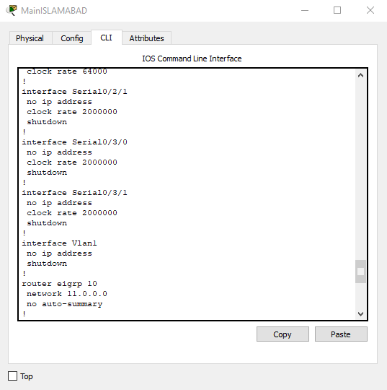 show running configuration and show ip interface brief

show ip route:

11.0.0.0/30 is subnetted, 12 subnets

C 11.0.0.0 is directly connected, Serial0/0/1

D 11.0.0.4 [90/2681856] via 11.0.0.1, 00:17:40, Serial0/0/1

C 11.0.0.8 is directly connected, Serial0/1/0

D 11.0.0.12 [90/2681856] via 11.0.0.9, 00:17:39, Serial0/1/0

C 11.0.0.16 is directly connected, Serial0/1/1

D 11.0.0.20 [90/3193856] via 11.0.0.1, 00:17:40, Serial0/0/1

[90/3193856] via 11.0.0.9, 00:17:37, Serial0/1/0

[90/3193856] via 11.0.0.46, 00:17:36, Serial0/0/0

[90/3193856] via 11.0.0.42, 00:17:35, Serial0/2/0

D 11.0.0.24 [90/2681856] via 11.0.0.1, 00:17:40, Serial0/0/1

[90/2681856] via 11.0.0.9, 00:17:39, Serial0/1/0

D 11.0.0.28 [90/2681856] via 11.0.0.9, 00:17:39, Serial0/1/0

D 11.0.0.32 [90/2681856] via 11.0.0.42, 00:17:35, Serial0/2/0

D 11.0.0.36 [90/2681856] via 11.0.0.46, 00:17:37, Serial0/0/0

C 11.0.0.40 is directly connected, Serial0/2/0

C 11.0.0.44 is directly connected, Serial0/0/0

12.0.0.0/30 is subnetted, 13 subnets

D EX 12.0.0.0 [170/3074560] via 11.0.0.42, 00:17:17, Serial0/2/0

D EX 12.0.0.4 [170/3074560] via 11.0.0.42, 00:17:17, Serial0/2/0

D EX 12.0.0.8 [170/3074560] via 11.0.0.42, 00:17:17, Serial0/2/0

D EX 12.0.0.12 [170/3074560] via 11.0.0.42, 00:17:17, Serial0/2/0

D EX 12.0.0.16 [170/3074560] via 11.0.0.42, 00:17:17, Serial0/2/0

D EX 12.0.0.20 [170/3074560] via 11.0.0.42, 00:17:17, Serial0/2/0

D EX 12.0.0.24 [170/3074560] via 11.0.0.42, 00:17:17, Serial0/2/0

D EX 12.0.0.28 [170/3074560] via 11.0.0.42, 00:17:17, Serial0/2/0

D EX 12.0.0.32 [170/3074560] via 11.0.0.42, 00:17:17, Serial0/2/0

D EX 12.0.0.36 [170/3074560] via 11.0.0.42, 00:17:39, Serial0/2/0

D EX 12.0.0.40 [170/3074560] via 11.0.0.42, 00:17:39, Serial0/2/0

D EX 12.0.0.44 [170/3072000] via 11.0.0.46, 00:17:36, Serial0/0/0

D EX 12.0.0.48 [170/3072000] via 11.0.0.46, 00:17:36, Serial0/0/0

13.0.0.0/30 is subnetted, 14 subnets

D EX 13.0.0.0 [170/3072000] via 11.0.0.46, 00:17:39, Serial0/0/0

D EX 13.0.0.4 [170/3072000] via 11.0.0.46, 00:17:39, Serial0/0/0

D EX 13.0.0.8 [170/3072000] via 11.0.0.46, 00:17:39, Serial0/0/0

D EX 13.0.0.16 [170/3072000] via 11.0.0.46, 00:17:39, Serial0/0/0

D EX 13.0.0.20 [170/3072000] via 11.0.0.46, 00:17:39, Serial0/0/0

D EX 13.0.0.24 [170/3072000] via 11.0.0.46, 00:17:38, Serial0/0/0

D EX 13.0.0.28 [170/3072000] via 11.0.0.46, 00:17:36, Serial0/0/0

D EX 13.0.0.32 [170/3072000] via 11.0.0.46, 00:17:38, Serial0/0/0

D EX 13.0.0.36 [170/3072000] via 11.0.0.46, 00:17:38, Serial0/0/0

D EX 13.0.0.40 [170/3072000] via 11.0.0.46, 00:17:38, Serial0/0/0

D EX 13.0.0.44 [170/3072000] via 11.0.0.46, 00:17:38, Serial0/0/0

D EX 13.0.0.48 [170/3072000] via 11.0.0.46, 00:17:38, Serial0/0/0

D EX 13.0.0.52 [170/3072000] via 11.0.0.46, 00:17:37, Serial0/0/0

D EX 13.0.0.56 [170/3072000] via 11.0.0.46, 00:17:38, Serial0/0/0

15.0.0.0/30 is subnetted, 2 subnets

D EX 15.0.0.4 [170/3072000] via 11.0.0.46, 00:17:36, Serial0/0/0

D EX 15.0.0.8 [170/3072000] via 11.0.0.46, 00:17:36, Serial0/0/0

100.0.0.0/28 is subnetted, 3 subnets

D EX 100.16.0.0 [170/3072000] via 11.0.0.46, 00:17:37, Serial0/0/0

D EX 100.16.0.16 [170/3072000] via 11.0.0.46, 00:17:37, Serial0/0/0

D EX 100.16.0.32 [170/3072000] via 11.0.0.46, 00:17:37, Serial0/0/0

172.16.0.0/28 is subnetted, 2 subnets

D EX 172.16.1.0 [170/3072000] via 11.0.0.46, 00:17:36, Serial0/0/0

D EX 172.16.1.16 [170/3072000] via 11.0.0.46, 00:17:36, Serial0/0/0

172.168.0.0/28 is subnetted, 3 subnets

D 172.168.0.0 [90/2172416] via 11.0.0.1, 00:17:40, Serial0/0/1

D 172.168.0.16 [90/2172416] via 11.0.0.9, 00:17:39, Serial0/1/0

D 172.168.0.32 [90/3196416] via 11.0.0.1, 00:17:39, Serial0/0/1

[90/3196416] via 11.0.0.9, 00:17:36, Serial0/1/0

[90/3196416] via 11.0.0.46, 00:17:36, Serial0/0/0

[90/3196416] via 11.0.0.42, 00:17:35, Serial0/2/0

190.200.0.0/29 is subnetted, 2 subnets

D EX 190.200.10.0 [170/3074560] via 11.0.0.42, 00:17:17, Serial0/2/0

D EX 190.200.11.0 [170/3072000] via 11.0.0.46, 00:17:37, Serial0/0/0

192.168.10.0/27 is subnetted, 3 subnets

D EX 192.168.10.0 [170/3074560] via 11.0.0.42, 00:17:17, Serial0/2/0

D EX 192.168.10.32 [170/3074560] via 11.0.0.42, 00:17:17, Serial0/2/0

D EX 192.168.10.64 [170/3074560] via 11.0.0.42, 00:17:17, Serial0/2/0

Islamabad Branch 1:

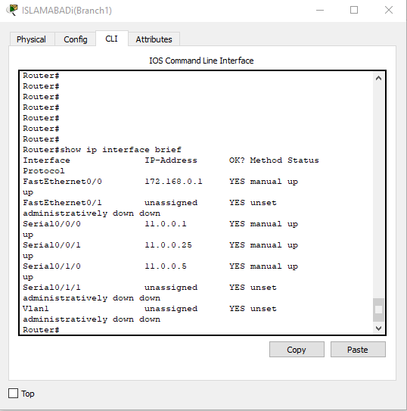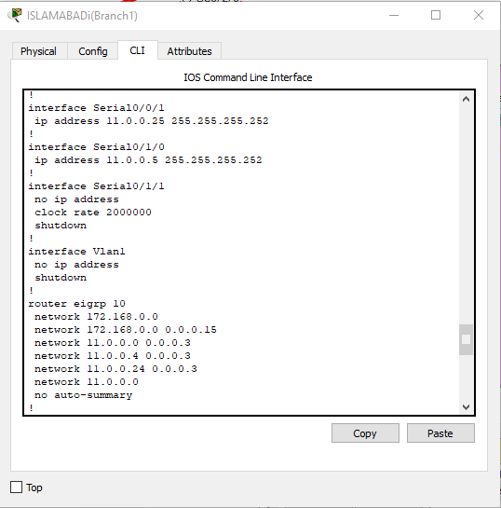Show running configuration and show ip interface brief

Show ip route:

11.0.0.0/30 is subnetted, 12 subnets

C 11.0.0.0 is directly connected, Serial0/0/0

C 11.0.0.4 is directly connected, Serial0/1/0

D 11.0.0.8 [90/2681856] via 11.0.0.2, 00:27:58, Serial0/0/0

[90/2681856] via 11.0.0.26, 00:27:58, Serial0/0/1

D 11.0.0.12 [90/2681856] via 11.0.0.6, 00:28:00, Serial0/1/0

[90/2681856] via 11.0.0.26, 00:27:58, Serial0/0/1

D 11.0.0.16 [90/2681856] via 11.0.0.2, 00:27:58, Serial0/0/0

D 11.0.0.20 [90/2681856] via 11.0.0.6, 00:28:00, Serial0/1/0

C 11.0.0.24 is directly connected, Serial0/0/1

D 11.0.0.28 [90/2681856] via 11.0.0.26, 00:27:58, Serial0/0/1

D 11.0.0.32 [90/2681856] via 11.0.0.6, 00:28:00, Serial0/1/0

D 11.0.0.36 [90/2681856] via 11.0.0.6, 00:28:00, Serial0/1/0

D 11.0.0.40 [90/2681856] via 11.0.0.2, 00:28:00, Serial0/0/0

D 11.0.0.44 [90/2681856] via 11.0.0.2, 00:28:00, Serial0/0/0

12.0.0.0/30 is subnetted, 13 subnets

D EX 12.0.0.0 [170/3586560] via 11.0.0.6, 00:27:37, Serial0/1/0

[170/3586560] via 11.0.0.2, 00:27:37, Serial0/0/0

D EX 12.0.0.4 [170/3586560] via 11.0.0.6, 00:27:37, Serial0/1/0

[170/3586560] via 11.0.0.2, 00:27:37, Serial0/0/0

D EX 12.0.0.8 [170/3586560] via 11.0.0.6, 00:27:37, Serial0/1/0

[170/3586560] via 11.0.0.2, 00:27:37, Serial0/0/0

D EX 12.0.0.12 [170/3586560] via 11.0.0.6, 00:27:37, Serial0/1/0

[170/3586560] via 11.0.0.2, 00:27:37, Serial0/0/0

D EX 12.0.0.16 [170/3586560] via 11.0.0.6, 00:27:37, Serial0/1/0

[170/3586560] via 11.0.0.2, 00:27:37, Serial0/0/0

D EX 12.0.0.20 [170/3586560] via 11.0.0.6, 00:27:37, Serial0/1/0

[170/3586560] via 11.0.0.2, 00:27:37, Serial0/0/0

D EX 12.0.0.24 [170/3586560] via 11.0.0.6, 00:27:37, Serial0/1/0

[170/3586560] via 11.0.0.2, 00:27:37, Serial0/0/0

D EX 12.0.0.28 [170/3586560] via 11.0.0.6, 00:27:37, Serial0/1/0

[170/3586560] via 11.0.0.2, 00:27:37, Serial0/0/0

D EX 12.0.0.32 [170/3586560] via 11.0.0.6, 00:27:37, Serial0/1/0

[170/3586560] via 11.0.0.2, 00:27:37, Serial0/0/0

D EX 12.0.0.36 [170/3586560] via 11.0.0.6, 00:27:59, Serial0/1/0

[170/3586560] via 11.0.0.2, 00:27:58, Serial0/0/0

D EX 12.0.0.40 [170/3586560] via 11.0.0.6, 00:27:59, Serial0/1/0

[170/3586560] via 11.0.0.2, 00:27:58, Serial0/0/0

D EX 12.0.0.44 [170/3584000] via 11.0.0.2, 00:27:56, Serial0/0/0

[170/3584000] via 11.0.0.6, 00:27:55, Serial0/1/0

D EX 12.0.0.48 [170/3584000] via 11.0.0.2, 00:27:56, Serial0/0/0

[170/3584000] via 11.0.0.6, 00:27:55, Serial0/1/0

13.0.0.0/30 is subnetted, 14 subnets

D EX 13.0.0.0 [170/3584000] via 11.0.0.2, 00:27:58, Serial0/0/0

[170/3584000] via 11.0.0.6, 00:27:56, Serial0/1/0

D EX 13.0.0.4 [170/3584000] via 11.0.0.2, 00:27:58, Serial0/0/0

[170/3584000] via 11.0.0.6, 00:27:57, Serial0/1/0

D EX 13.0.0.8 [170/3584000] via 11.0.0.2, 00:27:57, Serial0/0/0

[170/3584000] via 11.0.0.6, 00:27:56, Serial0/1/0

D EX 13.0.0.16 [170/3584000] via 11.0.0.6, 00:27:57, Serial0/1/0

[170/3584000] via 11.0.0.2, 00:27:57, Serial0/0/0

D EX 13.0.0.20 [170/3584000] via 11.0.0.2, 00:27:57, Serial0/0/0

[170/3584000] via 11.0.0.6, 00:27:56, Serial0/1/0

D EX 13.0.0.24 [170/3584000] via 11.0.0.2, 00:27:57, Serial0/0/0

[170/3584000] via 11.0.0.6, 00:27:56, Serial0/1/0

D EX 13.0.0.28 [170/3584000] via 11.0.0.2, 00:27:56, Serial0/0/0

[170/3584000] via 11.0.0.6, 00:27:55, Serial0/1/0

D EX 13.0.0.32 [170/3584000] via 11.0.0.2, 00:27:57, Serial0/0/0

[170/3584000] via 11.0.0.6, 00:27:56, Serial0/1/0

D EX 13.0.0.36 [170/3584000] via 11.0.0.2, 00:27:57, Serial0/0/0

[170/3584000] via 11.0.0.6, 00:27:56, Serial0/1/0

D EX 13.0.0.40 [170/3584000] via 11.0.0.2, 00:27:57, Serial0/0/0

[170/3584000] via 11.0.0.6, 00:27:56, Serial0/1/0

D EX 13.0.0.44 [170/3584000] via 11.0.0.6, 00:28:00, Serial0/1/0

[170/3584000] via 11.0.0.2, 00:27:57, Serial0/0/0

D EX 13.0.0.48 [170/3584000] via 11.0.0.6, 00:28:00, Serial0/1/0

[170/3584000] via 11.0.0.2, 00:27:57, Serial0/0/0

D EX 13.0.0.52 [170/3584000] via 11.0.0.2, 00:27:56, Serial0/0/0

[170/3584000] via 11.0.0.6, 00:27:55, Serial0/1/0

D EX 13.0.0.56 [170/3584000] via 11.0.0.2, 00:27:57, Serial0/0/0

[170/3584000] via 11.0.0.6, 00:27:56, Serial0/1/0

15.0.0.0/30 is subnetted, 2 subnets

D EX 15.0.0.4 [170/3584000] via 11.0.0.2, 00:27:56, Serial0/0/0

[170/3584000] via 11.0.0.6, 00:27:55, Serial0/1/0

D EX 15.0.0.8 [170/3584000] via 11.0.0.2, 00:27:56, Serial0/0/0

[170/3584000] via 11.0.0.6, 00:27:55, Serial0/1/0

100.0.0.0/28 is subnetted, 3 subnets

D EX 100.16.0.0 [170/3584000] via 11.0.0.2, 00:27:57, Serial0/0/0

[170/3584000] via 11.0.0.6, 00:27:56, Serial0/1/0

D EX 100.16.0.16 [170/3584000] via 11.0.0.2, 00:27:57, Serial0/0/0

[170/3584000] via 11.0.0.6, 00:27:56, Serial0/1/0

D EX 100.16.0.32 [170/3584000] via 11.0.0.2, 00:27:57, Serial0/0/0

[170/3584000] via 11.0.0.6, 00:27:56, Serial0/1/0

172.16.0.0/28 is subnetted, 2 subnets

D EX 172.16.1.0 [170/3584000] via 11.0.0.2, 00:27:56, Serial0/0/0

[170/3584000] via 11.0.0.6, 00:27:55, Serial0/1/0

D EX 172.16.1.16 [170/3584000] via 11.0.0.2, 00:27:56, Serial0/0/0

[170/3584000] via 11.0.0.6, 00:27:55, Serial0/1/0

172.168.0.0/28 is subnetted, 3 subnets

C 172.168.0.0 is directly connected, FastEthernet0/0

D 172.168.0.16 [90/2172416] via 11.0.0.26, 00:28:00, Serial0/0/1

D 172.168.0.32 [90/2684416] via 11.0.0.6, 00:28:00, Serial0/1/0

190.200.0.0/29 is subnetted, 2 subnets

D EX 190.200.10.0 [170/3586560] via 11.0.0.2, 00:27:37, Serial0/0/0

[170/3586560] via 11.0.0.6, 00:27:37, Serial0/1/0

D EX 190.200.11.0 [170/3584000] via 11.0.0.2, 00:27:57, Serial0/0/0

[170/3584000] via 11.0.0.6, 00:27:56, Serial0/1/0

192.168.10.0/27 is subnetted, 3 subnets

D EX 192.168.10.0 [170/3586560] via 11.0.0.2, 00:27:37, Serial0/0/0

[170/3586560] via 11.0.0.6, 00:27:37, Serial0/1/0

D EX 192.168.10.32 [170/3586560] via 11.0.0.6, 00:27:37, Serial0/1/0

[170/3586560] via 11.0.0.2, 00:27:37, Serial0/0/0

D EX 192.168.10.64 [170/3586560] via 11.0.0.6, 00:27:37, Serial0/1/0

[170/3586560] via 11.0.0.2, 00:27:37, Serial0/0/0

Islamabad main branch 2:

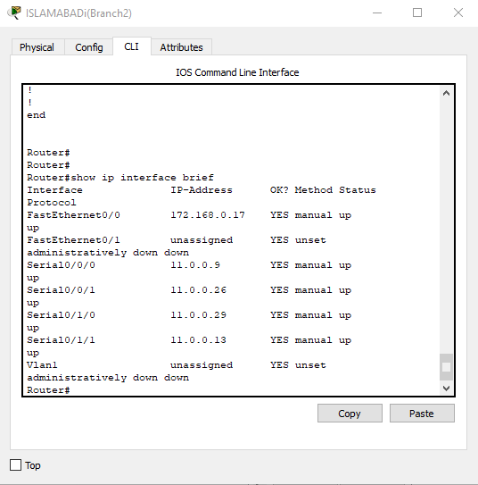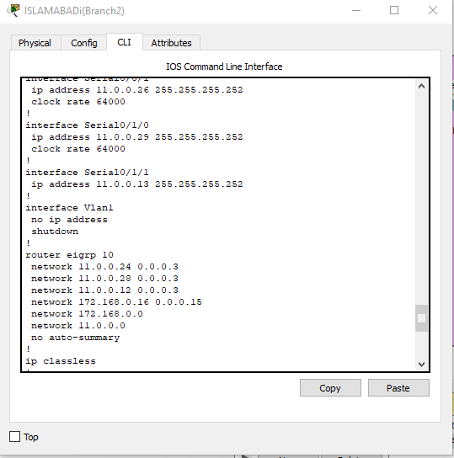Show running configuration and show ip interface brief

Show ip route:

11.0.0.0/30 is subnetted, 12 subnets

D 11.0.0.0 [90/2681856] via 11.0.0.10, 00:29:05, Serial0/0/0

[90/2681856] via 11.0.0.25, 00:29:05, Serial0/0/1

D 11.0.0.4 [90/2681856] via 11.0.0.25, 00:29:05, Serial0/0/1

[90/2681856] via 11.0.0.14, 00:29:05, Serial0/1/1

C 11.0.0.8 is directly connected, Serial0/0/0

C 11.0.0.12 is directly connected, Serial0/1/1

D 11.0.0.16 [90/2681856] via 11.0.0.10, 00:29:05, Serial0/0/0

D 11.0.0.20 [90/2681856] via 11.0.0.14, 00:29:05, Serial0/1/1

C 11.0.0.24 is directly connected, Serial0/0/1

C 11.0.0.28 is directly connected, Serial0/1/0

D 11.0.0.32 [90/2681856] via 11.0.0.14, 00:29:05, Serial0/1/1

D 11.0.0.36 [90/2681856] via 11.0.0.14, 00:29:05, Serial0/1/1

D 11.0.0.40 [90/2681856] via 11.0.0.10, 00:29:05, Serial0/0/0

D 11.0.0.44 [90/2681856] via 11.0.0.10, 00:29:05, Serial0/0/0

12.0.0.0/30 is subnetted, 13 subnets

D EX 12.0.0.0 [170/3586560] via 11.0.0.14, 00:28:43, Serial0/1/1

[170/3586560] via 11.0.0.10, 00:28:43, Serial0/0/0

D EX 12.0.0.4 [170/3586560] via 11.0.0.14, 00:28:43, Serial0/1/1

[170/3586560] via 11.0.0.10, 00:28:43, Serial0/0/0

D EX 12.0.0.8 [170/3586560] via 11.0.0.14, 00:28:43, Serial0/1/1

[170/3586560] via 11.0.0.10, 00:28:43, Serial0/0/0

D EX 12.0.0.12 [170/3586560] via 11.0.0.14, 00:28:44, Serial0/1/1

[170/3586560] via 11.0.0.10, 00:28:44, Serial0/0/0

D EX 12.0.0.16 [170/3586560] via 11.0.0.14, 00:28:43, Serial0/1/1

[170/3586560] via 11.0.0.10, 00:28:43, Serial0/0/0

D EX 12.0.0.20 [170/3586560] via 11.0.0.14, 00:28:43, Serial0/1/1

[170/3586560] via 11.0.0.10, 00:28:43, Serial0/0/0

D EX 12.0.0.24 [170/3586560] via 11.0.0.14, 00:28:43, Serial0/1/1

[170/3586560] via 11.0.0.10, 00:28:43, Serial0/0/0

D EX 12.0.0.28 [170/3586560] via 11.0.0.14, 00:28:43, Serial0/1/1

[170/3586560] via 11.0.0.10, 00:28:43, Serial0/0/0

D EX 12.0.0.32 [170/3586560] via 11.0.0.14, 00:28:44, Serial0/1/1

[170/3586560] via 11.0.0.10, 00:28:43, Serial0/0/0

D EX 12.0.0.36 [170/3586560] via 11.0.0.14, 00:29:05, Serial0/1/1

[170/3586560] via 11.0.0.10, 00:29:04, Serial0/0/0

D EX 12.0.0.40 [170/3586560] via 11.0.0.10, 00:29:05, Serial0/0/0

[170/3586560] via 11.0.0.14, 00:29:05, Serial0/1/1

D EX 12.0.0.44 [170/3584000] via 11.0.0.10, 00:29:02, Serial0/0/0

[170/3584000] via 11.0.0.14, 00:29:01, Serial0/1/1

D EX 12.0.0.48 [170/3584000] via 11.0.0.10, 00:29:02, Serial0/0/0

[170/3584000] via 11.0.0.14, 00:29:01, Serial0/1/1

13.0.0.0/30 is subnetted, 14 subnets

D EX 13.0.0.0 [170/3584000] via 11.0.0.10, 00:29:05, Serial0/0/0

[170/3584000] via 11.0.0.14, 00:29:03, Serial0/1/1

D EX 13.0.0.4 [170/3584000] via 11.0.0.10, 00:29:04, Serial0/0/0

[170/3584000] via 11.0.0.14, 00:29:03, Serial0/1/1

D EX 13.0.0.8 [170/3584000] via 11.0.0.10, 00:29:03, Serial0/0/0

[170/3584000] via 11.0.0.14, 00:29:02, Serial0/1/1

D EX 13.0.0.16 [170/3584000] via 11.0.0.14, 00:29:03, Serial0/1/1

[170/3584000] via 11.0.0.10, 00:29:03, Serial0/0/0

D EX 13.0.0.20 [170/3584000] via 11.0.0.10, 00:29:03, Serial0/0/0

[170/3584000] via 11.0.0.14, 00:29:02, Serial0/1/1

D EX 13.0.0.24 [170/3584000] via 11.0.0.10, 00:29:03, Serial0/0/0

[170/3584000] via 11.0.0.14, 00:29:02, Serial0/1/1

D EX 13.0.0.28 [170/3584000] via 11.0.0.10, 00:29:02, Serial0/0/0

[170/3584000] via 11.0.0.14, 00:29:01, Serial0/1/1

D EX 13.0.0.32 [170/3584000] via 11.0.0.10, 00:29:03, Serial0/0/0

[170/3584000] via 11.0.0.14, 00:29:02, Serial0/1/1

D EX 13.0.0.36 [170/3584000] via 11.0.0.14, 00:29:03, Serial0/1/1

[170/3584000] via 11.0.0.10, 00:29:03, Serial0/0/0

D EX 13.0.0.40 [170/3584000] via 11.0.0.10, 00:29:02, Serial0/0/0

[170/3584000] via 11.0.0.14, 00:29:02, Serial0/1/1

D EX 13.0.0.44 [170/3584000] via 11.0.0.14, 00:29:05, Serial0/1/1

[170/3584000] via 11.0.0.10, 00:29:02, Serial0/0/0

D EX 13.0.0.48 [170/3584000] via 11.0.0.14, 00:29:05, Serial0/1/1

[170/3584000] via 11.0.0.10, 00:29:02, Serial0/0/0

D EX 13.0.0.52 [170/3584000] via 11.0.0.10, 00:29:02, Serial0/0/0

[170/3584000] via 11.0.0.14, 00:29:01, Serial0/1/1

D EX 13.0.0.56 [170/3584000] via 11.0.0.14, 00:29:03, Serial0/1/1

[170/3584000] via 11.0.0.10, 00:29:02, Serial0/0/0

15.0.0.0/30 is subnetted, 2 subnets

D EX 15.0.0.4 [170/3584000] via 11.0.0.10, 00:29:02, Serial0/0/0

[170/3584000] via 11.0.0.14, 00:29:01, Serial0/1/1

D EX 15.0.0.8 [170/3584000] via 11.0.0.10, 00:29:02, Serial0/0/0

[170/3584000] via 11.0.0.14, 00:29:01, Serial0/1/1

100.0.0.0/28 is subnetted, 3 subnets

D EX 100.16.0.0 [170/3584000] via 11.0.0.14, 00:29:03, Serial0/1/1

[170/3584000] via 11.0.0.10, 00:29:02, Serial0/0/0

D EX 100.16.0.16 [170/3584000] via 11.0.0.10, 00:29:02, Serial0/0/0

[170/3584000] via 11.0.0.14, 00:29:02, Serial0/1/1

D EX 100.16.0.32 [170/3584000] via 11.0.0.14, 00:29:02, Serial0/1/1

[170/3584000] via 11.0.0.10, 00:29:02, Serial0/0/0

172.16.0.0/28 is subnetted, 2 subnets

D EX 172.16.1.0 [170/3584000] via 11.0.0.10, 00:29:02, Serial0/0/0

[170/3584000] via 11.0.0.14, 00:29:01, Serial0/1/1

D EX 172.16.1.16 [170/3584000] via 11.0.0.10, 00:29:02, Serial0/0/0

[170/3584000] via 11.0.0.14, 00:29:01, Serial0/1/1

172.168.0.0/28 is subnetted, 3 subnets

D 172.168.0.0 [90/2172416] via 11.0.0.25, 00:29:05, Serial0/0/1

C 172.168.0.16 is directly connected, FastEthernet0/0

D 172.168.0.32 [90/2684416] via 11.0.0.14, 00:29:05, Serial0/1/1

190.200.0.0/29 is subnetted, 2 subnets

D EX 190.200.10.0 [170/3586560] via 11.0.0.14, 00:28:43, Serial0/1/1

[170/3586560] via 11.0.0.10, 00:28:43, Serial0/0/0

D EX 190.200.11.0 [170/3584000] via 11.0.0.14, 00:29:02, Serial0/1/1

[170/3584000] via 11.0.0.10, 00:29:02, Serial0/0/0

192.168.10.0/27 is subnetted, 3 subnets

D EX 192.168.10.0 [170/3586560] via 11.0.0.10, 00:28:43, Serial0/0/0

[170/3586560] via 11.0.0.14, 00:28:43, Serial0/1/1

D EX 192.168.10.32 [170/3586560] via 11.0.0.14, 00:28:43, Serial0/1/1

[170/3586560] via 11.0.0.10, 00:28:43, Serial0/0/0

D EX 192.168.10.64 [170/3586560] via 11.0.0.10, 00:28:43, Serial0/0/0

[170/3586560] via 11.0.0.14, 00:28:43, Serial0/1/1

Islamabad branch 3:

Show ip route:

11.0.0.0/30 is subnetted, 12 subnets

D 11.0.0.0 [90/3193856] via 11.0.0.22, 00:29:46, Serial0/0/1

D 11.0.0.4 [90/2681856] via 11.0.0.22, 00:29:46, Serial0/0/1

D 11.0.0.8 [90/3193856] via 11.0.0.22, 00:29:44, Serial0/0/1

D 11.0.0.12 [90/2681856] via 11.0.0.22, 00:29:46, Serial0/0/1

C 11.0.0.16 is directly connected, Serial0/1/0

C 11.0.0.20 is directly connected, Serial0/0/1

D 11.0.0.24 [90/3193856] via 11.0.0.22, 00:29:45, Serial0/0/1

C 11.0.0.28 is directly connected, Serial0/0/0

D 11.0.0.32 [90/2681856] via 11.0.0.22, 00:29:46, Serial0/0/1

D 11.0.0.36 [90/2681856] via 11.0.0.22, 00:29:46, Serial0/0/1

D 11.0.0.40 [90/3193856] via 11.0.0.22, 00:29:42, Serial0/0/1

D 11.0.0.44 [90/3193856] via 11.0.0.22, 00:29:46, Serial0/0/1

12.0.0.0/30 is subnetted, 13 subnets

D EX 12.0.0.0 [170/3586560] via 11.0.0.22, 00:29:25, Serial0/0/1

D EX 12.0.0.4 [170/3586560] via 11.0.0.22, 00:29:25, Serial0/0/1

D EX 12.0.0.8 [170/3586560] via 11.0.0.22, 00:29:25, Serial0/0/1

D EX 12.0.0.12 [170/3586560] via 11.0.0.22, 00:29:25, Serial0/0/1

D EX 12.0.0.16 [170/3586560] via 11.0.0.22, 00:29:25, Serial0/0/1

D EX 12.0.0.20 [170/3586560] via 11.0.0.22, 00:29:25, Serial0/0/1

D EX 12.0.0.24 [170/3586560] via 11.0.0.22, 00:29:24, Serial0/0/1

D EX 12.0.0.28 [170/3586560] via 11.0.0.22, 00:29:25, Serial0/0/1

D EX 12.0.0.32 [170/3586560] via 11.0.0.22, 00:29:25, Serial0/0/1

D EX 12.0.0.36 [170/3586560] via 11.0.0.22, 00:29:45, Serial0/0/1

D EX 12.0.0.40 [170/3586560] via 11.0.0.22, 00:29:46, Serial0/0/1

D EX 12.0.0.44 [170/3584000] via 11.0.0.22, 00:29:43, Serial0/0/1

D EX 12.0.0.48 [170/3584000] via 11.0.0.22, 00:29:43, Serial0/0/1

13.0.0.0/30 is subnetted, 14 subnets

D EX 13.0.0.0 [170/3584000] via 11.0.0.22, 00:29:44, Serial0/0/1

D EX 13.0.0.4 [170/3584000] via 11.0.0.22, 00:29:44, Serial0/0/1

D EX 13.0.0.8 [170/3584000] via 11.0.0.22, 00:29:43, Serial0/0/1

D EX 13.0.0.16 [170/3584000] via 11.0.0.22, 00:29:45, Serial0/0/1

D EX 13.0.0.20 [170/3584000] via 11.0.0.22, 00:29:43, Serial0/0/1

D EX 13.0.0.24 [170/3584000] via 11.0.0.22, 00:29:44, Serial0/0/1

D EX 13.0.0.28 [170/3584000] via 11.0.0.22, 00:29:42, Serial0/0/1

D EX 13.0.0.32 [170/3584000] via 11.0.0.22, 00:29:43, Serial0/0/1

D EX 13.0.0.36 [170/3584000] via 11.0.0.22, 00:29:44, Serial0/0/1

D EX 13.0.0.40 [170/3584000] via 11.0.0.22, 00:29:44, Serial0/0/1

D EX 13.0.0.44 [170/3584000] via 11.0.0.22, 00:29:46, Serial0/0/1

D EX 13.0.0.48 [170/3584000] via 11.0.0.22, 00:29:46, Serial0/0/1

D EX 13.0.0.52 [170/3584000] via 11.0.0.22, 00:29:43, Serial0/0/1

D EX 13.0.0.56 [170/3584000] via 11.0.0.22, 00:29:44, Serial0/0/1

15.0.0.0/30 is subnetted, 2 subnets

D EX 15.0.0.4 [170/3584000] via 11.0.0.22, 00:29:43, Serial0/0/1

D EX 15.0.0.8 [170/3584000] via 11.0.0.22, 00:29:43, Serial0/0/1

100.0.0.0/28 is subnetted, 3 subnets

D EX 100.16.0.0 [170/3584000] via 11.0.0.22, 00:29:44, Serial0/0/1

D EX 100.16.0.16 [170/3584000] via 11.0.0.22, 00:29:43, Serial0/0/1

D EX 100.16.0.32 [170/3584000] via 11.0.0.22, 00:29:43, Serial0/0/1

172.16.0.0/28 is subnetted, 2 subnets

D EX 172.16.1.0 [170/3584000] via 11.0.0.22, 00:29:43, Serial0/0/1

D EX 172.16.1.16 [170/3584000] via 11.0.0.22, 00:29:43, Serial0/0/1

172.168.0.0/28 is subnetted, 3 subnets

D 172.168.0.0 [90/2684416] via 11.0.0.22, 00:29:46, Serial0/0/1

D 172.168.0.16 [90/2684416] via 11.0.0.22, 00:29:45, Serial0/0/1

C 172.168.0.32 is directly connected, FastEthernet0/0

190.200.0.0/29 is subnetted, 2 subnets

D EX 190.200.10.0 [170/3586560] via 11.0.0.22, 00:29:24, Serial0/0/1

D EX 190.200.11.0 [170/3584000] via 11.0.0.22, 00:29:44, Serial0/0/1

192.168.10.0/27 is subnetted, 3 subnets

D EX 192.168.10.0 [170/3586560] via 11.0.0.22, 00:29:24, Serial0/0/1

D EX 192.168.10.32 [170/3586560] via 11.0.0.22, 00:29:24, Serial0/0/1

D EX 192.168.10.64 [170/3586560] via 11.0.0.22, 00:29:24, Serial0/0/1

Show running configuration and show ip interface:

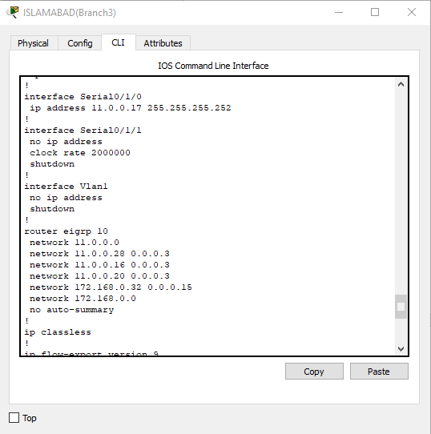

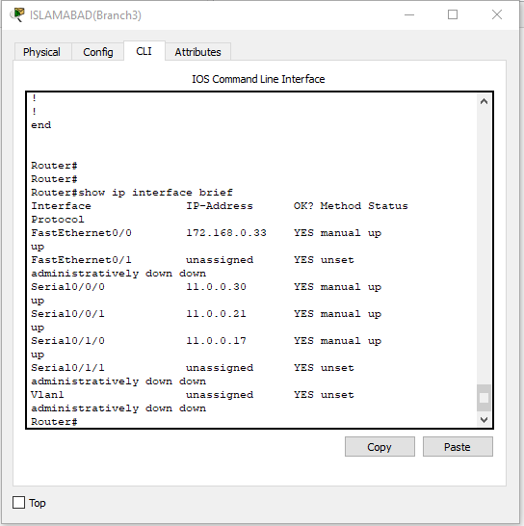

Lahore backup router configuration:

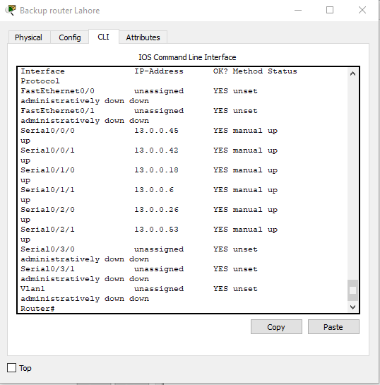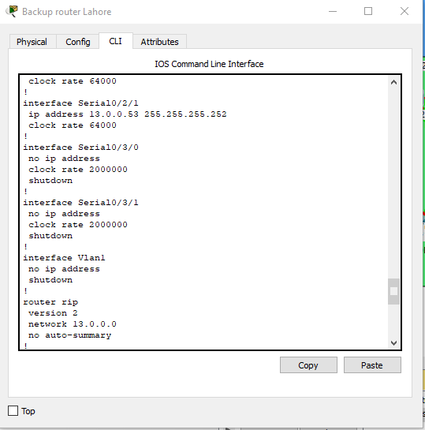Show running configuration and show ip interface brief

Show ip route:

11.0.0.0/30 is subnetted, 12 subnets

R 11.0.0.0 [120/1] via 13.0.0.46, 00:00:08, Serial0/0/0

R 11.0.0.4 [120/1] via 13.0.0.46, 00:00:08, Serial0/0/0

R 11.0.0.8 [120/1] via 13.0.0.46, 00:00:08, Serial0/0/0

R 11.0.0.12 [120/1] via 13.0.0.46, 00:00:08, Serial0/0/0

R 11.0.0.16 [120/1] via 13.0.0.46, 00:00:08, Serial0/0/0

R 11.0.0.20 [120/1] via 13.0.0.46, 00:00:08, Serial0/0/0

R 11.0.0.24 [120/1] via 13.0.0.46, 00:00:08, Serial0/0/0

R 11.0.0.28 [120/1] via 13.0.0.46, 00:00:08, Serial0/0/0

R 11.0.0.32 [120/1] via 13.0.0.46, 00:00:08, Serial0/0/0

R 11.0.0.36 [120/1] via 13.0.0.46, 00:00:08, Serial0/0/0

R 11.0.0.40 [120/1] via 13.0.0.46, 00:00:08, Serial0/0/0

R 11.0.0.44 [120/1] via 13.0.0.46, 00:00:08, Serial0/0/0

12.0.0.0/30 is subnetted, 13 subnets

R 12.0.0.0 [120/1] via 13.0.0.46, 00:00:08, Serial0/0/0

R 12.0.0.4 [120/1] via 13.0.0.46, 00:00:08, Serial0/0/0

R 12.0.0.8 [120/1] via 13.0.0.46, 00:00:08, Serial0/0/0

R 12.0.0.12 [120/1] via 13.0.0.46, 00:00:08, Serial0/0/0

R 12.0.0.16 [120/1] via 13.0.0.46, 00:00:08, Serial0/0/0

R 12.0.0.20 [120/1] via 13.0.0.46, 00:00:08, Serial0/0/0

R 12.0.0.24 [120/1] via 13.0.0.46, 00:00:08, Serial0/0/0

R 12.0.0.28 [120/1] via 13.0.0.46, 00:00:08, Serial0/0/0

R 12.0.0.32 [120/1] via 13.0.0.46, 00:00:08, Serial0/0/0

R 12.0.0.36 [120/1] via 13.0.0.46, 00:00:08, Serial0/0/0

R 12.0.0.40 [120/1] via 13.0.0.46, 00:00:08, Serial0/0/0

R 12.0.0.44 [120/1] via 13.0.0.54, 00:00:14, Serial0/2/1

R 12.0.0.48 [120/1] via 13.0.0.54, 00:00:14, Serial0/2/1

13.0.0.0/30 is subnetted, 14 subnets

R 13.0.0.0 [120/1] via 13.0.0.5, 00:00:05, Serial0/1/1

C 13.0.0.4 is directly connected, Serial0/1/1

R 13.0.0.8 [120/1] via 13.0.0.17, 00:00:20, Serial0/1/0

C 13.0.0.16 is directly connected, Serial0/1/0

R 13.0.0.20 [120/1] via 13.0.0.25, 00:00:25, Serial0/2/0

C 13.0.0.24 is directly connected, Serial0/2/0

R 13.0.0.28 [120/1] via 13.0.0.17, 00:00:20, Serial0/1/0

[120/1] via 13.0.0.5, 00:00:05, Serial0/1/1

R 13.0.0.32 [120/1] via 13.0.0.17, 00:00:20, Serial0/1/0

[120/1] via 13.0.0.25, 00:00:25, Serial0/2/0

R 13.0.0.36 [120/1] via 13.0.0.41, 00:00:28, Serial0/0/1

C 13.0.0.40 is directly connected, Serial0/0/1

C 13.0.0.44 is directly connected, Serial0/0/0

R 13.0.0.48 [120/1] via 13.0.0.46, 00:00:08, Serial0/0/0

C 13.0.0.52 is directly connected, Serial0/2/1

R 13.0.0.56 [120/1] via 13.0.0.54, 00:00:14, Serial0/2/1

15.0.0.0/30 is subnetted, 2 subnets

R 15.0.0.4 [120/1] via 13.0.0.54, 00:00:14, Serial0/2/1

R 15.0.0.8 [120/1] via 13.0.0.54, 00:00:14, Serial0/2/1

100.0.0.0/28 is subnetted, 3 subnets

R 100.16.0.0 [120/1] via 13.0.0.5, 00:00:05, Serial0/1/1

R 100.16.0.16 [120/1] via 13.0.0.17, 00:00:20, Serial0/1/0

R 100.16.0.32 [120/1] via 13.0.0.25, 00:00:25, Serial0/2/0

172.16.0.0/28 is subnetted, 2 subnets

R 172.16.1.0 [120/1] via 13.0.0.54, 00:00:14, Serial0/2/1

R 172.16.1.16 [120/1] via 13.0.0.54, 00:00:14, Serial0/2/1

172.168.0.0/28 is subnetted, 3 subnets

R 172.168.0.0 [120/1] via 13.0.0.46, 00:00:08, Serial0/0/0

R 172.168.0.16 [120/1] via 13.0.0.46, 00:00:08, Serial0/0/0

R 172.168.0.32 [120/1] via 13.0.0.46, 00:00:08, Serial0/0/0

190.200.0.0/29 is subnetted, 2 subnets

R 190.200.10.0 [120/1] via 13.0.0.46, 00:00:08, Serial0/0/0

R 190.200.11.0 [120/1] via 13.0.0.41, 00:00:28, Serial0/0/1

192.168.10.0/27 is subnetted, 3 subnets

R 192.168.10.0 [120/1] via 13.0.0.46, 00:00:08, Serial0/0/0

R 192.168.10.32 [120/1] via 13.0.0.46, 00:00:08, Serial0/0/0

R 192.168.10.64 [120/1] via 13.0.0.46, 00:00:08, Serial0/0/0

Main Lahore configuration:

Show running configuration and show ip interface brief

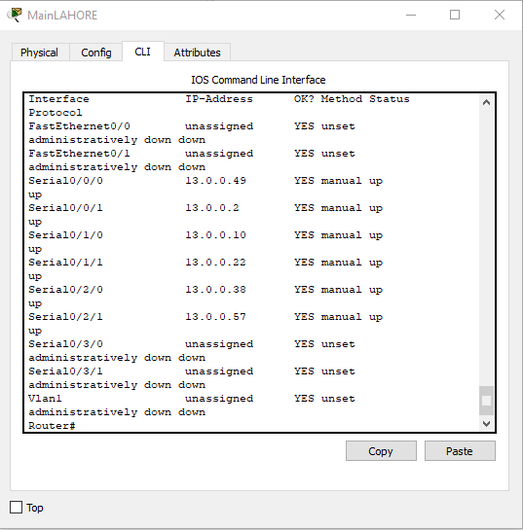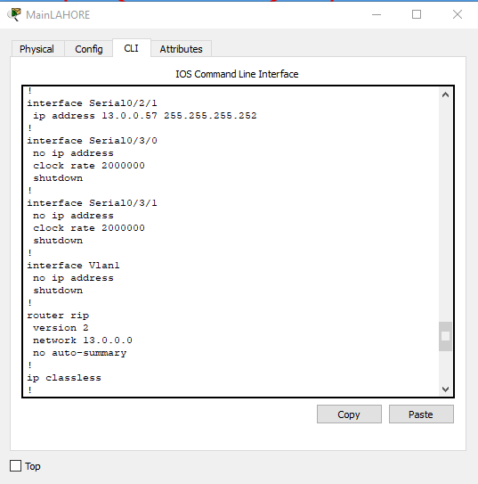show ip route:

11.0.0.0/30 is subnetted, 12 subnets

R 11.0.0.0 [120/1] via 13.0.0.50, 00:00:17, Serial0/0/0

R 11.0.0.4 [120/1] via 13.0.0.50, 00:00:17, Serial0/0/0

R 11.0.0.8 [120/1] via 13.0.0.50, 00:00:17, Serial0/0/0

R 11.0.0.12 [120/1] via 13.0.0.50, 00:00:17, Serial0/0/0

R 11.0.0.16 [120/1] via 13.0.0.50, 00:00:17, Serial0/0/0

R 11.0.0.20 [120/1] via 13.0.0.50, 00:00:17, Serial0/0/0

R 11.0.0.24 [120/1] via 13.0.0.50, 00:00:17, Serial0/0/0

R 11.0.0.28 [120/1] via 13.0.0.50, 00:00:17, Serial0/0/0

R 11.0.0.32 [120/1] via 13.0.0.50, 00:00:17, Serial0/0/0

R 11.0.0.36 [120/1] via 13.0.0.50, 00:00:17, Serial0/0/0

R 11.0.0.40 [120/1] via 13.0.0.50, 00:00:17, Serial0/0/0

R 11.0.0.44 [120/1] via 13.0.0.50, 00:00:17, Serial0/0/0

12.0.0.0/30 is subnetted, 13 subnets

R 12.0.0.0 [120/1] via 13.0.0.50, 00:00:17, Serial0/0/0

R 12.0.0.4 [120/1] via 13.0.0.50, 00:00:17, Serial0/0/0

R 12.0.0.8 [120/1] via 13.0.0.50, 00:00:17, Serial0/0/0

R 12.0.0.12 [120/1] via 13.0.0.50, 00:00:17, Serial0/0/0

R 12.0.0.16 [120/1] via 13.0.0.50, 00:00:17, Serial0/0/0

R 12.0.0.20 [120/1] via 13.0.0.50, 00:00:17, Serial0/0/0

R 12.0.0.24 [120/1] via 13.0.0.50, 00:00:17, Serial0/0/0

R 12.0.0.28 [120/1] via 13.0.0.50, 00:00:17, Serial0/0/0

R 12.0.0.32 [120/1] via 13.0.0.50, 00:00:17, Serial0/0/0

R 12.0.0.36 [120/1] via 13.0.0.50, 00:00:17, Serial0/0/0

R 12.0.0.40 [120/1] via 13.0.0.50, 00:00:17, Serial0/0/0

R 12.0.0.44 [120/1] via 13.0.0.58, 00:00:23, Serial0/2/1

R 12.0.0.48 [120/1] via 13.0.0.58, 00:00:23, Serial0/2/1

13.0.0.0/30 is subnetted, 14 subnets

C 13.0.0.0 is directly connected, Serial0/0/1

R 13.0.0.4 [120/1] via 13.0.0.1, 00:00:16, Serial0/0/1

C 13.0.0.8 is directly connected, Serial0/1/0

R 13.0.0.16 [120/1] via 13.0.0.9, 00:00:06, Serial0/1/0

C 13.0.0.20 is directly connected, Serial0/1/1

R 13.0.0.24 [120/1] via 13.0.0.21, 00:00:08, Serial0/1/1

R 13.0.0.28 [120/1] via 13.0.0.1, 00:00:16, Serial0/0/1

[120/1] via 13.0.0.9, 00:00:06, Serial0/1/0

R 13.0.0.32 [120/1] via 13.0.0.9, 00:00:06, Serial0/1/0

[120/1] via 13.0.0.21, 00:00:08, Serial0/1/1

C 13.0.0.36 is directly connected, Serial0/2/0

R 13.0.0.40 [120/1] via 13.0.0.37, 00:00:06, Serial0/2/0

R 13.0.0.44 [120/1] via 13.0.0.50, 00:00:17, Serial0/0/0

C 13.0.0.48 is directly connected, Serial0/0/0

R 13.0.0.52 [120/1] via 13.0.0.58, 00:00:23, Serial0/2/1

C 13.0.0.56 is directly connected, Serial0/2/1

15.0.0.0/30 is subnetted, 2 subnets

R 15.0.0.4 [120/1] via 13.0.0.58, 00:00:23, Serial0/2/1

R 15.0.0.8 [120/1] via 13.0.0.58, 00:00:23, Serial0/2/1

100.0.0.0/28 is subnetted, 3 subnets

R 100.16.0.0 [120/1] via 13.0.0.1, 00:00:16, Serial0/0/1

R 100.16.0.16 [120/1] via 13.0.0.9, 00:00:06, Serial0/1/0

R 100.16.0.32 [120/1] via 13.0.0.21, 00:00:08, Serial0/1/1

172.16.0.0/28 is subnetted, 2 subnets

R 172.16.1.0 [120/1] via 13.0.0.58, 00:00:23, Serial0/2/1

R 172.16.1.16 [120/1] via 13.0.0.58, 00:00:23, Serial0/2/1

172.168.0.0/28 is subnetted, 3 subnets

R 172.168.0.0 [120/1] via 13.0.0.50, 00:00:17, Serial0/0/0

R 172.168.0.16 [120/1] via 13.0.0.50, 00:00:17, Serial0/0/0

R 172.168.0.32 [120/1] via 13.0.0.50, 00:00:17, Serial0/0/0

190.200.0.0/29 is subnetted, 2 subnets

R 190.200.10.0 [120/1] via 13.0.0.50, 00:00:17, Serial0/0/0

R 190.200.11.0 [120/1] via 13.0.0.37, 00:00:06, Serial0/2/0

192.168.10.0/27 is subnetted, 3 subnets

R 192.168.10.0 [120/1] via 13.0.0.50, 00:00:17, Serial0/0/0

R 192.168.10.32 [120/1] via 13.0.0.50, 00:00:17, Serial0/0/0

R 192.168.10.64 [120/1] via 13.0.0.50, 00:00:17, Serial0/0/0

Backup server room:

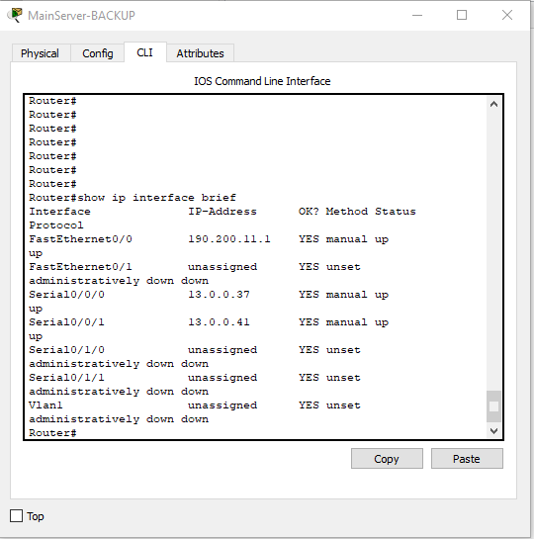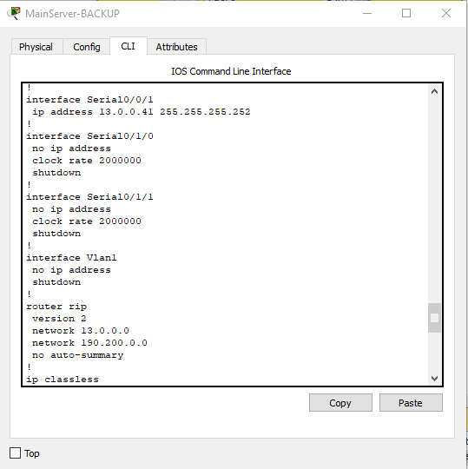Show running configuration and show ip interface brief

Show ip route:

11.0.0.0/30 is subnetted, 12 subnets

R 11.0.0.0 [120/2] via 13.0.0.42, 00:00:03, Serial0/0/1

[120/2] via 13.0.0.38, 00:00:14, Serial0/0/0

R 11.0.0.4 [120/2] via 13.0.0.42, 00:00:03, Serial0/0/1

[120/2] via 13.0.0.38, 00:00:14, Serial0/0/0

R 11.0.0.8 [120/2] via 13.0.0.38, 00:00:14, Serial0/0/0

[120/2] via 13.0.0.42, 00:00:03, Serial0/0/1

R 11.0.0.12 [120/2] via 13.0.0.38, 00:00:14, Serial0/0/0

[120/2] via 13.0.0.42, 00:00:03, Serial0/0/1

R 11.0.0.16 [120/2] via 13.0.0.42, 00:00:03, Serial0/0/1

[120/2] via 13.0.0.38, 00:00:14, Serial0/0/0

R 11.0.0.20 [120/2] via 13.0.0.42, 00:00:03, Serial0/0/1

[120/2] via 13.0.0.38, 00:00:14, Serial0/0/0

R 11.0.0.24 [120/2] via 13.0.0.42, 00:00:03, Serial0/0/1

[120/2] via 13.0.0.38, 00:00:14, Serial0/0/0

R 11.0.0.28 [120/2] via 13.0.0.38, 00:00:14, Serial0/0/0

[120/2] via 13.0.0.42, 00:00:03, Serial0/0/1

R 11.0.0.32 [120/2] via 13.0.0.42, 00:00:03, Serial0/0/1

[120/2] via 13.0.0.38, 00:00:14, Serial0/0/0

R 11.0.0.36 [120/2] via 13.0.0.42, 00:00:03, Serial0/0/1

[120/2] via 13.0.0.38, 00:00:14, Serial0/0/0

R 11.0.0.40 [120/2] via 13.0.0.42, 00:00:03, Serial0/0/1

[120/2] via 13.0.0.38, 00:00:14, Serial0/0/0

R 11.0.0.44 [120/2] via 13.0.0.42, 00:00:03, Serial0/0/1

[120/2] via 13.0.0.38, 00:00:14, Serial0/0/0

12.0.0.0/30 is subnetted, 13 subnets

R 12.0.0.0 [120/2] via 13.0.0.38, 00:00:14, Serial0/0/0

[120/2] via 13.0.0.42, 00:00:03, Serial0/0/1

R 12.0.0.4 [120/2] via 13.0.0.42, 00:00:03, Serial0/0/1

[120/2] via 13.0.0.38, 00:00:14, Serial0/0/0

R 12.0.0.8 [120/2] via 13.0.0.38, 00:00:14, Serial0/0/0

[120/2] via 13.0.0.42, 00:00:03, Serial0/0/1

R 12.0.0.12 [120/2] via 13.0.0.42, 00:00:03, Serial0/0/1

[120/2] via 13.0.0.38, 00:00:14, Serial0/0/0

R 12.0.0.16 [120/2] via 13.0.0.38, 00:00:14, Serial0/0/0

[120/2] via 13.0.0.42, 00:00:03, Serial0/0/1

R 12.0.0.20 [120/2] via 13.0.0.42, 00:00:03, Serial0/0/1

[120/2] via 13.0.0.38, 00:00:14, Serial0/0/0

R 12.0.0.24 [120/2] via 13.0.0.42, 00:00:03, Serial0/0/1

[120/2] via 13.0.0.38, 00:00:14, Serial0/0/0

R 12.0.0.28 [120/2] via 13.0.0.38, 00:00:14, Serial0/0/0

[120/2] via 13.0.0.42, 00:00:03, Serial0/0/1

R 12.0.0.32 [120/2] via 13.0.0.38, 00:00:14, Serial0/0/0

[120/2] via 13.0.0.42, 00:00:03, Serial0/0/1

R 12.0.0.36 [120/2] via 13.0.0.38, 00:00:14, Serial0/0/0

[120/2] via 13.0.0.42, 00:00:03, Serial0/0/1

R 12.0.0.40 [120/2] via 13.0.0.38, 00:00:14, Serial0/0/0

[120/2] via 13.0.0.42, 00:00:03, Serial0/0/1

R 12.0.0.44 [120/2] via 13.0.0.42, 00:00:03, Serial0/0/1

[120/2] via 13.0.0.38, 00:00:14, Serial0/0/0

R 12.0.0.48 [120/2] via 13.0.0.42, 00:00:03, Serial0/0/1

[120/2] via 13.0.0.38, 00:00:14, Serial0/0/0

13.0.0.0/30 is subnetted, 14 subnets

R 13.0.0.0 [120/1] via 13.0.0.38, 00:00:14, Serial0/0/0

R 13.0.0.4 [120/1] via 13.0.0.42, 00:00:03, Serial0/0/1

R 13.0.0.8 [120/1] via 13.0.0.38, 00:00:14, Serial0/0/0

R 13.0.0.16 [120/1] via 13.0.0.42, 00:00:03, Serial0/0/1

R 13.0.0.20 [120/1] via 13.0.0.38, 00:00:14, Serial0/0/0

R 13.0.0.24 [120/1] via 13.0.0.42, 00:00:03, Serial0/0/1

R 13.0.0.28 [120/2] via 13.0.0.42, 00:00:03, Serial0/0/1

[120/2] via 13.0.0.38, 00:00:14, Serial0/0/0

R 13.0.0.32 [120/2] via 13.0.0.38, 00:00:14, Serial0/0/0

[120/2] via 13.0.0.42, 00:00:03, Serial0/0/1

C 13.0.0.36 is directly connected, Serial0/0/0

C 13.0.0.40 is directly connected, Serial0/0/1

R 13.0.0.44 [120/1] via 13.0.0.42, 00:00:03, Serial0/0/1

R 13.0.0.48 [120/1] via 13.0.0.38, 00:00:14, Serial0/0/0

R 13.0.0.52 [120/1] via 13.0.0.42, 00:00:03, Serial0/0/1

R 13.0.0.56 [120/1] via 13.0.0.38, 00:00:14, Serial0/0/0

15.0.0.0/30 is subnetted, 2 subnets

R 15.0.0.4 [120/2] via 13.0.0.42, 00:00:03, Serial0/0/1

[120/2] via 13.0.0.38, 00:00:14, Serial0/0/0

R 15.0.0.8 [120/2] via 13.0.0.42, 00:00:03, Serial0/0/1

[120/2] via 13.0.0.38, 00:00:14, Serial0/0/0

100.0.0.0/28 is subnetted, 3 subnets

R 100.16.0.0 [120/2] via 13.0.0.38, 00:00:14, Serial0/0/0

[120/2] via 13.0.0.42, 00:00:03, Serial0/0/1

R 100.16.0.16 [120/2] via 13.0.0.38, 00:00:14, Serial0/0/0

[120/2] via 13.0.0.42, 00:00:03, Serial0/0/1

R 100.16.0.32 [120/2] via 13.0.0.38, 00:00:14, Serial0/0/0

[120/2] via 13.0.0.42, 00:00:03, Serial0/0/1

172.16.0.0/28 is subnetted, 2 subnets

R 172.16.1.0 [120/2] via 13.0.0.42, 00:00:03, Serial0/0/1

[120/2] via 13.0.0.38, 00:00:14, Serial0/0/0

R 172.16.1.16 [120/2] via 13.0.0.42, 00:00:03, Serial0/0/1

[120/2] via 13.0.0.38, 00:00:14, Serial0/0/0

172.168.0.0/28 is subnetted, 3 subnets

R 172.168.0.0 [120/2] via 13.0.0.42, 00:00:03, Serial0/0/1

[120/2] via 13.0.0.38, 00:00:14, Serial0/0/0

R 172.168.0.16 [120/2] via 13.0.0.38, 00:00:14, Serial0/0/0

[120/2] via 13.0.0.42, 00:00:03, Serial0/0/1

R 172.168.0.32 [120/2] via 13.0.0.38, 00:00:14, Serial0/0/0

[120/2] via 13.0.0.42, 00:00:03, Serial0/0/1

190.200.0.0/29 is subnetted, 2 subnets

R 190.200.10.0 [120/2] via 13.0.0.42, 00:00:03, Serial0/0/1

[120/2] via 13.0.0.38, 00:00:14, Serial0/0/0

C 190.200.11.0 is directly connected, FastEthernet0/0

192.168.10.0/27 is subnetted, 3 subnets

R 192.168.10.0 [120/2] via 13.0.0.42, 00:00:03, Serial0/0/1

[120/2] via 13.0.0.38, 00:00:14, Serial0/0/0

R 192.168.10.32 [120/2] via 13.0.0.42, 00:00:03, Serial0/0/1

[120/2] via 13.0.0.38, 00:00:14, Serial0/0/0

R 192.168.10.64 [120/2] via 13.0.0.42, 00:00:03, Serial0/0/1

[120/2] via 13.0.0.38, 00:00:14, Serial0/0/0

Lahore branch 1:

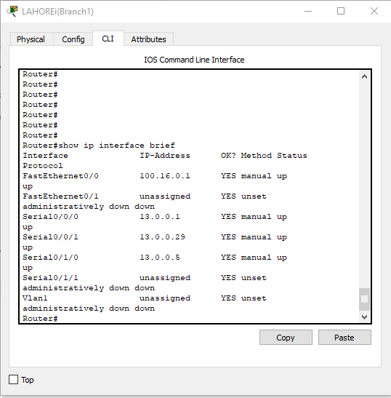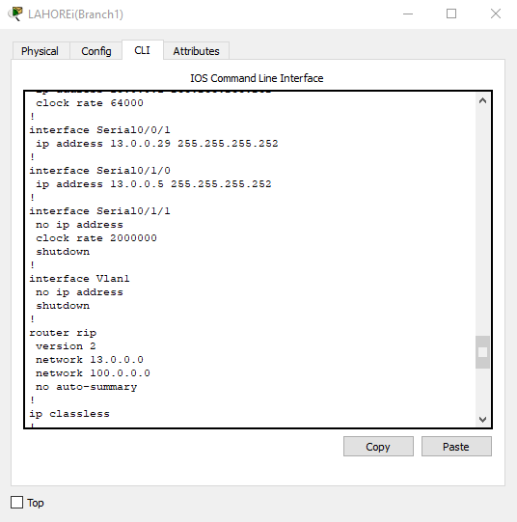Show running configuration and show ip interface brief

Show ip route:

11.0.0.0/30 is subnetted, 12 subnets

R 11.0.0.0 [120/2] via 13.0.0.2, 00:00:17, Serial0/0/0

[120/2] via 13.0.0.6, 00:00:08, Serial0/1/0

R 11.0.0.4 [120/2] via 13.0.0.6, 00:00:08, Serial0/1/0

[120/2] via 13.0.0.2, 00:00:17, Serial0/0/0

R 11.0.0.8 [120/2] via 13.0.0.2, 00:00:17, Serial0/0/0

[120/2] via 13.0.0.6, 00:00:08, Serial0/1/0

R 11.0.0.12 [120/2] via 13.0.0.2, 00:00:17, Serial0/0/0

[120/2] via 13.0.0.6, 00:00:08, Serial0/1/0

R 11.0.0.16 [120/2] via 13.0.0.2, 00:00:17, Serial0/0/0

[120/2] via 13.0.0.6, 00:00:08, Serial0/1/0

R 11.0.0.20 [120/2] via 13.0.0.2, 00:00:17, Serial0/0/0

[120/2] via 13.0.0.6, 00:00:08, Serial0/1/0

R 11.0.0.24 [120/2] via 13.0.0.2, 00:00:17, Serial0/0/0

[120/2] via 13.0.0.6, 00:00:08, Serial0/1/0

R 11.0.0.28 [120/2] via 13.0.0.2, 00:00:17, Serial0/0/0

[120/2] via 13.0.0.6, 00:00:08, Serial0/1/0

R 11.0.0.32 [120/2] via 13.0.0.6, 00:00:08, Serial0/1/0

[120/2] via 13.0.0.2, 00:00:17, Serial0/0/0

R 11.0.0.36 [120/2] via 13.0.0.6, 00:00:08, Serial0/1/0

[120/2] via 13.0.0.2, 00:00:17, Serial0/0/0

R 11.0.0.40 [120/2] via 13.0.0.2, 00:00:17, Serial0/0/0

[120/2] via 13.0.0.6, 00:00:08, Serial0/1/0

R 11.0.0.44 [120/2] via 13.0.0.6, 00:00:08, Serial0/1/0

[120/2] via 13.0.0.2, 00:00:17, Serial0/0/0

12.0.0.0/30 is subnetted, 13 subnets

R 12.0.0.0 [120/2] via 13.0.0.2, 00:00:17, Serial0/0/0

[120/2] via 13.0.0.6, 00:00:08, Serial0/1/0

R 12.0.0.4 [120/2] via 13.0.0.6, 00:00:08, Serial0/1/0

[120/2] via 13.0.0.2, 00:00:17, Serial0/0/0

R 12.0.0.8 [120/2] via 13.0.0.2, 00:00:17, Serial0/0/0

[120/2] via 13.0.0.6, 00:00:08, Serial0/1/0

R 12.0.0.12 [120/2] via 13.0.0.6, 00:00:08, Serial0/1/0

[120/2] via 13.0.0.2, 00:00:17, Serial0/0/0

R 12.0.0.16 [120/2] via 13.0.0.2, 00:00:17, Serial0/0/0

[120/2] via 13.0.0.6, 00:00:08, Serial0/1/0

R 12.0.0.20 [120/2] via 13.0.0.6, 00:00:08, Serial0/1/0

[120/2] via 13.0.0.2, 00:00:17, Serial0/0/0

R 12.0.0.24 [120/2] via 13.0.0.6, 00:00:08, Serial0/1/0

[120/2] via 13.0.0.2, 00:00:17, Serial0/0/0

R 12.0.0.28 [120/2] via 13.0.0.2, 00:00:17, Serial0/0/0

[120/2] via 13.0.0.6, 00:00:08, Serial0/1/0

R 12.0.0.32 [120/2] via 13.0.0.2, 00:00:17, Serial0/0/0

[120/2] via 13.0.0.6, 00:00:08, Serial0/1/0

R 12.0.0.36 [120/2] via 13.0.0.2, 00:00:17, Serial0/0/0

[120/2] via 13.0.0.6, 00:00:08, Serial0/1/0

R 12.0.0.40 [120/2] via 13.0.0.2, 00:00:17, Serial0/0/0

[120/2] via 13.0.0.6, 00:00:08, Serial0/1/0

R 12.0.0.44 [120/2] via 13.0.0.2, 00:00:17, Serial0/0/0

[120/2] via 13.0.0.6, 00:00:08, Serial0/1/0

R 12.0.0.48 [120/2] via 13.0.0.2, 00:00:17, Serial0/0/0

[120/2] via 13.0.0.6, 00:00:08, Serial0/1/0

13.0.0.0/30 is subnetted, 14 subnets

C 13.0.0.0 is directly connected, Serial0/0/0

C 13.0.0.4 is directly connected, Serial0/1/0

R 13.0.0.8 [120/1] via 13.0.0.2, 00:00:17, Serial0/0/0

[120/1] via 13.0.0.30, 00:00:20, Serial0/0/1

R 13.0.0.16 [120/1] via 13.0.0.6, 00:00:08, Serial0/1/0

[120/1] via 13.0.0.30, 00:00:20, Serial0/0/1

R 13.0.0.20 [120/1] via 13.0.0.2, 00:00:17, Serial0/0/0

R 13.0.0.24 [120/1] via 13.0.0.6, 00:00:08, Serial0/1/0

C 13.0.0.28 is directly connected, Serial0/0/1

R 13.0.0.32 [120/1] via 13.0.0.30, 00:00:20, Serial0/0/1

R 13.0.0.36 [120/1] via 13.0.0.2, 00:00:17, Serial0/0/0

R 13.0.0.40 [120/1] via 13.0.0.6, 00:00:08, Serial0/1/0

R 13.0.0.44 [120/1] via 13.0.0.6, 00:00:08, Serial0/1/0

R 13.0.0.48 [120/1] via 13.0.0.2, 00:00:17, Serial0/0/0

R 13.0.0.52 [120/1] via 13.0.0.6, 00:00:08, Serial0/1/0

R 13.0.0.56 [120/1] via 13.0.0.2, 00:00:17, Serial0/0/0

15.0.0.0/30 is subnetted, 2 subnets

R 15.0.0.4 [120/2] via 13.0.0.2, 00:00:17, Serial0/0/0

[120/2] via 13.0.0.6, 00:00:08, Serial0/1/0

R 15.0.0.8 [120/2] via 13.0.0.2, 00:00:17, Serial0/0/0

[120/2] via 13.0.0.6, 00:00:08, Serial0/1/0

100.0.0.0/28 is subnetted, 3 subnets

C 100.16.0.0 is directly connected, FastEthernet0/0

R 100.16.0.16 [120/1] via 13.0.0.30, 00:00:20, Serial0/0/1

R 100.16.0.32 [120/2] via 13.0.0.2, 00:00:17, Serial0/0/0

[120/2] via 13.0.0.30, 00:00:20, Serial0/0/1

[120/2] via 13.0.0.6, 00:00:08, Serial0/1/0

172.16.0.0/28 is subnetted, 2 subnets

R 172.16.1.0 [120/2] via 13.0.0.2, 00:00:17, Serial0/0/0

[120/2] via 13.0.0.6, 00:00:08, Serial0/1/0

R 172.16.1.16 [120/2] via 13.0.0.2, 00:00:17, Serial0/0/0

[120/2] via 13.0.0.6, 00:00:08, Serial0/1/0

172.168.0.0/28 is subnetted, 3 subnets

R 172.168.0.0 [120/2] via 13.0.0.2, 00:00:17, Serial0/0/0

[120/2] via 13.0.0.6, 00:00:08, Serial0/1/0

R 172.168.0.16 [120/2] via 13.0.0.2, 00:00:17, Serial0/0/0

[120/2] via 13.0.0.6, 00:00:08, Serial0/1/0

R 172.168.0.32 [120/2] via 13.0.0.2, 00:00:17, Serial0/0/0

[120/2] via 13.0.0.6, 00:00:08, Serial0/1/0

190.200.0.0/29 is subnetted, 2 subnets

R 190.200.10.0 [120/2] via 13.0.0.6, 00:00:08, Serial0/1/0

[120/2] via 13.0.0.2, 00:00:17, Serial0/0/0

R 190.200.11.0 [120/2] via 13.0.0.2, 00:00:17, Serial0/0/0

[120/2] via 13.0.0.6, 00:00:08, Serial0/1/0

192.168.10.0/27 is subnetted, 3 subnets

R 192.168.10.0 [120/2] via 13.0.0.6, 00:00:08, Serial0/1/0

[120/2] via 13.0.0.2, 00:00:17, Serial0/0/0

R 192.168.10.32 [120/2] via 13.0.0.6, 00:00:08, Serial0/1/0

[120/2] via 13.0.0.2, 00:00:17, Serial0/0/0

R 192.168.10.64 [120/2] via 13.0.0.6, 00:00:08, Serial0/1/0

[120/2] via 13.0.0.2, 00:00:17, Serial0/0/0

­­­Lahore branch 2:

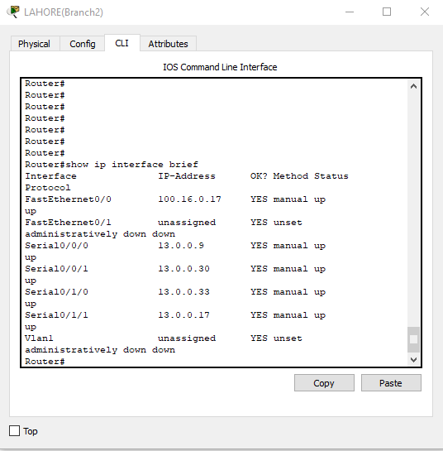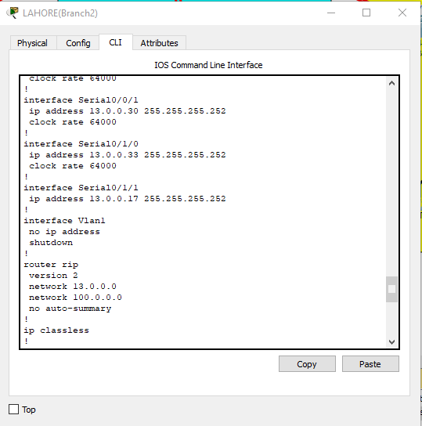Show running configuration and show ip interface brief:

Show ip route:

11.0.0.0/30 is subnetted, 12 subnets

R 11.0.0.0 [120/2] via 13.0.0.10, 00:00:15, Serial0/0/0

[120/2] via 13.0.0.18, 00:00:13, Serial0/1/1

R 11.0.0.4 [120/2] via 13.0.0.18, 00:00:13, Serial0/1/1

[120/2] via 13.0.0.10, 00:00:15, Serial0/0/0

R 11.0.0.8 [120/2] via 13.0.0.10, 00:00:15, Serial0/0/0

[120/2] via 13.0.0.18, 00:00:13, Serial0/1/1

R 11.0.0.12 [120/2] via 13.0.0.10, 00:00:15, Serial0/0/0

[120/2] via 13.0.0.18, 00:00:13, Serial0/1/1

R 11.0.0.16 [120/2] via 13.0.0.10, 00:00:15, Serial0/0/0

[120/2] via 13.0.0.18, 00:00:13, Serial0/1/1

R 11.0.0.20 [120/2] via 13.0.0.10, 00:00:15, Serial0/0/0

[120/2] via 13.0.0.18, 00:00:13, Serial0/1/1

R 11.0.0.24 [120/2] via 13.0.0.10, 00:00:15, Serial0/0/0

[120/2] via 13.0.0.18, 00:00:13, Serial0/1/1

R 11.0.0.28 [120/2] via 13.0.0.10, 00:00:15, Serial0/0/0

[120/2] via 13.0.0.18, 00:00:13, Serial0/1/1

R 11.0.0.32 [120/2] via 13.0.0.18, 00:00:13, Serial0/1/1

[120/2] via 13.0.0.10, 00:00:15, Serial0/0/0

R 11.0.0.36 [120/2] via 13.0.0.18, 00:00:13, Serial0/1/1

[120/2] via 13.0.0.10, 00:00:15, Serial0/0/0

R 11.0.0.40 [120/2] via 13.0.0.10, 00:00:15, Serial0/0/0

[120/2] via 13.0.0.18, 00:00:13, Serial0/1/1

R 11.0.0.44 [120/2] via 13.0.0.18, 00:00:13, Serial0/1/1

[120/2] via 13.0.0.10, 00:00:15, Serial0/0/0

12.0.0.0/30 is subnetted, 13 subnets

R 12.0.0.0 [120/2] via 13.0.0.10, 00:00:15, Serial0/0/0

[120/2] via 13.0.0.18, 00:00:13, Serial0/1/1

R 12.0.0.4 [120/2] via 13.0.0.18, 00:00:13, Serial0/1/1

[120/2] via 13.0.0.10, 00:00:15, Serial0/0/0

R 12.0.0.8 [120/2] via 13.0.0.10, 00:00:15, Serial0/0/0

[120/2] via 13.0.0.18, 00:00:13, Serial0/1/1

R 12.0.0.12 [120/2] via 13.0.0.18, 00:00:13, Serial0/1/1

[120/2] via 13.0.0.10, 00:00:15, Serial0/0/0

R 12.0.0.16 [120/2] via 13.0.0.10, 00:00:15, Serial0/0/0

[120/2] via 13.0.0.18, 00:00:13, Serial0/1/1

R 12.0.0.20 [120/2] via 13.0.0.18, 00:00:13, Serial0/1/1

[120/2] via 13.0.0.10, 00:00:15, Serial0/0/0

R 12.0.0.24 [120/2] via 13.0.0.18, 00:00:13, Serial0/1/1

[120/2] via 13.0.0.10, 00:00:15, Serial0/0/0

R 12.0.0.28 [120/2] via 13.0.0.10, 00:00:15, Serial0/0/0

[120/2] via 13.0.0.18, 00:00:13, Serial0/1/1

R 12.0.0.32 [120/2] via 13.0.0.10, 00:00:15, Serial0/0/0

[120/2] via 13.0.0.18, 00:00:13, Serial0/1/1

R 12.0.0.36 [120/2] via 13.0.0.10, 00:00:15, Serial0/0/0

[120/2] via 13.0.0.18, 00:00:13, Serial0/1/1

R 12.0.0.40 [120/2] via 13.0.0.10, 00:00:15, Serial0/0/0

[120/2] via 13.0.0.18, 00:00:13, Serial0/1/1

R 12.0.0.44 [120/2] via 13.0.0.10, 00:00:15, Serial0/0/0

[120/2] via 13.0.0.18, 00:00:13, Serial0/1/1

R 12.0.0.48 [120/2] via 13.0.0.10, 00:00:15, Serial0/0/0

[120/2] via 13.0.0.18, 00:00:13, Serial0/1/1

13.0.0.0/30 is subnetted, 14 subnets

R 13.0.0.0 [120/1] via 13.0.0.10, 00:00:15, Serial0/0/0

[120/1] via 13.0.0.29, 00:00:27, Serial0/0/1

R 13.0.0.4 [120/1] via 13.0.0.18, 00:00:13, Serial0/1/1

[120/1] via 13.0.0.29, 00:00:27, Serial0/0/1

C 13.0.0.8 is directly connected, Serial0/0/0

C 13.0.0.16 is directly connected, Serial0/1/1

R 13.0.0.20 [120/1] via 13.0.0.10, 00:00:15, Serial0/0/0

[120/1] via 13.0.0.34, 00:00:18, Serial0/1/0

R 13.0.0.24 [120/1] via 13.0.0.18, 00:00:13, Serial0/1/1

[120/1] via 13.0.0.34, 00:00:18, Serial0/1/0

C 13.0.0.28 is directly connected, Serial0/0/1

C 13.0.0.32 is directly connected, Serial0/1/0

R 13.0.0.36 [120/1] via 13.0.0.10, 00:00:15, Serial0/0/0

R 13.0.0.40 [120/1] via 13.0.0.18, 00:00:13, Serial0/1/1

R 13.0.0.44 [120/1] via 13.0.0.18, 00:00:13, Serial0/1/1

R 13.0.0.48 [120/1] via 13.0.0.10, 00:00:15, Serial0/0/0

R 13.0.0.52 [120/1] via 13.0.0.18, 00:00:13, Serial0/1/1

R 13.0.0.56 [120/1] via 13.0.0.10, 00:00:15, Serial0/0/0

15.0.0.0/30 is subnetted, 2 subnets

R 15.0.0.4 [120/2] via 13.0.0.10, 00:00:15, Serial0/0/0

[120/2] via 13.0.0.18, 00:00:13, Serial0/1/1

R 15.0.0.8 [120/2] via 13.0.0.10, 00:00:15, Serial0/0/0

[120/2] via 13.0.0.18, 00:00:13, Serial0/1/1

100.0.0.0/28 is subnetted, 3 subnets

R 100.16.0.0 [120/1] via 13.0.0.29, 00:00:27, Serial0/0/1

C 100.16.0.16 is directly connected, FastEthernet0/0

R 100.16.0.32 [120/1] via 13.0.0.34, 00:00:18, Serial0/1/0

172.16.0.0/28 is subnetted, 2 subnets

R 172.16.1.0 [120/2] via 13.0.0.10, 00:00:15, Serial0/0/0

[120/2] via 13.0.0.18, 00:00:13, Serial0/1/1

R 172.16.1.16 [120/2] via 13.0.0.10, 00:00:15, Serial0/0/0

[120/2] via 13.0.0.18, 00:00:13, Serial0/1/1

172.168.0.0/28 is subnetted, 3 subnets

R 172.168.0.0 [120/2] via 13.0.0.10, 00:00:15, Serial0/0/0

[120/2] via 13.0.0.18, 00:00:13, Serial0/1/1

R 172.168.0.16 [120/2] via 13.0.0.10, 00:00:15, Serial0/0/0

[120/2] via 13.0.0.18, 00:00:13, Serial0/1/1

R 172.168.0.32 [120/2] via 13.0.0.10, 00:00:15, Serial0/0/0

[120/2] via 13.0.0.18, 00:00:13, Serial0/1/1

190.200.0.0/29 is subnetted, 2 subnets

R 190.200.10.0 [120/2] via 13.0.0.18, 00:00:13, Serial0/1/1

[120/2] via 13.0.0.10, 00:00:15, Serial0/0/0

R 190.200.11.0 [120/2] via 13.0.0.10, 00:00:15, Serial0/0/0

[120/2] via 13.0.0.18, 00:00:13, Serial0/1/1

192.168.10.0/27 is subnetted, 3 subnets

R 192.168.10.0 [120/2] via 13.0.0.18, 00:00:13, Serial0/1/1

[120/2] via 13.0.0.10, 00:00:15, Serial0/0/0

R 192.168.10.32 [120/2] via 13.0.0.18, 00:00:13, Serial0/1/1

[120/2] via 13.0.0.10, 00:00:15, Serial0/0/0

R 192.168.10.64 [120/2] via 13.0.0.18, 00:00:13, Serial0/1/1

[120/2] via 13.0.0.10, 00:00:15, Serial0/0/0

Lahore branch 3:

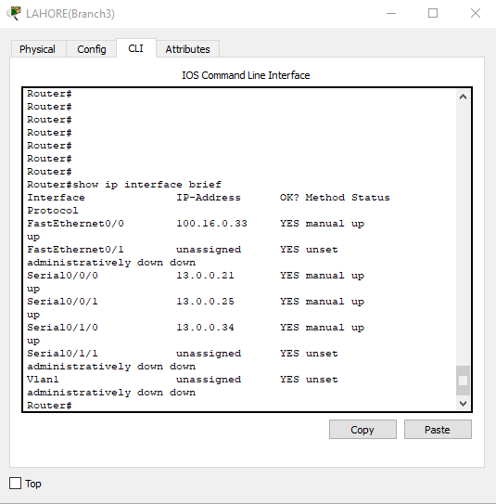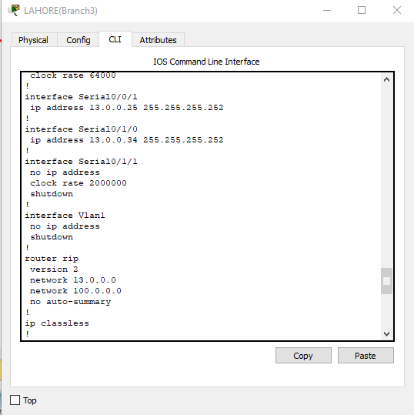Show running configuration and show ip interface brief:

Show ip route:

11.0.0.0/30 is subnetted, 12 subnets

R 11.0.0.0 [120/2] via 13.0.0.22, 00:00:17, Serial0/0/0

[120/2] via 13.0.0.26, 00:00:16, Serial0/0/1

R 11.0.0.4 [120/2] via 13.0.0.22, 00:00:17, Serial0/0/0

[120/2] via 13.0.0.26, 00:00:16, Serial0/0/1

R 11.0.0.8 [120/2] via 13.0.0.22, 00:00:17, Serial0/0/0

[120/2] via 13.0.0.26, 00:00:16, Serial0/0/1

R 11.0.0.12 [120/2] via 13.0.0.22, 00:00:17, Serial0/0/0

[120/2] via 13.0.0.26, 00:00:16, Serial0/0/1

R 11.0.0.16 [120/2] via 13.0.0.22, 00:00:17, Serial0/0/0

[120/2] via 13.0.0.26, 00:00:16, Serial0/0/1

R 11.0.0.20 [120/2] via 13.0.0.22, 00:00:17, Serial0/0/0

[120/2] via 13.0.0.26, 00:00:16, Serial0/0/1

R 11.0.0.24 [120/2] via 13.0.0.22, 00:00:17, Serial0/0/0

[120/2] via 13.0.0.26, 00:00:16, Serial0/0/1

R 11.0.0.28 [120/2] via 13.0.0.22, 00:00:17, Serial0/0/0

[120/2] via 13.0.0.26, 00:00:16, Serial0/0/1

R 11.0.0.32 [120/2] via 13.0.0.22, 00:00:17, Serial0/0/0

[120/2] via 13.0.0.26, 00:00:16, Serial0/0/1

R 11.0.0.36 [120/2] via 13.0.0.22, 00:00:17, Serial0/0/0

[120/2] via 13.0.0.26, 00:00:16, Serial0/0/1

R 11.0.0.40 [120/2] via 13.0.0.22, 00:00:17, Serial0/0/0

[120/2] via 13.0.0.26, 00:00:16, Serial0/0/1

R 11.0.0.44 [120/2] via 13.0.0.22, 00:00:17, Serial0/0/0

[120/2] via 13.0.0.26, 00:00:16, Serial0/0/1

12.0.0.0/30 is subnetted, 13 subnets

R 12.0.0.0 [120/2] via 13.0.0.22, 00:00:17, Serial0/0/0

[120/2] via 13.0.0.26, 00:00:16, Serial0/0/1

R 12.0.0.4 [120/2] via 13.0.0.26, 00:00:16, Serial0/0/1

[120/2] via 13.0.0.22, 00:00:17, Serial0/0/0

R 12.0.0.8 [120/2] via 13.0.0.22, 00:00:17, Serial0/0/0

[120/2] via 13.0.0.26, 00:00:16, Serial0/0/1

R 12.0.0.12 [120/2] via 13.0.0.26, 00:00:16, Serial0/0/1

[120/2] via 13.0.0.22, 00:00:17, Serial0/0/0

R 12.0.0.16 [120/2] via 13.0.0.22, 00:00:17, Serial0/0/0

[120/2] via 13.0.0.26, 00:00:16, Serial0/0/1

R 12.0.0.20 [120/2] via 13.0.0.26, 00:00:16, Serial0/0/1

[120/2] via 13.0.0.22, 00:00:17, Serial0/0/0

R 12.0.0.24 [120/2] via 13.0.0.26, 00:00:16, Serial0/0/1

[120/2] via 13.0.0.22, 00:00:17, Serial0/0/0

R 12.0.0.28 [120/2] via 13.0.0.22, 00:00:17, Serial0/0/0

[120/2] via 13.0.0.26, 00:00:16, Serial0/0/1

R 12.0.0.32 [120/2] via 13.0.0.22, 00:00:17, Serial0/0/0

[120/2] via 13.0.0.26, 00:00:16, Serial0/0/1

R 12.0.0.36 [120/2] via 13.0.0.22, 00:00:17, Serial0/0/0

[120/2] via 13.0.0.26, 00:00:16, Serial0/0/1

R 12.0.0.40 [120/2] via 13.0.0.22, 00:00:17, Serial0/0/0

[120/2] via 13.0.0.26, 00:00:16, Serial0/0/1

R 12.0.0.44 [120/2] via 13.0.0.22, 00:00:17, Serial0/0/0

[120/2] via 13.0.0.26, 00:00:16, Serial0/0/1

R 12.0.0.48 [120/2] via 13.0.0.22, 00:00:17, Serial0/0/0

[120/2] via 13.0.0.26, 00:00:16, Serial0/0/1

13.0.0.0/30 is subnetted, 14 subnets

R 13.0.0.0 [120/1] via 13.0.0.22, 00:00:17, Serial0/0/0

R 13.0.0.4 [120/1] via 13.0.0.26, 00:00:16, Serial0/0/1

R 13.0.0.8 [120/1] via 13.0.0.22, 00:00:17, Serial0/0/0

[120/1] via 13.0.0.33, 00:00:15, Serial0/1/0

R 13.0.0.16 [120/1] via 13.0.0.26, 00:00:16, Serial0/0/1

[120/1] via 13.0.0.33, 00:00:15, Serial0/1/0

C 13.0.0.20 is directly connected, Serial0/0/0

C 13.0.0.24 is directly connected, Serial0/0/1

R 13.0.0.28 [120/1] via 13.0.0.33, 00:00:15, Serial0/1/0

C 13.0.0.32 is directly connected, Serial0/1/0

R 13.0.0.36 [120/1] via 13.0.0.22, 00:00:17, Serial0/0/0

R 13.0.0.40 [120/1] via 13.0.0.26, 00:00:16, Serial0/0/1

R 13.0.0.44 [120/1] via 13.0.0.26, 00:00:16, Serial0/0/1

R 13.0.0.48 [120/1] via 13.0.0.22, 00:00:17, Serial0/0/0

R 13.0.0.52 [120/1] via 13.0.0.26, 00:00:16, Serial0/0/1

R 13.0.0.56 [120/1] via 13.0.0.22, 00:00:17, Serial0/0/0

15.0.0.0/30 is subnetted, 2 subnets

R 15.0.0.4 [120/2] via 13.0.0.22, 00:00:17, Serial0/0/0

[120/2] via 13.0.0.26, 00:00:16, Serial0/0/1

R 15.0.0.8 [120/2] via 13.0.0.22, 00:00:17, Serial0/0/0

[120/2] via 13.0.0.26, 00:00:16, Serial0/0/1

100.0.0.0/28 is subnetted, 3 subnets

R 100.16.0.0 [120/2] via 13.0.0.22, 00:00:17, Serial0/0/0

[120/2] via 13.0.0.33, 00:00:15, Serial0/1/0

[120/2] via 13.0.0.26, 00:00:16, Serial0/0/1

R 100.16.0.16 [120/1] via 13.0.0.33, 00:00:15, Serial0/1/0

C 100.16.0.32 is directly connected, FastEthernet0/0

172.16.0.0/28 is subnetted, 2 subnets

R 172.16.1.0 [120/2] via 13.0.0.22, 00:00:17, Serial0/0/0

[120/2] via 13.0.0.26, 00:00:16, Serial0/0/1

R 172.16.1.16 [120/2] via 13.0.0.22, 00:00:17, Serial0/0/0

[120/2] via 13.0.0.26, 00:00:16, Serial0/0/1

172.168.0.0/28 is subnetted, 3 subnets

R 172.168.0.0 [120/2] via 13.0.0.22, 00:00:17, Serial0/0/0

[120/2] via 13.0.0.26, 00:00:16, Serial0/0/1

R 172.168.0.16 [120/2] via 13.0.0.22, 00:00:17, Serial0/0/0

[120/2] via 13.0.0.26, 00:00:16, Serial0/0/1

R 172.168.0.32 [120/2] via 13.0.0.22, 00:00:17, Serial0/0/0

[120/2] via 13.0.0.26, 00:00:16, Serial0/0/1

190.200.0.0/29 is subnetted, 2 subnets

R 190.200.10.0 [120/2] via 13.0.0.26, 00:00:16, Serial0/0/1

[120/2] via 13.0.0.22, 00:00:17, Serial0/0/0

R 190.200.11.0 [120/2] via 13.0.0.22, 00:00:17, Serial0/0/0

[120/2] via 13.0.0.26, 00:00:16, Serial0/0/1

192.168.10.0/27 is subnetted, 3 subnets

R 192.168.10.0 [120/2] via 13.0.0.26, 00:00:16, Serial0/0/1

[120/2] via 13.0.0.22, 00:00:17, Serial0/0/0

R 192.168.10.32 [120/2] via 13.0.0.26, 00:00:16, Serial0/0/1

[120/2] via 13.0.0.22, 00:00:17, Serial0/0/0

R 192.168.10.64 [120/2] via 13.0.0.26, 00:00:16, Serial0/0/1

[120/2] via 13.0.0.22, 00:00:17, Serial0/0/0

Show ping result for port security:

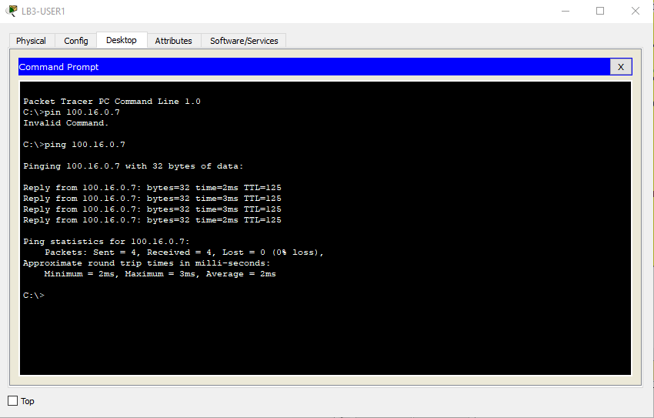

Show ping result for Redistribution router:

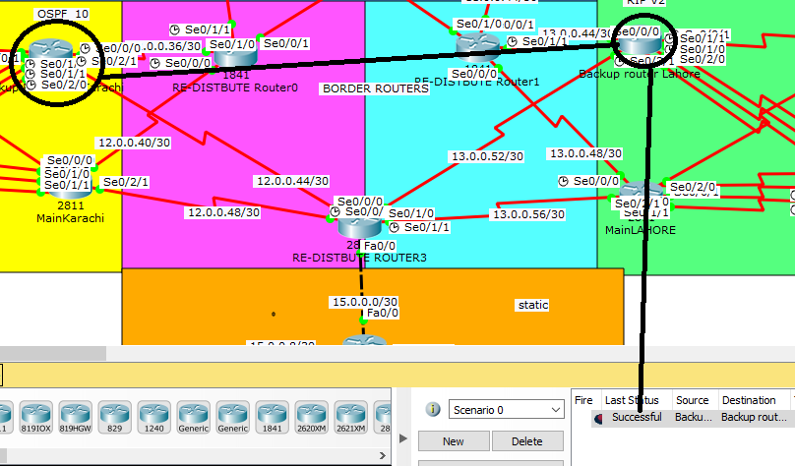OSPF TO RIPV2:

Show Running config:

router ospf 10

log-adjacency-changes

redistribute rip metric 200 subnets

redistribute static metric 200 subnets

network 12.0.0.48 0.0.0.3 area 0

network 12.0.0.44 0.0.0.3 area 0

!

router rip

version 2

redistribute ospf 10 metric 1

redistribute static metric 1

network 13.0.0.0

no auto-summary

!

EIGRP TO OSPF:

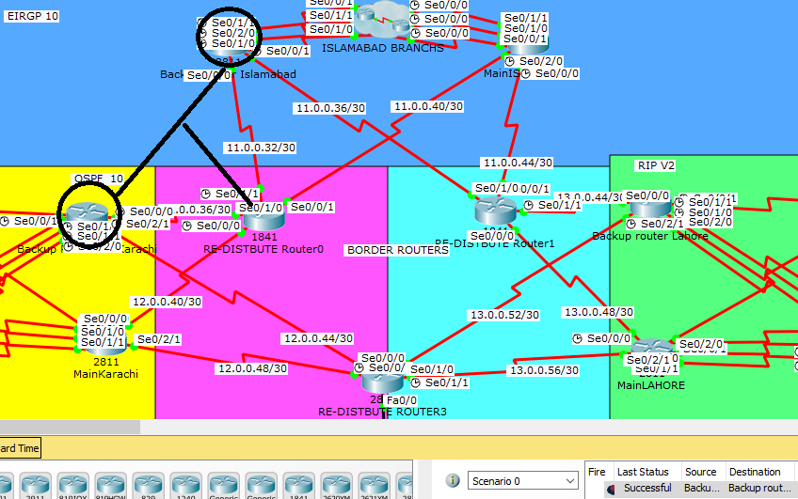

Show running configuration:

!

router eigrp 10

redistribute ospf 10 metric 1000 10 255 1 1500

network 11.0.0.0 0.0.0.255

network 11.0.0.0

no auto-summary

!

router ospf 10

log-adjacency-changes

redistribute eigrp 10 metric 200 subnets

network 12.0.0.36 0.0.0.3 area 0

network 12.0.0.40 0.0.0.3 area 0

!

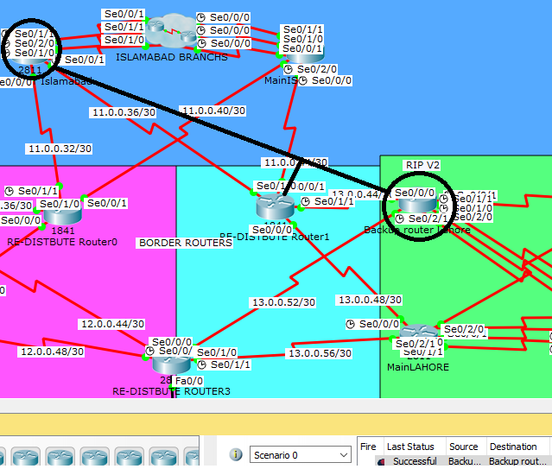EIGRP to RIP-V2 :

Show running configuration:

!

router eigrp 10

redistribute rip metric 1000 0 255 1 1500

network 11.0.0.0 0.0.0.255

network 11.0.0.0

no auto-summary

!

router rip

version 2

redistribute eigrp 10 metric 1

network 13.0.0.0

no auto-summary

!