Report for Assignment # 3 (Regression)

## Name: Muhammad Shehroz

## Roll No: BSEF16M515 (Add / Drop Student)

**Training Data Graph:**

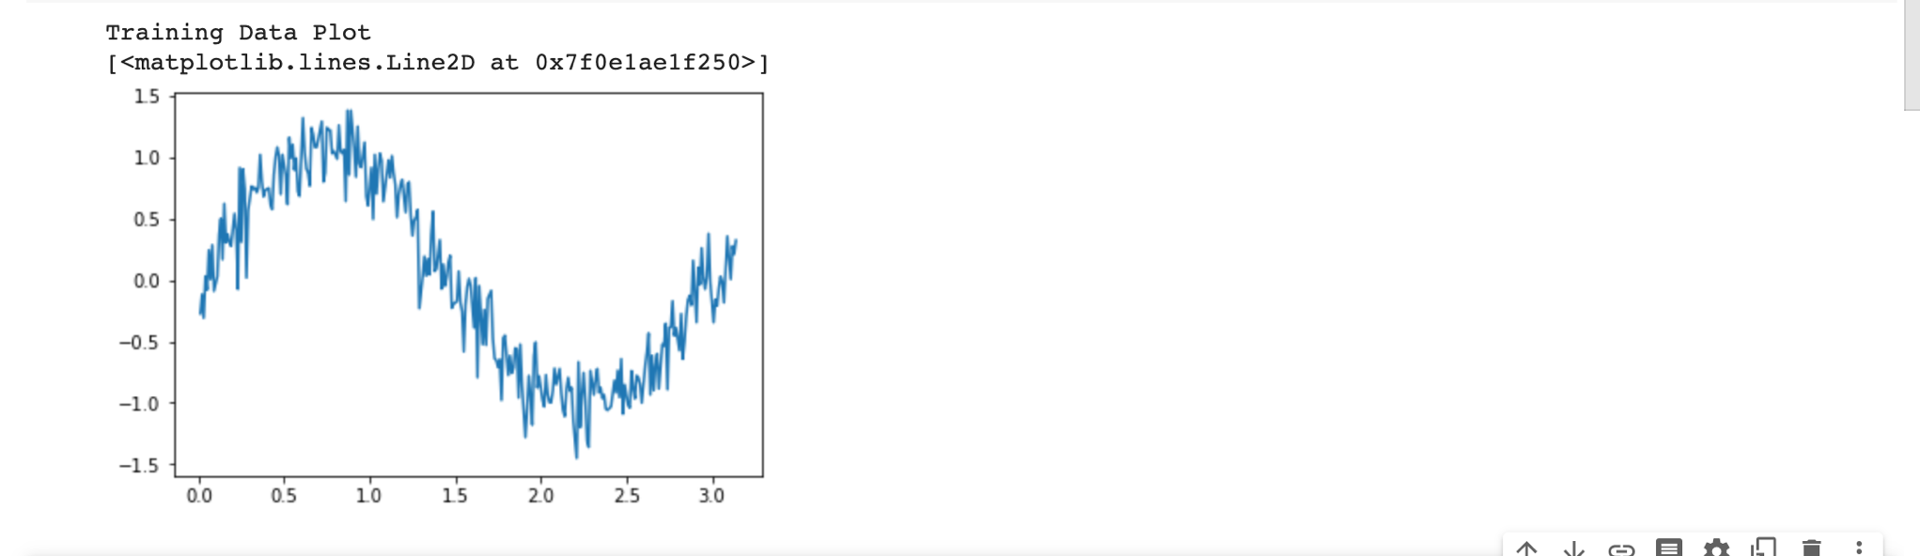

**Test Data Graph:**

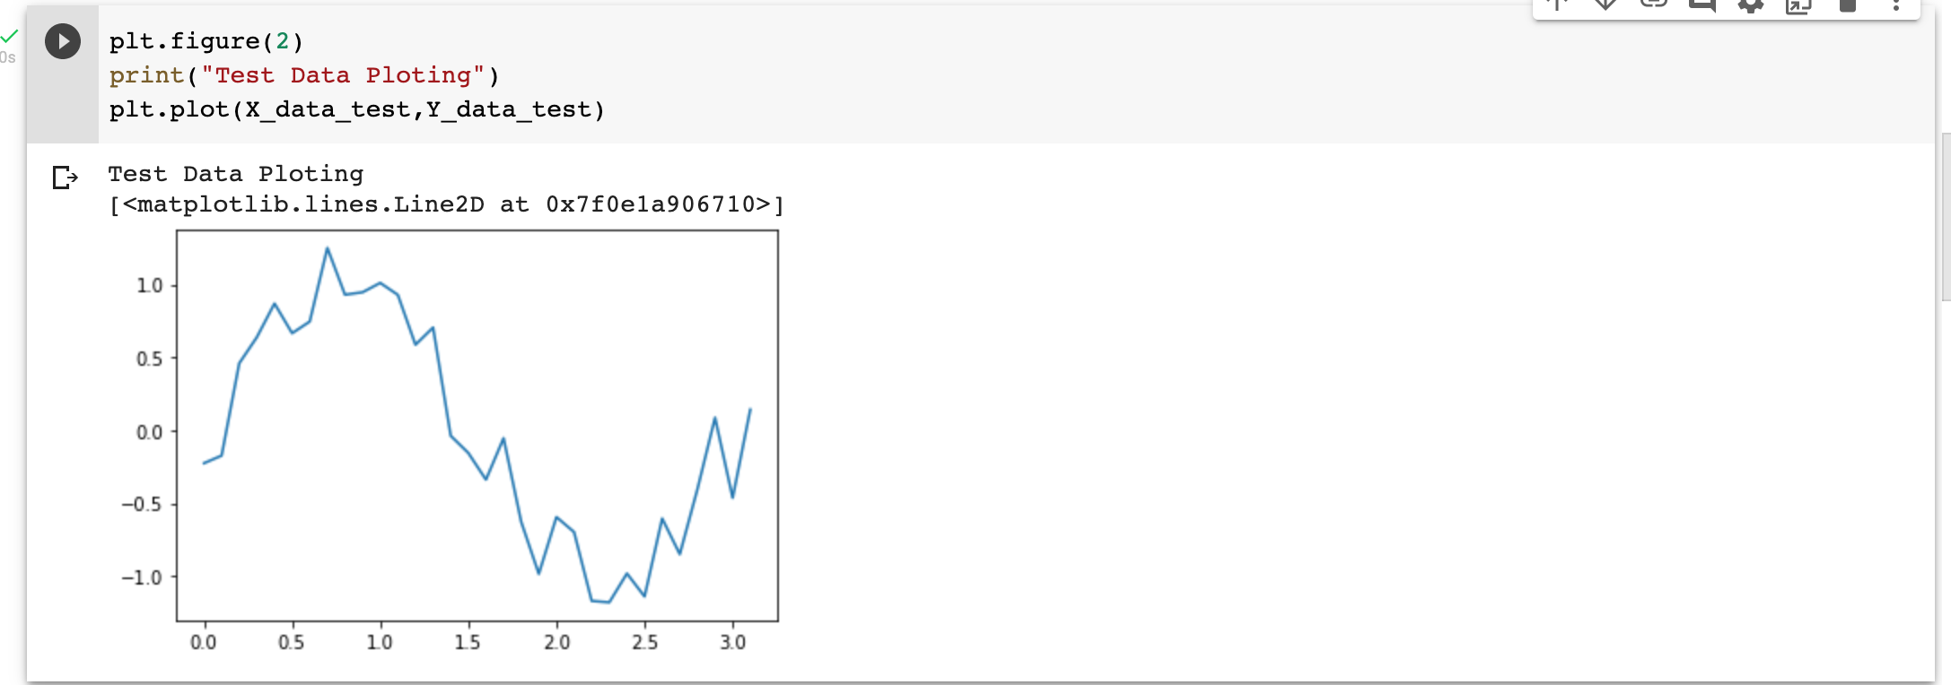

**Linear Regression Model Graph:**

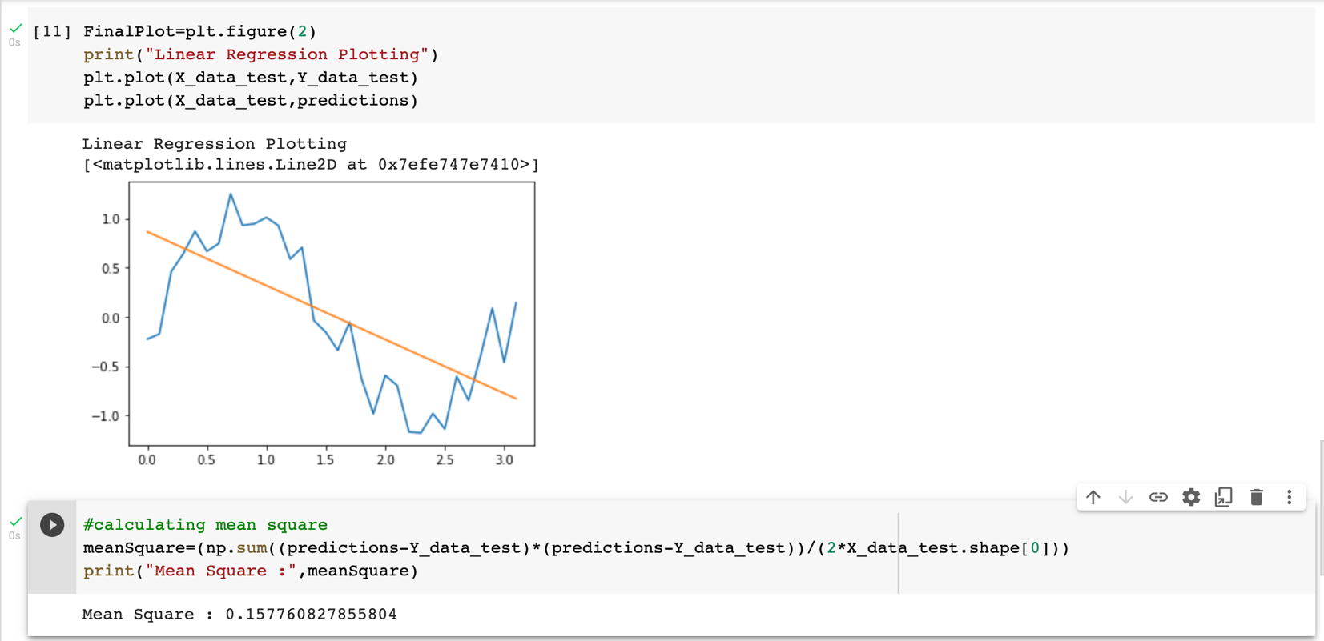

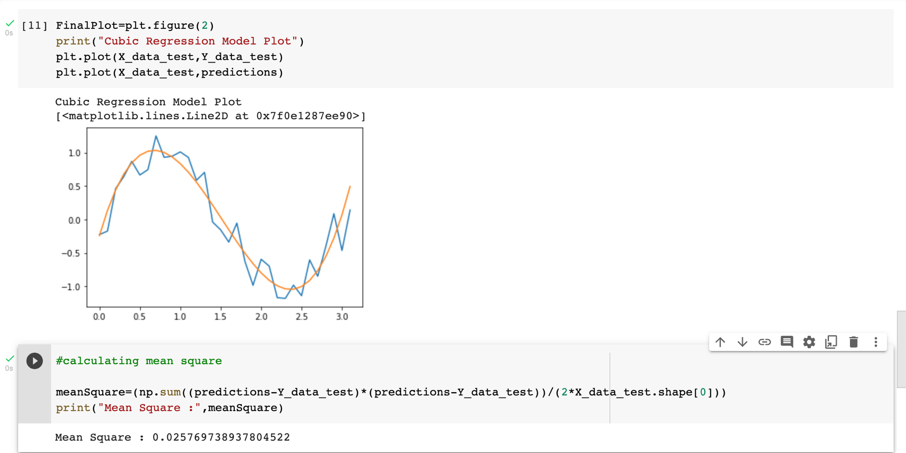

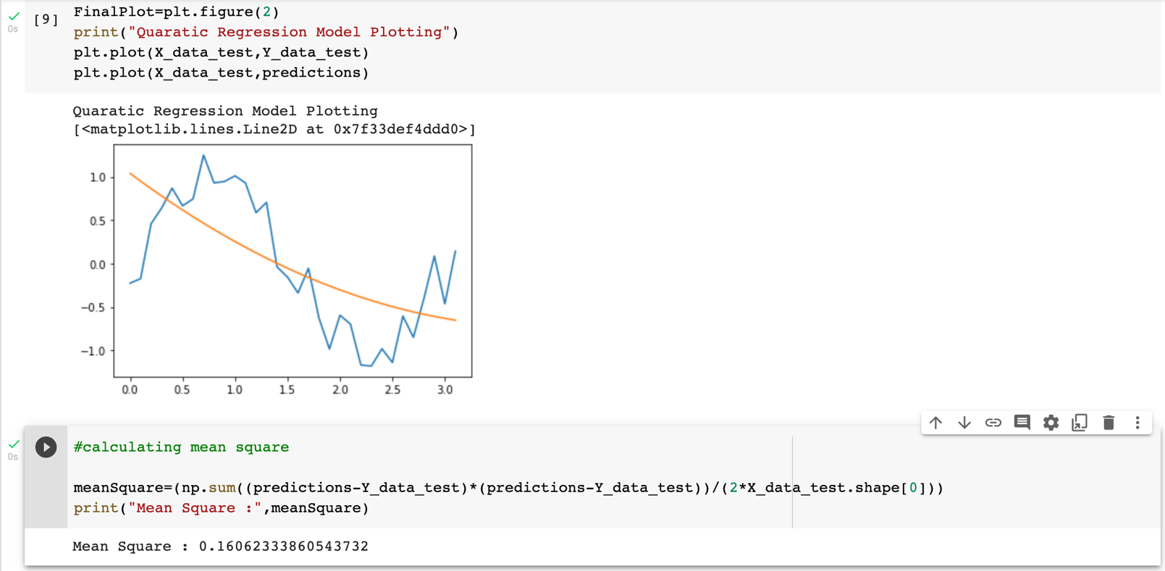

**Since the error rate for linear and quadratic model is higher as compared to cubic model. This is why the cubic model best fits for the our case.**