1. Go to code commit here Create repository.

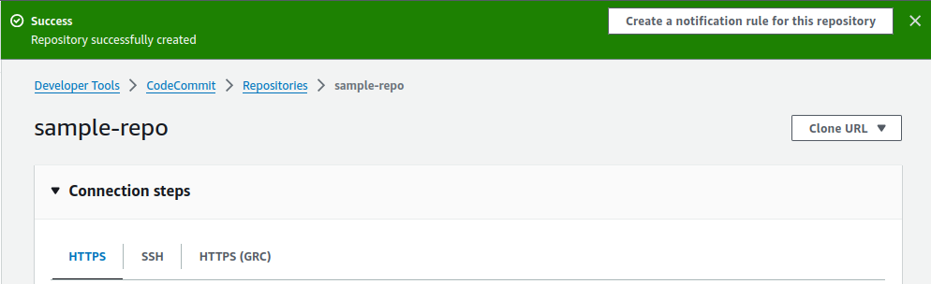

1. We should create/generate ‘ HTTPS Git credentials for AWS CodeCommit’ for code push code clone purpose.When we do git clone or git push it ask security credentials for secure,for that we created it in IAM console.

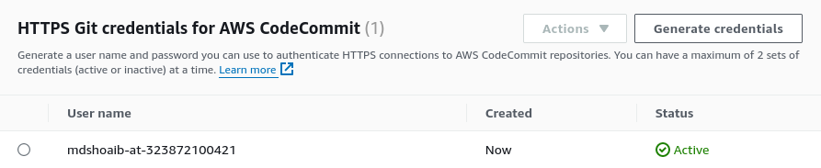

1. Now go to local terminal and run the below commands one by one.

$ mkdir demo

$ cd demo

demo$ git init (Initialized empty Git repository in /home/shoaib/Desktop/demo/.git/)

$ git clone <https://git-codecommit.ap-southeast-1.amazonaws.com/v1/repos/sample-repo> (this will get from clone URL ,take https url.)

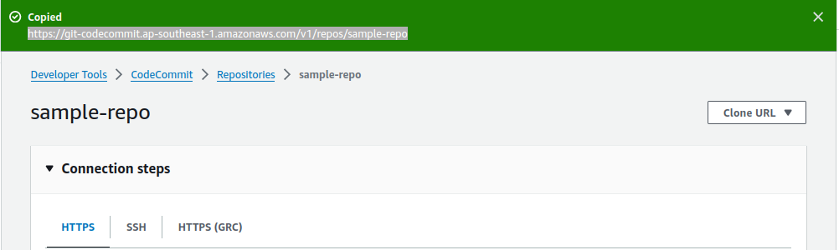

$ vi demo.yml (here create sample file to push)

$ git add .

$ git status (Changes to be committed:)

$ git commit -m "push"

$ git status (nothing to commit, working tree clean)

$ git remote add origin <https://git-codecommit.ap-southeast-1.amazonaws.com/v1/repos/sample-repo> (add our origin first and then push to origin)

$ git push origin master .

1. Now we can check in code commit repository where we get our file,which we have recently pushed.

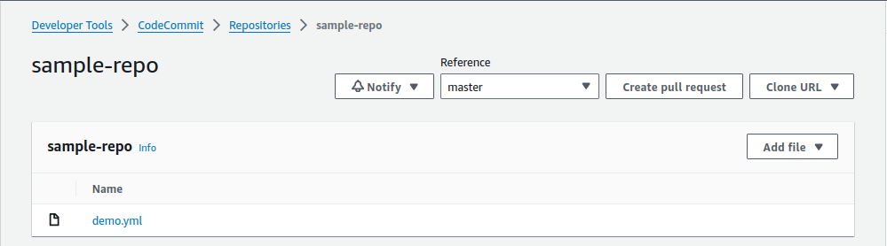

1. By this HTTPS Git credentials for AWS CodeCommit we get username and password,with this credentials anybody can access the code commit repo.whenever we do push we give this credentials.

—---------------------------------------------------------------------------------------------------------------------------

1. For ssh clone url method,You must use a Git client if not download git.
2. You must have an AWS CodeCommit managed policy attached to your IAM user like code commit full access or code commit power user.
3. Upload your SSH public key to your IAM user.for this first we generate ssh keys by $ ssh-keygen.copy the public key and upload it into SSH public keys for AWS CodeCommit.

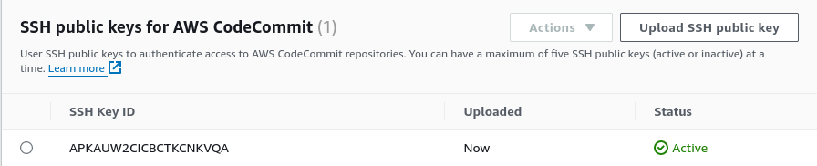

1. Once you have uploaded your SSH public key, copy the SSH Key ID. You will need it in the next step.
2. Create one file called config in ~/.ssh directory.
3. In this config file add the below content with your values.

Host git-codecommit.\*.amazonaws.com

User Your-IAM-SSH-Key-ID-Here (# give your SSH Key ID from IAM console)

IdentityFile ~/.ssh/Your-Private-Key-File-Name-Here (# give private key file name)

1. Once you have saved the file, make sure it has the right permissions by running the following command in the ~/.ssh directory.chmod 600 config.
2. Clone your repository to your local computer and start working on code. Run the following command:

git clone ssh://git-codecommit.ap-southeast-1.amazonaws.com/v1/repos/sample-repo

—------------------------------------------------------------------------------------------------