1. We created 2 ec2-instances ,one public and another one in private.and we connect private instance through public instance,here we installed the code-deploy agent in private ec2 by below commands.for that we required nat-gateway.

#!/bin/bash

sudo apt update -y

sudo apt install apache2 -y

sudo add-apt-repository ppa:ondrej/php -y

sudo apt update -y

sudo apt install php8.1 -y

sudo systemctl start apache2

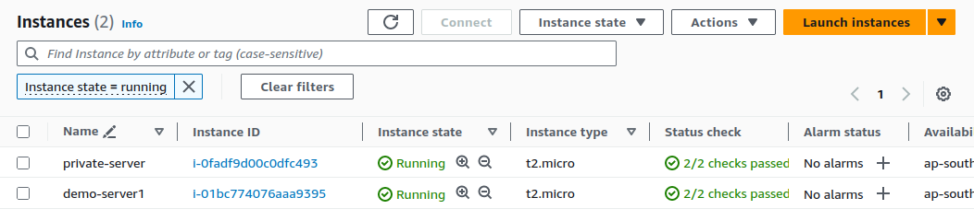

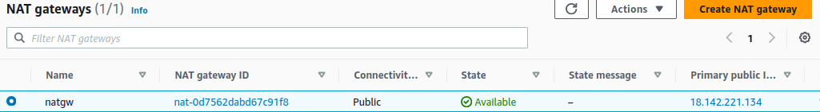

1. We need to create and attach a role to our instance that grants it access to S3 because the deployment files to be deployed exist there and for code-deploy.



###### To install the CodeDeploy agent on Ubuntu Server,Enter the following commands, one after the other:

sudo apt update

sudo apt install ruby-full

sudo apt install wget

cd /home/ubuntu

Wget <https://aws-codedeploy-us-east-2.s3.us-east-2.amazonaws.com/latest/install>

chmod +x ./install

sudo ./install auto

sudo ./install auto > /tmp/logfile

###### To check that the service is running

sudo service codedeploy-agent status

sudo service codedeploy-agent start

sudo service codedeploy-agent status

1. ref:<https://docs.aws.amazon.com/codedeploy/latest/userguide/codedeploy-agent-operations-install-ubuntu.html> (code-deploy-agent docs).
2. We created loadbalancer for private instance as a target here.

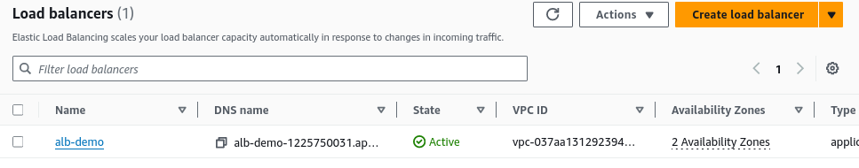

1. We created vpc-interface-endpoint for code-deploy.you can establish a private connection between your VPC and CodeDeploy.

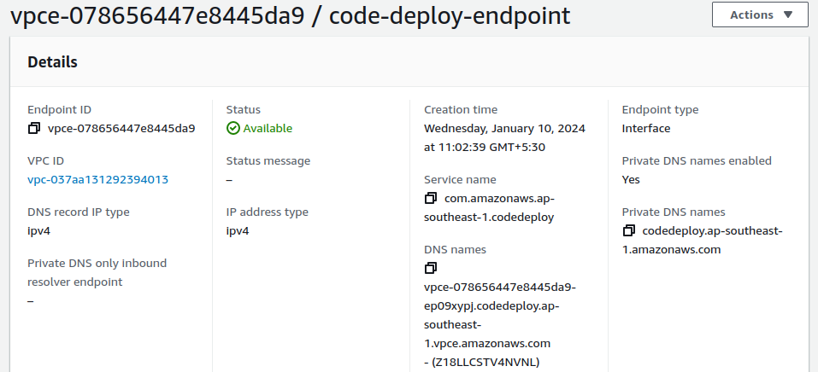

1. Now go to code-deploy,here we create application and deployement-group.for code deploy we need to create role for that.



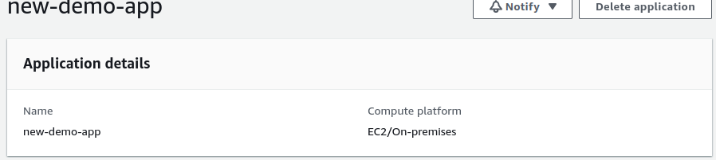

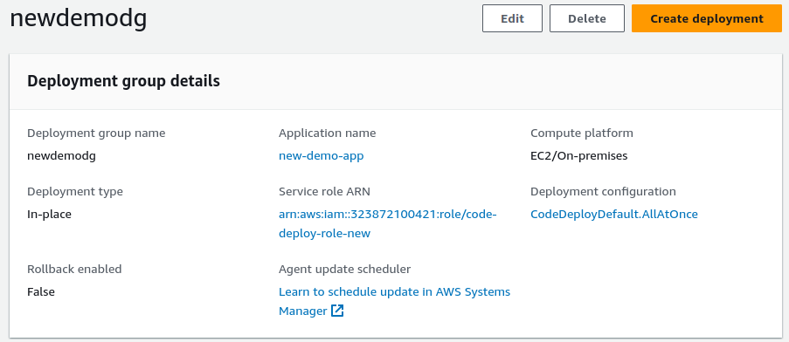

1. After that we go to code-pipeline and while creating code-pipeline we skip code-build and connect github account and select codedeploy and create code-pipeline.

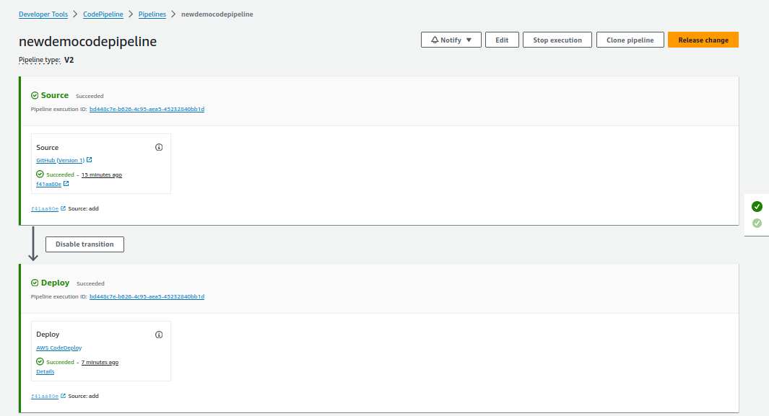

1. After codepipeline success we can check load balancer dns ,we can get our end result (webpage).



1. Whenever developer do changes and push to git hub,codepipeline automatically run the pipeline and gives the end result according to our changes.
2. If we want to manually approve changes to take and run pipeline,that is also possible.for that we add one stage in between source and deploy stages that is called manual-approval stage.

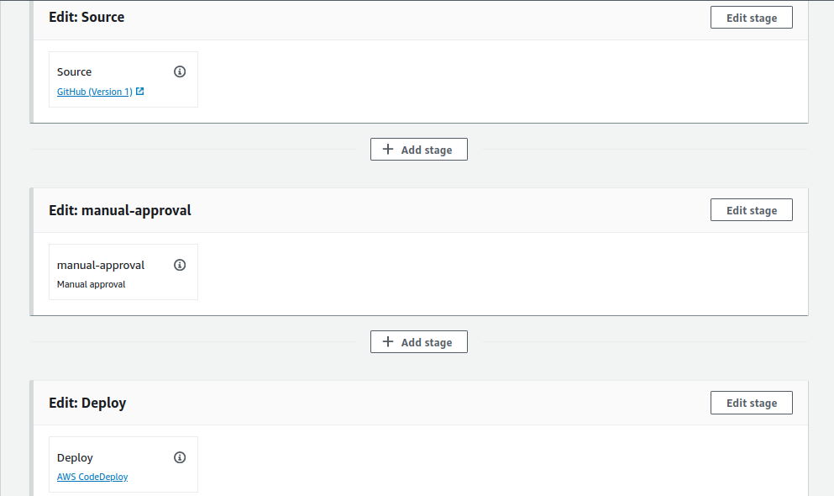

1. Whenever developer pushed the code,codepipeline can't run without manual-approval.