**Medical consulting application**

*Students:*

|  |  |
| --- | --- |
|  |  |
| **Mohammad Sofan** | **12043073** |
|  |  |

*Supervisor:*

**Dr. Adnan Salman**

*An-Najah National University*

*2023 / 2024*

**Table of Contents**

Table of Contents ii

List of Figures iv

List of Tables v

Acknowledgement vi

Abstract ix

**Chapter One**

**Introduction 1**

1.1 Introduction 1

1.2 Project Scope 1

1.3 Problem Specification 1

1.4 Goals and Objectives 1

1.5Motivation 1

1.6 System Requirement 1

1.7 Project Plan and Schedule 1

1.8Outline of the Project 1

**Chapter Two**

**Literature and Methodology 2**

2.1Introduction 2

2.2 Current Systems*(Advantages, disadvantages, and weakness)* 2

2.3 Proposed System*(Advantages, disadvantages, and weakness)* 2

2.4 Feasibility Study 2

2.5Methodology*(for example: Agile, Waterfall, etc.)* 2

**Chapter Three**

**System Analysis And Design 3**

3.1System Analysis 3

3.1.1 Requirement Collection 3

*Examples of methods:*

3.1.1.1 Interview outline 3

3.1.1.2 System Service Request 3

3.1.1.3 Prototype 3

3.1.1.4 *Other Methods* 3

3.1.2 Requirement Studied 3

3.1.3 Requirement Structured 3

3.1.4 DFDs 3

3.2 System Design 3

*For Examples:*

3.2.1 Static Context Diagram 3

3.2.2 Use Case Diagram 3

3.2.3 Sequence Diagrams 3

3.2.4 Activity Diagrams 3

3.2.5 Scenarios 3

3.2.6 State Diagrams 3

3.2.7 Class Diagram 3

3.2.8 Database Schema (Mapping “Tables”) 3

**Chapter Four:**

**System Implementation 4**

4.1 Programming Languages 4

4.1.1 Why Using *(for Example: Java*) 4

4.1.2 Why Using *(for Example: SQL Server)* 4

4.2Implementation 4

4.2.1 Introduction 4

4.2.2Sample of Forms 4

4.2.3 Sample of Reports 4

4.2.4Pseudo Codes 4

**Chapter Five:**

**System Testing 5**

**5.1 Testing Plans 5**

**5.2 Types and Steps of Test**ing 5

*For Examples:* (Unit testing, Integration testing, System testing, …)

**Chapter Six:**

**The Conclusions 6**

6.1Conclusion 6

6.2 Future Work 6

**Appendix 7**

A:System Installation 7

**References 8**

**List of Figures**

Figure 1: Title of the figure 1

Figure 2: Title of the figure 1

Figure 3: Title of the figure 1

Figure 4: Title of the figure 1

Figure 5: Title of the figure 1

Figure 6: Title of the figure 1

Figure 7: Title of the figure 1

Figure 8: Title of the figure 1

Figure 9: Title of the figure 1

Figure 10: Title of the figure 1

Figure 11: Title of the figure 1

Figure 12: Title of the figure 1

Figure 13: Title of the figure 1

Figure 14: Title of the figure 1

**List of Tables**

Table 1: Title of the table 1

Table 2: Title of the table 1

Table 3: Title of the table 1

Table 4: Title of the table 1

Table 5: Title of the table 1

Table 6: Title of the table 1

Table 7: Title of the table 1

Table 8: Title of the table 1

Table 9: Title of the table 1

Table 10: Title of the table 1

Table 11: Title of the table 1

Table 12: Title of the table 1

Table 13: Title of the table 1

Table 14: Title of the table 1

**Acknowledgement**

We would especially want to thank our instructor, Dr. Emad Saadeh, for giving us the chance to complete this amazing project on the topic of the medical consulting app, which also helped us in doing a lot of Research and we came to know about so many new things, we really thankful.

***Mohammad Sofan***

**Abstract**

Musculoskeletal disorders are a significant health concern, and automated diagnosis using deep learning can aid in early detection and treatment. This project focuses on classifying radiographs of seven body parts (shoulder, elbow, finger, hand, humerus, wrist, and forearm) from the MURA dataset as normal or abnormal using a Convolutional Neural Network (CNN) based on DenseNet-169. Transfer learning is employed to leverage the pre-trained features of DenseNet-169, improving model efficiency and generalization. A single model is trained, with checkpoints saved at each epoch. The five models with the lowest validation loss are selected for ensembling to enhance prediction robustness. To address class imbalance, a custom data generator incorporating class weighting and data augmentation is utilized. The model’s performance is evaluated using accuracy, precision, recall, F1-score, and Cohen's Kappa. To make the model accessible, a Python API and a web-based interface are developed, enabling seamless interaction with the classification system. This approach demonstrates the potential of deep learning in musculoskeletal diagnosis, paving the way for more efficient and accessible medical imaging solutions.

**Chapter 1**

**Introduction**

**1.1 Introduction**

Musculoskeletal disorders (MSDs) represent a significant global health challenge, affecting individuals of all ages and contributing to disability and reduced quality of life. These conditions often require early diagnosis and intervention to prevent further complications. Radiographic imaging is a common diagnostic tool for MSDs, but manual interpretation of radiographs by radiologists can be time-consuming, subjective, and prone to inter-observer variability. Therefore, automating the diagnostic process using deep learning techniques has the potential to enhance diagnostic accuracy, consistency, and efficiency. Deep learning, particularly Convolutional Neural Networks (CNNs), has shown remarkable success in various medical imaging tasks. The MURA (Musculoskeletal Radiographs) dataset, one of the largest publicly available musculoskeletal radiograph datasets, serves as an ideal benchmark for developing automated diagnostic systems. This project aims to classify radiographs of seven body parts—shoulder, elbow, finger, hand, humerus, wrist, and forearm—as normal or abnormal using a CNN based on DenseNet-169.

**1.2 Project Scope**

This project aims to develop a web application that enables users to classify one or multiple radiograph images of seven body parts—shoulder, elbow, finger, hand, humerus, wrist, and forearm—as normal or abnormal. The targeted users include doctors, medical staff, and individuals seeking a preliminary assessment of their radiographs. By providing an intuitive and accessible interface, the system allows users to obtain an initial indication of potential abnormalities before consulting a medical professional. This tool is designed to assist in early detection, facilitate decision-making, and enhance accessibility to musculoskeletal diagnostic insights.

**1.3 Problem Specification**

Musculoskeletal disorders are a significant health concern, requiring timely and accurate diagnosis for effective treatment. Radiographic imaging is a key diagnostic tool, but interpreting these images can be complex and requires specialized medical expertise. Patients may seek an initial understanding of their radiographs before consulting a doctor, yet without medical training, interpreting these images accurately is challenging. Additionally, medical professionals often face a high workload, making preliminary screening tools valuable for optimizing their workflow.

This project addresses these challenges by developing an AI-powered web application that serves as a **first-step screening tool** for musculoskeletal radiographs. Using a deep learning model (DenseNet-169) trained on the MURA dataset, the system classifies radiographs of seven body parts—shoulder, elbow, finger, hand, humerus, wrist, and forearm—as **normal or abnormal**. The goal is to provide users, including doctors, medical staff, and individuals, with an initial assessment before seeking professional medical consultation.

Key objectives of the system include:

* **Providing individuals** with a preliminary indication of potential abnormalities before consulting a doctor.
* **Assisting radiologists and medical staff** by offering an AI-powered pre-screening tool to support clinical decision-making.
* **Enhancing accessibility** to musculoskeletal assessments, particularly in areas with limited medical resources.

This project does not replace manual interpretation by radiologists but acts as a complementary tool to facilitate early detection and streamline the diagnostic process.

**1.4 Goals and Objectives**

Providing customers with convenience and quickness while also considering their conditions in situations where they cannot physically contact a doctor or pharmacy is our app goal.

First, immediately find the user's nearest open pharmacy in a couple of minutes.

Second, saving user time by allowing him to contact a pharmacy and ask whether they have the medicine he needs, due to the fact that not all pharmacies carry every medicine.

Third, consulting several doctors and pharmacies, as well as evaluating it via the Internet. These goals are to provide as much support as we can to all users.

**1.5 Motivation**

The purpose behind our project is to help people medically, meet their needs and consider their circumstances. Though there are online apps available,none of them could give users the ability to communicate with different doctors and pharmacies via the Internet or direct them to the closest pharmacy that carries the medicine they need. For this reason, we decided to start our project in order to give users the services that previous applications were unable to offer.

**1.6 System Requirement**

* **High Level Language Java**
* **External Database**
* **Android Studio**

**1.7 Project Plan and Schedule**

Start at the end of February 2023 and expected to be finished by the start of May 2023.

* **Analysis,** Start Date: 28/2, End Date: 7/4
* SWOT Analysis
* Project Planning
* **Information Collection,** Start Date: 8/4, End Date: 16/5
* Client Requirement
* Market Requirement
* **Selecting Tools,** Start Date: 18/5, End Date: 21/6
* OS Environment
* High Level Language
* Framework
* Platform
* **Writing,** Start Date: 22/6, End Date: 15/7
* Documentation
* **Implementation,** Start Date: 16/7, End Date: 1/9
* Build Database
* Construct Model
* Create Modules
* Interface Designing
* **Final Phase,** Start Date: 2/9, End Date: 15/9
* QA Testing
* Feedback
* Maintain

**1.8 Outline of the Project**

The six Chapters of the medical consulting app project are as follows: The project scope, system requirements, objectives, and project strategy are discussed in Chapter 1's introduction. The second chapter discusses literature and methodology, discusses the distinction between the present and proposed systems, and covers feasibility studies. System analysis, system design, and requirements including requirement gathering, requirement research, and requirement structure are all covered in Chapter 3. System UML design is the step that is covered in Chapter 4. The system's conclusion and upcoming work are presented in Chapter 5.

**Chapter Two**

**Literature and Methodology**

**2.1 Introduction**

The use of pharmacy and doctor online consultation apps has become increasingly popular in recent years, especially due to the COVID-19 pandemic. Many studies have explored the effectiveness and usability of medical apps. According to certain surveys, online consultations are typically well-received by patients, with high levels of satisfaction regarding convenience and accessibility, However, other studies have identified potential limitations, such as a lack of physical examination and incorrect medication recommendations.

**2.2 Current System***.*

Although there are several applications that support doctor and online pharmacy consultations, they do not offer all services. Yet, it is essential to consider the advantages, disadvantages, and weaknesses of these applications.

* Advantages of Current Systems:

1. Privacy: Patients may feel more comfortable discussing sensitive medical issues through an online consultation rather than in-person consultations.
2. Accessibility: Patients in areas far from a specific doctor or pharmacy can access the location of them.

.

* Disadvantages of Current Systems:

1. Physical examination: The lack of physical examination can limit the accuracy of diagnoses, and some medical conditions may require in-person examination and tests.
2. Legal issues: Not all governments have legalized internet consultations, and some healthcare professionals might not have the necessary licenses.
3. The patient does not have the ability to evaluate the doctors and pharmacies he dealt with.

* Weaknesses of online doctor and pharmacy consultation mobile application:

1. Lack of continuity of care.
2. limited range of services: Access to all healthcare services that are offered through in-person consultations may not be available via online consultations.
3. Security and privacy concerns: There is a risk of personal and medical information being compromised through online consultations.
4. Absence of a patient-doctor interaction: Online consultations may prevent patients and doctors from forming a long-term relationship, which can be important for some patients.
5. Pharmacies and doctors do not have the ability to display their products through the application, nor offer offers to customers.

**2.3 Proposed System**

Online doctor and pharmacy consultation mobile applications provide an innovative way for patients to consult quickly and easily and try to provide the services that people need. However, these applications also have their advantages, disadvantages, and weaknesses that must be considered.

* Advantages of online doctor and pharmacy consultation mobile application:

1. Convenience: Patients can access the application of medical consultations from the comfort of their homes, book appointments for medical examinations, in addition to quick medical consultations through instant conversation with doctors, and also specify the pharmacy that has the required medicines available.
2. Save time: Online consultations are typically quicker than in-person consultations, patients can save time by using the application to find the closest open pharmacy through map, rather than looking for nearby opened pharmacies.
3. Privacy: Patients may feel more comfortable discussing sensitive medical issues through an online consultation rather than in-person consultations.
4. Accessibility: Patients in areas far from a specific doctor can access medical consultations more easily through online consultations.
5. Rating: Users can rate the doctors and pharmacies they have dealt with so that others can benefit from this rating.
6. Doctors and pharmacists can display their products and offers to customers.
7. Security: The application is very interested in keeping the user's information and personal data out of the reach of hackers so that the necessary protection is available in the application.

* Disadvantages of online doctor and pharmacy consultation mobile application:

1. Physical examination: The lack of physical examination can limit the accuracy of diagnoses, and some medical conditions may require in-person examination and tests.
2. Legal issues: Not all governments have legalized internet consultations, and some healthcare professionals might not have the necessary licenses.

* Weaknesses of online doctor and pharmacy consultation mobile application:

1. limited range of services: Access to all healthcare services that are offered through in-person consultations may not be available via online consultations.

**2.4 Feasibility Study**

Through this application, it is possible to benefit by displaying advertisements to users in addition to the annual subscriptions provided to doctors and pharmacies (so that some services will be exclusive by paying an amount of money annually).

**2.5 Methodology (SDLC)**

Surveys, interviews, and comparisons have all been used to study the use of pharmacy and doctor online consultation applications. While surveys and interviews are typically used to gather data on patient experiences and opinions, comparing means evaluating the effectiveness of the applications in contrast to conventional in-person consultations

**Chapter Three**

**System Analysis and Design**

The analysis and design of an online doctor and pharmacy consultation system are critical phases in the software development life cycle. They provide a clear understanding of the current system and its limitations and services as the basis for designing a new and improved system that meets the needs of the users. The design of an online doctor and pharmacy consultation system must take into account the unique needs users. It must also provide a secure platform for communication between patients and medical professionals, including secure messaging, video consultations, and prescription management.

**3.1 Requirements discovery**

These methods were used by the team members to better understand the system requirements throughout the requirements discovery process. Activities for identifying requirements included:

1. Contact customer: We talked to different pharmacists to find out more about their requirements and recommendations, such as adding a page to the app where they can show their medication discounts.
2. Online research: We use search engines to find information about online doctors and pharmacies consultation systems and came across <https://www.healthgrades.com/>, <https://www.goodrx.com/health> we read reviews and ratings from other patients to get an idea of the quality of service provided.
3. Ask for Recommendations: We've seen our friends, family members, and colleagues ask for their recommendations, and they seem happy to have such a convenient app, but their recommendation was to have a secure communication with their medical professional and pharmacist because private is important in these topics.
   * 1. **Functional Requirements**
4. Online chatting: The system should provide a secure channel for patients to communicate with medical professionals via messaging and video consultations.
5. Patient Feedback: The application should let users to provide feedback about their experiences with doctors and pharmacies and the application itself. This can help to improve the quality of the service and build trust among users.
6. Location: Instead of wasting time looking for an open pharmacy, an application may provide users with the closest one using maps
7. Offers: Doctors and pharmacists should be able to display their products and offers to customers.

**3.1.2 Non-Functional Requirements**

1. Usability: The application should be easy to use. The process of interacting with medical professionals should be straightforward.
2. Security and Privacy: The application should have strong security measures in place to protect users' personal and medical information.
3. Availability of medical professionals: A sufficient number of medical professionals and pharmacies who are ready to offer consultations at any time should be included in the application. Moreover, users should have the option of selecting their chosen medical specialist based on their specialization.
4. Performance: The system should be able to handle a large number of simultaneous users and provide fast response times

**3.2 Requirements classification and organization**

Medical consulting app is divided into the 4 increments as follows:

1. First increment: Registration, may focus on implementing basic features such as patient, doctors, and pharmacist registration.
2. Second increment: Increments may focus on more advanced features such as Online chatting and Location Finding.
3. Third increment: Patient Feedback, this increment focuses on user feedback and experience, which is important for the application's success.
4. Fourth increment: Adding a page to the app where pharmacist and doctors can show their medication discounts and offers.

**3.3 Requirements prioritization and negotiation**

As we noted from above, this system divided into 4 increments: Registration, Online chatting and Location Finding, Patient Feedback, Medication discounts page:

1. Registration, since this increment focuses on implementing basic features, it should be prioritized first to ensure that patients are registered to the application and share their personal and medical information so doctors and pharmacist can view it.
2. Online chatting and Location Finding, this increment builds on the basic features of the first increment and provides more advanced features which is allowing each patient to view the closest pharmacies according to their information that was entered by them. Additionally, provides users with a place for searching for any doctor or pharmacy using their name, location, and specialization to communicate with them. It should be prioritized second.
3. Patient Feedback, the application will let users to provide feedback about their experiences with doctors and pharmacies and the application itself. It should be prioritized third.
4. Page for medication discounts: While adding a page for medication discounts is important, it may be less critical than the other increments. Therefore, it could be prioritized last.

**3.4 Requirements specification**

* **Online Chatting:**

1. The system should provide an online chatting feature that enables patients to communicate with doctors or pharmacists.
2. The chatting feature should be secure, private, and only accessible to the patient and the doctors or pharmacists.

* **Location of Closest Pharmacy:**

1. The system should allow patients to enter their location or allow the system to access their current location.
2. The system should provide a list of the closest pharmacies to the patient's location.
3. The list of pharmacies shall include information such as pharmacy name and address.

* **Patient Feedback:**

1. The system should provide a feature that allows patients to provide feedback on their experiences with doctors, pharmacists, and the application itself.
2. The feedback feature should be easy to use, secure, and only accessible to the patients.
3. The system should store patients’ feedback and make it available to the system administrators for analysis and improvement.

**3.5 Requirements Validation**

The following approaches we used to validate the requirements:

1. Acceptance testing: This could be by asking a group of users and collecting feedback on their experience with the online chatting feature. This would help to ensure that the feature is easy to use, reliable, and meets the needs of the users.
2. Usability testing: Checking the accuracy of the location data could be tested by comparing it with data from other sources, such as Google Maps.
3. Perspective-based reading: Every use case is looked through individually by every team member.

**3.6 Requirements management**

Melon was developed using Agile method, so any changing in requirements has four possibilities. First, collecting and clearly outlining the system's requirements. Second, reviewing the requirements to ensure they are complete and consistent. Third, any changes to the requirements should be reviewed before implementation to ensure that they do not affect other requirements. Fourth, ensuring that the requirements have been met through testing and verification techniques.

**Chapter Four**

System UML Design

1. Use case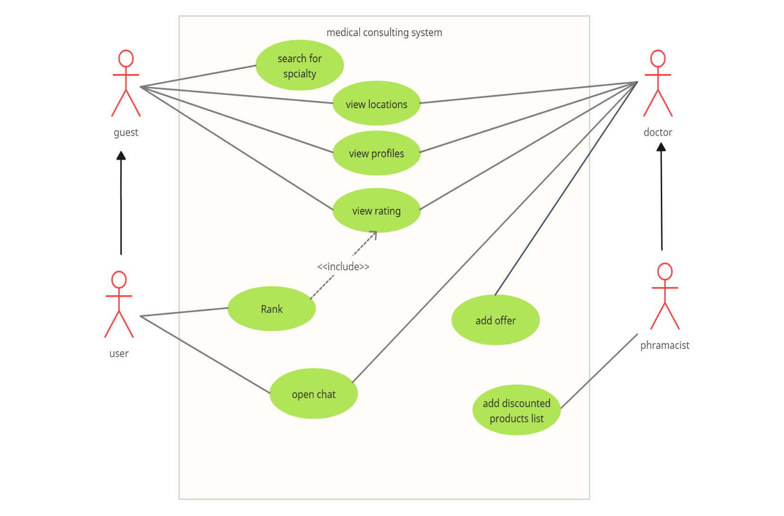
2. Class diagram

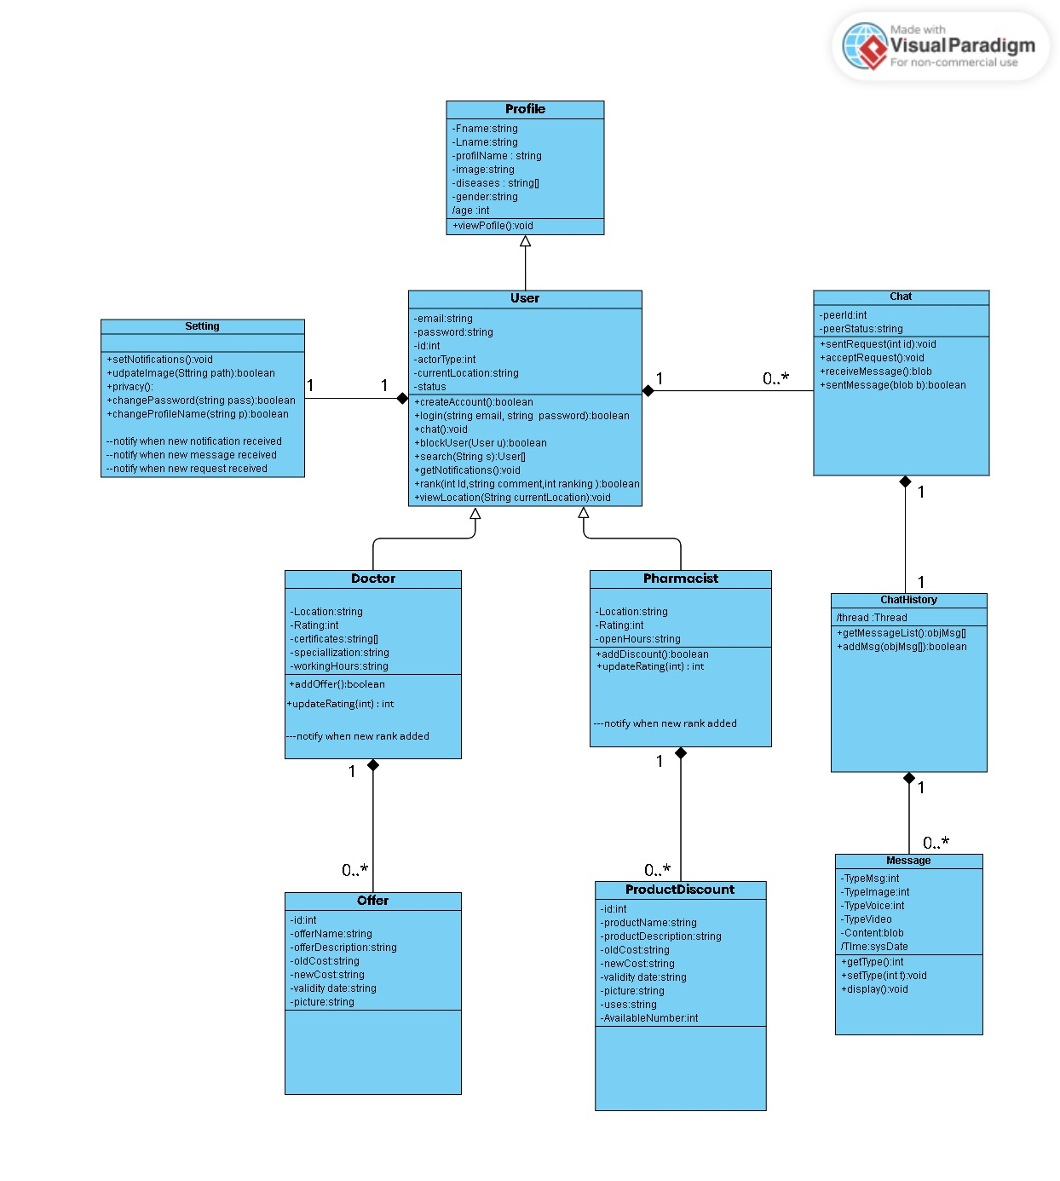

1. Activity diagram

Nearest pharmacy

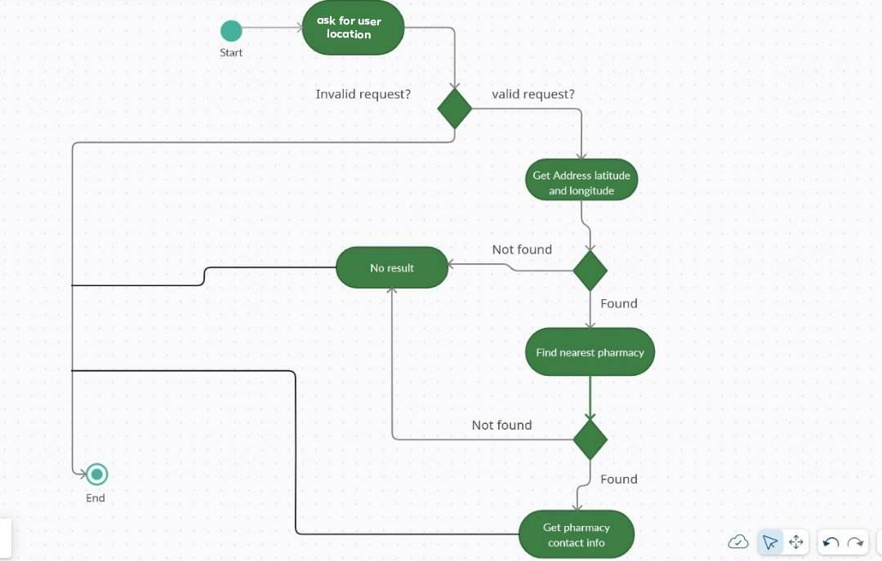

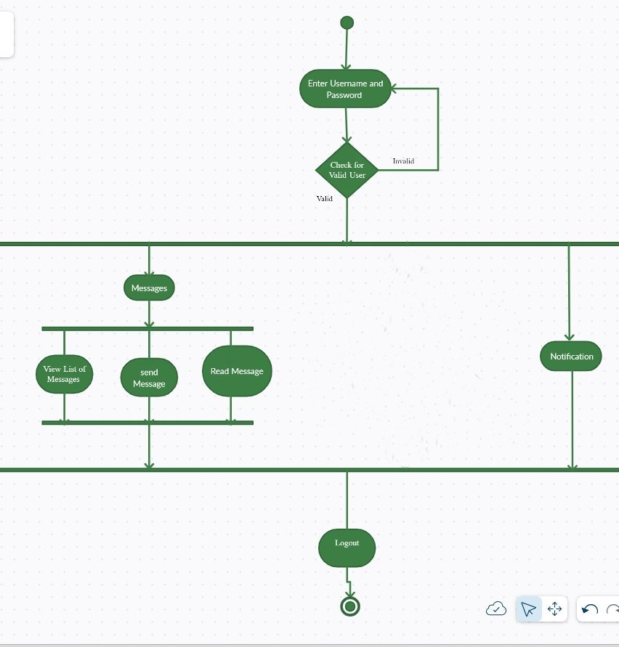

Chatting

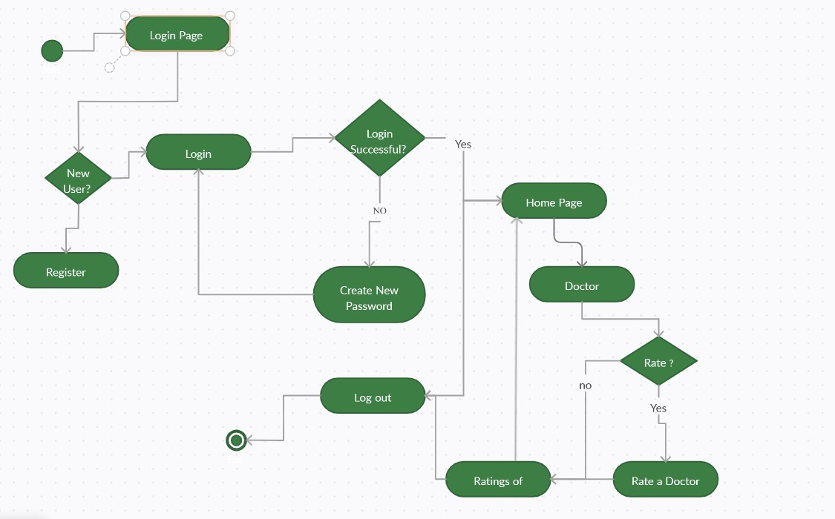

**Rating**

1. Sequence Diagram

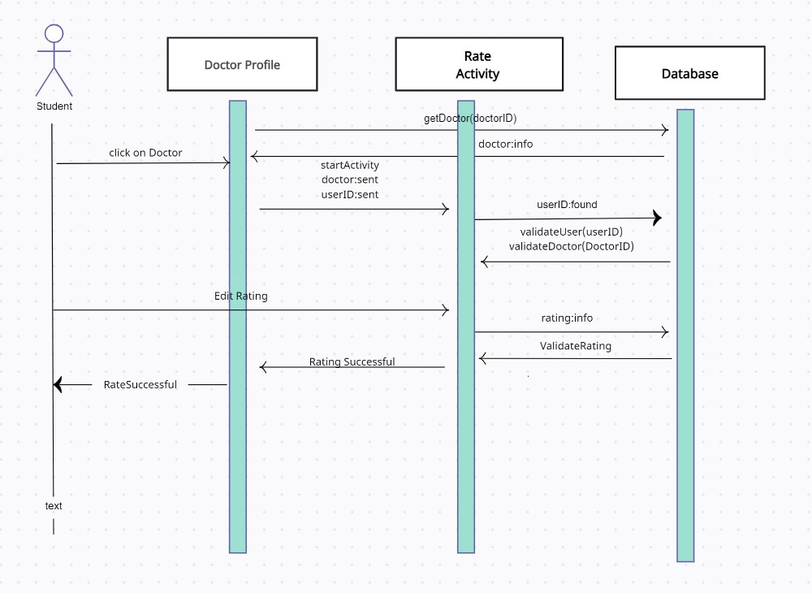

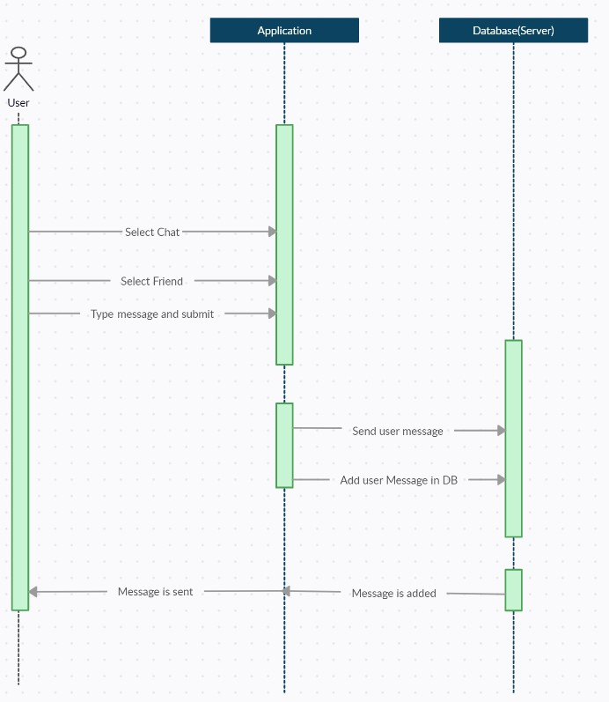

1. State Diagram

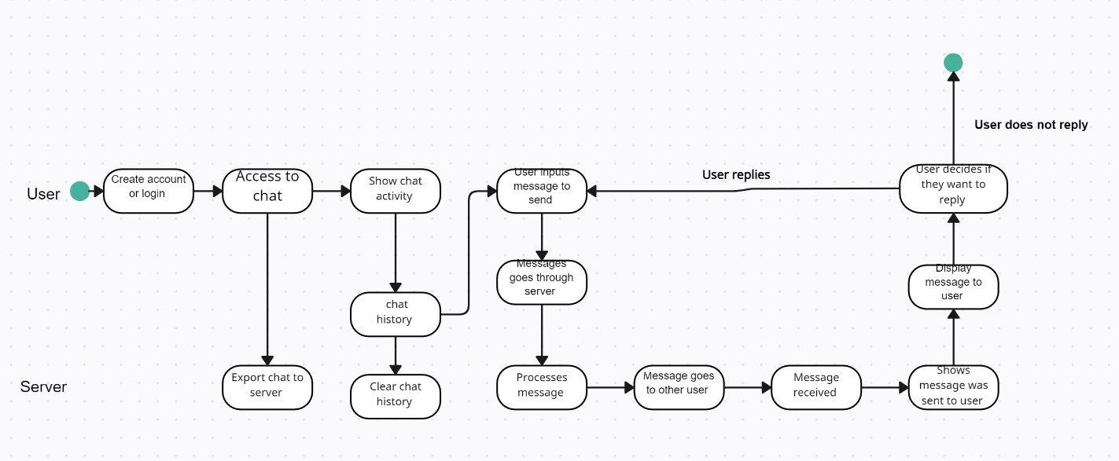

**References**

* ***Books:***
* Ian Sommerville, SOFTWARE ENGINEERING, *6th* Edition.2010.
* *Pascal Roques, “UML in Practice: The Art of Modeling Software Systems Demonstrated through Worked Examples and Solutions”, 1st Edition, Wiley, 2004.*