KINEMATICS OF RIGID BODIES

Course Notes

# Table of Contents

(Right-click and update field to generate Table of Contents)

# 1. Introduction to Rigid Body Kinematics

## 1.1 Definition of a Rigid Body

A rigid body is defined as a system of particles in which the distance between any two particles remains constant regardless of any motions of the body or forces acting on it. In reality, all bodies deform to some extent when forces are applied, but if these deformations are negligible compared to the overall motion, the body can be treated as rigid.

## 1.2 Types of Rigid Body Motion

Rigid body motion can be classified into the following categories:

**• Translation:** All particles in the body follow parallel paths and have the same velocity and acceleration at any given time.

**• Rotation about a Fixed Axis:** The body moves such that all particles follow circular paths around a fixed axis, with velocities proportional to their distances from the axis.

**• General Plane Motion:** A combination of translation and rotation occurring in a single plane.

**• Spatial Motion:** The most general case where the body can translate and rotate in three-dimensional space.

## 1.3 Mathematical Representation

Rigid body motion can be fully described by specifying:

• The position, velocity, and acceleration of any reference point in the body (typically the center of mass)

• The angular position, angular velocity, and angular acceleration of the body about an axis

# 2. Translation

## 2.1 Rectilinear Translation

When a rigid body undergoes rectilinear translation, all points in the body move along straight parallel lines. The velocity and acceleration of every point in the body are identical.

For a body in rectilinear translation:

• Position vector: ri = ro + rio (constant)

• Velocity vector: vi = vo for all points i

• Acceleration vector: ai = ao for all points i

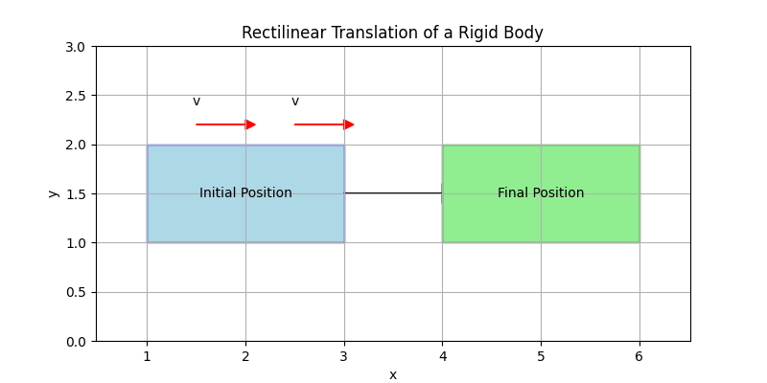

Figure 1: Rectilinear Translation of a Rigid Body

## 2.2 Curvilinear Translation

In curvilinear translation, all points in the body move along curved paths, but these paths are parallel to each other. At any instant:

• All points have the same velocity vector

• All points have the same acceleration vector

# 3. Rotation About a Fixed Axis

## 3.1 Angular Position, Velocity, and Acceleration

**• Angular Position (θ):** Measured in radians

**• Angular Velocity (ω = dθ/dt):** Measured in radians per second

**• Angular Acceleration (α = dω/dt = d²θ/dt²):** Measured in radians per second squared

## 3.2 Equations for Rotation About a Fixed Axis

For a point P located at distance r from the axis of rotation:

• Linear velocity: v = rω

• Linear acceleration components:

- Tangential acceleration: at = rα

- Normal acceleration: an = rω²

- Total acceleration: a = √(at² + an²)

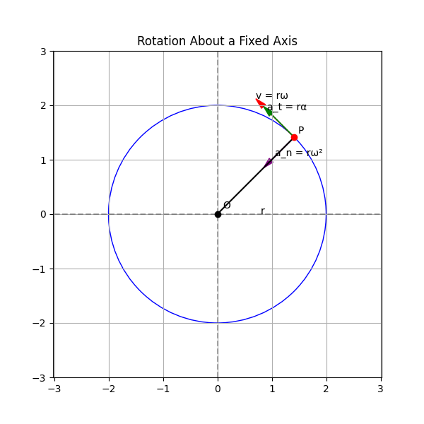

Figure 2: Rotation About a Fixed Axis

## 3.3 Example Problem: Rotating Wheel

**Problem:** A wheel rotates according to the relation θ = 2t³ - 3t² + t (θ in radians, t in seconds). Find the angular velocity and angular acceleration at t = 2 seconds.

**Solution:**

• ω = dθ/dt = 6t² - 6t + 1

• α = dω/dt = 12t - 6

• At t = 2 seconds:

- ω = 6(2)² - 6(2) + 1 = 24 - 12 + 1 = 13 rad/s

- α = 12(2) - 6 = 24 - 6 = 18 rad/s²

# 4. General Plane Motion

## 4.1 Combination of Translation and Rotation

General plane motion can be analyzed as a combination of:

• Translation of a reference point (typically the center of mass)

• Rotation about an axis through the reference point

## 4.2 Velocity Analysis in General Plane Motion

For a rigid body in general plane motion, the velocity of any point B relative to a reference point A is given by:

vB = vA + ω × rBA

Where:

• vB is the velocity of point B

• vA is the velocity of reference point A

• ω is the angular velocity vector

• rBA is the position vector from A to B

# 5. Instantaneous Center of Zero Velocity

## 5.1 Definition and Properties

The instantaneous center of zero velocity (IC) is a point in a rigid body (or its extension) that has zero velocity at a given instant. For a body in plane motion:

• Every point in the body appears to rotate about the IC at that instant

• The velocity of any point is perpendicular to the line joining that point to the IC

• The magnitude of velocity of any point is proportional to its distance from the IC

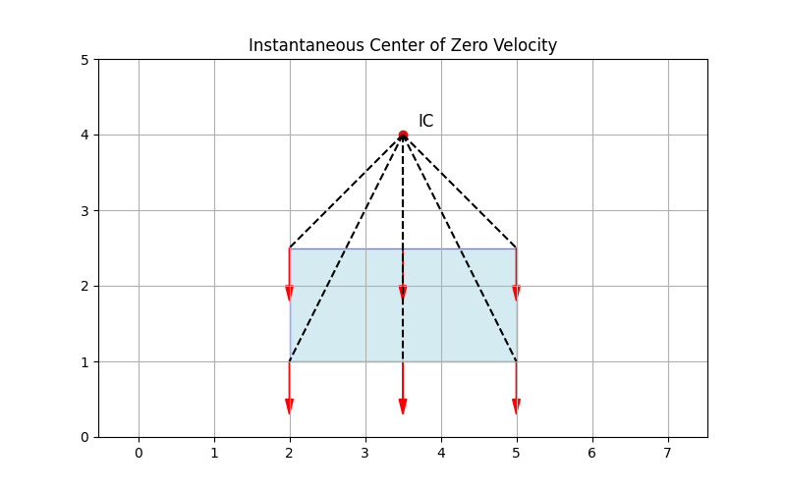

Figure 3: Instantaneous Center of Zero Velocity