STUDENT NAME- Mohammed Tokir SUTHAR
ID- TIS2600023

Week 1 Tutorial 1a
Task 1: Getting to Know Each Other
My partner and I discovered that we both enjoy travelling. We are both studying IT, and we share an interest in coding.
Task 2: PyCharm Installation
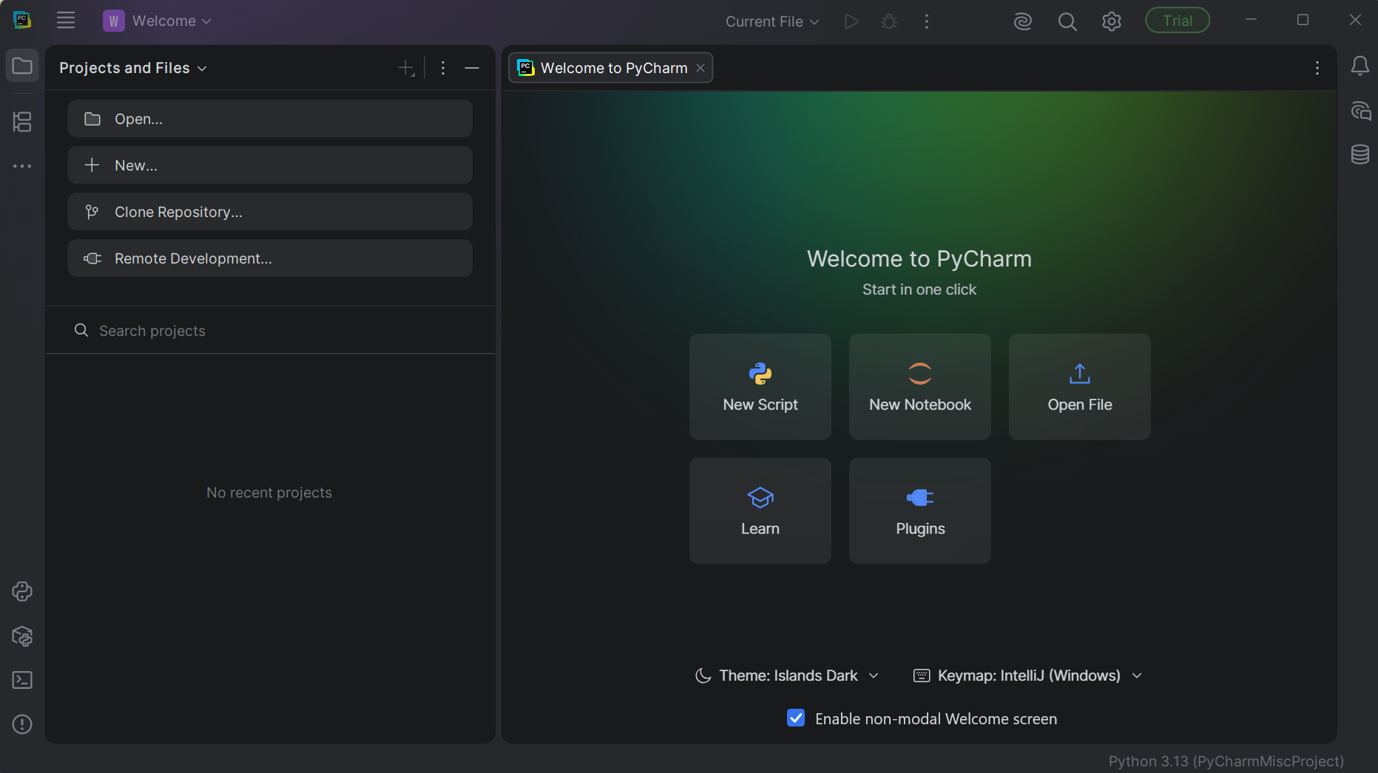
Explanation:
PyCharm is an integrated development environment used to write, run and debug Python programs. A project was created to store the Python file and related settings. The Python interpreter executes each instruction contained in the source file.
Task 3: Evaluate Expressions
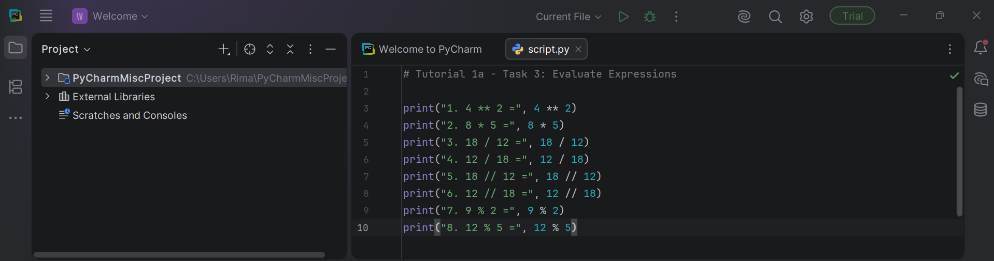
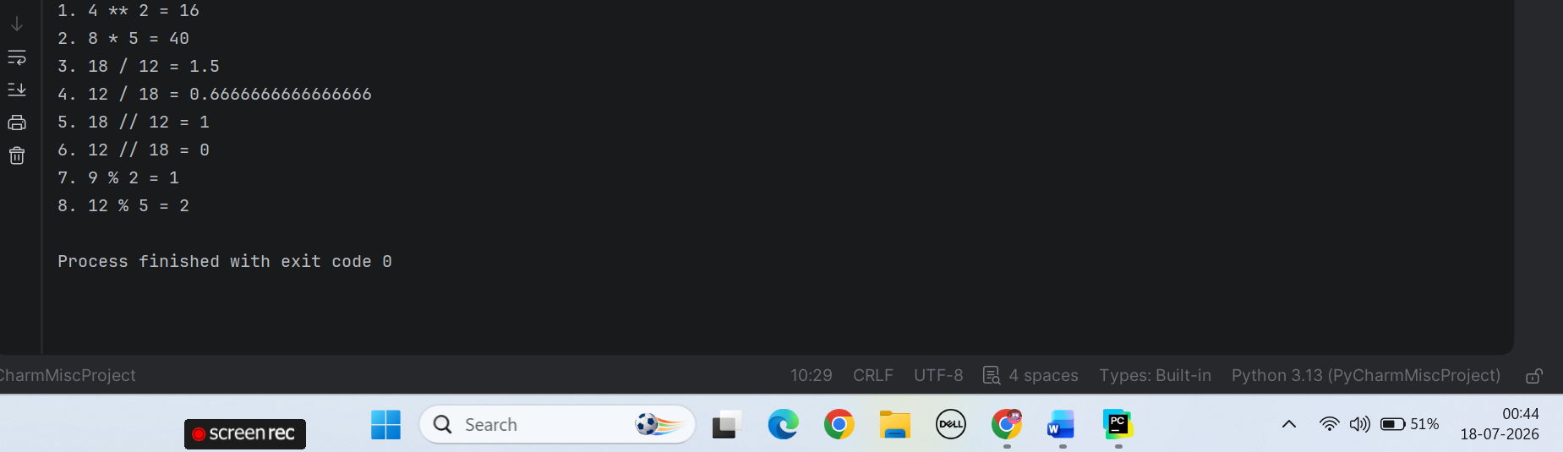
Explanation:
- ** performs exponentiation, so 4 ** 2 means $4^{2}$.
- * performs multiplication.
- / performs standard division and returns a float.
- // performs floor division and removes the fractional part for positive numbers.
- % returns the remainder after division.
- The values 4, 2, 8, 5, 18 and 12 are integers.
- Results produced by / are floating-point values.

Task 4: Operator Precedence
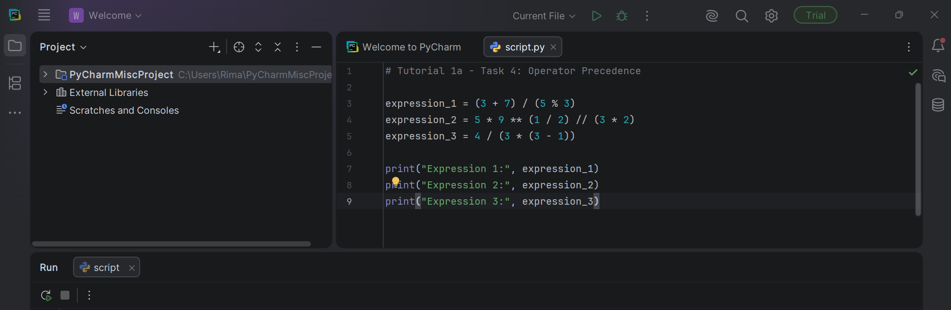
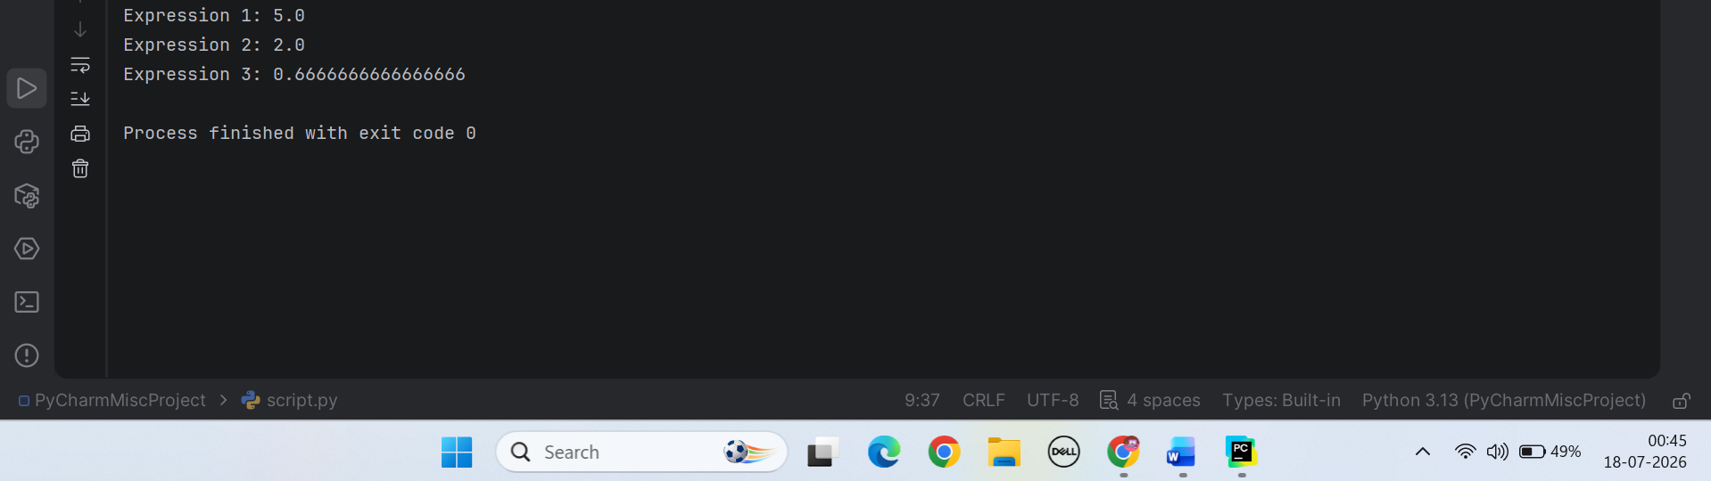
Explanation:
Parentheses are evaluated first, followed by exponentiation, multiplication or division, and then addition or subtraction.
Tutorial 1b
Task 1: Boolean Logic Challenge
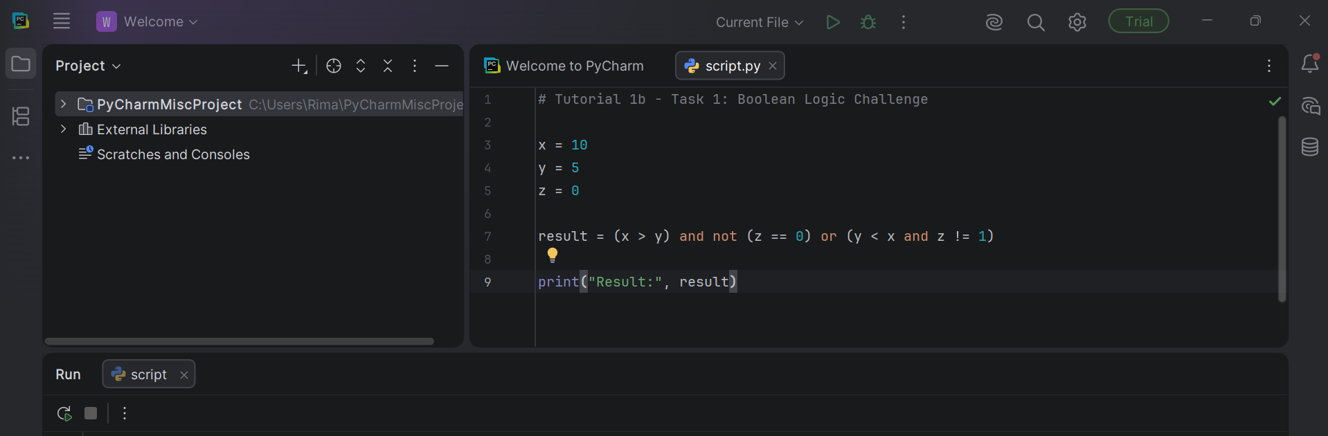
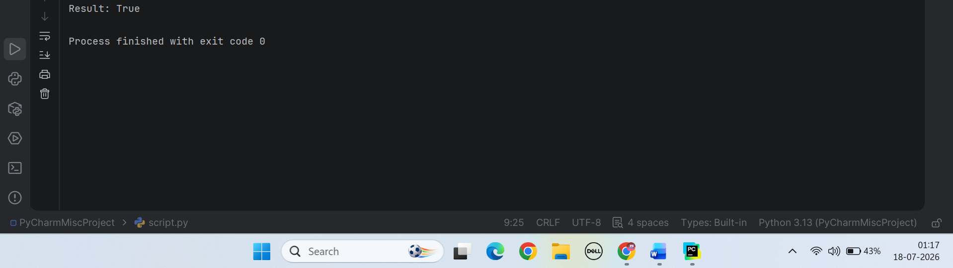
Explanation:
The expression is true because the second grouped condition, y < x and z != 1, contains two true comparisons.
Task 2: Dynamic User Input
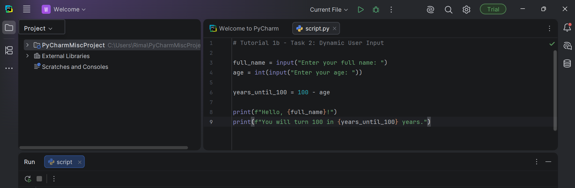
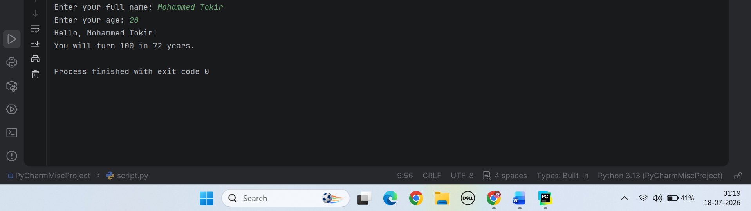
Explanation:
- input() collects information from the keyboard.
- The name remains a string.
- input() initially returns the age as a string.
- int() converts the age into an integer.
- 100 - age calculates the remaining years.
- An f-string inserts variable values into the output message.

Task 3: Temperature Converter
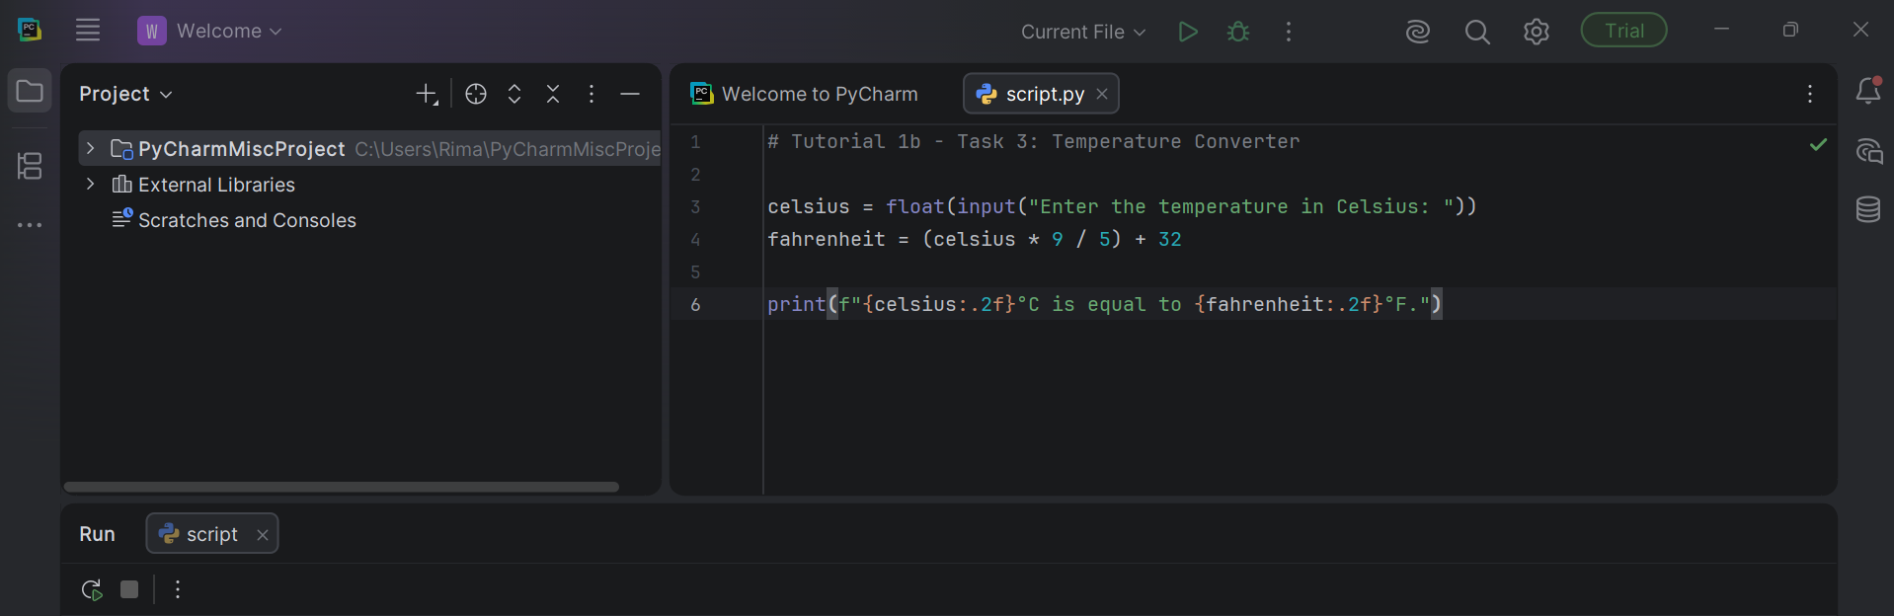
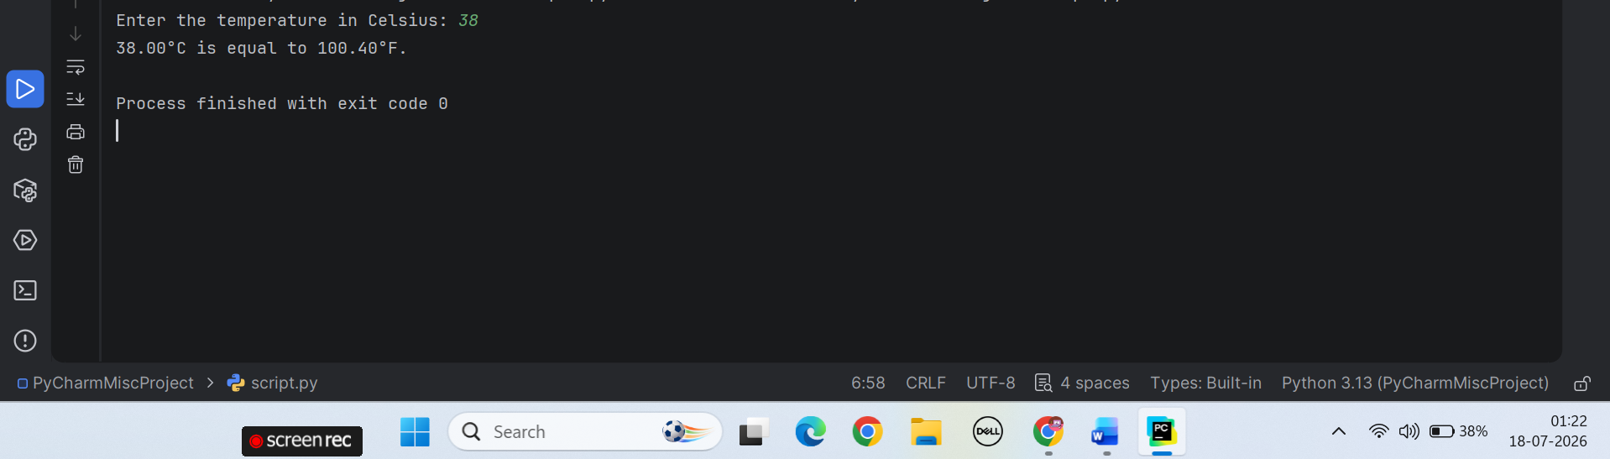
Explanation:
- input() receives the Celsius temperature as text.
- float() permits whole numbers and decimal temperatures.
- The Celsius value is multiplied by 9 / 5.
- 32 is added to obtain Fahrenheit.
- :.2f displays the result to two decimal places.
Task 4: Math Module Exploration
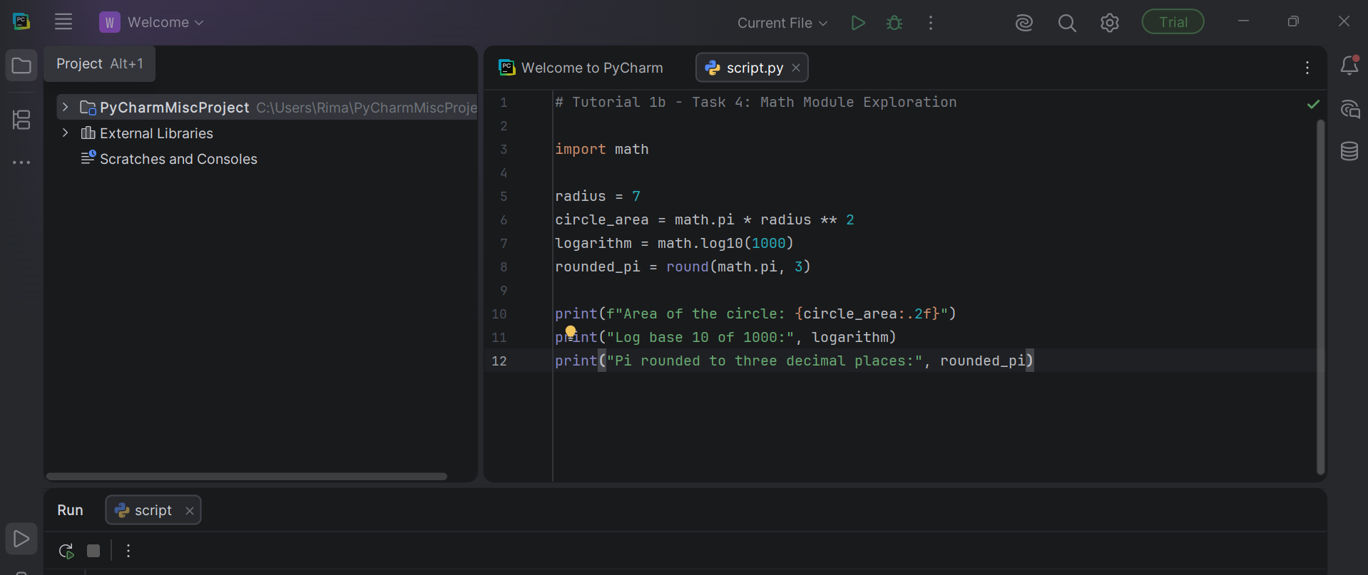
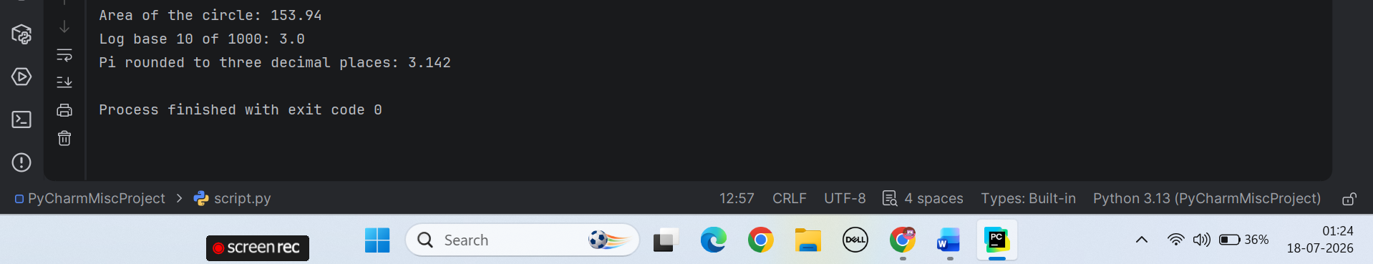
Explanation:
- import math provides mathematical constants and functions.
- math.pi represents π.
- radius ** 2 squares the radius.
- math.pi * radius ** 2 calculates the circle’s area.
- math.log10(1000) calculates the base-10 logarithm.
- The result is 3.0 because ${10}^{3}=1000$.
- round(math.pi, 3) rounds π to three decimal places.

Task 5: Code Debugging
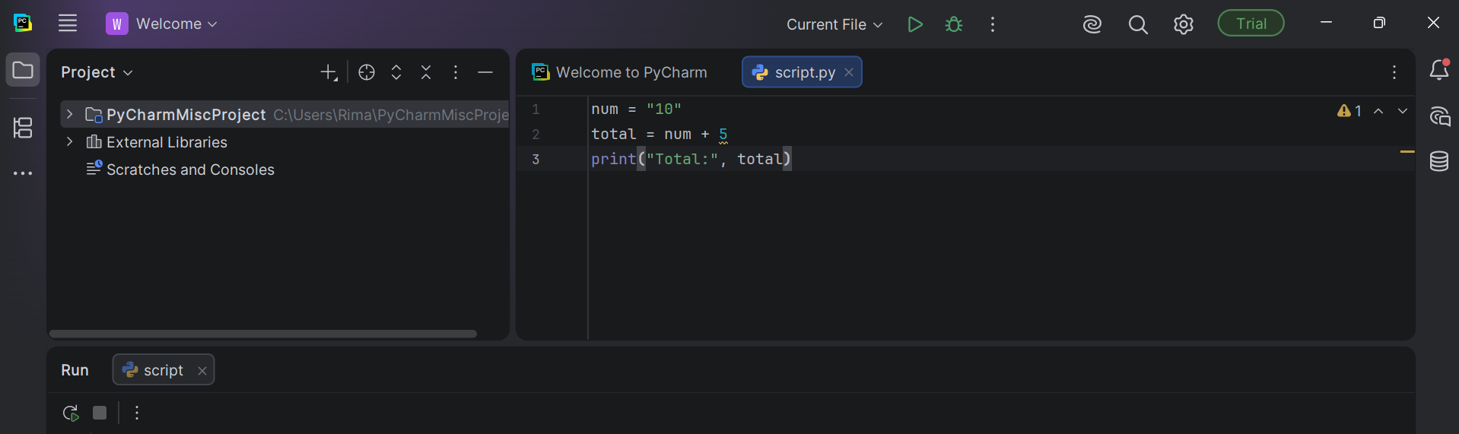
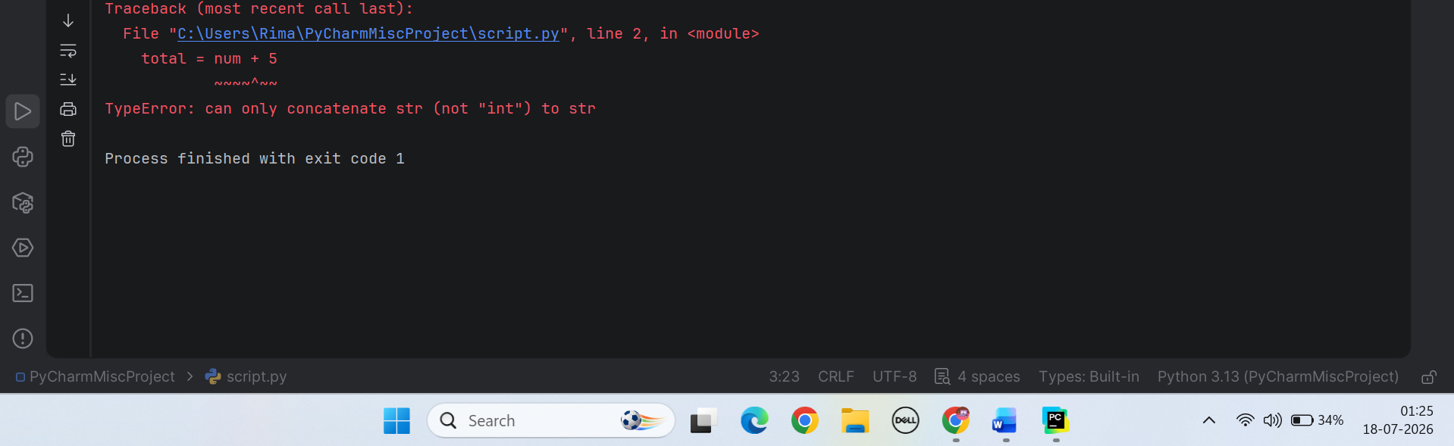
Explanation
The error is:
TypeError: can only concatenate str (not "int") to str
This occurs because:
- "10" is a string.
- 5 is an integer.
- Python cannot directly add a string and an integer.
Corrected code:
# Tutorial 1b - Task 5: Code Debugging

num = "10"
total = int(num) + 5

print("Total:", total)
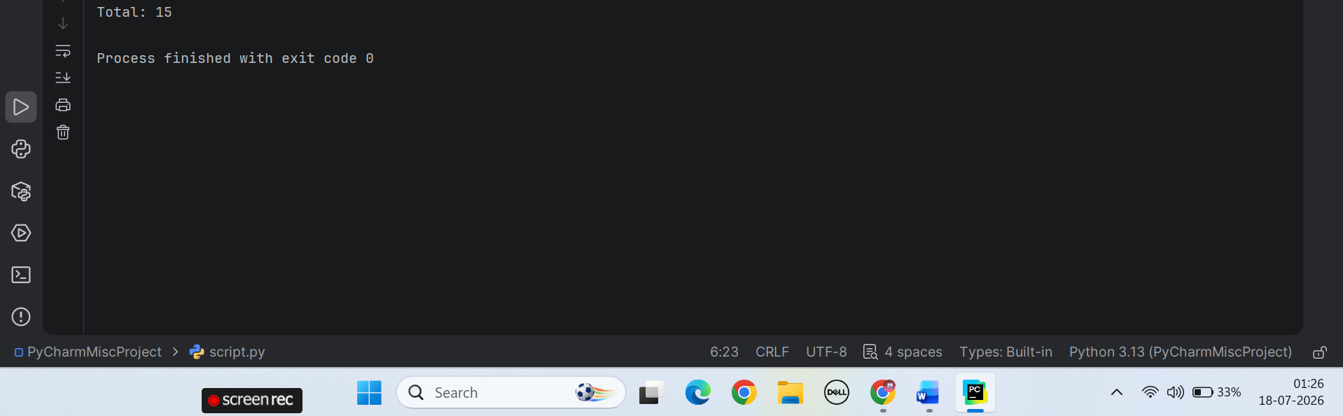
Explanation:
The int() function converts the string "10" into the integer 10. Python can then add the two integer values, producing a total of 15.

