Admin panel
1) form to submit data/food item
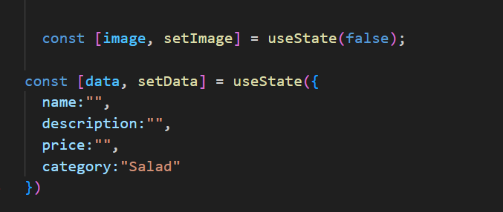
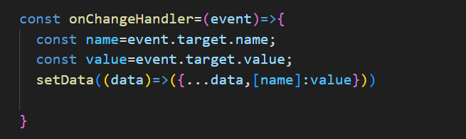
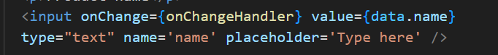

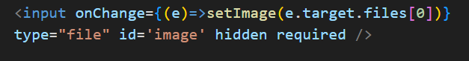

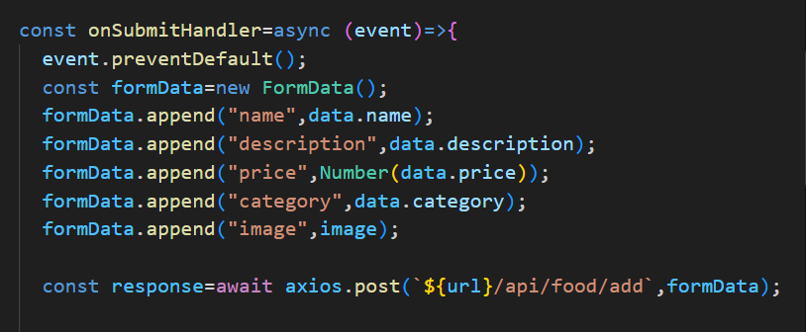

Useform hook to create a form data

ii) list all items
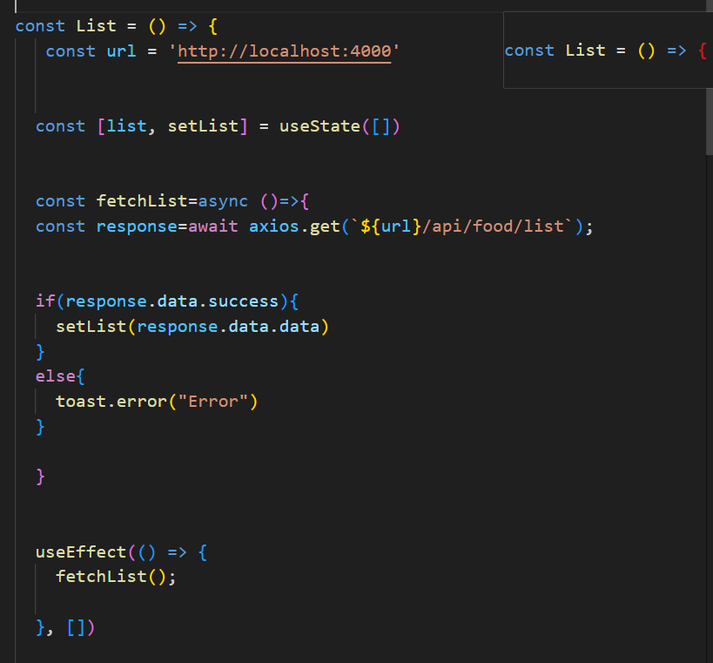
Send get request on first render

Fetch from api-> then set state

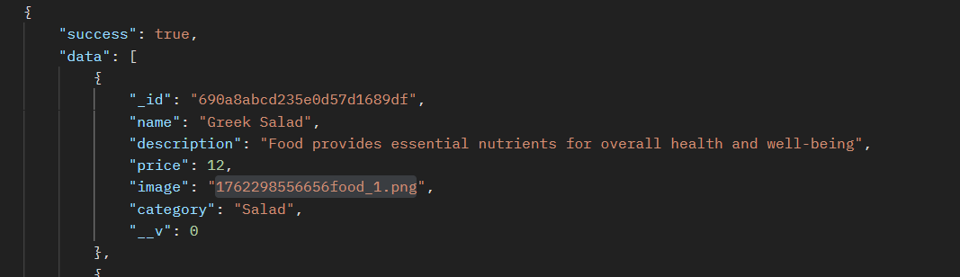

At this route uploads folder is served

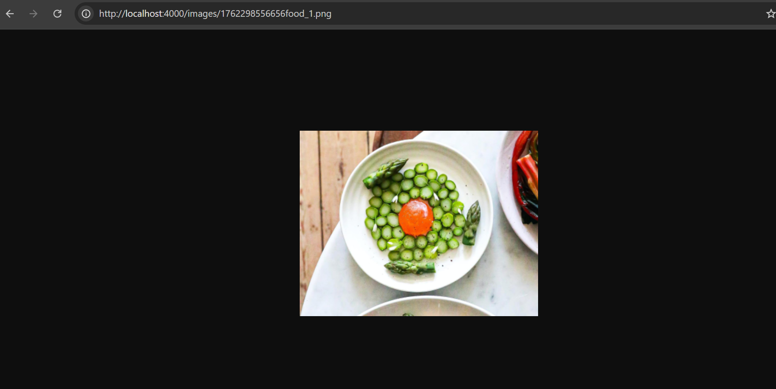

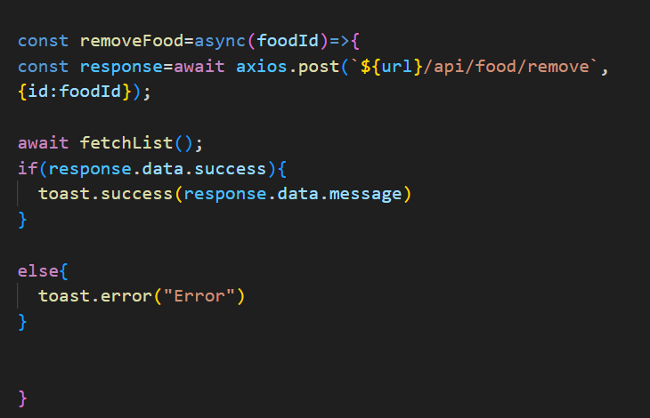
Authentication
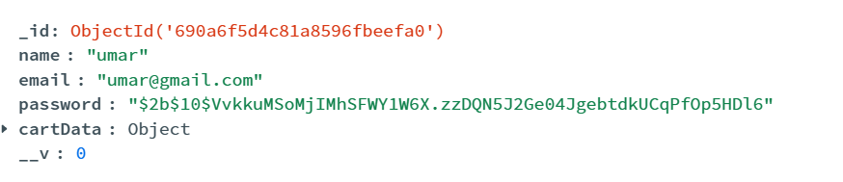
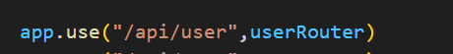
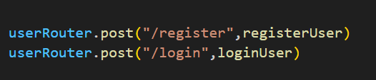

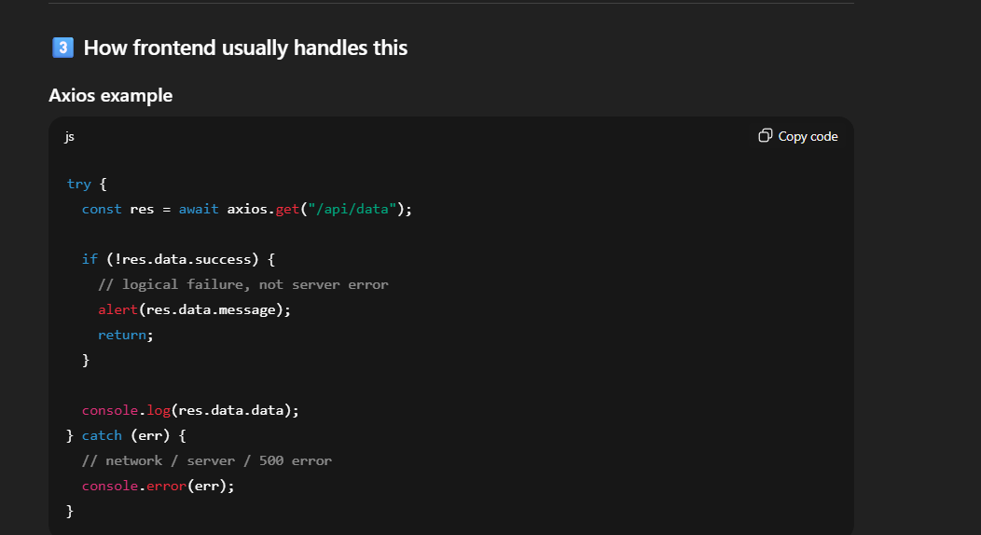
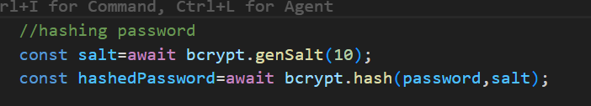

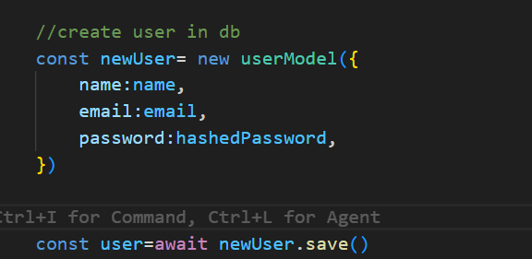

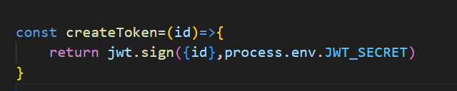
Sign the id from mongodb with secret key

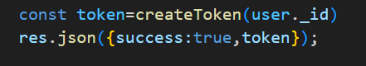
Send token on successful registration

Complete code
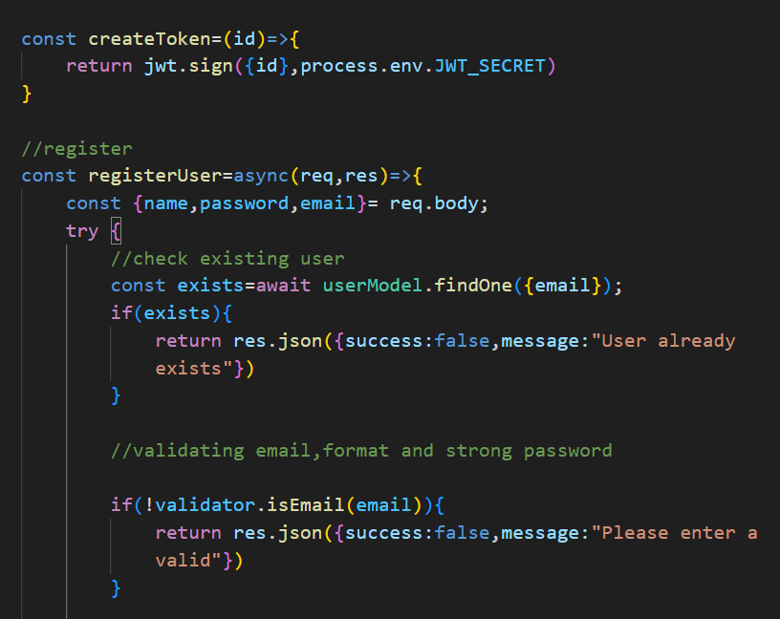
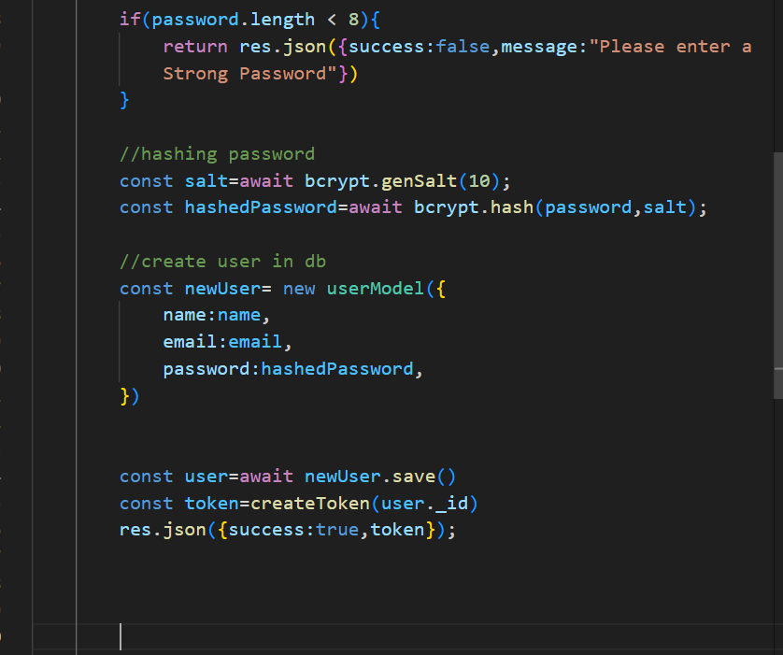
Login
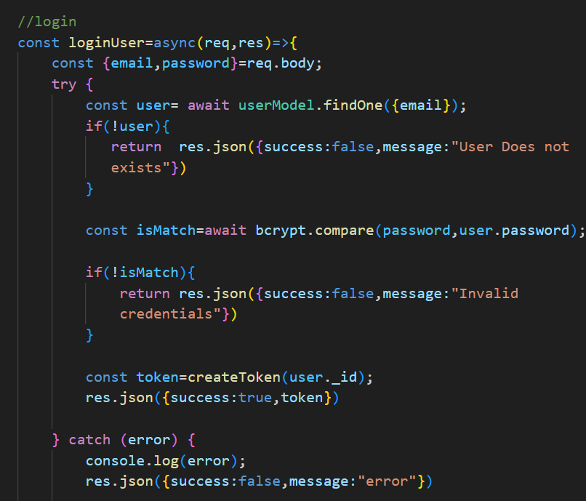
After login also send a token

Frontend
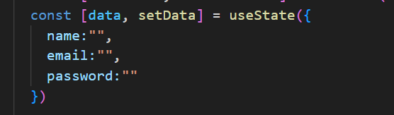
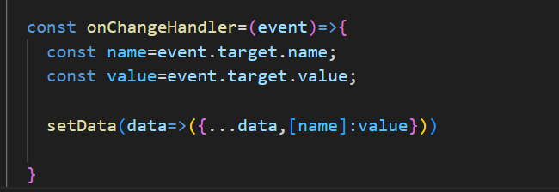

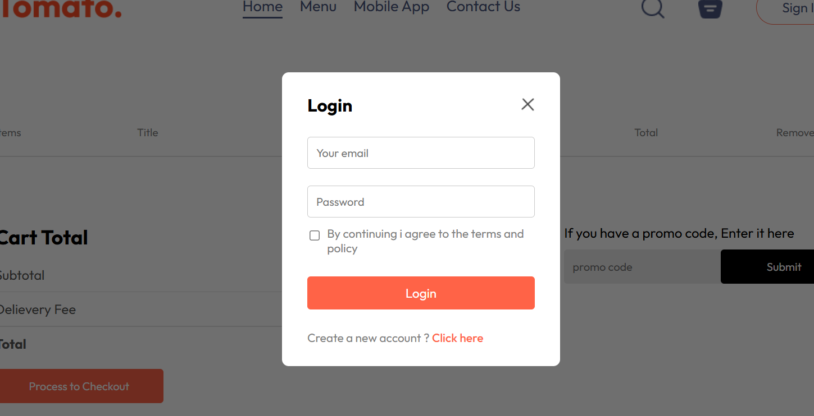
On login it will not set the name

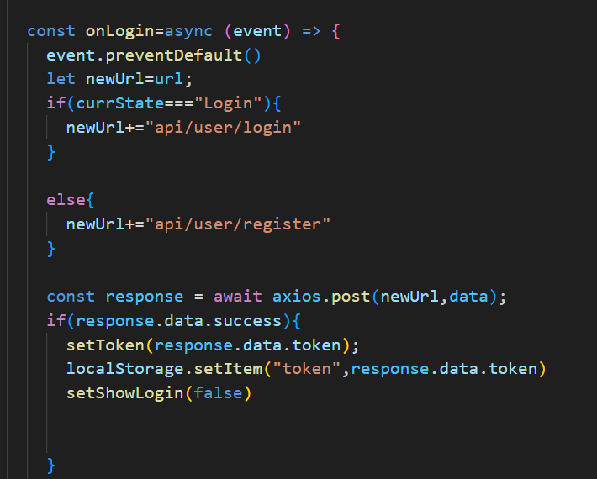
Post request on correct url login.register pass the data state which is an object
Will recive data like success:true/false and token
Token is a state in usecontext
Store in localstorage

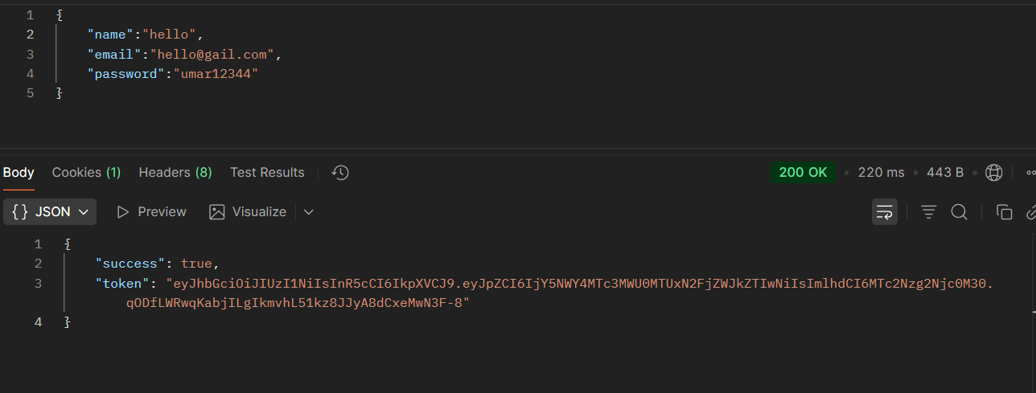
Response.data.success

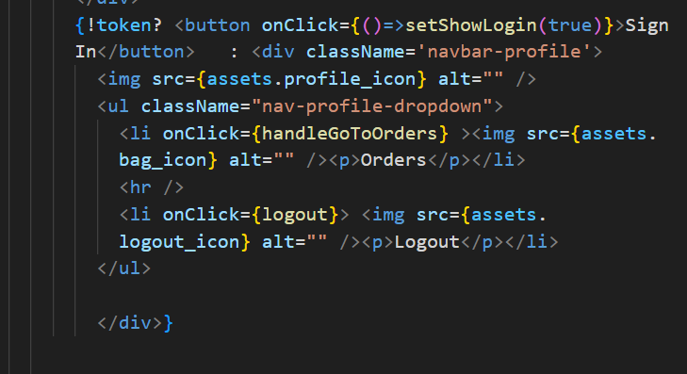
In navbar if there is token then display logout button

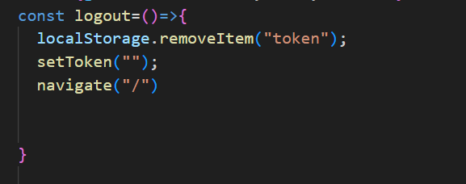
If logout remove the token

When you reload webpage
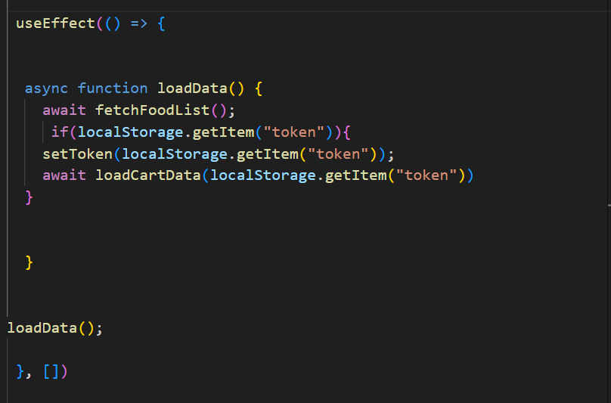
It will fetch token from local storage and set it in token state

4) fetching items from db
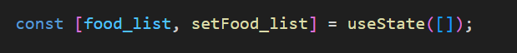
In context
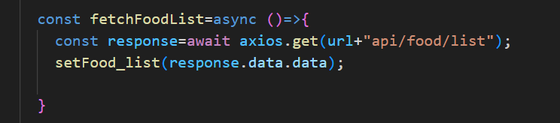
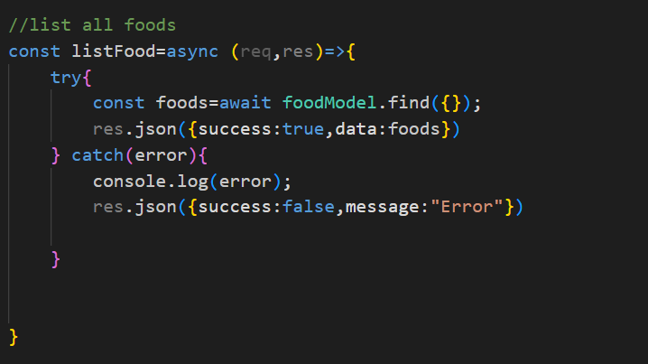
Returns
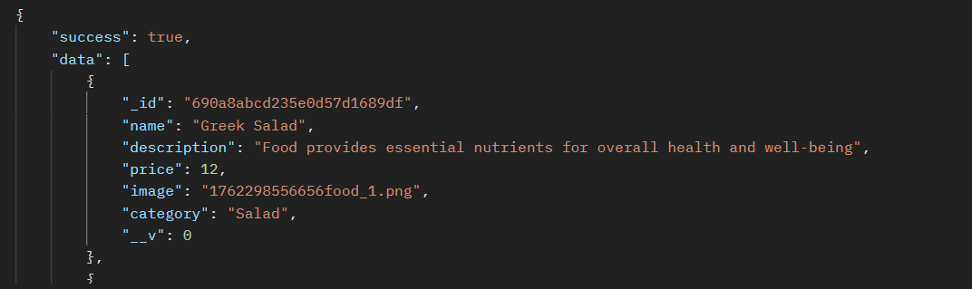
Inside data there is array

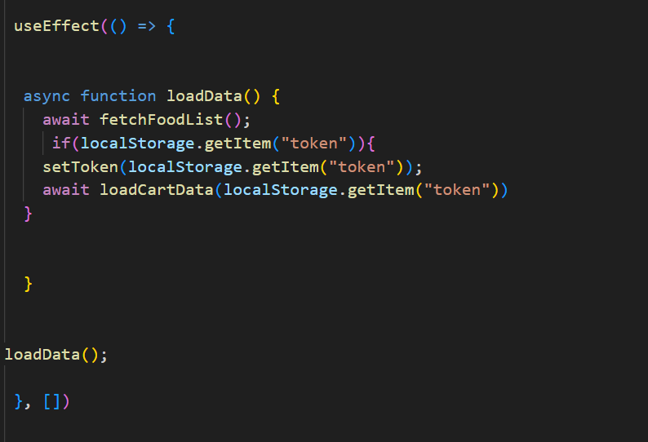
Runs on first render

5) cart functionality
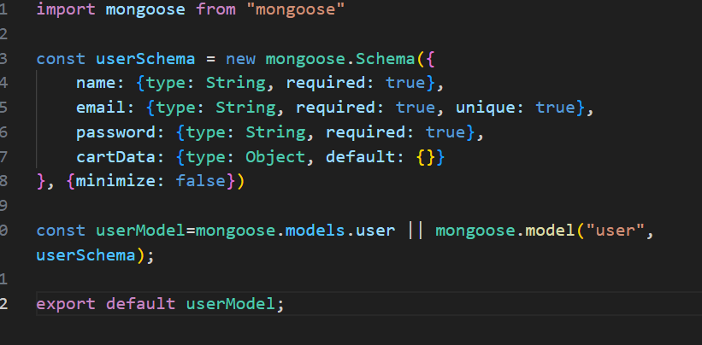
Db schema
Bae routes
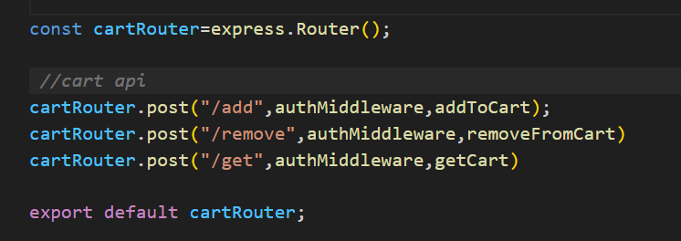
Main route

Auth middleware
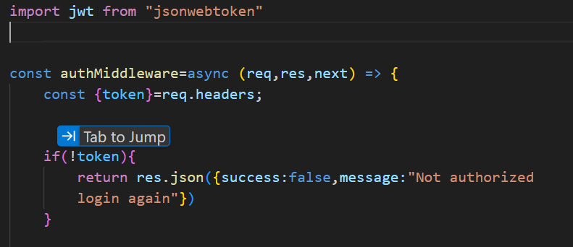
Get token from headers
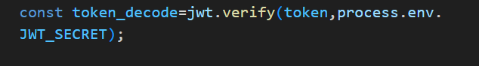
Decode the token to get the id no token_decode has the userid which is in db
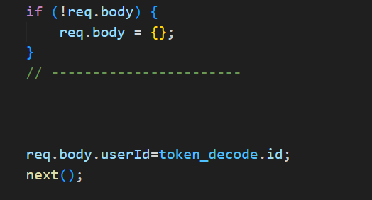
Attach the token in req.body with name userId

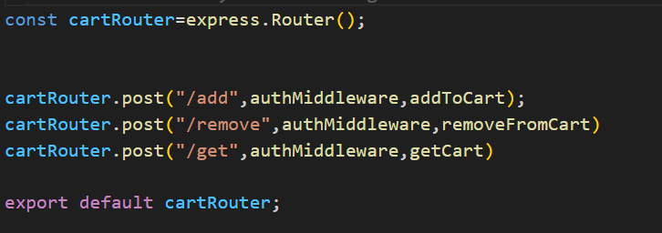
Add middleware in these routes

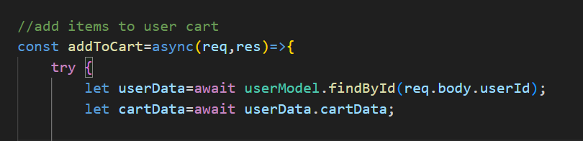
In the controller function
Pass the req.body.userid to get the data from db
Get the card data from it
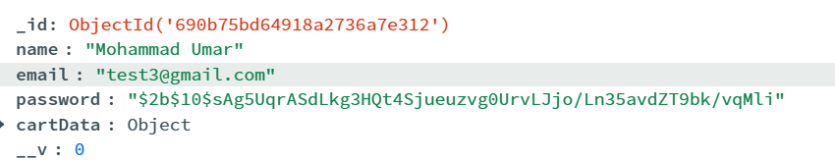
Cart data is an object like {“id1”:1,”id2”:45}

We will send the itemid in req.body from frontend
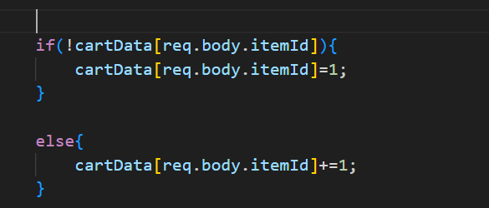
So acess it create if it does not exists or increase it
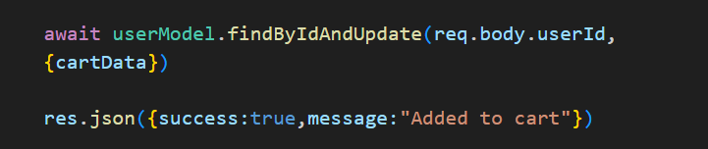
Update the changes

Remove from cart same thing
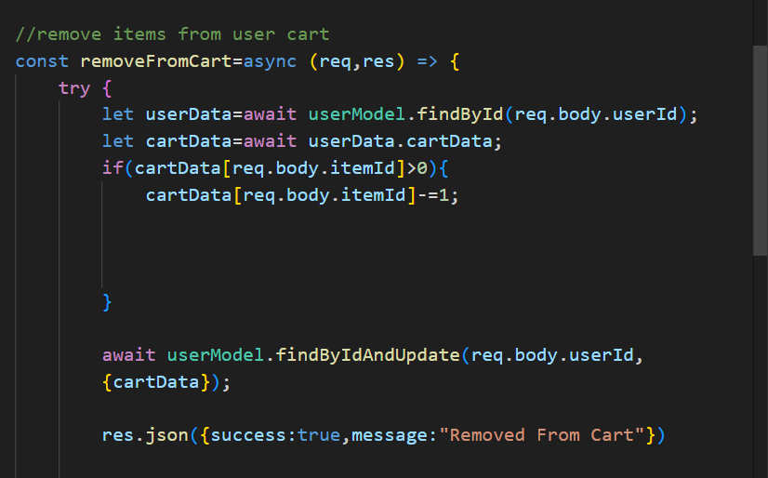

Fetch cart data controller
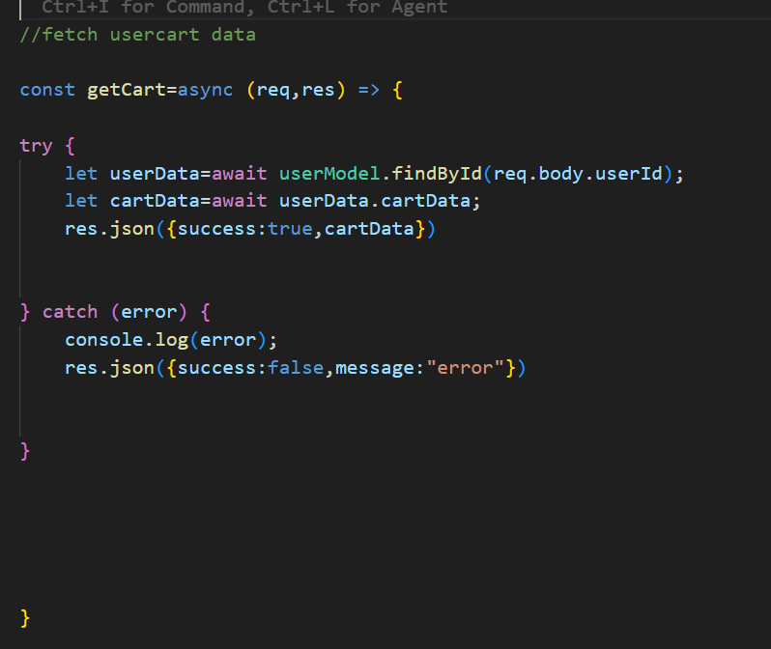
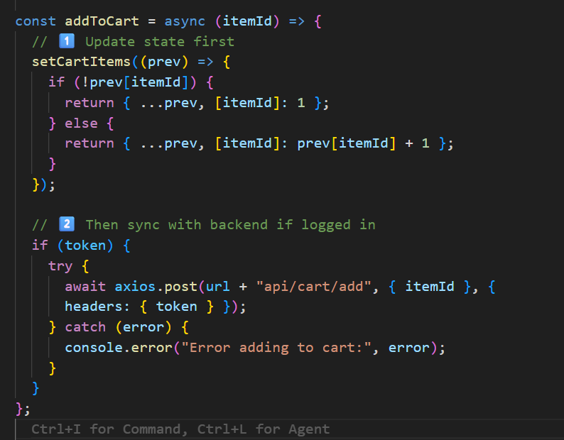
In front end call like this
Same for remove the cart
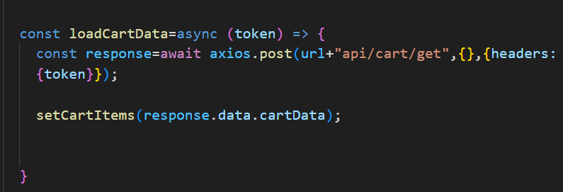
To fetch items also need to send post request with headers

6) orders
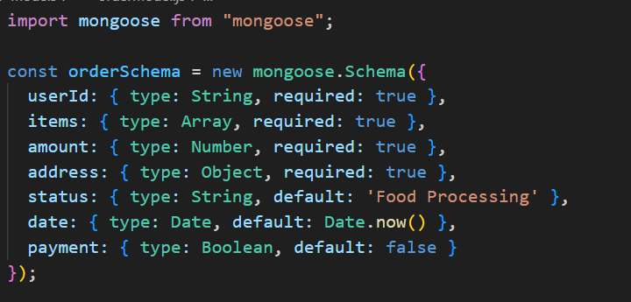
Model
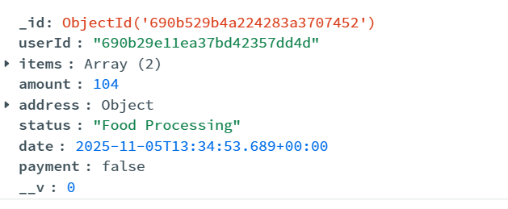
Route
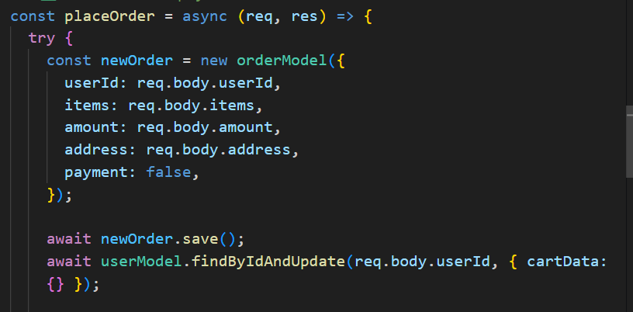
Create a order document and save it and also empty the cart

We get userid from the middleware
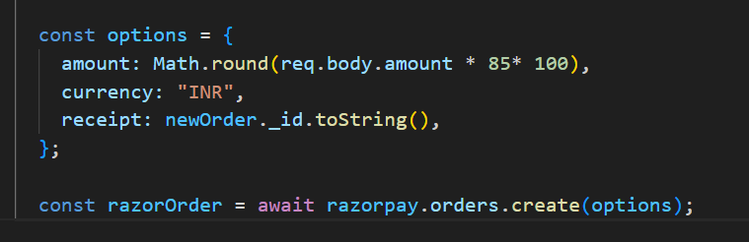
Create a razorpay order
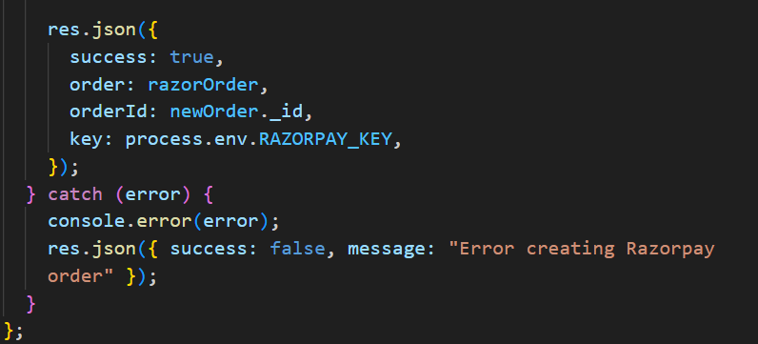
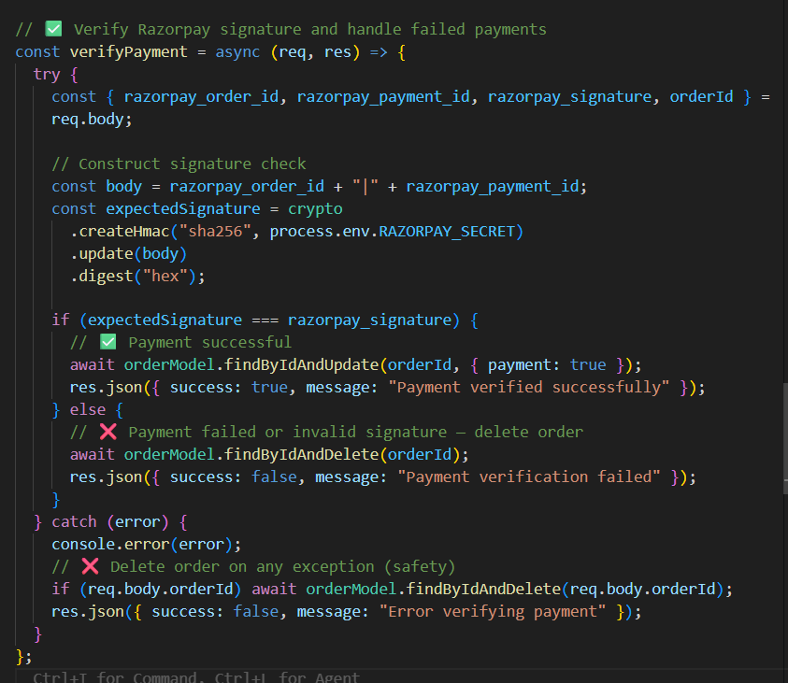
If success find by order_id and update true
If false then delete the order

Frontend:-
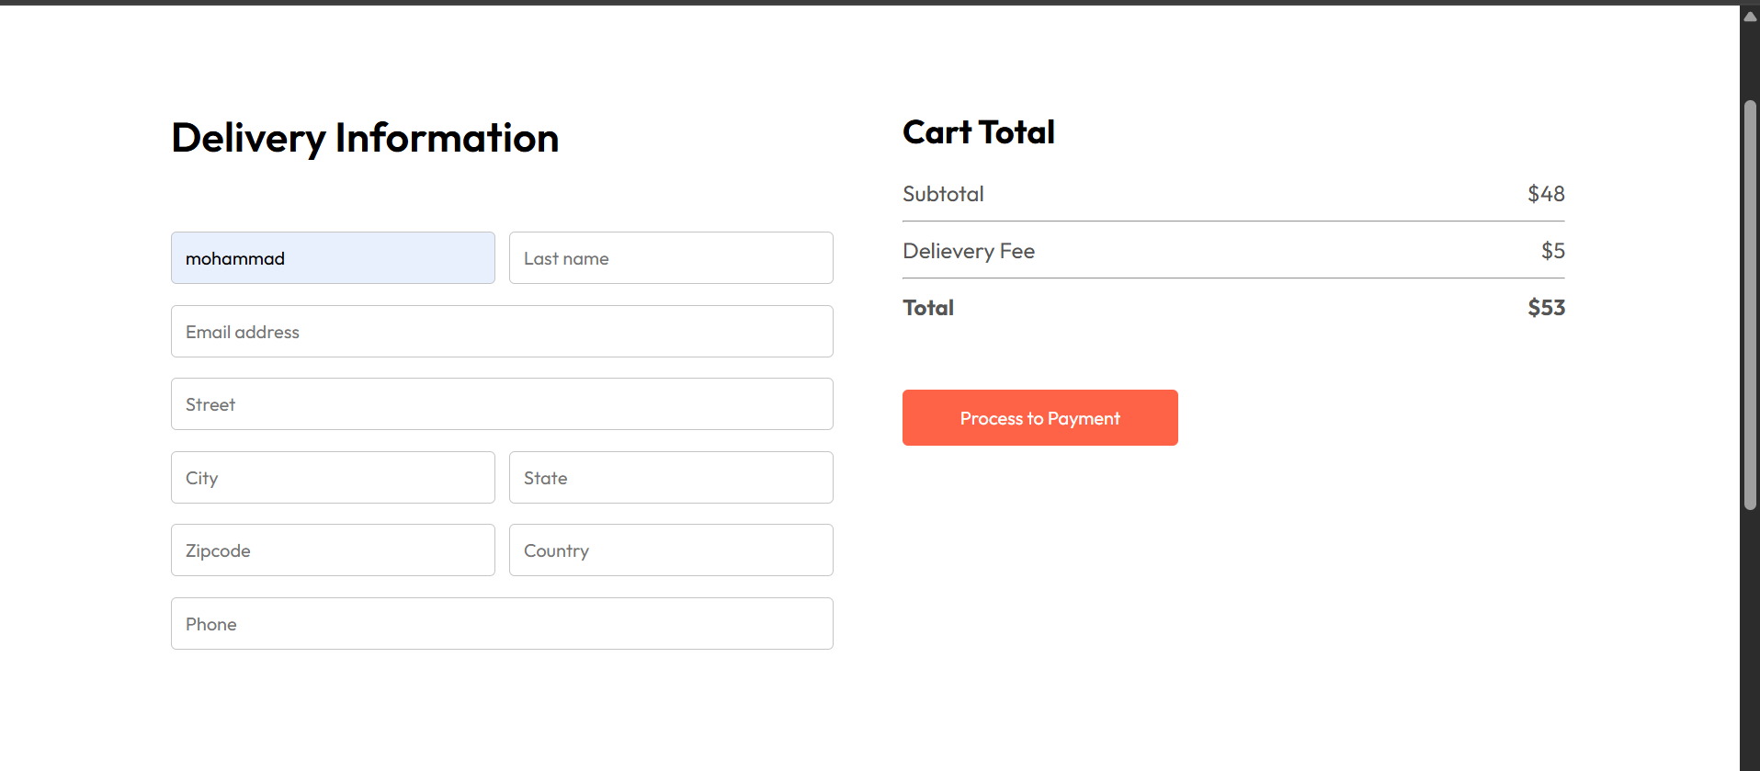
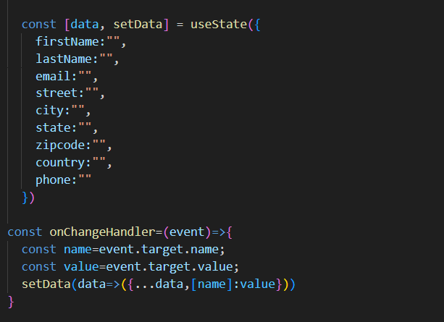 set the form data
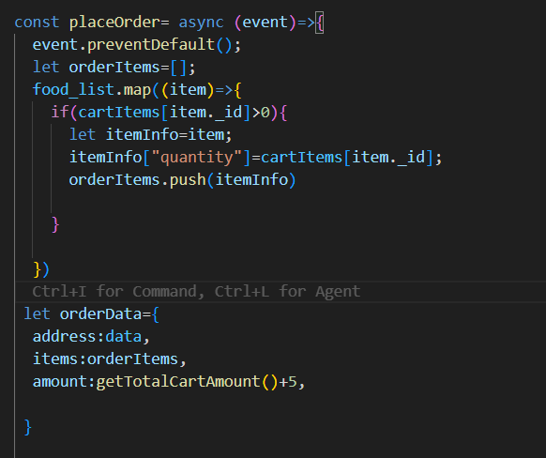
Order data is individual order
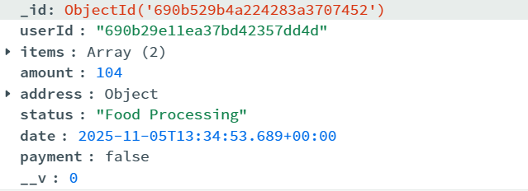
We need address, items, amount from frontend rest is handled by backend
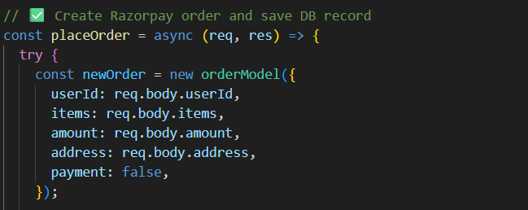

Send post request
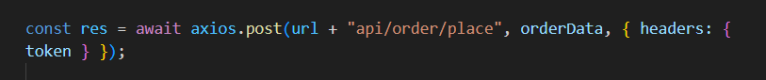
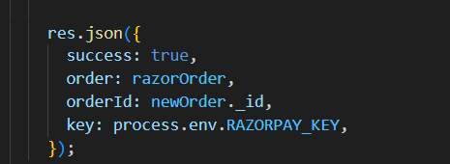
It sends back success:true
Verify payment with backend
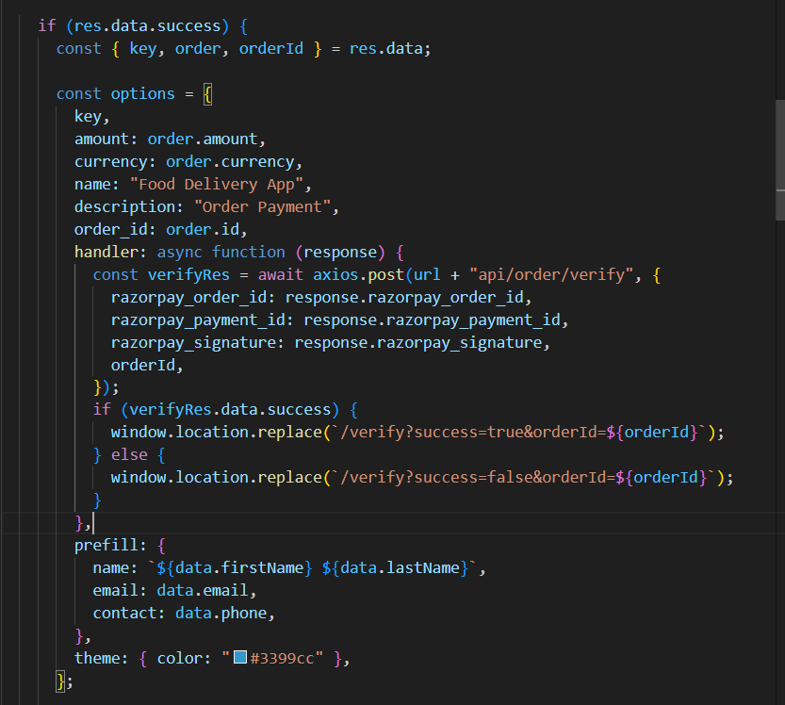

When backend verifies payment
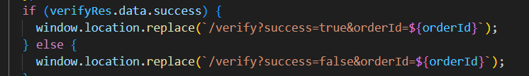
Route to these pages
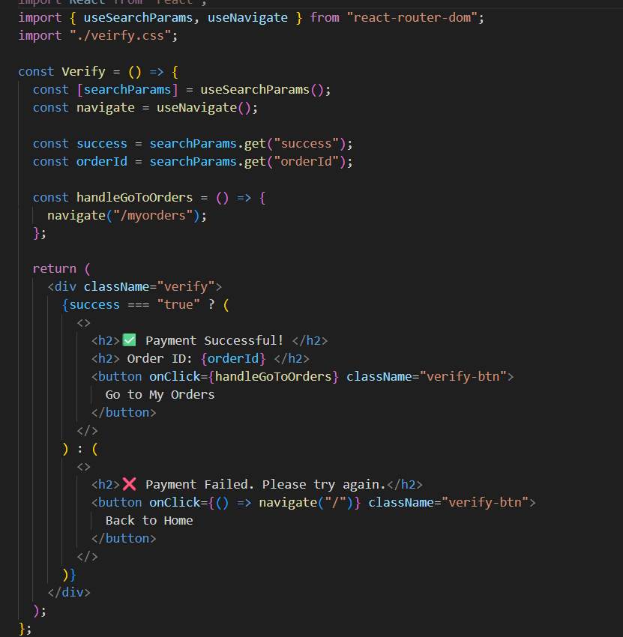
Get using params

7) listing all orders
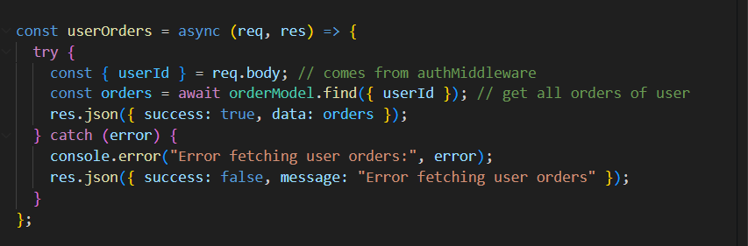
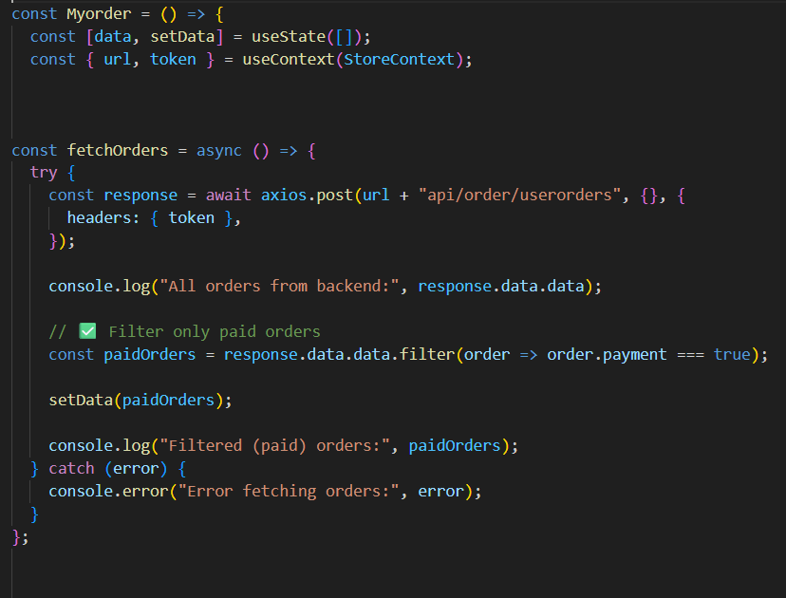
Fetch all orders of user show only payment true ones
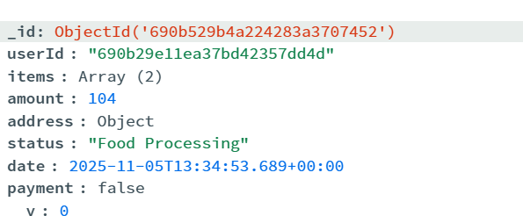
To know status of orders have to refresh

9) changing status of orders from admin

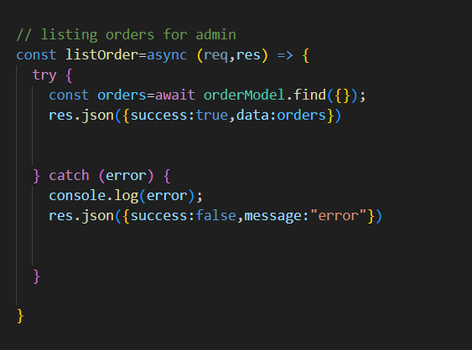
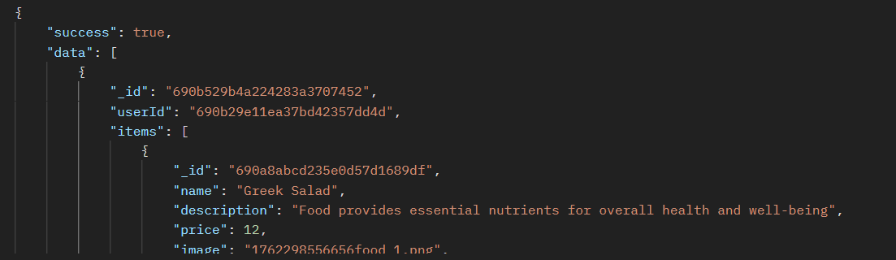
Return an array named data which has multiple orders

Handling status
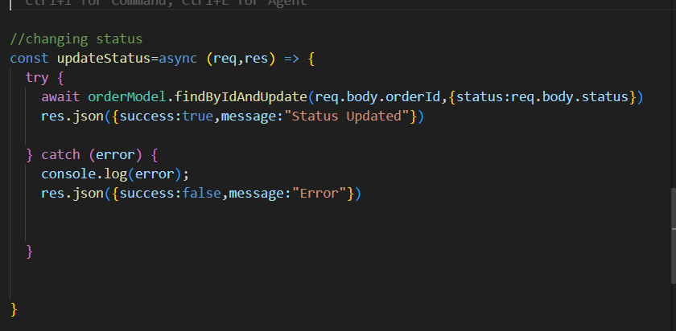
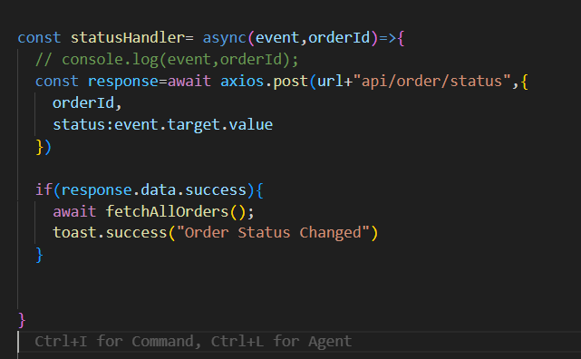
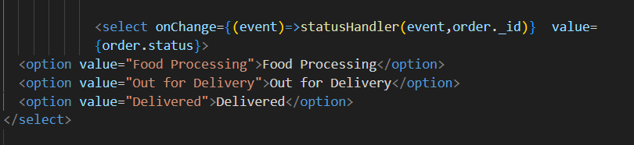
Order is individual document in db

