Sample login:-
User3@gmail.com
User1234
To make payments:-
https://razorpay.com/docs/payments/payments/test-card-details/?preferred-country=IN&utm_source=chatgpt.com

Running code:-

Backend
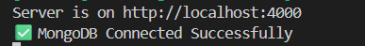
Npm run server

Frontend
Two folders admin and frontend
Run both npm run dev will run on different ports

No need to change any frontend url, if needed change in frontend folder if backend base url is changed
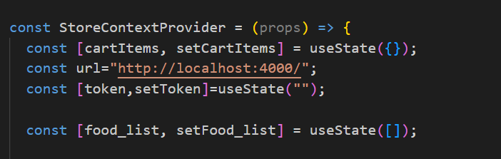
In storecontext.js

Don’t forget / in the end

Database:-
https://cloud.mongodb.com/v2/690a032fdd5c232d0e6a6104#/metrics/replicaSet/690a03ac07db20379cfce991/explorer/food-del/orders/find
login as mohdumar0302@gmail.com

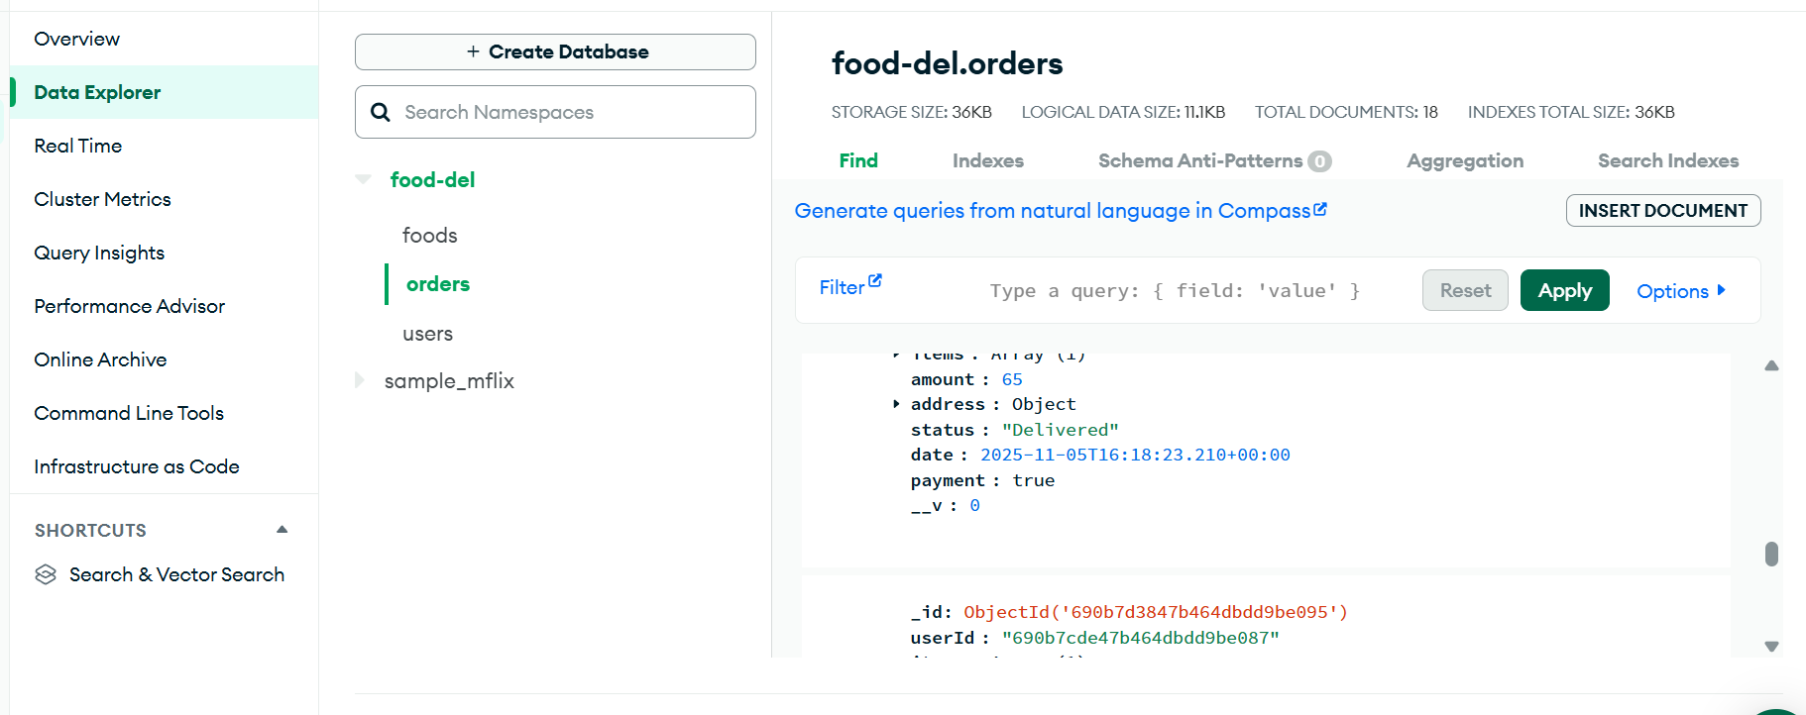
Data explorer

