AI DEV FEST 2026 · DIU CPC × upay AI Hackathon
Project Report
Shurokkha (সুরক্ষা)
AI Trust & Financial-Safety Copilot for upay
Stop the scam before the money leaves.
Item | Details
Primary track | Track 01: Trust & Risk Intelligence
Supporting tracks | Track 03: Customer empowerment · Track 06: Investigation copilot
Team | <team name>
Members | <member names>
Repository | https://github.com/mohammadyaksafu/DIU_Hackathon_final
Live demo | https://165-99-219-251.sslip.io
Data | 100% synthetic. No real customer, phone number or transaction is used.

Contents
Abstract 3
1. Problem 3
2. Proposed Idea 3
3. Implemented Solution 4
3.1 Architecture 4
3.2 Technology stack 5
4. Key Features 5
5. AI Approach 5
5.1 Data 5
5.2 Features 6
5.3 Models and decision policy 6
5.4 Explainability 6
5.5 Generative AI 6
5.6 Evaluation 6
5.7 Robustness: beyond the easy test 7
5.8 Evaluating the generative AI 7
6. Intended Real-Life Impact 8
6.1 Integration and scaling path 8
7. Responsible AI and Security 8
8. Limitations and Future Work 9
9. Disclosures 9
Appendix: Screenshots 10

Abstract
First-time and low-digital-literacy mobile financial service (MFS) users, such as remittance receivers and garment workers, are the main targets of social-engineering scams, account takeovers after SIM swaps, and money-mule networks that cash out stolen funds within minutes. Shurokkha is a real-time AI copilot that intervenes before the money moves. It scores every transfer in milliseconds with a calibrated LightGBM model, an anomaly detector, a mule-network graph score and deterministic rules, combined by a transparent policy into ALLOW, WARN or HOLD. Verified SHAP reason codes explain each decision to the customer in plain Bangla, and analysts get a ranked queue, a mule-ring network view and a generative-AI case summary grounded only in evidence.
On a held-out 10-day window of 22,126 synthetic transactions, Shurokkha reaches 0.995 PR-AUC and 96.2% recall at 91.7% precision with a 0.24% false-positive rate, flagging 94.3% of victim-loss value before completion at about 5 ms scoring latency.

1. Problem
For first-time and low-digital-literacy upay users and upay's risk-operations team, social-engineering scams, account takeovers and money-mule networks cause irreversible losses, customer distrust and slow manual investigations. The upay guideline (Track 01) describes trust as foundational to wallet adoption and transaction growth.
A typical case looks like this:
- The pressure call. A caller tells a remittance receiver she has won a prize and must first pay a 2,000 BDT "fee", or claims he sent money by mistake and asks for a refund.
- The transfer. She sends money to a number she has never paid before. That number is a mule wallet that has received money from dozens of new senders.
- The cash-out. The mule forwards or cashes out the funds within minutes. Once the transfer completes, the money is effectively gone.
Meanwhile, risk analysts review alerts by hand, with little context about the wider network, and rule-based systems either miss new patterns or flood the queue with false alarms that frustrate legitimate customers.

2. Proposed Idea
A real-time trust copilot that intervenes before money leaves the wallet and answers three questions for every transfer:
Question | How Shurokkha answers it
What happened? | Point-in-time behavioural, device, SIM-swap and transaction-network evidence for the transfer.
Why is it risky? | Calibrated ML, anomaly, graph and rule signals, explained with verified SHAP reason codes in Bangla and English.
What should upay do next? | A transparent policy chooses ALLOW, WARN (interrupt the customer with a Bangla warning) or HOLD (send to a human analyst with an AI case summary and SOP-cited next steps).

Design principle: the AI explains; it never decides. Every decision comes from calibrated models and an auditable policy, every HOLD is reviewed by a person, and nothing is blocked permanently by the machine.

3. Implemented Solution
Shurokkha is a working, deployed web application with six parts:
Component | What it does
Customer wallet simulator | A phone-style upay wallet. One-click demo scenarios (prize scam, refund scam, account takeover, structuring, normal transfers). Shows the pre-transaction scam interrupt in Bangla or English with Cancel / Send anyway.
Risk API | POST /api/v1/score scores a transfer in about 5 ms server-side: feature engine → 4 plug-in detectors → policy → explanations. Idempotent and audit-logged.
Analyst console | Ranked alert queue with filters; case view with reasons, SHAP drivers, mule-ring network graph, related alerts and audit trail. Analyst labels release held transfers and feed retraining.
AI copilot & chat | Evidence-grounded case narratives, SOP question answering with citations, and a page- and case-aware AI chat assistant, with deterministic fallbacks when no AI key is set.
Impact dashboard | Lift table versus baselines, recall per fraud scenario, business impact, fairness audit by segment, live latency and scams averted.
Admin | Live policy editing with validation and hot reload, model-registry switching, graph refresh and feature flags.

3.1 Architecture
Every transfer passes through the same pipeline:
- Input: the customer app or a partner API calls /score before the money moves.
- Features: one stateful feature engine computes 46 point-in-time features. The same code is used for training replay and live serving, so there is no train/serve skew.
- Detectors: rules, Isolation Forest, calibrated LightGBM and a mule-graph risk score, registered as plug-ins in detectors.yaml.
- Policy: a hot-reloadable YAML policy turns scores into ALLOW, WARN or HOLD, with per-segment overrides.
- Explain: exact TreeSHAP contributions map to reason codes in Bangla and English.
- Action: the customer sees the warning; HOLD cases go to the analyst queue with an AI case summary.
- Feedback: analyst labels feed the model registry and threshold tuning.
The hot path (features, detectors, policy) runs synchronously in about 5 ms. The warm path generates AI case summaries, cached by an evidence hash. The cold path rebuilds the transaction-graph snapshot every 10 minutes and retrains through the pipeline.

3.2 Technology stack
Layer | Technology
Machine learning | LightGBM, scikit-learn (Isolation Forest, logistic-regression baseline), NetworkX (Louvain, PageRank), NumPy, pandas
Generative AI | Google Gemini (default when a key is set) or Anthropic Claude, through one gateway with JSON-schema output; BM25 retrieval over SOPs
Backend | Python, FastAPI, Pydantic v2, SQLAlchemy 2, JWT auth, Uvicorn
Storage | PostgreSQL or SQLite; optional Redis cache with in-memory fallback
Frontend | Next.js 16, React 19, Tailwind CSS 4, Recharts, d3-force
Operations | Docker Compose, Caddy (automatic HTTPS), GitHub Actions CI, Prometheus-format metrics, JSON logs

4. Key Features
# | Feature | AI / technique
F1 | Real-time risk scoring API (~5 ms server-side) | Platt-calibrated LightGBM on 46 point-in-time features
F2 | Hybrid decision engine: ALLOW / WARN / HOLD | Rules + ML + anomaly + graph signals → hot-reloadable YAML policy
F3 | Verified reason codes in Bangla and English | Exact TreeSHAP; a reason is shown only if its factual condition holds
F4 | Pre-transaction scam interrupt | Deterministic Bangla/English templates (customer text never depends on an LLM)
F5 | Analyst console with feedback loop | Calibrated risk ranking; labels feed retraining
F6 | Money-mule network view | Transaction graph, Louvain communities, PageRank, fan-in and forwarding features
F7 | AI investigation copilot and chat | Gemini / Claude grounded in case evidence and BM25-retrieved SOPs, with numeric checks and fallbacks
F8 | Impact and fairness dashboard | Held-out metrics, lift table, per-scenario recall, false-positive rate by segment
F9 | Synthetic data generator | Seeded simulation of 7 personas, legitimate look-alikes and 6 fraud scenarios

5. AI Approach

5.1 Data
Because real customer data cannot be used, Shurokkha generates 90 days of synthetic data for 2,000 customers across 7 personas (remittance receiver, garment worker, student, professional, shopkeeper, online seller, freelancer). To keep the problem honest, the data includes hard legitimate look-alikes: online sellers with many first-time senders, shopkeepers with near-limit cash-outs, legitimate SIM replacements and new joiners. Six fraud scenarios are injected: account takeover, prize scam, refund scam, mule forwarding / cash-out, structuring and social engineering.

5.2 Features
A single stateful feature engine produces 46 features, including transaction velocity, receiver novelty, device and SIM-swap signals, amount patterns, and transaction-graph features from rolling 14-day snapshots: Louvain community membership, PageRank, community fan-in, cash-out ratio and forwarding ratio.

5.3 Models and decision policy
- LightGBM with Platt calibration, so a score of 0.8 means roughly 80% fraud probability.
- Isolation Forest anomaly percentile for unusual behaviour the supervised model has not seen.
- Graph mule-risk score, transparent and based on the wallet's network community.
- Deterministic rules for hard red flags.
A YAML policy combines the signals. Thresholds are learned on a separate validation window: WARN at 1% legitimate false-positive rate, and HOLD at 90% or higher precision.

5.4 Explainability
Exact TreeSHAP contributions are mapped to human-readable reason codes such as "many new senders paid this number" or "money is forwarded quickly". Each reason is emitted only if its factual condition is true for the transaction, so the customer is never shown a misleading explanation.

5.5 Generative AI
A single LLM gateway supports Google Gemini (preferred when a key is configured) and Anthropic Claude, with JSON-schema output, a timeout and a circuit breaker. The case-summary prompt may use only facts from an evidence JSON plus retrieved SOP passages. Untrusted text is isolated against prompt injection, and every number in the narrative must exist in the evidence; otherwise a deterministic template is used instead. The LLM never makes or changes a risk decision.

5.6 Evaluation
Models were evaluated with a time-based split: the last 10 days (22,126 transactions) were held out and never used for training or threshold setting.
Model (same 10-day test set) | PR-AUC | Recall @ 1% FPR
Rules only | 0.166 | 15.6%
Logistic regression | 0.822 | 80.1%
LightGBM without graph / anomaly features | 0.952 | 93.8%
Shurokkha (LightGBM + graph + anomaly) | 0.995 | 99.5%
Table: AI adds value at each step. Graph and anomaly features lift PR-AUC from 0.952 to 0.995.
Through the real decision policy, the full system reaches precision 91.7%, recall 96.2%, false-positive rate 0.24% and HOLD precision 98.2%.
Fraud scenario | Recall (WARN or HOLD)
Account takeover | 100%
Prize scam | 84%
Refund scam | 100%
Mule forwarding / cash-out | 100%
Structuring | 94%
Social engineering | 87%
Table: recall per injected fraud scenario on the held-out window.
Latency (laptop, single worker): about 5 ms server-side scoring including the database write; end-to-end p50 14.5 ms / p95 26 ms for one user, and p50 121 ms / p95 181 ms at 10 concurrent users.

5.7 Robustness: beyond the easy test
Synthetic fraud is easier than real fraud, so the headline numbers above are an upper bound. We therefore also test what happens when the model meets something it has never seen (backend/pipelines/robustness.py, same time-based split, 1% false-positive operating point, ML model alone):
Fraud family | Recall when seen in training | Recall when never seen
Account takeover | 100% | 87%
Prize scam | 97% | 85%
Refund scam | 100% | 76%
Social engineering | 97% | 97%
Mule network | 100% | 47%
Structuring | 100% | 0%
Table: leave-one-scenario-out. The model is retrained without one fraud family and tested on it.
Most scam types are still caught even when the model was never trained on them. New mule networks and new structuring patterns are the weak spots; in the deployed system the deterministic rules (near-limit cash-outs, SIM-swap plus PIN-reset combination) and the graph detector cover these. When a mule ring is brand new and has no graph history, recall falls only from 99% to 94% (PR-AUC 0.995 to 0.958), because live behaviour features carry most of the signal.
Calibration. Expected calibration error is 0.0024. Mid-range scores are conservative: transfers the model scored between 0.25 and 0.50 were fraud 96% of the time. This is why a transfer showing a fraud probability of about 38% is correctly held, and why the app shows a risk level measured against the policy thresholds rather than the raw number alone.

5.8 Evaluating the generative AI
An automated harness (backend/pipelines/genai_eval.py) checks every AI case summary against its evidence. On 20 alerts (10 HOLD, 10 WARN):
Check | Pass rate
Every number is grounded in the evidence | 100%
Every citation is a real reason code or a retrieved SOP | 100%
States the alert's real decision, never another | 100%
Recommends at least one SOP-referenced action | 100%
A fabricated summary with invented numbers is rejected | Yes

The harness also found a real defect: the grounding guard read "SOP-05" as the number 5, which would have rejected valid AI summaries and silently replaced them with templates. It was fixed and covered by a regression test.

6. Intended Real-Life Impact
Who | Impact
Customers | 94.3% of victim-loss value was flagged before completion. Assuming 60% of warned customers cancel (to be measured in a pilot), the estimated loss prevented is BDT 606,100 over the 10-day simulated window, at a cost of about 5 legitimate customers warned per day.
Risk operations | A ranked queue with 98% HOLD precision, case summaries with SOP-cited next steps, and the full mule-ring picture on one screen, so analysts decide faster. Median time-to-decision is tracked live.
The MFS ecosystem | Mule-ring detection disrupts the cash-out network itself, not just single transactions.
Financial inclusion | Bangla-first, plain-language explanations protect first-time users without blocking them, which builds trust in digital wallets.

6.1 Integration and scaling path
Shurokkha plugs into upay as a pre-authorisation hook (/score) with a confirm callback, through a versioned REST API with OpenAPI documentation. It already runs in Docker with PostgreSQL and Redis, plug-in detectors and a hot-reload policy. The production path adds a shared online feature store, streaming ingestion and incremental graph processing. Real-data validation would follow offline back-test → shadow mode → WARN-only pilot → HOLD with SLAs.

7. Responsible AI and Security
- Synthetic data only; only pseudonymous IDs are ever sent to the LLM.
- Verified explanations: no reason is shown unless it is factually true.
- Human in the loop: every HOLD is reviewed by an analyst; there is no permanent auto-block.
- Fairness audit of false-positive rates across division, age, KYC level and tenure. Shopkeepers and new accounts currently show a higher rate, handled through segment overrides and merchant onboarding.
- Admin protection: the website signs visitors in automatically as the demo customer and analyst only. Changing the live policy or model requires a separate admin password that is never built into the website; in production, admin login is disabled until that password is set.
- Security: JWT roles, rate limiting, sandboxed policy expressions, prompt-injection isolation, an audit log, automated dependency-vulnerability audit in CI (0 known vulnerabilities after upgrading FastAPI/Starlette, PyJWT and python-multipart), secret scanning, and an accessibility audit with 0 WCAG 2.1 AA violations on all pages.

8. Limitations and Future Work
- Synthetic fraud patterns are easier than real fraud; real performance must be established with governed upay data, starting in shadow mode.
- Live feature state is held in a single API worker; production needs a shared feature store.
- The calibration window is small, and SOP retrieval uses BM25 rather than semantic search.
Next steps: a shared feature store, shadow evaluation on real data, A/B testing of warning designs, Bangla voice warnings, and agent-risk benchmarking.

9. Disclosures
- External services: Google Gemini API and Anthropic Claude API, both optional. They are used only for natural-language summaries and chat, never for risk decisions.
- Pre-trained models and datasets: none. All ML models are trained from scratch on our own seeded synthetic data.
- SOP documents were written by the team for the demo and are not official upay documents.
- Open-source libraries: FastAPI, LightGBM, scikit-learn, NetworkX, Next.js, React, Tailwind CSS, Recharts and others, used under their licences (full list in DISCLOSURES.md).

Appendix: Screenshots
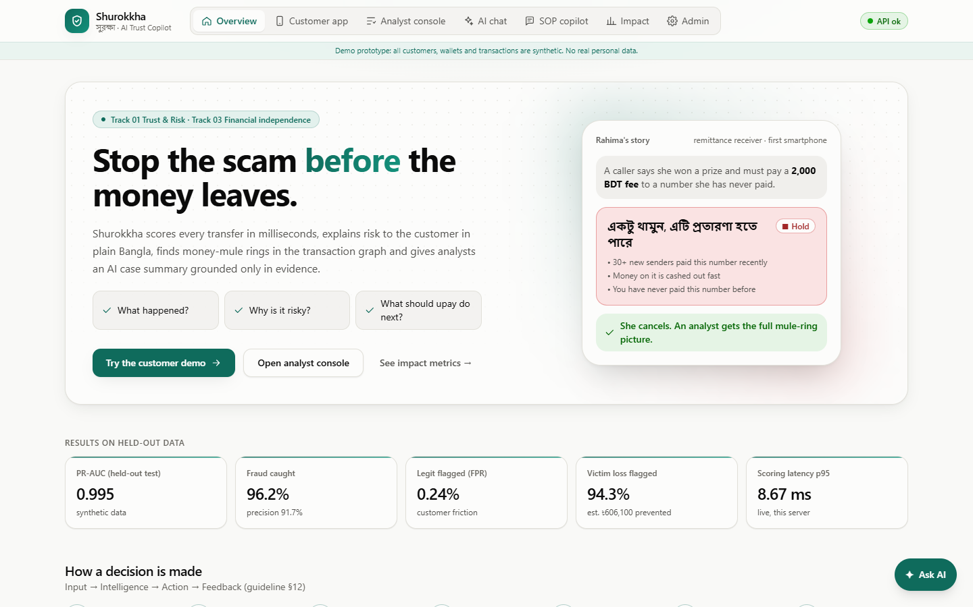
Figure 1: Overview page with the value proposition, live results and the decision pipeline.
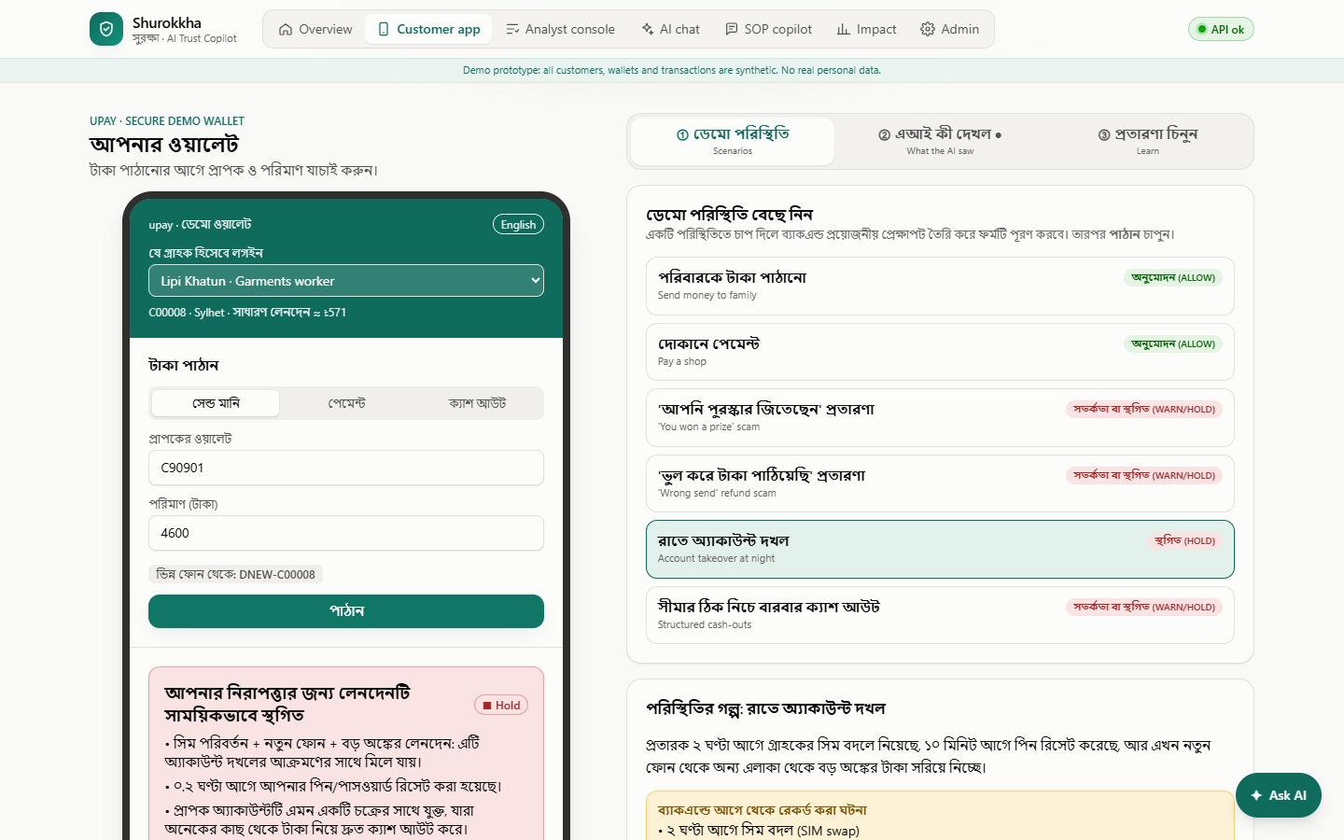
Figure 2: Account takeover held in the customer wallet, with a plain Bangla explanation.
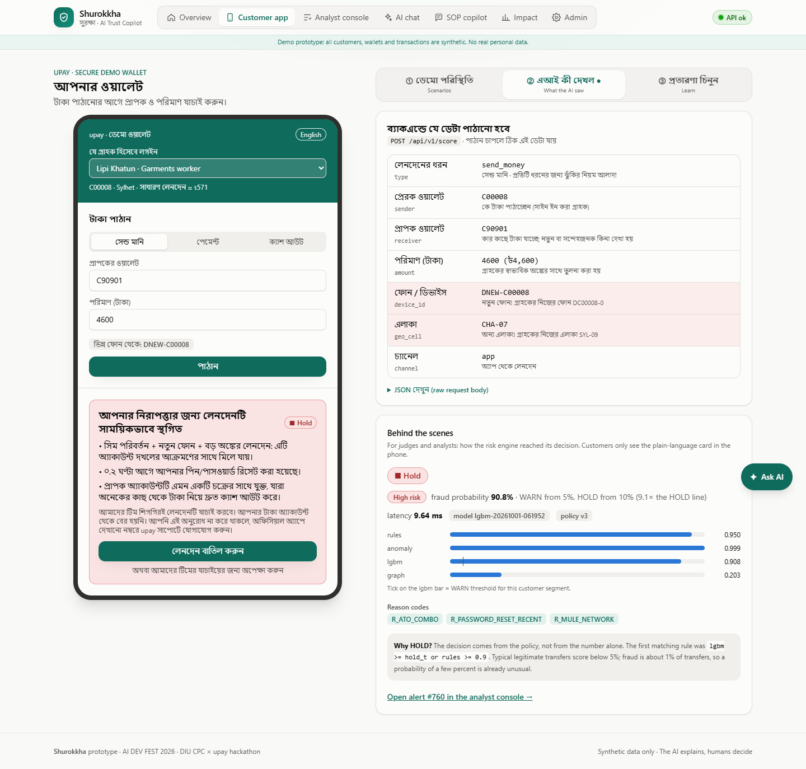
Figure 3: What the AI saw: the exact request, the flagged new phone and area, the risk level against the thresholds, and why the transfer was held.
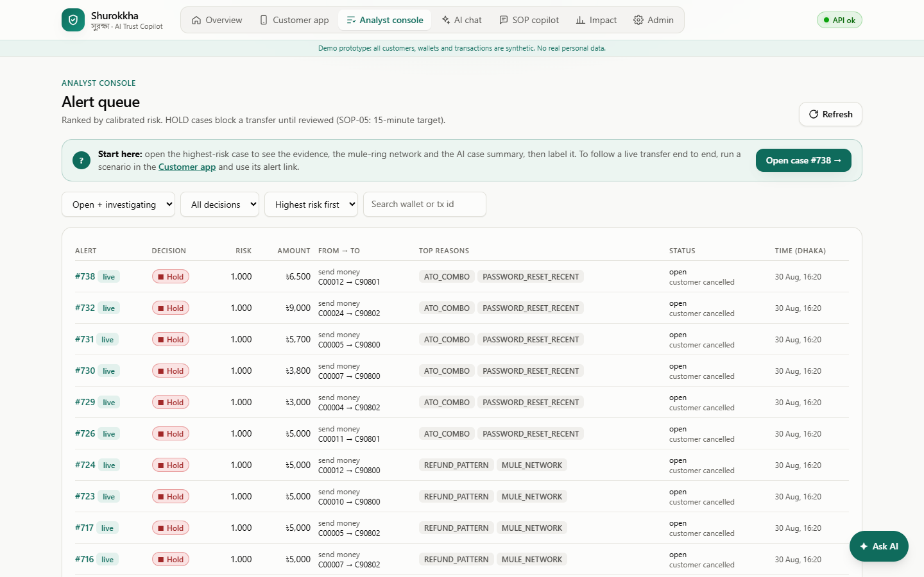
Figure 4: Analyst console with the ranked alert queue and a start-here guide.
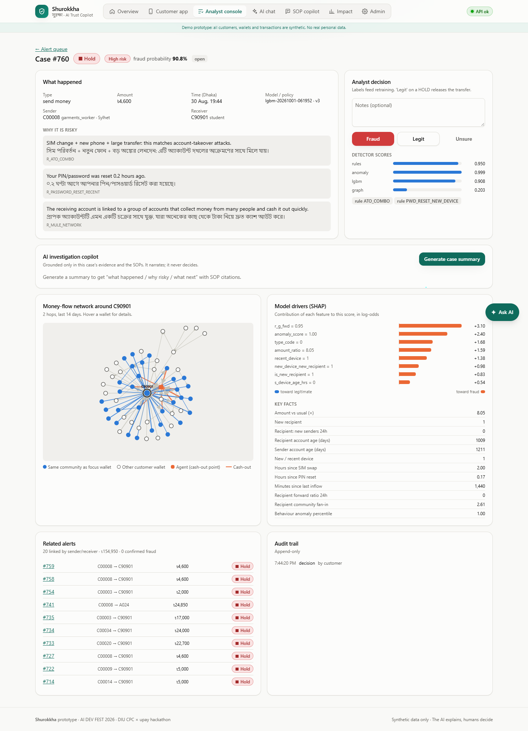
Figure 5: Case view with evidence, SHAP drivers, the mule-ring network and the AI case summary.
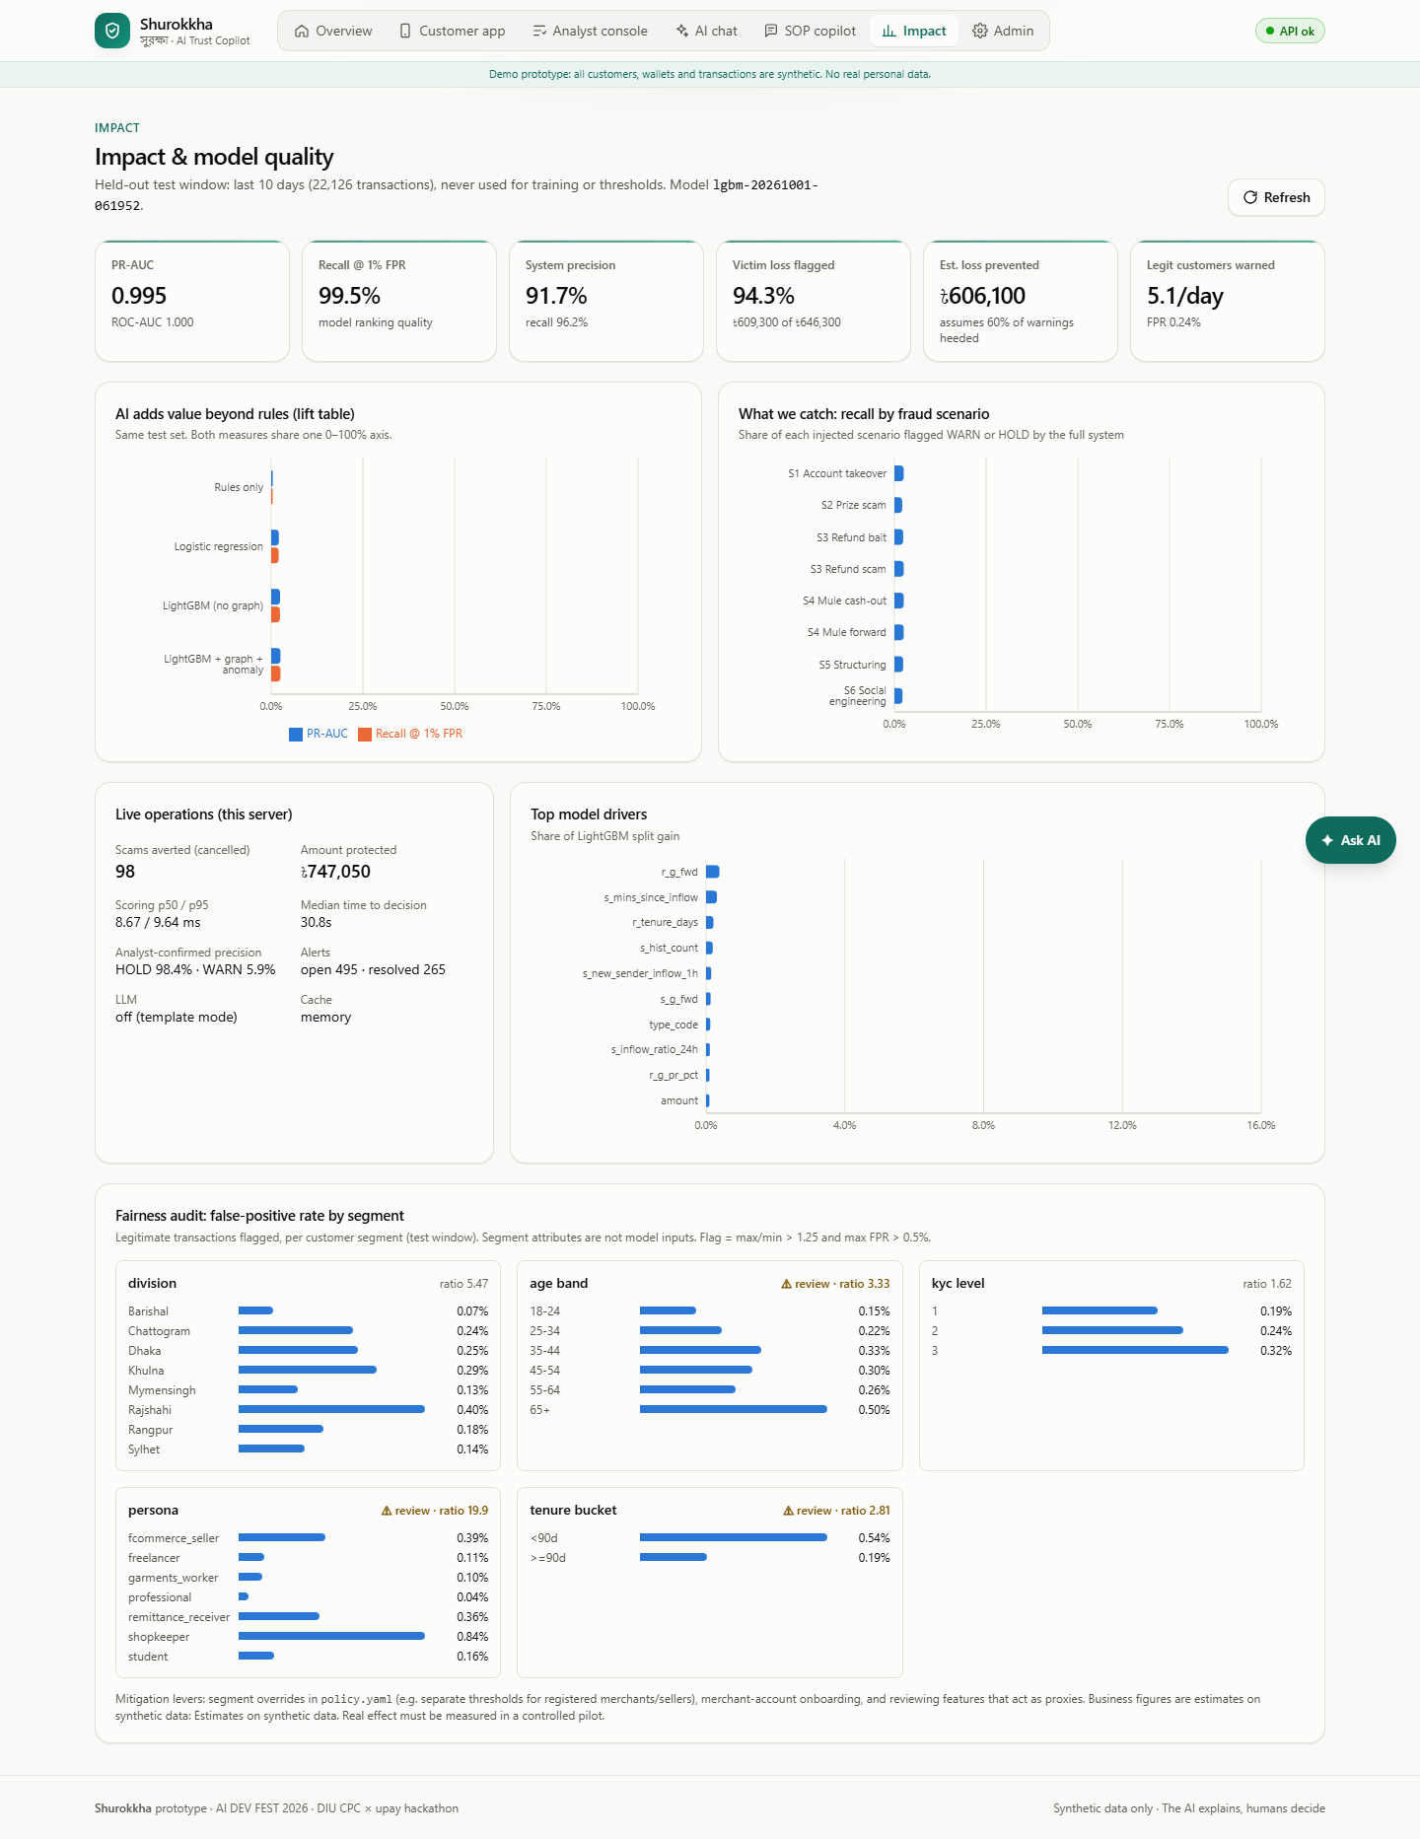
Figure 6: Impact dashboard with lift over baselines, recall per fraud scenario and the fairness audit.
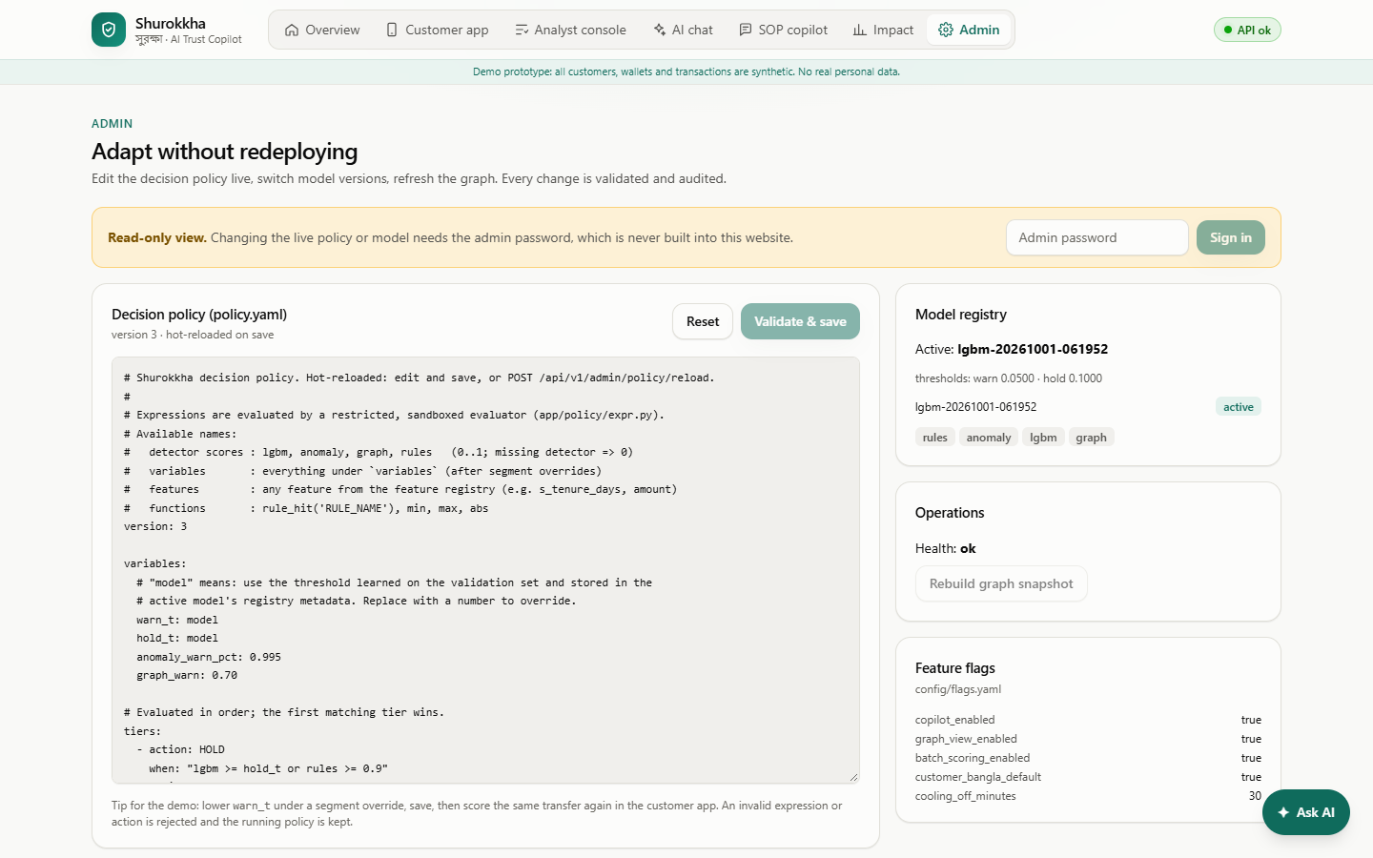
Figure 7: Admin page: live policy editing, read-only until the admin password is entered.

