I am a fully enthusiastic person at my field with excellent coding and Communication Skills. And love to Write New and Unique Content.

COMPUTER SCIENCE AND ENGINEERING

**Lovely Professional University**

**Bachelor of Technology**

**2019-2023**

**Board Of Secondary Education**

**2016-2017**

007zaidameen@gmail.com

**EDUCATION**

**CONTACT**

**PROFILE**

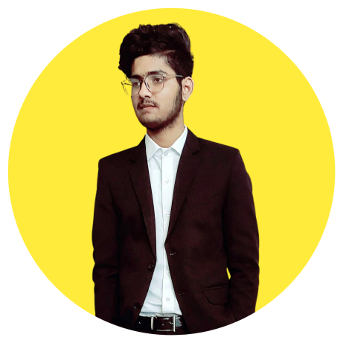

**Mohammad Zaid**

Full Stack Developer



<https://www.linkedin.com/in/mohammad-zaid-479729192/>

CGPA : 8.94

**2017-2018**

**Percentage : 83%**

391-mail4.png

9785575657

067-phone.png

**PROJECTS**

001-home.png

Kota Rajasthan

**Twitter Sentimental Analysis**

**Developer Account API,tweepy,Textblob**

**OCT 2020**

**Covid Medicine Finder**

**Using Python,frameworks,Front End Dev.**

**MAY 2021**

**SKILLS**

1. Python 7. DSA
2. C 8. OOP

**LANGUAGES**

1. C++ 9. SQL
2. JAVASCRIPT 10. DATABASES
3. HTML 11. FRONT END
4. CSS 12. BACK END English Hindi Arabic Urdu