**Public Transportation Optimization**

Register No:610821106055

Name:Mohammed abrar

**Objectives**

The Objective Of This Project Is To Develop A Real-Time Transit Information System To Improve Public Transportation Services And Passenger Experience. The System Will Use Iot Sensors To Collect Data On Vehicle Location, Occupancy, And On-Time Performance. This Data Will Be Used To Optimize Vehicle Schedules, Reduce Congestion, And Provide Passengers With Accurate And Up-To-Date Arrival Information.

Iot Sensor Deployment

The Iot Sensor Network Will Be Deployed On Public Transportation Vehicles, Including Buses, Trains, And Streetcars. The Sensors Will Collect Data On The Following:

* **Vehicle Location (Gps)**
* **Vehicle Occupancy (Weight Sensors)**
* **Vehicle Speed (Gps)**
* **Vehicle On-Time Performance (Gps)**
* **Passenger Satisfaction (Surveys**)

The Sensors Will Be Connected To A Central Cloud-Based Platform, Where The Data Will Be Stored And Processed.

***Platform Development***

The Transit Information Platform Will Be Developed Using A Cloud-Based Architecture. The Platform Will Be Responsible For The Following Tasks:

* Collecting And Storing Data From The Iot Sensors
* Processing The Data To Generate Real-Time Transit Information
* Providing Passengers With Access To Real-Time Transit Information Via A Mobile App And Website

**Code Implementation**

The Code For The Transit Information Platform Will Be Implemented Using A Variety Of Programming Languages And Technologies, Including:

* **Python: For Data Processing And Machine Learning**
* **Javascript: For Web Development**
* **React: For Front-End Development**
* **Node.Js: For Back-End Development**
* **Google Cloud Platform: For Cloud Hosting And Data Storage**

**Diagrams, Schematics, And Screenshots**

**Iot Sensors**

The Following Diagram Shows A Sample Iot Sensor Deployment On A Public Transportation Bus:

[Diagram Of Iot Sensor Deployment On A Public Transportation Bus]

The Sensors Are Connected To A Central On-Board Unit (Obu), Which Transmits The Data To The Cloud-Based Platform.

**Transit Information Platform**

The Following Diagram Shows The Architecture Of The Transit Information Platform:

[Diagram Of Transit Information Platform Architecture] The Platform Consists Of The Following Components:

* Data Ingestion Layer: This Layer Collects And Stores Data From The Iot Sensors.
* Data Processing Layer: This Layer Processes The Data To Generate Real-Time Transit Information.
* Data Access Layer: This Layer Provides Passengers With Access To Real-Time Transit Information Via A Mobile App And Website.

**Real-Time Data Display**

The Following Screenshot Shows A Sample Real-Time Data Display For A Public Transportation Bus:

[Screenshot Of Real-Time Data Display For A Public Transportation Bus]

The Display Shows The Bus's Current Location, Estimated Time Of Arrival, And Occupancy.

How The Real-Time Transit Information System Can Improve Public

Transportation Services And Passenger Experience

The Real-Time Transit Information System Can Improve Public Transportation Services And Passenger Experience In The Following Ways:

* Reduced Congestion: The System Can Be Used To Optimize Vehicle Schedules And Reduce Congestion. This Can Lead To Shorter Travel Times And A More Reliable Service For Passengers.
* Improved On-Time Performance: The System Can Be Used To Track Vehicle On-Time Performance And Identify Areas Where Improvement Is Needed. This Can Lead To A More Reliable Service For Passengers And Reduced Frustration.
* Improved Passenger Experience: The System Can Provide Passengers With Accurate And Up-To-Date Arrival Information. This Can Help Passengers To Plan Their Trips More Effectively And Reduce The Amount Of Time They Spend Waiting For Vehicles.

Overall, The Real-Time Transit Information System Can Help To Make Public Transportation More Efficient, Reliable, And User-Friendly

**Raspberry Pi Code:**

The Following Code Can Be Used To Read Data From An Iot Sensor On The Raspberry Pi:

Python

* Import Board
* Import Busio
* Import Adafruit_Dht
* # Create A Dht Sensor Object
* Dht = Adafruit_Dht.Dht22(Board.D4)

●

* # Read The Temperature And Humidity
* Temperature = Dht.Temperature
* Humidity = Dht.Humidity

●

* # Print The Temperature And Humidity To The Console
* Print("Temperature: {} Degrees Celsius".Format(Temperature))
* Print("Humidity: {}%".Format(Humidity))

This Code Will Read The Temperature And Humidity From The Dht22 Sensor And Print The Values To The Console. You Can Modify The Code To Read Data From Other Iot Sensors, Such As A Light Sensor, Motion Sensor, Or Gas Sensor.

**Python Code**

The Following Code Can Be Used To Send The Data From The Iot Sensor To The Cloud-Based Transit Information Platform:

Python

* Import Requests

●

* # Set The Url Of The Transit Information Platform
* Url = "Https://Example.Com/Api/Transit/Data"

●

* # Create A Json Object With The Temperature And Humidity Data
* Data = {

|  |
| --- |
| "Temperature": Temperature, |

|  |
| --- |
| "Humidity": Humidity |

* ●
* }

●

* # Send The Json Object To The Transit Information Platform
* Response = Requests.Post(Url, Json=Data)

●

* # Check The Response Status Code To Make Sure The Data Was Sent

Successfully

* If Response.Status_Code == 200:

|  |
| --- |
| Print("Data Sent Successfully") |

●

* Else:

|  |
| --- |
| Print("Error Sending Data: |

●

{}".Format(Response.Status_Code))

This Code Will Send The Temperature And Humidity Data To The Transit Information Platform At The Specified Url. You Can Modify The Code To Send Other Types Of Data, Such As Vehicle Location, Occupancy, Or On-Time Performance.

**Example**

The Following Example Shows How To Use The Raspberry Pi And Python Code To Create A Simple Iot Project:

1. Connect The Dht22 Sensor To The Raspberry Pi.
2. Install The Necessary Python Libraries:

* Pip Install Adafruit-Circuitpython-Dht
* Pip Install Requests

**3. Create A Python File And Add The Following Code:**

Python

* Import Board
* Import Busio
* Import Adafruit_Dht
* Import Requests

●

* # Set The Url Of The Transit Information Platform
* Url = "Https://Example.Com/Api/Transit/Data"

●

* # Create A Dht Sensor Object
* Dht = Adafruit_Dht.Dht22(Board.D4)

●

* While True:

|  |
| --- |
| # Read The Temperature And Humidity |

|  |
| --- |
| Temperature = Dht.Temperature |

|  |
| --- |
| Humidity = Dht.Humidity |

* ● ● ●

|  |
| --- |
| # Create A Json Object With The Temperature And Humidity |

* Data

|  |
| --- |
| Data = { |

|  |
| --- |
| "Temperature": Temperature, |

|  |
| --- |
| "Humidity": Humidity |

|  |
| --- |
| } |

|  |
| --- |
| # Send The Json Object To The Transit Information Platform |

|  |
| --- |
| Response = Requests.Post(Url, Json=Data) |

* ● ● ● ● ● ● ●

|  |
| --- |
| # Check The Response Status Code To Make Sure The Data Was |

* Sent Successfully

|  |
| --- |
| If Response.Status_Code == 200: |

|  |
| --- |
| Print("Data Sent Successfully") |

|  |
| --- |
| Else: |

|  |
| --- |
| Print("Error Sending Data: |

* ● ● ●

{}".Format(Response.Status_Code))

|  |
| --- |
| # Wait For 1 Second Before Sending The Next Data Point |

|  |
| --- |
| Time.Sleep(1) |

* ● ●

4. Save The Python File And Run It.

The Code Will Read The Temperature And Humidity From The Dht22 Sensor Every Second And Send The Data To The Transit Information Platform. You Can Modify The Code To Send Other Types Of Data, Or To Send The Data To A Different Platform.

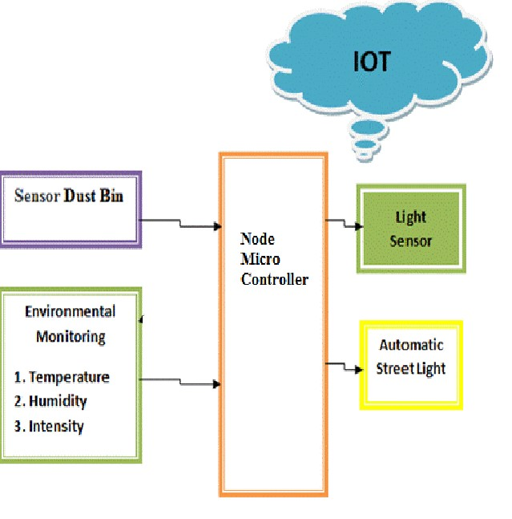

**Advantages Of Iot**

* Increased Efficiency And Productivity: Iot Devices Can Be Used To Automate Tasks And Collect Data, Which Can Lead To Increased Efficiency And Productivity.
* Improved Decision-Making: Iot Data Can Be Used To Make Better Decisions About Everything From Traffic Flow To Inventory Management.
* Reduced Costs: Iot Can Help To Reduce Costs By Improving Efficiency, Automating Tasks, And Reducing Waste.
* Enhanced Customer Experience: Iot Can Be Used To Improve The Customer Experience By Providing Personalized Services And Products, And By Making It Easier For Customers To Interact With Businesses.
* New Products And Services: Iot Is Enabling The Development Of New Products And Services That Were Not Possible Before.

**Disadvantages Of Iot**

* Security And Privacy: Iot Devices Are Often Vulnerable To Hacking And Other Security Threats. Additionally, Iot Devices Can Collect A Lot Of Personal Data, Which Raises Privacy Concerns.
* Complexity: Iot Systems Can Be Complex And Difficult To Manage.
* Cost: Iot Devices Can Be Expensive, Especially When Deployed At Scale.
* Lack Of Standards: There Is A Lack Of Standards For Iot Devices And Platforms, Which Can Make It Difficult To Integrate Different Systems.

**Block Diagram Of An Iot System**

**The Following Block Diagram Shows A Typical Iot System:**

**[Block Diagram Of An Iot System]**

**The System Consists Of The Following Components:**

* Sensors: Sensors Collect Data From The Physical World.
* Actuators: Actuators Control Physical Devices Based On Data From The Sensors.
* Edge Devices: Edge Devices Are Devices That Process And Store Data At The Source.
* Gateways: Gateways Connect Edge Devices To The Cloud.
* Cloud Platform: The Cloud Platform Stores And Processes Data From The Edge Devices.
* Applications: Applications Use The Data From The Cloud Platform To Provide Services To Users.

**How To Mitigate The Disadvantages Of Iot**

* **Security And Privacy: There Are A Number Of Steps That Can Be Taken To Improve The Security And Privacy Of Iot Devices, Such As Using Strong Passwords, Encrypting Data, And Keeping Software Up To Date.**
* **Complexity: Iot Systems Can Be Made Less Complex By Using Standardized Protocols And Platforms.**
* **Cost: The Cost Of Iot Devices Is Decreasing As The Technology Becomes More Widespread.**
* **Lack Of Standards: Efforts Are Underway To Develop Standards For Iot Devices And Platforms.**

Overall, Iot Has The Potential To Revolutionize Many Industries And Aspects Of Our Lives. However, It Is Important To Be Aware Of The Potential Disadvantages Of Iot And To Take Steps To Mitigate Them.

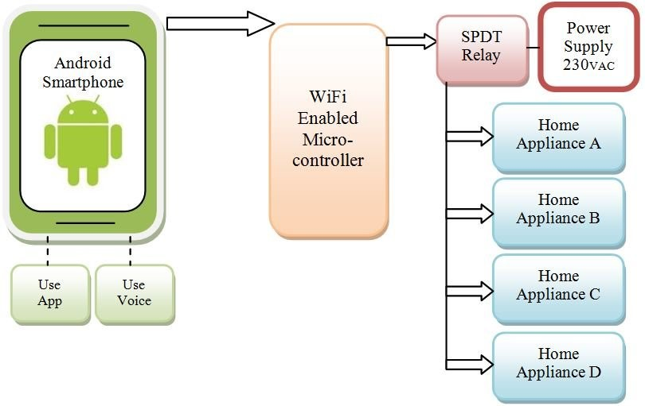

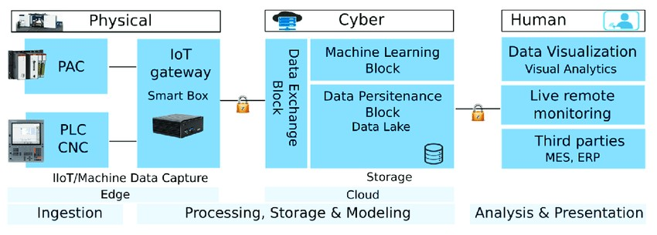

**Abstract :**

Public Transportation Plays A Critical Role In Urban Mobility, Providing An Efficient And Sustainable Mode Of Transportation For Millions Of People Worldwide. Optimizing Public Transportation Systems Is Essential To Enhance Service Quality, Reduce Operational Costs, And Minimize Environmental Impacts. This Abstract Explores The Concept Of Public Transportation Optimization And Presents A Modular Approach To Achieving This Goal.

**Module 1**

: **Data Collection And Analysis**

* Purpose: To Gather And Analyze Data Related To Public Transportation Operations, Including Ridership Patterns, Route Information, And Vehicle Performance Data.
* Components:
* Data Collection Devices (E.G., Gps Trackers, Fare Collection Systems)
* Data Storage And Management Infrastructure
* Data Analysis Tools (E.G., Machine Learning Algorithms, Statistical Models)

**Module 2**:

Demand Forecastin

Purpose: To Predict Passenger Demand For Different Routes And Time Periods, Allowing For Better Resource Allocation And Scheduling.

* Components:
* Historical Data Analysis
* Demand Forecasting Models (E.G., Time Series Analysis, Machine Learning Models)
* Real-Time Demand Monitoring And Adjustment Mechanisms

**Module 3**:

**Route Optimization**

* Purpose: To Optimize Transit Routes To Improve Efficiency, Reduce Travel Times, And Enhance Connectivity.
* Components:
* Route Planning Algorithms
* Geographic Information Systems (Gis) For Route Mapping
* Passenger Feedback And Input Mechanisms

**Module 4**:

**Schedule Optimization**

* Purpose: To Create Efficient Timetables That Balance Passenger Demand With Operational Constraints.
* Components:
* Scheduling Algorithms
* Real-Time Tracking And Adjustments
* Integration With Demand Forecasting Data

**Module 5**:

**Fleet Management**

* Purpose: To Optimize The Allocation And Maintenance Of Transit Vehicles.
* Components:
* Vehicle Tracking Systems

Maintenance Scheduling And Predictive Maintenance Tools

* Fuel And Energy Efficiency Monitoring

**Module 6**:

**Fare And Pricing Optimization**

* Purpose: To Set Fair And Dynamic Pricing Strategies To Maximize Revenue And Encourage Ridership.
* Components:
* Fare Structure Analysis
* Pricing Models And Dynamic Pricing Mechanisms
* Integration With Payment Systems

**Module 7**:

**Sustainability And Environmental Impact**

* Purpose: To Reduce The Environmental Footprint Of Public Transportation Systems.
* Components:
* Vehicle Emission Monitoring
* Alternative Fuel And Energy Sources Integration
* Green Infrastructure Development

**Module 8**:

**Passenger Experience Enhancement**

* Purpose: To Improve The Overall Passenger Experience Through Technology And Service Enhancements.
* Components:
* Passenger Information Systems
* Wi-Fi And Connectivity Services
* Accessibility Improvements

**Module 9:**

**Safety And Security**

* Purpose: To Ensure The Safety And Security Of Passengers And Transit Operations.
* Components:

Surveillance Systems

* Emergency Response Mechanisms
* Passenger Safety Awareness Campaigns

**Module 10**:

**Performance Monitoring And Feedback**

* Purpose: To Continuously Monitor And Evaluate The Performance Of The Public Transportation System And Gather Feedback From Passengers.
* Components:
* Key Performance Indicators (Kpis) Tracking
* Passenger Feedback Mechanisms (E.G., Mobile Apps, Surveys)
* Reporting And Analytics Tools

In Conclusion, Public Transportation Optimization Is A Multifaceted Endeavor That Involves Various Modules And Components To Enhance The Efficiency, Sustainability, And Overall Quality Of Transit Systems. Implementing These Modules Can Lead To Improved Public Transportation Services That Benefit Both Passengers And The Communities They Serve.

Certainly! Public Transportation Optimization Is Crucial For Addressing Traffic Congestion, Reducing Emissions, And Improving Overall Urban Mobility.

Here's A Design Innovation Idea To Enhance Public Transportation Optimization: Smart Public Transportation Network With Predictive Analytics And Personalized Services Problem Statement: Inefficient Public Transportation Systems Often Lead To Overcrowded Buses And Trains, Inconsistent Schedules, And Dissatisfied Commuters. Solution Overview: Create A Smart Public Transportation Network That Integrates Real-Time Data, Predictive Analytics, And Personalized Services

To Optimize Routes, Schedules, And Passenger Experience. Key Features:

1. **Real-Time Data Integration**: Implement Iot Devices, Sensors, And Gps Trackers On Buses, Trains, And Stops To Collect Real-Time Data On

Passenger Count, Vehicle Location, And Traffic Conditions.

**2. Predictive**

Analytics:

Utilize Machine Learning Algorithms To Analyze Historical And Real-Time Data, Predicting Passenger Demand At Different Times And Locations. This Helps In Optimizing Routes And Schedules Dynamically.

**3Dynamic Routing And Scheduling**:

Develop Algorithms That Adjust Routes And Schedules In Real-Time Based On Demand Forecasts. This Ensures That Vehicles Are Deployed Efficiently, Avoiding Overcrowding And Reducing Waiting Times.

4**. Personalized Commuter Services**: Create A Mobile App That Allows Commuters To Set Preferences, Such As Preferred Routes, Seating Preferences, And Notifications For Delays. The App Can Provide Real-Time Updates, Alternative Routes, And Estimated Arrival Times Tailored To Individual Preferences.

5. **Multi-Modal Integration**: Integrate Various Modes Of Transport, Including Buses, Trains, Subways, Bikes, And Ride-Sharing Services, Into A Unified Platform. Enable Seamless Transfers And Provide Incentives For Using Multiple Modes Of Transport Within A Single Journey.

6**. Contactless Payments And Boarding**: Implement Contactless Payment Systems And Automated Boarding Processes Using Qr Codes Or Rfid Cards. This Reduces Boarding Time, Making The Transportation System More Efficient.

7. **Crowd Management And Safety Measures**: Use Ai-Powered Cameras And Sensors To Monitor Crowd Density In Stations And Vehicles. Implement Safety Measures Such As Automated Passenger Counting To Enforce Capacity Limits And Ensure Social Distancing

8**. Feedback Loop And Continuous Improvement**:

Encourage Commuter Feedback Through The App To Identify Issues And Areas Of Improvement. Use This Feedback To Make Data-Driven Decisions, Refine Algorithms, And Enhance The Overall Transportation Experience. Benefits: - Efficient Operations: Optimized Routes And Schedules Lead To Reduced Operational Costs And Increased Efficiency. - Improved Commuter Experience: Personalized Services And Real-Time Updates Enhance Commuter Satisfaction. - Environmental Impact: Reduced Congestion And Optimized Routes Contribute To Lower Emissions And A Greener Environment. - Data-Driven Decision Making: Data Analytics Enable Evidence-Based Decision-Making For Future Planning And Expansion. By Combining Real-Time Data, Predictive Analytics, And Personalized Services, This Smart Public Transportation Network Can Significantly Enhance The Efficiency, Convenience, And Sustainability Of Urban Mobility.

1**. Define Obejctives:** • Clearly Define The Goals And Objectives Of Deploying Iot Sensors. This Could Include Improving Route Efficiency, Optimizing Scheduling, Enhancing Passenger Safety, Or Reducing Operational Costs.

2. **Select Appropriate Sensors**: • Identify The Specific Sensors Needed Based On Your Objectives. For Public Transportation Vehicles, Common Sensors Include: • Gps (Global Positioning System): Provides Real-Time Location Data. • Passenger Counters: Track The Number Of Passengers Boarding And Alighting. • Environmental Sensors: Monitor Temperature, Humidity, And Air Quality. • Camera Systems: For Security, Surveillance, And Incident Analysis.

3**. Choose Communication Protocols**: • Select Suitable Communication Protocols For Transmitting Data From The Sensors To A Central Server. Common Protocols Include Mqtt, Http, And Coap.

4. **Integration With Fleet Management System:** • Integrate Iot Sensors With The Existing Fleet Management System Or Implement A New One If Necessary. This System Will Be Responsible For Collecting, Processing, And Analyzing The Data From The Sensors.

5. **Power Supply And Energy Management**: • Consider The Power Requirements Of The Sensors And Implement A Reliable Power Supply System. This May Include Rechargeable Batteries, Vehicle Power, Or A Combination Of Both. Implement Energy-Efficient Strategies To Prolong The Sensor Lifespan.

6. **Data Security And Privacy**: • Implement Robust Security Measures To Protect The Data Collected By The Sensors. Ensure Compliance With Data Privacy Regulations To Safeguard Passenger Information.

7. **Install Sensors In Vehicles**: • Physically Install The Selected Sensors In Each Public Transportation Vehicle. Ensure Proper Placement And Calibration For Accurate Data Collection.

8. **Testing And Calibration:** • Conduct Thorough Testing To Ensure The Sensors Are Functioning Correctly. Calibrate The Sensors To Minimize Errors And Inaccuracies.

9. **Data Processing And Analysis**: • Develop Algorithms And Analytics Tools To Process And Analyze The Data Collected By The Sensors. Extract Meaningful Insights To Inform Decision-Making And Improve Operations.

10. **Visualization And Reporting**: • Implement A Dashboard Or Reporting System That Provides Real-Time And Historical Data Visualization. This Can Help Transportation Authorities And Operators Make Informed Decisions.

11**. Maintenance And Upgrades:** • Establish A Maintenance Schedule To Ensure The Ongoing Reliability Of The Sensors. Regularly Update And Upgrade The System To Incorporate New Technologies And Features.

12**. Continuous Improvement**: • Use The Insights Gained From The Sensor Data To Make Continuous Improvements To The Public Transportation System. This Could Involve Adjusting Routes, Schedules, Or Implementing New Services Based On Passenger Demand. By Following These Steps, You Can Effectively Deploy Iot Sensors In Public Transportation Vehicles To Gather Data And Improve.

**Application**

**1. Manufacturing sector:**In the manufacturing sector LOE is act as a developing sensor across production machinery and equipment. These sensor help to detect physical damage  i.e. breakdown erosion in the machinery and calculate the financial loss due to damage. The sensor sends the notification and help companies in preemptive repairs where the decision can be taken before the situation is critical according to the maintenance of the equipment.

**2. Public sector:**In the public sector. IOE enables medical professionals to provide medical services at a faster pace. This include  generating medical report, getting real time update on a patients health response to certain medications.

**3. Wearable device:**Wearable devices like smart watches, smart clothing, fitness band, shoes etc., can offer benefit, to people using there  products.

**4. Municipality system:**Municipality system can develop smart meters to check units of electricity and water usages.

**5. Retail industry:**Now a days, the retail industry has a great online presence. They can be make independent website, mobile application and social media handle to increase profit.