**UNIVERSITY OF NAIROBI**



**SCHOOL OF COMPUTING AND INFORMATICS**

**DAKTARI ONLINE**

**NAME: MOSES KAHUNYO**

**ADM. NO: P15/39297/2011**

# ABSTRACT

This project is based on an Online Medical Consultation site (OMCs) and an empirical analysis of existing OMC websites to explore their major themes, modalities, costs, and geographical coverage.

These features have been studied for a better understanding of the promise on which these services operate and ways of enriching this system on the basis of what currently exists.

Regardless of the different labels given to OMC, academic works have reported several advantages and raised multiple concerns regarding particular OMC practices.

OMC is a growing phenomenon featuring several interaction modalities, serving various medical consultation purposes, and accessible to consumers throughout the world. This proposal is meant to present the current status and synthesize features of available OMC services to create a faster, safer and more reliable system.

Table of Contents

ABSTRACT 2

1.1 Background 5

1.2 Problem Statement 8

1.3 Objectives 8

A Research Objectives 8

B System Objectives 8

2.1 Online Research 9

Review of Websites 9

2.2 Findings 9

2.3 Findings from web site analysis 12

2.4 Concierge Medicine 15

2.5 Similar Systems 16

3.1 Incremental Development Methodology (Iterative Model) 17

3.2 Iterative Model design 17

3.3 Iterative Model Application 18

3.4 Iterative Model Pros and Cons 18

A. Basic Principles: 20

B. Phasing: 21

*1.* *Planning Requirements* 21

3.5 Modules 22

a. Patient Form and Login Module 22

b. Online Appointment Module 22

c. Medicine Module 23

d. Referral Module 23

e. Payment Module 23

f. Online Report Module 23

g. Interaction Module 23

3.6 Business logics 23

SYSTEM ANALYSIS 24

4.1 FEASIBILITY ANALYSIS 24

4.2 REQUIREMENTS ANALYSIS 25

4.3 Conceptual Model 27

4.4 Use Case Diagrams 27

4.5 Data Flow Diagram 29

4.6 Activity Diagram 30

4.7 Sequence Diagram 33

4.8 Entity Relationship Diagram 35

SYSTEM DESIGN 36

4.9: Data Model 36

4.10: Database Design 36

4.11: Table Design 37

4.12 Interfaces 39

RESOURCES 43

5.1 Hardware equipment 43

5.2 Software Requirements 43

5.3 Services 43

TESTING 43

Choice of programming tools 43

6.1: Discussion 46

6.2 Project Limitation 49

6.3 Suggestion for further work 49

References 50

APPENDIX A: Further Review 53

APPENDIX B: URLs Accessed 55

APPENDIX C: Sample Code 56

Registration Module 56

Login Module 58

**Chapter 1**

**INTRODUCTION**

## 1.1 Background

While the internet has long been a source of medical information, it has only recently been used for online private patient-doctor consultations. Online Medical Consultation (OMC) is now offered by many providers internationally with diverse models and features.

OMC is the term used to refer to internet-based remote patient-doctor (consumer-provider) medical consultations. OMC can be regarded as part of telemedicine where the term “Remote Consultation” refers to “consultation via remote telecommunications, generally for the purpose of diagnosis or treatment” (NLM, 2014).

However, OMC differs from remote consultations in three main aspects:

First, the definition of OMC excludes non-internet-based consultations like telephone-only or radio-based consultations.

Second, OMC carries a paradigm shift in the way patients seek medical consultation where they can independently "shop around" for medical consultation the same way they do for online services.

Third, OMC is about direct patient-doctor consultations, therefore it will not include doctor-doctor (provider-provider) consultations or consultations for health education and other purposes.

OMC as a concept goes beyond the common telemedicine practices which are usually limited to specific medical categories for patients within specific geographical/geopolitical regions.

With OMC, the service is usually open to patients with a wide range of medical needs coming from different regions or countries. Patients may choose or be assigned to any doctor/care provider who is available online. They are not restricted to a specific provider either by previous knowledge or by geographical closeness.

***The Root Cause***

Seeking online health advice is proving to be of great use to patients around the world. It's an effective means of getting professional medical advice. Some of the reasons are:

1. No Location Boundaries or Limitations. Obviously, one of the major advantages is the fact that you can gain online access to reputable general doctors and specialists that otherwise would not be available to you. And you can also get medical advice in places where it's not possible. Online medical consultations provide remarkable benefits to everyone, even if you are restricted at home, in rural areas, remote locations or in other settings that limit your access to conventional treatment options.

2. Better than Self-Diagnosis. Many people tend to use general search engines to search symptoms of diseases or conditions. It is important to realize that relying on health and medical information provided by general health sites to self-diagnose your condition is dangerous and counterproductive.

 Looking at health and medical photos and studying articles using the Internet can give you some ideas about your current health condition, but it will never be a substitute for consulting a doctor. Without expert advice (and proper diagnosis), you won't be able to identify what underlying causes are behind your condition.

3. Cost Effective. In these days of hefty medical bills, the appeal for low-cost health care is strong among patients. An average doctor visit costs way more than online medical consultations without insurance.

4. Confidentiality. Some people seek online contact with doctors they have never met because they value the confidentiality for sensitive medical topics or conditions.

 5. Better than Telemedicine Services. Online doctor consultations have a slight advantage over telemedicine. You can take your time to write a detailed description of your condition. Also, you can submit your previous and current medical reports.

6. 24/7 Health Support. Most online health service providers offer twenty-four-hour access to doctor consultations and the convenience of receiving care at home.

 7. Second Opinions. Online doctor consultations can provide patients with second opinions from doctors using a completely different approach to medical problems such as Conventional, Integrative, Alternative or Naturopathic approaches.

**Online Consultation Software for doctors**  
Details of the patients for a travelling doctor can be maintained via online. This is the most effective way of storing databases. Each doctor can enter the website using his login id and password. Patients also get to maintain the details or symptoms of their various diseases. It would keep a busy doctor well updated on their patient's diseases and prescribe an effective medication to their valuable patients.  
  
The services that come under online consultation software for doctors are:  
  
- Doctors can use this system individually.  
- It is very much ideal for NRIs/ traveling/ busy doctors etc.  
- Patient can maintain their details.  
- Case sheets and records of patients are maintained online.  
- Mail alerts are available when a conversation is received.  
  
**Online Consultation Software for hospitals**  
  
- It is very user friendly software which can be installed in a hospital.  
- Patients registered in the hospital are given login details.  
- Patient can choose a particular doctor in that hospital.  
- Details can be managed by patients itself.  
- Easy and efficient interaction between doctors and patients is ensured.  
- Case sheets and records of patients are maintained online.  
- Option to send reports to doctor through interface.  
- Mail alerts are available for admin, doctor, and patients, associate etc.  
  
For appointment issues this technique can be very much effective. Taking the correct or right blood tests the appointed date is also very important.  
  
Staffs cannot be present day in and day out, as there are limitations. Front office helpdesk cannot work 24/7 without taking a single leave. So having an Online Consultation Software for hospitals can be very effective.  
  
It helps patients to register online and book appointments without the help of the front office medical staff. Thus confusion can be eliminated to a greater extent. It calls the patient automatically and confirms appointments automatically. Visit to the doctor can be confirmed, restrictions in dietary intakes and medications to be taken can be solved through this method.  
  
With the online doctor appointment scheduling system, many of your difficulties can be prevented or eliminated.

## 1.2 Problem Statement

1. Risk of patients misdiagnosing themselves with wrong information on the Internet.
2. Risk of a patient who won't adhere to prescribed treatment.
3. Interruptions at odd hours with health questions from people whom the doctor(s) can't place.
4. Doctors’ inability to follow up with elderly and really sick patients.

## 1.3 Objectives

### A Research Objectives

1. To explore OMC practices on the global level.
2. To examine features and themes evident in the literature and in a range of currently operating OMC services.
3. Research on the response rate of requests, queries and complaints within OMC sites.

### B System Objectives

1. Create a fast and accurate search mechanism where a patient can choose a particular doctor in any field.
2. Create an easy and efficient interaction module where interaction between doctors and patients is ensured.
3. Ensure a safe and secure storage facility so that sheets and records of patients are maintained online.
4. Create a mailing system where mail alerts are available for patients.
5. To create a consolidated storage of data for analysis purposes. These help in creation of user logs thus ensuring that all transactions are accounted for.

**Chapter 2**

**LITERATURE REVIEW**

## 2.1 Online Research

Databases including MEDLINE and Inspec were searched for relevant publications mainly within the past five years. Multiple search terms were used, combining “online consultation” with “health or medical”, using the MeSH term “remote consultation”, or using “e-visit”, econsultation”, and “video consultation”.

### Review of Websites

A convenience sample of current OMC web sites was derived from sites that appeared among Google’s results when searching for “online health/medical consultation” or “online doctor”. These sites were examined against our OMC definition to eliminate web sites that did not match with the inclusion criteria such as health information sites, health advertising, generic wellbeing advice, automated symptom checkers, telephone-only consultations, or sites with no private channel for communicating information.

This left few web sites which were examined more closely to determine the modality of the consultation, the intended purpose of the consultation, the cost, the medical specialty, the geographical coverage, web site establishment date and the geographic location of the service provider. Data were sourced directly from the web sites, requested from the providers by email or found in public media reports.

## 2.2 Findings

I did not find any published research that evaluated multiple OMC sites. The majority of papers provided an evaluation of remote consultation use for a particular medical practice but not for a large group. They mainly discussed medical implications, communication styles, and information exchange.

Some eVisit studies evaluated consumers’ demographics, disease categories, response times, and some impact and financial aspects (Padman et al., 2009, Mehrotra et al., 2013, Adamson and Bachman, 2010, Albert et al., 2011).

Diverse terminology is used to label various medical services delivered through internet and there are no universally accepted definitions of these terms (Bailey, 2011). Consultations over internet have many names: teleconsultation (Verhoeven et al., 2010, Deldar et al., 2011), e-Visit (Padman et al., 2009, Mehrotra et al., 2013, Handler, July 2013, Adamson and Bachman, 2010, Albert et al., 2011), e-Consultation (Liddy et al., 2013, Drop et al., 2012), video consultation (Jiwa and Meng, 2013, Joseph et al., 2012, Smith et al., 2012), or online medical consultation (Brockes et al., 2012, Bailey, 2011, Braverman and Samsonov, 2011, Lu et al., 2011, Medaglia and Andersen, 2010).

In the US, the term eVisit is more common. However, the term is associated in many references with the asynchronous form of OMC (Gidwani et al., Mehrotra et al., 2013). In Australia, the common term is “video consultation”, apparently referring to the synchronous form of OMC. To have a balanced and clear reference for both forms, the term online medical consultation (OMC) appears to be most appropriate.

OMC carries several opportunities for research and practice. OMC has attracted providers’ and consumers’ attention since the beginning of this century. In 2006, the editor of the Health Management Technology magazine reported that healthcare consumers have always wanted to be able to communicate with doctors - electronically - the way they now do with the rest of the world, especially for non-urgent matters not requiring a face-to-face office visit (Blair, 2006). The same point is affirmed by recent research (Dudas & Crocetti, 2013).

OMC is expected to attract demand from patients who live in remote areas, from aged and disabled patients, and from patients with chronic diseases. It may also be favoured by young and internet-savvy people, and employees with inflexible working conditions. Academic reviews of telemedicine/OMC/eVisits have cited several advantages for patients such as increased convenience and accessibility to health services, reduced travel and waiting time to see a doctor, and being a more cost-effective delivery mode (Moffatt and Eley, 2011, Albert et al., 2011, ATA, 2012, Moffatt et al., 2010).

With OMC, patients don’t have to leave their homes or places of work, sit in traffic then sit in a room with other patients, perhaps catch or cause an infection meantime, and then return to where they came from. A baby’s mother may not need to go with her child to a clinic for diagnosis of a simple condition such as diaper rash that doctors can accurately recognise from some images.

Patients with chronic diseases may benefit from OMC to perform their regular routine checks and get test results with no need to go to a clinic unless requested. The Mayo Clinic eVisit pilot program reported in 2010 that their online consultation service was used for patients aged from 4 days (for diaper rash) to 86 years (for insomnia and hypertension) (Adamson and Bachman, 2010). OMC is a promising innovation. Several US publications have reported that eVisits were found to be feasible with high patient satisfaction levels (Mettner, 2009, Albert et al., 2011, Adamson and Bachman, 2010).

Internet-based video consultations have been practiced successfully in Australia in fields such as psychiatry, emergency care, and paediatrics (Moffatt et al., 2010, Richardson et al., 2009).

Consumers have been reported to be in favour of OMC services. An evaluation study by researchers from Pittsburgh University (USA) reported that the eVisit services offered benefits to patients in terms of access, speed and convenience, without increasing the risk of inappropriate or incomplete care (Albert et al., 2011).

Over 90% of the eVisit patients indicated that their health problem was addressed fully during the eVisits, concluding that it is an appropriate alternative to office visits. The same study suggests that further investigation is required, to compare eVisit outcomes with office visits for similar medical conditions, and to investigate providers’ perspectives. On the other hand, concerns are being raised regarding safety and quality of OMC practices.

A study in Australia showed that only 29% of the study population (young people) were willing to participate in a video consultation regarding their sexual health issues, while 63% gave higher preference to telephone consultation (Garrett et al., 2011). Another review showed a slow uptake of telepsychiatry in Australia despite its reported successes internationally (Smith et al., 2012). A recent media release by the royal Australian college of general practitioners (RACGP) stated that the service delivery model of certain OMC providers adds more difficulty for doctors, who may have to diagnose the patient without fully understanding the medical and social context , or being able to do a physical examination (RACGP, 2012).

Additionally, the economic advantages of OMC could be questioned. The cost of the healthcare system in Denmark was found to be escalating with the use of online GP consultations (Medaglia and Andersen, 2010). Another study in the UK reported that there is lack of evidence regarding cost-effectiveness, quality, efficacy and patient satisfaction in teledental applications (Patel and Antonarakis, 2013). These conflicting reports indicate a lack of clarity as to the efficacy of OMC despite the apparent potential and reported benefits. OMC can be viewed as a disruptive technology to the traditional model of medical consultation.

OMC may bring remarkable changes to the processes of doctor selection, patient examination, and treatment options.

## 2.3 Findings from web site analysis

**4.1 OMC growth**

OMC services have grown at an average rate of 150% every five years since the year 2000 (Figure 1).

**Figure 1: Date of establishment of 28 OMC sites**

**4.2 Modality**

Each OMC site utilized several modalities (Table 1). Telephone was used in conjunction with other internet-based modalities in all the services.

|  |  |  |  |  |  |
| --- | --- | --- | --- | --- | --- |
| **Private**  **portal** | **Video conference** | **Telephone** | **Email** | **Smart**  **phone** | **Public**  **forum** |
| 19  (68%) | 17  (61%) | 10  (36%) | 9  (32%) | 7  (25%) | 2  (7%) |

**Table 1: Modalities used by 28 OMC sites**

**4.3 Purpose of consultation**

The research sought to confirm what each OMC site offers. Is it for wellbeing advice and information only? Does it include a diagnosis or clinical opinion? Can it be used to obtain prescription medicines?

Table 2 shows the findings.

|  |  |  |
| --- | --- | --- |
| **Diagnosis** | **Wellbeing**  **advice** | **Prescription** |
| 28 (100%) | 28 (100%) | 19 (68%) |

**Table 2: Consultation purposes of 28 OMC sites**

**4.4 Medical Specialty**

Information obtained from almost all OMC sites (96%) showed no restriction to a specific medical specialty. They appear to have flexibility to expand services and ability to recruit specialist consultants in all fields. Some sites claim to have hundreds of participating consultants from multiple countries.

**4.5 Cost**

Regardless of some promotional offers, almost all OMC sites (93%) charge fees for their services. In most cases, consumers have to pay for the service directly at the site, but a few providers offer the possibility of private insurance or government reimbursement. The cost of an OMC service ranges from a few dollars (Evaidya, India) to more than $700 (Cleveland e-consult service for specialized second opinion). Payment schemes vary, such as paying per consultation or as monthly plans. The average cost for a single OMC service in the US is around $33 and ranges from $18 to $50 (excluding the cost of Cleveland e-consult). Among the 28 OMC

providers, two are free (Partners HealthCare, Medanta) and serve as second opinion services (one is e-mail based and the other supports video).

**4.6 Geographical location and coverage**

Most OMC sites (79%) offer their services worldwide and are not bound by the country where their operating business is legally based. The remaining 21% are limited to the country of operation due to their dependence on local insurance or government rebates, for example, two

US-based companies, and three Australian providers. Figure 2 shows countries where operations are based.

**5 Discussion and conclusion**

OMC is a growing phenomenon featuring several interaction modalities, serving various medical consultation purposes, and accessible to millions across the world. Online medical consultations are readily accessible and very topical.

**Figure 2: Country operation base of 28 OMC sites**

A simple internet search of ‘online doctor’, or ‘online medical consultation’, returns hundreds of links for sites ranging from free ask-the-doctor sites to highly prestigious sites with sophisticated diagnostic tools and multi-interactive options.

OMC may be unevenly available worldwide. The countries of operation for OMC sites may need further analysis to correlate with local factors. Factors may include scale of internet services, recognition by professional bodies, and availability of reimbursement systems, not to mention cultural and linguistic factors that may have significant impact on OMC raise.

Future research is in progress to fully describe OMC models of service and models of care, and to investigate OMC services adoption and quality from both providers’ and consumers’ perspectives. Since OMC providers and consumers are more autonomous than conventional telemedicine, there is a need for their quality to be evaluated using innovative criteria that are adapted to their unique nature.

Professional, legal, and financial systems will need to be modified in order to create the proper environment for OMC growth, and at the same time to ensure good health outcomes with patient and clinician satisfaction. The challenges and opportunities for health service provider organisations responding to the rise of OMC services also merit further investigation. Our work casts light on a new avenue for consumer choice, an open market space for health care providers, and a field of research with many unanswered questions.

# 2.4 Concierge Medicine

Concierge medicine is a private form of practice where doctors charge patients an out-of-pocket retainer fee for full access to their services.

Patient loads typically decrease when a physician switches from more traditional fee-per-service practice to concierge medicine.

Unlike high-end concierge practices, which typically bill insurers for medical services on top of collecting retainer fees, the lower-end outfits usually don't accept insurance. Instead, they charge patients directly for treatment along with membership, often posting menu-style prices for services and requiring payment up front, which is why it is called "direct primary care." Eliminating insurance billing cuts 40% of the practices' overhead expenses, enabling them to keep fees low, doctors say.

Concierge physicians care for fewer patients than those in a conventional practice, ranging from 50 patients per doctor to 1,000, compared to 3,000 to 4,000 patients that the average traditional physician now sees every year. All generally claim to be accessible via telephone or email at any time of day or night or offer some other service above and beyond the customary care. The annual fees vary widely, ranging, on average, from US$195 to US$5,000 per year for an individual with incremental savings when additional family members are added. The higher priced plans generally include most "covered" services where the client is not charged additional fees for most services (labs, x-rays, etc.). Some of the other benefits of concierge healthcare are: in-home visits, worldwide access to doctors and expedited emergency room care.

# 2.5 Similar Systems

**Doctorspring.com**

They let you ask a question & they promise to give a quick and detailed reply. Your question can be as detailed as possible and you can also upload files. There are follow up questions which are included in the fee but we’ll discuss that in detail below. One thing to keep in mind is that they have a Quality Assurance team which objectively audits all consultations for depth, scientific accuracy and patient satisfaction. In the event that a patient is not happy with the answers then they offer 100% Money Back Guarantee.

**My.clevelandclinic.org**

Cleveland Clinic's **Find a Doctor** tool assists in choosing a health specialist from their diverse pool of physicians and doctors. They also offer doctor ratings and reviews, to help patients find the right specialist.

**Sema Doc**

In a country where the doctor-to-patient ratio currently stands at an alarming 1 doctor to 100,000 patients, the need for innovation in the health sector is critical if hospitals and clinics are to offer quality services. This product will help improve primary healthcare across the country especially in areas where the health centers are under resourced. The most encouraging news about this healthcare system is anchored highly and dependent on mobile telephone accessibility and network an area where Kenya is well defined.

**Chapter 3**

**METHODOLOGY**

## 3.1 Incremental Development Methodology (Iterative Model)

In Iterative model, iterative process starts with a simple implementation of a small set of the software requirements and iteratively enhances the evolving versions until the complete system is implemented and ready to be deployed.

An iterative life cycle model does not attempt to start with a full specification of requirements. Instead, development begins by specifying and implementing just part of the software, which is then reviewed in order to identify further requirements. This process is then repeated, producing a new version of the software at the end of each iteration of the model.

## 3.2 Iterative Model design

Iterative process starts with a simple implementation of a subset of the software requirements and iteratively enhances the evolving versions until the full system is implemented. At each iteration, design modifications are made and new functional capabilities are added. The basic idea behind this method is to develop a system through repeated cycles *iterative* and in smaller portions at a time *incremental*.

Following is the pictorial representation of Iterative and Incremental model:

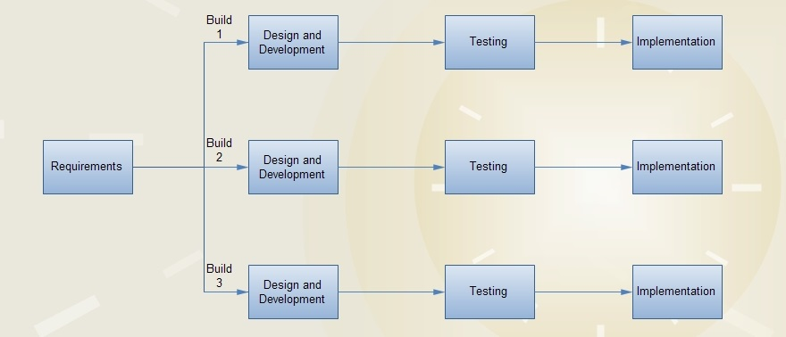

**Incremental Model**

Iterative and Incremental development is a combination of both iterative design or iterative method and incremental build model for development. "During software development, more than one iteration of the software development cycle may be in progress at the same time." and "This process may be described as an "evolutionary acquisition" or "incremental build" approach."

In incremental model the whole requirement is divided into various builds. During each iteration, the development module goes through the requirements, design, implementation and testing phases. Each subsequent release of the module adds function to the previous release. The process continues till the complete system is ready as per the requirement.

The key to successful use of an iterative software development lifecycle is rigorous validation of requirements, and verification & testing of each version of the software against those requirements within each cycle of the model. As the software evolves through successive cycles, tests have to be repeated and extended to verify each version of the software.

## 3.3 Iterative Model Application

Like other SDLC models, Iterative and incremental development has some specific applications in the software industry. This model is most often used in the following scenarios:

Requirements of the complete system are clearly defined and understood.

Major requirements must be defined; however, some functionalities or requested enhancements may evolve with time.

There is a time to the market constraint.

A new technology is being used and is being learnt by the development team while working on the project.

Resources with needed skill set are not available and are planned to be used on contract basis for specific iterations.

There are some high risk features and goals which may change in the future.

## 3.4 Iterative Model Pros and Cons

The advantage of this model is that there is a working model of the system at a very early stage of development which makes it easier to find functional or design flaws. Finding issues at an early stage of development enables to take corrective measures in a limited budget.

The disadvantage with this SDLC model is that it is applicable only to large and bulky software development projects. This is because it is hard to break a small software system into further small serviceable increments/modules.

The following table lists out the pros and cons of Iterative and Incremental SDLC Model:

|  |  |
| --- | --- |
| **Pros** | **Cons** |
| Some working functionality can be developed quickly and early in the life cycle. | More resources may be required. |
| Results are obtained early and periodically. | Although cost of change is lesser but it is not very suitable for changing requirements. |
| Parallel development can be planned. | More management attention is required. |
| Progress can be measured. | System architecture or design issues may arise because not all requirements are gathered in the beginning of the entire life cycle. |
| Less costly to change the scope/requirements. | Defining increments may require definition of the complete system. |
| Testing and debugging during smaller iteration is easy. | Management complexity is more. |
| Risks are identified and resolved during iteration; and each iteration is an easily managed milestone. | End of project may not be known which is a risk. |
| Easier to manage risk - High risk part is done first. | Highly skilled resources are required for risk analysis. |
| With every increment operational product is delivered. | Not suitable for smaller projects. |
| Issues, challenges & risks identified from each increment can be utilized/applied to the next increment. | Projects’ progress is highly dependent upon the risk analysis phase. |
| Risk analysis is better. |  |
| It supports changing requirements. |  |
| Better suited for large and mission-critical projects. |  |
| During life cycle software is produced early which facilitates customer evaluation and feedback. |  |
| Initial Operating time is less |  |

### A. Basic Principles:

Various methods are acceptable for combining linear and iterative system development methodologies, with the primary objective of each being to reduce inherent project risk by breaking a project into smaller segments and providing more ease-of-change during the development process:

1. A series of mini-Waterfalls are performed, where all phases of the Waterfall development model are completed for a small part of the system, before proceeding to the next increment; OR
2. Overall requirements are defined before proceeding to evolutionary, mini-Waterfall development of individual increments of the system, OR
3. The initial software concept, requirements analysis, and design of architecture and system core are defined using the Waterfall approach, followed by iterative Prototyping, which culminates in installation of the final prototype (i.e., working system).

### B. Phasing:

#### Planning Requirements Incremental Development usually has a short list of requirements that need to be defined and then quickly converted into test / use cases.

#### **Analysis and Design**

In software development, still come after gathering user requirements. Based on these requirements, there will be use cases developments to determine the different persona and roles individuals who interact with the system play. From the use cases the general workflows the application is to encompass will be determined and represented in form of data flow diagrams. The next stage of the design phase is to design screen mock ups of the User interface. Testing will be carried out concurrently and each stage is iterated incase new requirements are brought to light.  
Due to the smaller requirement set and shorter design cycle it is important to quickly build test cases from the requirements so that the increment / component can be delivered on time when complete.   
As projects progress and new increments are created the design phase is the time to assess impact and risk of new features, link existing Test Cases to requirements, and create and improve the regression suite.

#### **Implementation and Deployment**

With the Incremental methodology it is generally easier to test and debug than other methods of software development because relatively smaller changes are made during each increment. This allows for more targeted and rigorous testing of each element within the overall product.

Using the Incremental methodology even after the first increment the expectation that a product is ready and can be implemented. This means that all requirements must be tested and passed. As mentioned in the design phase you can link Test Cases to Requirements to establish coverage; however, you can also use a simple approach of testing all Test Cases directly, or organizing your Test Cases in folders for testing.

#### **Testing**

Testing is a fundamental aspect at each stage of development. There will be verification and validation of deliverables at each stage. These tests will be established during requirement gathering stage.

For the modules and final application, the metric that will be tested include; performance, scalability, validity, correctness and robustness. There will be both white-box (end to end test) as well as black box tests (unit tests).  
After each increment, regression testing should be conducted. During this testing, faulty elements of the software can be quickly identified because few changes are made within any single increment.

Usually Incremental projects test against a specific build during a single testing cycle; however, some development groups allow for multiple builds within a cycle (e.g. if the last build failed the smoke test and needed to be rebuilt).

To make a truly Online Doctor System to have meet with online doctors, all manual process has been automated through this system. Patient have to fill online form by which id and password created and sent to their email and upon accepting data, automatic login to patient panel. Through this panel, patients can select the doctors and have appointment with them on their time from their own place. Patients will get all their reports and medicine prescriptions in their inbox by notification indication just after appointment session. There is no need of cash and a secure payment gateway has been used to pay the required fees using their account or debit or credit card.

## 3.5 Modules

These are the core modules that will be implemented in the system.

1. Patient Form and Login Module.
2. Online Appointment Module.
3. Medicine Module.
4. Referral Module.
5. Payment Module.
6. Online Reports Module.
7. Interaction Module.

### a. Patient Form and Login Module

For the first time visitors, they have to just enter their basic details and can enter their dashboard. System will take care of creating their new profile. For existing patients, they will have to enter their id and password sent to their email earlier. This module will like virtual office from where all activity can be performed.

### b. Online Appointment Module

Through this module, patients can select doctors and have discussion regarding their health problems. Patients will able to get their availability time or choose from the available ones and start their diagnosis immediately.

### c. Medicine Module

This module will provide details of medicines which should be taken by the patients. It will also include the limit up to which these medicines should be taken and date to have meet again with doctors.

### d. Referral Module

Referral module will allow patients to change their doctors. For this process, patients have to click on the doctor name whose request will be made available to particular doctor inbox and provide their meeting time.

### e. Payment Module

Patients will have to make their payment online to take services using this system. Each doctors will have some fees which need to pay before their appointment session begins.

### f. Online Report Module

Patients can get their lab results and health reports through this section. When documents are available under this module, a special notification symbol appears above it which helps to notify their patients. Thus it provide relieve to patients for carrying these from here and there.

### g. Interaction Module

Patients will be able to interact with doctors on a one-to-one basis by either text, audio or video calls. This saves time and helps solve minor issues.

## 3.6 Business logics

·   There should be doctor for each department.

·   The mail to the related diseases should reach a valid department mailbox.

·   Every online activity must be charged by wire transfer.

**Chapter 4**

**SYSTEM ANALYSIS AND DESIGN**

# SYSTEM ANALYSIS

System analysis involved the evaluation of current existing systems as well as the gathered requirements to ascertain whether it met the user’s current and projected needs. It was consequently used to determine specification of the system. This was done by studying the information domain and the required function, behavior, performance and interfacing. The need for an efficient, simple and usable web application for citizens was established by analyzing the current needs of patients and by studying the already existing mode of operation for hospitals.

System analysis very important during the development of a system. This is because

1. Allows us to determine how the system operates and gives a problem breakdown structure (PBS).
2. It is the stage at which the requirements of a system are gathered from those meant to use the system or other relevant sources, and determine how **people, data, processes** in the system interact and lead to the accomplishment of the overall functioning of the system as required by the user

Systems analysis involves three main stages:

* Determining the requirements of the system.
* Structuring the requirements.
* Selecting the best alternative design strategy.

### 4.1 FEASIBILITY ANALYSIS

This is an analysis of the system viability, one of the ways of assessing system viability is cost benefit analysis of the system.

#### **ECONOMIC FEASIBILITY**

This is investigating whether the economic benefits derived from the system out-weight the costs that accrue as a result of running the system. Since the system leverages web technology and digital money transfer hence automating most of business processes it was found out to be cost efficient system to deploy.

#### **TECHNOLOGICAL FEASIBILITY**

This investigates whether the project meets the current technological advances. The OMC platform leverages web technology which is currently being highly adopted globally. It also utilizes e-commerce with focus on mobile fund transfer which is currently widely utilized and adopted among the public. Hence these make the project technologically feasible.

#### **TECHNICAL FEASIBILITY**

This study involves checking the system interaction with other systems and the availability of the hardware, software and personnel for building and running of the system. These technologies are readily available.

#### **OPERATIONAL FEASIBILITY**

This study involves checking what changes need to be introduced in users work flows and how to manage the changes as they adopt new technology. Patients would need to create business profiles on the OMC platform, and make appointments over the platform as well as make repayments across the platform. The same would be required for doctors.

#### **TIME FEASIBILITY**

The duration giving for the development of the system is 4 months. In this time all objectives stated for the app will be met. This was due to the methodology that was chosen to build the app.

### 4.2 REQUIREMENTS ANALYSIS

**Requirements elicitation** is the practice of collecting the requirements of a system from users, customers and other stakeholders. The practice is also sometimes referred to as **requirements gathering**.

These techniques may be:

1. One-on-one interviews
2. Questionnaires
3. Prototyping
4. Brainstorming

This phase was concerned on how the requirements will be represented in terms of technical specification which in turn resulted to the logical design of the system. In requirement specification it involved using the results of problem domain analysis to define the functional and non-functional requirements.

#### **A FUNCTIONAL REQUIREMENTS**

The system should meet the following functional requirements:

* Patients and doctors should be able to register as users
* Patients should be able to create an accurate profile on the system
* Patients should be able to apply for an appointment and track it in terms of money paid, and remittances made based on impromptu rescheduling or any other unforeseen circumstances.
* Doctors should be able view patient records
* Doctors should be able to interact with the patients at the arranged time.

#### **B NONFUNCTIONAL REQUIREMENTS**

These requirements are not the core functionary of the system. However, they play a role in ensuring a better presentation of functional requirements. The system should meet the following non-functional requirements:

* Accuracy: e.g. the system should be able to properly authenticate different users as well as data representation.
* Speed and robust: the system should operate at optimal speed and implementation should consider lack of or poor internet connection.

### 4.3 Conceptual Model

This represents a high level representation of overall system architecture:

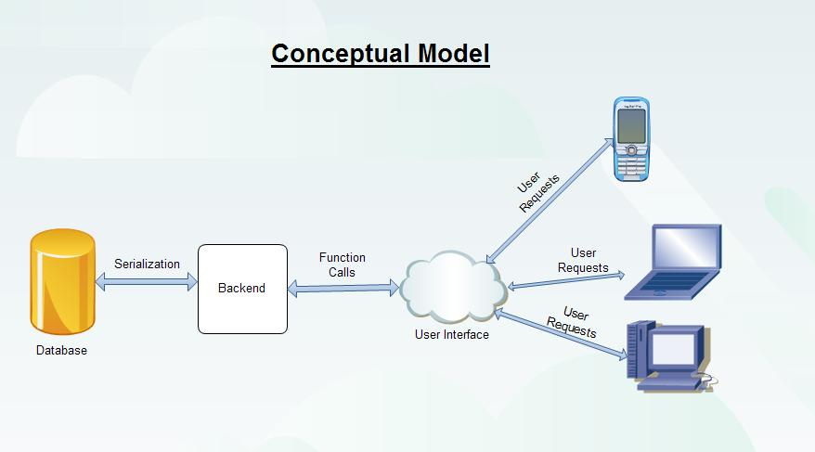

This diagram shows the nature of operation within the system. System users view data on the graphical user interface that has been processed using scripts in the server, calling on various functions that pull data from the database. All transactions using an MVC(Model-View-Controller) framework make it very secure because no scripts are visible and all that can be accessed as far as scripts are concerned are the pull statements which remain at the developers’ discretion.

### 4.4 Use Case Diagrams

A use case: Is a collection of task-related activities describing a discrete part of a system. Describes a set of actions sequences that a system performs to present an observable result to an actor Describes a system from an external usage viewpoint.

Key attributes of a use case:

1) Description;

2) Action sequence;

3) Includes variants;

4) Produces observable results

The use case diagram was drawn to design a representation of the functional requirements of the application (what the system is required to do). It was drawn to graphically depict the interactions between the system and external systems and users. The main activities that were represented include;

* A patient using the logging in and viewing doctor biography and other relevant information.
* A system administrator being able to manage their users and also transaction information.
* Doctor and patients interacting through chosen means i.e. video call, audio chat or online text messaging.

Consider the diagrams below:

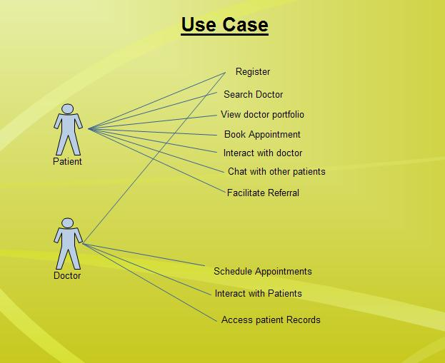

**Figure 4.41: The User Use Case**

This use-case shows the key features that the user and the doctor can access on the site. The patient can register him/her-self and once that is completed, he/she can search for doctors in relation to their areas of specialization, view their biographies and work history, schedule appointments and begin live interactions with them as long as they have paid beforehand.

The doctors on the other hand will be registered by the system administrator(s) after proper vetting. Once that is done, they only need to update their appointment schedules and begin interacting with patients. They can also view their patients’ records.

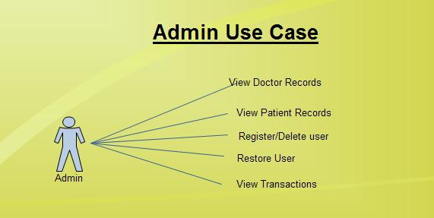

**Figure 4.42: The Admin Use Case**

This use-case is pertaining to the administrator who plays a vital role in the system. The administrator is the only one who can register a new doctor. The administrator is also able to access patient records if need be. The administrator also has the rights to delete a user or restore a user back to the system, should there be viable cause to do so. The system administrator also has a panel that lets him/her see the system statistics (i.e. the number of users, transactions etc.)

### 4.5 Data Flow Diagram

DFDs are used to illustrate the process that capture, manipulate, store and distribute data between the system and its environments and among system components. They model how data flows through the system.

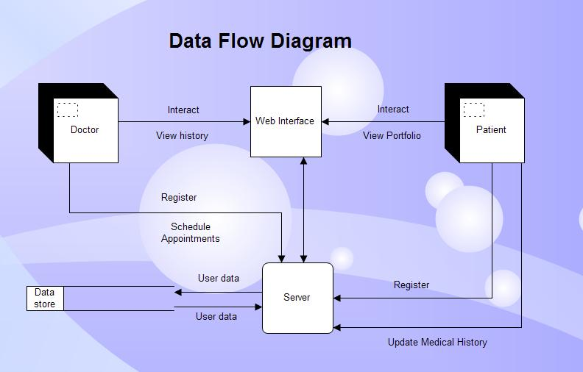

**Figure 4.5: Data Flow Diagram**

This data flow diagram shows the general flow of data throughout the system. It all begins with the user logging in either as a patient or doctor. One inputs their personal username and password and logs in after data has been verified with the store data in the database. Once that is done, from a patient’s interface, he/she initiates data retrieval from the database on the doctors available given their area of specialty. From a doctor’s interface, he/she can pull patient records from the database and view their status. When both interact with the system, there is transfer of patient records, payment transactions as well as medical history data.

### 4.6 Activity Diagram

The activity diagram was drawn to determine the flow of events/activities between system administrators, doctors and patients. What activities can the system administrators, doctors and patients perform and what are the outcomes.

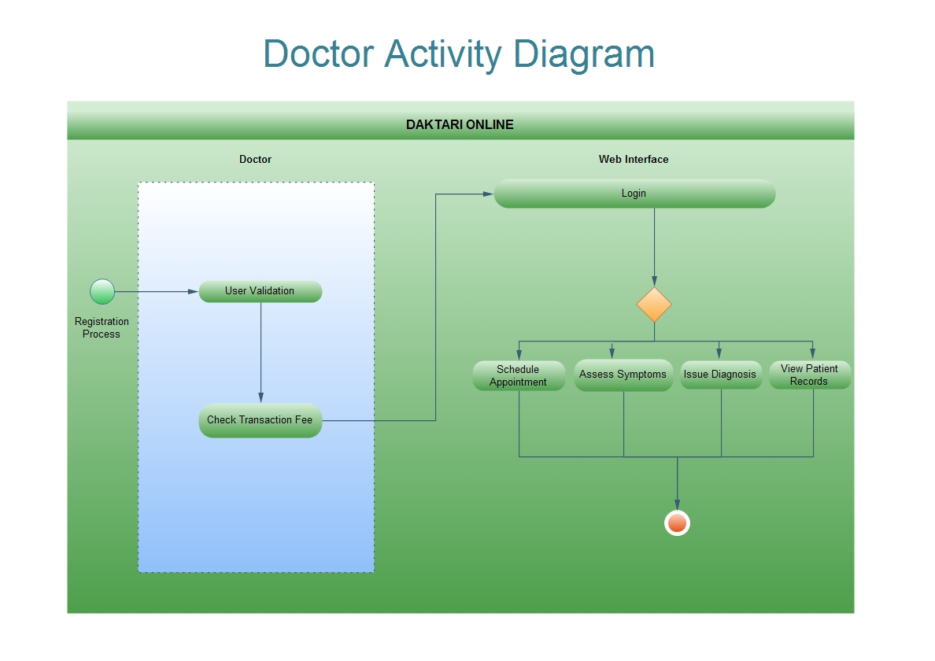

**Figure 4.61: Doctor Activity Diagram**

This doctor’s activity diagram displays a list of activities that are performed by the doctor when he/she logs on to the site. The activities include:

1. Scheduling appointments
2. Interacting with patients
3. Assessing symptoms either by video, use of pictures or by dialogue with the patient
4. View patient records to determine their medical history so as to issue proper diagnosis
5. Issue a diagnosis with a proper follow-up

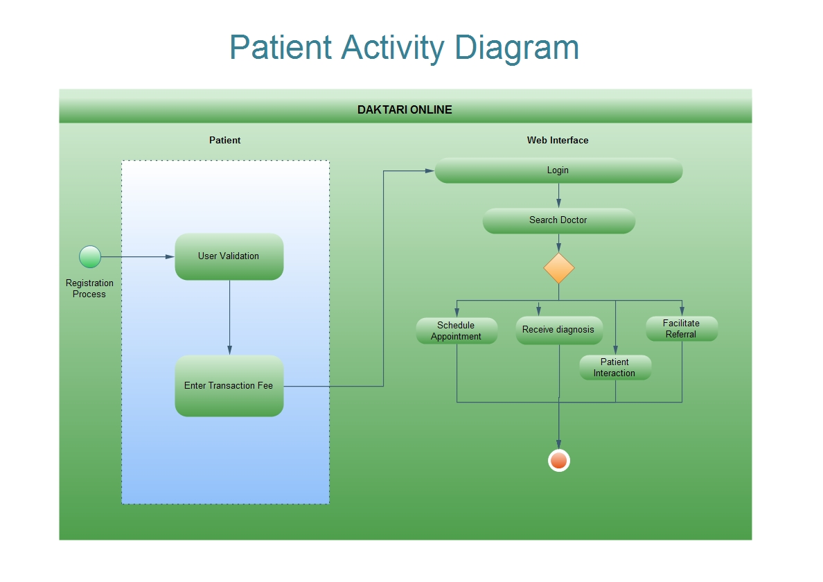

**Figure 4.62: Patient Activity Diagram**

This patient’s activity diagram displays a list of activities that are performed by the patient when he/she logs on to the site. The activities include:

1. Registering
2. Paying a consultation fee
3. Searching for the doctor in regards to his/her illness
4. Schedule an appointment
5. Interacting with doctors live online

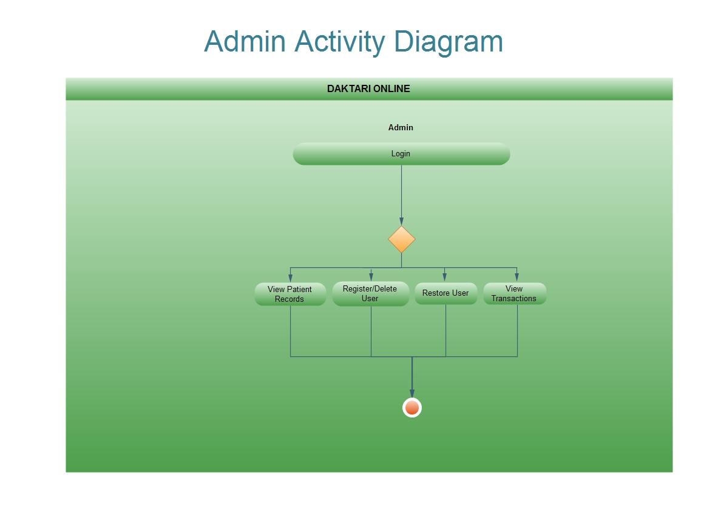

**Figure 4.63 Admin Activity Diagram**

This administrator’s activity diagram displays a list of activities that are performed by the administrator when he/she logs on to the site. The activities include:

1. Registering doctors
2. Viewing patient records
3. Register/delete users
4. Restore users
5. View completed transactions

### 4.7 Sequence Diagram

A sequence diagram shows how various objects interact during a certain period of time. It defines event sequences that result in some desired outcome, that is, what messages are sent between the system objects as well as the order in which they occur. The diagram below conveys this information along the horizontal and vertical dimensions: the vertical dimension shows, top down, the time sequence of messages/calls as they occur, and the horizontal dimension shows, left to right, the object instances that the messages are sent to.

Consider the sequence diagram below;

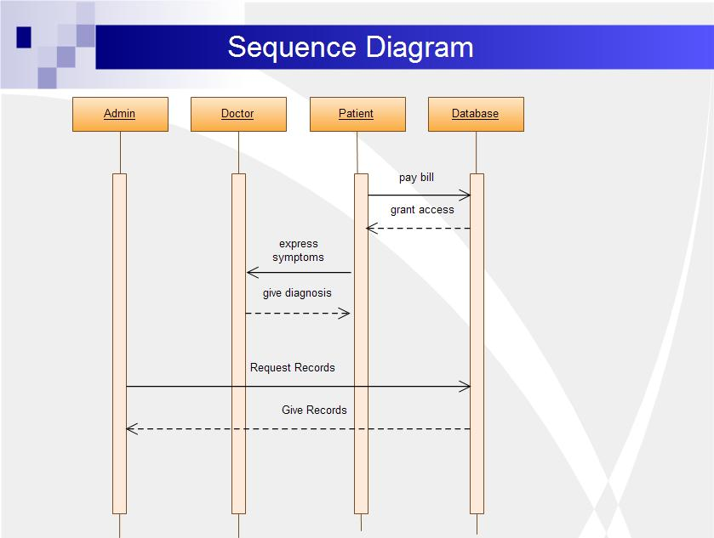

**Figure 4.7: Sequence Diagram**

If the lifeline is that of an object, it demonstrates a role. Leaving the instance name blank can represent anonymous and unnamed instances.

Messages, written with horizontal [arrows](https://en.wikipedia.org/wiki/Arrow_(symbol)) with the message name written above them, display interaction. Solid arrow heads represent synchronous calls, [open arrow heads](http://i.stack.imgur.com/PO1pz.png) represent [asynchronous messages](http://www.uml-diagrams.org/sequence-diagrams.html), and dashed lines represent reply messages. If a caller sends a synchronous message, it must wait until the message is done, such as invoking a subroutine. If a caller sends an asynchronous message, it can continue processing and doesn’t have to wait for a response. Asynchronous calls are present in multithreaded applications and in [message-oriented middleware](https://en.wikipedia.org/wiki/Message-oriented_middleware). Activation boxes, or [method](https://en.wikipedia.org/wiki/Method_(computer_science))-call boxes, are opaque rectangles drawn on top of lifelines to represent that processes are being performed in response to the message (Execution Specifications in UML).

Objects calling methods on themselves use messages and add new activation boxes on top of any others to indicate a further level of [processing](https://en.wikipedia.org/wiki/Process_(computing)). If an object is [destroyed](https://en.wikipedia.org/wiki/Object_lifetime) (removed from [memory](https://en.wikipedia.org/wiki/Computer_storage)), an X is drawn on top of the lifeline, and the dashed line ceases to be drawn below it. It should be the result of a message, either from the object itself, or another.

A message sent from outside the diagram can be represented by a message originating from a filled-in circle (*found message* in UML) or from a border of the sequence diagram (*gate* in UML).

### 4.8 Entity Relationship Diagram

An ERD is used to depict the design of the database. It is a data modeling technique used to create a graphical representation of entities, their attributes and the relationships between them in an information system. Entity refers to an object, a place, a person or an event for which data is to be collected; relationship is the interaction between the entities whereas attributes are the data we collect about the entities.

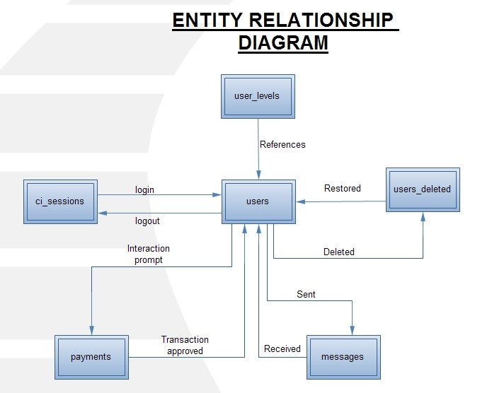

**Figure 4.8: Entity Relationship Diagram**

Here is the design an Entity Relationship (ER) model for the systems database. Say we have the following entities:

1. Administrator(s)
2. Doctor(s)
3. Patient(s)

# SYSTEM DESIGN

Systems design is the process of defining the architecture, components, modules, interfaces, and data for a system to satisfy specified requirements. The purpose of system design is to prepare you for the implementation it allows you to model how your system will function on paper before implementation begins.

Conceptual design can be divided into two parts: The **data model** and the **process model**. The data model focuses on what data should be stored in the database while the process model deals with how the data is processed. To put this in the context of the relational database, the data model is used to design the relational tables. The process model is used to design the queries that will access and perform operations on those tables.

## 4.9: Data Model

A data model can be thought of as a diagram or flowchart that illustrates the relationships between data.   
This is a conceptual representation of the data structures that are required by a database. The first step in designing a database is to develop an Entity-Relation Diagram (ERD). The ERD serves as a blue print from which a relational database maybe deduced.

## 4.10: Database Design

Database design is the process of producing a detailed data model of a database. This logical data model contains all the needed logical and physical design choices and physical storage parameters needed to generate a design in a Data Definition Language, which can then be used to create a database. A fully attributed data model contains detailed attributes for each entity.

#### **Database Schema**

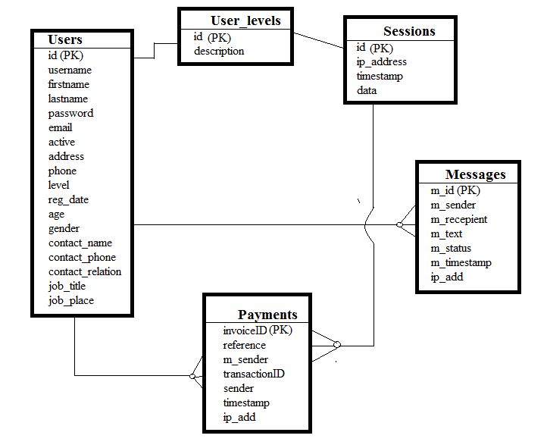

## 4.11: Table Design

#### **a. Sessions Table**

This is the table where all the sessions will be stored.

|  |  |  |  |  |
| --- | --- | --- | --- | --- |
| **Column** | **Type** | **Null** | **Default** | **Comments** |
| id | varchar(40) | No |  |  |
| ip_address | varchar(45) | No |  |  |
| timestamp | int(10) | No | 0 |  |
| data | blob | No |  |  |

#### **b. Messages Table**

This table shows where all the messages will be stored.

|  |  |  |  |  |
| --- | --- | --- | --- | --- |
| **Column** | **Type** | **Null** | **Default** | **Comments** |
| m_id | int(5) | No |  |  |
| m_sender | varchar(10) | No |  |  |
| m_recepient | varchar(10) | No |  |  |
| m_text | text | No |  |  |
| m_status | int(1) | No | 0 |  |
| m_timestamp | timestamp | No | CURRENT_TIMESTAMP |  |
| ip_add | varchar(100) | No |  |  |

#### **c. Users Table**

This table shows where all the users will be stored.

|  |  |  |  |  |
| --- | --- | --- | --- | --- |
| **Column** | **Type** | **Null** | **Default** | **Comments** |
| id | int(12) | No |  |  |
| username | varchar(255) | No |  |  |
| firstname | char(100) | No |  |  |
| lastname | char(100) | No |  |  |
| password | char(32) | No |  |  |
| email | varchar(100) | No | N/A |  |
| active | tinyint(1) | No | 1 |  |
| address | varchar(100) | No | N/A |  |
| phone | varchar(20) | No | N/A |  |
| level | int(1) | No | 3 |  |
| reg_date | timestamp | No | CURRENT_TIMESTAMP |  |
| age | int(3) | No | 0 |  |
| gender | varchar(7) | No | Male |  |
| contact_name | varchar(250) | No | None |  |
| contact_phone | varchar(20) | No |  |  |
| contact_relation | varchar(50) | No |  |  |
| job_title | varchar(250) | No | N/A |  |
| job_place | varchar(250) | No |  |  |

#### **d. Payments Table**

This table shows where all the payment transactions will be stored.

|  |  |  |  |  |
| --- | --- | --- | --- | --- |
| **Column** | **Type** | **Null** | **Default** | **Comments** |
| invoiceID | int(11) | No |  |  |
| reference | text | No |  |  |
| m_sender | text | No |  |  |
| transactionID | varchar(100) | No |  |  |
| sender | int(4) | No |  |  |
| timestamp | timestamp | No | CURRENT_TIMESTAMP |  |
| ip_add | varchar(20) | No |  |  |

## 4.12 Interfaces

The following are some of the front-end designs, simulating a patient using the system:

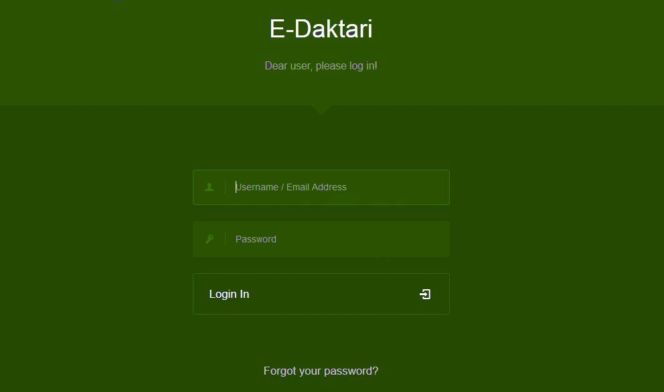

**Figure 4.91: Login Form**

The diagram above shows the login page. This is the first page users find when they log onto the site.

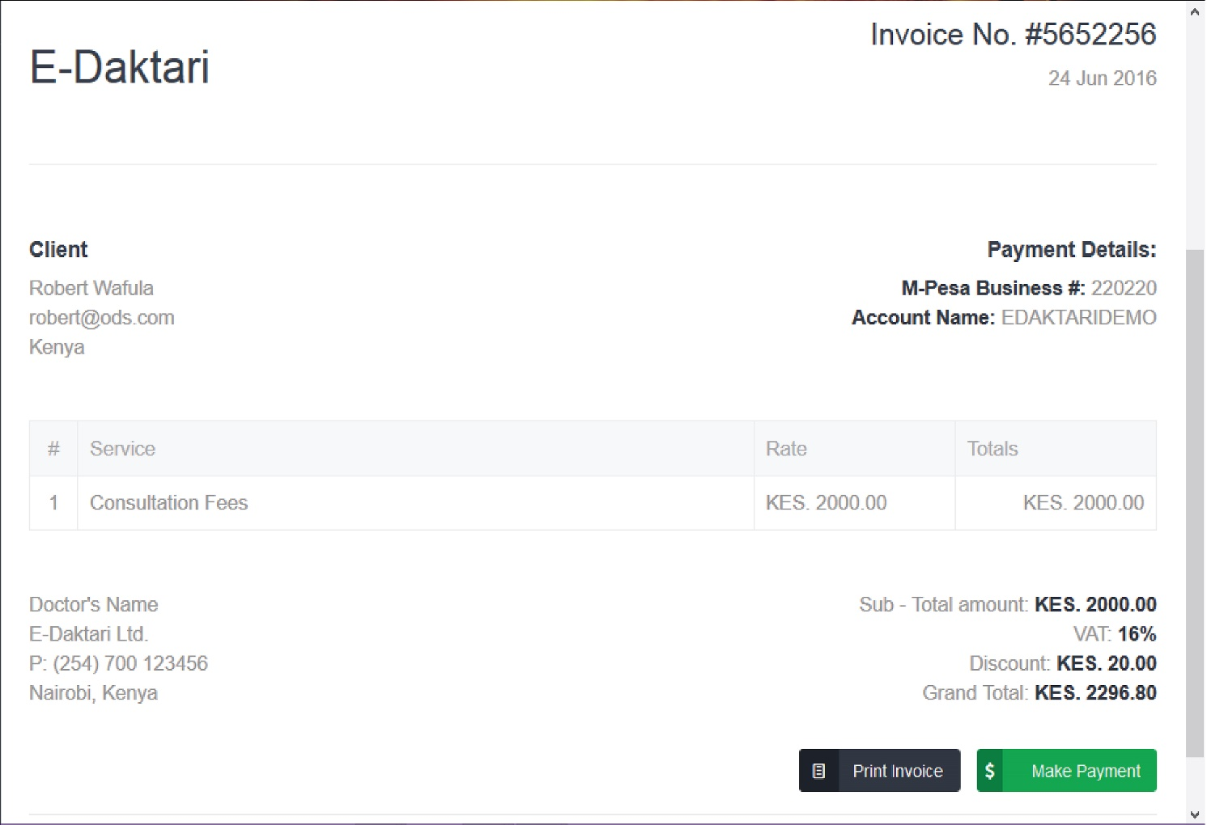

**Figure 4.92: Payment Invoice**

The diagram above shows the payment invoice. This page occurs when a user tries connecting to a doctor without prior payment. He/she is then redirected to this page where he/she can pay immediately so that the consultation can begin.

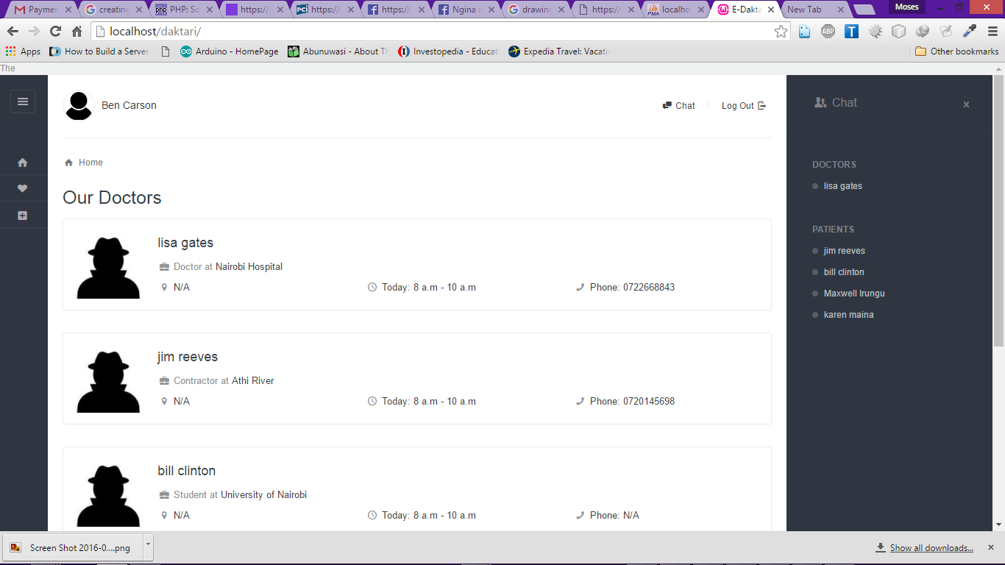

**Figure 4.93: Admin Search Panel**

The diagram above shows the Admin. This page occurs when a admin tries searching for a specific site user. Note that the admin can view both doctors and patients.

**Chapter 5 - IMPLEMENTATION**

## RESOURCES

### 5.1 Hardware equipment

* Computer  (with at least 1GB ram, 2 GHZ, 20gb hard disk).

### 5.2 Software Requirements

* Netbeans IDE
* Wamp Server.
* Gantt Project for project management.
* Windows operating system for development and testing.
* JavaScript, CSS 3, HTML 5, PHP.

### 5.3 Services

* Internet connection.

## TESTING

Testing is an important part of system development. It involves any activity aimed at evaluating  
an attribute or capability of a program or system and determining that it meets its required  
results. Testing was carried out with an aim is to find the errors in a system as well as getting  
feedback on usability. The following test techniques were carried out.

The most important aspect in Daktari Online is the user restrictions and form validations.

### Choice of programming tools

#### **PHP**

Compared to other languages and especially compared to web frameworks, PHP is lower level, less abstract, and more transparent.

* Easy for beginners to pick up
* Can be hosted nearly everywhere.
* By default there is a 1-1 correspondence between URLs and files, making it easy for designers, programmers, and other team members to edit and create pages.
* Scaling PHP is relatively common knowledge.
* Easy to deploy: just copy the files (or if you are more sophisticated, *rsync* the files, *svn up* the files, or *git pull* the files)
* Has frameworks with a relatively easy learning curve
* Documentation is excellent
* Easy to outsource development - there are many coders around the world willing to code PHP inexpensively
* If you are creating software that needs to be deployed to a wide variety of hosting environments (such as Wordpress or forums) PHP is the lingua franca of web hosting companies and will work nearly everywhere.
* PHP has a selection of decent CMS's such as Drupal, Expression Engine and Wordpress
* PHP runs in separate isolated processes within Apache so it is very difficult for any one process to bring down the entire web server.  If anything goes wrong, there is minimal effect because PHP's state is completely reset at the beginning of each request.  This ends up being more reliable than systems that use long-lived processes that handle many requests.

#### **Node js**

As an asynchronous event driven JavaScript runtime, Node is designed to build scalable network applications. In the following "hello world" example, many connections can be handled concurrently. Upon each connection the callback is fired, but if there is no work to be done Node is sleeping.

const http = require('http');

const hostname = '127.0.0.1';

const port = 3000;

const server = http.createServer((req, res) => {

res.statusCode = 200;

res.setHeader('Content-Type', 'text/plain');

res.end('Hello World\n');

});

server.listen(port, hostname, () => {

console.log(`Server running at http://${hostname}:${port}/`);

});

This is in contrast to today's more common concurrency model where OS threads are employed. Thread-based networking is relatively inefficient and very difficult to use. Furthermore, users of Node are free from worries of dead-locking the process, since there are no locks. Almost no function in Node directly performs I/O, so the process never blocks. Because nothing blocks, scalable systems are very reasonable to develop in Node.

#### **Javascript**

JavaScript (JS) is an interpreted computer programming language. It was originally implemented as part of web browsers so that client-side scripts could interact with the user, control the browser, communicate asynchronously, and alter the document content that was displayed.

This language is used for verification in the login and sign up pages.

#### **MYSQL open source database management system**

Mysql is an open source data base management system. This eliminated the need to have enterprise data base systems such as windows sql server.

Mysql has little demand for memory space hence can be used on a machine with minimal disk capacity e.g 10gb.

Mysql was chosen for the following reasons.

* Up to 90% Lower TCO vs. Microsoft SQL Server 2012
* Performance & Scalability
* Ease of Use & Administration
* Reliability
* Broad Platform support
* Integration into the Windows Environment

**Chapter 6 - CONCLUSION**

## 6.1: Discussion

The application and portal development concluded successfully and at the end of the development term was able to delineate potential to meet the objectives set at the inception of its development. The resulting application was both easy to use and contained useful features. Since the application was built using codeigniter framework it can easily be ported to other platforms without diminishing in quality. The portal is both simplistic in design and easy to use. The portal has achieved its goals in patient and doctor management while also offering a way to update records for payment transactions. Finally, Daktari Online as a whole is able to bring about convenience to the health sector and accurate information to the citizens.

#### **Social Implications**

The arrival of e-commerce has caught the health sector unprepared and without existing conventions. Innovators have adopted electronic medical consultation at a pace that has surpassed the formalization of any frameworks or guidelines. This situation has engendered a developmental environment that is relatively unfettered by any of the standards usually applied to a new form of treatment or service.

It is likely that protocols and guidelines will evolve as emerging trends and patterns become more obvious or pressing. However, because of a significant gap in the literature related to social impacts (particularly empirical work), predictions put forward continue to be speculation. There are several relevant potential social effects of e-health, including issues related to equity, consumerism, and altered relationships.

#### **Equity**

Most national health systems should develop equity policies for electronic medical consultation. Although Internet connections are very accessible in New Zealand, computing resources should be made available to the consumer to ensure equity. The profile of the Internet-enabled consumer is significantly skewed to higher socio-economic and better educated segments. Therefore, patient-initiated e-mail consultation may have entry barriers. As well as access to resources, the user must have adequate language abilities, literacy, and technical knowledge. These requisites give several groups, such as ethnic minorities, older persons, the poor, and people with literacy problems, a potential equity disadvantage with regard to electronic healthcare options. Some of these may be within. Eysenbach highlighted this point in his discussion of a potential widening gap between privileged "Internet-able" populations and underprivileged populations that will not be able to participate in Internet-distributed healthcare. However, electronic consultation can also offer significant benefits to some groups that are arguably disadvantaged in traditional models of healthcare. Telemedicine supplied to rural areas, for example, could dramatically reduce costs incurred in transfer to specialist care and improve speed of access.

Public policy will eventually need to address these issues in the longer term, particularly as public health systems move toward greater use of e-health initiatives. This task may require the eventual supply of resources to selected individuals or groups, such as the provision of community Internet kiosks or centers. Or, as some have suggested, provision might be made through a contact person, such as a community nurse, who has access to the Internet.

#### **Consumerism**

Information technology gives patients access to a wealth of knowledge and information. An informed patient can participate more actively in healthcare decisions. This circumstance may, however, lead to a situation in which providers find themselves faced with more aggressive and demanding patients, who require more time and explanation. It may be difficult to meet these needs within the usual length of commentary supplied in e-mailed responses. It may also be time-consuming to compile and find additional information to attach as an accompanying file or document.

Online medical consultation services may be designed for patients who have an established relationship with a provider or, alternatively, may be offered as a means of attracting business. Egger suggested that when patients indicated that access to their doctor by e-mail was important to them, then doctors would consider introducing e-mail into their practices. Hence, it is feasible that offering this service could give future competitive advantage to a health practice.

The Internet has opened up new opportunities for financial gain. In the space of only a few years there has been a burgeoning number of both small and large e-health providers responding to the demands of a new wave of consumer-driven healthcare seekers. It is now possible for healthcare suppliers to create revenue regardless of physical location and even to offer niche services on a global basis.

#### **Provider-Patient Relationships**

The extent to which consultation over the Internet will change the patient-provider relationship is unclear. Stevens compared the social impact of the Industrial Revolution with that of information technology. Just as the Industrial Revolution ultimately re-ordered traditional relationships, such as how children related to parents or men related to women, the Internet may likewise radically redefine traditional models. It seems likely that the evolution of styles and frameworks will be one response to the many aspects that communication technology brings to the context.

Historically, a patient base comprised those who lived or worked near a health practice. The Internet now provides the healthcare seeker with the opportunity to decide where to get information. This information may be from a provider far from the patient's locality. A patient may even approach a provider from a different country who is considered to be a leading expert within a particular field.

The adoption of online medical consultation is by no means the only factor that will influence how patients and practitioners interact in the future. Other forces that will have an impact on this interaction include the vast array of information available through Web sites; the increasing financial imperatives to contain costs; and the new generations of software and hardware that enable increasingly sophisticated systems of interaction, for example, SendTalk, PowerTalk, and video-streaming through NetMeeting.

When entering into an online consultation with an unknown online provider, patients will need to take on more responsibility for their treatment. Without the usual tangible evidence that bricks and mortar supply, patients will potentially be exposed to more risk and will have to invest extra time and effort into researching questions to ask providers, assessing quality of responses, and coordinating their own healthcare. "Surfing" providers and the use of advice in a piecemeal fashion also pose significant risks to patients. Currently, it seems unlikely that a provider would happily become involved in cases where multiple consultation and treatment trial are being undertaken, but in the future this practice might be normal.

#### **Legal and Ethical Issues**

At present there is no special legislation in Kenya that covers electronic consultation. E-commerce laws are currently under review. These laws will be of a general nature and will need to be adapted to cover e-health.

## 6.2 Project Limitation

Despite the success of the application, some minor but grave challenges were discovered. Among them was the cross browser compatibility issue involved in processing JavaScript commands. This made it very difficult in establishing a video call.

Due to lack of enough labour it was impossible to cover many fields. As a result Daktari Online at the time of this presentation covers approximately five areas of doctors’ specialisation.

## 6.3 Suggestion for further work

The application can be easily expanded to cover all specialization areas in Nairobi and not just from the CBD area. It’s possible to also cover areas outside Nairobi and hospitals at different provinces. Another expansion for this application would be to bring about concierge medicine to the country which would help make many physicians self-employed and help de-congest hospitals as it stands.

## References

Adamson, S. C. & Bachman, J. W. (2010): Pilot study of providing online care in a primary care setting. *Mayo Clinic Proceedings,* Elsevier, 704-710.

Albert, S. M., Shevchik, G. J., Paone, S. & Martich, G. D. (2011): Internet-based medical visit and diagnosis for common medical problems: experience of first user cohort. *Telemedicine and e-Health*, **17**:304-308.

ATA, A. T. A. (2012): What is Telemedicine? [Online]. American Telemedicine Association. Available: http://www.americantelemed.org 2014.

Bailey, R. A. (2011): Legal, Financial, and Ethical Implications of Online Medical Consultations, *The. J. Tech. L. & Pol'y*, **16**:53.

Blair, R. (2006): Phone-free virtual visits. Aetna covers online doctor-patient communication for insured members in Florida and California. *Health Management Technology*, **27**:24.

Braverman, J. & Samsonov, D. V. (2011): A study of online consultations for paediatric renal patients in Proceedings of the 8th Australasian Workshop on Health Informatics and Knowledge Management (HIKM 2015), Sydney, Australia, 27 - 30 January 2015 99 Russia*. Journal of telemedicine and telecare*, **17**:99-104.

Brockes, C., Brockes, J., Schenkel, R., Buehler, K., Gratz, S. & Schmidt, W. (2012): Medical online

consultation service regarding maxillofacial surgery. *Journal of cranio-maxillo-facial surgery*, **40**:626-630.

Deldar, K., Marouzi, P. & Assadi, R. (2011): Teleconsultation via the web: an analysis of the type of questions that Iranian patients ask. *Journal of telemedicine and telecare*, **17**:324-327.

Drop, S. L. S., Mure, P.-Y., Wood, D., El-Ghoneimi, A. & Faisal Ahmed, S. (2012): E-consultation for DSD: a global platform for access to expert advice. *Journal of pediatric urology*, **8**:629-32.

Dudas, R. A., & Crocetti, M. (2013): Pediatric caregiver attitudes toward email communication: survey in an urban primary care setting. *Journal of Medical Internet Research*, **15**(10).

Friedman, C. P. (2009): A “fundamental theorem” of biomedical informatics. *Journal of the American Medical Informatics Association*, **16**:169-170.

Garrett, C., Garrett, J., Hocking, M., Chen, C., Fairley, M. & Kirkman. (2011): Young people's views on the potential use of telemedicine consultations for sexual health: results of a national survey. *BMC infectious diseases*, **11**:285.

George, C. & Duquenoy, P. (2005): Online Medical Consultations: Are We Heading in the Right Direction. Ethicomp 2005, Looking Back to the Fufz~re, *Linkoping University*, Linkoping, Sweden, September 2005, 12-15.

Gidwani, N., Fernandez, L. & Schlossman, D. Connecting with Patients Online: E-Visits. Consulting report prepared for the US Department of Family and Community Medicine Academic Health Center Handler, T. J. July (2013): Hype Cycle for Telemedicine

2013 - Healthcare Provider E-Visits. In: GARTNER (ed.). Gartner report.

Howarth, B. (2012): Telehealth trial declared a success. Sydney Morning Herald, 24/7/2014.

Jiwa, M. & Meng, X. (2013): Video Consultation Use by Australian General Practitioners: Video Vignette Study. *Journal of medical Internet research,* 15.

Joseph, B., Hadeed, G., Sadoun, M., Rhee, P. M. & Weinstein, R. S. (2012): Video consultation for trauma and emergency surgical patients. *Critical care nursing quarterly*, **35**:341-5.

Khoja, S., Durrani, H., Scott, R. E., Sajwani, A. & Piryani, U. (2013): Conceptual framework for

development of comprehensive e-health evaluation tool. *Telemedicine and e-Health*, **19**:48-53.

Liddy, C., Rowan, M. S., Afkham, A., Maranger, J. & Keely, E. (2013): Building access to specialist care through e-consultation. *Open Medicine*, **7**:e1.

Lu, H.-Y., Shaw, B. R. & Gustafson, D. H. (2011): Online health consultation: Examining uses of an interactive cancer communication tool by low-income women with breast cancer. *International journal of medical informatics*, **80**:518-528.

Medaglia, R. & Andersen, K. N. (2010): Information systems and healthcare XXXVIII: Virus outbreak─Online GP consultations escalating healthcare costs. *Information Systems*, **11**:1-2010.

Mehrotra, A., Paone, S., Martich, G. D., Albert, S. M. & Shevchik, G. J. (2013): Characteristics of patients who seek care via eVisits instead of office visits. *Telemedicine and e-Health*, **19**:515-519.

Mettner, J. (2009): The doctor is in (your inbox) [Online]. [Accessed August 2014 92]. Available:

http://www.minnesotamedicine.com/Past-Issues/Past-Issues-2009/January-2009/Pulse-Inbox-January-2009.

Moffatt, J., Moffatt, D. & Eley (2010): The reported benefits of telehealth for rural Australians. *Australian health review*, **34**:276.

Moffatt, J. J. & Eley, D. S. (2011): Barriers to the up-take of telemedicine in Australia--a view from providers. *Rural and remote health*, **11**:1581.

NLM 2014. Medical Subject Headings – MeSH Descriptor Data. *National Library of Medicine*.

Padman, R., Shevchik, G., Paone, S., Dolezal, C. & Cervenak, J. (2009): eVisit: a pilot study of a new kind of healthcare delivery. *Studies in health technology and informatics*, **160**:262-266.

Patel, R. N. & Antonarakis, G. S. (2013): Factors influencing the adoption and implementation of

teledentistry in the UK, with a focus on orthodontics. *Community dentistry and oral epidemiology*, **41**:424-431.

RACGP 2012. RACGP wary of rise in virtual consultations between a doctor and unknown patients. *Royal Australian College of General Practitioners*.

Egger E. Market memo: how technology is changing the health care system. Health Care Strateg Manage 2000;18(1).

Stevens L. Changing relationships: how the Web is altering traditional healthcare models [Medicine on the Net Web site]. 2000. p. 6-12   URL: <http://www.mednet-i.com/> [[WebCite Cache](http://www.webcitation.org/query?url=http%3A%2F%2Fwww.mednet-i.com%2F&refdoi=10.2196/jmir.3.1.e13)]

# APPENDIX A: Further Review

If knowledge is power, then content (in proper context) is king. Many doctors now are found online blogging, pushing content through my website and even interacting on Facebook, Twitter, Google+, Pinterest and many other sites because many patients are there. Increasingly, they are utilizing the Internet to self-diagnose; to look for “second opinions” from peers and friends; to research a physician, recommended treatment, or hospital; or to find the latest information on their disease.

Studies suggests that patients forget more than 50 percent of what they are told in the doctor’s office. Add to that misremembering or misinterpretation, and the information holes grow even larger. What happens to the holes when these individuals get home? Research shows that consumers trust the recommendations of [peers or friends](http://www.mediapost.com/publications/article/172180/friends-have-more-credibility-than-brands.html) far above those of any advertisement. And where are people interacting with those friends? Where are they searching? In many instances, online. They are sharing useful information, and this includes health concerns, treatment protocols, and medications. When patients feel they can’t turn to their doctor for answers, pulling information from the Internet is an easy, efficient, and logical choice.

Medicine and healthcare are undergoing [massive changes](http://www.thedoctorblog.com/challenges-in-the-new-healthcare-environment/); more and more regulations and obligations eat into physicians’ clinic time. Reimbursements have dropped, and as a result many doctors have felt they needed to increase their appointment load and decrease the time they spend on each. For patients, that translates to less time with their physician, less learning, more questions, more doubt, and sadly, more fear. Their antidote is Google.

The root word for doctor is “docere,” or “to teach,” and patients are making decisions based on what they read online. Physicians have a moral obligation to be sure that the information they are receiving is accurate. If they do not have the time to teach their patients while they are in the clinic, they need to be present where they are to address their residual questions, hesitancy, and fears (often due to lack of knowledge), and also to aid them through their medical decision-making process. In short, [they need to be active](http://www.thedoctorblog.com/physicians-why-your-future-is-online-and-how-to-own-it/) in producing or curating online medical content to aid their patients.

Doctors often believe that they need to spend hours upon hours coming up with content; they believe there is too much risk involved in “tweeting” or putting a post on Facebook. Yet most studies show that physician content and social media interactions are perfectly appropriate.

We are physicians; our job is to lead patients [toward health](http://www.thedoctorblog.com/creating-health-with-patients/). We owe it to them to be sure that the information they are reading is of the same quality as we would give in our office, or want to get if (or, rather, when) we looked in the mirror and saw a patient staring back.

**Convenience of E-visits**

A number of websites offer face-to-face consultations of the virtual kind to anyone with a credit card and access to a webcam-equipped computer. The services are intended for patients with relatively minor problems that don't require hands-on diagnoses or treatments, not for people who need stitches, MRIs or casts on broken limbs.

But an estimated 50 million times a year, patients go to their doctors for just the sorts of problems these sites are meant to handle, says Dr. Ateev Mehrotra, an associate professor at Harvard. "They're filling a niche."

Some e-visit sites charge per-consultation fees: MedCareLive.com, $45; MeMD, $44.95; Teladoc, $35. Others charge different rates for different services: At Online USA Doctors, single consults start at 99 cents. As for insurance, some plans cover e-visits at some sites, but not all.

Although MedCareLive.com does not contract with any insurance companies, co-founders Dr. David Tashman and nurse practitioner Sigi Marmorstein set out to make their service a good deal — for people who have insurance and people who don't. "We set our price point at $45 for a reason," Tashman says. "Most co-pays run from $30 to $50."

"We want to help people stay away from the ER and urgent care," Marmorstein adds. "We want to save people money."

So far, hard data on e-visits are limited. Mehrotra and colleagues have looked at convenience and cost, though the e-visits they considered were not offered through public sites. Patients in their studies interacted with their own doctors or doctors in the same practice, and for the most part the interactions were not in real time and did not use webcams. Patients described their condition on a questionnaire, and a doctor responded about two hours later on average.

In an article published in July in the journal Telemedicine and e-Health, the researchers found that the greater the convenience of e-visits compared with office visits, the more likely patients were to use them. Patients with urinary tract infections who lived farther than 10 miles away from their doctors were more than three times as likely to use the e-visit option as those who lived five miles or less away. And sinusitis sufferers who lived more than 10 miles away were more than six times as likely to use the e-option as those who lived five miles or less away.

In another paper published in January in JAMA Internal Medicine, the same researchers found evidence that, on a per-visit basis, e-visits generally are cheaper than office visits, let alone trips to the ER. "For anyone with no insurance or with a high deductible, e-visits may be particularly attractive," Mehrotra says. In the big picture, though, the economics become more complicated. Because of the added convenience and lower price of e-visits, "people might use them who otherwise would have stayed at home and not gone for care at all." Such increased healthcare use could be a good thing, he observes, "but it could increase total costs."

http://articles.latimes.com/images/pixel.gif

And how good is the care? Again, data are sparse. In its January study, Mehrota's team found welcome evidence that diagnosis and treatment were equally successful in e-visits and office visits for patients with sinusitis and urinary tract infections. On the other hand, doctors prescribed more antibiotics in e-visits, which could represent an unfortunate trend.

In another potential drawback, Mehrotra says, primary care doctors are encouraged to offer preventive care — e.g., pap smears, cholesterol tests — to their patients at every visit. But in the January study, Mehrotra's team found that doctors were less likely to do so during e-visits than during office visits. .

Overall, more research would seem to be in order, but the January study found that e-visitors are generally happy with the service. Simons and Barzilai are two enthusiastic examples.

And e-usage is growing. "Patients are voting with their feet," Mehrotra says, "or make that their mouse pads."

# APPENDIX B: URLs Accessed

[<http://www.telemedtoday.com/>]

[<http://www.telehealthmag.com/>]

[<http://www.yi.com/mednet99/index.htm>]

[<http://www.askyourdoctoronthenet.com/>]

[<http://www.healthfile.co.uk/>]

[<http://www.hon.ch/Conduct.html>]

[<http://www.mdweb.com/>]

[<http://www.la-doctor.com/main-directory.htm>]

[<http://www.marketadoctor.com/index.html>]

[<http://www.retina-doctor.com/namequery.htm>]

[<http://207.198.253.192/default.htm>]

[<http://www.ppdnet.com/content/netdisc/doctorcom.htm>]

[<http://www.1-800-doctors.com/index.cfm>]

[<http://www.e-med.co.uk/home.html>]

[<http://www.dis.port.ac.uk/ndtm/>]

[<http://www.ihealthcoalition.org/community/join.html>]

[<http://www.atmeda.org/news/testimony04112000.htm>]

[<http://www.cyberdialogue.com/resource/press/releases/1999/11-03-cch-ehealth.html>]

[<http://www.dc.com/deloitte_research/featured/e-health/e-health.pdf>]

[<http://tie.telemed.org/legal/>]

[<http://telehealth.net/>]

[<http://www.doctorgeorge.com/consultation_room/index.htm>]

[<http://www.doctors.net.uk/>]

[<http://www.nap.edu/html/networking_health/ch2.html>]

[<http://intel.com/intel/e-health/whatisehealth.htm>]

[<http://intel.com/intel/e-health/tips.htm>]

[<http://intel.com/pressroom/kits/events/9810ihd.htm>]

[<http://www.noie.gov.au/projects/ecommerce/ehealth/rise_of_ehealth/ehealth3.htm>]

[<http://psychological.com/>]

[<http://www.dr-ann.org/>]

# APPENDIX C: Sample Code

## Registration Module

<?php

class Register extends CI_Controller {

function index() {

//$this->load->view('includes/header');

$this->load->view('register');

//$this->load->view('includes/footer');

}

/*function process() { /* Processing of new user requests

$this->load->library('form_validation');

// validation rules

$this->form_validation->set_rules('first_name', 'First Name', 'trim|required');

$this->form_validation->set_rules('last_name', 'Last Name', 'trim|required');

$this->form_validation->set_rules('email', 'Email Address', 'trim|required|valid_email|callback_check_email_exists');

$this->form_validation->set_rules('username', 'Username', 'trim|required|min_length[4]|max_length[15]|callback_check_username_exists');

$this->form_validation->set_rules('password', 'Password', 'trim|required|min_length[4]|max_length[32]');

$this->form_validation->set_rules('password_confirm', 'Password Confirmation', 'trim|required|matches[password]');

if ($this->form_validation->run() == false) {

$this->load->view('includes/header');

$this->load->view('view_register'); // redirect to index if validation fails

$this->load->view('includes/footer');

} else {

$this->load->model('model_login');

if ($query = $this->model_login->create_user()) {

$data['account_created'] = '<h4 class="text-center">Your account has been created!</h4>';

$this->load->view('includes/header');

$this->load->view('view_login', $data); // display message if the user was just created

$this->load->view('includes/footer');

} else {

$this->load->view('includes/header');

$this->load->view('view_register'); // redirect to index if validation fails

$this->load->view('includes/footer');

}

}

}

function check_email_exists($req) {

$this->load->model('model_login');

$email_ok = $this->model_login->check_if_email_exists($req);

if ($email_ok) {

return true;

} else {

return false;

}

}

function check_username_exists($req) {

$this->load->model('model_login');

$username_ok = $this->model_login->check_if_username_exists($req);

if ($username_ok) {

return true;

} else {

return false;

}

}*/

}

?>

## Login Module

<?php

defined('BASEPATH') OR exit('No direct script access allowed');

class Login extends CI_Controller {

function index() {

// Check if user is logged in first

$session_user = $this->session->userdata('username');

$session_log = $this->session->userdata('username');

if ($session_user != NULL && $session_log == TRUE) {

redirect('home');

} else {

$this->load->view('login');

}

}

function process() {

$this->load->model('model_login');

$this->load->library('form_validation');

// Validation rules

$this->form_validation->set_rules('username','Username/Email Address','trim|required|min_length[4]|max_length[50]');

$this->form_validation->set_rules('password','Password','trim|required|max_length[32]|callback_check_password_match');

$query = $this->model_login->validate();

if ($this->form_validation->run() == false) {

echo '{"login_status":"invalid"}';

} else {

if ($query) {

$data = array(

'username' => $this->input->post('username'),

'is_logged_in' => true

);

$this->session->set_userdata($data);

echo '{"login_status":"success","redirect_url":""}';

} else {

echo '{"login_status":"invalid"}';

}

}

}

// callback to check if ID is already registered

function check_password_match($request) {

$this->load->library('form_validation');

$this->load->model('model_login');

$pass_match = $this->model_login->check_password_match($request);

$user_activated = $this->form_validation->set_rules('username','Username/Email Address','callback_check_account_active');

if ($pass_match) {

if ($user_activated) {

return TRUE; // User present and activated

} else {

return FALSE; // User present but deactivated

}

} else {

return FALSE; // User not present

}

}

function check_account_active($request) {

$this->load->model('model_login');

$account_active = $this->model_login->check_account_active($request);

if ($account_active) {

return TRUE;

} else {

return FALSE;

}

}

}

?>