YuvaIntern
Data Science with Python Analyst Internship | Week 1 Assignment
Understanding Customer Satisfaction and Product Recommendation Behaviour in the Beauty Industry
An Exploratory Data Analysis of the Sephora Products and Skincare Reviews Dataset
Submitted by: Mohammed Anas
Programme: Bachelor of Engineering, Artificial Intelligence and Machine Learning (AIML), P A College of Engineering, Mangalore
Internship domain: Beauty and Wellness
Tools: Python, Pandas, NumPy, SciPy, Matplotlib, Google Colab
Date: 24 October 2026

1. Executive Summary
This report examines customer satisfaction and product recommendation behaviour in the beauty industry using the Kaggle "Sephora Products and Skincare Reviews" dataset. The work began with an initial inspection of the first 1,000 rows of one file (reviews_0-250.csv). That sample turned out to contain only two products and two brands (999 LANEIGE reviews and one NUDESTIX review), so it could not support general conclusions. After all six uploaded files were inspected, the analysis was repeated on the complete review data: 1,094,411 reviews, 2,351 products, 142 brands and 503,216 distinct reviewer identifiers, written between 2008-08-28 and 2023-03-21.
Main findings (full dataset). Ratings are strongly skewed towards the top of the scale: 63.9% of reviews give 5 stars and 82.1% give 4 or 5 stars, while 10.4% give 1 or 2 stars (mean rating 4.30). Of the 926,423 reviews that record a recommendation decision, 84.0% recommend the product. Recommendation rate rises steeply with star rating, from 0.8% at 1 star to 99.9% at 5 stars (Spearman ρ = 0.72), although this describes an association, not a cause. Keyword analysis of 114,061 low-rated reviews shows recurring mentions of dryness/oiliness, breakouts, fragrance, irritation and price/value, and the phrase group "no visible effect" appears far more often in low-rated than in 5-star reviews.
Validation. All 1,000-row results reported earlier (rating counts, recommendation rates, brand counts and missing values) were recomputed and match exactly. However, the full dataset differs in important ways: for example, the 3-star recommendation rate is 35.7% rather than 27.4%, 15.4% of reviews have no recommendation value, and LANEIGE has 27,519 reviews rather than 999. The 1,000-row sample is therefore reported only as an initial inspection, not as a representation of the industry.
Scope. This is an exploratory, descriptive analysis. No machine-learning, sentiment-classification or predictive model was built, and no claim of causation is made.

2. Introduction
Online reviews have become one of the main ways in which customers evaluate beauty and personal-care products before buying them. A review combines a numerical star rating, a written opinion and, on some platforms, a yes/no statement on whether the reviewer would recommend the product. Together these signals describe how satisfied customers are and what drives their satisfaction or disappointment.
This Week 1 assignment of the YuvaIntern "Data Science with Python Analyst Internship" asks for a clearly defined business problem and an exploratory analysis in the beauty and wellness domain. The report defines the problem, states research questions and hypotheses, describes the data, documents the preparation steps, presents the findings with figures, and discusses limitations, ethics and next steps.

3. Background of the Beauty and Wellness Industry
The beauty and wellness industry covers skincare, make-up, haircare, fragrance and personal-care products. Product choice is highly personal: the same moisturiser may suit one skin type and irritate another, and results are often gradual and hard to judge before purchase. Customers therefore rely heavily on the experiences of other shoppers, and retailers and brands collect large volumes of review data.
For businesses, reviews are a low-cost, continuous source of feedback. They can reveal product problems (for example irritation or breakouts), mismatches between expectations and real performance, and issues with fragrance, texture, packaging or price. Analysing them systematically is a typical data-analyst task. According to McKinsey & Company (2025), the global beauty industry is worth about $450 billion, grew by about 7% a year between 2022 and 2024 and is expected to grow by about 5% a year to 2030. The same report expects online channels to rise from 26% of global beauty sales in 2024 to nearly one third by 2030, which increases the importance of online customer feedback.

3.1 Research context
Industry and academic research supports the choice of this problem in four ways.
- Online sales are growing. McKinsey & Company (2025) expects online channels to reach nearly one third of global beauty sales by 2030, so more purchase decisions will depend on online information such as reviews.
- Reviews influence purchases. Northwestern University's Spiegel Research Center, working with PowerReviews, found that the purchase likelihood of a product with five reviews was 270% greater than that of a product with none, and that purchase likelihood peaked at average ratings of about 4.0 to 4.7 rather than at 5.0 (Spiegel Research Center, 2017). That study analysed online retail in general, not only beauty, and it measured purchase likelihood, which this project does not.
- Ratings are not a neutral measure of quality. Hu, Zhang and Pavlou (2009) explain the positively skewed (J-shaped) distribution of online ratings through self-selection and recommend looking beyond the simple average. This is why this project examines the whole rating distribution and the recommendation decision, not only the mean.
- Review text can be analysed computationally. Opinion mining and sentiment analysis are established research fields for extracting opinions from text such as online reviews (Pang and Lee, 2008). In Week 1 only simple keyword counts are used; formal sentiment or topic models are proposed future work.

4. Business Problem Statement
Beauty retailers and brands receive thousands of reviews per product, but it is not practical to read them manually. The business problem is: how can review data be used to measure customer satisfaction, understand when satisfied customers actually recommend a product, and identify the recurring complaints that signal dissatisfaction?

5. Importance of the Problem
- Product teams can prioritise improvements when complaints cluster around specific issues.
- Customer-experience teams can monitor satisfaction and recommendation rates over time and across products.
- Retailers can improve product descriptions and guidance so that customers choose products suited to their skin type.
- Analysts can avoid misleading conclusions by checking sample size and representativeness before comparing products or brands, a lesson demonstrated directly by the initial 1,000-row sample in this project.

6. Project Aim and Objectives
Aim: to explore customer ratings and recommendation behaviour in Sephora skincare reviews and to identify patterns that could help a beauty business understand and improve customer satisfaction.
Objectives:
- Inspect and document all supplied files and combine the review files safely.
- Measure the distribution of star ratings and the share of recommended reviews.
- Examine how recommendation rate varies with star rating.
- Compare average ratings across products and brands while reporting sample sizes.
- Identify recurring complaint themes in low-rated reviews using keyword analysis.
- Check whether the earlier 1,000-row results hold for the full dataset.
- State limitations and propose further analysis.

7. Research Questions
Table 1 lists the research questions and shows which have been investigated in this report and which still require further analysis.
Table 1. Research questions and status
# | Research question | Status
RQ1 | What is the distribution of customer star ratings? | Investigated (Section 13)
RQ2 | What proportion of reviews recommend the product? | Investigated (Section 13)
RQ3 | How does recommendation behaviour vary by star rating? | Investigated (Section 13)
RQ4 | How do average ratings differ across products and brands? | Investigated descriptively; no significance test
RQ5 | What common themes appear in negative reviews? | Partly investigated: keyword counts only
RQ6 | Which product or customer attributes are associated with dissatisfaction? | Partly investigated: price band and customer attributes; product-level drivers pending
RQ7 | How could businesses use review analysis to improve products and experience? | Discussed in Section 15 (proposals)

8. Initial Hypotheses
Table 2. Hypotheses and current evidence status
Hypothesis | Evidence status
H1: Higher star ratings are associated with higher recommendation rates. | Supported as an association in the full dataset (rate rises from 0.8% to 99.9%; Spearman ρ = 0.72; chi-square test p < 0.001). With over 900,000 reviews almost any difference is "significant", so the effect size matters more than the p-value. Association only, not causation.
H2: Negative reviews contain recurring complaint themes that may help identify product or customer-experience problems. | Initial observation only. Keyword counts show recurring themes (Section 13.5), but no topic modelling or sentiment classification was done and keyword matching can mis-handle negation.
H3: Feedback patterns differ across products or brands. | Initial observation only. Average ratings differ between brands and products with large review counts (Section 13.4), but no statistical test has been run and differences may reflect product category or reviewer mix. Cannot be assessed from the 1,000-row sample.

9. Dataset Description
The data come from the Kaggle dataset "Sephora Products and Skincare Reviews" (Inky, 2023), which contains product details and customer reviews collected from the Sephora website. Six CSV files were supplied: one product file and five review files. The original files were read but never modified.
Table 3. Uploaded files
File | Rows | Columns | Content
reviews_0-250.csv | 602,130 | 19 | Customer reviews
reviews_250-500_1.csv | 206,725 | 19 | Customer reviews
reviews_500-750_1.csv | 116,262 | 19 | Customer reviews
reviews_750-1250_1.csv | 119,317 | 19 | Customer reviews
reviews_1250-end.csv | 49,977 | 19 | Customer reviews
product_info.csv | 8,494 | 27 | Product catalogue (price, category, ingredients, etc.)
All review files combined | 1,094,411 | 19 | Customer reviews

All five review files share the same 19 columns, so they can be stacked without alignment problems. The column "Unnamed: 0" is a row counter that restarts at 0 in every file (492,281 values repeat across files), so it is not a unique identifier and was ignored. Ignoring it, 224 rows (0.02%) are exact duplicates of another row, which suggests the files do not overlap in any meaningful way. Every product_id in the reviews appears in product_info.csv (0 unmatched), and product_info.csv has no duplicate product IDs. The review files contain 2,351 products out of 8,494 listed in the product file.
Table 4. Data dictionary of the review files and the role of each variable
Column | Meaning | Role in this analysis
rating | Star rating, 1 to 5 | Main outcome (ordinal)
is_recommended | 1 = reviewer recommends, 0 = does not | Main outcome (binary)
review_text / review_title | Free-text review | Complaint-theme keyword analysis
product_id / product_name | Product identifier and name | Grouping variable
brand_name | Brand | Grouping variable
price_usd | Product price in US dollars | Explanatory variable (price bands)
skin_type, skin_tone, eye_color, hair_color | Self-reported reviewer characteristics | Explanatory variables, with missing data
helpfulness, total_feedback_count, total_pos/neg_feedback_count | Votes other users gave the review | Context only (helpfulness is mostly missing)
submission_time | Date of the review | Date range check
author_id | Pseudonymous reviewer ID | Counting reviewers only; not profiled
Unnamed: 0 | Row counter per file | Ignored

Other data in the supplied files could support later work: product_info.csv contains product category, ingredients, size, "loves" count, stock and exclusivity flags, which could be merged with the reviews. Data not available in this project but useful for a fuller study (proposed only) include sales and return records, customer-service complaints, and review data from other retailers.

10. Data Preparation and Cleaning
- Combining files: the five review files were concatenated (1,094,411 rows). The row counts add up to the sum of the individual files.
- Duplicates: 224 exact duplicate rows (0.02%) were identified but retained in the reported figures. Because they represent about 0.02% of the data, they cannot change the percentages materially.
- Missing recommendation values: 167,988 reviews (15.3%) have no is_recommended value. They are shown as a separate "not recorded" group and are excluded from recommendation-rate denominators. Nothing was imputed.
- Other missing values: customer attributes, review titles and helpfulness were left missing; group comparisons use only the rows where the attribute exists.
- Inconsistent labels: the eye_color column contains both "Grey" and "gray" as separate categories, which should be merged in future work.
- Data types: submission_time was converted to a date for range checking; author_id and product_id are treated as text identifiers.
- Prices: price statistics use product_info.csv (one row per product); price bands for reviews were obtained by matching product_id.

11. Analytical Approach and Exploratory Data Analysis Methodology
The approach below was followed step by step. Each step states the method used and the reason it was chosen. Steps 1 to 9 were completed in this report; step 10 is proposed future work and has not been carried out.
Table 5. Step-by-step analytical approach and justification
Step | Action | Method and tools | Why this method
1 | Define the problem, questions and hypotheses | Business context and research review (Section 3.1) | Keeps the analysis linked to a business decision
2 | Inspect and combine the files | Pandas read_csv, concat, duplicated | Files must be checked for structure and overlap before they are combined
3 | Clean and prepare the data | Pandas; missing values kept and reported, not imputed | 15.4% of recommendation values are missing; guessing them could bias the results
4 | Describe rating and recommendation distributions | Counts, percentages, bar charts (Matplotlib) | Simple and easy to interpret for ordinal and binary variables
5 | Test the link between rating and recommendation | Chi-square test and Spearman correlation (SciPy) | Chi-square suits two categorical variables; Spearman suits an ordinal rating; with over 900,000 rows the effect size matters more than the p-value
6 | Compare brands, products, price bands and customer groups | Pandas groupby with minimum review counts | Small groups give unreliable averages
7 | Explore complaint themes | Keyword groups using regular expressions, compared with 5-star reviews | Transparent, quick and reproducible as a first step before any model; limitations are stated
8 | Validate the initial 1,000-row sample | Recompute and compare with the full data | Shows how sample size and coverage change conclusions
9 | Interpret and recommend | Separate findings, interpretation and proposals | Prevents unsupported claims
10 | Proposed, not done: formal text and statistical modelling | Topic modelling, a validated sentiment classifier, confidence intervals and significance tests for group differences | Needed before making stronger claims about complaint drivers or brand differences

12. Tools and Technologies
Python 3 in Google Colab and a local environment; Pandas for data handling (McKinney, 2010); NumPy (Harris et al., 2020); SciPy for the statistical tests (Virtanen et al., 2020); Matplotlib for charts (Hunter, 2007); Microsoft Word for the final report. Python was chosen because it is free, widely used in data science and reproducible, and the chosen libraries cover data handling, statistics and charts without extra software. The full code is supplied as a notebook and scripts in the project repository: https://github.com/mohammed-anas-2006/sephora-customer-review-analysis.

13. Results and Findings

13.1 Initial 1,000-row sample (recomputed)
The first 1,000 rows of reviews_0-250.csv were re-read and every figure from the earlier Colab analysis was recomputed. All values match exactly (Table 6), including the recommendation rates and the missing-value counts. The sample covers only two products and two brands: LANEIGE with 999 reviews (mean rating 4.10) and NUDESTIX with one review (rating 5.0).
Table 6. Validation of the initial 1,000-row sample
Rating | Reviews | Reviews / recommended | Recommendation rate | Previous result
1 star | 85 | 85 / 0 | 0.00% | Match
2 stars | 83 | 83 / 3 | 3.61% | Match
3 stars | 84 | 84 / 23 | 27.38% | Match
4 stars | 144 | 144 / 135 | 93.75% | Match
5 stars | 604 | 604 / 604 | 100.00% | Match

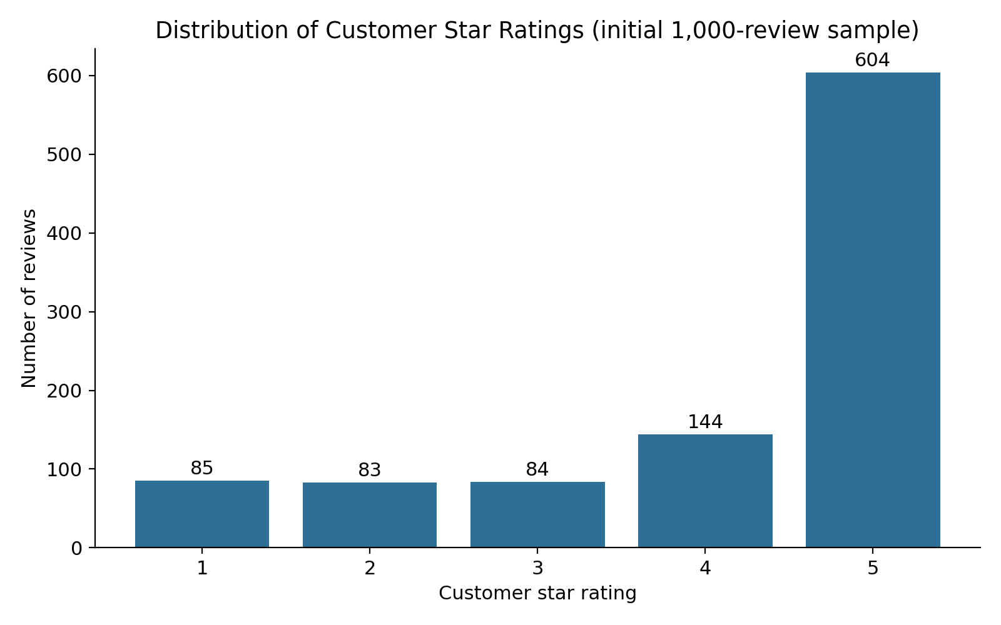
Figure 1. Distribution of customer star ratings in the initial 1,000-review sample (85, 83, 84, 144 and 604 reviews for 1 to 5 stars).
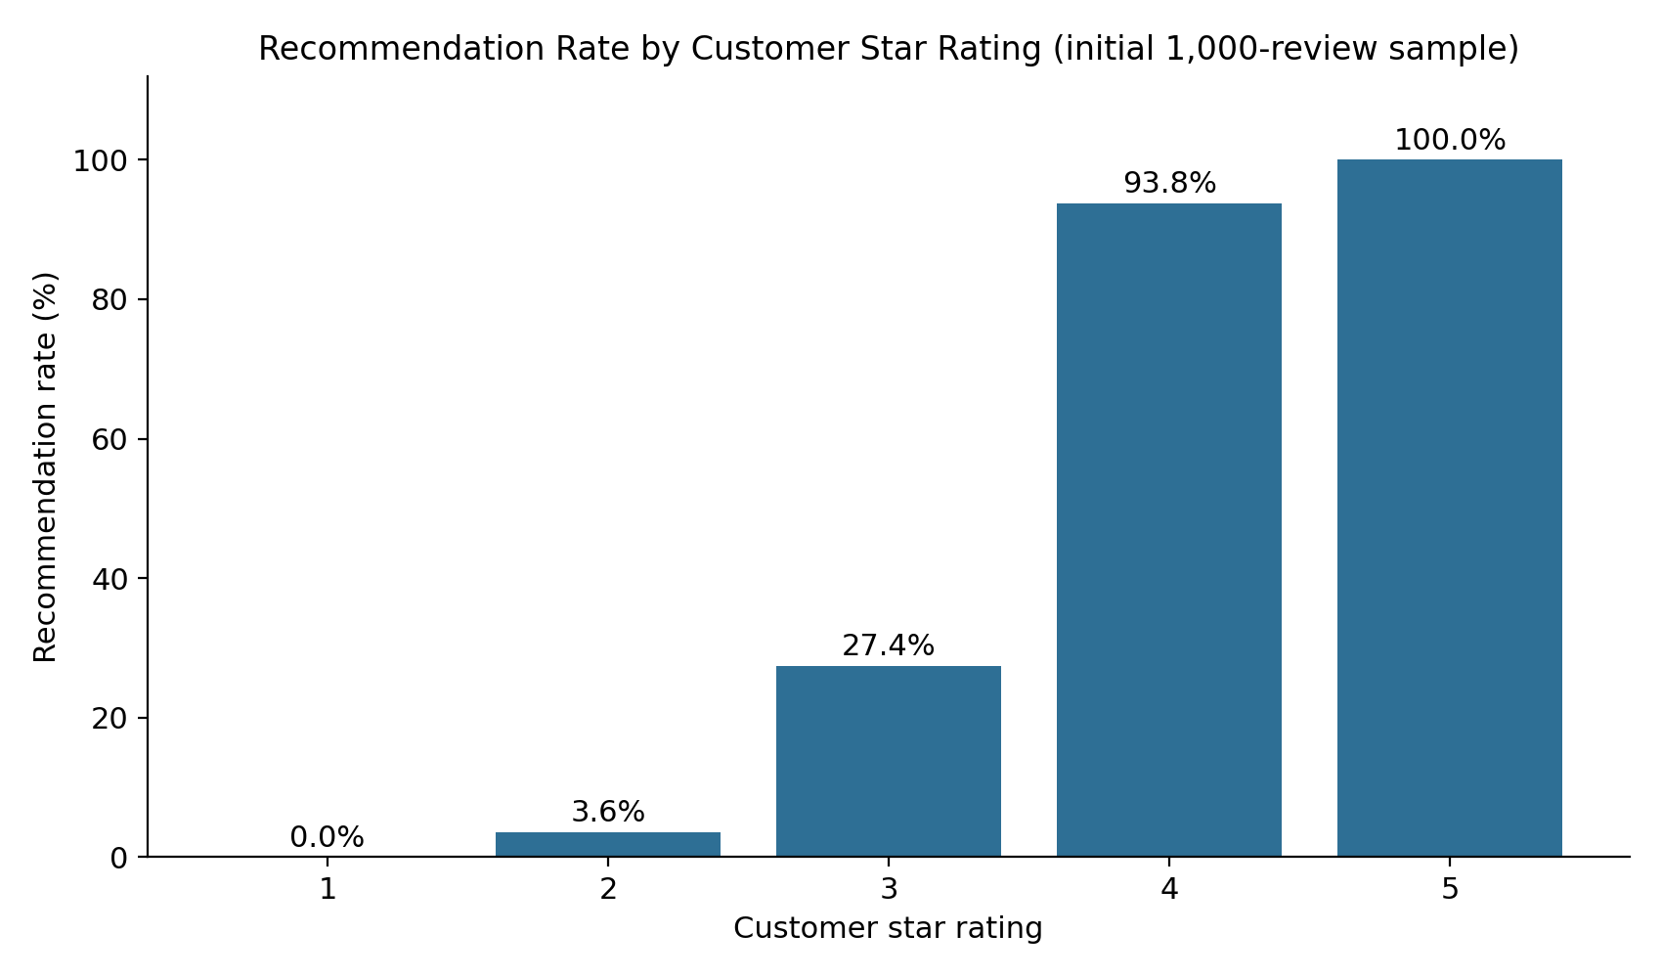
Figure 2. Recommendation rate by star rating in the initial 1,000-review sample (0.0%, 3.6%, 27.4%, 93.8% and 100.0%).
Interpretation and limitation. In the sample, 60.4% of reviews are 5-star and recommendation rates rise from 0.0% at 1 star to 100.0% at 5 stars. This describes the sample only. Because almost every review concerns one LANEIGE product, the sample says nothing reliable about other products, brands or the industry. A one-review brand (NUDESTIX, 5.0 stars) should not be compared with a 999-review brand.

13.2 Full dataset: customer rating distribution
Table 7. Rating distribution, full dataset
Rating | Reviews | Share of all reviews
1 star | 61,223 | 5.6%
2 stars | 53,032 | 4.8%
3 stars | 81,816 | 7.5%
4 stars | 199,389 | 18.2%
5 stars | 698,951 | 63.9%
Total | 1,094,411 | 100.0%

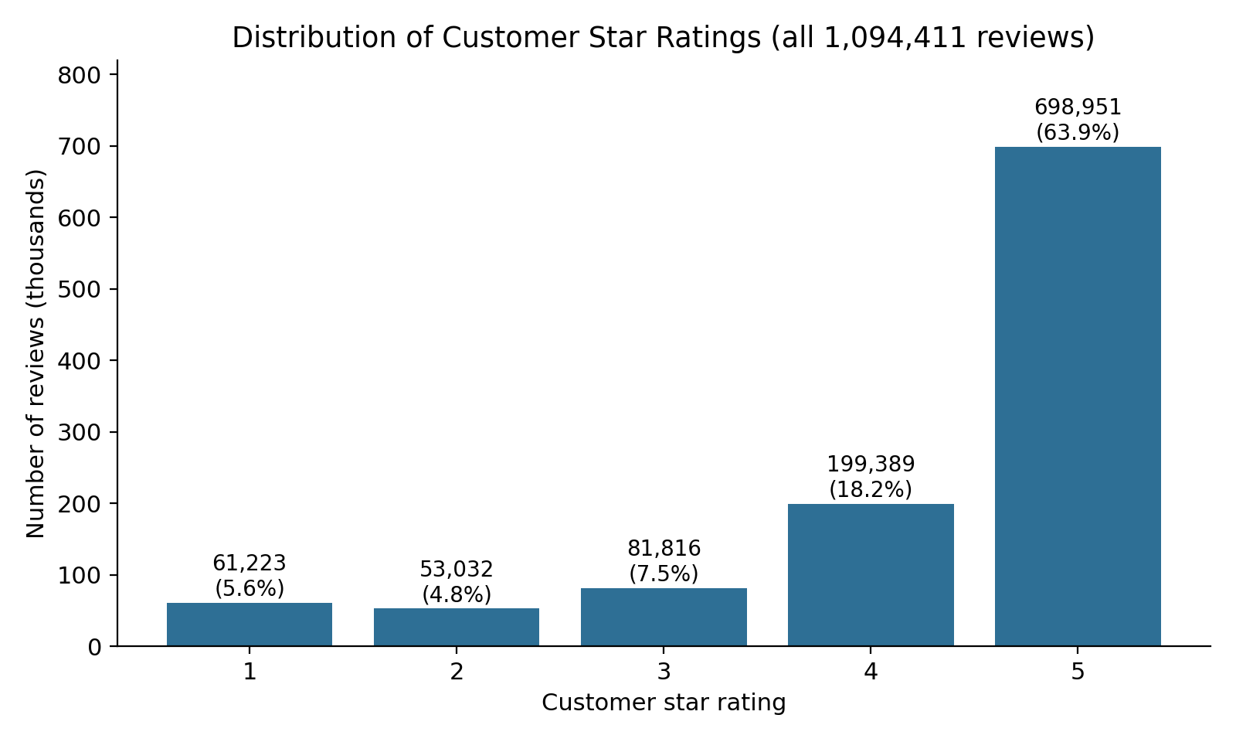
Figure 3. Distribution of customer star ratings across all 1,094,411 reviews.
The distribution is heavily weighted towards 5 stars (63.9%); reviews of 4 or 5 stars total 898,340 (82.1%), against 114,255 (10.4%) for 1 or 2 stars. The mean rating is 4.30, which lies inside the 4.0 to 4.7 range in which Spiegel Research Center (2017) found purchase likelihood to peak, although this dataset contains no purchase data. The shape is similar to the initial sample in having a dominant 5-star group, but the sample over-represents low ratings (16.8% for 1-2 stars versus 10.4% in the full data). Positively skewed, "J-shaped" rating distributions have been reported for online product reviews, and Hu, Zhang and Pavlou (2009) attribute them to self-selection: customers who buy a product tend to like it, and customers with strong opinions are more likely to write a review. The ratings here therefore cannot be assumed to represent all customers, and the simple average is a limited measure of quality.

13.3 Recommendation behaviour
Of 1,094,411 reviews, 778,160 (71.1%) are recommended, 148,263 (13.5%) are not recommended, and 167,988 (15.3%) have no recommendation value. Among reviews with a recorded decision, 84.0% recommend the product.
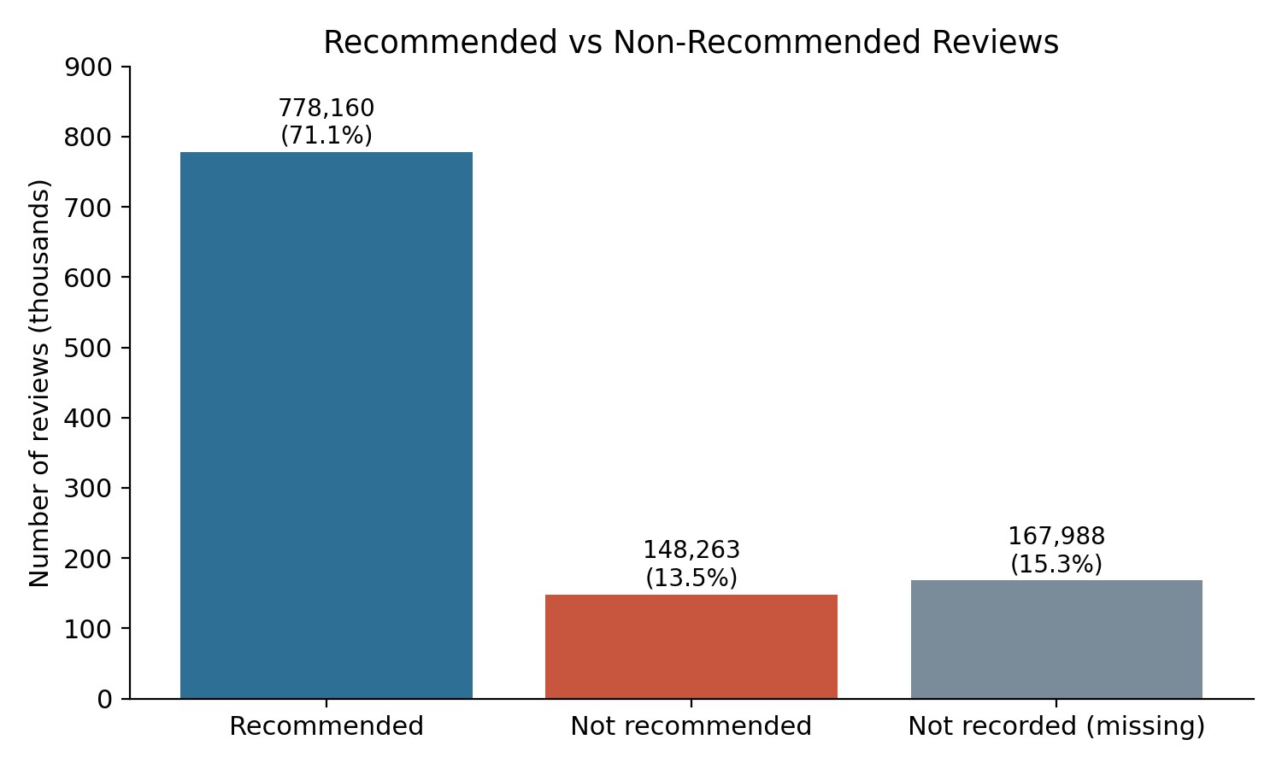
Figure 4. Recommended, not recommended and unrecorded reviews (all 1,094,411 reviews).
Table 8. Recommendation rate by star rating, full dataset
Rating | All reviews | With recorded decision | Recommended | Recommendation rate
1 star | 61,223 | 52,493 | 406 | 0.77%
2 stars | 53,032 | 45,262 | 1,660 | 3.67%
3 stars | 81,816 | 71,395 | 25,459 | 35.66%
4 stars | 199,389 | 170,192 | 164,351 | 96.57%
5 stars | 698,951 | 587,081 | 586,284 | 99.86%

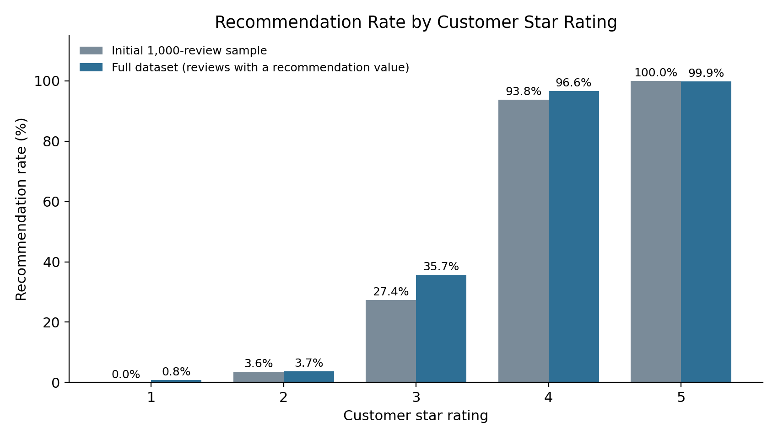
Figure 5. Recommendation rate by star rating: initial 1,000-review sample compared with the full dataset (reviews with a recorded decision).
Recommendation rate increases sharply with rating: almost no 1-star reviewers (0.77%) recommend the product, a minority of 3-star reviewers do (35.7%), and nearly all 4- and 5-star reviewers do (96.6% and 99.9%). The same upward pattern appears in the sample and the full data, but the sample understates the 3-star rate (27.4% versus 35.7%) and overstates how clean the pattern is (0.0% at 1 star versus 0.77%). Statistically, the association is strong (Spearman ρ = 0.72; chi-square = 741,794, p < 0.001). Limitation: this is an association between two reported answers given by the same person at the same time; it does not show that either causes the other. The 3-star group, where recommendation decisions are most divided, is the most informative for understanding hesitant customers.

13.4 Products, brands, price and customer characteristics
Review counts are very unequal: the median product has 164 reviews, the largest has 16,138, and 1,394 of 2,351 products have at least 100 reviews. Comparisons are therefore limited to groups with enough reviews. Table 9 shows the ten brands with the most reviews, whose average ratings lie in a narrow range (4.09 to 4.38).
Table 9. Ten brands with the most reviews
Brand | Reviews | Average rating | Recommendation rate*
CLINIQUE | 49,029 | 4.25 | 83.4%
Tatcha | 46,770 | 4.24 | 81.3%
Drunk Elephant | 42,395 | 4.08 | 76.7%
fresh | 40,886 | 4.38 | 86.5%
The Ordinary | 35,934 | 4.21 | 81.9%
Glow Recipe | 31,490 | 4.32 | 83.8%
Youth To The People | 29,154 | 4.28 | 82.0%
Origins | 29,063 | 4.36 | 86.6%
Peter Thomas Roth | 28,846 | 4.32 | 84.8%
LANEIGE | 27,519 | 4.37 | 84.4%
*Share of reviews with a recorded recommendation decision that recommend the product.
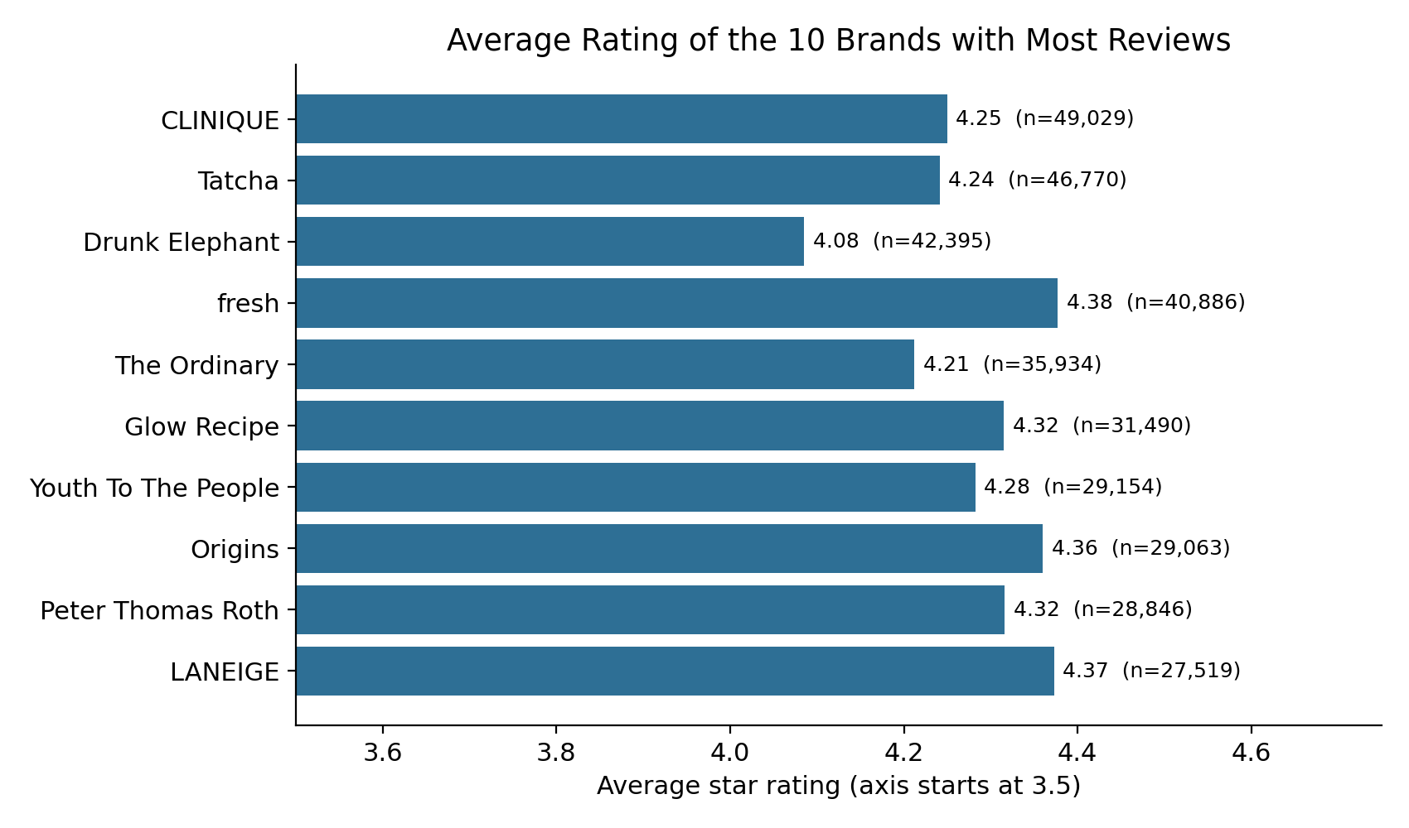
Figure 6. Average rating of the ten brands with the most reviews (n shown beside each bar).
Among the 95 brands with at least 1,000 reviews, average ratings range from 3.66 (Topicals, n = 1,838) to 4.74 (DAMDAM, n = 1,128). Among the 578 products with at least 500 reviews, the lowest-rated and highest-rated are shown in Table 10. These are descriptive rankings: they have not been tested for statistical significance and may reflect product type (for example cleansing wipes versus overnight masks) and the kind of customer who buys them.
Table 10. Lowest- and highest-rated products with at least 500 reviews
Group | Product | Brand | Reviews | Mean rating
Lowest | Clean Lip Balm & Scrub | SEPHORA COLLECTION | 611 | 2.28
Lowest | Clean Cleansing & Gentle Exfoliating Wipes | SEPHORA COLLECTION | 524 | 2.56
Lowest | Vitamin C Brightening Cream | The INKEY List | 518 | 3.03
Lowest | Focuspot Micro Tip Patches | Dr. Jart+ | 579 | 3.04
Lowest | Umbra Tinte Physical Daily Defense SPF 30 | Drunk Elephant | 845 | 3.30
Highest | Black Tea Anti-Aging Moisturizer with Retinol-Alternative BT Matrix | fresh | 1,389 | 4.84
Highest | Facial Cotton | Shiseido | 2,827 | 4.83
Highest | Truth Barrier Booster Orange Ferment Vitamin C Essence | OLEHENRIKSEN | 602 | 4.81
Highest | Floral Recovery Overnight Mask with Squalane | fresh | 1,128 | 4.80
Highest | Daily Milkfoliant Exfoliator | Dermalogica | 561 | 4.79

The brand illustration is instructive: NUDESTIX appeared with a single 5-star review in the sample, but the full data contain 381 NUDESTIX reviews with a mean of 4.13. LANEIGE, with 999 sample reviews, has 27,519 reviews across 26 products and a mean of 4.37 (sample mean 4.10). The sample result for LANEIGE was therefore lower than the full-data figure, and the sample brand comparison was not meaningful.
Price shows no meaningful relationship with rating. Across all products in the catalogue file the median price is $35 (range $3 to $1,900). Average ratings by price band are nearly identical (Table 11), and the review-level Spearman correlation between price and rating is 0.008.
Table 11. Average rating by price band (price from product_info.csv)
Price band (USD) | Reviews | Average rating
25 or less | 277,686 | 4.26
25 to 50 | 437,229 | 4.30
50 to 100 | 319,904 | 4.33
Over 100 | 59,592 | 4.27

Customer characteristics also show little difference in average rating. Among the most common categories, mean rating ranges only from 4.27 to 4.31 across skin types and from 4.26 to 4.33 across skin tones. Differences of this size are too small to justify business conclusions without further testing, and these attributes are missing for 10% to 21% of reviews and are self-reported.

13.5 Complaint themes in low-rated reviews
There are 114,255 reviews with 1 or 2 stars; 114,061 include review text. Simple word counts are dominated by general terms (skin, face, using) and also include positive words such as "love" and "good", which shows that word frequency without context can mislead. A keyword-group approach was therefore used: each group is a set of related words or phrases, and a review counts once if it mentions any of them. The same groups were counted in all 697,943 five-star reviews that include text, as a baseline.
Table 12. Share of reviews mentioning each keyword group
Keyword group | 1-2 star reviews | 5-star reviews
dryness / oiliness / heavy feel | 32.5% | 34.5%
breakout / acne | 21.9% | 16.2%
smell / fragrance | 21.6% | 22.5%
price / value | 14.7% | 11.3%
irritation / burning / rash | 14.0% | 11.6%
no visible effect | 12.8% | 0.5%
packaging / leaking / pump | 12.6% | 5.9%
pilling / flaking / residue | 6.2% | 4.1%

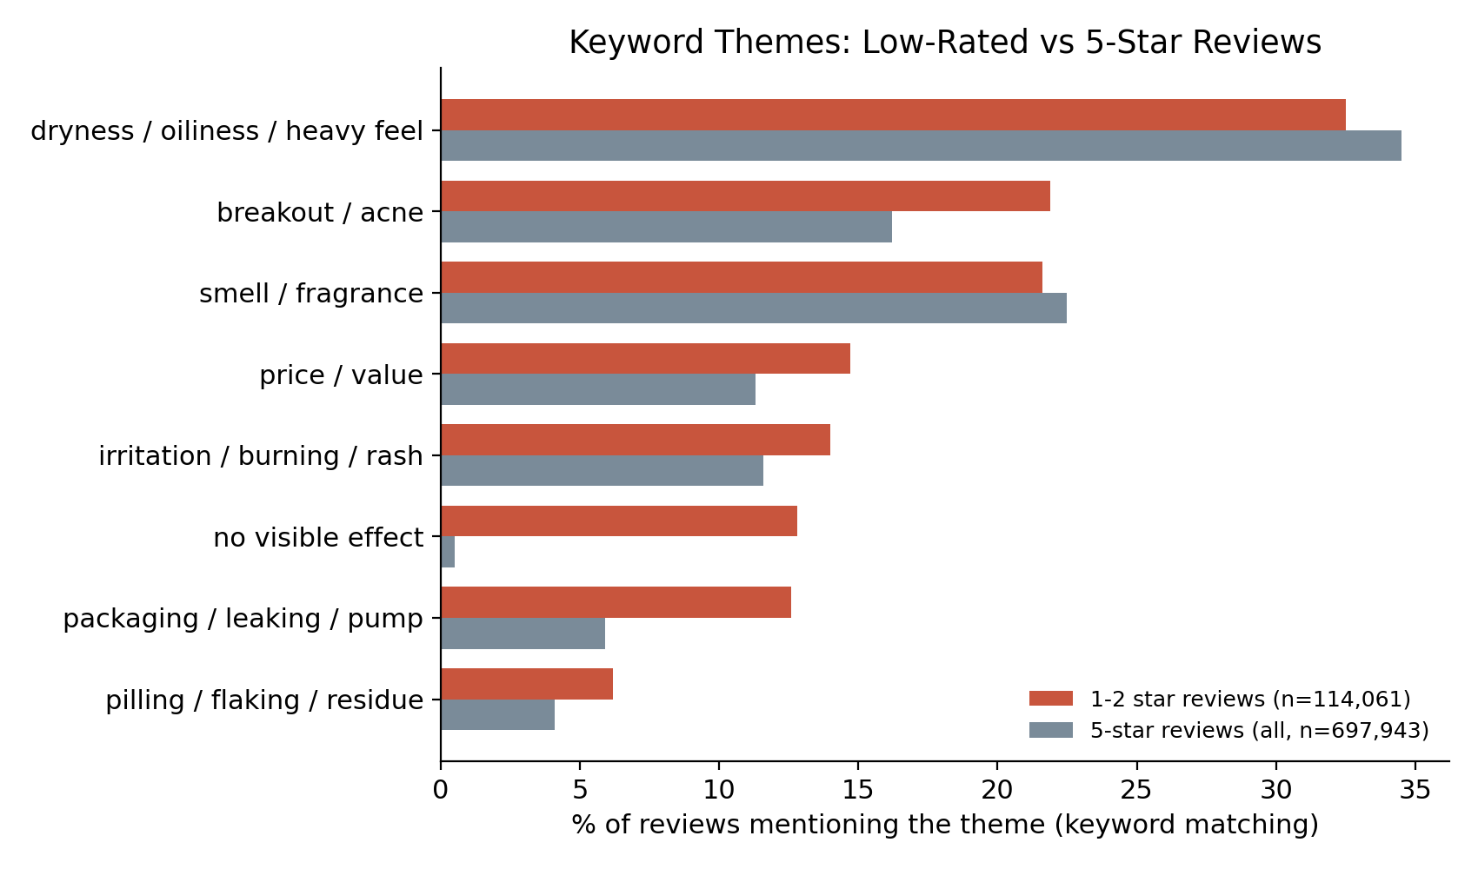
Figure 7. Keyword themes in low-rated reviews compared with 5-star reviews (keyword matching; groups overlap).
The most discriminating group is "no visible effect" (12.8% of low-rated reviews versus 0.5% of 5-star reviews), followed by packaging/leaking/pump, irritation and price/value. Dryness/oiliness and fragrance terms appear in both groups at similar rates, so their mention alone does not indicate dissatisfaction (customers often name their skin type or describe a pleasant scent).
Limitation: keyword matching cannot detect negation (for example "no breakouts"), sarcasm or context, groups overlap, and the percentages are indicative only. A reliable theme analysis would need topic modelling or a validated sentiment model, which has not been carried out.

14. Interpretation of Findings
- Customers rate most skincare products highly (mean 4.30), so the informative signal is in the minority of low and middle ratings, not in the average.
- The 3-star group is where recommendation behaviour is split, which suggests that mixed experiences could be a useful target for follow-up analysis.
- A star rating and a recommendation decision are closely linked but not identical: 3-star reviewers are mixed, and the small number of low-rated reviewers who still recommend a product is a separate pattern that has not been analysed.
- Differences between brands and products exist but are descriptive; price and reviewer characteristics showed little association with rating.
- The initial sample was internally consistent but unrepresentative, which shows why dataset coverage should be checked before analysis.

15. Business Implications and Recommendations
Supported by the current results:
- Monitor both the share of 1-2 star reviews and the recommendation rate; both are easy to compute and moved together in this data.
- Treat recommendation rate among 3-star reviewers as an indicator of hesitant customers and examine their reviews first.
- When comparing products or brands, require a minimum number of reviews and always display the sample size.
- Do not use price alone to predict satisfaction: no relationship was found.
Proposals requiring further analysis:
- Investigate recurring complaints for the lowest-rated products in Table 10, for example by reading a sample of their reviews and building a validated theme list.
- Improve product descriptions and expectation-setting for products whose reviews often say the product had no visible effect or irritated the skin; this needs product-level evidence first.
- Run a trend analysis by review date and a product-category analysis before drawing conclusions about changes in satisfaction.
- Add a sentiment or topic model to quantify complaint themes with measured accuracy.

16. Data Quality and Limitations
- Selection bias: only customers who chose to write a review are represented, and ratings are skewed towards 5 stars.
- Missing data: 15.3% of reviews have no recommendation value, and customer attributes are missing for 10% to 21% of reviews. If the data are missing for a reason related to satisfaction, the results could be biased. Helpfulness is missing for 51% of reviews and was not used for conclusions.
- Unequal sample sizes: product and brand review counts vary from a few to over 16,000, so rankings of small groups are unreliable.
- Scope: the data come from one retailer and cover skincare reviews written between 2008 and March 2023; results should not be generalised to the whole beauty industry or to current reviews.
- Initial sample: the first 1,000 rows contain only two products and two brands and are not representative.
- Text analysis: keyword groups are approximate and do not capture meaning; no sentiment or machine-learning model was built.
- Statistics: with more than a million rows, very small differences become statistically significant; effect sizes and context should be examined.
- Duplicates: 224 exact duplicate rows were kept (0.02% of the data).
Table 13. Missing values: full dataset compared with the initial 1,000-row sample
Column | Missing (full) | % of full | Missing (sample) | % of sample
helpfulness | 561,592 | 51.3% | 199 | 19.9%
review_title | 310,654 | 28.4% | 243 | 24.3%
hair_color | 226,768 | 20.7% | 258 | 25.8%
eye_color | 209,628 | 19.2% | 120 | 12.0%
skin_tone | 170,539 | 15.6% | 223 | 22.3%
is_recommended | 167,988 | 15.3% | 0 | 0.0%
skin_type | 111,557 | 10.2% | 102 | 10.2%
review_text | 1,444 | 0.1% | 0 | 0.0%
All other columns have no missing values in the full data. Note that the sample has no missing recommendations, while 15.4% are missing in the full data, an example of how the sample differs from the whole.

17. Ethical Considerations and Responsible Data Use
- Privacy: reviews are public, but author_id values are pseudonymous identifiers. They were used only for counting and no attempt was made to identify or profile individuals.
- Sensitive attributes: skin tone, eye colour and hair colour are self-reported personal characteristics. Results by such attributes should be reported as aggregates and not used to target or exclude customers.
- Fair interpretation: ratings reflect self-selected reviewers and are not a complete measure of product quality or safety. Reports of irritation or reactions in reviews are anecdotal and are not medical evidence.
- Fair comparison: brands and products should not be ranked publicly using small samples or without noting the sample size.
- Data terms: the dataset is a public Kaggle resource; the licence and terms stated on its Kaggle page should be checked before any reuse or redistribution.
- Transparency: all code is provided so that the results can be reproduced and checked.

18. Proposed Next Steps and Future Improvements
- Merge reviews with product_info.csv to compare satisfaction by product category, ingredients and price tier.
- Standardise category labels (for example "Grey"/"gray") and review duplicates in more detail.
- Analyse trends over time and the effect of review volume on ratings.
- Apply topic modelling and a validated sentiment model to low-rated reviews, and report accuracy against a hand-labelled sample.
- Test product and brand differences formally, using minimum sample sizes and confidence intervals.
- Study reviewers who give low ratings but still recommend (and the reverse).
- Repeat the work on other review sources before generalising to the industry.

19. Conclusion
This project started from a 1,000-row sample that was correct but unrepresentative, and extended the analysis to all 1,094,411 reviews in the supplied files. The results show highly positive ratings (82.1% 4 or 5 stars), a strong association between star rating and recommendation (from 0.8% to 99.9%), differences in average rating between some brands and products, no meaningful price effect, and recurring complaint keywords in low-rated reviews. The earlier sample results were reproduced exactly but should not be used to describe the dataset as a whole. The analysis is exploratory and descriptive: causal conclusions, product rankings with statistical confidence, and model-based sentiment analysis are left for later work. The main lesson is that rigorous data science depends on checking coverage, sample size and missing data before drawing business conclusions.

20. References
Harris, C.R., Millman, K.J., van der Walt, S.J., et al. (2020). Array programming with NumPy. Nature, 585, 357-362.
Hu, N., Zhang, J. and Pavlou, P.A. (2009). Overcoming the J-shaped distribution of product reviews. Communications of the ACM, 52(10), 144-147. https://doi.org/10.1145/1562764.1562800
Hunter, J.D. (2007). Matplotlib: A 2D graphics environment. Computing in Science & Engineering, 9(3), 90-95.
Inky, N. (2023). Sephora Products and Skincare Reviews [Data set]. Kaggle. https://www.kaggle.com/datasets/nadyinky/sephora-products-and-skincare-reviews
McKinney, W. (2010). Data structures for statistical computing in Python. Proceedings of the 9th Python in Science Conference, 56-61.
McKinsey & Company (2025). State of Beauty 2025: Solving a shifting growth puzzle. https://www.mckinsey.com/industries/consumer-packaged-goods/our-insights/state-of-beauty-2025 (accessed 24 October 2026).
Pang, B. and Lee, L. (2008). Opinion mining and sentiment analysis. Foundations and Trends in Information Retrieval, 2(1-2), 1-135.
Spiegel Research Center (2017). How Online Reviews Influence Sales. Northwestern University, Medill School. https://spiegel.medill.northwestern.edu/How-Online-Reviews-Influence-Sales (accessed 24 October 2026).
Virtanen, P., Gommers, R., Oliphant, T.E., et al. (2020). SciPy 1.0: fundamental algorithms for scientific computing in Python. Nature Methods, 17, 261-272.

