YuvaIntern
Data Science with Python Analyst Internship | Week 2 Assignment
Sephora Customer Review Analysis
Data Identification, Sourcing Strategy and Initial Analysis Planning
Student: Mohammed Anas
Degree: Bachelor of Engineering, Artificial Intelligence and Machine Learning
College: P A College of Engineering, Mangalore
Organization: YuvaIntern
Internship: Data Science with Python Analyst Internship
Domain: Beauty and Wellness
Repository: github.com/mohammed-anas-2006/sephora-customer-review-analysis
Date: 31 October 2026

1. Executive Summary
Week 1 defined the business problem: how Sephora customer reviews can show customer satisfaction, recommendation behaviour and recurring dissatisfaction. Week 2 answers the next question: which data can support that problem, how reliable it is, and what analysis should come next. The report evaluates six candidate sources, selects a primary dataset, inspects all six uploaded CSV files with Python, assesses data quality on eight dimensions, and sets out statistical and NLP plans. A small, clearly labelled sentiment-classification pilot was also run to test feasibility.
Source decision. Six sources were compared: two Kaggle datasets, one Hugging Face mirror, Amazon Reviews 2023, Google Trends and the Reddit Data API. The Kaggle "Sephora Products and Skincare Reviews" dataset (Inky, 2023) is the primary source because it is the only candidate with over one million reviews, a recommendation label, reviewer attributes and a product catalogue that links by product_id. The Hugging Face dataset is a mirror of the second Kaggle dataset and is not counted as independent evidence.
Week 1 figures re-verified. All headline Week 1 figures were recomputed from the original CSV files and match: 1,094,411 reviews, 2,351 products, 142 brands, 503,216 reviewer identifiers, 8,494 catalogue records, mean rating 4.30 and an 84.0% recommendation rate among recorded decisions.
New findings verified in Week 2:
- The reviews cover skincare only. All 1,094,411 reviews belong to products in the Skincare category (2,351 of 2,420 skincare products). The catalogue's makeup, hair, fragrance and other categories have no reviews, so conclusions apply to skincare, not the whole beauty industry.
- Recommendation labels are missing for a structural reason. is_recommended is blank for every review from 2008 to 2016, for 53.5% of 2017 reviews, and almost never from 2018. The missing 15.3% is therefore not random, and recommendation analysis rests on 926,423 reviews from 2017 onwards. A check restricted to 2018 onwards gives the same pattern (Spearman ρ = 0.717 versus 0.716).
- Brand differences are detectable but small. A Kruskal-Wallis test across 95 brands with at least 1,000 reviews gives H = 18,073 (p < 0.001), but the effect size is ε² = 0.017, meaning brand explains about 1.7% of rank variation in ratings. Skin type has ε² = 0.00007, which is negligible.
- Specific data problems were found. 64 reviews carry placeholder reviewer IDs ("orderGen…", "dummyUser"), 224 rows are exact duplicates, "Grey" and "gray" are separate eye-colour labels, and helpfulness is undefined for the 51.3% of reviews that received no votes.
- The files are complete relative to the catalogue. For all 2,351 reviewed products, the review files contain 100.3% of the review count the catalogue lists, and mean ratings differ from the catalogue rating by only 0.010 stars on average.
- NLP pilot (feasibility only). On a random sample of 99,867 reviews with author-grouped train/test splitting and weak labels from star ratings, VADER reached macro-F1 0.452 and TF-IDF with logistic regression reached 0.706 (3-fold CV 0.704 ± 0.002). VADER's accuracy (0.812) was below the majority-class baseline (0.818), which shows why accuracy alone is misleading.
Status of work. Completed: data inventory, quality assessment, preliminary statistics and the NLP pilot. Planned: full preprocessing, production sentiment models, topic modelling, external-source collection and formal hypothesis testing in Weeks 3 and onwards. No source other than the primary Kaggle files has been downloaded or analysed.

2. Introduction and Week 1 Continuity
Week 1 set the project identity, which is unchanged: using Sephora customer reviews to understand customer satisfaction, product recommendation behaviour and recurring dissatisfaction themes in the beauty and wellness industry. The Week 1 report analysed all review files and reported descriptive results, a keyword-based complaint analysis and a recommendation analysis, but it did not build a sentiment model, which the evaluator identified as a gap.
Table 1. Week 1 headline figures and their Week 2 re-verification from the original CSV files
Measure | Week 1 report | Week 2 recomputed | Status
Reviews | 1,094,411 | 1,094,411 | Reproduced
Products with reviews | 2,351 | 2,351 | Reproduced
Brands | 142 | 142 | Reproduced
Distinct reviewer identifiers | 503,216 | 503,216 | Reproduced
Product catalogue records | 8,494 | 8,494 | Reproduced
Mean rating | 4.30 | 4.2992 | Reproduced
Five-star reviews | 63.9% | 63.87% | Reproduced
Four- and five-star reviews | 82.1% | 82.09% | Reproduced
Recommendation rate (recorded decisions) | 84.0% | 84.00% | Reproduced
Spearman ρ, rating vs recommendation | 0.72 | 0.716 | Reproduced

Table 2. How Week 2 responds to the Week 1 evaluator feedback
Evaluator comment (Week 1) | Week 2 response | Section
"Competent but generic" | Source-by-source evaluation with verified facts, a column-level data dictionary and a quality issue register tied to actual counts | 5, 8, 9
"Lacks depth in analysis and specific data examples" | Concrete evidence: structural missingness by year, placeholder IDs, label inconsistencies, catalogue cross-check, brand effect sizes, review excerpts | 9, 11, 12
"Consider machine learning models and sentiment classification" | Full NLP strategy plus a feasibility pilot with VADER, TF-IDF + logistic regression and TF-IDF + naive Bayes, evaluated with macro-F1, confusion matrices and cross-validation | 13

3. Research Objectives
Week 2 objectives are measurable and tied to the official assignment requirements:
- O1. Identify and compare at least five candidate data sources using the same criteria (Section 5).
- O2. Select and justify a primary dataset and classify the others as independent, mirror or supplementary (Section 6).
- O3. Inventory every uploaded file and verify the Week 1 figures (Sections 7 and 2).
- O4. Document a data dictionary and assess quality on eight dimensions with evidence (Sections 8 and 9).
- O5. Specify an exploratory analysis plan, statistical methods and an NLP strategy, and test feasibility with a pilot (Sections 11 to 13).
- O6. Map each Week 1 hypothesis to variables, methods and expected evidence (Section 14).
- O7. Document a reproducible collection and cleaning workflow (Sections 15 and 16).

3.1 Research questions and hypotheses carried over from Week 1
The Week 1 research questions and hypotheses are retained without change, because the data inspection did not show a methodological reason to alter them.
Table 3. Week 1 hypotheses and their status after Week 2
Hypothesis (unchanged) | Status after Week 2
H1: Higher product ratings are associated with higher recommendation rates. | Strong association in the data (ρ = 0.716; Cramér's V = 0.89), stable when restricted to 2018 onwards. Supported as an association; formal confidence intervals by subgroup remain planned.
H2: Negative customer reviews contain recurring complaint themes that may indicate product or customer-experience problems. | Initial evidence from Week 1 keyword counts and the Week 2 pilot (most informative negative n-grams). Not yet tested with topic models or a validated classifier.
H3: Customer feedback patterns differ across products and brands. | Brand differences are statistically detectable but small (ε² = 0.017). Product-level and category-adjusted testing remains planned.

4. Data Identification Strategy
The project needs data that can answer questions about satisfaction, recommendation and complaint themes. Candidate sources were screened with six criteria applied identically to each source, and only information I could retrieve or verify in the supplied files was recorded. Where a fact could not be verified (for example a licence field), the report says so instead of assuming it.
Table 4. Source selection criteria
Criterion | Question asked | Why it matters here
Relevance | Does it contain customer opinions, ratings or interest signals about beauty products? | H1 to H3 need ratings, recommendation labels and review text
Variables | Are rating, recommendation, text, product and customer attributes available? | Determines which hypotheses can be tested
Scale and coverage | How many records, which products, which years? | Subgroup analysis and time trends need volume
Accessibility and terms | Is it free, downloadable and legally usable without scraping or bypassing restrictions? | Project rules prohibit scraping and API circumvention
Reliability | Who collected it, how, and can it be cross-checked? | Unofficial scrapes need internal validation
Independence | Is it a different collection or only a copy? | Mirrors cannot validate each other

Four source types were considered: review corpora (customer opinions), product metadata (attributes such as price, ingredients and category), market-interest data (search interest over time) and social discussion (unstructured opinions). A strong project uses a main review corpus and, later, one or two supplementary signals for triangulation.

5. Potential Data Sources and Comparison
Table 5 lists the six sources with links and the independence classification. Tables 6 to 8 compare them on variables, coverage, accessibility, reliability, advantages, limitations, terms and practical use. All links were opened on 31 October 2026; facts below come from the pages named in the notes.
Table 5. Candidate sources, links and independence
ID | Source | Official link | Data type | Independence
S1 | Kaggle: Sephora Products and Skincare Reviews (N. Inky) | kaggle.com/datasets/nadyinky/sephora-products-and-skincare-reviews | Review corpus + product catalogue | Primary collection (Sephora, scraped)
S2 | Kaggle: Sephora Skincare Reviews & Sentiment (N. Messier) | kaggle.com/datasets/natashamessier/sephora-skincare-reviews-and-sentiment | Review sample + product info + VADER sentiment | Separate scrape of the same retailer; not independent of Sephora platform effects
S3 | Hugging Face: haoxianc/natashamessier_sephora-skincare-reviews-and-sentiment | huggingface.co/datasets/haoxianc/natashamessier_sephora-skincare-reviews-and-sentiment | Same files as S2 | Mirror of S2 (tagged kaggle-mirror); zero independent value
S4 | Amazon Reviews 2023 (McAuley Lab) | huggingface.co/datasets/McAuley-Lab/Amazon-Reviews-2023 | Review corpus + item metadata (different retailer) | Independent retailer; cross-platform validation
S5 | Google Trends | trends.google.com/trends/ (method: support.google.com/trends/answer/4365533) | Normalised search-interest time series | Independent signal type
S6 | Reddit Data API | support.reddithelp.com/hc/en-us/articles/16160319875092-Reddit-Data-API-Wiki | Posts and comments (social discussion) | Independent signal type

Table 6. Source comparison (1): variables, coverage and accessibility
ID | Available variables | Coverage and update frequency | Accessibility
S1 | 19 review columns (rating, is_recommended, review_text, skin_type, skin_tone, brand_name, price_usd, dates, helpfulness) and 27 catalogue columns. Verified in the supplied files. | 1,094,411 reviews, 2,351 skincare products, 2008-08-28 to 2023-03-21 (verified). Static snapshot; Kaggle page describes it as about 1 million reviews and 8k+ products from the Skincare category. | Free Kaggle account; CSV download. Local copies supplied on 22 October 2026.
S2 | Per HF card: review_id, date_published, rating_value, title, text, marketing label (clean, planet aware, vegan, cruelty-free, luxury), product name, brand, category, price, review_count, aggregate_rating, VADER sentiment and polarity_score. | Per HF card: 40,234 reviews, 2,012 skincare products, up to 10 most recent reviews per product. Preview shows reviews dated into 2025, so it is more recent than S1. Not downloaded. | Free; Kaggle download or Hugging Face files.
S3 | Same as S2 (raw and cleaned CSVs). | Same as S2. Total file size reported as 54.2 MB. The HF dataset viewer fails because the three CSVs have different columns; files must be loaded individually. | Free; no account needed to view files.
S4 | Per dataset card: rating, title, text, timestamp, helpful_vote, verified_purchase; item metadata includes price and average rating. No recommendation flag. | Beauty_and_Personal_Care: 11.3M users, 1.0M items, 23.9M ratings; All_Beauty: 632.0K users, 112.6K items, 701.5K ratings. Interactions span May 1996 to Sep 2023. Not downloaded. | Free; Hugging Face or project download links; very large files.
S5 | Relative search interest (0 to 100) by term, region and time; related queries. | Reflects a sample of Google searches. Normalised per query; low-volume terms appear as 0; includes statistical noise (per Google help). Not downloaded. | Free web interface with CSV export.
S6 | Posts, comments, scores, timestamps, subreddit (candidate beauty subreddits to be confirmed). | Depends on subreddit and API access; historical depth not verified. Not accessed. | Free tier requires OAuth2 (100 queries per minute per client ID, per Reddit wiki); commercial or research access needs approval.

Table 7. Source comparison (2): reliability, advantages and limitations
ID | Reliability | Advantages | Limitations
S1 | Medium-high. Unofficial scrape, but internally consistent: no invalid ratings, all product IDs match the catalogue, and review counts match catalogue counts (Section 9). | Scale; recommendation label; reviewer attributes; catalogue link; text for NLP. | Skincare only; recommendation missing before 2017; no verified-purchase flag; self-selection; collection method not documented in retrievable page content.
S2 | Medium. Scraped; sentiment from VADER, not human labels. Original description reports cleaning steps. | Already contains sentiment labels and marketing labels; newer reviews; suited to marketing-claim questions. | Small (up to 10 reviews per product); sampling favours recent reviews; VADER labels are model output.
S3 | Same as S2; adds no new evidence. | Convenient format and MIT licence text in repository. | Mirror: using it to "validate" S2 would be circular.
S4 | High for scale and documentation (peer-reviewed dataset paper, Hou et al., 2024). | Independent retailer for cross-platform checks; large beauty categories; helpful_vote and verified_purchase. | Different platform and product mix; no recommendation flag; very large; category is broader than skincare.
S5 | Medium. Google states it is not a poll, is a filtered sample and can include noise. | Market-interest time series for brands, ingredients and trends; complements review timing. | Relative index only; no sentiment; cannot be linked to individual reviews; low-volume terms are unreliable.
S6 | Low-medium. Unmoderated, self-selected posts; spam and promotion possible. | Rich unstructured opinions and vocabulary (for example ingredient and reaction language). | No ground-truth labels; access and terms restrictions; sampling bias; heavy preprocessing.

Table 8. Source comparison (3): licence, terms and practical use in this project
ID | Licence or usage terms | Practical use | Status
S1 | Licence field not visible in the page content I could retrieve; check it on the Kaggle page. Data originate from sephora.com, so Sephora's own terms may also apply. | Yes: primary analysis dataset. | Downloaded, inspected and analysed (Week 2).
S2 | Hugging Face card states MIT licence for the original Kaggle dataset; confirm on the Kaggle page. | Possible: cross-check of Sephora rating patterns and a labelled-sentiment comparison. | Link verified; not downloaded.
S3 | MIT licence text stated on the mirror card. | No: duplicate of S2. Use S2 or S3, not both. | Link verified; not downloaded.
S4 | Terms not verified in this review; check the dataset page. Cite Hou et al. (2024). | Optional: cross-platform validation of rating skew and sentiment models on the All_Beauty subset. | Details verified from dataset card; not downloaded.
S5 | Subject to Google Terms of Service (linked from the help page). | Optional: monthly interest series for top brands or ingredients, aligned to review volume. | Method page verified; not used.
S6 | Subject to Reddit Developer Terms and Data API Terms; unique User-Agent and OAuth2 required; no scraping or bypassing limits. | Optional, later: complaint vocabulary from beauty discussion. | Rules verified; no access requested; credentials must never be stored in the repository.

Notes on evidence. S1 facts come from the supplied files and the Kaggle page meta-description. S2 and S3 facts come from the Hugging Face dataset card (the Kaggle page for S2 could be opened but its body is not retrievable without JavaScript). S4 facts come from the McAuley Lab dataset card and the arXiv paper. S5 and S6 facts come from the Google Trends help page and the Reddit Data API wiki linked in the assignment.

6. Primary Dataset Selection and Justification
Decision: S1, the Kaggle "Sephora Products and Skincare Reviews" dataset, is the primary source.
Table 9. Fit of each source to the Week 1 problem (High / Medium / Low)
Requirement from Week 1 | S1 | S2/S3 | S4 | S5 | S6
Rating distribution (H1) | High | Medium | High | Low | Low
Recommendation label (H1) | High (2017+) | Low | Low | Low | Low
Review text for complaint themes (H2) | High | Medium | High | Low | High
Product and brand comparison (H3) | High | Low | Medium | Medium | Low
Volume for subgroup analysis | High | Low | High | Medium | Medium
Reviewer attributes (skin type, tone) | High | Low | Low | Low | Low
Ease and legality of access | High | High | Medium | Medium | Medium

The ratings in Table 9 are my judgement based on the verified source facts. S1 is the only candidate that supports all three hypotheses, because it combines ratings, a recommendation label, text, brands and customer attributes at scale. The other sources add value only for specific purposes: S4 for cross-platform validation, S5 for market interest over time and S6 for vocabulary. S2 and S3 are small and VADER-labelled, so they are not better than S1 as a main source, though S2 can serve as a secondary Sephora comparison. Because S1 is a scrape, the quality checks in Section 9 are essential; they show that it is internally consistent enough for exploratory analysis.

7. Dataset Inventory
All six uploaded files were opened with Python (Pandas) without modification. Table 10 lists the inventory. The five review files share an identical 19-column schema, so they can be stacked safely; the sixth file is the product catalogue.
Table 10. File inventory (verified)
File | Size (MB) | Rows | Columns | Role
product_info.csv | 7.9 | 8,494 | 27 | product catalogue
reviews_0-250.csv | 282.3 | 602,130 | 19 | customer reviews
reviews_1250-end.csv | 24.2 | 49,977 | 19 | customer reviews
reviews_250-500_1.csv | 100.3 | 206,725 | 19 | customer reviews
reviews_500-750_1.csv | 56.3 | 116,262 | 19 | customer reviews
reviews_750-1250_1.csv | 58.0 | 119,317 | 19 | customer reviews
Total (five review files) |  | 1,094,411 | 19 | customer reviews

- Combined size is 529 MB; the review files add up to 1,094,411 rows. A SHA-256 checksum of every file is recorded in Appendix F so the same files can be recognised later.
- The first column, "Unnamed: 0", restarts at 0 in each file, so it is a row counter and not an identifier (492,281 values repeat across files). It is ignored.
- Referential integrity: every one of the 2,351 product IDs in the reviews exists in product_info.csv (0 unmatched), and product_id is unique in the catalogue. 6,143 catalogue products (72.3%) have no reviews, and 142 of 304 catalogue brands appear in the reviews.
- Date coverage: 2008-08-28 to 2023-03-21, across 176 calendar months. 60.2% of reviews are from 2020 onwards and the peak month is 2020-04 (23,924 reviews).
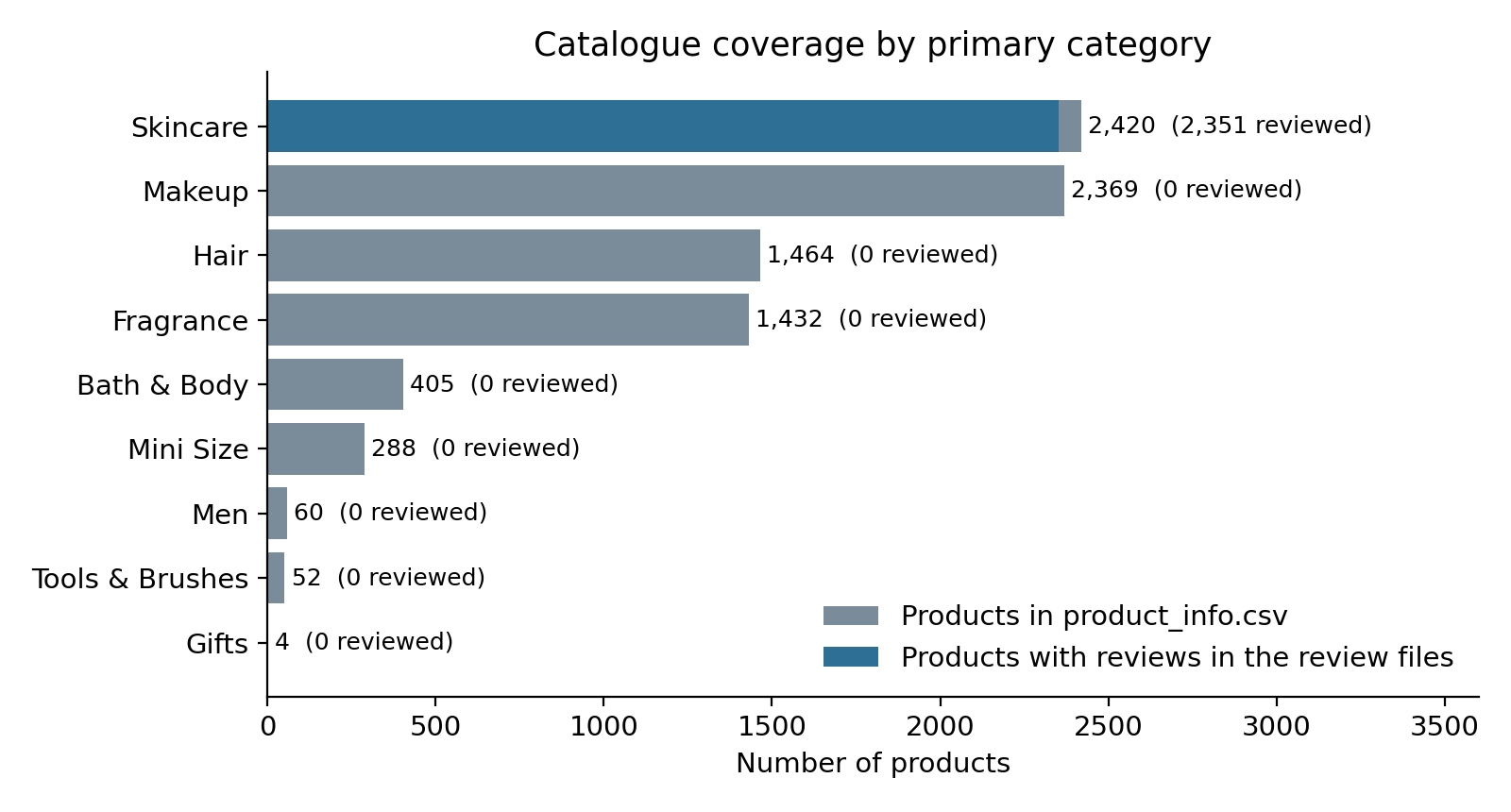
Figure 1. Catalogue products by primary category and the number with reviews. All reviews belong to Skincare.

8. Data Dictionary
Column names and data types are taken from the files as read by Pandas. Descriptions for review columns follow the column names and verified value patterns; descriptions for catalogue columns marked (inferred) come from names and values because I could not retrieve a formal dictionary from the Kaggle page. Missing percentages are exact counts from the files.
Table 11. Data dictionary: review files (19 columns, 1,094,411 rows)
Column | Type | Description | Analytical role | Quality concerns
Unnamed: 0 | int64 | Row counter restarting at 0 in each file | Not used | Not unique across files
author_id | text (int64 in 1,094,347 rows) | Pseudonymous reviewer identifier | Counting reviewers; grouping for train/test splits | 64 rows hold placeholders ("orderGen…", "dummyUser"); 503,216 distinct values
rating | int64 | Star rating, 1 to 5 | Main outcome (ordinal) | No invalid values; strongly left-skewed (skewness -1.68)
is_recommended | float64 (1.0, 0.0, blank) | Whether the reviewer recommends the product | Binary outcome (H1) | 15.35% missing; blank for all of 2008 to 2016
helpfulness | float64 | Share of voters who rated the review helpful (positive votes / total votes) | Context only | 51.31% undefined because no one voted
total_feedback_count | int64 | Total helpfulness votes | Context | 51.3% of reviews have 0 votes
total_neg_feedback_count | int64 | Negative helpfulness votes | Context | Equals total minus positive in 100% of rows
total_pos_feedback_count | int64 | Positive helpfulness votes | Context | As above
submission_time | text (YYYY-MM-DD) | Date the review was posted | Time analysis (convert to date) | 2008-08-28 to 2023-03-21; 2023 is partial
review_text | text | Body of the review | NLP, complaint themes (H2) | 1,444 missing (0.13%); may mention star ratings
review_title | text | Review headline | Optional NLP feature | 28.39% missing
skin_tone | text | Self-reported skin tone (14 labels) | Customer attribute (H3) | 15.58% missing; "notSureST" (70) is a placeholder; "ebony" has 3 reviews
eye_color | text | Self-reported eye colour (6 labels) | Customer attribute | 19.15% missing; "Grey" (4,859) and "gray" (621) are separate labels
skin_type | text | Self-reported skin type (4 labels) | Customer attribute (H3) | 10.19% missing
hair_color | text | Self-reported hair colour (7 labels) | Customer attribute | 20.72% missing; "brown" and "brunette" overlap
product_id | text | Sephora product identifier (for example P379064) | Key to product_info.csv | All 2,351 IDs found in the catalogue
product_name | text | Product name | Label | 17 names are shared by more than one product ID
brand_name | text | Brand name | Grouping (H3) | 142 brands; no variants after case-folding
price_usd | float64 | Price in US dollars | Explanatory variable | Identical to the catalogue price for all 2,351 products: a snapshot, not the price on the review date

Table 12. Data dictionary: product_info.csv (27 columns, 8,494 rows)
Column | Type | Description | Analytical role | Quality concerns
product_id | text | Unique product key | Join key | Unique; matches all reviews
product_name | text | Product name | Label | Complete
brand_id | int64 | Numeric brand ID (inferred) | Grouping | Complete
brand_name | text | Brand name | Grouping | 304 brands
loves_count | int64 | Count of "loves" or favourites (inferred) | Popularity proxy | Complete
rating | float64 | Average product rating on the site (inferred) | Cross-check with review means | 3.27% missing
reviews | float64 | Number of reviews listed on the site (inferred) | Completeness cross-check | 3.27% missing
size | text | Pack size | Optional | 19.20% missing
variation_type | text | Type of variant (inferred) | Optional | 17.00% missing
variation_value | text | Variant value (inferred) | Optional | 18.81% missing
variation_desc | text | Variant description (inferred) | Not used | 85.28% missing
ingredients | text | Ingredient list | Future ingredient analysis | 11.13% missing
price_usd | float64 | Price in US dollars | Price bands | Complete, all positive
value_price_usd | float64 | Reference ("value") price (inferred) | Not used | 94.69% missing
sale_price_usd | float64 | Sale price (inferred) | Not used | 96.82% missing
limited_edition | int64 | Flag (0/1) | Optional | Complete
new | int64 | Flag (0/1) | Optional | Complete
online_only | int64 | Flag (0/1) | Optional | Complete
out_of_stock | int64 | Flag (0/1) | Optional | Complete
sephora_exclusive | int64 | Flag (0/1) | Optional | Complete
highlights | text | Marketing highlight tags (inferred) | Marketing-claim analysis | 25.98% missing
primary_category | text | Top-level category (9 values) | Coverage check | Complete
secondary_category | text | Second-level category | Product-type grouping | 0.09% missing
tertiary_category | text | Third-level category | Product-type grouping | 11.66% missing
child_count | int64 | Number of child variants (inferred) | Not used | Complete
child_max_price | float64 | Highest child price (inferred) | Not used | 67.58% missing
child_min_price | float64 | Lowest child price (inferred) | Not used | 67.58% missing

9. Data Quality Assessment
Quality was assessed on eight dimensions. Every statement below is backed by a check in week2/code (script 01) and the number is stated so it can be reproduced.
Table 13. Quality assessment by dimension
Dimension | Rating | Evidence from the files
Completeness | Moderate | Review text is present in 99.87% of reviews. is_recommended is missing for 167,988 reviews (15.3%); helpfulness is undefined for 51.31%; customer attributes are missing for 10.2% to 20.7% of reviews. As a completeness check, the review files hold 1,094,411 reviews against 1,090,564 listed in the catalogue (100.3%); 1,568 products match exactly, 782 have more reviews than listed, and 1 has fewer.
Validity | Good, with exceptions | All 1,094,411 ratings are integers from 1 to 5; helpfulness always lies between 0 and 1; all dates parse; all prices are positive. Exceptions: 64 placeholder author IDs (60 "orderGen…" and 4 "dummyUser") and a "notSureST" skin-tone label.
Accuracy limitations | Moderate-good | Mean rating per product differs from the catalogue's rating by 0.010 stars on average (median 0.000). Truthfulness of individual reviews cannot be verified: there is no verified-purchase flag, and incentivised or fake reviews cannot be identified.
Consistency | Good | Total votes equal positive plus negative votes in 100% of rows; helpfulness equals the positive-vote share in 100.0% of reviews with votes. Each product_id has exactly one name, brand and price. Label inconsistencies: "Grey" versus "gray"; "brown" versus "brunette"; 17 product names shared by several IDs.
Uniqueness | Good | 224 exact duplicate rows (0.02%) ignoring the row counter. 5,525 reviews repeat an author-product pair already seen; these may be legitimate later reviews and are flagged, not removed. The row counter is not unique across files.
Timeliness | Moderate | Reviews end on 2023-03-21, about three and a half years before this report; the files are a static snapshot. 60.2% of reviews date from 2020 onwards and 7.7% from before 2015. Prices are scrape-time values.
Representativeness | Low-moderate | All reviews concern skincare (2,351 of 8,494 catalogue products, 27.7%). The ten largest brands supply 33.0% of reviews (CLINIQUE alone has 49,029). Ratings are strongly skewed (63.9% five-star), typical of self-selected online reviews (Hu et al., 2009). One retailer only.
Referential integrity | Good | 0 review product IDs are missing from the catalogue; the catalogue has no duplicate product IDs. 6,143 catalogue products have no reviews (the 6,074 non-skincare products plus 69 skincare products).

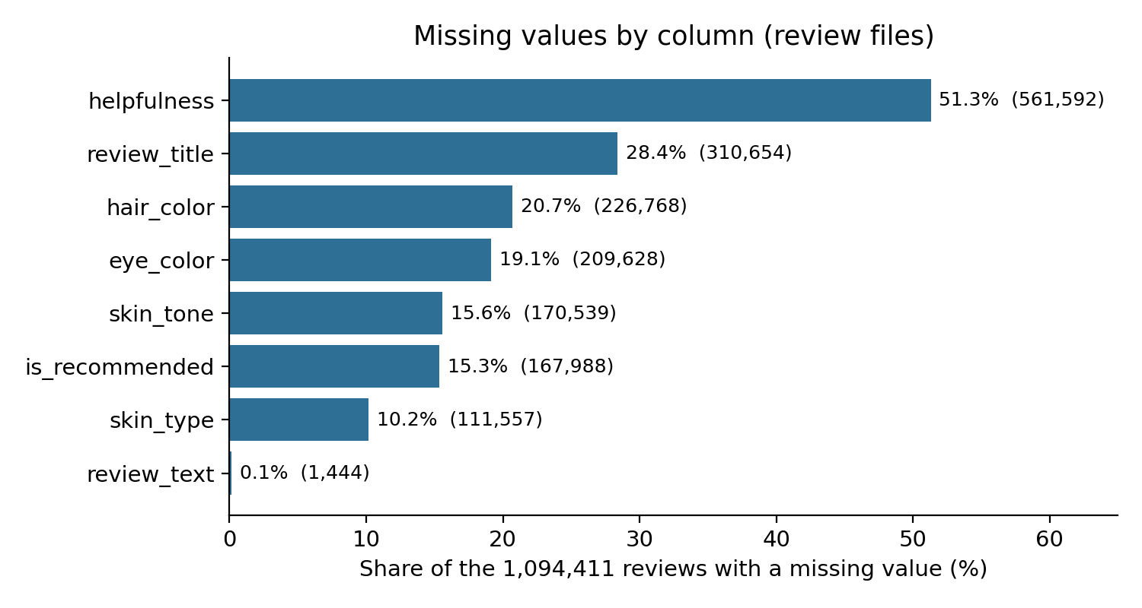
Figure 2. Missing values by column in the review files.
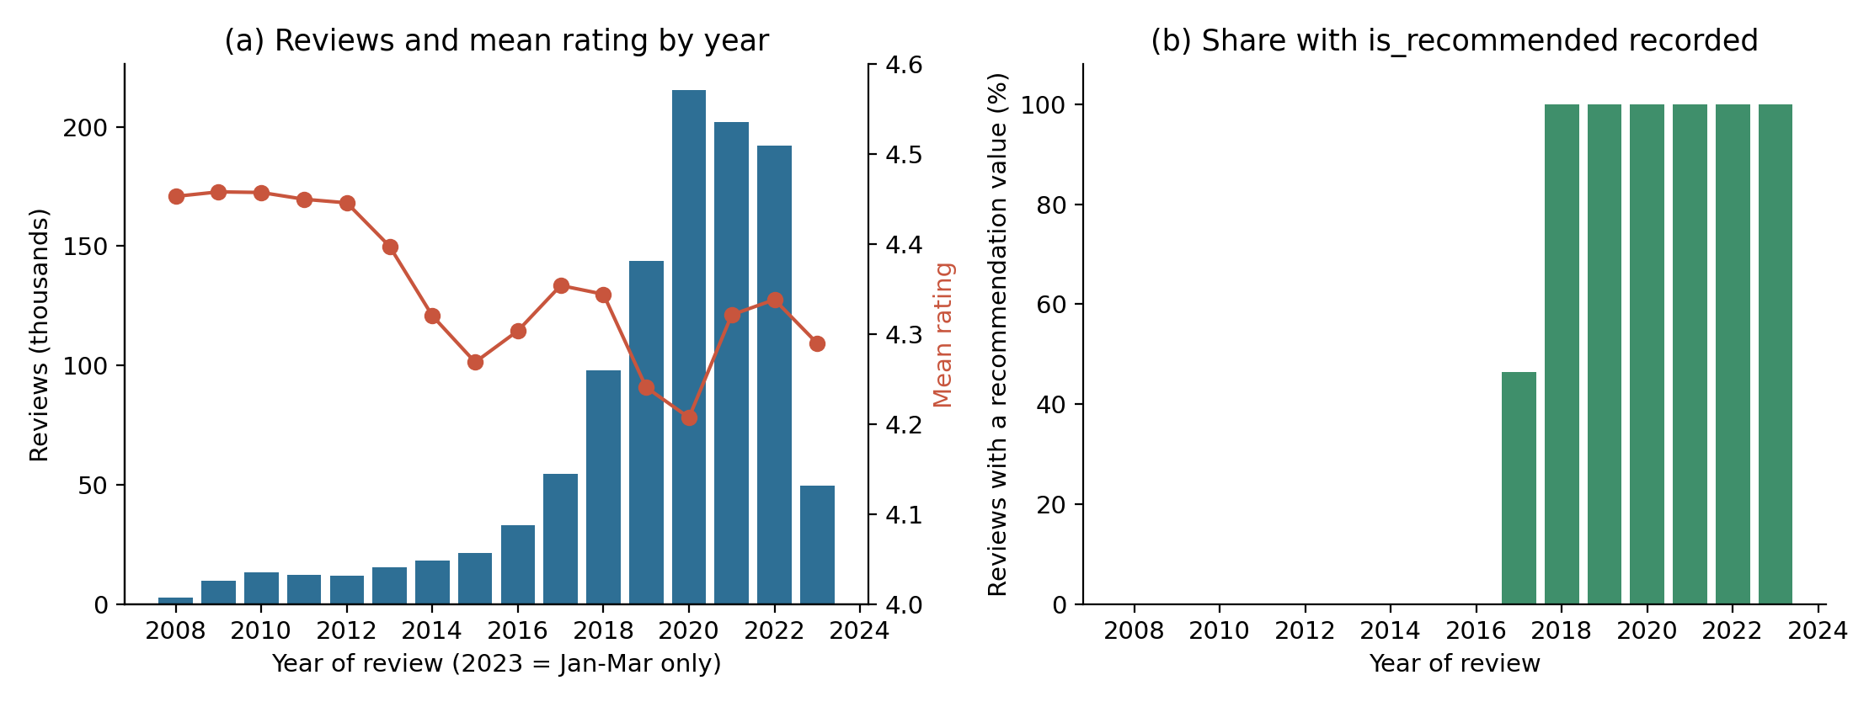
Figure 3. (a) Reviews and mean rating by year; (b) share of reviews with a recommendation value. The recommendation field is empty before 2017.
Why this matters. The recommendation gap looks like ordinary missing data in a summary table but is structural: the field does not exist in the data before 2017. Treating it as missing at random would be wrong, and any trend in recommendation rate before 2018 cannot be studied. Week 1 reported the 15.4% missing figure; Week 2 shows its cause. A sensitivity check on 2018 onwards (Appendix D) shows that the rating-recommendation pattern does not depend on the early years.
Table 14. Data-quality issue register
ID | Issue | Evidence | Potential impact | Proposed treatment | Status
Q1 | Recommendation structurally missing | Blank for 100% of 2008-2016 reviews, 53.5% of 2017, ~0% from 2018; 167,988 reviews in total | H1 rates reflect 2017-2023 only; early years cannot be used | Do not impute; report structure; run all recommendation analysis with a 2018+ sensitivity check | Check done; rule planned
Q2 | Helpfulness undefined without votes | 51.31% missing = 51.3% reviews with zero votes | Biased if used as an outcome | Create has_votes flag; use helpfulness only where votes exist | Planned
Q3 | Customer attributes missing | 10.2% (skin type) to 20.7% (hair colour) | Complete-case analysis shrinks and may bias samples | Analyse per attribute with "not provided" category; report n | Planned
Q4 | Inconsistent or placeholder labels | "Grey" 4,859 vs "gray" 621; "brown" vs "brunette"; "notSureST" 70; "ebony" 3 | Split categories; unstable tiny groups | Merge Grey/gray; set notSureST to missing; collapse groups under 1,000 reviews | Planned
Q5 | Duplicates and repeat reviews | 224 exact duplicates; 5,525 repeated author-product pairs | Slight inflation; leakage across train/test | Flag; drop exact duplicates for modelling; keep repeats with a flag | Planned
Q6 | Placeholder reviewer IDs | 64 rows; 21 distinct values (orderGen…, dummyUser) | Different people grouped together in author-level splits | Exclude from reviewer-level analysis; treat author_id as text | Planned
Q7 | Missing review text | 1,444 reviews (0.13%) | No text for NLP on these rows | Exclude from text tasks only | Applied in pilot
Q8 | Skincare-only coverage | 100% of reviews are Skincare; 0 reviews for 6,074 other-category products | Findings do not generalise to makeup, hair or fragrance | State scope; use S4 All_Beauty for cross-checks | Scope stated
Q9 | Highly unequal review volume | Median 164 reviews per product, maximum 16,138; 229 products have under 10 reviews | Averages of small groups are unreliable | Minimum-n rule (Section 12); confidence intervals | Rule defined
Q10 | Time skew and drift | 60.2% of reviews from 2020; yearly mean rating ranges 4.21 to 4.46 | Product mix and time are confounded | Stratify by year; avoid pooling across eras without checks | Planned
Q11 | Price is a snapshot | Review-level price equals catalogue price for 2,351 of 2,351 products | Price-rating relationship approximates current price only | Label as "price at collection" | Documented
Q12 | Product names shared by IDs | 17 names map to several product IDs | Wrong merges if name used as key | Use product_id as the key | Applied
Q13 | Self-selection and rating skew | 63.9% five-star; skewness -1.68; no verified-purchase flag | Ratings overstate satisfaction of all buyers | State limitation; cross-check on S4 (verified_purchase) | Planned
Q14 | Sparse catalogue columns | sale_price 96.8%, value_price 94.7%, variation_desc 85.3% missing | Unusable for modelling | Drop from analysis; keep ingredients and highlights (11% / 26% missing) | Planned
Q15 | Star ratings quoted inside text | Pilot top n-grams include "two stars" and "three stars" | Label leakage in text models | Remove star-rating phrases during preprocessing | Planned

10. Data Relevance Assessment
Relevance asks whether the data can answer the Week 1 questions. Table 15 links variable groups to the hypotheses and states what the data cannot show.
Table 15. Relevance of variable groups
Variable group | Supports | Relevance | Caveat
rating, is_recommended | H1, all descriptive questions | High | Recommendation only from 2017; self-selection
review_text, review_title | H2, sentiment and complaint themes | High | No human labels; text may quote the star rating
brand_name, product_id, price_usd | H3, product and brand comparison | High | Very unequal sample sizes; price is a snapshot
skin_type, skin_tone, eye_color, hair_color | H3, differences by customer group | Medium | 10 to 21% missing; self-reported
submission_time | Trends, drift checks | Medium-high | 2023 partial; 60% of data from 2020
helpfulness and vote counts | Context | Low | 51% undefined
product_info.csv fields (category, ingredients, highlights) | Product-type and marketing questions | Medium | Skincare-only reviews; ingredient parsing needed

Not answerable from this dataset: whether a review led to a purchase or return, sales, market share, causes of dissatisfaction beyond what reviewers write, and anything about non-skincare categories. These need the optional sources (S4 to S6) or business data not available here.
Overall assessment: fit for exploratory analysis of rating, recommendation and review-text patterns in Sephora skincare reviews from 2008 to March 2023. Not fit for industry-wide generalisation, causal claims, or current-trend claims without additional sources.

11. Initial Exploratory Analysis Plan
Each analysis states the question, variables, method, output, business relevance and limitations. Preliminary results marked "Week 2 result" were computed from the full dataset; everything else is planned.

11.1 A. Rating analysis
Item | Detail
Research question | What is the distribution of star ratings, and how imbalanced is it? (RQ1)
Variables | rating
Method | Frequency table, mean, median, mode, standard deviation, skewness; bar chart; histogram of counts; yearly mean rating
Expected output | Distribution table and charts; imbalance ratio between classes
Business relevance | Shows whether the average rating is informative or whether the low-rating minority is the signal
Limitations | Ordinal scale: means are indicative; self-selected reviewers
Week 2 result | Mean 4.299, median 5, mode 5, SD 1.149, skewness -1.68. Shares: 1 star 5.59%, 2 stars 4.85%, 3 stars 7.48%, 4 stars 18.22%, 5 stars 63.87%. Five-star reviews outnumber one-star reviews 11.4 to 1. Yearly mean rating ranges from 4.21 (2020) to 4.46 (2009); Spearman ρ between year and rating is -0.015, a negligible trend.

11.2 B. Recommendation analysis
Item | Detail
Research question | What share of reviews recommend the product, and how does this vary by star rating? (RQ2, RQ3, H1)
Variables | is_recommended, rating, submission_time
Method | Counts and rates with Wilson 95% confidence intervals; 100% stacked bar by rating; chi-square test with Cramér's V; Spearman correlation; sensitivity restricted to 2018 onwards
Expected output | Rate table with intervals; stacked bar chart; effect sizes
Business relevance | Identifies where star rating and recommendation diverge (for example 3-star reviews)
Limitations | Field exists only from 2017; association not causation
Week 2 result | 778,160 recommended, 148,263 not recommended, 167,988 not recorded. Among recorded decisions the recommendation rate is 84.0%. By rating (reviews from 2018 onwards): 1 star 0.77%, 2 stars 3.62%, 3 stars 35.68%, 4 stars 96.55%, 5 stars 99.86%. The 3-star group is mixed: 35.7% recommend.

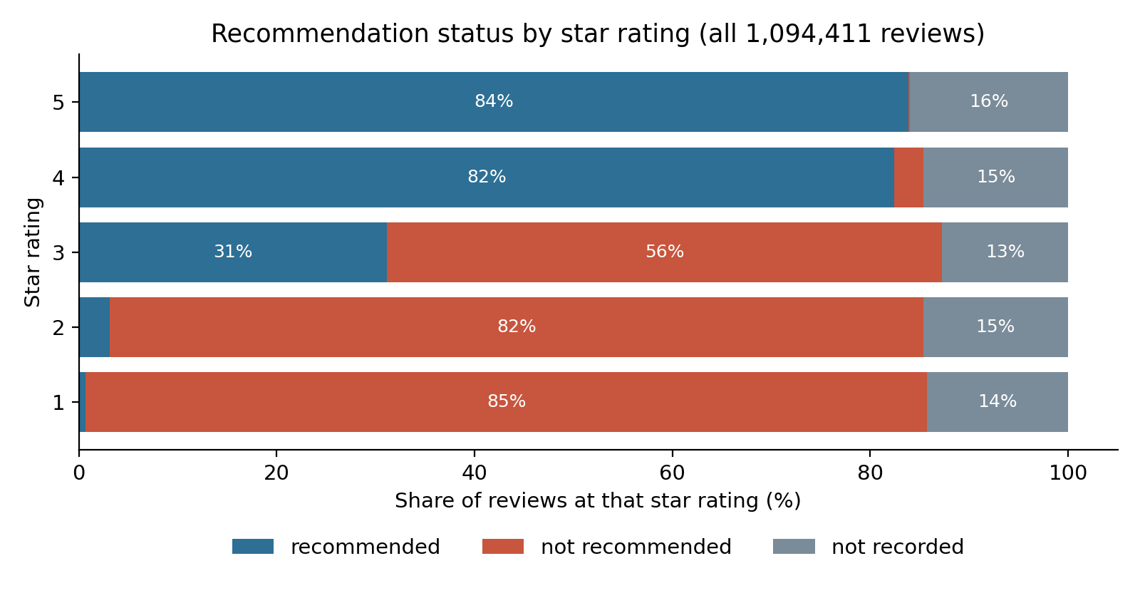
Figure 4. Recommendation status by star rating, all reviews. The grey share is the structurally missing field.

11.3 C. Product and brand analysis
Item | Detail
Research question | Do ratings and recommendation rates differ across products and brands? (RQ4, H3)
Variables | product_id, brand_name, rating, is_recommended, price_usd
Method | Mean rating with t-based 95% interval; Wilson interval for recommendation rate; minimum-sample rule; Kruskal-Wallis test with epsilon-squared effect size; multiple-comparison control for any pairwise tests
Minimum sample rule | With rating SD 1.149, a mean-rating interval of ±0.10 stars needs about 508 reviews; a recommendation-rate interval of ±5 percentage points needs about 385 recorded decisions. In the files, 565 products have at least 508 reviews. Groups below the threshold are reported with their n and not ranked.
Business relevance | Finds products and brands that stand out, and avoids ranking noisy small groups
Limitations | Brand and product type are confounded; descriptive only until category-adjusted
Week 2 result | Reviews per product: median 164, 90th percentile 1,197, maximum 16,138; 229 products have fewer than 10 reviews. Among 95 brands with 1,000+ reviews: H = 18,073, ε² = 0.017 (small effect).

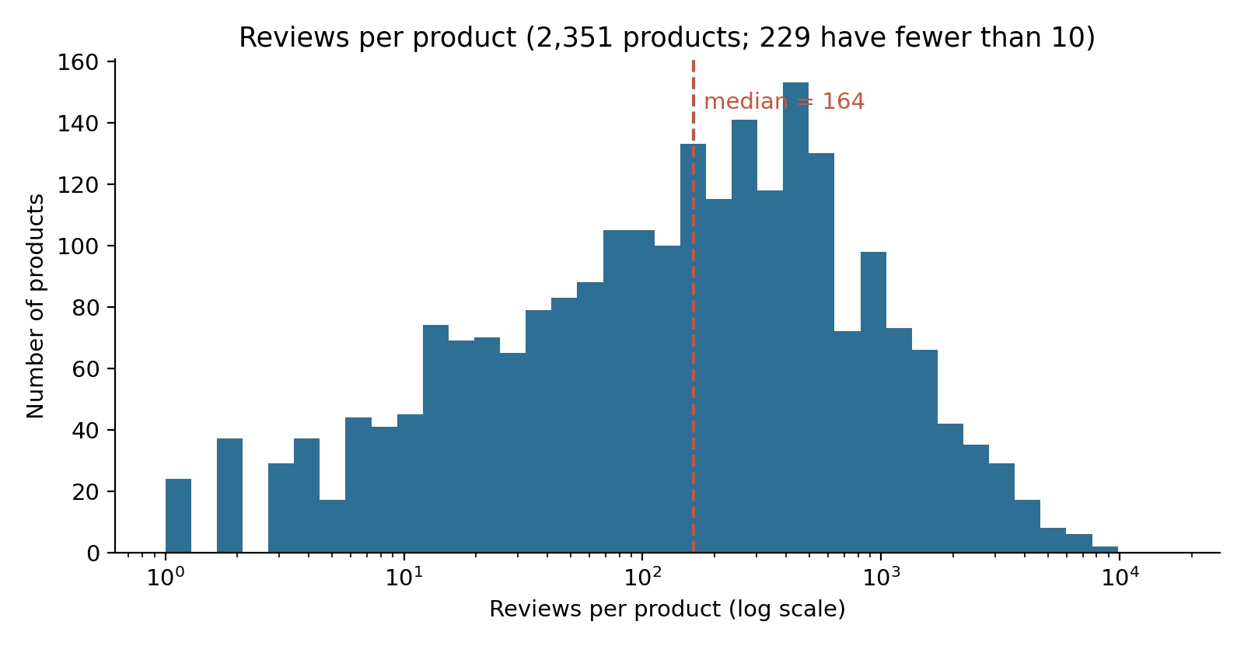
Figure 5. Distribution of review counts per product (log scale).
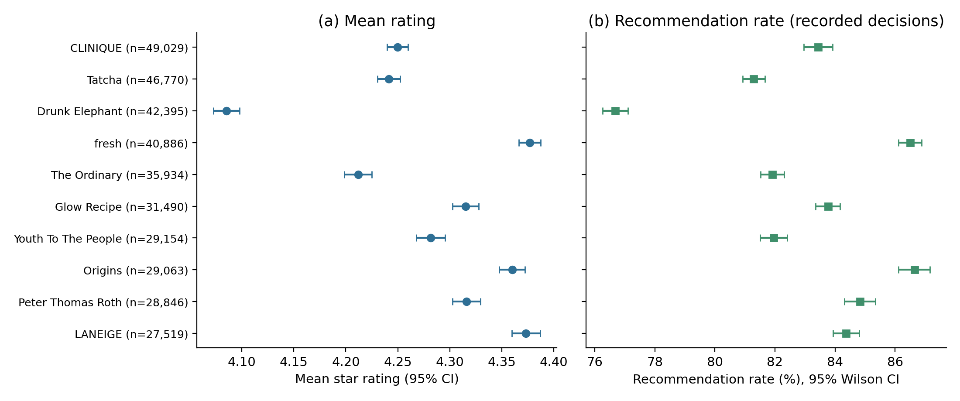
Figure 6. Mean rating and recommendation rate with 95% intervals for the ten brands with most reviews. Intervals are narrow because n is large; differences are modest in practical terms.

11.4 D. Time-based analysis
Item | Detail
Research question | How do review volume, ratings and recommendation change over time?
Variables | submission_time, rating, is_recommended
Method | Counts by year and month; mean rating by year; recommendation rate from 2018; line and bar charts; later, seasonal decomposition
Expected output | Time-series charts and a drift assessment before pooling years
Business relevance | Separates product-mix shifts from changes in satisfaction; supports comparison with S5 interest series
Limitations | 2023 covers January to March only; volume grew sharply so recent years dominate
Week 2 result | Volume rose from 2,761 reviews in 2008 to a peak of 215,449 in 2020; peak month 2020-04. Mean rating fell from about 4.45 (2008-2012) to 4.21 in 2020 and recovered to 4.34 in 2022. Median rating is 5 in every year. Recommendation rate (recorded) was 87.2% in 2017, 81.9% in 2020 and 85.7% in 2022.

11.5 E. Customer review text analysis
Item | Detail
Research question | How do low-rated and high-rated reviews differ in length, vocabulary and themes? (RQ5, H2)
Variables | review_text, rating
Method | Review length (words); word and n-gram frequency; TF-IDF; keyword-group comparison; most informative n-grams from a classifier; later topic models (Section 13)
Expected output | Length table, term lists, theme shares by rating group
Business relevance | Points product teams to concrete complaint language
Limitations | Word counts ignore negation and context; star ratings quoted inside text
Week 2 result | Reviews average 60.5 words (median 50; 90th percentile 112); 0.43% have five words or fewer. Length is only weakly related to rating (Spearman ρ = -0.033). Median length: 1 star 44, 2 star 50, 3 star 54, 4 star 54, 5 star 49 words.

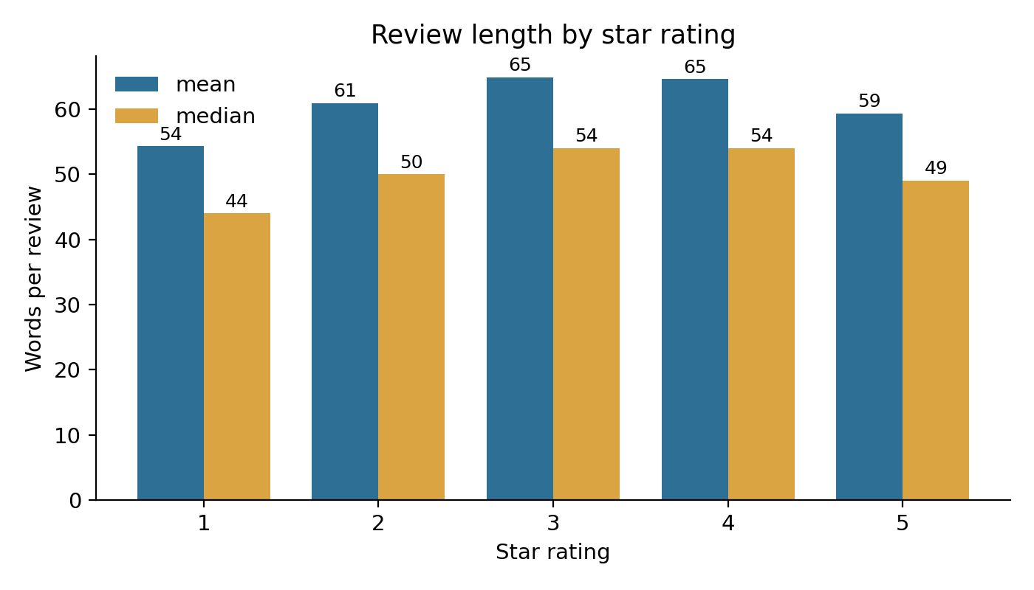
Figure 7. Review length by star rating.

12. Statistical Methods
Methods were chosen from the variable types (ordinal rating, binary recommendation, categorical groups) and the research questions. With more than 900,000 recorded decisions, almost any difference is statistically significant, so each method is paired with an effect size or interval and judged on practical size.
Table 16. Planned and applied statistical methods
Method | Used for | Key assumptions | Reading the result | Limitations | Status
Descriptive statistics and frequencies | Rating and recommendation distributions | None | Shape and imbalance | Mean of an ordinal scale is indicative | Applied
Chi-square test of independence with Cramér's V | Rating (5 levels) vs recommendation (2 levels) | Independent observations; expected counts above 5 | V near 0 = none, near 1 = very strong | Repeat reviewers violate independence; p-value overstated | Applied
Spearman rank correlation | Rating vs recommendation; length vs rating; year vs rating | Monotonic relationship; ties handled by ranks | ρ from −1 to 1; sign and size matter | Binary variable gives limited resolution | Applied
Wilson 95% interval for proportions (Wilson, 1927) | Recommendation rates by rating and brand | Independent trials | Interval around the rate | Independence not guaranteed | Applied
t-based 95% interval for mean rating | Mean rating by brand and product | Large n (central limit theorem) | Width shows precision | Ordinal data; skewed | Applied
Kruskal-Wallis test with ε² (Kruskal and Wallis, 1952) | Rating across brands, skin types, price bands | Independent groups; ordinal data | H and p show difference; ε² = H/(n−1) shows share of rank variance | Does not say which groups differ | Applied (brands, skin type); others planned
Post-hoc pairwise tests with Holm correction (Holm, 1979) | Which brands or products differ | Family of tests defined in advance | Adjusted p-values and effect sizes | 95 brands give 4,465 pairs; correction is strict | Planned
Mann-Whitney U with rank-biserial effect size | Two-group comparisons (for example recommended vs not) | Independent groups | Probability that one group outranks the other | Large n makes p uninformative | Planned
Regression (logistic for recommendation; ordinal for rating) | Adjusting for year, category and brand | Correct specification; limited multicollinearity | Adjusted associations | Observational data; no causal claim | Planned (Week 4)

Table 17. Preliminary statistical results (Week 2, full dataset)
Test | Data | Statistic | Effect size | Interpretation
Chi-square, rating × recommendation | n = 926,423 recorded decisions | χ² = 741,794, df = 4, p < 0.001 | Cramér's V = 0.895 | Very strong association (H1)
Spearman, rating vs recommendation (all recorded) | n = 926,423 | ρ = 0.716 | Large | Higher ratings go with recommendation
Spearman, same, reviews from 2018 | n = 901,033 | ρ = 0.717 | Large | Unchanged when early years are excluded
Kruskal-Wallis, rating across brands | 95 brands with 1,000+ reviews; n = 1,077,698 | H = 18,073, p < 0.001 | ε² = 0.0168 | Detectable but small (H3)
Kruskal-Wallis, rating across skin types | 4 groups; n = 982,854 | H = 66.9, p < 0.001 | ε² = 0.00007 | Negligible in practice
Spearman, year vs rating | n = 1,094,411 | ρ = -0.015 | Negligible | No overall time trend in rating
Spearman, review length vs rating | every 5th review, n ≈ 218,882 | ρ = -0.033 | Very weak | Length does not distinguish ratings

Reading the results: the chi-square p-value is effectively zero, yet what matters is V = 0.89, a very large effect. The skin-type test has p < 0.001 as well, but ε² = 0.00007 means skin type explains almost none of the variation in ratings. This is why p-values are not used alone. Reviews written by the same person are not independent, so p-values are optimistic; effect sizes and intervals remain informative.

13. NLP and Sentiment Classification Strategy

13.1 Weak labels and why they need care
No human-labelled sentiment exists in the primary dataset. A common shortcut is to derive labels from star ratings (1 to 2 stars negative, 3 neutral, 4 to 5 positive). These weak labels are noisy: a 2-star review may praise the texture but criticise the price, and a 5-star review may mention a past bad experience. Week 2 evidence shows the problem directly: in the pilot test set, 57.7% of 1-2 star reviews received a positive VADER score, and the most informative n-grams include "two stars" and "three stars", meaning reviewers sometimes write their rating in the text. Metrics against weak labels therefore measure agreement with the star rating, not true sentiment. A hand-labelled validation set is planned (Section 13.6).

13.2 Text preprocessing plan
Table 18. Preprocessing steps
Step | Treatment | Reason
Missing text | Drop the 1,444 reviews without text from text tasks only; keep them for rating analysis | No information to model; no imputation
Lowercasing and Unicode | Lowercase; normalise curly apostrophes and accents | Consistent tokens; the data contain typographic apostrophes
Special characters | Remove URLs and control characters; keep letters, digits and basic punctuation; handle emoji separately (convert or keep for VADER) | Reduces noise without losing emphasis cues
Tokenisation | Word and bigram tokens (scikit-learn default pattern in the pilot) | Bigrams capture phrases such as "not worth" and "highly recommend"
Negation preservation | Do not remove "not", "no", "never", "n't"; do not use a standard stop-word list that deletes them | Negation reverses meaning in complaints
Stop words | Use only a reduced list (articles, prepositions); keep negations and intensifiers | Avoids losing sentiment-bearing words
Lemmatisation | Optional for topic models (for example NLTK or spaCy); skip for transformers and VADER | Reduces vocabulary for LDA; transformers use sub-word tokens
Star-rating phrases | Remove phrases such as "two stars" and "3/5" from text | Prevents label leakage in weak-label models
Length handling | Truncate for transformers (for example 256 tokens); report share truncated | Review length has a long tail (maximum 1,216 words)

13.3 Sentiment classification approaches compared
Table 19. Candidate approaches
Approach | How it works | Strengths | Weaknesses | Status
VADER (Hutto and Gilbert, 2014) | Rule- and lexicon-based scoring of text; compound score from −1 to 1 | No training; fast; handles negation, capitalisation and punctuation emphasis; transparent | Built for short social-media text; weak on mixed or domain-specific language (for example "dry" or "heavy" in skincare); neutral class poorly defined | Pilot run
TF-IDF + logistic regression | Weights words and bigrams by distinctiveness; linear classifier | Strong baseline; interpretable coefficients; fast; supports class weighting | Ignores word order beyond bigrams; needs labels (weak here) | Pilot run
TF-IDF + multinomial naive Bayes | Probabilistic model of word counts per class | Very fast; works with small data; good recall for the majority class | Independence assumption; poorly calibrated; tends to favour the majority class | Pilot run
Pretrained transformer (for example a DistilBERT-based sentiment checkpoint; Sanh et al., 2019) | Contextual embeddings fine-tuned on sentiment data | Understands context and negation; often best accuracy | Needs GPU for 1 million reviews; checkpoint trained on other domains; harder to explain; licence and training data must be checked | Planned (Week 3-4, Colab GPU on a stratified sample)

13.4 Evaluation design
- Planned split: use a group-aware 80/20 train-test split by reviewer (author_id), with class balance if supported by the grouping constraints; no reviewer may appear in both sets. The Week 2 pilot used an unstratified GroupShuffleSplit, and its observed class shares are reported in Section 13.5. Time-based splits will be added to test drift.
- Cross-validation: grouped k-fold on the training part for model selection; the test set is used once at the end.
- Metrics: accuracy, precision, recall and F1 per class, macro-F1 (unweighted mean of class F1) as the headline metric, and a confusion matrix. Accuracy alone is insufficient because the positive class is about 82%: a model that always predicts "positive" is 82% accurate and useless for finding complaints.
- Imbalance handling: class weights ("balanced"), threshold tuning for the negative class, and optional resampling inside training folds only.
- Baselines: majority class, star-rating rule, VADER; a model must beat these to be reported as useful.
- Validation: a 500-review hand-labelled sample (stratified by rating) to estimate how well star-derived labels match human judgement, with a second annotator on a subset for agreement.

13.5 Pilot experiment performed in Week 2
Purpose: test feasibility and expose problems early, not to produce a final model. A random sample of 99,867 reviews with text (about 9.1% of the data; seed 42) was split by reviewer into 79,810 training and 20,057 test reviews (0 reviewers in both). Labels: negative 1-2 stars (10.5%), neutral 3 stars (7.6%), positive 4-5 stars (82.0%). TF-IDF used 1-2 word n-grams, minimum document frequency 5 and 50,000 features; models came from scikit-learn (Pedregosa et al., 2011) with default settings except class weighting for logistic regression. No hyper-parameter tuning was done.
Table 20. Pilot results on the held-out test set (precision / recall / F1 per class)
Method | Accuracy | Macro-F1 | Negative | Neutral | Positive
Majority class | 0.818 | 0.300 | 0.00 / 0.00 / 0.00 | 0.00 / 0.00 / 0.00 | 0.82 / 1.00 / 0.90
VADER | 0.812 | 0.452 | 0.47 / 0.35 / 0.40 | 0.11 / 0.04 / 0.05 | 0.86 / 0.94 / 0.90
TF-IDF + naive Bayes | 0.889 | 0.649 | 0.79 / 0.61 / 0.69 | 0.54 / 0.22 / 0.31 | 0.91 / 0.99 / 0.95
TF-IDF + logistic regression | 0.876 | 0.706 | 0.69 / 0.74 / 0.71 | 0.39 / 0.56 / 0.46 | 0.97 / 0.92 / 0.95

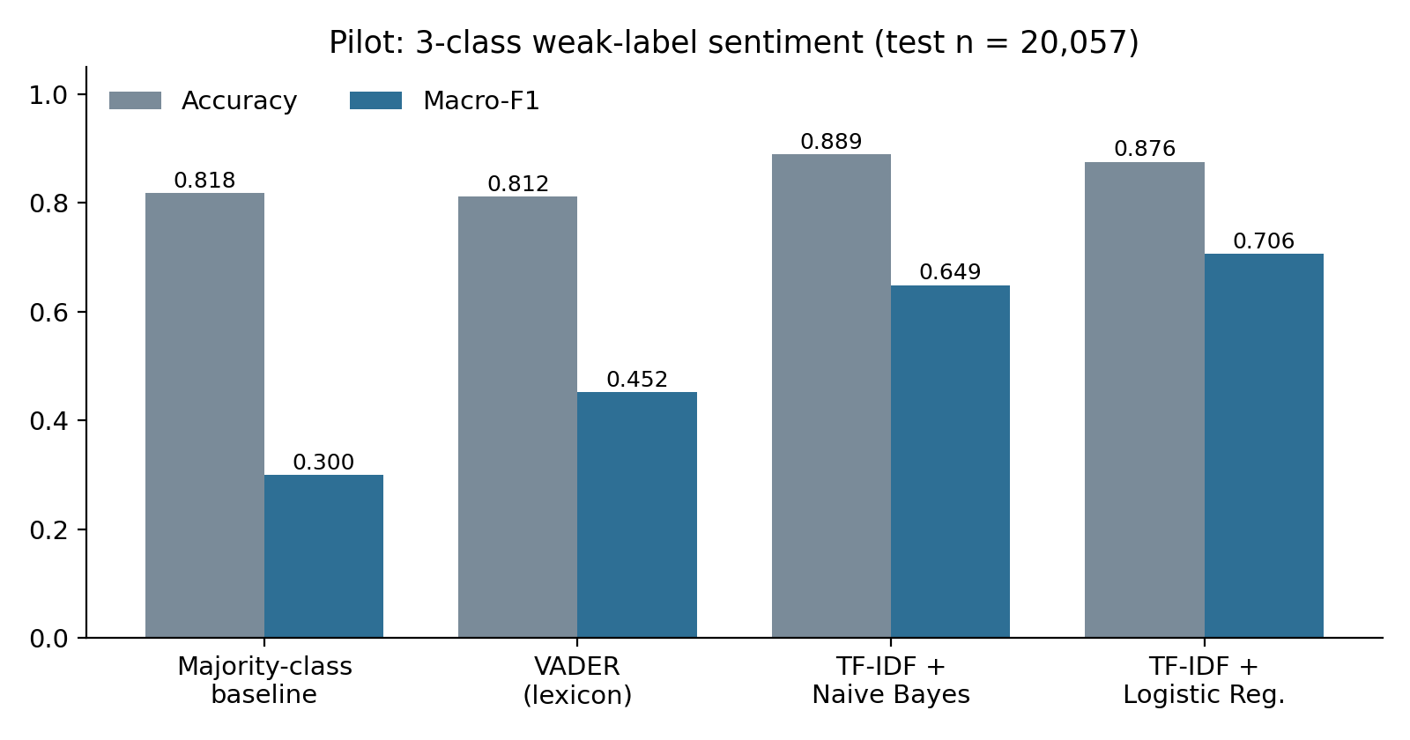
Figure 8. Pilot accuracy and macro-F1 on the test set. The majority-class baseline is shown for reference.
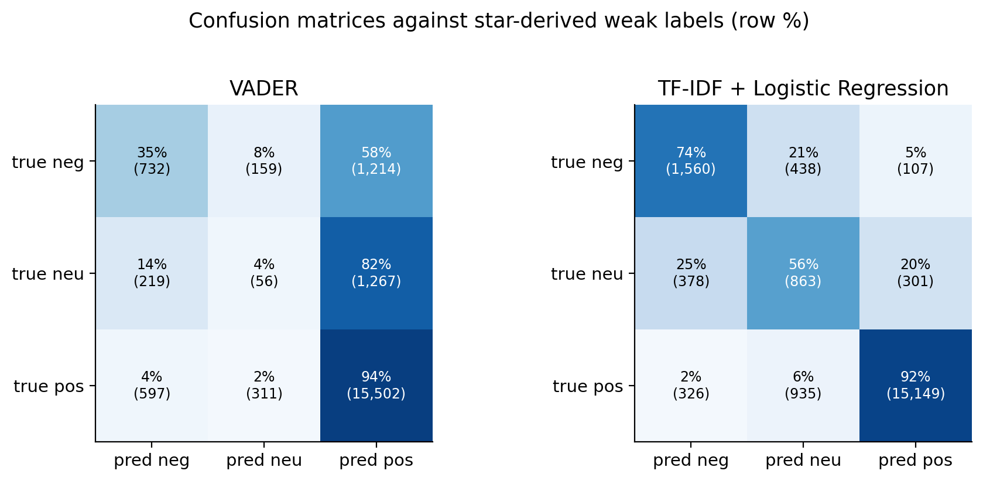
Figure 9. Confusion matrices (row percentages) for VADER and logistic regression.
What the pilot shows. (1) Logistic regression had the best macro-F1 (0.706; 3-fold grouped cross-validation 0.704 ± 0.002, so the result is stable across folds). (2) Naive Bayes had the highest accuracy (0.889) but a lower macro-F1 (0.649) because it recognised only 22% of neutral reviews. Accuracy and macro-F1 rank the models differently, which is why macro-F1 is the headline. (3) VADER's accuracy (0.812) is below the majority baseline (0.818); it detects 35% of low-rated reviews and labels 58% of them positive. (4) The 3-star (neutral) class is hardest for every model (best F1 0.46), consistent with mixed reviews.
Limits of the pilot. One random sample and one split; no tuning; labels are derived from the same star ratings the models are compared with; no human validation; no transformer was run (no GPU in this environment). These results support the choice of TF-IDF with logistic regression as the Week 3 baseline but do not show that sentiment can be predicted accurately.
Table 21. Most informative n-grams per class from the logistic-regression coefficients (pilot)
Rank | Negative (1-2 stars) | Neutral (3 stars) | Positive (4-5 stars)
1 | disappointed | however | love
2 | not | but | amazing
3 | not worth | three stars | love this
4 | broke | to love | great
5 | worst | though | perfect
6 | returning | okay | without
7 | two stars | special | soft
8 | nothing | ok | best
9 | returned | that said | definitely
10 | to love | just not | love it
11 | no for | once week | highly
12 | wouldn recommend | average | highly recommend
13 | didn | stars | works
14 | disappointing | too sensitive | not too
15 | not recommend | decent | smooth

Negative terms are dominated by explicit disappointment and return language ("disappointed", "returning", "not worth", "worst"), which supports H2 qualitatively. The terms "two stars" and "three stars" show label leakage and will be removed in preprocessing; "to love" probably reflects hedged phrases such as "wanted to love it", which should be confirmed by reading the reviews. Product-specific complaint terms (for example breakouts, scent) do not appear in the top 15 because sentiment words dominate; topic modelling is the better tool for complaint themes.
Table 22. Examples where the star rating and VADER disagree (excerpts from the test set, truncated)
Case | Stars | VADER | Excerpt
1-2 stars but VADER strongly positive | 1 | 0.94 | "I feel like the foam doesn’t do much. It comes out foamy but I don’t feel like my face is clean. I use the face wash and like ..."
1-2 stars but VADER strongly positive | 2 | 0.822 | "I got this in a Sunday Riley set. After using the small bottle, there was some skin brightening but overall didn’t see any major changes in my dark ..."
1-2 stars but VADER strongly positive | 2 | 0.968 | "I really wanted to love this because I love Fresh. Smells amazing and it’s a really nice texture. However was definitely not enough moisture. Dries very fast and ..."
5 stars but VADER strongly negative | 5 | -0.669 | "My new go-to daily sunscreen. Doesn’t leave a white cast, doesn’t leave me dewy, and doesn’t pill. It works well with or without makeup on. Perfect for protecting ..."
5 stars but VADER strongly negative | 5 | -0.771 | "I had the worst sunburn on my nose and my face felt like leather. I used these wipes to take off layers of dead skin and then applied ..."
5 stars but VADER strongly negative | 5 | -0.664 | "This is a lightweight sunscreen that goes on effortlessly. I’ve had nothing but great experiences when using this whether it is for every day use, at the beach ..."

13.6 Complaint-theme analysis plan
Table 23. Techniques for complaint themes
Technique | Use | Strengths | Weaknesses | Status
TF-IDF and n-gram comparison | Terms and phrases distinguishing low-rated from high-rated reviews (log-odds ratios with smoothing) | Simple and transparent; extends the Week 1 keyword groups | Misses context; many near-duplicate phrases | Week 3
Keyword groups (Week 1) | Counts of complaint vocabulary such as breakouts, irritation, no effect | Interpretable; already built | Cannot handle negation; hand-picked | Done (Week 1); refine
LDA topic model (Blei et al., 2003) | Latent topics in 1-2 star reviews | Established; yields word lists per topic | Needs preprocessing and tuning of topic count; topics can be vague | Week 4
BERTopic (Grootendorst, 2022) | Topics from transformer embeddings and clustering | Handles context; better coherence on short text | Computationally heavy; needs GPU; less transparent | Optional (Week 4, if resources allow)

Themes in low-rated reviews will be compared with those in 5-star reviews using the same method and corpus size, reporting each theme's share in both groups and its ratio, so that generic vocabulary (for example "dry", which also appears in positive reviews) is not mistaken for dissatisfaction. Topic labels will be assigned by reading sample reviews, and two reviewers will check a subset.

14. Hypothesis-to-Data Mapping
Table 24. How the data can test each Week 1 hypothesis
Hypothesis | Required variables | Data source | Proposed method | Expected evidence | Limitations
H1: Higher ratings are associated with higher recommendation rates | rating, is_recommended, submission_time | S1 (S2 sentiment as secondary check) | Rate by rating with Wilson intervals; chi-square and Cramér's V; Spearman; 2018+ sensitivity; later logistic regression with year and brand | Monotonic rise in rate; large effect size stable across years (observed in Week 2) | Association only; field exists from 2017; repeat reviewers
H2: Negative reviews contain recurring complaint themes | review_text, rating, product_id | S1; S4 All_Beauty for cross-platform checks; S6 later for vocabulary | Weak-label classifier; n-gram log-odds; LDA or BERTopic on 1-2 star reviews; compare with 5-star baseline; human check of themes | Stable, interpretable themes (for example no effect, irritation, price) with higher share than in 5-star reviews | Weak labels; keyword limitations; self-selected reviewers
H3: Feedback patterns differ across products and brands | brand_name, product_id, rating, is_recommended, price_usd, skin_type | S1 (+ catalogue categories) | Mean and rate intervals; Kruskal-Wallis with ε²; Holm-corrected post-hoc tests; minimum-n rule; later mixed model with category | Small but real brand differences; product-level outliers with enough reviews | Unequal n; product type confounded with brand; descriptive until adjusted

15. Data Collection Workflow and Reproducibility
Table 25. Reproducible sourcing workflow and its status
# | Step | Evidence or action | Status
1 | Identify the source | S1 selected (Section 6) | Done
2 | Record the dataset URL | kaggle.com/datasets/nadyinky/sephora-products-and-skincare-reviews (Table 5) | Done
3 | Record the access date | Local copies supplied 22 October 2026 (file dates); links and cards checked 31 October 2026 | Done
4 | Record the dataset version | Not stated in the page content I could retrieve; note the Version shown on Kaggle when downloading again; checksums in Appendix F identify the exact files used | Partly; student to confirm on Kaggle
5 | Download raw files | Six CSV files downloaded by the student; kept in data/ (not committed to GitHub) | Done
6 | Preserve originals | Scripts only read data/; no script writes to it; processed data will go to a separate folder | Done
7 | Record file names and sizes | Table 10; Appendix F | Done
8 | Validate schemas | All five review files have the identical 19 columns; product_info has 27 | Done
9 | Check missing values and duplicates | Section 9; script 01 | Done
10 | Document every transformation | No transformation was applied to the data in Week 2. The pilot samples and trims text inside script 03; Week 3 transformations will be logged in a cleaning log | Done for Week 2
11 | Maintain reproducible scripts | week2/code/00 to 04, run in order (Appendix G) | Done
12 | Record limitations and restrictions | Sections 5, 9 and 17 | Done

Raw versus processed data. Raw files stay in data/ and are never edited. From Week 3, a cleaned analysis table will be written to a separate folder (data_processed/) by a script, with each cleaning rule recorded; both folders are excluded from Git because of size and licence terms. Only small derived tables (week2/tables) and figures are committed. API keys and credentials for optional sources (for example Reddit) must be kept in environment variables or a local file listed in .gitignore, never in the repository.

16. Initial Cleaning and Preprocessing Strategy
The cleaning plan follows the issue register (Table 14). Nothing is deleted from the raw files; each rule creates flags or a derived table so that analyses can be repeated with and without the rule.
Table 26. Cleaning and preprocessing plan
Step | Issue (ID) | Treatment | Reason | Status
1 | Types and dates | Parse submission_time to a date; keep author_id as text; recommendation as nullable integer | Correct operations and no data loss | Planned (Week 3)
2 | Duplicates (Q5) | Flag exact duplicates; drop them for model training; keep repeat author-product reviews with a flag | Avoid train-test leakage | Planned
3 | Placeholder IDs (Q6) | Flag the 64 placeholder rows; exclude from reviewer-level analysis | Not real reviewers | Planned
4 | Labels (Q4) | Merge "Grey" and "gray"; set "notSureST" to missing; collapse groups under 1,000 reviews into "other" | Stable groups | Planned
5 | Recommendation (Q1) | Keep blanks as missing; add era flag (before 2017, 2017, 2018 onwards); report main results for 2018 onwards | Structural missingness | Planned (sensitivity done)
6 | Helpfulness (Q2) | Create has_votes flag; use helpfulness only when votes exist | Undefined otherwise | Planned
7 | Text (Q7, Q15) | Drop empty text for NLP; normalise; remove star-rating phrases; keep negations | Leakage and meaning | Planned
8 | Small groups (Q9) | Apply minimum-n rule; show n beside every estimate | Unreliable averages | Rule defined
9 | Catalogue columns (Q14) | Keep id, name, brand, category, price, ingredients, highlights; drop sparse price columns | Usability | Planned
10 | Quality log | Record rows before/after each step and the reason in a cleaning log table | Reproducibility | Planned

17. Limitations and Risks
Table 27. Limitations and risks
Risk or limitation | Why it matters | Mitigation
Self-selection and rating skew | Reviewers are not a random sample of buyers; ratings are heavily positive (Hu et al., 2009) | Report as limitation; use effect sizes; cross-check on S4 verified purchases
Skincare-only, single retailer, ends March 2023 | Cannot generalise to the beauty industry or to current trends | State scope; add S4 or S5 for context
Structural missing recommendation labels | H1 evidence is from 2017 onwards | Report scope and 2018+ sensitivity
Weak sentiment labels | Models learn star ratings, not true sentiment | Human-labelled validation set; report macro-F1 and confusion matrices
Unequal group sizes | Rankings of small products are unreliable | Minimum-n rule and confidence intervals
Computational limits | A transformer on over 1 million reviews needs a GPU | Use stratified samples and Colab; report sample sizes
Licence or terms uncertainty | Kaggle licence field and Sephora terms not verified in this review | Check the Kaggle licence before publishing data; do not redistribute raw files
Optional sources not yet accessed | S2, S4, S5 and S6 findings are plans only | Treat as proposals until downloaded and checked

18. Ethical and Responsible Data Use
- Privacy: author_id values are pseudonymous. They are used only to count reviewers and to keep a reviewer out of both train and test sets. No attempt will be made to identify individuals, and review excerpts in reports are short and without identifiers.
- Sensitive attributes: skin tone, eye colour and hair colour are self-reported personal characteristics. Group results will be reported in aggregate, and models will be checked for performance differences across skin-tone groups before any use.
- Terms of use: no scraping and no bypassing of API limits. Reddit access, if used, requires OAuth2, a descriptive User-Agent and compliance with the Developer Terms and Data API Terms. Google Trends is a sample of search interest, not a poll, and must be described as such.
- Licences: raw data are not redistributed in the repository. The Kaggle licence must be checked on the dataset page, and the MIT licence stated for S2 and S3 should be confirmed on the Kaggle page before reuse.
- Fair interpretation: reviews are opinions and reports of reactions; they are not medical evidence. Brands should not be ranked publicly using small samples, and sentiment predictions should not be used to judge individual reviewers.
- Transparency: all code, intermediate tables and checksums are provided so that each number in this report can be reproduced.

19. Conclusion and Week 3 Preparation
Week 2 turned the Week 1 plan into an evidence-based data strategy. The primary dataset (S1) was confirmed as the best available source for the three Week 1 hypotheses, five alternative sources were evaluated with verified facts, and the Week 1 headline figures were reproduced from the original files. The inspection also found issues that change how the analysis must be done: the data are skincare-only, the recommendation field exists only from 2017, a small set of rows has placeholder reviewer IDs, and brand differences, though detectable, are small. A feasibility pilot showed that TF-IDF with logistic regression is a practical baseline (macro-F1 0.71 against weak labels) and that VADER and accuracy alone are poor guides for this domain.
Week 3 plan (proposed, not yet done):
- Build the cleaned analysis table and cleaning log following Table 26.
- Produce the full descriptive analysis with confidence intervals for products and brands that meet the minimum-n rule.
- Create a 500-review hand-labelled validation set and measure how well star-derived labels match human labels.
- Train and evaluate the baseline classifiers with grouped cross-validation and report per-class results; run one transformer on a stratified sample if a GPU is available.
- Run the n-gram log-odds comparison and a first LDA topic model for 1-2 star reviews.
- Download one supplementary source (S4 All_Beauty or an S5 interest series) for a limited cross-check, after confirming its terms.

20. References
Note on verification: items marked * were opened and checked online during this project (24-31 October 2026). The other items are standard published works cited with their usual bibliographic details; check them against the publisher record before submission.
Blei, D.M., Ng, A.Y. and Jordan, M.I. (2003). Latent Dirichlet allocation. Journal of Machine Learning Research, 3, 993-1022.
Grootendorst, M. (2022). BERTopic: Neural topic modeling with a class-based TF-IDF procedure. arXiv:2203.05794.
*Google (n.d.). FAQ about Google Trends data. Trends Help. https://support.google.com/trends/answer/4365533 (accessed 31 October 2026).
*haoxianc (n.d.). natashamessier_sephora-skincare-reviews-and-sentiment [Data set; mirror of the Kaggle dataset by N. Messier]. Hugging Face. https://huggingface.co/datasets/haoxianc/natashamessier_sephora-skincare-reviews-and-sentiment (accessed 31 October 2026).
Holm, S. (1979). A simple sequentially rejective multiple test procedure. Scandinavian Journal of Statistics, 6(2), 65-70.
*Hou, Y., Li, J., He, Z., Yan, A., Chen, X. and McAuley, J. (2024). Bridging Language and Items for Retrieval and Recommendation. arXiv:2403.03952.
*Hu, N., Zhang, J. and Pavlou, P.A. (2009). Overcoming the J-shaped distribution of product reviews. Communications of the ACM, 52(10), 144-147.
Hutto, C.J. and Gilbert, E. (2014). VADER: A parsimonious rule-based model for sentiment analysis of social media text. Proceedings of the Eighth International AAAI Conference on Weblogs and Social Media, 216-225.
*Inky, N. (2023). Sephora Products and Skincare Reviews [Data set]. Kaggle. https://www.kaggle.com/datasets/nadyinky/sephora-products-and-skincare-reviews (accessed 31 October 2026).
Kruskal, W.H. and Wallis, W.A. (1952). Use of ranks in one-criterion variance analysis. Journal of the American Statistical Association, 47(260), 583-621.
*McAuley Lab (2024). Amazon Reviews 2023 [Data set]. Hugging Face. https://huggingface.co/datasets/McAuley-Lab/Amazon-Reviews-2023 (accessed 31 October 2026).
*Messier, N. (n.d.). Sephora Skincare Reviews & Sentiment [Data set]. Kaggle. https://www.kaggle.com/datasets/natashamessier/sephora-skincare-reviews-and-sentiment (accessed 31 October 2026).
Pedregosa, F., et al. (2011). Scikit-learn: Machine learning in Python. Journal of Machine Learning Research, 12, 2825-2830.
*Reddit Inc. (n.d.). Reddit Data API Wiki. Reddit Help. https://support.reddithelp.com/hc/en-us/articles/16160319875092-Reddit-Data-API-Wiki (accessed 31 October 2026).
Sanh, V., Debut, L., Chaumond, J. and Wolf, T. (2019). DistilBERT, a distilled version of BERT: smaller, faster, cheaper and lighter. arXiv:1910.01108.
Wilson, E.B. (1927). Probable inference, the law of succession, and statistical inference. Journal of the American Statistical Association, 22(158), 209-212.
Software: McKinney, W. (2010). Data structures for statistical computing in Python. Proceedings of the 9th Python in Science Conference, 56-61; Harris, C.R., et al. (2020). Array programming with NumPy. Nature, 585, 357-362; Virtanen, P., et al. (2020). SciPy 1.0. Nature Methods, 17, 261-272; Hunter, J.D. (2007). Matplotlib: A 2D graphics environment. Computing in Science & Engineering, 9(3), 90-95.

21. Appendix: Technical Tables and Supporting Evidence

Appendix A. Missing values in product_info.csv (columns with missing data)
Column | Missing | Percent
sale_price_usd | 8,224 | 96.82%
value_price_usd | 8,043 | 94.69%
variation_desc | 7,244 | 85.28%
child_max_price | 5,740 | 67.58%
child_min_price | 5,740 | 67.58%
highlights | 2,207 | 25.98%
size | 1,631 | 19.20%
variation_value | 1,598 | 18.81%
variation_type | 1,444 | 17.00%
tertiary_category | 990 | 11.66%
ingredients | 945 | 11.13%
reviews | 278 | 3.27%
rating | 278 | 3.27%
secondary_category | 8 | 0.09%

Appendix B. Value domains of customer attribute columns (review files)
Column | Labels and review counts
skin_type | combination (544,513), dry (185,937), normal (131,910), oily (120,494)
skin_tone | light (266,418), fair (208,034), lightMedium (196,541), medium (70,486), mediumTan (62,456), fairLight (56,228), tan (33,678), deep (20,601), rich (5,493), olive (1,730), porcelain (1,612), dark (522), notSureST (70), ebony (3)
eye_color | brown (471,181), blue (172,022), hazel (118,194), green (117,906), Grey (4,859), gray (621)
hair_color | brown (403,099), blonde (203,255), black (188,404), auburn (31,146), red (25,777), brunette (10,541), gray (5,421)

Appendix C. Reviews, mean rating and recommendation by year
Year | Reviews | Mean rating | Recommendation rate (recorded) | Share without recommendation value
2008 | 2,761 | 4.453 | not recorded | 100.0%
2009 | 9,709 | 4.458 | not recorded | 100.0%
2010 | 13,485 | 4.457 | not recorded | 100.0%
2011 | 12,417 | 4.450 | not recorded | 100.0%
2012 | 11,800 | 4.446 | not recorded | 100.0%
2013 | 15,621 | 4.398 | not recorded | 100.0%
2014 | 18,224 | 4.320 | not recorded | 100.0%
2015 | 21,590 | 4.269 | not recorded | 100.0%
2016 | 33,137 | 4.304 | not recorded | 100.0%
2017 | 54,592 | 4.354 | 87.2% | 53.5%
2018 | 97,996 | 4.344 | 84.9% | 0.0%
2019 | 143,860 | 4.241 | 82.5% | 0.0%
2020 | 215,449 | 4.207 | 81.9% | 0.0%
2021 | 202,012 | 4.322 | 84.9% | 0.0%
2022 | 192,227 | 4.338 | 85.7% | 0.0%
2023 | 49,531 | 4.290 | 84.0% | 0.1%

Appendix D. Recommendation rate by star rating: all recorded decisions versus 2018 onwards (Wilson 95% interval)
Rating | All recorded: n | All recorded: rate | 2018+: n | 2018+: rate | 2018+: 95% interval
1 star | 52,493 | 0.77% | 51,414 | 0.77% | 0.70% to 0.85%
2 stars | 45,262 | 3.67% | 44,169 | 3.62% | 3.45% to 3.80%
3 stars | 71,395 | 35.66% | 69,832 | 35.68% | 35.33% to 36.04%
4 stars | 170,192 | 96.57% | 165,794 | 96.55% | 96.46% to 96.64%
5 stars | 587,081 | 99.86% | 569,824 | 99.86% | 99.85% to 99.87%

Appendix E. Pilot cross-validation and class counts
Item | Value
Sample size | 99,867
Train / test | 79,810 / 20,057
Reviewers in both sets | 0
3-fold grouped CV macro-F1 (logistic regression) | 0.7036, 0.7063, 0.7011; mean 0.7037
Test class shares | negative 10.5%, neutral 7.7%, positive 81.8%
VADER run time (test set) | 4.1 seconds
Spearman, VADER compound vs star rating | 0.311

Appendix F. File checksums (SHA-256) of the raw files analysed
File | Bytes | SHA-256
product_info.csv | 7,912,721 | d5ddb391be522e7bfcecbba93dd61129217c1381bf14a7580c0f6097ac8da063
reviews_0-250.csv | 282,260,770 | 97c0e4beb282c8e85172dba7d7d08af454665a9c3cee95e446ae344639e27a82
reviews_1250-end.csv | 24,193,736 | 54d9ec2339dab3661ce2d58af883f8c8c29080918ce906b0bc0c83997d12cab0
reviews_250-500_1.csv | 100,294,822 | a84ce0dae70025d22d16bd8488d88223e9401a448fad42b10c8446b913c26133
reviews_500-750_1.csv | 56,306,953 | 7ebed9367af4325ac3ebef6d21971932d9cb1476aa681cfc91a7fbf0e7f767d5
reviews_750-1250_1.csv | 57,980,731 | 2db1f683b8512eda6894f2ebbc3cde5b899c7a680da5bae97ff4f70c0945a6ca

Appendix G. Repository additions and how to run the Week 2 scripts
sephora-customer-review-analysis/
README.md requirements.txt .gitignore (updated for Week 2)
week2_data_quality_assessment.ipynb git_update_commands.md submission_description.txt
charts/ code/ report/ project_description.txt (Week 1, unchanged)
week2/
code/ 00_file_checksums.py 01_data_inventory.py 02_stats_and_text_profile.py
03_nlp_pilot.py 04_make_week2_figures.py
results/ w2_inventory.json w2_stats.json w2_nlp_pilot.json
tables/ t00 ... t16 (CSV)
figures/ w2_fig01 ... w2_fig09 (PNG)
docs/ data_sources.md data_dictionary.md compliance_checklist.md
report/ YuvaIntern_Week2_Sephora_Data_Sourcing_Report.docx

pip install -r requirements.txt
python week2/code/00_file_checksums.py
python week2/code/01_data_inventory.py
python week2/code/02_stats_and_text_profile.py
python week2/code/03_nlp_pilot.py
python week2/code/04_make_week2_figures.py

