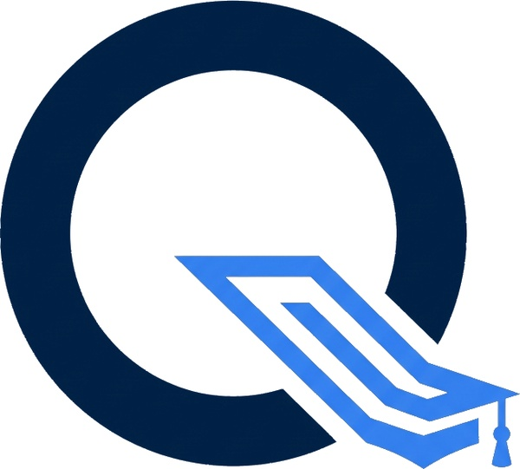 | QUANTECH INFOSYSTEM LLP.  3rd Floor, Behind Gurudwara, Mumbai-Agra Highway, Dhule, Maharashtra – 424001  Email: admin@quantechinfosystem.com | Web: https://quantechinfosystem.com
MEMORANDUM OF UNDERSTANDING
{mouSubtitle}
Ref No: {refId} | Date: {date}
PARTY A — SERVICE PROVIDER  Quantech Infosystem LLP.  {providerRoleDetail}  India | PARTY B — INSTITUTION  {schoolName}  {city}  {address}  UDISE Code: {udiseCode}

1. Background & Purpose
This Memorandum of Understanding ("MOU") is entered into between Quantech Infosystem LLP. (hereinafter "the Provider") and {schoolName} (hereinafter "the School"), collectively referred to as "the Parties."
{clause1Purpose}

2. Scope of Enrollment
{clause2Intro}
Agreed Student Enrollment Strength | {studentCount} Students
{#isCollege}College Year-wise Breakdown | 1st Year: {yr1Count} students @ ₹{yr1Rate} | 2nd Year: {yr2Count} students @ ₹{yr2Rate}{/isCollege}
Total Commercial Amount | {totalPrice} ({totalPriceLabel})
{upfrontRowTitle} | {upfrontPrice}
Billing Schedule & Terms | {commFooter}
{clause2Sla}

3. Obligations of the Provider
{#clause3Items}
• {text}
{/clause3Items}

{clause4Title}
{#clause4Items}
• {text}
{/clause4Items}

5. Confidentiality
Both Parties agree to maintain strict confidentiality of all information exchanged under this MOU, including student data, pricing, and platform configurations. Student data shall be used solely for the purpose of providing the agreed services and shall not be shared with any third party without prior written consent.

6. Duration & Termination
This MOU shall be effective from the date of signing and shall remain valid for a period of {durationWords}, renewable by mutual written consent. Either Party may terminate this MOU with 30 days' written notice. Upon termination, the School's data shall be made available for export for a period of 30 days before deletion.

7. Limitation of Liability
The Provider's total liability under this MOU shall not exceed the total fees paid by the School in the preceding 3 months. The Provider shall not be liable for indirect, incidental, or consequential damages arising from the use or inability to use the platform.

8. Governing Law
This MOU shall be governed by the laws of India. Any disputes arising out of or in connection with this MOU shall be subject to the exclusive jurisdiction of the courts in {jurisdiction}.

9. Entire Agreement
This MOU constitutes the entire understanding between the Parties with respect to its subject matter and supersedes all prior discussions, representations, or agreements. Amendments to this MOU shall be valid only if made in writing and signed by both Parties.
Signatures & Execution
For and on behalf of Institution (Party B):  {%schoolSignature}  {principalName}  {designation}  {schoolName}  UDISE Code: {udiseCode}  Date: {date} | For and on behalf of Provider (Party A):  {%providerSignature}  Authorised Representative  Director / CEO  Quantech Infosystem LLP.  For office use only  Date: {date}
This document was digitally generated & executed via Quantech Platform MOU Portal | Ref: {refId} | Date: {date}

