Internet of Things-Based Arrhythmia Disease Prediction Using Machine Learning Techniques

Mohammad Ghouse Mohiuddin1

Student, Department of CSE, Lords Institute of Engineering and Technology, India

160923733107@lords.ac.in

Syed Muzaffarullah Hussaini

Department of Nursing

GNM,Owaisi School of

Exellence

syedmuzaffar9182@gmail.com

Ruhiat Sultana Department of CSE, Lords Institute of Engineering and Technology, India

ruhiatsultana@lords.ac.in

***Abstract:* Arrhythmia-related cardiac death continues to be the leading cause of death worldwide. Arrhythmia patient monitoring is a crucial method that provides clients with all essential information regarding a cardiovascular patient's daily activities. An irregular heartbeat, or arrhythmia, is caused by problems that coincide with the electrical pulses that synchronize the heart's beating rhythm. The coronary heart's irregular or regular pounding is caused by malfunctioning signalling. This study uses an ECG to measure heart rate, a 5–50 Hz bandpass filter for filtering, and a stationary wavelet transform to eliminate artifacts. The characteristics extracted using the independent component analysis technique are Age, Cp, Trestbps, Chol, Fbs, Rest ECG, Thlach, Exang, Old Peak, Slope, Thal, Sex, and Target. Ultimately, support vector machines have achieved an accuracy of 85% and higher in classifying the dataset as either healthy or arrhythmia patients. The suggested approach is made to predict arrhythmia diseases and sends the results via a Telegram bot. Through the usage of a bot, the user's emergency numbers receive the classification result. Our suggested system's primary goal is to keep an eye on folks who are disabled or lonely at home. The planned project may significantly affect the elderly population, healthcare systems, paraplegics, and society at large.**

***Keywords. Machine Learning, Internet of Things, Support Vector Machine, Bandpass Filter****.*

* 1. **INTRODUCTION**

One of the most serious diseases in the modern world is arrhythmia, which manifests as an irregular heartbeat and can be fatal if left untreated. Patients suffering from arrhythmias hence require ongoing care [1]. Cardiac arrhythmia is reported to be the cause of 12% of all deaths worldwide [2]. Heart disease risk may rise due to stress [3-5]. An arrhythmia's early identification can reduce the risk to life. To treat cardiac arrhythmias effectively, medical management must be astute and able to supply the necessary medical facilities. Up to 86% of false warnings in the intensive care unit have been shown to lower the quality of care given, which has an impact on both patients and medical staff by delaying the time needed to respond to emergencies [6].We can now resolve the problems arrhythmic patients confront thanks to IoT, which can simplify medicine through automatic and non-invasive monitoring. The Internet of Things (IoT) network retrieves and analyzes ECG data to anticipate cardiovascular disease. In an emergency, it notifies medical professionals using an IoT-connected ECG measuring structure that promptly diagnoses irregularities. When the electrical signals that keep the heart's rhythm synchronized malfunction, the heart either beats too quickly (tachycardia) or too slowly (bradycardia), which causes an irregular heartbeat. In such cases, the heart beats uniformly.

In this study, we will propose an algorithm to support patients at home and also help patients with arrhythmias receive further healthcare support. The suggested system is simple to use and has a low total project cost, making it beneficial for patients of any age with arrhythmia diseases.

**II. LITERATURE SURVEY**

In this study, we will propose an algorithm to support patients at home and also help patients with arrhythmias receive further healthcare support. The suggested system is simple to use and has a low total project cost, making it beneficial for patients of any age with arrhythmia diseases.

In a previously published paper [7], the categorization of heart rate during movie viewing or rating sharing in a Telegram bot was illustrated. A person may occasionally suffer a rapid increase in heart rate while viewing a movie, which could hurt their health or possibly cause cardiac arrest. The ECG uses sensors to detect and interpret heart signals that are produced by electrical fields. The aforementioned paper maintains the pulse condition during the viewing of the film, which falls under the Backpropagation Neural Network category. Ac- A discretionary message regarding the nature of the film will be given via telegram based on the observations and analysis of the data gathered as well as the ratings of those who have previously viewed it.A person can then use that information to determine whether or not to watch that specific movie in light of their health. Teenagers, parents, and those with weak hearts will all benefit from this method.

In the current paper, ECG monitoring is done on elderly people and the alert is sent to their family members, the nearest hospital, and emergency services available using Telegram Bot.

Our previously published paper [8], will be discussed IoT and ML-based smart systems for cardiovascular disease. IoT is a popular intelligent system that manifests the non-hazardous machine learning technique and speculates results. In the previous paper, we focused on speculating cardiovascular disease output with the help of IoT along with machine learning strategies for safety in blockchain platforms. The electrical signals were collected from the human heart by placing the electrodes on the chest – a process called ECG. The dataset collected was pre-processed by using 5-15 Hz band pass filtering and SWT and PCA were used for undesired artifact elimination. SVM is used to classify any individual as healthy or a patient with a compromised cardiovascular condition.

In the current paper, we are focusing on the health care of elderly people and we are using Telegram Bot for sending alert messages which is cost-effective as well.

Izci et. al. [9], were discussed, that heart diseases are among the primary reasons for sudden fatality. Cardiac arrhythmia if diagnosed early and treated could help prevent life risk. To develop an algorithm for predicting arrhythmia based on the principle of EMD. Pre-processing, Empirical Mode Decomposition, feature extraction, and classification are the four steps of this algorithm. To differentiate between signals obtained from normal and arrhythmic hearts six types of arrhythmia features were used.

In this current paper, the steps of our algorithm are as follows: filtering, artifact removal, feature extraction, classification, and sending messages to the user to classify the data set as arrhythmia or healthy person.

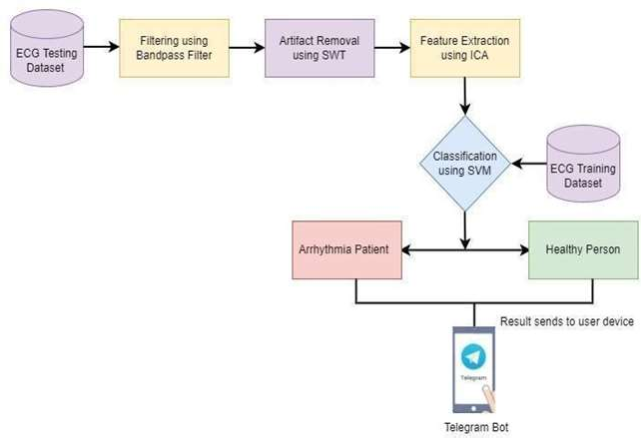

Figure 1. Arrhythmia Prediction using AI Tools and Bot

1. **PROPOSED WORK**

This proposed work dataset collects signals from the heart through the use of an ECG sensor, and 5-50 Hz range of bandpass filter used for filtering, and the SWT method used for artifact removal and ICA used for feature extraction. SVM is used for classification results as Arrhythmia if features are matched, if the criterion isn't matched then the result is proven as healthy. The result is sent to the user’s mobile by using the Telegram Bot. The proposed work is shown in Figure 1.

In this section, it explains the results of the research and at the same time given the comprehensive discussion. Results can be presented in figures, graphs, tables, and others that make the reader understands easily[14], [15]. The discussion can be made in several sub-sections.

**IV. RESULTS**

1. **RESULT**
   1. Dataset Collection

The training dataset was collected from the MIT-BIHA trial Fibrillation database. According to the dataset, there were recordings of 23 channels of ECG of patients with arrhythmia. The frequency of ECG collected data is 250Hz accompanied by 12- bit resolution which ranges between- 10 to +10 milli volts. The sample of the arrhythmia disease prediction dataset is shown in Table1.

Table 1. Sample data set collection for arrhythmia prediction

**Sl No A S C Tb Cl F R Tl E Op Tar**

|  |  |  |  |  |  |  |  |  |  |  |  |  |
| --- | --- | --- | --- | --- | --- | --- | --- | --- | --- | --- | --- | --- |
| 1 | 61 | 1 | 3 | 146 | 230 | 1 | 0 | 153 | 0 | 2.2 | 0 | 1 |
| 2 | 35 | 1 | 2 | 133 | 254 | 0 | 1 | 183 | 0 | 3.4 | 0 | 1 |
| 3 | 40 | 0 | 1 | 133 | 200 | 0 | 0 | 170 | 0 | 1.3 | 2 | 1 |
| 4 | 53 | 1 | 1 | 121 | 233 | 0 | 1 | 175 | 0 | 0.9 | 2 | 1 |
| 5 | 59 | 0 | 0 | 122 | 350 | 0 | 1 | 160 | 1 | 0.7 | 2 | 1 |

**4.2 Classical Result**

In Table 2, by calculating the F1 score, Recall, and Precision we find that SVM is the suitable machine learning technique for arrhythmia disease prediction.

Table 2.F1 Score,Recall, Precision by Using Support Vector Machine

|  |  |  |  |  |  |
| --- | --- | --- | --- | --- | --- |
| Training Accuracy | Testing Accuracy | F1 score | Recall | Precision | Time |
| 0.923 | 0.812 | 0.88 | 0.87 | 0.88 | 1 Min 2sec |

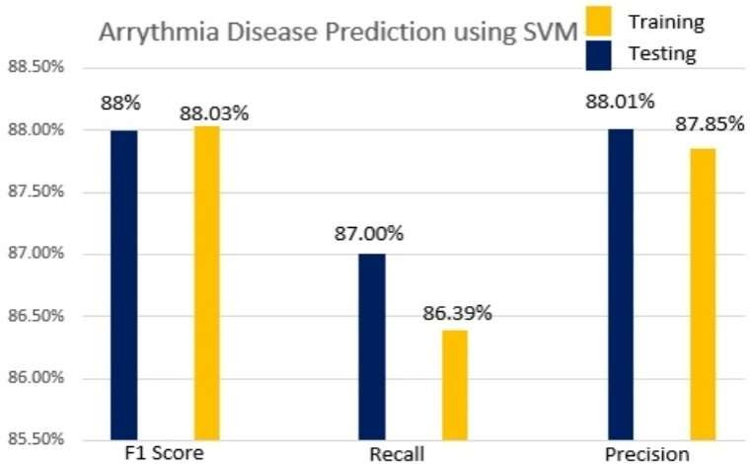

Figure.2 F1 score, Recall, and Precision by using Support vector machine

**4.3 Performance Analysis**

Performance of the proposed method is analyzed by Mc Nemar’s Test as shown inTable3.

Table 3. Mc Nemar’s Test

|  |  |  |  |  |
| --- | --- | --- | --- | --- |
| Other Machine Learning  Algorithms Testing (P) | Proposed Support Vector Machine(SVM) Algorithm(Q) | | | |
| N01 | N10 | Z | Component |
| Back Propagation Neural Network(BPNN) | 7 | 29 | 11.5 | Reject |
| Analysis (LDA) | | | | |
| Quadratic Discremenent Analysis (QDA) | 6 | 23 | 12.8 | Reject |
|  |  |  |  |  |

The performance analysis for the proposed work is compared with different types of machine learning techniques by using MC Nemar’s numerical test. In this paper, SVM is the control algorithm let P, another competitor algorithm as BPNN, kNN, QDA, and LDA is Q. The null speculation right at this point visualizes each procedure will distribute the identical mistakes frequency. Here the null hypothesis was neglected, when Z is going above 2.87, that's the necessary cost forχ2distributionfor 1 degree of freedom of possibility is 0.04. Table 3 shows that the significant variation in overall result is discovered by using Mc Nemar’s test despite the fact of comparing the currently proposed SVM system with all other 4 class methods.

**4.4. Complexity Analysis**

The training time complexity of the proposed work using a support vector machine is O(n2), where n is the number of inputs and if n is very large amount of data then it will be complex. The run-time complexity of the proposed system is O(k*d), here k is the number of support vectors and d is used for the dimensionality of the data.

**V. Conclusion and Future Work**

In this section, the conclusion and future research will be covered. The current proposed model is an end-to-end model that uses data gathered from a wearable ECG device. Two processes are used for pre-processing the data: filtering in the 5–50 Hz band, using SWT to remove artifacts, and using Independent Component Analysis to extract and select features. Databases are classified as having arrhythmia patients and healthy individuals using support vector machines. The end user receives the classification results via a Telegram bot. The suggested method uses machine learning algorithms and ECG inputs to perform arrhythmia identification.   
Different machine learning and deep learning approaches will be used in the future for various disease prediction applications.

**REFERENCES**

1. D P, Y. and D. L. N, (2021) "Early Detection of Cardiac Arrhythmia Disease using Machine Learning and IoT Technologies," 2021 2nd International Conference on Smart Electronics and Communication (ICOSEC), pp.1658-1661,doi:10.1109/ICOSEC51865.2021.9591884.
2. Dube, D., Kumar, D. S. and Gupta, S. K. (2021) "An Empirical study of the IoT arrhythmia detection methods: Review and research gaps," 2021 International Conference on Computer Communication and Informatics (ICCCI), pp. 1-8, doi: 10.1109/ICCCI50826.2021.9402472.
3. Das, Sima & Ghosh, Lidia &Saha, Sriparna. (2020). Analyzing Gaming Effects on Cognitive Load Using Artificial Intelligent Tools. 10.1109/CONECCT50063.2020.9198662.
4. Das, Sima &Saha, Sriparna. (2022). Home Automation System Combining Internet-of-Things with Brain-Computer Interfacing. 10.1007/978-981-19-1408-9_11.
5. Ghosh, Ahona& Das, Sima &Saha, Sriparna. (2022). Stress detection for cognitive rehabilitation in COVID-19 scenario. 10.1049/PBHE042E_ch12.
6. Alinejad, G. M., Rasoulinezhad, S. and Shamsollahi, M. B. ,(2019) "Prediction of Life-Threatening Heart Arrhythmias Using Obstructive Sleep Apnoea Characteristics," 2019 27th Iranian Conference on Electrical Engineering (ICEE), pp. 1761-1764, doi: 10.1109/Irani- anCEE.2019.8786614.
7. Das, Sima & Bhattacharya, Aakashjit. (2021). ECG Assess Heartbeat rate, Classifying using BPNN while Watching the Movie and send Movie Rating through Telegram. 465-474. 10.1007/978-981-15-9774-9_43.
8. Das, Sima & Das, Jaya &Modak, Subrata & Mazumdar, Kaushik. (2022). Internet of Things with Machine Learning based smart Cardiovascular disease classifier for Healthcare in Secure platform.
9. Izci, E.,Ozdemir, M. A. , Sadighzadeh, R. and Akan, A.( 2018 ) "Arrhythmia Detection on ECG Sig- nals by Using Empirical Mode Decomposition," Medical Technologies National Congress (TIPTEKNO), 2018, pp. 1-4, doi: 10.1109/TIPTEKNO.2018.8597094.
10. Z.Wang, V.Ramamoorthy, U.Gal, and A.Guez, "Possible Life Saver: A Review on Human Fall Detection Technology." Robotics, Vol. 9(3), pp. 55, July 2020.
11. M.H.Arshad, M.Bilal, and A.Gani, "Human Activity Recognition: Review, Taxonomy and Open Challenges." Sensors, Vol. 22(17), pp. 6463, August 2020.
12. K.Dae-Eon, J.BongKyu, and K.Dong-Soo, "3D Convolutional Neural Networks Based Fall Detection with Thermal Camera." The Journal of Korea Robotics Society 13(1), 45-54, February 2018.
13. A.Sizhe, and U.Y.Ogras, "Mars: mmwave-based assistive rehabilitation system for smart healthcare." ACM Transactions on Embedded Computing Systems (TECS), vol. 20(5s), pp. 1-22, September 2021.
14. A. M. De Boissiere and R. Noumeir, "Infrared and 3D Skeleton Feature Fusion for RGB-D Action Recognition," in IEEE Access, vol. 8, pp. 168297-168308, September 2020.
15. G.Zheng, L.Songtao, W.Feng, L.Zeming, and S.Jian, "Yolox: Exceeding Yolo Series in 2021." arXiv preprint arXiv:2107.08430, August 2021