Chapter 14—Fluid Mechanics

MULTIPLE CHOICE

1. A stonecutter's chisel has an edge area of 0.7 cm². If the chisel is struck with a force of 42 N, what is the pressure exerted on the stone?
a. | 600 N/m²
b. | 30 000 N/m²
c. | 300 000 N/m²
d. | 600 000 N/m²
e. | 6 000 N/m²

ANS: D PTS: 2 DIF: Average

2. When water freezes, it expands about nine percent. What would be the pressure increase inside your automobile engine block if the water in there froze? The bulk modulus of ice is 2.0 × 10⁹ N/m², and 1 ATM = 1.01 × 10⁵ N/m².
a. | 18 ATM
b. | 360 ATM
c. | 1 100 ATM
d. | 1 800 ATM
e. | 600 ATM

ANS: D PTS: 2 DIF: Average

3. All people come very close to being able to float in water. What therefore is the volume (in cubic meters) of a 50-kg woman?
a. | 0.007
b. | 0.035
c. | 0.050
d. | 0.070
e. | 0.085

ANS: C PTS: 2 DIF: Average

4. Find the average density of a white dwarf star if it has a mass equal to that of the sun (2.0 × 10³⁰ kg) and a radius equal to that of the Earth (6.4 × 10⁶ m).
a. | 9.0 × 10⁶ kg/m³
b. | 1.8 × 10⁷ kg/m³
c. | 1.8 × 10⁹ kg/m³
d. | 3.6 × 10¹⁰ kg/m³
e. | 9.0 × 10⁷ kg/m³

ANS: C PTS: 2 DIF: Average

5. Find the average density of a red giant star with a mass of 20 × 10³⁰ kg (approximately 10 solar masses) and a radius of 150 × 10⁹ m (equal to the Earth's distance from the sun).
a. | 1.41 × 10⁻⁴ kg/m³
b. | 0.007 kg/m³
c. | 1.41 kg/m³
d. | 710 kg/m³
e. | 1.41 × 10⁻³ kg/m³

ANS: E PTS: 2 DIF: Average

6. Find the pressure in atmospheres in the water at the base of Dworshak Dam if the water in the reservoir is 200 meters deep. (1.01 × 10⁵ N/m² = 1 ATM.)
a. | 20.4 ATM
b. | 24.7 ATM
c. | 29.4 ATM
d. | 194 ATM
e. | 75 ATM

ANS: A PTS: 2 DIF: Average

7. Some species of whales can dive to depths of one kilometer. What is the total pressure they experience at this depth? (ρ_{sea} = 1 020 kg/m³ and 1.01 × 10⁵ N/m² = 1 ATM.)
a. | 9.00 ATM
b. | 90.0 ATM
c. | 100 ATM
d. | 111 ATM
e. | 130 ATM

ANS: C PTS: 2 DIF: Average

8. What is the total mass of the Earth's atmosphere? The radius of the Earth is 6.4 × 10⁶ m, and 1 ATM = 1.01 × 10⁵ N/m².
a. | 5.3 × 10¹⁶ kg
b. | 1.1 × 10¹⁸ kg
c. | 5.3 × 10¹⁸ kg
d. | 1.1 × 10²⁰ kg
e. | 5.3 × 10⁹ kg

ANS: C PTS: 2 DIF: Average

9. A blimp is filled with 200 m³ of helium. How much mass can the balloon lift? The density of helium is one-seventh that of air, and the density of air is 1/800 that of water. Consider the mass of the balloon to be negligible.
a. | 115 kg
b. | 214 kg
c. | 315 kg
d. | 415 kg
e. | 37 kg

ANS: B PTS: 2 DIF: Average

10. To the nearest percent, what fraction of an iceberg is submerged? (ρ_{ice} = 917 kg/m³, ρ_{sea} = 1.03 × 10³ kg/m³.)
a. | 95%
b. | 93%
c. | 91%
d. | 89%
e. | 77%

ANS: D PTS: 2 DIF: Average

11. A supertanker filled with oil has a total mass of 6.1 × 10⁸ kg. If the dimensions of the ship are those of a rectangular box 300 meters long, 80 meters wide, and 40 meters high, determine how far the bottom of the ship is below sea level. (ρ_{sea} = 1 020 kg/m³.)
a. | 10 m
b. | 15 m
c. | 20 m
d. | 25 m
e. | 30 m

ANS: D PTS: 2 DIF: Average

12. Determine the minimum area of a flat ice floe 1.0 meter thick if it is to support a 2 000-kg car above seawater. (ρ_{ice} = 920 kg/m³, ρ_{sea} = 1 020 kg/m³.)
a. | 20 m²
b. | 40 m²
c. | 60 m²
d. | 80 m²
e. | 100 m²

ANS: A PTS: 2 DIF: Average

13. A hydraulic lift raises a 2 000-kg automobile when a 500-N force is applied to the smaller piston. If the smaller piston has an area of 10 cm², what is the cross-sectional area of the larger piston?
a. | 40 cm²
b. | 80 cm²
c. | 196 cm²
d. | 392 cm²
e. | 160 cm²

ANS: D PTS: 2 DIF: Average

14. A hole is punched in a full milk carton, 10 cm below the top. What is the initial velocity of outflow?
a. | 1.4 m/s
b. | 2.0 m/s
c. | 2.8 m/s
d. | 3.9 m/s
e. | 4.2 m/s

ANS: A PTS: 2 DIF: Average

15. The water level in a reservoir is maintained at a constant level. What is the exit velocity in an outlet pipe 3.0 m below the water surface?
a. | 2.4 m/s
b. | 3.0 m/s
c. | 5.4 m/s
d. | 7.7 m/s
e. | 49 m/s

ANS: D PTS: 2 DIF: Average

16. Water is flowing at 4.0 m/s in a circular pipe. If the diameter of the pipe decreases to 1/2 its former value, what is the velocity of the water downstream?
a. | 1.0 m/s
b. | 2.0 m/s
c. | 8.0 m/s
d. | 16 m/s
e. | 4.0 m/s

ANS: D PTS: 2 DIF: Average

17. Water pressurized to 3.5 × 10⁵ Pa is flowing at 5.0 m/s in a horizontal pipe which contracts to 1/3 its former area. What are the pressure and velocity of the water after the contraction?
a. | 2.5 × 10⁵ Pa, 15 m/s
b. | 3.0 × 10⁵ Pa, 10 m/s
c. | 3.0 × 10⁵ Pa, 15 m/s
d. | 4.5 × 10⁵ Pa, 1.5 m/s
e. | 5.5 × 10⁵ Pa, 1.5 m/s

ANS: A PTS: 2 DIF: Average

18. A fountain sends water to a height of 100 meters. What must be the pressurization (above atmospheric) of the water system? 1 ATM = 1.01 × 10⁵ N/m².
a. | 1.0 ATM
b. | 4.2 ATM
c. | 7.2 ATM
d. | 9.7 ATM
e. | 8.2 ATM

ANS: D PTS: 2 DIF: Average

19. What is the net force inward acting on a spherical bathysphere of diameter 2.00 m at an ocean depth of 1 000 m? (The pressure inside the bathysphere is, hopefully, 1 ATM.) ρ_{(sea water)} = 1.02 × 10³ kg/m³.
a. | 1.26 × 10⁴ N
b. | 1.26 × 10⁶ N
c. | 1.26 × 10⁸ N
d. | 1.26 × 10¹⁰ N
e. | 1.26 × 10² N

ANS: C PTS: 2 DIF: Average

20. The pressure inside a commercial airliner is maintained at 1 ATM (1.01 × 10⁵ N/m²). What is the outward force exerted on a 1.0 m × 2.0 m cabin door if the outside pressure (at 10 km height) is 0.3 ATM?
a. | 1.4 × 10² N
b. | 1.4 × 10³ N
c. | 1.4 × 10⁴ N
d. | 1.4 × 10⁵ N
e. | 7.0 × 10³ N

ANS: D PTS: 2 DIF: Average

21. In a wind tunnel the pressure on the top surface of a model airplane wing is 8.8 × 10⁴ N/m and the pressure on the bottom surface is 9.0 × 10⁴ N/m². If the area of the top and bottom surfaces of each wing is 2.0 m², what is the total lift on the model airplane?
a. | 2.0 × 10³ N
b. | 8.0 × 10³ N
c. | 1.6 × 10⁴ N
d. | 3.6 × 10⁴ N
e. | 1.0 × 10³ N

ANS: B PTS: 2 DIF: Average

22. Air within the funnel of a large tornado may have a pressure of only 0.2 ATM. What is the approximate outward force on a (5 m × 10 m) wall if a tornado suddenly envelops the house? (1 ATM = 1.01 × 10⁵ N/m².)
a. | 4 × 10³ N
b. | 4 × 10⁴ N
c. | 4 × 10⁵ N
d. | 4 × 10⁶ N
e. | 7 × 10⁵ N

ANS: D PTS: 2 DIF: Average

23. A Boeing 737 airliner has a mass of 20 000 kg and the total area of both wings (top or bottom) is 100 m². What is the pressure difference between the top and bottom surface of each wing when the airplane is in flight at a constant altitude?
a. | 1 960 N/m²
b. | 3 920 N/m²
c. | 7 840 N/m²
d. | 4 560 N/m²
e. | 3 070 N/m²

ANS: A PTS: 2 DIF: Average

24. The siphon shown is used to transfer liquid from a higher level to a lower level. If the fluid is drawn up and is continuous through the tube, determine the velocity of flow of gasoline if the vertical distance from the liquid surface to the outlet is 1.0 m.

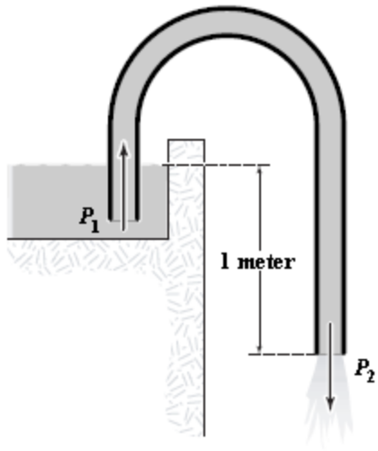

a. | 1.1 m/s
b. | 2.2 m/s
c. | 4.4 m/s
d. | 9.8 m/s
e. | 6.5 m/s

ANS: C PTS: 2 DIF: Average

25. A venturi tube may be used as the inlet to an automobile carburetor. If the 2.0-cm diameter pipe narrows to a 1.0-cm diameter, what is the pressure drop in the constricted section for an airflow of 3.0 m/s in the 2.0-cm section? (ρ = 1.2 kg/m³.)
a. | 70 Pa
b. | 85 Pa
c. | 100 Pa
d. | 120 Pa
e. | 81 Pa

ANS: E PTS: 2 DIF: Average

26. A wind of velocity 10 m/s is blowing through a wind generator with blade radius 5.00 meters. What is the maximum power output if 30.0% of the wind's energy can be extracted? ρ_{air} = 1.25 kg/m³.
a. | 7.20 kW
b. | 14.7 kW
c. | 21.3 kW
d. | 29.4 kW
e. | 39.6 kW

ANS: B PTS: 2 DIF: Average

27. How much power is theoretically available from a mass flow of 1 000 kg/s of water when it falls a vertical distance of 100 meters?
a. | 980 kW
b. | 98 kW
c. | 4 900 W
d. | 980 W
e. | 9 600 W

ANS: A PTS: 2 DIF: Average

28. Water is sent from a firehose at 30.0 m/s at an angle of 30.0° above the horizontal. What is the maximum height reached by the water?
a. | 7.50 m
b. | 11.5 m
c. | 15.0 m
d. | 19.0 m
e. | 30.0 m

ANS: B PTS: 2 DIF: Average

29. A thin rectangular piece of wood floats in water. You slowly pour oil with a density equal to that of the wood on the surface of the water until the height of the oil above the water is twice the height of the piece of wood. Which statement is correct?
a. | The wood floats on top of the oil, so it sticks up in the air.
b. | The wood does not change its position
c. | The wood sinks below the surface of the water.
d. | The wood is half in the water and half in the oil.
e. | The wood floats in the oil just above the water.

ANS: E PTS: 1 DIF: Easy

30. Two identical fish, both at sea level, float in two identical aquariums with identical quantities of water. Fish A is in Alaska, so it weighs more than fish B at the equator, since g is larger at sea level in Alaska. Which statement is correct?
a. | A comparison is impossible unless they are both floating at the same level.
b. | Fish A displaces a greater quantity of water than fish B.
c. | Fish B displaces a greater quantity of water than fish A.
d. | They both displace the same quantity of water.
e. | Fish A has a smaller acceleration than Fish B when equal horizontal forces are applied to each, because Fish A weighs more.

ANS: D PTS: 1 DIF: Easy

31. A waiter in a restaurant fills a pitcher full of water and ice so that water would spill out if any more were added. As the ice starts to melt
a. | the water level in the pitcher falls.
b. | the water level in the pitcher remains the same.
c. | water starts to flow out the spout of the pitcher.
d. | the pressure on the bottom of the pitcher decreases.
e. | the pressure on the bottom of the pitcher increases.

ANS: B PTS: 1 DIF: Easy

32. People can snorkel down to a depth of roughly one meter. This means that the additional pressure on the air in their lungs is roughly
a. | 9 800 N.
b. | 9 800 Pa.
c. | 9 800 ATM.
d. | 19 600 N.
e. | 19 600 N/m².

ANS: B PTS: 2 DIF: Average

33. A wood block is placed on top of the ice in a large bowl half full of ice. The bowl is then filled to the brim with water, with the wood block riding on top of the ice. As the ice melts,
a. | the density of the water decreases.
b. | the water level falls below the rim.
c. | the water level rises and water spills out of the bowl.
d. | the water level does not change.
e. | the wood block descends, causing water to spill out of the bowl.

ANS: D PTS: 1 DIF: Easy

34. An empty spice bottle has an inner volume of 1.31 × 10⁻⁴ m³. It has a mass of 112 g when filled with air, and it displaces 1.63 × 10⁻⁴ m³ of water when fully submerged. What fraction of the total volume of the bottle will be beneath the surface when it is placed in a tank of water?
a. | 0.69
b. | 0.81
c. | 0.85
d. | 1.00
e. | 1.46

ANS: A PTS: 2 DIF: Average

35. An empty spice bottle has an inner volume of 1.31 × 10⁻⁴ m³. It has a mass of 112 g when filled with air, and it displaces 1.63 × 10⁻⁴ m³ of water when fully submerged. What volume of mercury (ρ_{Hg} = 13.6 × 10³ kg/m³) must be added to the empty bottle so that it will just submerge?
a. | 3.75 cm³
b. | 12.0 cm³
c. | 101 cm³
d. | 147 cm³
e. | 237 cm³

ANS: A PTS: 2 DIF: Average

36. The figure below shows a container filled with water to the height shown. When we compare the pressure at A to the pressure at B, we find that

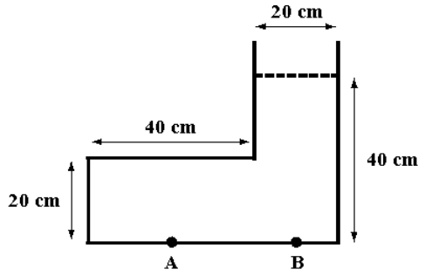

a. | 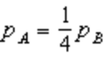.
b. | 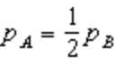.
c. | p_{A} = p_{B}.
d. | p_{A} = 2p_{B}.
e. | p_{A} = 4p_{B}.

ANS: C PTS: 1 DIF: Easy

37. The water level in identical bowls, A and B, is exactly the same. A contains only water; B contains floating ice as well as water. When we weigh the bowls, we find that
a. | W_{A} < W_{B}.
b. | W_{A} = W_{B}.
c. | W_{A} > W_{B}.
d. | W_{B} > W_{A} if the volume of the ice cubes is greater than the volume of the water.
e. | W_{B} > W_{A} if the volume of the ice cubes is greater than 9 times the volume of the water.

ANS: B PTS: 1 DIF: Easy

38. A cube of water ice (ρ = 0.917 × 10³ kg/m³) is placed in mercury (ρ = 13.6 × 10³ kg/m³), which is liquid at 0° Celsius. If we ignore any possible melting of the ice cube and problems with the surface tension of mercury, the fraction of the ice cube that floats above the surface of the mercury is
a. | 0.067 4.
b. | 0.073 5.
c. | 0.926.
d. | 0.933.
e. | 1.00.

ANS: D PTS: 2 DIF: Average

39. A police crime lab is trying to determine whether someone was murdered or died as a result of an accident. He was struck in the temple by a 4.20 kg sculpture that is alleged to have fallen off a bookcase. The sculpture presumably fell a distance of 1.43 m and the corner that struck him had an area of 0.250 cm². If the time for the sculpture to stop was 1.00 ms, the pressure on his temple, in N/m², was
a. | 8.89 × 10⁴.
b. | 1.65 × 10⁵.
c. | 1.65 × 10⁶.
d. | 8.89 × 10⁸.
e. | 1.65 × 10⁹.

ANS: D PTS: 3 DIF: Challenging

40. A hose has been clamped so that the area at the clamp is only one quarter the area of the rest of the hose. When we ignore the viscosity of water, the ratio of the volume of water delivered per unit time when the clamp is on to the volume of water delivered per unit time without the clamp is
a. | .
b. | .
c. | .
d. | .
e. | 1.

ANS: E PTS: 1 DIF: Easy

41. A hose has been clamped so that the area at the clamp is only one quarter the area of the rest of the hose. When we ignore the viscosity of water, the ratio of the speed of the water through the clamped area to the speed of the water when it leaves the hose is
a. | .
b. | .
c. | 1.
d. | 2
e. | 4.

ANS: E PTS: 2 DIF: Average

42. A dictator has built a bunker for his use in emergencies. Its dimensions are shown below. When it floods to ground level during a tropical storm, the gauge pressure at point A, in Pa, is

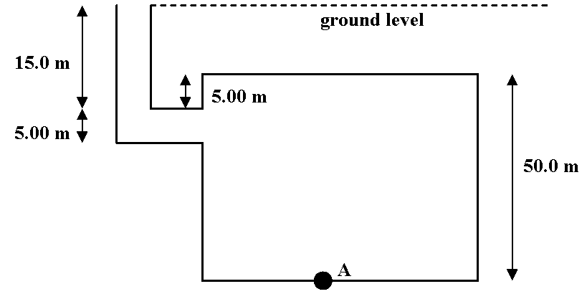

a. | 3.92 × 10⁵.
b. | 4.90 × 10⁵.
c. | 5.39 × 10⁵.
d. | 5.88 × 10⁵.
e. | 6.89 × 10⁵.

ANS: D PTS: 2 DIF: Average

Exhibit 14-1
A dictator has built a bunker for his use in emergencies. Its dimensions are shown below. When it floods to ground level during a tropical storm, air is trapped above the dashed line in the bunker.

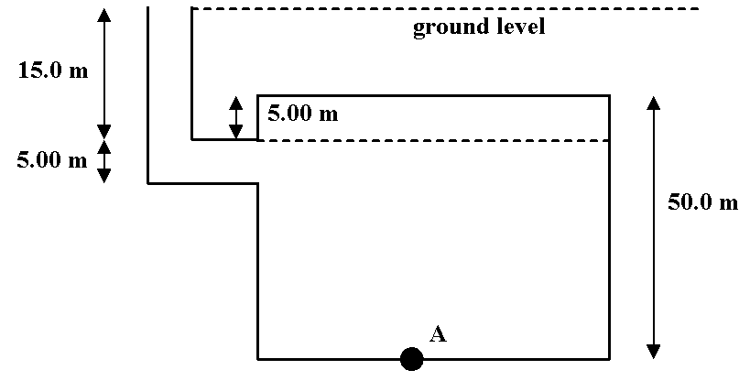

Use this exhibit to answer the following question(s).

43. Refer to Exhibit 14-1. The gauge pressure at point A, in Pa, is
a. | 3.92 × 10⁵.
b. | 4.90 × 10⁵.
c. | 5.39 × 10⁵.
d. | 5.88 × 10⁵.
e. | 6.89 × 10⁵.

ANS: D PTS: 2 DIF: Average

44. Refer to Exhibit 14-1. The absolute pressure at point A, in Pa, is
a. | 3.92 × 10⁵.
b. | 4.90 × 10⁵.
c. | 5.39 × 10⁵.
d. | 5.88 × 10⁵.
e. | 6.89 × 10⁵.

ANS: E PTS: 2 DIF: Average

45. Melanie says that when a diver enters an underwater cave of height h, the pressure on her is no greater than ρ_{W}gh. Rosalind says that if the bottom of the cave is a distance H below the water surface, the pressure on the soles of the diver's feet can reach ρ_{W}gH. Which one, if either, is correct? (The density of water is ρ_{W}.)
a. | Melanie, because the roof of the cave absorbs the water pressure from above.
b. | Melanie, because only the fluid directly above any volume of the fluid can contribute to the pressure on that volume.
c. | Rosalind, because a fluid exerts equal pressure in all directions at a given depth.
d. | Rosalind, because the pressure also depends on the density, ρ_{c}, of the material above the cave roof, so that p = ρ_{c}g(H − h) + ρ_{W}gh.
e. | Melanie, because the pressure equals p = ρ_{W}gH − ρ_{c}g(H − h).

ANS: C PTS: 2 DIF: Average

46. An iron block of density ρ_{Fe} and of volume l³ is immersed in a fluid of density ρ_{fluid}. The block hangs from a scale which reads W as the weight. The top of the block is a height h below the surface of the fluid. The correct equation for the reading of the scale is
a. | W = (ρ_{Fe} − ρ_{fluid})ghl².
b. | W = (ρ_{fluid} − ρ_{Fe})gl³.
c. | W = (ρ_{Fe} − ρ_{fluid})gl³.
d. | W = (ρ_{Fe} + ρ_{fluid})ghl².
e. | W = (ρ_{Fe} + ρ_{fluid})gl³.

ANS: C PTS: 2 DIF: Average

47. A boat is floating in a small pond. The boat then sinks so that it is completely submerged. What happens to the level of the pond?
a. | It increases.
b. | It decreases.
c. | It stays the same.
d. | In some cases it would decrease, in others it would stay the same.
e. | In some cases it would increase, in others it would stay the same.

ANS: B PTS: 2 DIF: Average

48. A boat is floating in a small pond. The boat then sinks resting on the bottom, but the pond is so shallow that part of the boat is not submerged. What happens to the level of the pond?
a. | It increases.
b. | It decreases.
c. | It stays the same.
d. | In some cases it would decrease, in others it would stay the same.
e. | In some cases it would increase, in others it would stay the same.

ANS: B PTS: 2 DIF: Average

49. A large water storage container is filled to a depth of 3.0 m. The volume above the water is filled with air. In order to pump the water from the container, the air pressure in the container is increased by 3.0 10⁵ N/m². What happens to the pressure in the water at a depth of 1.0 m when the air pressure is increased?
a. | Nothing, it is still at a depth of 1.0 m and the pressure in the water depends only on the depth.
b. | It increases by 1.0 10⁵ N/m², since it is at 1/3 the depth of the water.
c. | It increases by 2.0 10⁵ N/m², since it is at 2/3 the depth from the bottom of the container.
d. | It increases by 3.0 10⁵ N/m².
e. | It increases by 3.0 10⁵ N/m² + 9.8 10³ N/m² since it is 1.0 m deep in the water.

ANS: D PTS: 2 DIF: Average

PROBLEM

50. One hundred milliliters of water is poured into a U-tube that has a cross-sectional area of 1 cm². Then 100 milliliters of oil, with a density 80% that of water, is poured down one side of the U-tube so that the oil floats on the water. Find the difference in height of the liquid surfaces on the two sides of the U-tube.

ANS:
20 cm

PTS: 2 DIF: Average

51. A natural gas pipeline with a diameter 0.250 m delivers 1.55 cubic meters of gas per second. What is the flow speed of the gas in the pipeline?

ANS:
31.6 m/s

PTS: 2 DIF: Average

52. A fountain sends a stream of water 20.0 m up into the air. If the base of the stream is 10.0 cm in diameter, what power is required to send the water to this height?

ANS:
30.5 kW

PTS: 2 DIF: Average

53. A vertical pipe, closed at the bottom end, is filled to a depth of 1.00 m with water and then an amount of oil of density 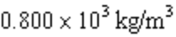 is added to make the total depth 2.00 m. The oil and water don’t mix with the oil floating on top of the water. What is the increase in pressure at the bottom end of the pipe as a result of adding the fluids?

ANS:
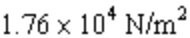

PTS: 2 DIF: Average

