SIMATS ENGINEERING
ASSESSMENT TOOL 1 : Concept Mapping

COURSE NAME: | Cloud Computing and Big Data Analytics | COURSE CODE: | CSA1502

COURSE OUTCOME COVERED
CO1: Apply cloud computing technologies including hardware-software evolution, virtualization, web services, and service models to develop cloud-based solutions. (BL2)
Assessment Tool Weightage: 20%

Dave's Taxonomy: Imitation (Level 1)  Question Count: 4 | Total Marks: 50

Code of Conduct
I MOHAMMED SABIQ S / 192511014 certify that this submission is my original work and that I have adhered to the guidelines specified for this assessment.
I understand that any violation of academic integrity rules will result in disciplinary action.
Signature of the student: MOHAMMED SABIQ S

Assessment Tasks
Concept Mapping Tasks
Create concept maps for the following tasks. Each map must show key nodes, link labels, and a logical hierarchy.
- Concept Map 1: Cloud Computing Fundamentals. Include definition, characteristics, benefits, and limitations.
- Concept Map 2: Evolution of Cloud Computing. Connect hardware evolution, internet software evolution, distributed systems, and service delivery.
- Concept Map 3: Service Models. Map IaaS, PaaS, SaaS, and XaaS with provider responsibilities and user responsibilities.
- Concept Map 4: Virtualization and Web Services as Enablers of Cloud. Show how these two concepts support cloud deployment and scalability.
Expected concept nodes:
- Elasticity, scalability, resource pooling, on-demand access, measured service
- Virtual machine, hypervisor, abstraction, API, SOAP, REST, provider, consumer
- Infrastructure layer, platform layer, application layer, shared responsibility

Concept Mapping Rubric

Criteria | Weightage | Level 4 - Exemplary | Level 3 - Proficient | Level 2 - Developing | Level 1 - Beginning
Concept Identification | 25% | All major concepts are accurately identified | Most concepts are identified correctly | Limited concepts are identified | Essential concepts are missing
Relationship Mapping | 25% | Links between concepts are accurate and meaningful | Most links are correct | Some links are weak or unclear | Relationships are mostly incorrect
Hierarchy and Organization | 20% | Excellent structure with clear hierarchy | Mostly organized with minor issues | Basic structure with weak hierarchy | No logical organization
Technical Relevance | 20% | Map strongly reflects cloud course content | Mostly aligned to topic | Partially aligned to topic | Weak alignment to topic
Visual Clarity | 10% | Neat, readable, and easy to interpret | Generally readable | Somewhat cluttered | Poorly presented

CONCEPT MAP 1
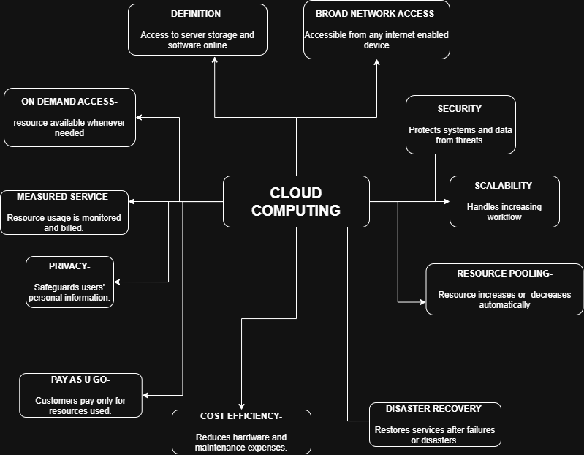

Concept Map 2
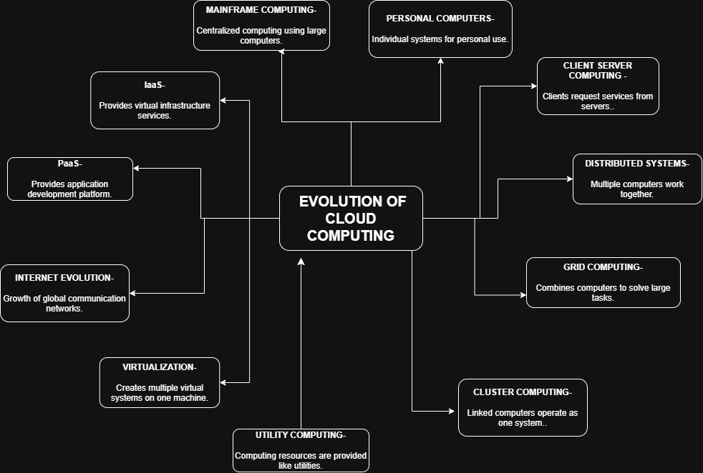
Concept Map 3
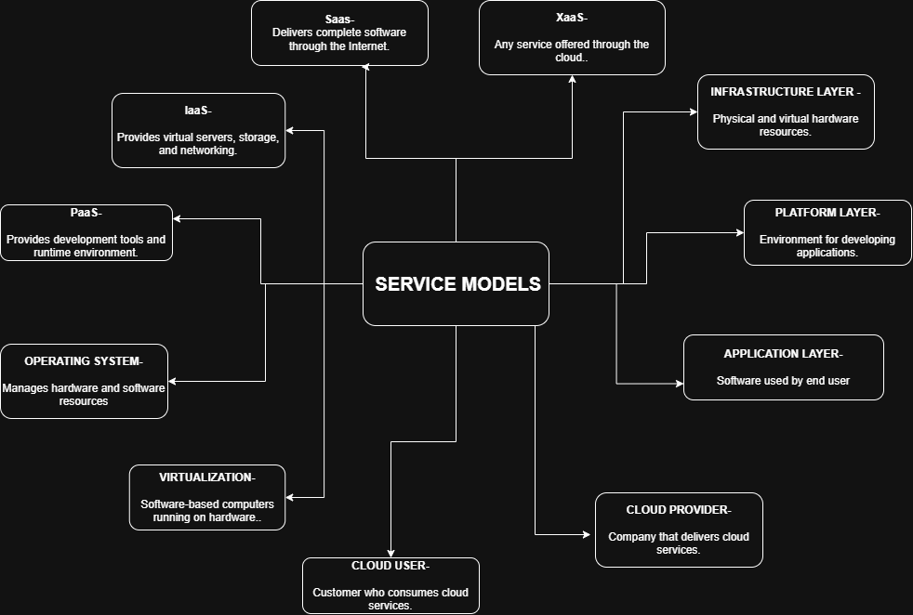

Concept Map 4:
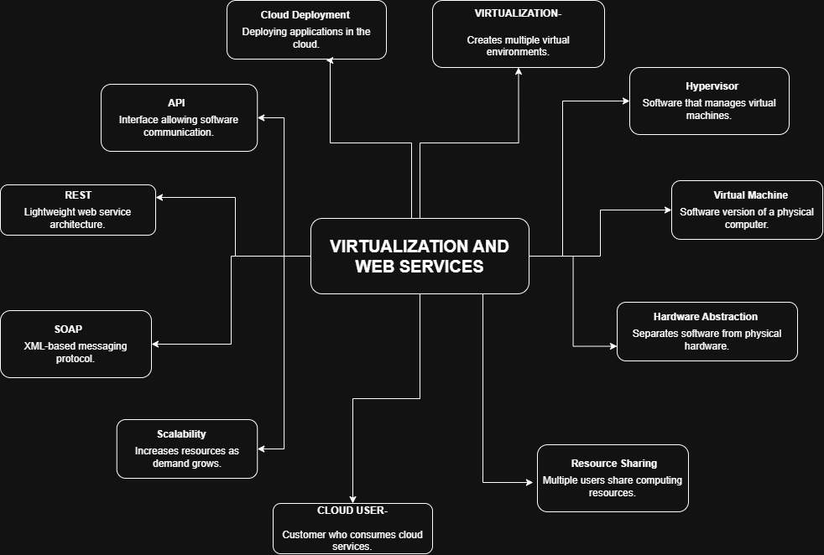

- Evaluate the effectiveness of your concept map in representing cloud computing principles. Which design decisions most strongly support your solution, and why?
The concept map effectively represents cloud computing principles by organizing concepts into a logical hierarchy that starts with cloud computing fundamentals and branches into service models, deployment models, virtualization, web services, scalability, and elasticity. The use of labeled relationships such as enables, depends on, and supports clearly explains how each concept is connected. Color coding and grouping similar concepts improve readability and make the relationships easier to understand. The inclusion of cloud actors, APIs, and virtualization demonstrates how cloud services are delivered in real-world environments. These design decisions provide a clear understanding of cloud architecture and simplify complex concepts.

- Analyze how scalability, elasticity, and resource management influence the architecture shown in your concept map. What challenges could arise if these capabilities were absent?
Scalability allows the cloud system to increase or decrease computing resources based on workload demands, while elasticity automatically adjusts resources in real time. Resource management ensures efficient allocation of storage, memory, and processing power, reducing operational costs and improving performance. These features enable the architecture to maintain high availability and reliability during varying workloads. Without scalability and elasticity, the system could experience performance degradation, server overload, increased downtime, poor user experience, and unnecessary infrastructure costs due to inefficient resource utilization.

- Justify the selection of the APIs, web services, or cloud services included in your concept map. How do they contribute to the overall functionality and efficiency of the system?
The concept map includes REST APIs, SOAP web services, virtualization, and cloud service models such as IaaS, PaaS, and SaaS because they are essential components of modern cloud computing. REST APIs provide lightweight and efficient communication between applications, while SOAP ensures secure and standardized enterprise communication. Virtualization enables multiple virtual machines to share physical hardware efficiently, improving resource utilization. IaaS provides infrastructure, PaaS supports application development, and SaaS delivers ready-to-use software to users. Together, these technologies improve system flexibility, interoperability, scalability, and cost efficiency.
- Critically examine the relationships between the components in your concept map. How do these interactions improve reliability, performance, or user experience?
The relationships between cloud services, virtualization, APIs, and scalability demonstrate how cloud systems function as an integrated environment. Virtualization supports resource pooling, enabling efficient hardware utilization. APIs facilitate communication between applications and cloud services, while scalability and elasticity maintain consistent performance during changing workloads. Service models clearly define provider and user responsibilities, improving security and management. These interactions enhance system reliability by reducing failures, improve performance through optimized resource allocation, and provide users with fast, secure, and uninterrupted access to cloud applications.

5. Reflect on the process of developing your concept map. How has creating and analyzing the map changed your understanding of cloud computing architecture, and what improvements would you make if you were redesigning it?
Developing the concept map improved my understanding of how different cloud computing components interact to form a complete cloud ecosystem. It helped me visualize the relationships between virtualization, web services, APIs, service models, deployment models, scalability, and elasticity. Creating the map also clarified the shared responsibility model between cloud providers and users. If I were redesigning the concept map, I would include additional cloud security concepts, serverless computing, containerization, Kubernetes, AI based cloud services, and more detailed examples of public cloud platforms such as AWS, Microsoft Azure, and Google Cloud to make the diagram more comprehensive and practical.

