SIMATS ENGINEERING
ASSESSMENT TOOL 1 : Concept Mapping

COURSE NAME: | Cloud Computing and Big Data Analytics | COURSE CODE: | CSA15

COURSE OUTCOME COVERED
CO1: Apply cloud computing technologies including hardware-software evolution, virtualization, web services, and service models to develop cloud-based solutions. (BL2)
Assessment Tool Weightage: 20%

Dave's Taxonomy: Imitation (Level 1)  Question Count: 4 | Total Marks: 50

Code of Conduct
I ____________________ (Name / Reg No) certify that this submission is my original work and that I have adhered to the guidelines specified for this assessment.
I understand that any violation of academic integrity rules will result in disciplinary action.
Signature of the student: ____________________

Assessment Tasks
Concept Mapping Tasks
Create concept maps for the following tasks. Each map must show key nodes, link labels, and a logical hierarchy.
- Concept Map 1: Cloud Computing Fundamentals. Include definition, characteristics, benefits, and limitations.
- Concept Map 2: Evolution of Cloud Computing. Connect hardware evolution, internet software evolution, distributed systems, and service delivery.
- Concept Map 3: Service Models. Map IaaS, PaaS, SaaS, and XaaS with provider responsibilities and user responsibilities.
- Concept Map 4: Virtualization and Web Services as Enablers of Cloud. Show how these two concepts support cloud deployment and scalability.
Expected concept nodes:
- Elasticity, scalability, resource pooling, on-demand access, measured service
- Virtual machine, hypervisor, abstraction, API, SOAP, REST, provider, consumer
- Infrastructure layer, platform layer, application layer, shared responsibility

Concept Mapping Rubric
Criteria | Weightage | Level 4 - Exemplary | Level 3 - Proficient | Level 2 - Developing | Level 1 - Beginning
Concept Identification | 25% | All major concepts are accurately identified | Most concepts are identified correctly | Limited concepts are identified | Essential concepts are missing
Relationship Mapping | 25% | Links between concepts are accurate and meaningful | Most links are correct | Some links are weak or unclear | Relationships are mostly incorrect
Hierarchy and Organization | 20% | Excellent structure with clear hierarchy | Mostly organized with minor issues | Basic structure with weak hierarchy | No logical organization
Technical Relevance | 20% | Map strongly reflects cloud course content | Mostly aligned to topic | Partially aligned to topic | Weak alignment to topic
Visual Clarity | 10% | Neat, readable, and easy to interpret | Generally readable | Somewhat cluttered | Poorly presented

Permitted Tools :
draw.io / diagrams.net, Lucidchart, MindMeister, Miro, Canva, PowerPoint, Google Drawings, or equivalent diagramming tool

Procedure for Preparing the Digital Concept Map
- Use the following procedure to prepare the diagram and upload evidence.
- Students who already know another diagramming tool may use it, but the exported evidence and source file must still be submitted.
- Open https://app.diagrams.net/ or the desktop version of draw.io / diagrams.net.
- Choose Device, Google Drive, or OneDrive as the save location according to availability.
- Create a blank diagram and name the file as CSA15_CO1_AT1_RegisterNumber_Concept_Map.drawio.
- Place the concept map title at the center or as a clearly visible anchor node.
- Add major cloud nodes: cloud definition, cloud evolution, cloud architecture, service models, deployment models, virtualization, web services, SOAP, REST, APIs, elasticity, scalability, resource pooling, measured service, and emerging paradigms.
- Connect nodes with labeled arrows such as uses, depends on, enables, scales through, communicates through, belongs to, supports, provides, consumes, or controls.
- Use colors meaningfully: one color for service models, one for cloud characteristics, one for API/web-service concepts, and one for concept map title-specific elements.
- Export the final diagram as PNG or PDF. Keep the editable .drawio source file also.
- Paste the exported diagram image or screenshot in this DOCX under Task 1.
- Upload the DOCX, exported PNG/PDF, and .drawio file to Google Classroom.

Task 1: Concept Map
Create a concept map in draw.io, Lucidchart, Miro, Figma, or any suitable diagramming tool. The map must connect cloud ecosystem, cloud actors, service models, deployment models, virtualization, web services, REST/SOAP APIs, scalability, elasticity, and the student's Project.

Task 2A: Service Model Responsibility Matrix
Prepare a technical matrix that compares SaaS, PaaS, IaaS, FaaS/serverless, database-as-a-service, storage-as-a-service, identity-as-a-service, and monitoring/logging services. For each selected service category, explain what is managed by the cloud provider, what is managed by the student application team, and why that split fits the Project.

Task 2B: Cloud Service Decision Matrix
Map Project modules to cloud services. Include authentication, frontend hosting, backend/API layer, database, object storage, analytics/logging, notification, AI/Python module, security, CI/CD, backup, and monitoring. Students should justify the most relevant service choices instead of forcing every possible cloud service into the design.

Task 3: API Flow, Elasticity, and Scalability Design
Draw a professional cloud-flow diagram for the Project modules. The diagram must show user app or web app, API gateway/backend service, authentication, compute layer, database, object storage, analytics/logging, monitoring, security boundaries, and scaling points. Students may replicate the given visual pattern, but all components and labels must be customized to their own architecture.

Task 4: Technical Justification
Write a concise justification explaining how the diagram and matrices prove CO1. The justification must discuss service model selection, API role, elasticity, scalability, virtualization or managed compute choice, and cloud responsibility boundaries.

1. Evaluate the effectiveness of your concept map in representing cloud computing principles. Which design decisions most strongly support your solution, and why?
2. Analyze how scalability, elasticity, and resource management influence the architecture shown in your concept map. What challenges could arise if these capabilities were absent?
3. Justify the selection of the APIs, web services, or cloud services included in your concept map. How do they contribute to the overall functionality and efficiency of the system?
4. Critically examine the relationships between the components in your concept map. How do these interactions improve reliability, performance, or user experience?
5. Reflect on the process of developing your concept map. How has creating and analyzing the map changed your understanding of cloud computing architecture, and what improvements would you make if you were redesigning it?

Expected Digital Evidence
- Editable diagram source file and exported PNG/PDF for the concept map.
- Completed service model responsibility matrix and cloud service decision matrix.
- Architecture/API flow diagram exported as PNG/PDF.
- README file containing title, tools used, repository structure, and a short CO1 reflection.
GitHub and Google Classroom Submission
- Create a repository using a clear name: CSA15_CO1_AT<Number>_<RegisterNumber>.
- Upload editable source files, exported PDF/PNG evidence, screenshots, and a short README explaining the work.
- Keep filenames professional and include the register number where appropriate.
- Submit only the GitHub repository link in Google Classroom before the deadline.
- Ensure the repository is accessible to the faculty evaluator during assessment.
Implementation Note
Faculty may evaluate the submitted evidence digitally using repository inspection, diagram quality, oral explanation, and CO-aligned rubric scoring. The focus is on technical understanding, cloud design reasoning, and hands-on evidence rather than routine written work.

CONCEPT MAP 1
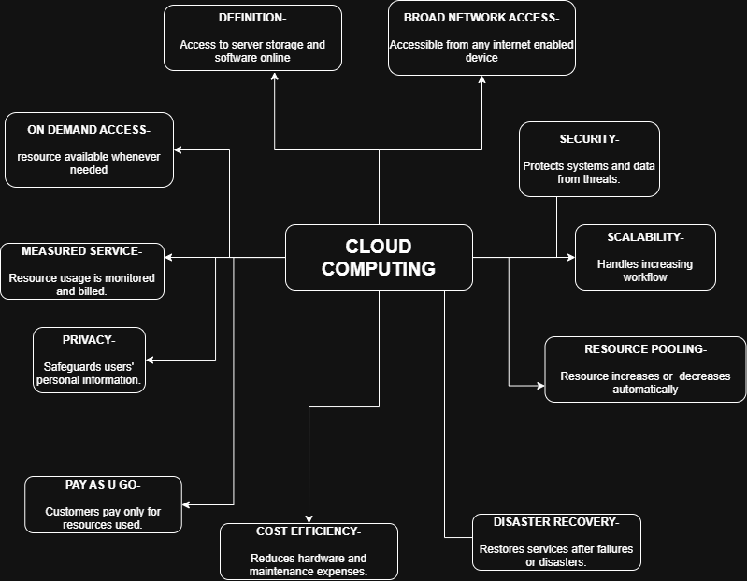

1. Evaluate the effectiveness of your concept map.

The concept map effectively represents cloud computing by organizing the core concepts such as on-demand access, resource pooling, elasticity, scalability, measured service, benefits, and limitations around the central idea of cloud computing. The hierarchical structure and labeled relationships make the concepts easy to understand. The use of different colors and meaningful links improves readability and clearly shows how each concept is connected.

2. Analyze scalability, elasticity, and resource management.
Scalability enables the system to support increasing workloads by adding resources, while elasticity automatically adjusts resources according to demand. Resource pooling allows efficient sharing of computing resources among multiple users. Without these capabilities, cloud systems would experience poor performance, resource wastage, higher costs, and difficulty handling sudden increases in user demand.

3. Justify the selection of APIs, web services, or cloud services.
Although this concept map focuses on cloud fundamentals, APIs and web services are essential because they enable communication between cloud applications and users. Cloud services such as IaaS, PaaS, and SaaS provide different levels of computing resources, making cloud systems flexible, cost-effective, and easy to manage.

4. Examine the relationships between components.
The relationships among characteristics, benefits, and limitations demonstrate how cloud computing delivers reliable and efficient services. Features like elasticity, scalability, and measured service improve performance, while security and privacy protect user data. Together, these interactions provide better reliability and user experience.

5. Reflection.
Developing this concept map improved my understanding of the fundamental characteristics and benefits of cloud computing. It helped me understand how different cloud features work together to deliver efficient services. If redesigned, I would include real-world cloud platforms such as AWS, Microsoft Azure, and Google Cloud for better practical understanding.

Concept Map 2
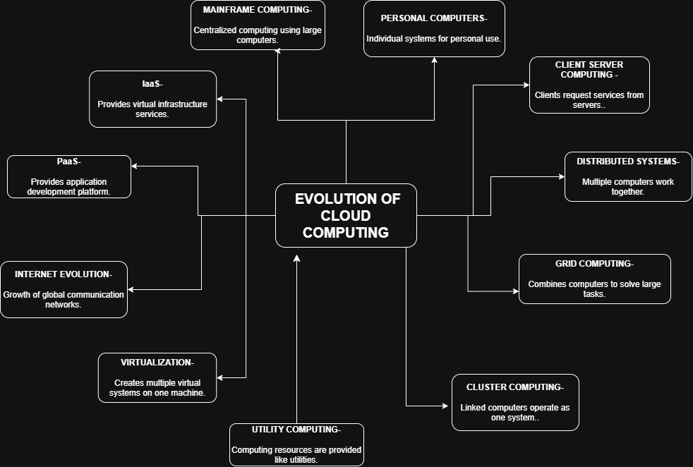

1. Evaluate the effectiveness of your concept map.
The concept map clearly illustrates the progression from mainframe computing to modern cloud computing. The chronological arrangement of technologies such as client-server computing, distributed systems, virtualization, and cloud service models makes the evolution easy to follow. This logical structure effectively explains how cloud computing developed over time.

2. Analyze scalability, elasticity, and resource management.
As cloud computing evolved, scalability and elasticity became essential features that improved resource utilization and application performance. Resource management ensures efficient allocation of computing power and storage. Without these features, modern cloud systems would be expensive, inefficient, and unable to meet changing user demands.

3. Justify the selection of APIs, web services, or cloud services.
Web services and APIs were included because they enable communication between distributed applications over the Internet. Virtualization made cloud computing possible by allowing multiple virtual machines to share hardware resources. Service models such as IaaS, PaaS, and SaaS demonstrate how cloud services evolved to meet different user requirements.

4. Examine the relationships between components.
Each technology builds upon the previous generation. Mainframes evolved into client-server systems, which later developed into distributed computing and virtualization before enabling cloud computing. These relationships improve system flexibility, reliability, and performance while reducing operational costs.

5. Reflection.
Creating this concept map helped me understand that cloud computing is the result of continuous technological advancements rather than a completely new technology. If I redesigned it, I would include a timeline and examples of major cloud providers to make the evolution more visually informative.

Concept Map 3
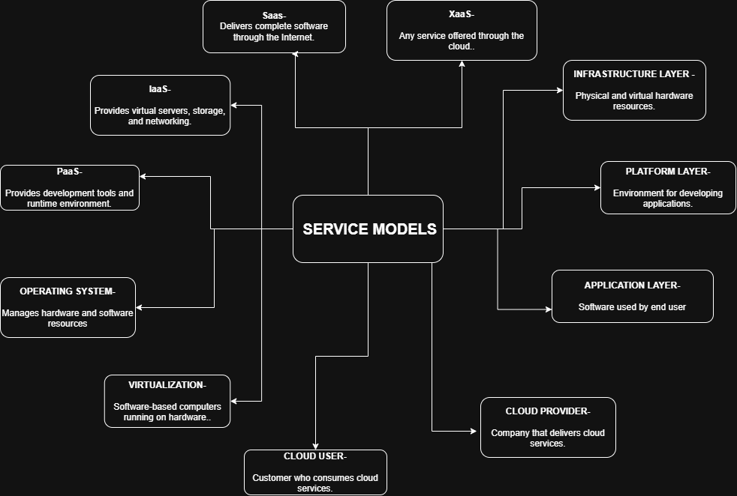

1. Evaluate the effectiveness of your concept map.
The concept map effectively explains the differences between IaaS, PaaS, SaaS, and XaaS by showing the responsibilities of cloud providers and users. The layered structure clearly distinguishes infrastructure, platform, and application services, making the relationships easy to understand.

2. Analyze scalability, elasticity, and resource management.
All cloud service models rely on scalability and elasticity to provide computing resources according to demand. Resource management allows efficient allocation of storage, processing power, and networking resources. Without these capabilities, cloud services would become inefficient, expensive, and unable to meet customer requirements.

3. Justify the selection of APIs, web services, or cloud services.
The selected cloud service models represent the most commonly used methods of delivering cloud services. APIs enable communication between applications, while web services support software integration. Shared responsibility ensures that both providers and users contribute to maintaining system security and reliability.

4. Examine the relationships between components.
The provider manages infrastructure, while users manage their applications and data according to the service model. These relationships improve security, reduce management complexity, and provide flexibility for organizations to select the most suitable cloud service model.

5. Reflection.
Developing this concept map improved my understanding of how responsibilities change across different service models. It also clarified the advantages and limitations of each model. If redesigned, I would include practical examples such as Amazon EC2, Google App Engine, and Microsoft 365.

Concept Map 4:
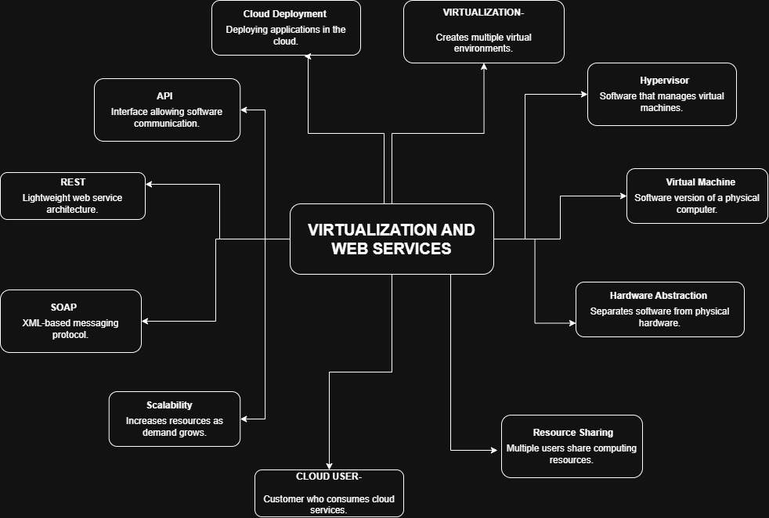
1. Evaluate the effectiveness of your concept map.
The concept map effectively demonstrates how virtualization and web services act as the foundation of cloud computing. It connects virtual machines, hypervisors, APIs, REST, SOAP, scalability, and cloud deployment using logical relationships, making the architecture easy to understand.

2. Analyze scalability, elasticity, and resource management.
Virtualization allows multiple virtual machines to share hardware efficiently, while elasticity automatically adjusts resources based on workload. Scalability supports application growth without affecting performance. Without these capabilities, cloud systems would require more physical hardware, resulting in higher costs and lower efficiency.

3. Justify the selection of APIs, web services, or cloud services.
REST and SOAP APIs were selected because they enable communication between cloud applications and external systems. Hypervisors and virtual machines provide efficient resource utilization, while cloud deployment allows applications to be delivered quickly and reliably to users.

4. Examine the relationships between components.
Virtualization supports cloud deployment by creating virtual resources, while APIs and web services enable communication between cloud services and users. These interactions improve reliability, system performance, scalability, and overall user experience by ensuring efficient resource utilization and seamless connectivity.

5. Reflection.
Creating this concept map helped me understand how virtualization and web services work together to enable cloud computing. It highlighted the importance of APIs, hypervisors, and virtual machines in building scalable cloud systems. If redesigned, I would include containers, Kubernetes, and microservices to represent modern cloud-native architectures.

