Campus Connect - Phase 1: Software Requirements Specification (SRS)

1. Problem Statement
University students today face challenges in building meaningful connections within their academic community.
While general social media platforms exist, they lack features specifically designed for the unique needs of student life.
Such features include finding study partners, discovering campus events, sharing academic resources, finding nearby services,
coordinating group projects, and connecting with peers in the same courses or departments.

2. Target Users
• university students
• University administrators
• Website administrators

3. Functional Requirements
1. User registration and login system
2. Profile management
3. Ability to create edit and delete posts
4. Commenting posts
5. Search functionality (for people, posts, and communities)
6. Event creation and joining
7. Community creation and joining
8. Direct messaging between users
9. Sharing academic materials and resources
10. Reporting inappropriate content
11. Admin moderation (banding posts and users)
12. Password reset
13. Notifications for posts and messages
14. Viewing campus services and maps
15. show system errors and user actions

4. Non-Functional Requirements
1. The system must be available 24 hour
2. It should be sufficient for at least 7000 users
3. The user interface should be easy to use and responsive.
4. errors must be displayed with descriptive and user-friendly messages.
5. The system must ensure user data privacy and security.
6. The platform must follow SOLID design principles.
7. The system must be scalable to support more users in the future

5. Use Case Diagram
The following diagram illustrates the main actors and their interactions with the system:
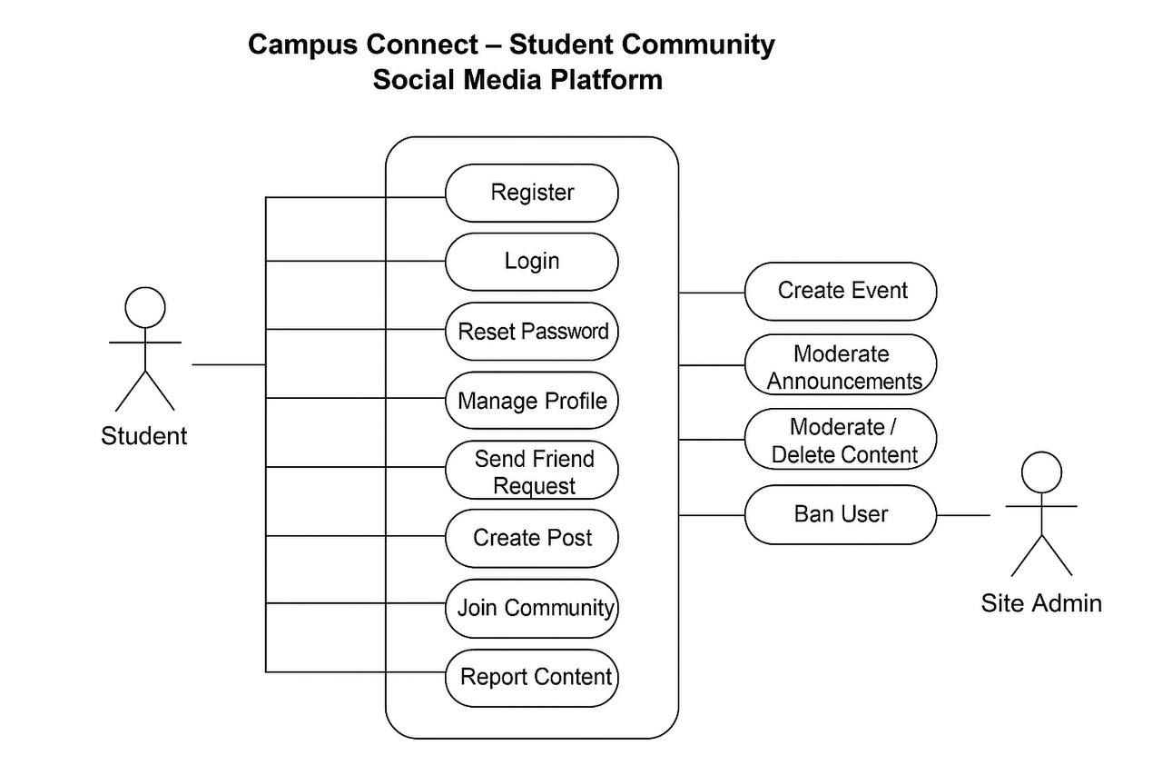

6. Use Case Descriptions
Use Case | Description
Register / Login | Students can create an account or log in using their credentials.
Create Post | A student can share a post .
Join Community | Students can join communities related to their courses or interests.
Create Event | Students or admins can create campus-related events.
Send Message | Students can send direct messages to peers.
Report Post | Students can report inappropriate content to admins.

7. Traceability
Requirement ID | Requirement Description | Related Use Case
FR1 | The system shall allow users to register and authenticate securely. | UC1, UC2
FR2 | The system shall allow users to manage friendships (send, accept, block). | UC3
FR3 | The system shall allow users to create and interact with posts. | UC4
FR4 | The system shall allow users to create and join communities. | UC5
FR5 | The system shall allow users to create and discover events. | UC6
FR6 | The system shall allow users to send and receive messages. | UC7
FR7 | The system shall provide notifications for new activities. | UC8
FR8 | The administrator shall be able to moderate and manage user content. | UC9

8. Conclusion
This document outlined the primary user and system requirements for the Campus Connect project.
It defines the target users, functional and non-functional requirements, and use cases that guide the next development phases.
The system will follow SOLID design principles and the V-model for test-driven development.

9.Unrequired addition (github)
https://github.com/mohammed0335/Campus-Connect-

