Payroll Module – Task Completion Report

Odoo Payroll Bugs Fixed & Tested Successfully

1. Task Overview
The task involved identifying and fixing two critical bugs in the Odoo Payroll module on the erpnamma staging environment. Both bugs affected payslip generation and display.

1.1 Bug #1 – Time Off Auto-Importing into Payslip
Time off (leave) records from the Time Off module were automatically imported into the payslip's Worked Days tab. This caused validated leave (e.g., Paid Time Off) to reduce the employee's salary without manual control. For example, RAM LAL's payslip showed Paid Time Off: 12 days, 96 hours, 476.80 SR — automatically pulled and reducing salary.

1.2 Bug #2 – Wrong Month in Payslip Heading
The payslip report title used the Start Date month instead of the End Date month. For a payslip with period 21/11/2025 – 20/12/2025 (ending in December), the heading incorrectly showed 'November 2025 Payslip' instead of 'December 2025 Payslip'.

2. Before – Issues Identified
The following screenshots show the BEFORE state of the system, illustrating both bugs.
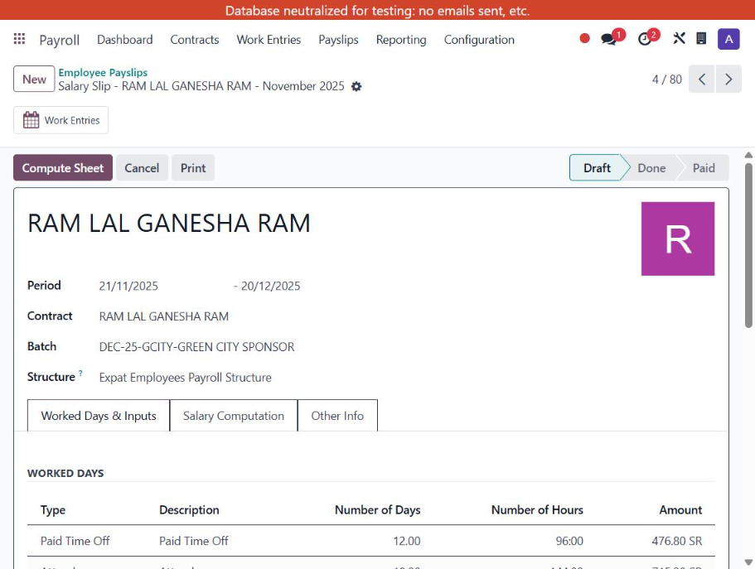
Figure 1: RAM LAL's payslip – Paid Time Off auto-imported (12 days, 96h, 476.80 SR); heading shows November 2025 despite period ending 20/12/2025
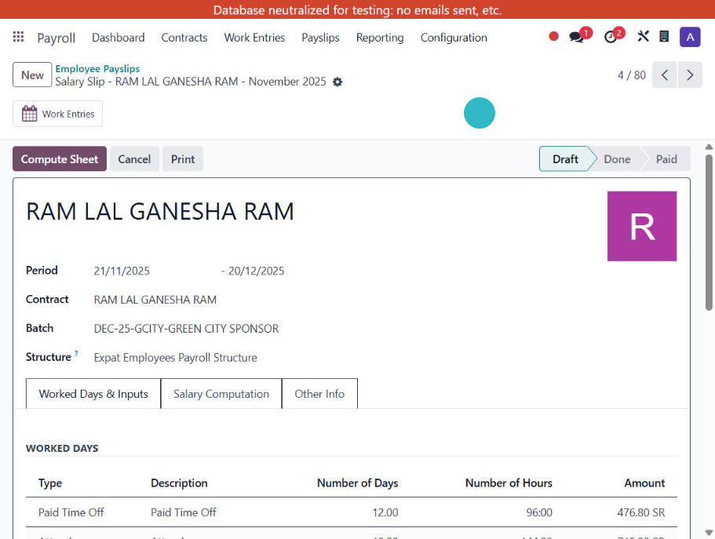
Figure 2: Worked Days tab showing Paid Time Off automatically pulled from Time Off module (Bug #1)

3. Fix 1 – Disable Time Off → Payroll Link
To stop time off from auto-importing into payslips, the 'Time Off' checkbox was unchecked for all leave-type Work Entry Types under Payroll → Configuration → Work Entry Types.

3.1 Navigation Path
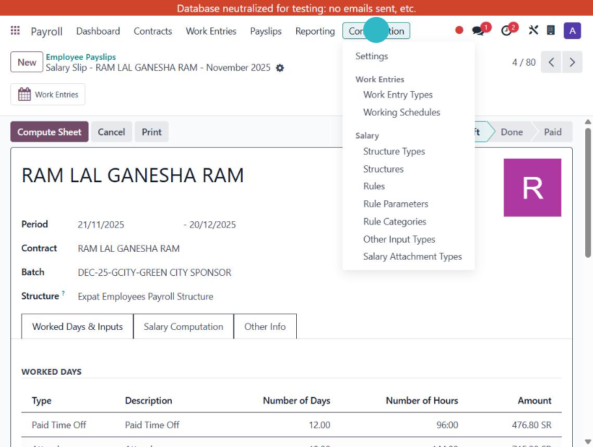
Figure 3: Payroll → Configuration → Work Entry Types

3.2 Work Entry Types Modified
The following Work Entry Types were updated (Time Off checkbox unchecked):
Work Entry Type | Code | Action
Generic Time Off | LEAVE100 | Time Off unchecked
Compensatory Time Off | LEAVE105 | Time Off unchecked
Unpaid | LEAVE90 | Time Off unchecked
Sick Time Off | LEAVE110 | Time Off unchecked
Paid Time Off | LEAVE120 | Time Off unchecked

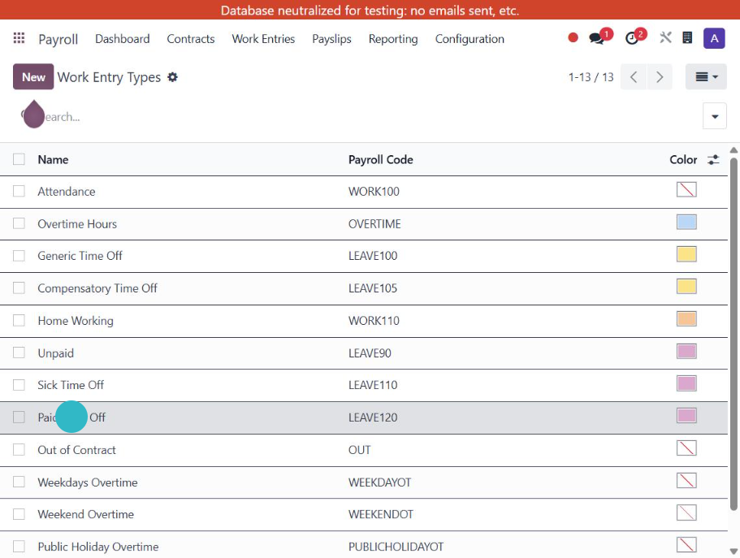
Figure 4: Work Entry Types list – Paid Time Off (LEAVE120) selected
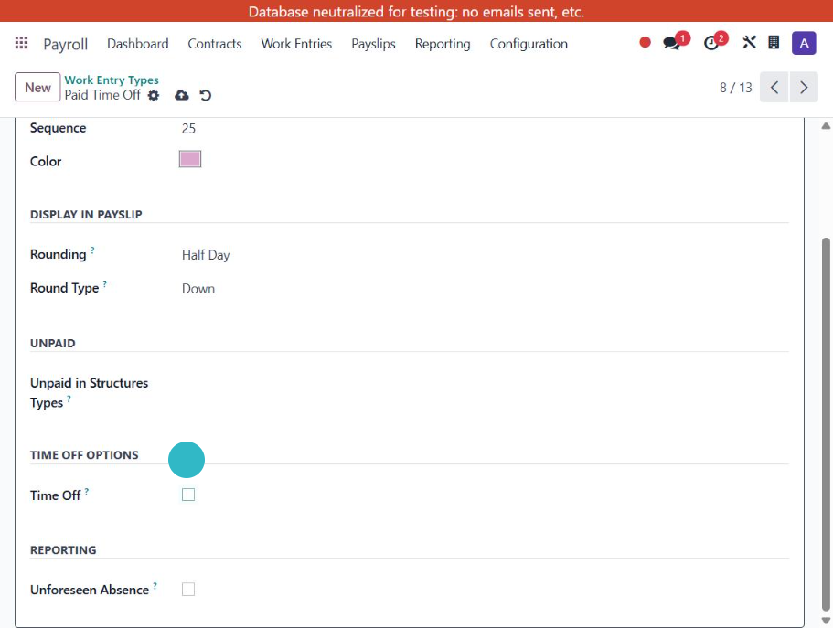
Figure 5: AFTER – Time Off checkbox UNCHECKED for Paid Time Off work entry type
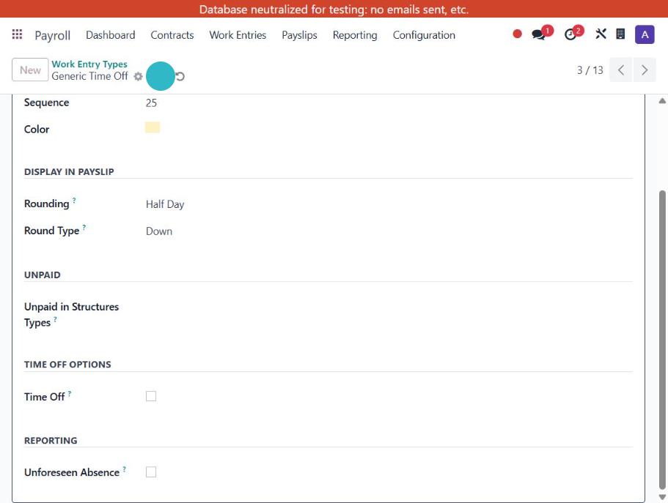
Figure 6: Generic Time Off – Time Off checkbox UNCHECKED

4. Fix 2 – Payslip Report Month Heading (Use End Date)
The payslip report template was modified so the heading uses the period End Date instead of the Start Date.

4.1 Location
Settings → Technical → User Interface → Views → Search 'report_payslip' → hr_payroll.report_payslip

4.2 Code Change
BEFORE (Line 4):
<h2 id="payslip_name"><span t-field="o.name">August 2023 Payslip</span></h2>
AFTER:
<h2 id="payslip_name"><span t-esc="o.date_to.strftime('%B %Y') + ' Payslip'"/></h2>

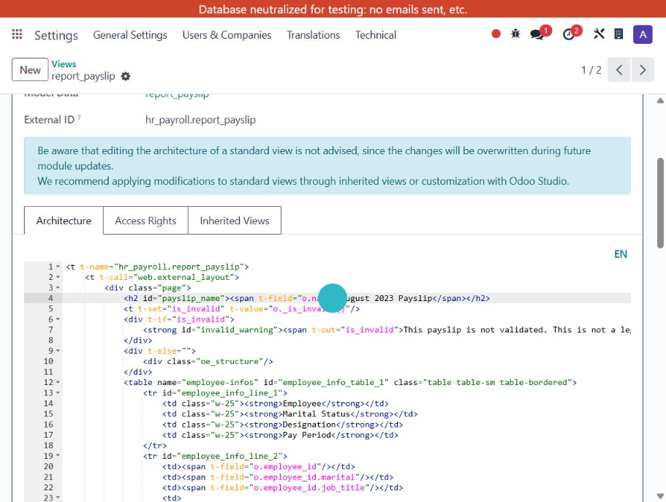
Figure 7: Report template – Line 4 (highlighted) was modified to use date_to (End Date)

5. Test Results
Both fixes were tested and verified successfully on the erpnamma staging environment.

5.1 Test Case 1 – RAM LAL (Period: 21/11/2025 → 20/12/2025)
BEFORE: 'November 2025 Payslip' | AFTER: 'December 2025 Payslip'

5.2 Test Case 2 – AAVEZ NAUSHAD DALVI (Period: 01/01/2026 → 31/01/2026)
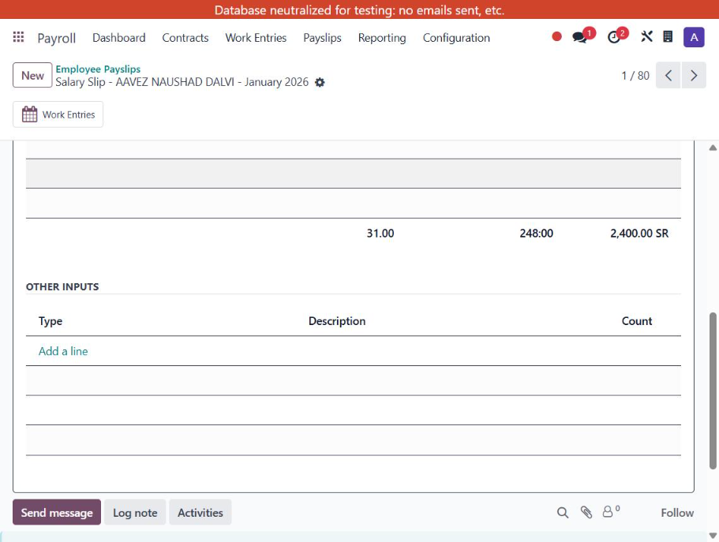
Figure 8: AAVEZ DALVI – January 2026 Payslip (correct heading); OTHER INPUTS empty (no Time Off auto-import)
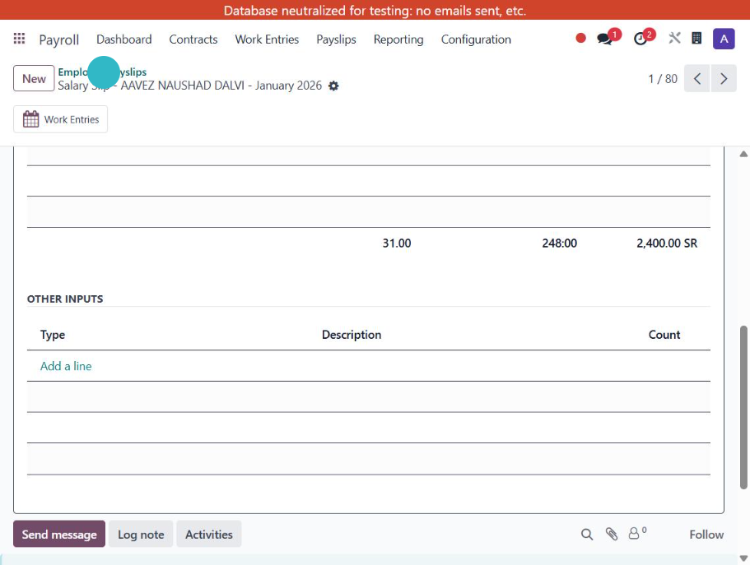
Figure 9: Correct heading 'January 2026 Payslip' for period ending 31/01/2026

5.3 Test Case 3 – Paid Time Off Work Entry Type
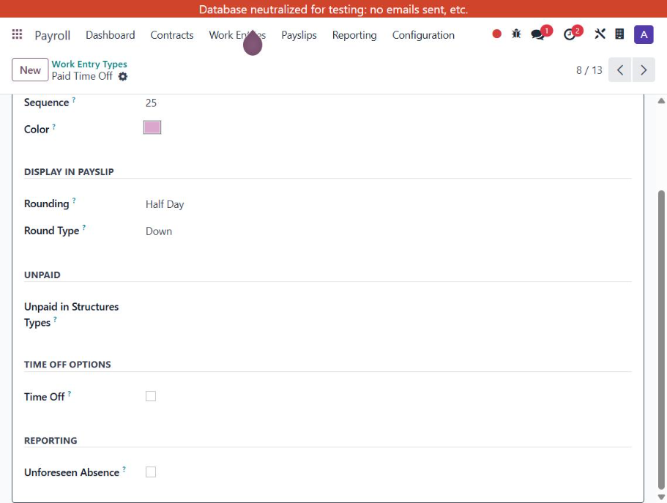
Figure 10: Paid Time Off – Time Off checkbox UNCHECKED; link to Time Off module disabled

6. Conclusion
Both tasks were completed and tested successfully. Time Off no longer auto-imports into payslips, and the payslip report heading correctly displays the month based on the period End Date.

An upgrade-safe Odoo module (hr_payroll_payslip_fix) was also created for Fix 2 to ensure the report heading change persists across Odoo updates.

— End of Report —

