Pneumatic Launcher — Complete Analysis

Input Parameters
Charge chamber volume: 1.0 mL
Working pressure (gauge): 10.0 bar
Barrel ID: 52 mm; Length: 700 mm

Theoretical Energy Estimates
Ideal isothermal work: 2637.7 J
Isothermal formula: $W = P_0 V_0 ln(P_0 / P_f)$

Representative Payload Scenarios
Mass (kg) | Efficiency (%) | Muzzle velocity (m/s) | Energy (J)
0.20 | 25 | 81.2 | 659
0.20 | 50 | 114.8 | 1319
0.20 | 75 | 140.7 | 1978
0.50 | 25 | 51.4 | 659
0.50 | 50 | 72.6 | 1319
0.50 | 75 | 89.0 | 1978
1.00 | 25 | 36.3 | 659
1.00 | 50 | 51.4 | 1319
1.00 | 75 | 62.9 | 1978

Structural Checks (Summary)
6061-T6 yield: 276 MPa; design SF used: 3.0
Calculated required hoop thickness at P0: 0.31 mm
Thickness (mm) | Hoop stress (MPa) | SF vs yield
2.0 | 14.3 | 19.30
3.0 | 9.5 | 28.95
5.0 | 5.7 | 48.25
8.0 | 3.6 | 77.20

Transient 1D Simulation Results
Simulated muzzle velocity: 27.60 m/s
Impulse delivered: 27.60 N·s
Discharge time: 37.5 ms
Peak force (sim): 3282 N; Average force: 736 N
Metric | Value
Muzzle velocity (m/s) | 27.60
Impulse (N·s) | 27.60
Discharge time (ms) | 37.5
Peak force (N) | 3282
Average force (N) | 736

Parametric Sweep Summary (sample)
orifice_d_m | Vc_m3 | Cd | muzzle_v | impulse | t_end_s | peak_F
0.0060 | 0.0005 | 0.6000 | 7.7771 | 7.7771 | 0.0955 | 2185.8
0.0060 | 0.0005 | 0.7000 | 9.0378 | 9.0378 | 0.0840 | 2251.3
0.0060 | 0.0005 | 0.8000 | 10.2887 | 10.2887 | 0.0755 | 2245.8
0.0060 | 0.0008 | 0.6000 | 7.7903 | 7.7903 | 0.0954 | 2187.4
0.0060 | 0.0008 | 0.7000 | 9.0630 | 9.0630 | 0.0837 | 2252.8
0.0060 | 0.0008 | 0.8000 | 10.3334 | 10.3334 | 0.0752 | 2247.5
0.0060 | 0.0010 | 0.6000 | 7.7940 | 7.7940 | 0.0953 | 2187.9
0.0060 | 0.0010 | 0.7000 | 9.0699 | 9.0699 | 0.0837 | 2253.3
0.0060 | 0.0010 | 0.8000 | 10.3454 | 10.3454 | 0.0751 | 2248.0
0.0060 | 0.0012 | 0.6000 | 7.7963 | 7.7963 | 0.0953 | 2188.3
0.0060 | 0.0012 | 0.7000 | 9.0741 | 9.0741 | 0.0836 | 2253.6
0.0060 | 0.0012 | 0.8000 | 10.3526 | 10.3526 | 0.0751 | 2248.4
0.0080 | 0.0005 | 0.6000 | 13.5262 | 13.5262 | 0.0616 | 2386.8
0.0080 | 0.0005 | 0.7000 | 15.4529 | 15.4529 | 0.0562 | 2456.4
0.0080 | 0.0005 | 0.8000 | 17.0951 | 17.0951 | 0.0524 | 2731.4
0.0080 | 0.0008 | 0.6000 | 13.6793 | 13.6793 | 0.0612 | 2390.3
0.0080 | 0.0008 | 0.7000 | 15.6795 | 15.6795 | 0.0558 | 2457.1
0.0080 | 0.0008 | 0.8000 | 17.3920 | 17.3920 | 0.0519 | 2732.4
0.0080 | 0.0010 | 0.6000 | 13.7203 | 13.7203 | 0.0611 | 2391.4
0.0080 | 0.0010 | 0.7000 | 15.7440 | 15.7440 | 0.0556 | 2457.3
0.0080 | 0.0010 | 0.8000 | 17.4802 | 17.4802 | 0.0517 | 2732.8
0.0080 | 0.0012 | 0.6000 | 13.7445 | 13.7445 | 0.0610 | 2392.2
0.0080 | 0.0012 | 0.7000 | 15.7848 | 15.7848 | 0.0555 | 2457.4
0.0080 | 0.0012 | 0.8000 | 17.5377 | 17.5377 | 0.0516 | 2733.0
0.0100 | 0.0005 | 0.6000 | 19.0088 | 19.0088 | 0.0486 | 2989.5
0.0100 | 0.0005 | 0.7000 | 20.8232 | 20.8232 | 0.0455 | 2976.9
0.0100 | 0.0005 | 0.8000 | 22.3461 | 22.3461 | 0.0432 | 2834.0
0.0100 | 0.0008 | 0.6000 | 19.3993 | 19.3993 | 0.0480 | 2991.4
0.0100 | 0.0008 | 0.7000 | 21.3281 | 21.3281 | 0.0449 | 2981.3
0.0100 | 0.0008 | 0.8000 | 22.9690 | 22.9690 | 0.0426 | 2841.3

Plots
vel_vs_orifice_Vc_500uL.png
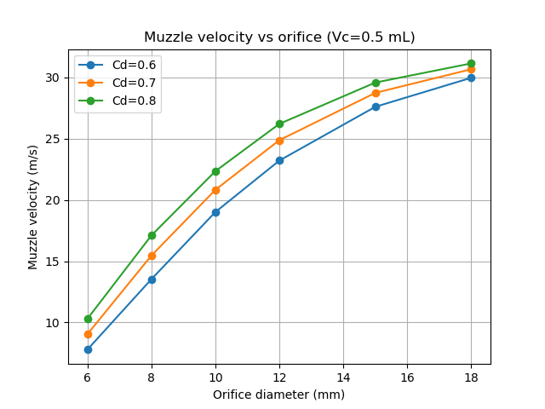
vel_vs_orifice_Vc_800uL.png
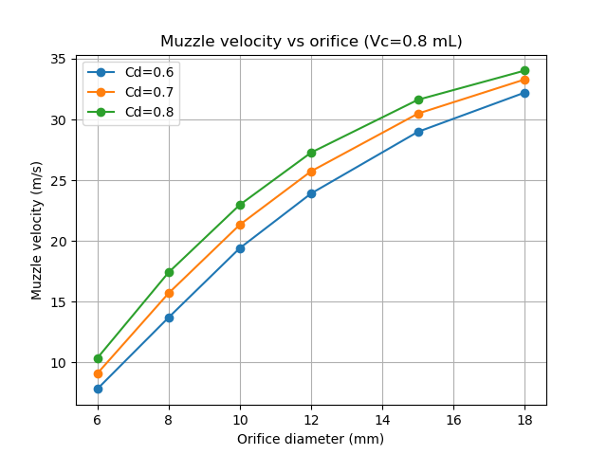
vel_vs_orifice_Vc_1000uL.png
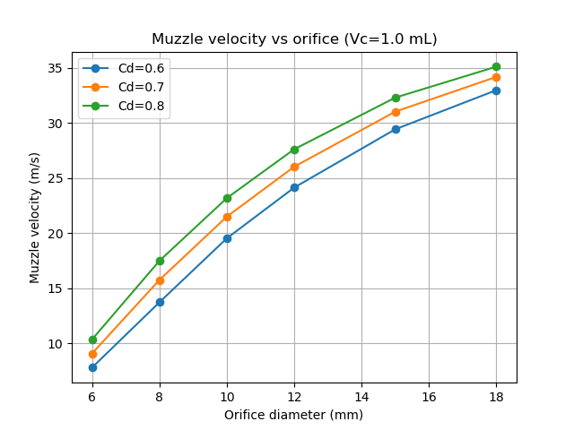
vel_vs_orifice_Vc_1200uL.png
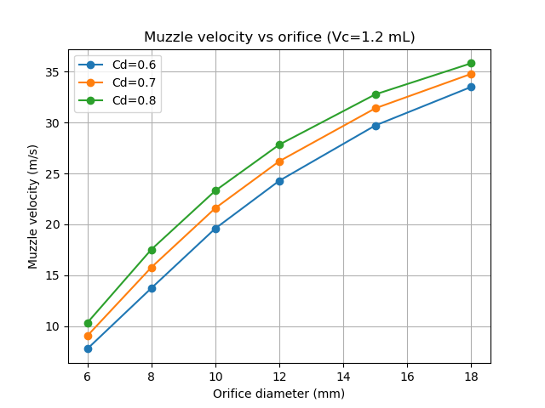
peakF_vs_orifice_Vc_1000uL.png
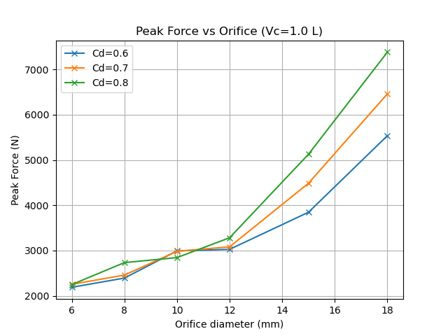
impulse_vs_orifice_Vc_1000uL.png
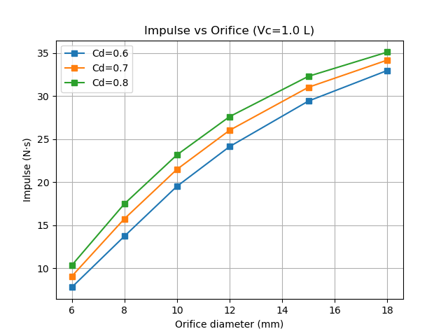

Engineering Drawing
Embedded preview:
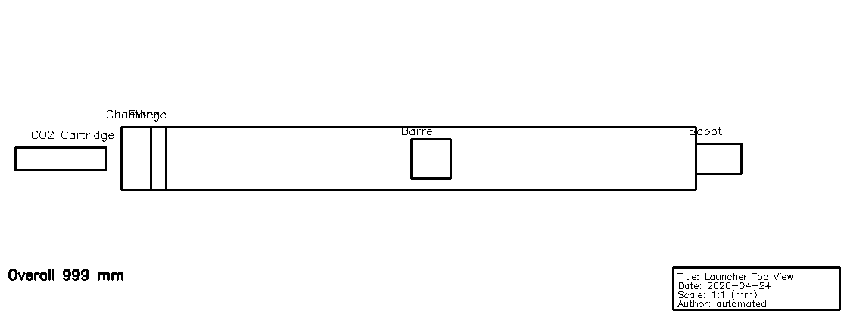

Flange and Bolt Check

Flange Assumptions
Parameter | Value
n_bolts | 6
pcd_m | 0.08
bolt_dia_m | 0.008
bolt_material_shear | 240000000.0

Flange Check Result
Metric | Value
n_bolts | 6
cap_per_bolt_N | 12063.715789784805
bolts_needed | 1

Worst-case Sweep Result
Metric | Value
orifice_d_m | 0.018
Vc_m3 | 0.0005
Cd | 0.8
muzzle_v | 31.14752690198767
impulse | 31.14752690198767
t_end_s | 0.03339999999999993
peak_F | 7384.324205739658

Bolt Shear Check (endcap)
Bolt | Capacity (N) | Bolts required
M6 | 4800 | 1
M8 | 8784 | 1
M10 | 13920 | 1

Formulas and Conclusion
Key formulas used in this analysis:
Isothermal work: $W = P_0 V_0 ln(P_0 / P_f)$
Hoop stress (thin-wall): $\backslash sigma_\{hoop\} = P\backslash ; r / t$
Required thickness (hoop): $t = P\backslash ; r / \backslash sigma_\{allowable\}$
Axial stress (thin-wall): $\backslash sigma_\{axial\} = P\backslash ; r / (2\backslash ; t)$
Impulse and average force: I = m * v; F_avg ≈ I / t_discharge (crude estimate)
Using 6061-T6 (yield ≈ 276 MPa) and safety factor 3.0, allowable stress ≈ 92.0 MPa.
Calculated required hoop thickness at working pressure (10.0 bar gauge) is ≈ 0.31 mm.
Recommendation: select a standard tube/wall thickness equal to or greater than the calculated required thickness, and verify endcap/flange/bolt margins separately. Use ASME/EN pressure-vessel rules or certified fittings for the chamber when safety is critical.

Barrel–Payload Geometric Compatibility Constraint
The payload–sabot assembly shall fit within the barrel internal diameter under all operating conditions without interference.

Core Constraint
Clearance condition:
D_eq + 2·C_sab ≤ D_barrel,min
where:
D_eq = √(W² + H²) (worst-case diagonal envelope of payload cross-section)
C_sab = sabot radial clearance per side
D_barrel,min = D_barrel,nom − manufacturing tolerance

Numerical Check
Given:
W = 40 mm, H = 45 mm ⇒ D_eq = √(40² + 45²) = 60.2 mm
C_sab = 1.5 mm ⇒ 2·C_sab = 3.0 mm
D_barrel,nom = 52 mm, tolerance = ±0.3 mm
⇒ D_barrel,min = 51.7 mm
Check:
D_eq + 2·C_sab = 60.2 + 3.0 = 63.2 mm
63.2 mm > 51.7 mm ⇒ INTERFERENCE if payload is misaligned in barrel

Interpretation
The payload does not satisfy the worst-case diagonal envelope constraint. Unconstrained rotation inside the barrel will result in interference (jamming). A sabot or alignment feature is mandatory to constrain the payload orientation and ensure the presented envelope does not exceed D_barrel,min.

Design Requirements
Requirement G-01:
The sabot shall enforce axial alignment such that payload rotation is constrained and the effective envelope presented to the barrel remains within D_barrel,min.
Requirement G-02:
Total radial clearance (including sabot) shall be limited to 1.0–1.5 mm per side to prevent tilt-induced interference while maintaining acceptable friction and ease of loading.

Governing ODE System for Launcher Simulation
The launcher’s internal ballistics are modeled as a coupled system of ordinary differential equations (ODEs), solved numerically at each timestep. The state vector is:
s(t) = [x, v, P, m]
where:
x = projectile position
v = projectile velocity
P = chamber pressure
m = mass of gas in chamber
The system:
1. Projectile motion (Newton’s law):
dv/dt = (P * A_bore - F_friction) / m_payload
2. Kinematics:
dx/dt = v
3. Gas mass balance:
dm/dt = -m_dot_out
4. Pressure evolution (ideal gas, real-gas correction applied in code):
P = m * R * T / V(t)
dP/dt = (R * T / V) * dm/dt - (m * R * T / V^2) * dV/dt
5. Chamber volume change (moving projectile):
V(t) = V0 + A_bore * x(t)
dV/dt = A_bore * v
6. Valve mass flow (critical):
Choked: m_dot_out = Cd * A_orifice * P * sqrt(gamma / (R * T)) * (2/(gamma+1))^((gamma+1)/(2*(gamma-1)))
Subsonic: m_dot_out = f(Cv, P_up, P_down)
Key insight: There is no single closed-form velocity equation. The exit velocity is obtained by integrating this ODE system over time.
This system is implemented in simulate_transient() in scripts/gen_doc.py.

