Pneumatic Launcher — Complete Analysis

Input Parameters
Charge chamber volume: 1.0 mL
Working pressure (gauge): 15.0 bar
Barrel ID: 52 mm; Length: 700 mm

Theoretical Energy Estimates
Ideal isothermal work: 4436.1 J
Isothermal formula: W = P0*V0*ln(P0/Pf)

Representative Payload Scenarios
Mass = 0.20 kg
Ideal muzzle velocity (no losses): 210.6 m/s
Efficiency 25%: v = 105.3 m/s, energy = 1109 J
Efficiency 50%: v = 148.9 m/s, energy = 2218 J
Efficiency 75%: v = 182.4 m/s, energy = 3327 J
Mass = 0.50 kg
Ideal muzzle velocity (no losses): 133.2 m/s
Efficiency 25%: v = 66.6 m/s, energy = 1109 J
Efficiency 50%: v = 94.2 m/s, energy = 2218 J
Efficiency 75%: v = 115.4 m/s, energy = 3327 J
Mass = 1.00 kg
Ideal muzzle velocity (no losses): 94.2 m/s
Efficiency 25%: v = 47.1 m/s, energy = 1109 J
Efficiency 50%: v = 66.6 m/s, energy = 2218 J
Efficiency 75%: v = 81.6 m/s, energy = 3327 J

Structural Checks (Summary)
6061-T6 yield: 276 MPa; design SF used: 3.0
Calculated required hoop thickness at P0: 0.45 mm
Thickness (mm) | Hoop stress (MPa) | SF vs yield
2.0 | 20.8 | 13.27
3.0 | 13.9 | 19.90
5.0 | 8.3 | 33.17
8.0 | 5.2 | 53.08

Transient 1D Simulation Results
Simulated muzzle velocity: 32.16 m/s
Impulse delivered: 32.16 N·s
Discharge time: 31.9 ms
Peak force (sim): 4753 N; Average force: 1008 N

Parametric Sweep Summary (sample)
orifice_d_m | Vc_m3 | Cd | muzzle_v | impulse | t_end_s | peak_F
0.0060 | 0.0005 | 0.6000 | 9.2176 | 9.2176 | 0.0811 | 3117.7
0.0060 | 0.0005 | 0.7000 | 10.7605 | 10.7605 | 0.0712 | 3259.0
0.0060 | 0.0005 | 0.8000 | 12.3176 | 12.3176 | 0.0640 | 3384.2
0.0060 | 0.0008 | 0.6000 | 9.1941 | 9.1941 | 0.0812 | 3119.6
0.0060 | 0.0008 | 0.7000 | 10.7247 | 10.7247 | 0.0713 | 3261.6
0.0060 | 0.0008 | 0.8000 | 12.2698 | 12.2698 | 0.0641 | 3386.9
0.0060 | 0.0010 | 0.6000 | 9.1859 | 9.1859 | 0.0812 | 3120.2
0.0060 | 0.0010 | 0.7000 | 10.7117 | 10.7117 | 0.0713 | 3262.5
0.0060 | 0.0010 | 0.8000 | 12.2511 | 12.2511 | 0.0641 | 3387.8
0.0060 | 0.0012 | 0.6000 | 9.1803 | 9.1803 | 0.0813 | 3120.6
0.0060 | 0.0012 | 0.7000 | 10.7028 | 10.7028 | 0.0714 | 3263.1
0.0060 | 0.0012 | 0.8000 | 12.2381 | 12.2381 | 0.0641 | 3388.4
0.0080 | 0.0005 | 0.6000 | 16.2765 | 16.2765 | 0.0526 | 3640.9
0.0080 | 0.0005 | 0.7000 | 18.4284 | 18.4284 | 0.0481 | 3648.4
0.0080 | 0.0005 | 0.8000 | 20.2719 | 20.2719 | 0.0448 | 3951.5
0.0080 | 0.0008 | 0.6000 | 16.2861 | 16.2861 | 0.0524 | 3644.1
0.0080 | 0.0008 | 0.7000 | 18.5156 | 18.5156 | 0.0479 | 3651.9
0.0080 | 0.0008 | 0.8000 | 20.4358 | 20.4358 | 0.0446 | 3952.8
0.0080 | 0.0010 | 0.6000 | 16.2799 | 16.2799 | 0.0524 | 3645.1
0.0080 | 0.0010 | 0.7000 | 18.5327 | 18.5327 | 0.0478 | 3653.0
0.0080 | 0.0010 | 0.8000 | 20.4777 | 20.4777 | 0.0445 | 3953.2
0.0080 | 0.0012 | 0.6000 | 16.2723 | 16.2723 | 0.0524 | 3645.8
0.0080 | 0.0012 | 0.7000 | 18.5442 | 18.5442 | 0.0478 | 3653.8
0.0080 | 0.0012 | 0.8000 | 20.5000 | 20.5000 | 0.0444 | 3953.5
0.0100 | 0.0005 | 0.6000 | 22.4434 | 22.4434 | 0.0415 | 4381.1
0.0100 | 0.0005 | 0.7000 | 24.5318 | 24.5318 | 0.0388 | 4541.2
0.0100 | 0.0005 | 0.8000 | 26.3350 | 26.3350 | 0.0369 | 4194.5
0.0100 | 0.0008 | 0.6000 | 22.6998 | 22.6998 | 0.0412 | 4383.5
0.0100 | 0.0008 | 0.7000 | 24.9035 | 24.9035 | 0.0385 | 4546.1
0.0100 | 0.0008 | 0.8000 | 26.8043 | 26.8043 | 0.0365 | 4184.2

Plots
vel_vs_orifice_Vc_500uL.png
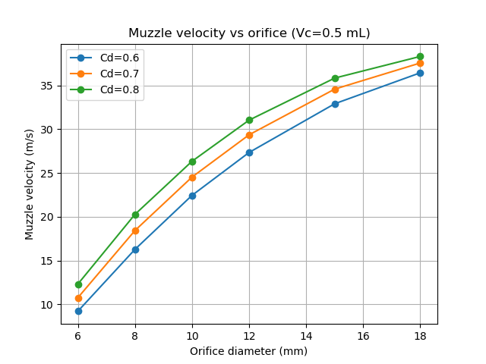
vel_vs_orifice_Vc_800uL.png
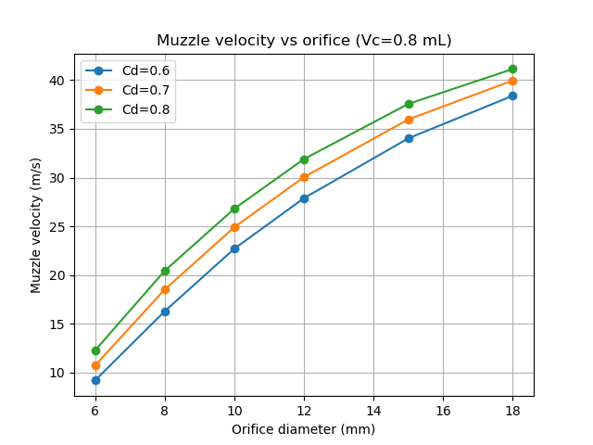
vel_vs_orifice_Vc_1000uL.png
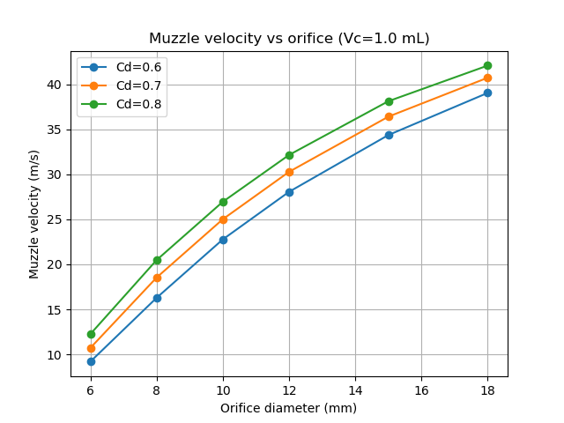
vel_vs_orifice_Vc_1200uL.png
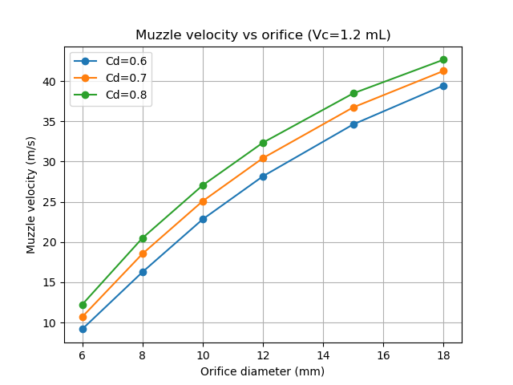
peakF_vs_orifice_Vc_1000uL.png
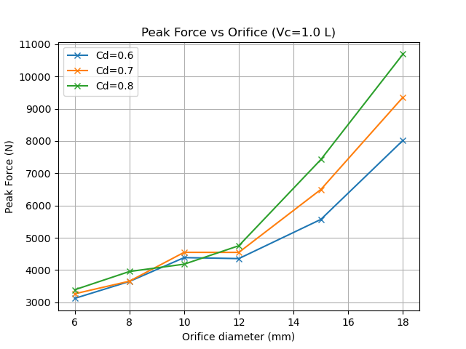
impulse_vs_orifice_Vc_1000uL.png
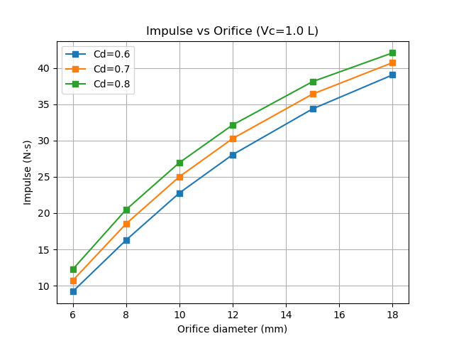

Flange and Bolt Check
{
"assumptions": {
"n_bolts": 6,
"pcd_m": 0.08,
"bolt_dia_m": 0.008,
"bolt_material_shear": 240000000.0
},
"worst_peak_F_N": 10694.11419802843,
"flange_result": {
"n_bolts": 6,
"cap_per_bolt_N": 12063.715789784805,
"bolts_needed": 1
},
"worst_case": {
"orifice_d_m": 0.018,
"Vc_m3": 0.0005,
"Cd": 0.8,
"muzzle_v": 38.307600282677335,
"impulse": 38.307600282677335,
"t_end_s": 0.02739999999999989,
"peak_F": 10694.11419802843
}
}

Appendix: Generated Files
C:\Users\BBBS-AI-01\d\uav_neutralisation\pneumatic_launcher_analysis.docx
C:\Users\BBBS-AI-01\d\uav_neutralisation\pneumatic_launcher_analysis_structural.docx
C:\Users\BBBS-AI-01\d\uav_neutralisation\pneumatic_launcher_analysis_transient.docx
C:\Users\BBBS-AI-01\d\uav_neutralisation\pneumatic_launcher_analysis_final.docx
C:\Users\BBBS-AI-01\d\uav_neutralisation\parametric_sweep.csv
C:\Users\BBBS-AI-01\d\uav_neutralisation\parametric_sweep_summary.json
C:\Users\BBBS-AI-01\d\uav_neutralisation\flange_check.json
C:\Users\BBBS-AI-01\d\uav_neutralisation\analysis_summary.json

