**Documentation for Grill Test Case Study for Lodestone**



**Prepared for Loadestone**

**Prepared by:**

**Mohammed Shayerwala**

**Contents:**

* **Executive Summary**
  + **Business Objectives**
* **Case Study Details**
  + **Sheet Names**
  + **Problem Statement**
  + **Data Description**
* **Excel Calculations**
* **Tableau Dashboard**
* **SQL Server Scripts**
* **Aggregated Data**
* **Visualizations**
* **Findings**
* **Conclusion**

**Executive Summary:**

As a part of the case study we had to find out whether Charcoal Grill is better than Propane Grill.

Business Objective:

The Business Objective was to recommend users and manufacturers which type of grill to purchase based on our finidings.

**Case Study Details:**

Sheet Names:

SheetA: GT_Specifications

SheetB: GT_Satisfaction_Data

SheetC: GT_Taste_Test_Data

Problem Statement:

To find out which grill type is better for what kind of grilling and which one is recommended based on the data provided.

Data Description:

grill_type: The type of grill – Charcoal or Propane.

pre_heat_time: The time taken to pre-heat the grill before grilling.

fuel_cost_per_meal: Cost of fuel per meal.

market_share: The percentage market share.

easiness_to_use: A value defining usage of easiness.

life_span_year: The lifespan after which the user changed a grill

initial_investment: The initial investment based for installing each grill.

**Excel Calculations:**

Created two tables to calculate cost of fuel on a long run and Total Cost for n years with workbook name – GT_Fuel_Cost_Data and GT_Total_Cost respectively.

The calculations give us the following visualizations.

**Tableau Dashboard:**

On tableau I created a dashboard to find all the findings:

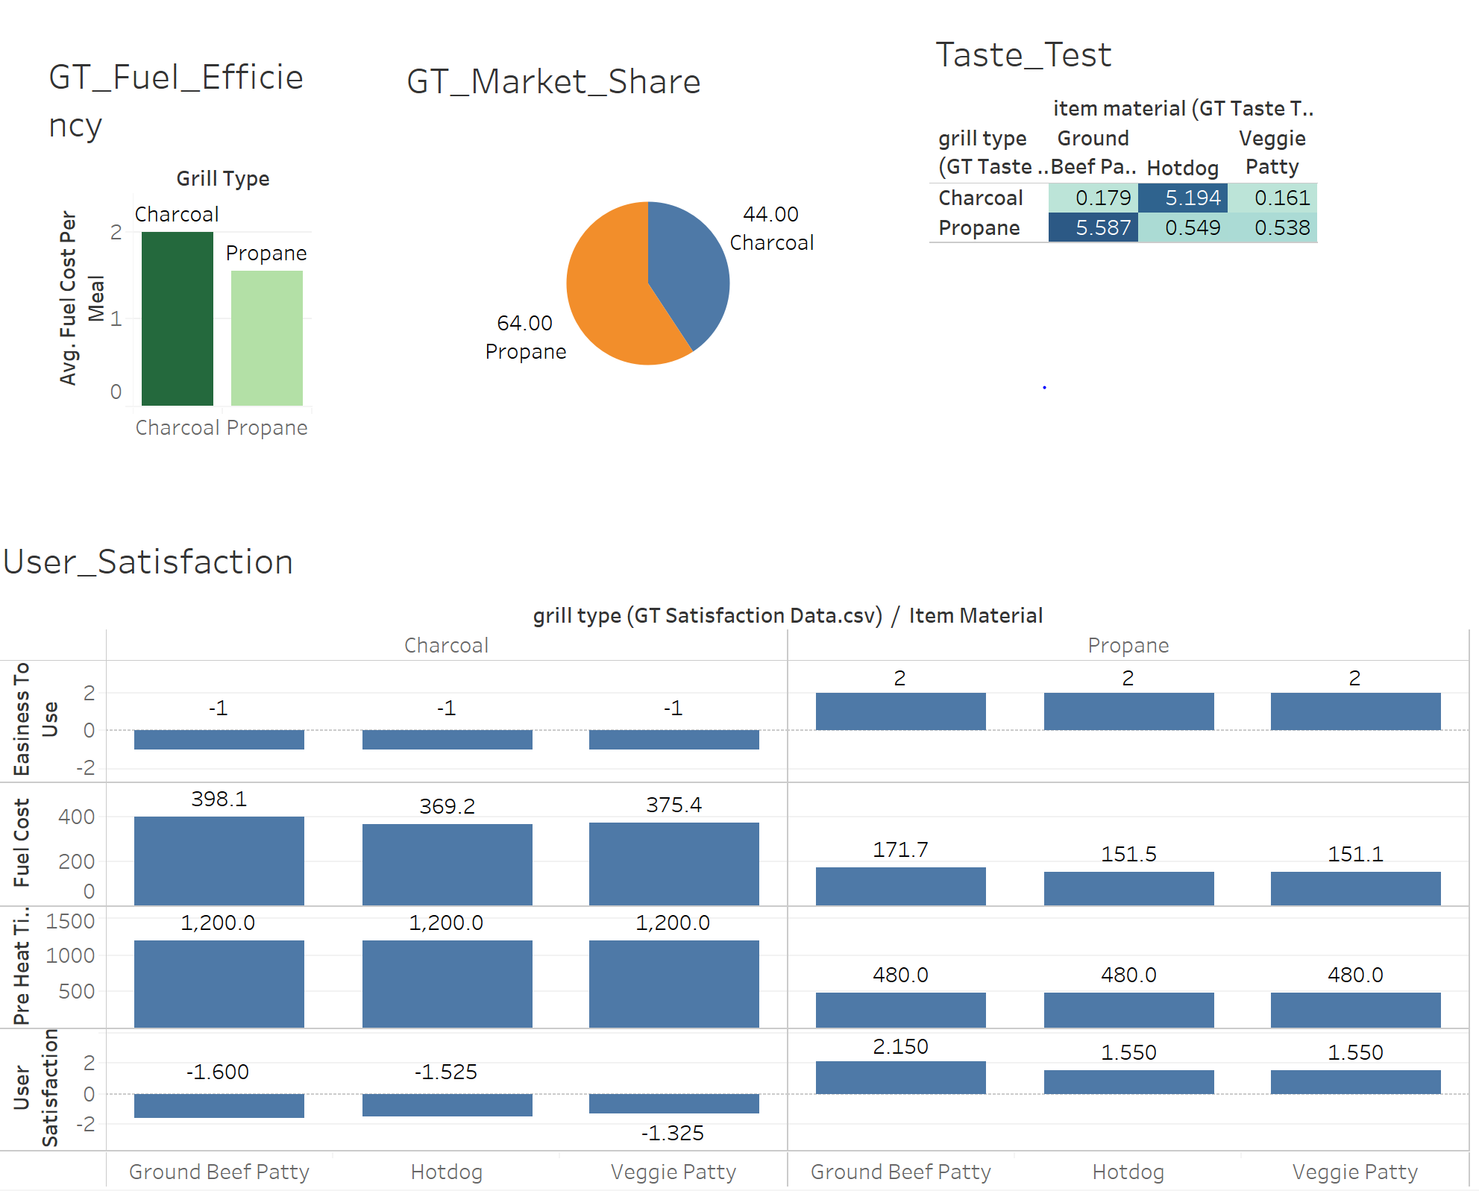

**SQL Server Scripts:**

Used SQL Server to aggregate the Data to define conclusions:

Script:

select b.grill_type, b.pre_heat_time, b.fuel_cost_per_meal, b.market_share, b.easiness_to_use, b.life_span_year, b.initial_investment, avg(a.user_satisfaction) as user_satisfaction,

avg(a.fuel_cost) as avg_fuel_cost, case when b.grill_type = 'Charcoal' then b.initial_investment + 38*b.fuel_cost_per_meal when b.grill_type = 'Propane' then b.initial_investment + 40*b.fuel_cost_per_meal End as Total_cost_for_3_years

from [Lodestone].[dbo].[GT_Satisfaction_Data] a

join [Lodestone].[dbo].[GT_Total_Cost] b

on a.grill_type = b.grill_type

group by b.grill_type, b.grill_type, b.pre_heat_time, b.fuel_cost_per_meal, b.market_share, b.easiness_to_use, b.life_span_year, b.initial_investment

**Aggregated Data:**

The aggregated data looks like:



**Visualizations:**

The visualizations as in the Tableau file named: GT_Visualizations.

**Findings:**

We found that there are various factors effecting the grill selection based on Taste, Fuel Cost, Ease of Use, Temperature Control and Pre-Heat Time.

**Conslusion:**

According to our finding we found that users would prefer propane grill than charcoal grill and hence the market share of propane 64% justifies over the 44% of Charcoal grill.